Gitlab Server Installation

Download and Install the RPM

| Curl -s https://packages.gitlab.com/install/repositories/gitlab/gitlab-ce/script.rpm.sh | sudo bash |
| --- |

when we give the command after get the script execution successful it will shows to the complete

We need to install the gitlab ce on rhel 8

| # yum install gitlab-ce -y |
| --- |

Then it begin installation of gitlab ce

After the installation we need to go the configuration file

| # vim /etc/gitlab/gitlab.rb |
| --- |

Then set the url in this file

| external_url ' http://gitlab.example.com ' |
| --- |

once it is done save and exit

After the save we need to run the gitlab reconfiguration script

| # gitlab-ctl reconfigure |
| --- |

After reconfiguration is successful it will shows the Running handlers

Access it locally at http://<external_url>/

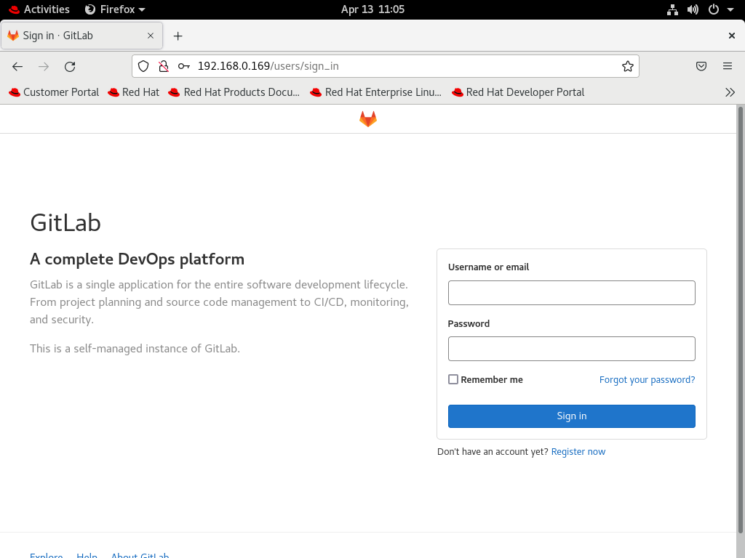

Change the password when prompted, initially

If not got to /etc/gitlab/initial_root_password file and search for the root password and enter that password with username root initially and then access the gitlab and then go to preference and change the password

Log in using your Username<root> and Password<*******>

Now if you can access it, the GitLab Server is successfully carried out.

