****介绍：****   
PermGen Space：指的是****内存的永久保存区****，该块内存主要是被JVM用来存放 class 和 mete 信息的，当 class 被加载 loader 的时候就会被存储到该内存区中，与存放类的实例的heap区不同，java中的 ****垃圾回收器GC 不会在主程序运行期对 PermGen space 进行清理****。

****原因：****

1. 当我们的应用中****有很多的class时****，很可能就会出现PermGen space的错误。
2. 我们的 tomcat 在重启的时候，不是使用的 ./bin/shutdown.sh 而是使用 kill -9 xxx 直接杀掉，这样的话，存在 PermGen space 里面的内存不会被释放的，这样多长进行 kill 之后，就会导致系统的内存被渐渐吃完了，直到最后 tomcat 报错。

# **在运行大型项目时，tomcat会报“java.lang.OutOfMemoryError: PermGen space”**

解决方法：

双击tomcat->Open Launch Configuration->Arguments ->VM Arguments：最后面加上：-Xms256M -Xmx512M -XX:PermSize=256m -XX:MaxPermSize=512m

图解：

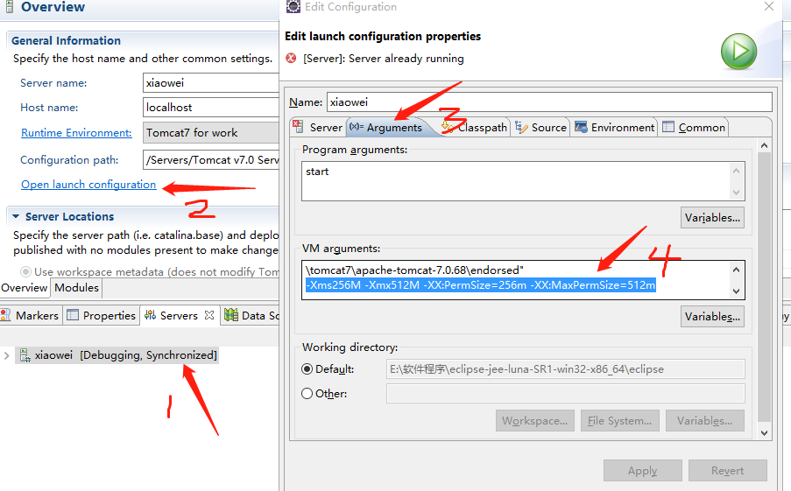

1. dmp文件导出/入本地数据库

导出：

exp xiaowei/xiaowei@localhost:1521/xe file='D:\xiaowei.dmp'

导入：

imp 用户名/密码@localhost:1521/xe file='E:\E\NewTT_xw.dmp' full=y ignore=y

Ps:1.如果出现只有dba才能导入由其他dba导出的文件时，需要运行以下授权语句，给用户授予dba权限

--给权限

grant connect,resource,dba to 用户名;

commit;

2.由oracle 11g导出的dmp文件只能导入相同版本的数据库，假如要导入10g版本数据库则需要修改dmp文件的第一行版本信息“TEXPORT:V11.02.00”

**新建maven项目时，出现这种错误**

**Could not calculate build plan: Failure to transfer org.apache.maven.plugins:maven-surefire-plugin:pom:2.7.1 from http://repo1.maven.org/maven2 was cached in the local repository, resolution will not be reattempted until the update interval of central has elapsed or updates are forced. Original error: Could not transfer artifact org.apache.maven.plugins:maven-surefire-plugin:pom:2.7.1 from/to central (http://repo1.maven.org/maven2): Access denied to http://repo1.maven.org/maven2/org/apache/maven/plugins/maven-surefire-plugin/2.7.1/maven-surefire-plugin-2.7.1.pom. Error code 407, Proxy Authentication Required ( The ISA Server requires authorization to fulfill the request. Access to the Web Proxy service is denied.  ) log4j-test01 Unknown Maven Problem**

**分析原因：现在的maven本地仓库用了之前版本的maven本地仓库，由于里面有很多东西无法预知，故应删除**

**解决办法：**

（1）将C:\User\.m2\repository\org\apache\maven\plugins\maven-deploy-plugin目录下的文件夹删除，

（2）然后右击项目Maven->Update Project->Update Dependencies（如果更新无效，选择强制更新如下图）

1. **启动tomcat时struts报错**

SEVERE: Exception starting filter struts2Filter

Class: com.opensymphony.xwork2.spring.SpringObjectFactory

File: SpringObjectFactory.java

Method: getClassInstance

Line: 220 - com/opensymphony/xwork2/spring/SpringObjectFactory.java:220:-1

at org.apache.struts2.dispatcher.Dispatcher.init(Dispatcher.java:428)

at org.apache.struts2.dispatcher.FilterDispatcher.init(FilterDispatcher.java:190)

at org.apache.catalina.core.ApplicationFilterConfig.initFilter(ApplicationFilterConfig.java:279)

at org.apache.catalina.core.ApplicationFilterConfig.getFilter(ApplicationFilterConfig.java:260)

at org.apache.catalina.core.ApplicationFilterConfig.<init>(ApplicationFilterConfig.java:105)

at org.apache.catalina.core.StandardContext.filterStart(StandardContext.java:4908)

at org.apache.catalina.core.StandardContext.startInternal(StandardContext.java:5602)

at org.apache.catalina.util.LifecycleBase.start(LifecycleBase.java:147)

at org.apache.catalina.core.ContainerBase$StartChild.call(ContainerBase.java:1572)

at org.apache.catalina.core.ContainerBase$StartChild.call(ContainerBase.java:1562)

at java.util.concurrent.FutureTask$Sync.innerRun(FutureTask.java:334)

at java.util.concurrent.FutureTask.run(FutureTask.java:166)

at java.util.concurrent.ThreadPoolExecutor.runWorker(ThreadPoolExecutor.java:1145)

at java.util.concurrent.ThreadPoolExecutor$Worker.run(ThreadPoolExecutor.java:615)

at java.lang.Thread.run(Thread.java:722)

Caused by: java.lang.NullPointerException

at com.opensymphony.xwork2.spring.SpringObjectFactory.getClassInstance(SpringObjectFactory.java:220)

at com.opensymphony.xwork2.config.providers.XmlConfigurationProvider.verifyResultType(XmlConfigurationProvider.java:530)

at com.opensymphony.xwork2.config.providers.XmlConfigurationProvider.addResultTypes(XmlConfigurationProvider.java:501)

at com.opensymphony.xwork2.config.providers.XmlConfigurationProvider.addPackage(XmlConfigurationProvider.java:457)

at com.opensymphony.xwork2.config.providers.XmlConfigurationProvider.loadPackages(XmlConfigurationProvider.java:275)

at org.apache.struts2.config.StrutsXmlConfigurationProvider.loadPackages(StrutsXmlConfigurationProvider.java:111)

at com.opensymphony.xwork2.config.impl.DefaultConfiguration.reloadContainer(DefaultConfiguration.java:204)

at com.opensymphony.xwork2.config.ConfigurationManager.getConfiguration(ConfigurationManager.java:66)

at org.apache.struts2.dispatcher.Dispatcher.init_PreloadConfiguration(Dispatcher.java:371)

at org.apache.struts2.dispatcher.Dispatcher.init(Dispatcher.java:415)

... 14 more

原因：

配置了依赖：

**Xml代码**

1. **<dependency>**
2. **<groupId>**org.apache.struts**</groupId>**
3. **<artifactId>**struts2-spring-plugin**</artifactId>**
4. **<version>**2.2.1**</version>**
5. **</dependency>**

但是工程web.xml中没有配置加载spring ApplicationContext相关的listener

**Xml代码**

1. **<listener>**
2. **<listener-class>**
3. org.springframework.web.context.ContextLoaderListener
4. **</listener-class>**
5. **</listener>**

原理：

查看struts2插件struts2-spring-plugin中的strtus-plugin.xml

**Xml代码**

1. **<struts>**
2. **<bean** type="com.opensymphony.xwork2.ObjectFactory" name="spring" class="org.apache.struts2.spring.StrutsSpringObjectFactory" **/>**
4. <!--  Make the Spring object factory the automatic default -->
5. **<constant** name="struts.objectFactory" value="spring" **/>**

8. **<constant** name="struts.class.reloading.watchList" value="" **/>**
9. **<constant** name="struts.class.reloading.acceptClasses" value="" **/>**
10. **<constant** name="struts.class.reloading.reloadConfig" value="false" **/>**
12. **<package** name="spring-default"**>**
13. **<interceptors>**
14. **<interceptor** name="autowiring" class="com.opensymphony.xwork2.spring.interceptor.ActionAutowiringInterceptor"**/>**
15. **<interceptor** name="sessionAutowiring" class="org.apache.struts2.spring.interceptor.SessionContextAutowiringInterceptor"**/>**
16. **</interceptors>**
17. **</package>**
18. **</struts>**

 注意下面部分，表明该插件引入工程后，会自动设置Struts的ObjectFactory为StrutsSpringObjectFactory，从而让Spring的IOC容器来托管Struts的Action。所以导致了启动的问题。

**Xml代码**

1. **<bean** type="com.opensymphony.xwork2.ObjectFactory" name="spring" class="org.apache.struts2.spring.StrutsSpringObjectFactory" **/>**
2. <!--  Make the Spring object factory the automatic default -->
3. **<constant** name="struts.objectFactory" value="spring" **/>**

**记录一下错误，方便查看。**

**5.**

SEVERE: Servlet [InitSystemDataServlet] in web application [/WebXw] threw load() exception

java.lang.ClassNotFoundException: app.oscache.MBaseCache

at org.apache.catalina.loader.WebappClassLoaderBase.loadClass(WebappClassLoaderBase.java:1858)

at org.apache.catalina.loader.WebappClassLoaderBase.loadClass(WebappClassLoaderBase.java:1701)

at com.core.struts.ScreenCache.<init>(ScreenCache.java:23)

at com.core.struts.InitSystemDataServlet.init(InitSystemDataServlet.java:18)

at javax.servlet.GenericServlet.init(GenericServlet.java:158)

at org.apache.catalina.core.StandardWrapper.initServlet(StandardWrapper.java:1282)

at org.apache.catalina.core.StandardWrapper.loadServlet(StandardWrapper.java:1195)

at org.apache.catalina.core.StandardWrapper.load(StandardWrapper.java:1085)

at org.apache.catalina.core.StandardContext.loadOnStartup(StandardContext.java:5318)

at org.apache.catalina.core.StandardContext.startInternal(StandardContext.java:5610)

at org.apache.catalina.util.LifecycleBase.start(LifecycleBase.java:147)

at org.apache.catalina.core.ContainerBase$StartChild.call(ContainerBase.java:1572)

at org.apache.catalina.core.ContainerBase$StartChild.call(ContainerBase.java:1562)

at java.util.concurrent.FutureTask$Sync.innerRun(FutureTask.java:334)

at java.util.concurrent.FutureTask.run(FutureTask.java:166)

at java.util.concurrent.ThreadPoolExecutor.runWorker(ThreadPoolExecutor.java:1145)

at java.util.concurrent.ThreadPoolExecutor$Worker.run(ThreadPoolExecutor.java:615)

at java.lang.Thread.run(Thread.java:722)

**原因：**

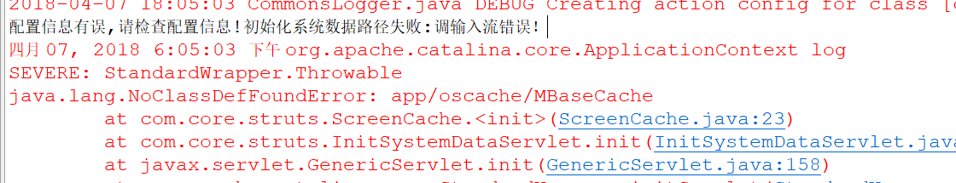

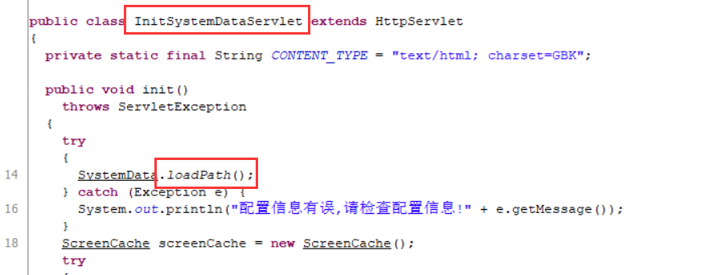

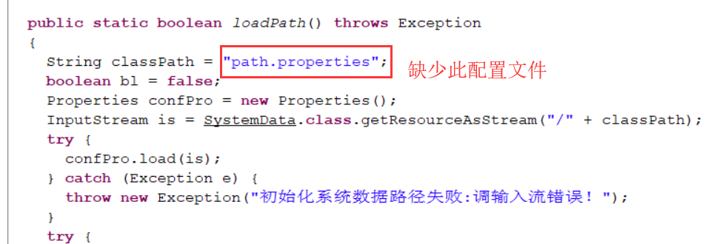

**另外缺少MBaseCache类。加上即可**

1. **启动tomcat时，在加载配置文件时，出现“**ERROR Unable to find parent packages struts-cms**”，**

**Unable to load optional class: java.lang.NoClassDefFoundError: org/apache/velocity/tools/view/ToolboxManager**

**缺少velocity-tools-2.0.jar包**

1. **插入数据时，提示序列不存在**

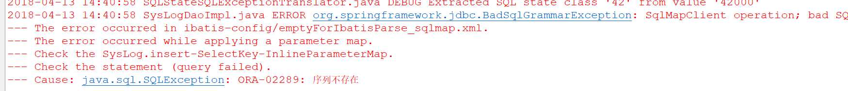

解决：在数据库添加序列即可

create sequence SYS_LOG_SEQ

INCREMENT BY 1 -- 每次加几个

START WITH 1 -- 从1开始计数

NOMAXVALUE -- 不设置最大值

NOCYCLE -- 一直累加，不循环

CACHE 10;

1. **函数引用出错**

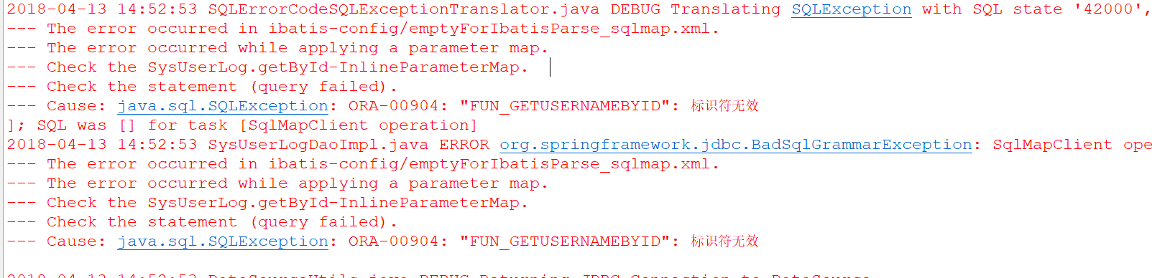

**解决：添加上相应的函数即可。**

1. **在某action中，引用某一实现类，显示为空，原因是未给此实现类的对象进行setter,getter方法。**

**10.**

**进入此页面**MyProj_Echarts_DetailTab.jsp后，执行下列方法后，报错，但是信息页面能显示

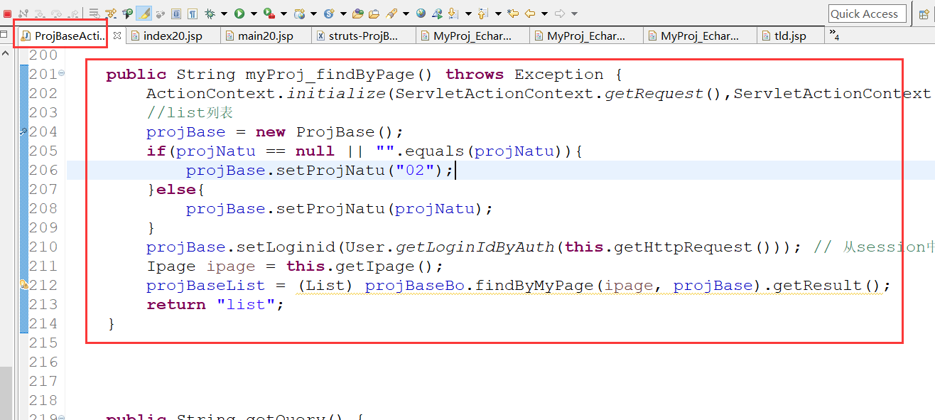

对象没有 brName 属性null

2018-04-20 10:53:33 AbstractConcurrentReadCache.java DEBUG get called (key=CMSII_FUN_TYPE)

2018-04-20 10:53:33 AbstractConcurrentReadCache.java DEBUG persistRetrieve called (key=CMSII_FUN_TYPE)

2018-04-20 10:53:33 Cache.java DEBUG No cache entry exists for key='CMSII_FUN_TYPE', creating

2018-04-20 10:53:33 AbstractConcurrentReadCache.java DEBUG get called (key=CMSII_FUN_TYPE)

2018-04-20 10:53:33 AbstractConcurrentReadCache.java DEBUG persistRetrieve called (key=CMSII_FUN_TYPE)

2018-04-20 10:53:33 Cache.java DEBUG No cache entry exists for key='CMSII_FUN_TYPE', creating

java.lang.NullPointerException

at com.core.struts.taglib.BaseTag.getOptionDes(BaseTag.java:224)

at com.core.struts.taglib.BaseTableTag.getRowHtml(BaseTableTag.java:169)

at com.core.struts.taglib.ListTableTag.doStartTag(ListTableTag.java:173)

at org.apache.jsp.creditapp.proj.MYProj_005fEcharts_005fList_jsp._jspx_meth_dhcc_005ftableTag_005f0(MYProj_005fEcharts_005fList_jsp.java:1027)

at org.apache.jsp.creditapp.proj.MYProj_005fEcharts_005fList_jsp._jspx_meth_s_005fform_005f0(MYProj_005fEcharts_005fList_jsp.java:989)

at org.apache.jsp.creditapp.proj.MYProj_005fEcharts_005fList_jsp._jspService(MYProj_005fEcharts_005fList_jsp.java:611)

at org.apache.jasper.runtime.HttpJspBase.service(HttpJspBase.java:70)

at javax.servlet.http.HttpServlet.service(HttpServlet.java:731)

at org.apache.jasper.servlet.JspServletWrapper.service(JspServletWrapper.java:439)

at org.apache.jasper.servlet.JspServlet.serviceJspFile(JspServlet.java:395)

at org.apache.jasper.servlet.JspServlet.service(JspServlet.java:339)

at javax.servlet.http.HttpServlet.service(HttpServlet.java:731)

at org.apache.catalina.core.ApplicationFilterChain.internalDoFilter(ApplicationFilterChain.java:303)

at org.apache.catalina.core.ApplicationFilterChain.doFilter(ApplicationFilterChain.java:208)

at org.apache.tomcat.websocket.server.WsFilter.doFilter(WsFilter.java:52)

at org.apache.catalina.core.ApplicationFilterChain.internalDoFilter(ApplicationFilterChain.java:241)

at org.apache.catalina.core.ApplicationFilterChain.doFilter(ApplicationFilterChain.java:208)

at org.apache.catalina.core.ApplicationDispatcher.invoke(ApplicationDispatcher.java:747)

at org.apache.catalina.core.ApplicationDispatcher.processRequest(ApplicationDispatcher.java:485)

at org.apache.catalina.core.ApplicationDispatcher.doForward(ApplicationDispatcher.java:410)

at org.apache.catalina.core.ApplicationDispatcher.forward(ApplicationDispatcher.java:337)

at org.apache.struts2.dispatcher.ServletDispatcherResult.doExecute(ServletDispatcherResult.java:159)

at org.apache.struts2.dispatcher.StrutsResultSupport.execute(StrutsResultSupport.java:186)

at com.opensymphony.xwork2.DefaultActionInvocation.executeResult(DefaultActionInvocation.java:373)

at com.opensymphony.xwork2.DefaultActionInvocation.invoke(DefaultActionInvocation.java:277)

at com.opensymphony.xwork2.interceptor.ExceptionMappingInterceptor.intercept(ExceptionMappingInterceptor.java:187)

at com.opensymphony.xwork2.DefaultActionInvocation.invoke(DefaultActionInvocation.java:248)

at app.base.interceptor.AuthenticationInterceptor.intercept(AuthenticationInterceptor.java:61)

at com.opensymphony.xwork2.DefaultActionInvocation.invoke(DefaultActionInvocation.java:248)

at app.util.syslog.interceptor.ExceptionInterceptor.intercept(ExceptionInterceptor.java:27)

at com.opensymphony.xwork2.DefaultActionInvocation.invoke(DefaultActionInvocation.java:248)

at com.opensymphony.xwork2.interceptor.DefaultWorkflowInterceptor.doIntercept(DefaultWorkflowInterceptor.java:176)

at com.opensymphony.xwork2.interceptor.MethodFilterInterceptor.intercept(MethodFilterInterceptor.java:98)

at com.opensymphony.xwork2.DefaultActionInvocation.invoke(DefaultActionInvocation.java:248)

at com.opensymphony.xwork2.validator.ValidationInterceptor.doIntercept(ValidationInterceptor.java:263)

at org.apache.struts2.interceptor.validation.AnnotationValidationInterceptor.doIntercept(AnnotationValidationInterceptor.java:68)

at com.opensymphony.xwork2.interceptor.MethodFilterInterceptor.intercept(MethodFilterInterceptor.java:98)

at com.opensymphony.xwork2.DefaultActionInvocation.invoke(DefaultActionInvocation.java:248)

at com.opensymphony.xwork2.interceptor.ConversionErrorInterceptor.intercept(ConversionErrorInterceptor.java:133)

at com.opensymphony.xwork2.DefaultActionInvocation.invoke(DefaultActionInvocation.java:248)

at com.opensymphony.xwork2.interceptor.ParametersInterceptor.doIntercept(ParametersInterceptor.java:207)

at com.opensymphony.xwork2.interceptor.MethodFilterInterceptor.intercept(MethodFilterInterceptor.java:98)

at com.opensymphony.xwork2.DefaultActionInvocation.invoke(DefaultActionInvocation.java:248)

at com.opensymphony.xwork2.interceptor.ParametersInterceptor.doIntercept(ParametersInterceptor.java:207)

at com.opensymphony.xwork2.interceptor.MethodFilterInterceptor.intercept(MethodFilterInterceptor.java:98)

at com.opensymphony.xwork2.DefaultActionInvocation.invoke(DefaultActionInvocation.java:248)

at com.opensymphony.xwork2.interceptor.StaticParametersInterceptor.intercept(StaticParametersInterceptor.java:190)

at com.opensymphony.xwork2.DefaultActionInvocation.invoke(DefaultActionInvocation.java:248)

at org.apache.struts2.interceptor.MultiselectInterceptor.intercept(MultiselectInterceptor.java:75)

at com.opensymphony.xwork2.DefaultActionInvocation.invoke(DefaultActionInvocation.java:248)

at org.apache.struts2.interceptor.CheckboxInterceptor.intercept(CheckboxInterceptor.java:94)

at com.opensymphony.xwork2.DefaultActionInvocation.invoke(DefaultActionInvocation.java:248)

at org.apache.struts2.interceptor.FileUploadInterceptor.intercept(FileUploadInterceptor.java:243)

at com.opensymphony.xwork2.DefaultActionInvocation.invoke(DefaultActionInvocation.java:248)

at com.opensymphony.xwork2.interceptor.ModelDrivenInterceptor.intercept(ModelDrivenInterceptor.java:100)

at com.opensymphony.xwork2.DefaultActionInvocation.invoke(DefaultActionInvocation.java:248)

at com.opensymphony.xwork2.interceptor.ScopedModelDrivenInterceptor.intercept(ScopedModelDrivenInterceptor.java:141)

at com.opensymphony.xwork2.DefaultActionInvocation.invoke(DefaultActionInvocation.java:248)

at org.apache.struts2.interceptor.debugging.DebuggingInterceptor.intercept(DebuggingInterceptor.java:267)

at com.opensymphony.xwork2.DefaultActionInvocation.invoke(DefaultActionInvocation.java:248)

at com.opensymphony.xwork2.interceptor.ChainingInterceptor.intercept(ChainingInterceptor.java:142)

at com.opensymphony.xwork2.DefaultActionInvocation.invoke(DefaultActionInvocation.java:248)

at com.opensymphony.xwork2.interceptor.PrepareInterceptor.doIntercept(PrepareInterceptor.java:166)

at com.opensymphony.xwork2.interceptor.MethodFilterInterceptor.intercept(MethodFilterInterceptor.java:98)

at com.opensymphony.xwork2.DefaultActionInvocation.invoke(DefaultActionInvocation.java:248)

at com.opensymphony.xwork2.interceptor.I18nInterceptor.intercept(I18nInterceptor.java:176)

at com.opensymphony.xwork2.DefaultActionInvocation.invoke(DefaultActionInvocation.java:248)

at org.apache.struts2.interceptor.ServletConfigInterceptor.intercept(ServletConfigInterceptor.java:164)

at com.opensymphony.xwork2.DefaultActionInvocation.invoke(DefaultActionInvocation.java:248)

at com.opensymphony.xwork2.interceptor.AliasInterceptor.intercept(AliasInterceptor.java:190)

at com.opensymphony.xwork2.DefaultActionInvocation.invoke(DefaultActionInvocation.java:248)

at com.opensymphony.xwork2.interceptor.ExceptionMappingInterceptor.intercept(ExceptionMappingInterceptor.java:187)

at com.opensymphony.xwork2.DefaultActionInvocation.invoke(DefaultActionInvocation.java:248)

at org.apache.struts2.impl.StrutsActionProxy.execute(StrutsActionProxy.java:52)

at org.apache.struts2.dispatcher.Dispatcher.serviceAction(Dispatcher.java:485)

at org.apache.struts2.dispatcher.FilterDispatcher.doFilter(FilterDispatcher.java:395)

at org.apache.catalina.core.ApplicationFilterChain.internalDoFilter(ApplicationFilterChain.java:241)

at org.apache.catalina.core.ApplicationFilterChain.doFilter(ApplicationFilterChain.java:208)

at org.apache.catalina.core.StandardWrapperValve.invoke(StandardWrapperValve.java:220)

at org.apache.catalina.core.StandardContextValve.invoke(StandardContextValve.java:122)

at org.apache.catalina.authenticator.AuthenticatorBase.invoke(AuthenticatorBase.java:505)

at org.apache.catalina.core.StandardHostValve.invoke(StandardHostValve.java:169)

at org.apache.catalina.valves.ErrorReportValve.invoke(ErrorReportValve.java:103)

at org.apache.catalina.valves.AccessLogValve.invoke(AccessLogValve.java:956)

at org.apache.catalina.core.StandardEngineValve.invoke(StandardEngineValve.java:116)

at org.apache.catalina.connector.CoyoteAdapter.service(CoyoteAdapter.java:436)

at org.apache.coyote.http11.AbstractHttp11Processor.process(AbstractHttp11Processor.java:1078)

at org.apache.coyote.AbstractProtocol$AbstractConnectionHandler.process(AbstractProtocol.java:625)

at org.apache.tomcat.util.net.JIoEndpoint$SocketProcessor.run(JIoEndpoint.java:318)

at java.util.concurrent.ThreadPoolExecutor.runWorker(ThreadPoolExecutor.java:1145)

at java.util.concurrent.ThreadPoolExecutor$Worker.run(ThreadPoolExecutor.java:615)

at org.apache.tomcat.util.threads.TaskThread$WrappingRunnable.run(TaskThread.java:61)

at java.lang.Thread.run(Thread.java:722)

**解决：再启动项目时，未加载数据字典。配好数据字典的加载文件后，正常**

**11.**java.lang.NullPointerException

空指针异常