**workprocName**

1. **目的和目标**

目的：purpose

目标：target

|  |  |  |  |
| --- | --- | --- | --- |
| 重要特性参数 | 目标 | | |
| 内容 | 要求 | 控制线 |
| pecuParam | content | requires | controlLine |

1. **原材料、辅料、材料**

|  |  |  |
| --- | --- | --- |
| 序号 | 名称 | 规格/型号 |
| seqNo | materialName | materialModel |

1. **设备仪器**

|  |  |  |  |  |
| --- | --- | --- | --- | --- |
| 序号 | 名称 | 规格/型号 | 设备编号 | 操作规程编号 |
| seqNo | equipmentName | equipmentModel | equipmentNo | ruleNo |

1. **工装、用品**

|  |  |  |  |
| --- | --- | --- | --- |
| 序号 | 名称 | 规格 | 编号 |
| seqNo | toolName | toolModel | toolNo |

1. **操作过程**

|  |  |  |  |
| --- | --- | --- | --- |
| 序号 | | 项目 | 内容 |
| seqNo | seqNo2 | itemName | 检验按下述要求进行：   |  |  |  |  |  |  | | --- | --- | --- | --- | --- | --- | | **参数名称** | **目标值** | **控制线** | **抽样方案** | **检验方法** | **批次合格判据** | | paramName | targetVal | controlLine | sampleDesign | checkMeth | batchQuaReason |   itemContent |

1. **工作环境要求**

|  |  |  |  |
| --- | --- | --- | --- |
| 项目 | 目标值/下限（要求） | 容差/上限 | 使用环境 |
| project | qtyMin | qtyMax | useSurroundings |

1. **注意事项**

Attention

1. **引用文件**

|  |  |
| --- | --- |
| 文件名称 | 文件编号 |
| fileName | fileCode |
| 注：引用文件执行最新版本 | |

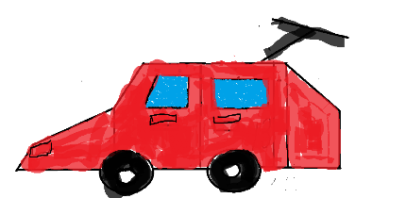

啊啊啊啊