1./averageWeb :

/getList post

RequestBody: {“resourceId”:”1”}

2./ctAlarm :

/list get

Params : alarm,pageNo,pageSize

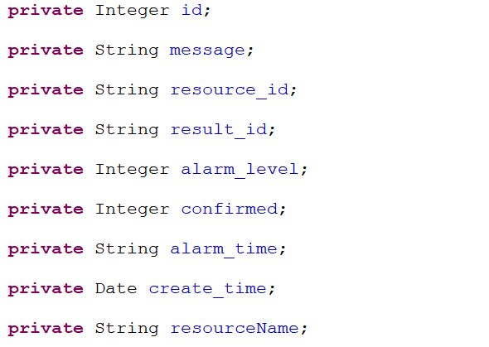

alarm的属性，同时也是json字符串的键

/add post

RequestBody: alarm的json字符串

/edit put 编辑告警信息

RequestBody:同上 id为必须

/recover post 确认告警

RequestBody:同上 有id即可

/batchRecover post 确认多个告警

RequestBody: {“ids”:”1,2,3”}逗号分隔id

1. /ctMetric :

/getCtMetricsByType 获取ct指标

Param:type 0:页面采集,1:ping

/getOne/{id} post 获取单个指标信息

1. /metricTemplates :

/get/{profilelibId} post 获取某个策略对应的指标设置

/updateOrInsertTemplates post 修改或添加指标设置

vo：{“profilelibId”:”1”,”metricTemplates”:[{MsMetricTemplates},{MsMetricTemplates}]}

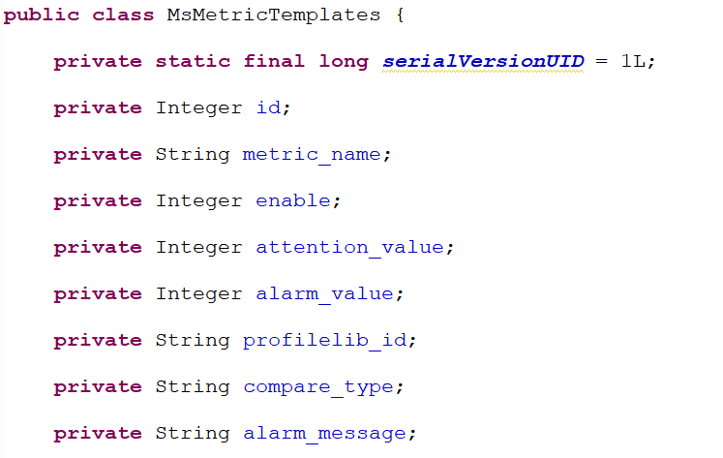

MsMetricTemplates的属性，同时也是json字符串的键

/delete/{profilelibId} post 根据策略id删除指标设置，删除策略的时候传递

1. /pingMetric :

/getList post 根据资源id获取ping指标

RequestBody : {“id”:”1”}

1. /probe :
   1. /list get 获取指针

Params:pageNo,pageSize,msProbeParams

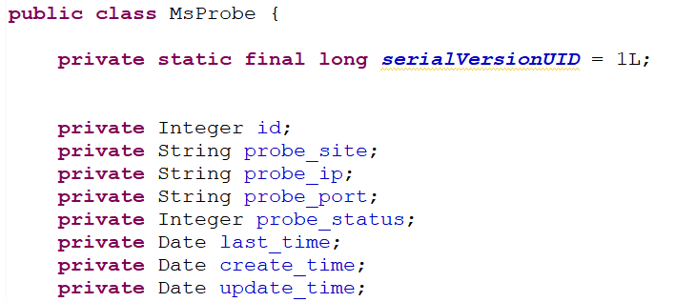

Probe的类属性

* 1. /add post

RequestBody: MsProbe的json字符串

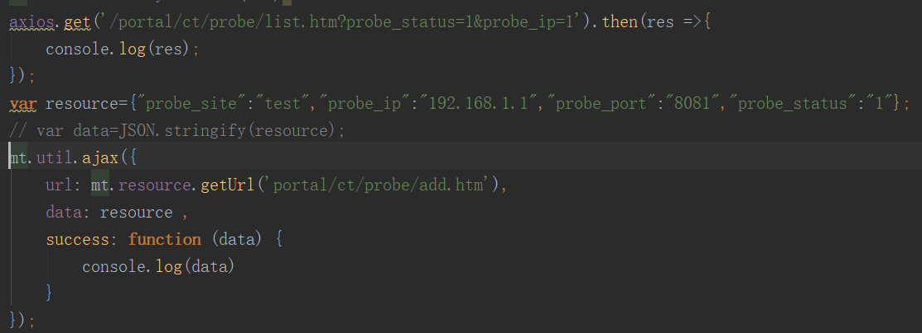

* 1. /edit put

RequestBody: MsProbe的json字符串,id必须

* 1. /delete delete 根据id删除

RequestParam:id

* 1. /deleteBatch delete 批量删除

RequestParam: ids 字符串,采用逗号分隔

* 1. /queryProbes get 查询所有可用探针

无参

1. /profilelib :
   1. /list get

Params:pageNo,pageSize,msProfilelibParams

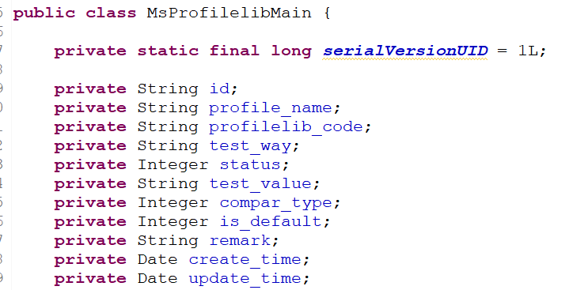

msProfilelib的类属性

* 1. /add post

RequestBody:msProfilelib的JSON字符串

* 1. /edit put

RequestBody:msProfilelib的JSON字符串,id必须

* 1. /delete delete 根据id删除

RequestParam:id

* 1. /deleteBatch delete 批量删除

RequestParam: ids 字符串,采用逗号分隔

* 1. /queryProfilelibs get 查询所有策略

无参

1. /ctResource :
   1. /list get

Params:pageNo,pageSize,msResourceParams

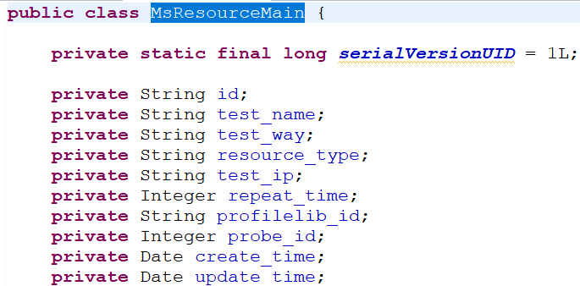

msResource的类属性

* 1. /getList post 根据监控方法获取资源

RequestBody:{“testWay”:””}

* 1. /add post

RequestBody:msResource的json字符串

* 1. /edit post

RequestBody:msResource的json字符串,id必须

* 1. /delete delete 根据id删除

RequestParam:id

* 1. /deleteBatch delete 批量删除

RequestParam: ids 字符串,采用逗号分隔

1. /websiteMetric :
   1. /getList post 根据资源id获取网页指标信息

RequestBody:{“id”,”1”}

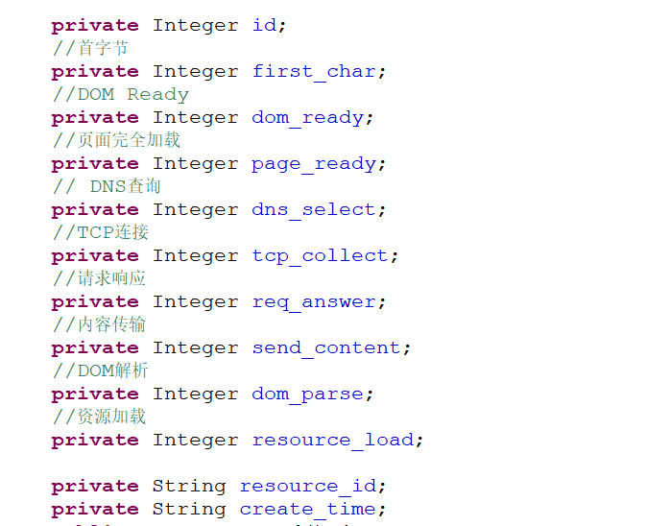

MsAverageWeb