|  |  |  |  |
| --- | --- | --- | --- |
| 项目名称 |  | | |
| 文档版本 |  | 最后修订时间 |  |

网贷手机APP接口文档

修订控制页

|  |  |  |  |  |  |
| --- | --- | --- | --- | --- | --- |
| **编号** | **版本** | **修订章节** | **修改原因** | **修订日期** | **修订人** |
| 1 | V1.0 |  |  | 20150515 | 王侃涛 |
| 2 | V1.1 |  |  | 20150516 | 王侃涛 |
|  | **beta** |  |  | **20150619** |  |
|  |  |  |  |  |  |
|  |  |  |  |  |  |
|  |  |  |  |  |  |
|  |  |  |  |  |  |
|  |  |  |  |  |  |
|  |  |  |  |  |  |
|  |  |  |  |  |  |
|  |  |  |  |  |  |

目录

第一章接口 1

一、首页 1

1、首页 1

二、投资中心 1

1、投资中心 1

2、项目详情页 1

3、项目投资记录 1

4、还款计划 1

5、投资项目(弹出) 1

6、 投资项目 1

三、登录注册 1

1. 登录 1

2. 发送短信验证码(找回登录密码) 1

3. 找回登录密码验证 1

4. 重置登录密码 1

5. 发送短信验证码（注册） 1

6. 注册 1

7. 退出 1

四、会员中心首页 1

1. 会员中心首页 1

五、会员账户管理 1

1. 账户管理 1

2. 实名认证信息 1

3. 实名认证提交 1

4. 发送手机验证码（更换号码—发到旧号码） 1

5. 手机号码更改申请 1

6. 发送手机验证码（更换号码—发到新号码） 1

7. 手机号码更改提交 1

8. 邮箱地址为空时 1

9. 邮箱地址不为空时 1

10. 获取银行卡信息 1

11. 银行卡提交 1

12. 登录密码设置 1

13. 安全密码状态 1

14. 修改安全密码 1

15. 忘记安全密码 1

16. 忘记登录密码 1

六、会员中心-我的投资 1

1. 投资记录 1

2. 回款明细 1

3. 自动投资信息 1

4. 自动投资设置 1

七、 会员中心-资金管理 1

1.我要充值 1

1. 我要充值提交 1

2. 充值记录 1

3. 我要提现 1

4. 我要提现提交 1

5. 提现列表 1

6. 我的红包 1

7. 红包明细 1

8. 好友列表 1

9. 资金记录 1

10. 奖励记录 1

八、更多 1

1. 更多 1

2. CMS列表页 – 以帮助中心为例 1

3. CMS内容页 – 以网站公告内容页为例 1

第二章数据结构 1

# 第一章接口

# 一、首页

## 1、首页

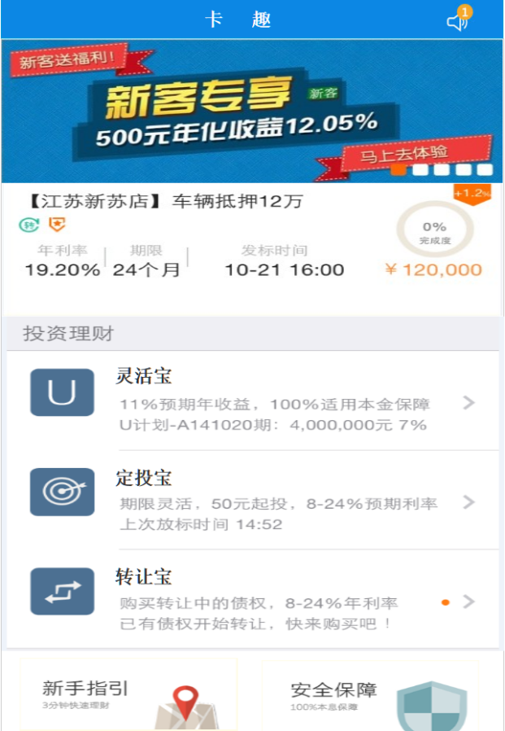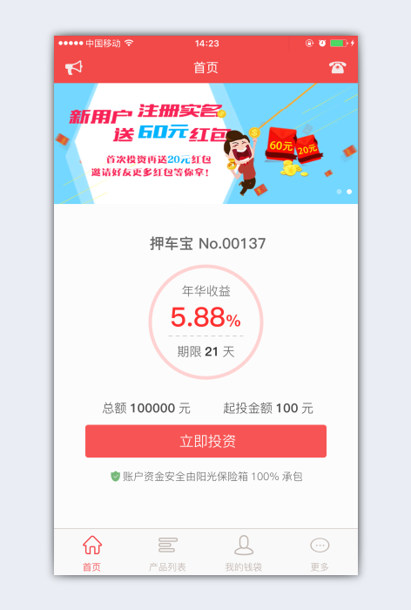

1. 接口名称：

/index

1. 输入

|  |  |  |  |  |  |  |  |  |
| --- | --- | --- | --- | --- | --- | --- | --- | --- |
| **名称** | **类型** | **必须** | **长度** | **默认值** | **最小值** | **最大值** | **示例值** | **描述** |
| **way** |  |  |  |  |  |  |  | 请求端类型:0网页，1 H5端,2 Andriod,3 IOS |

1. 返回

|  |  |  |  |  |  |  |  |  |
| --- | --- | --- | --- | --- | --- | --- | --- | --- |
| **名称** | **类型** | **必须** | **长度** | **默认值** | **最小值** | **最大值** | **示例值** | **描述** |
| **indexImageItemList** |  |  |  |  |  |  |  | 以下滚动图列表开始 |
| **imageUrl** |  |  |  |  |  |  |  | 滚动图url |
| **type** |  |  |  |  |  |  |  | 类型：0无1网页2项目类型3文章id |
| **typeTarget** |  |  |  |  |  |  |  | 网页url（类型1时启用。类型2时，为项目类型。类型3时，为文章id） |
|  |  |  |  |  |  |  |  | 以下滚动图列表结束 |
| **IndexBorrow** |  |  |  |  |  |  |  | 以下为推荐项目开始 |
| lowestAccount |  |  |  |  |  |  |  | 起投金额 |
| **id** |  |  |  |  |  |  |  | 推荐项目id |
| **name** |  |  |  |  |  |  |  | 推荐项目名称 |
| **businessType** |  |  |  |  |  |  |  | 推荐项目类型ID |
| **businessCode** |  |  |  |  |  |  |  | 推荐项目编号 |
| **timeLimit** |  |  |  |  |  |  |  | 推荐项目期限 |
| **account** |  |  |  |  |  |  |  | 推荐项目金额 |
| **apr** |  |  |  |  |  |  |  | 推荐项目年化收益 |
| **funds** |  |  |  |  |  |  |  | 推荐项目奖励 |
| **status** |  |  |  |  |  |  |  | 推荐项目状态 |
| **showBorrowStatus** |  |  |  |  |  |  |  | 推荐项目状态名称 |
| **schedule** |  |  |  |  |  |  |  | 推荐项目进度 |
| **tenderSize** |  |  |  |  |  |  |  | 推荐已投次数 |
| **tenderSubject** |  |  |  |  |  |  |  | 推荐新客图片 |
| **verifyTime** |  |  |  |  |  |  |  | 推荐项目发布时间 |
|  |  |  |  |  |  |  |  | 以上为推荐项目结束 |
| **indexTypeItemList** |  |  |  |  |  |  |  | 以下为平台项目类型列表开始 |
| **type** |  |  |  |  |  |  |  | 平台项目类型 |
| **showBorrowType** |  |  |  |  |  |  |  | 平台项目类型名称 |
| **typeImage** |  |  |  |  |  |  |  | 平台项目类型图片 |
| **typeDescribe** |  |  |  |  |  |  |  | 平台项目类型简介 |
| **notReadNum** |  |  |  |  |  |  |  | 未读网站公告数量 |

1. 错误码

|  |  |  |
| --- | --- | --- |
| **错误码** | **错误描述** | **解决方案** |
|  |  |  |

# 二、投资中心

## 1、投资中心

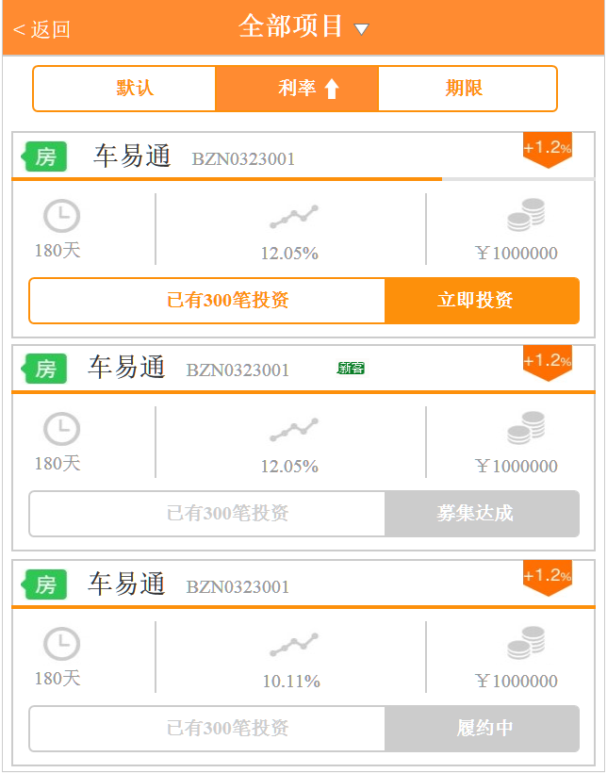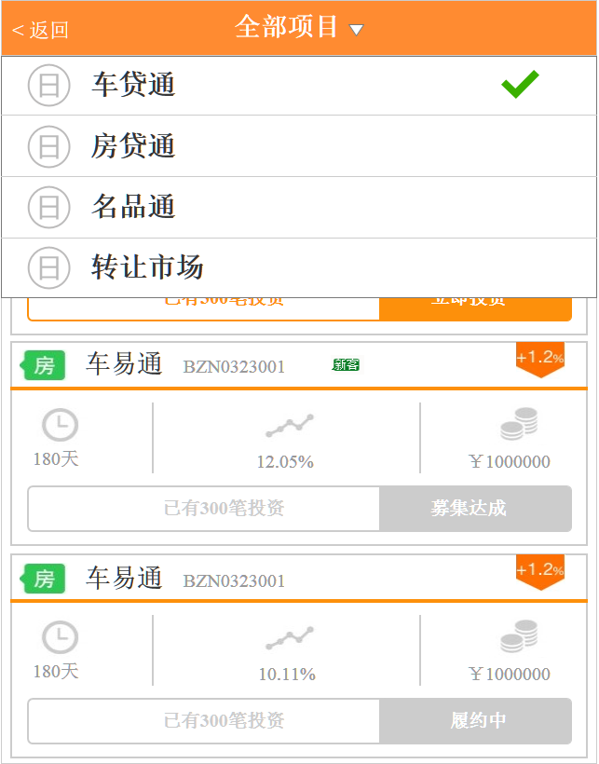

1. 接口名称：

/rest/borrow

1. 输入

|  |  |  |  |  |  |  |  |  |
| --- | --- | --- | --- | --- | --- | --- | --- | --- |
| **名称** | **类型** | **必须** | **长度** | **默认值** | **最小值** | **最大值** | **示例值** | **描述** |
| **type** |  |  |  |  |  |  |  | 项目类型 |
| **businessType** |  |  |  |  |  |  | 1质押宝 2抵押宝 3按揭宝, 17体验标 | 项目业务类型 |
| **pager** |  |  |  |  |  |  |  |  |
| **pageNumber** | **pager** |  |  |  |  |  |  | 页数 |
| **pageSize** | **pager** |  |  |  |  |  |  | 单页条数 |
|  |  |  |  |  |  |  |  |  |
| **orderBy** |  |  |  |  |  |  |  | 排序字段 0无1利率2期限 |
| **orderSort** |  |  |  |  |  |  |  | 排序方式 0ASC 1DESC |

1. 返回

|  |  |  |  |  |  |  |  |  |
| --- | --- | --- | --- | --- | --- | --- | --- | --- |
| **名称** | **类型** | **必须** | **长度** | **默认值** | **最小值** | **最大值** | **示例值** | **描述** |
| **pageBean** |  |  |  |  |  |  |  | 翻页信息 |
|  |  |  |  |  |  |  |  | -以下【pageBean】开始 |
| **pageNumber** |  |  |  |  |  |  |  | 当前页数 |
| **totalCount** |  |  |  |  |  |  |  | 总记录数 |
| **pageCount** |  |  |  |  |  |  |  | 总页数 |
| **pageSize** |  |  |  |  |  |  |  | 每页记录数 |
|  |  |  |  |  |  |  |  | --以上【pageBean】结束 |
|  |  |  |  |  |  |  |  |  |
| **borrowItemList** | BorrowItem |  |  |  |  |  |  | 项目列表信息 |
|  |  |  |  |  |  |  |  | --以下【项目列表】循环开始 |
| **id** |  |  |  |  |  |  |  | 项目id |
| **type** |  |  |  |  |  |  |  | 项目类型ID |
| **showBorrowType** |  |  |  |  |  |  |  | 项目类型名称 |
| **borImage** |  |  |  |  |  |  |  | 项目图片 |
| **businessCode** |  |  |  |  |  |  |  | 项目编号 |
| **timeLimit** |  |  |  |  |  |  |  | 项目期限 |
| **account** |  |  |  |  |  |  |  | 项目金额 |
| **apr** |  |  |  |  |  |  |  | 项目年化收益 |
| **award** |  |  |  |  |  |  |  | 项目奖励方式 |
| **funds** |  |  |  |  |  |  |  | 项目奖励比例 |
| **status** |  |  |  |  |  |  |  | 项目状态 |
| **showBorrowStatus** |  |  |  |  |  |  |  | 项目状态名称 |
| **schedule** |  |  |  |  |  |  |  | 项目进度 |
| **tenderSize** |  |  |  |  |  |  |  | 已投次数 |
| **tenderSubject** |  |  |  |  |  |  |  | 新客 |
| **validTime** |  |  |  |  |  |  |  | 开放期 |
| **verifyTime** |  |  |  |  |  |  |  | 项目发布时间 |
| **businessType** |  |  |  |  |  |  |  | 业务类型 |
|  |  |  |  |  |  |  |  | --以上【项目列表】循环结束 |

1. 错误码

|  |  |  |
| --- | --- | --- |
| **错误码** | **错误描述** | **解决方案** |
|  |  |  |

## 2、项目详情页

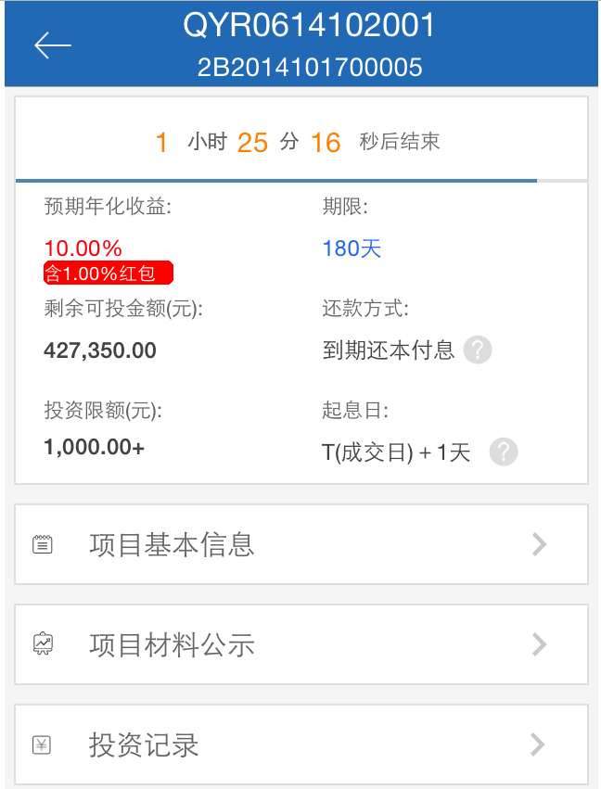

1. 获取单个项目所有信息
2. 接口名称：

/rest/borrow/{id}

1. 输入

|  |  |  |  |  |  |  |  |  |
| --- | --- | --- | --- | --- | --- | --- | --- | --- |
| **名称** | **类型** | **必须** | **长度** | **默认值** | **最小值** | **最大值** | **示例值** | **描述** |
| **id** |  |  |  |  |  |  |  | 项目id |

1. 返回

|  |  |  |  |  |  |  |  |  |
| --- | --- | --- | --- | --- | --- | --- | --- | --- |
| **名称** | **类型** | **必须** | **长度** | **默认值** | **最小值** | **最大值** | **示例值** | **描述** |
| **id** |  |  |  |  |  |  |  | 项目id |
| **name** |  |  |  |  |  |  |  | 项目名称 |
| **type** |  |  |  |  |  |  |  | 项目类型 |
| **businessCode** |  |  |  |  |  |  |  | 项目编号 |
| **timeLimit** |  |  |  |  |  |  |  | 项目期限 |
| **account** |  |  |  |  |  |  |  | 项目金额 |
| **apr** |  |  |  |  |  |  |  | 项目年化收益 |
| **funds** |  |  |  |  |  |  |  | 项目奖励 |
| **style** |  |  |  |  |  |  |  | 还款方式 |
| **lowestAccount** |  |  |  |  |  |  |  | 最小投资额 |
| **mostAccount** |  |  |  |  |  |  |  | 最大投资额 |
| **pwdFlg** |  |  |  |  |  |  |  | 定向密码标记 |
|  |  |  |  |  |  |  |  | 续投奖励 |
| **verifyTime** |  |  |  |  |  |  |  | 发布时间（初审通过时间） |
| **status** |  |  |  |  |  |  |  | 项目状态 |
| **showBorrowStatus** |  |  |  |  |  |  |  | 项目状态名称 |
| **showSchedule** |  |  |  |  |  |  |  | 项目进度 |
| **content** |  |  |  |  |  |  |  | 项目基本信息 |
| **borImage** |  |  |  |  |  |  |  | 项目资料公示（图片）-循环 |
| **userFlg** |  |  |  |  |  |  |  | 会员登录状态 |
| **userAbleMoney** |  |  |  |  |  |  |  | 会员可用余额 |
| **currentDate** |  |  |  |  |  |  |  | 当前时间 |
| **overDate** |  |  |  |  |  |  |  | 过期时间 |
| **businessType** |  |  |  |  |  |  |  | 业务类型 |

1. 错误码

|  |  |  |
| --- | --- | --- |
| **错误码** | **错误描述** | **解决方案** |
| **M0010** | 此标不能存在！ |  |
| **M0011** | 此标未发布！ |  |

1. 获取车辆信息
2. 接口名称：

/rest/car/{id}

1. 输入

|  |  |  |  |  |  |  |  |  |
| --- | --- | --- | --- | --- | --- | --- | --- | --- |
| **名称** | **类型** | **必须** | **长度** | **默认值** | **最小值** | **最大值** | **示例值** | **描述** |
| **id** |  |  |  |  |  |  |  | 项目id |

1. 返回

|  |  |  |  |  |  |  |  |  |
| --- | --- | --- | --- | --- | --- | --- | --- | --- |
| **名称** | **内部字段** | **必须** | **长度** | **默认值** | **最小值** | **最大值** | **示例值** | **描述** |
| **id** |  |  |  |  |  |  |  | 项目id |
| **borrowInfoJson** | **carBrand** |  |  |  |  |  |  | **车辆品牌** |
| **carSeries** |  |  |  |  |  |  | **车系** |
| **carSpec** |  |  |  |  |  |  | **车型** |
| **onCardTime** |  |  |  |  |  |  | **上牌时间** |
| **certificationTime** |  |  |  |  |  |  | **发证时间** |
| **roadHaul** |  |  |  |  |  |  | **行驶里程** |
| **vin** |  |  |  |  |  |  | **车辆识别号** |
| **engineNumber** |  |  |  |  |  |  | **发动机号** |
| **use** |  |  |  |  |  |  | **用途** |
| **modelsLink** |  |  |  |  |  |  | **车型链接** |
| **borrowVerifyJson** | **idCard** |  |  |  |  |  | **1表示是，0表示否** | **是否有身份证** |
| **household** |  |  |  |  |  | **1表示是，0表示否** | **是否有户口本** |
| **zhengXin** |  |  |  |  |  | **1表示是，0表示否** | **是否有征信报告** |
| **income** |  |  |  |  |  | **1表示是，0表示否** | **是否有收入证明** |
| **anCase** |  |  |  |  |  | **1表示是，0表示否** | **是否有在执行案件查询** |
| **cardDriving** |  |  |  |  |  | **1表示是，0表示否** | **是否有车辆行驶证** |
| **gouZhi** |  |  |  |  |  | **1表示是，0表示否** | **是否有购置税凭证** |
| **guJia** |  |  |  |  |  | **1表示是，0表示否** | **是否有车辆评估报告** |
| **gcfp** |  |  |  |  |  | **1表示是，0表示否** | **是否有购车发票机** |
| **jdczs** |  |  |  |  |  | **1表示是，0表示否ss** | **是否有动车登记证书** |
| **borImage2** |  |  |  |  |  |  |  | 车辆图片-循环 |
| **userFlg** |  |  |  |  |  |  |  | 会员登录状态 |
| **userAbleAccount** |  |  |  |  |  |  |  | 会员可用余额 |

1. 错误码

|  |  |  |
| --- | --- | --- |
| **错误码** | **错误描述** | **解决方案** |
| **M0010** | 此标不能存在！ |  |
| **M0011** | 此标未发布！ |  |

## 3、项目投资记录

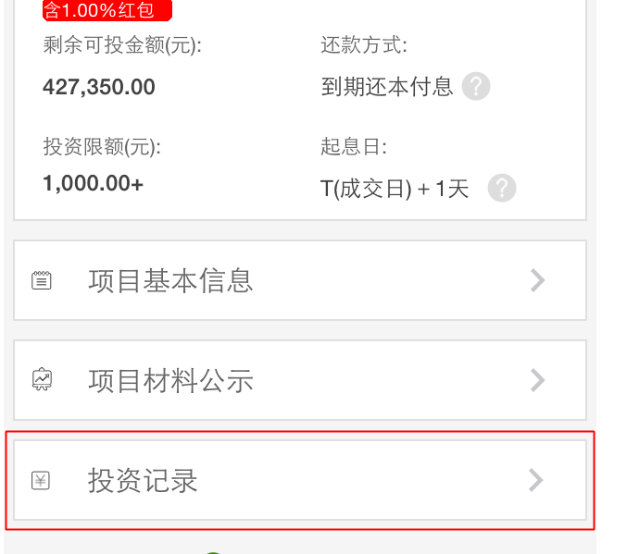

1. 接口名称：

/rest/borrowTenderList/{id}

1. 输入

|  |  |  |  |  |  |  |  |  |  |  |
| --- | --- | --- | --- | --- | --- | --- | --- | --- | --- | --- |
| **名称** | **类型** | | | **必须** | **长度** | **默认值** | **最小值** | **最大值** | **示例值** | **描述** |
| **id** | |  | |  |  |  |  |  |  | 项目id |
| **pageNumbe** | |  | |  |  |  |  |  |  | 页数 |
| **pageSize** | | |  |  |  |  |  |  |  | 单页条数 |
| **orderBy** | | |  |  |  |  |  |  |  | 排序字段 0：投资时间 |
| **orderSort** | | |  |  |  |  |  |  |  | 排序方式 0ASC 1DESC |

1. 返回

|  |  |  |  |  |  |  |  |  |  |
| --- | --- | --- | --- | --- | --- | --- | --- | --- | --- |
| **名称** | **类型** | | **必须** | **长度** | **默认值** | **最小值** | **最大值** | **示例值** | **描述** |
| **id** | |  |  |  |  |  |  |  | 项目id |
| **tenderId** | |  |  |  |  |  |  |  | 投资记录id |
| **username** | |  |  |  |  |  |  |  | 投资会员会员名 |
| **createDate** | |  |  |  |  |  |  |  | 投资时间 |
| **money** | |  |  |  |  |  |  |  | 投资金额 |
| **account** | |  |  |  |  |  |  |  | 投资成功金额 |
| **autoTenderstatus** | |  |  |  |  |  |  | 1自动，  2手动 | 投资类型（手动、自动） |
| **status** | |  |  |  |  |  |  | 1：全部通过;  2：部分通过 | 投资完成度（全部、部分） |
| **loginStatus** | |  |  |  |  |  |  |  | 会员登录状态 |
| **ableMoney** | |  |  |  |  |  |  |  | 会员可用余额 |
| **clientType** | | 客户端类型（0-pc,1-android;2-ios） |

1. 错误码

|  |  |  |
| --- | --- | --- |
| **错误码** | **错误描述** | **解决方案** |
| M0006 |  | 投资记录为空 |
|  |  |  |

## 4、还款计划

1. 接口名称：

/rest/repaymentInfo/{id}

1. 输入

|  |  |  |  |  |  |  |  |  |
| --- | --- | --- | --- | --- | --- | --- | --- | --- |
| **名称** | **类型** | **必须** | **长度** | **默认值** | **最小值** | **最大值** | **示例值** | **描述** |
| **id** |  |  |  |  |  |  |  | 项目id |

1. 返回

|  |  |  |  |  |  |  |  |  |
| --- | --- | --- | --- | --- | --- | --- | --- | --- |
| **名称** | **类型** | **必须** | **长度** | **默认值** | **最小值** | **最大值** | **示例值** | **描述** |
| orderNum |  |  |  |  |  |  |  | 期数 |
| interest |  |  |  |  |  |  |  | 小计-还款利息 |
| capital |  |  |  |  |  |  |  | 小计-还款本金 |
| account |  |  |  |  |  |  |  | 小计-还款总额 |
| isdayString |  |  |  |  |  |  | 天、月 |  |
|  |  |  |  |  |  |  |  | --以下循环开始 |
| orderNum |  |  |  |  |  |  |  | 借款标分期顺序 |
| interest |  |  |  |  |  |  |  | 本期所还利息 |
| capital |  |  |  |  |  |  |  | 本期所还本金 |
| account |  |  |  |  |  |  |  | 本期所还总额 |
| repaymentDateInt |  |  |  |  |  |  | 第X天 | 还款时间 |
|  |  |  |  |  |  |  |  |  |
|  |  |  |  |  |  |  |  | --以下循环结束 |
|  |  |  |  |  |  |  |  |  |

1. 错误码

|  |  |  |
| --- | --- | --- |
| **错误码** | **错误描述** | **解决方案** |
| M0006 |  | 投资记录为空 |
|  |  |  |

## 5、投资项目(弹出)

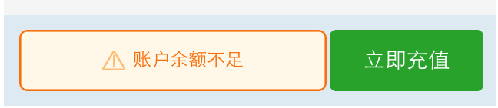

1. 接口名称：

/rest/poputInvest/{id}

1. 输入

|  |  |  |  |  |  |  |  |  |
| --- | --- | --- | --- | --- | --- | --- | --- | --- |
| **名称** | **类型** | **必须** | **长度** | **默认值** | **最小值** | **最大值** | **示例值** | **描述** |
| **id** |  |  |  |  |  |  |  | 项目id |

1. 返回

|  |  |  |  |  |  |  |  |  |
| --- | --- | --- | --- | --- | --- | --- | --- | --- |
| **名称** | **类型** | **必须** | **长度** | **默认值** | **最小值** | **最大值** | **示例值** | **描述** |
| **id** |  |  |  |  |  |  |  | 项目id |
| tenderMoney |  |  |  |  |  |  |  | 项目名称 |
| ableMoney |  |  |  |  |  |  |  | 可用金额 |
| awardMoney |  |  |  |  |  |  |  | 红包金额 |
| tasteMoney |  |  |  |  |  |  |  | 体验金 |
| wardScale |  |  |  |  |  |  |  | 红包使用比例 |
| isDxb |  |  |  |  |  |  |  | 是否定向标 |
| userHongbaoItem |  |  |  |  |  |  |  | --以下循环开始 |
| userId |  |  |  |  |  |  |  | 用户ID |
| hbNo |  |  |  |  |  |  |  | 红包编号 |
|  |  |  |  |  |  |  |  |  |
|  |  |  |  |  |  |  |  |  |
| money |  |  |  |  |  |  |  | 红包金额 |
| status |  |  |  |  |  |  | 0未使用  1使用  2已过期 | 红包状态 |
| startTime |  |  |  |  |  |  |  | 领取时间 |
| endTime |  |  |  |  |  |  |  | 到期时间 |
| sourceString |  |  |  |  |  |  |  | 来源说明 |
|  |  |  |  |  |  |  |  | --以上循环结束 |

## 投资项目

1. 接口名称：

/rest/investDo/${id}

1. 输入

|  |  |  |  |  |  |  |  |  |  |  |  |  |  |
| --- | --- | --- | --- | --- | --- | --- | --- | --- | --- | --- | --- | --- | --- |
| **名称** | **类型** | **必须** | | | **长度** | | **默认值** | **最小值** | | **最大值** | | **示例值** | **描述** |
|  | | |  |  | |  |  | |  | |  |  | 会员id |
| **tenderMoney** | | |  | YES | |  |  | |  | |  |  | 投资金额 |
| **id** | | |  | YES | |  |  | |  | |  |  | 项目id |
| safepwd | | |  | YES | |  |  | |  | |  |  | 安全密码 |
| **clientType** | | |  |  | |  |  | |  | |  |  | 客户端来源（1-android;2-ios） |
| dxpwd | | |  |  | |  |  | |  | |  |  | 定向密码 |
| hongbao | | |  |  | |  |  | |  | |  |  | 红包数组(红包id) |

1. 返回

|  |  |  |  |  |  |  |  |  |  |
| --- | --- | --- | --- | --- | --- | --- | --- | --- | --- |
| **名称** | **类型** | | **必须** | **长度** | **默认值** | **最小值** | **最大值** | **示例值** | **描述** |
| **rcd** | |  |  |  |  |  |  | R0001 成功 | 投资状态（失败、成功） |
| **rmg** | |  |  |  |  |  |  |  | 失败原因 |
| **tenderMoney** | |  |  |  |  |  |  |  | 投资金额 |
| **id** | |  |  |  |  |  |  |  | 项目ID |

1. 错误码

|  |  |  |
| --- | --- | --- |
| **错误码** | **错误描述** | **解决方案** |
| M0007_0 | 账户余额不足! |  |
| M0007_1 | 请输入投资金额 |  |
| M0007_2 | 投资金额必须为数字 |  |
| M0007_3 | 投资金额必须为100的整数倍 |  |
| M0007_4 | 投资金额至少大于XXX元 |  |
| M0007_5 | 投资金额不能超过XXX元 |  |
| M0007_6 | 项目已满 |  |

# 三、登录注册

## 登录

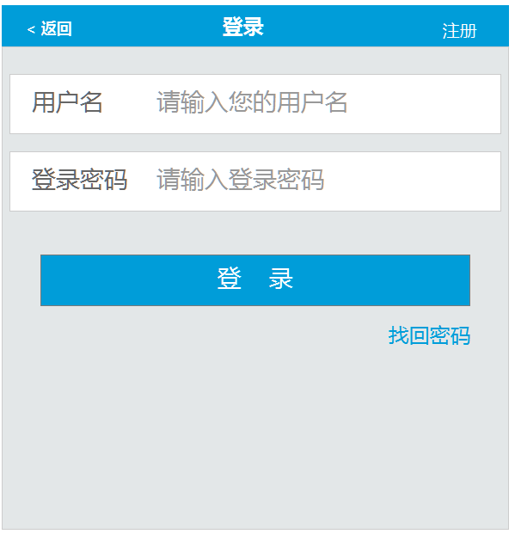

1. 接口名称：

/rest/login

1. 输入

|  |  |  |  |  |  |  |  |  |
| --- | --- | --- | --- | --- | --- | --- | --- | --- |
| **名称** | **类型** | **必须** | **长度** | **默认值** | **最小值** | **最大值** | **示例值** | **描述** |
| **username** |  |  |  |  |  |  |  | 会员名 |
| **password** |  |  |  |  |  |  |  | 密码 |

1. 返回

|  |  |  |  |  |  |  |  |  |
| --- | --- | --- | --- | --- | --- | --- | --- | --- |
| **名称** | **类型** | **必须** | **长度** | **默认值** | **最小值** | **最大值** | **示例值** | **描述** |
| **userId** |  |  |  |  |  |  |  | 用户ID |
| **username** |  |  |  |  |  |  |  | 用户名 |
| **realName** |  |  |  |  |  |  |  | 用户姓名 |

1. 错误码

|  |  |  |
| --- | --- | --- |
| **错误码** | **错误描述** | **解决方案** |
| **M0002** | 您的账号已被禁用,无法登录，如有疑问请联系客服人员 |  |
| **M0003** | 您的账号已被锁定，如有疑问请联系客服人员! |  |
| **M0004** | 若连续N次密码输入错误,您的账号将被锁定! |  |
| **M0001** | 您的用户名或密码错误! |  |

## 发送短信验证码(找回登录密码)

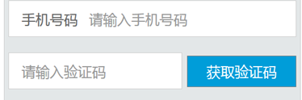

1. 接口名称：

/rest/sendPCode2/

1. 输入

|  |  |  |  |  |  |  |  |  |
| --- | --- | --- | --- | --- | --- | --- | --- | --- |
| **名称** | **类型** | **必须** | **长度** | **默认值** | **最小值** | **最大值** | **示例值** | **描述** |
| phoneRegs | String |  |  |  |  |  |  | 手机号 |
|  |  |  |  |  |  |  |  |  |

1. 返回

|  |  |  |  |  |  |  |  |  |
| --- | --- | --- | --- | --- | --- | --- | --- | --- |
| **名称** | **类型** | **必须** | **长度** | **默认值** | **最小值** | **最大值** | **示例值** | **描述** |
| **rcd** |  |  |  |  |  |  | R0001 成功 | 注册是否成功 |

1. 错误码

|  |  |  |
| --- | --- | --- |
| **错误码** | **错误描述** | **解决方案** |
| *M0008_5* | 系统无法获取手机号 |  |
| *M0008_6* | 该手机号获取验证码太频繁，请5分钟后再尝试 |  |
| *M0008_13* | 请输入手机号码！ |  |
|  |  |  |
|  |  |  |

## 找回登录密码验证

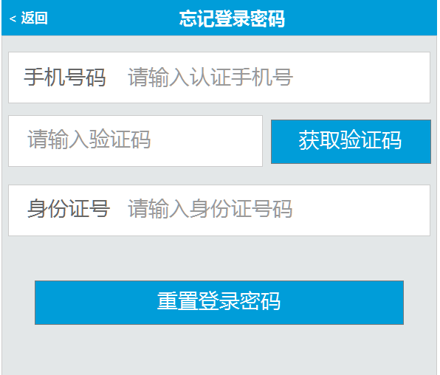

1. 接口名称：

/rest/checklogp

1. 输入

|  |  |  |  |  |  |  |  |  |
| --- | --- | --- | --- | --- | --- | --- | --- | --- |
| **名称** | **类型** | **必须** | **长度** | **默认值** | **最小值** | **最大值** | **示例值** | **描述** |
| **phone** | user |  |  |  |  |  |  | 手机号码 |
| **codeReg** | string |  |  |  |  |  |  | 手机验证码 |
| **cardId** | user |  |  |  |  |  |  | 身份证号码 |

1. 返回

|  |  |  |  |  |  |  |  |  |
| --- | --- | --- | --- | --- | --- | --- | --- | --- |
| **名称** | **类型** | **必须** | **长度** | **默认值** | **最小值** | **最大值** | **示例值** | **描述** |
| **phoneState** |  |  |  |  |  |  | 0正确，1不正确 | 手机号码是否正确 |
| **codeState** |  |  |  |  |  |  | 0正确，1不正确 | 验证码是否正确 |
| **CardStates** |  |  |  |  |  |  | 0正确，1不正确 | 身份证号码是否正确 |

1. 错误码

|  |  |  |
| --- | --- | --- |
| **错误码** | **错误描述** | **解决方案** |
| **M0008_0** | 短信验证码不能为空 |  |
| **M0008_11** | 用户未实名认证s |  |

## 重置登录密码

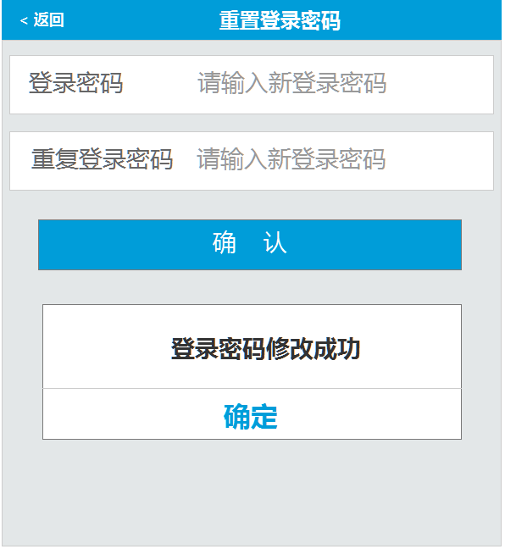

1. 接口名称：

/rest/updatePwd

1. 输入

|  |  |  |  |  |  |  |  |  |
| --- | --- | --- | --- | --- | --- | --- | --- | --- |
| **名称** | **类型** | **必须** | **长度** | **默认值** | **最小值** | **最大值** | **示例值** | **描述** |
| **password** | user |  |  |  |  |  |  | 登录密码 |

1. 返回

|  |  |  |  |  |  |  |  |  |
| --- | --- | --- | --- | --- | --- | --- | --- | --- |
| **名称** | **类型** | **必须** | **长度** | **默认值** | **最小值** | **最大值** | **示例值** | **描述** |
| **rcd** |  |  |  |  |  |  | R0001 成功 | 登录密码修改是否正确 |

1. 错误码

|  |  |  |
| --- | --- | --- |
| **错误码** | **错误描述** | **解决方案** |
| **S0003** | 登录密码输入错误 |  |
|  |  |  |

## 发送短信验证码（注册）



1. 接口名称：

/rest/sendPCode/

1. 输入

|  |  |  |  |  |  |  |  |  |
| --- | --- | --- | --- | --- | --- | --- | --- | --- |
| **名称** | **类型** | **必须** | **长度** | **默认值** | **最小值** | **最大值** | **示例值** | **描述** |
| phoneReg | String |  |  |  |  |  |  | 手机号 |

1. 返回

|  |  |  |  |  |  |  |  |  |
| --- | --- | --- | --- | --- | --- | --- | --- | --- |
| **名称** | **类型** | **必须** | **长度** | **默认值** | **最小值** | **最大值** | **示例值** | **描述** |
| **rcd** |  |  |  |  |  |  | R0001 成功 | 发送是否成功 |

1. 错误码

|  |  |  |
| --- | --- | --- |
| **错误码** | **错误描述** | **解决方案** |
| *M0008_5* | 系统无法获取手机号 |  |
| *M0008_6* | 该手机号获取验证码太频繁，请5分钟后再尝试 |  |
| *M0008_7* | 手机号已经注册过帐号 |  |
| *M0008_8* | 此返回值是短信方接口返回信息具体详情取值 |  |
|  |  |  |

## 注册

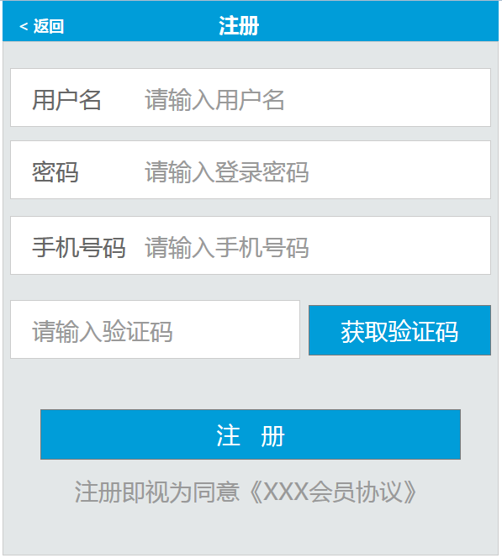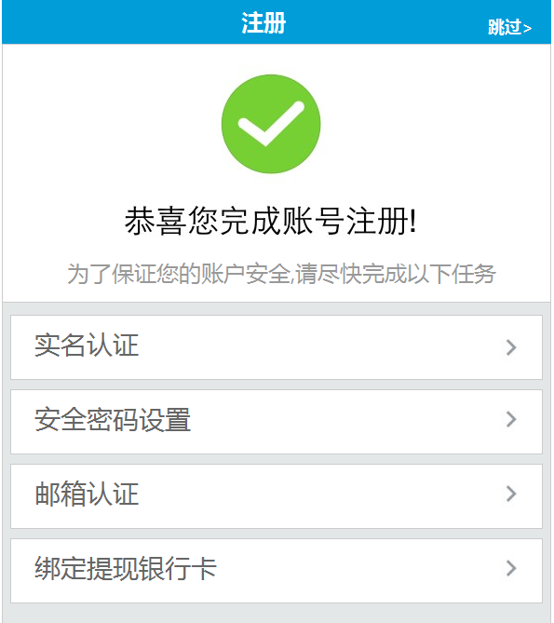

1. 接口名称：

/rest/reg

1. 输入

|  |  |  |  |  |  |  |  |  |
| --- | --- | --- | --- | --- | --- | --- | --- | --- |
| **名称** | **类型** | **必须** | **长度** | **默认值** | **最小值** | **最大值** | **示例值** | **描述** |
|  |  |  |  |  |  |  |  |  |
| password | user |  |  |  |  |  |  | 密码 |
| phone | user |  |  |  |  |  |  | 手机号 |
| codeReg |  |  |  |  |  |  |  | 手机验证码 |

1. 返回

|  |  |  |  |  |  |  |  |  |
| --- | --- | --- | --- | --- | --- | --- | --- | --- |
| **名称** | **类型** | **必须** | **长度** | **默认值** | **最小值** | **最大值** | **示例值** | **描述** |
| **rcd** |  |  |  |  |  |  | R0001 成功 | 注册是否成功 |
|  |  |  |  |  |  |  |  | 失败原因 |
| **id** |  |  |  |  |  |  |  | 会员id |

1. 错误码

|  |  |  |  |  |  |
| --- | --- | --- | --- | --- | --- |
| **错误码** | | **错误描述** | | **解决方案** | |
| *M0008_0* | 短信验证码不能为空 | |  | |
| *M0008_1* | 短信验证码不正确 | |  | |
| *M0008_2* | 用户已存在 | |  | |
| *M0008_3* | 密码必须包含字母！ | |  | |
| *M0008_4* | 密码长度必须在8-16个字符之间 | |  | |
|  | |  | |  | |

## 退出

1. 接口名称：

/rest/logout

1. 输入

|  |  |  |  |  |  |  |  |  |
| --- | --- | --- | --- | --- | --- | --- | --- | --- |
| **名称** | **类型** | **必须** | **长度** | **默认值** | **最小值** | **最大值** | **示例值** | **描述** |
|  |  |  |  |  |  |  |  |  |

1. 返回

|  |  |  |  |  |  |  |  |  |
| --- | --- | --- | --- | --- | --- | --- | --- | --- |
| **名称** | **类型** | **必须** | **长度** | **默认值** | **最小值** | **最大值** | **示例值** | **描述** |
| **rcd** |  |  |  |  |  |  | R0001 |  |

1. 错误码

|  |  |  |
| --- | --- | --- |
| **错误码** | **错误描述** | **解决方案** |
|  |  |  |

# 四、会员中心首页

## 会员中心首页

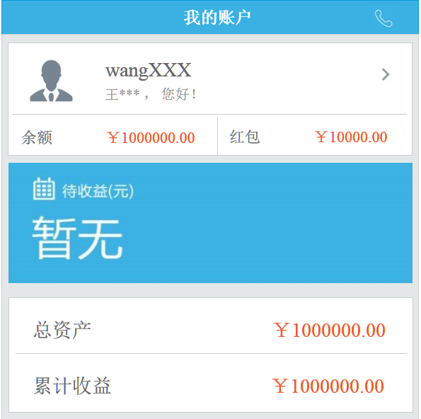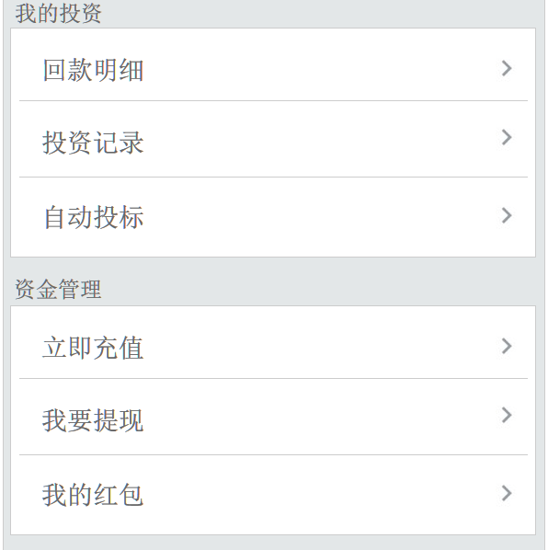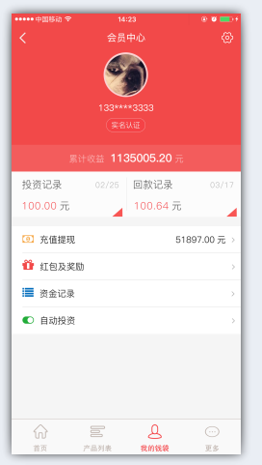

1. 接口名称：

/rest/userCenter

1. 输入

|  |  |  |  |  |  |  |  |  |
| --- | --- | --- | --- | --- | --- | --- | --- | --- |
| **名称** | **类型** | **必须** | **长度** | **默认值** | **最小值** | **最大值** | **示例值** | **描述** |
|  |  |  |  |  |  |  |  | 用户id |

1. 返回

|  |  |  |  |  |  |  |  |  |
| --- | --- | --- | --- | --- | --- | --- | --- | --- |
| **名称** | **类型** | **必须** | **长度** | **默认值** | **最小值** | **最大值** | **示例值** | **描述** |
| **username** |  |  |  |  |  |  |  | 用户名 |
| **realName** |  |  |  |  |  |  |  | 用户姓名 |
| **ableMoney** |  |  |  |  |  |  |  | 可用余额 |
| **awardMoney** |  |  |  |  |  |  |  | 红包余额 |
| **investorCollectionCapital** |  |  |  |  |  |  |  | 待收本金 |
| **investorCollectionInterest** |  |  |  |  |  |  |  | 待收利息 |
| **total** |  |  |  |  |  |  |  | 资金总额 |
| **totalIncome** |  |  |  |  |  |  |  | 累计收益 |
| autoTenderStatus |  |  |  |  |  |  |  | 自投状态1启用0关闭 |
| tenderTime |  |  |  |  |  |  |  | 最近投资日期 |
| repaymentTime |  |  |  |  |  |  |  | 最近回款日期 |
| tenderMoney |  |  |  |  |  |  |  | 投资金额 |
| repaymentMoney |  |  |  |  |  |  |  | 回款金额 |

1. 错误码

|  |  |  |
| --- | --- | --- |
| **错误码** | **错误描述** | **解决方案** |
|  |  |  |
|  |  |  |

# 五、会员账户管理

## 账户管理

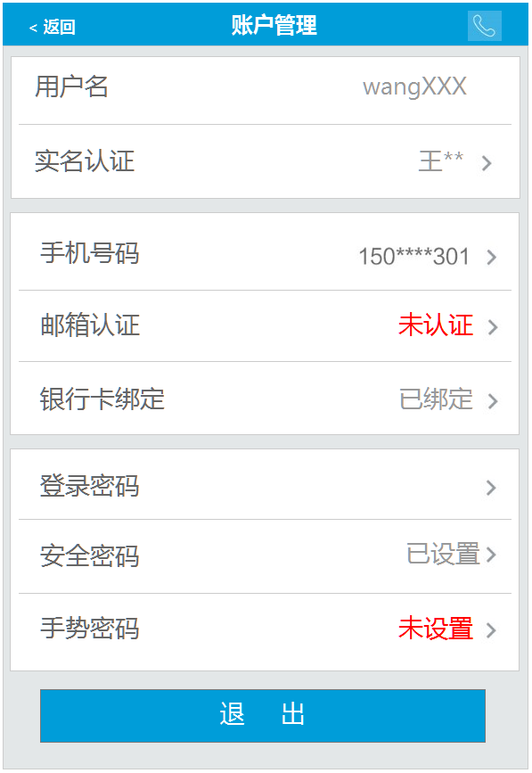

1. 接口名称：

/rest/user

1. 输入

|  |  |  |  |  |  |  |  |  |
| --- | --- | --- | --- | --- | --- | --- | --- | --- |
| **名称** | **类型** | **必须** | **长度** | **默认值** | **最小值** | **最大值** | **示例值** | **描述** |
|  |  |  |  |  |  |  |  | 会员id |

1. 返回

|  |  |  |  |  |  |  |  |  |
| --- | --- | --- | --- | --- | --- | --- | --- | --- |
| **名称** | **类型** | **必须** | **长度** | **默认值** | **最小值** | **最大值** | **示例值** | **描述** |
| **username** |  |  |  |  |  |  |  | 会员用户名 |
| **realStatus** |  |  |  |  |  |  |  | 实名认证是否通过 |
| **realName** |  |  |  |  |  |  |  | 会员真实姓名 |
| **phoneStatus** |  |  |  |  |  |  |  | 手机认证是否通过 |
| **phone** |  |  |  |  |  |  |  | 手机号码 |
| **emailStatus** |  |  |  |  |  |  |  | 邮箱认证是否通过 |
| **email** |  |  |  |  |  |  |  | 邮箱 |
| **bankStatus** |  |  |  |  |  |  |  | 银行卡是否设置 |
| **safePwdStatus** |  |  |  |  |  |  |  | 安全密码是否设置 |
| **handStatus** |  |  |  |  |  |  |  | 手势密码是否设置 |

1. 错误码

|  |  |  |
| --- | --- | --- |
| **错误码** | **错误描述** | **解决方案** |
|  |  |  |
|  |  |  |

## 上传头像

1. 接口名称：

/rest/upHeadImg

1. 输入

|  |  |  |  |  |  |  |  |  |
| --- | --- | --- | --- | --- | --- | --- | --- | --- |
| **名称** | **类型** | **必须** | **长度** | **默认值** | **最小值** | **最大值** | **示例值** | **描述** |
| **file** | 文件 | 是 |  |  |  |  |  | 文件 |

1. 返回

|  |  |  |  |  |  |  |  |  |
| --- | --- | --- | --- | --- | --- | --- | --- | --- |
| **名称** | **类型** | **必须** | **长度** | **默认值** | **最小值** | **最大值** | **示例值** | **描述** |
| **rcd** | String |  |  |  |  |  |  | 返回码 |
| **rmg** | String |  |  |  |  |  |  | 返回信息 |
| **filename** | String |  |  |  |  |  |  | 文件名 |
| **url** | String |  |  |  |  |  |  | 文件在服务器上的相对路径，在提交表单的时候，要把这个url填在表单里提交 |
| **fullUrl** | String |  |  |  |  |  |  | 完整的访问url，用于显示上传文件 |

## 实名认证信息

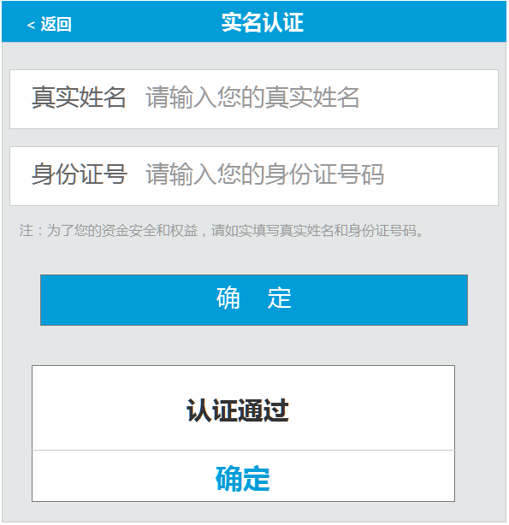

1. 接口名称：

/rest/userReal/${userId}

1. 输入信息

|  |  |  |  |  |  |  |  |  |
| --- | --- | --- | --- | --- | --- | --- | --- | --- |
| **名称** | **类型** | **必须** | **长度** | **默认值** | **最小值** | **最大值** | **示例值** | **描述** |
| **userId** |  |  |  |  |  |  |  | 会员id |

1. 返回信息

|  |  |  |  |  |  |  |  |  |
| --- | --- | --- | --- | --- | --- | --- | --- | --- |
| **名称** | **类型** | **必须** | **长度** | **默认值** | **最小值** | **最大值** | **示例值** | **描述** |
| **realStatus** |  |  |  |  |  |  |  | 实名认证状态（1成功、2审核中、0失败） |
| **realName** |  |  |  |  |  |  |  | 会员真实姓名 |
| **cardId** |  |  |  |  |  |  |  | 会员身份证号码 |

## 实名认证提交

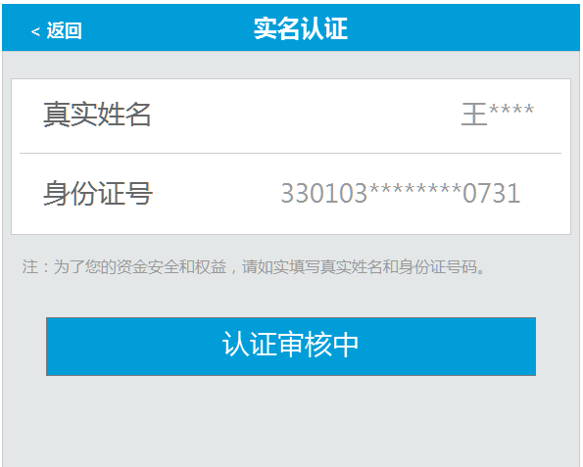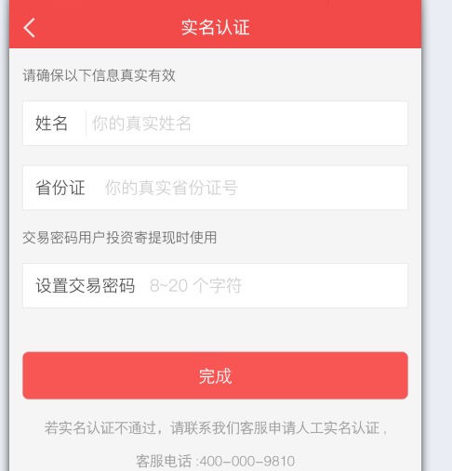

1. 接口名称：

/rest/userReal

1. 输入信息

|  |  |  |  |  |  |  |  |  |
| --- | --- | --- | --- | --- | --- | --- | --- | --- |
| **名称** | **类型** | **必须** | **长度** | **默认值** | **最小值** | **最大值** | **示例值** | **描述** |
|  |  |  |  |  |  |  |  |  |
| **user.realName** |  |  |  |  |  |  |  | 会员真实姓名 |
| **user.cardId** |  |  |  |  |  |  |  | 会员身份证号码 |
| **user.p**ayPassword |  |  |  |  |  |  |  | 交易密码 |

1. 返回信息

|  |  |  |  |  |  |  |  |  |
| --- | --- | --- | --- | --- | --- | --- | --- | --- |
| **名称** | **类型** | **必须** | **长度** | **默认值** | **最小值** | **最大值** | **示例值** | **描述** |
|  |  |  |  |  |  |  |  |  |

## 发送手机验证码（更换号码—发到旧号码）

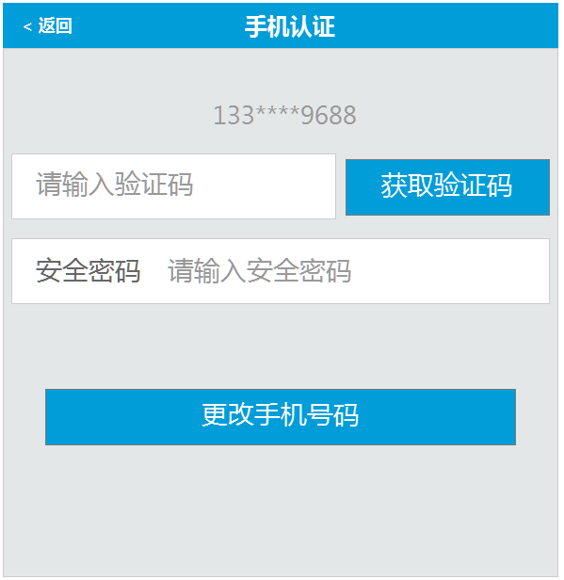

1. 接口名称：

/rest/sendPCodeUser

1. 输入信息

|  |  |  |  |  |  |  |  |  |
| --- | --- | --- | --- | --- | --- | --- | --- | --- |
| **名称** | **类型** | **必须** | **长度** | **默认值** | **最小值** | **最大值** | **示例值** | **描述** |
|  |  |  |  |  |  |  |  |  |

1. 返回信息

|  |  |  |  |  |  |  |  |  |
| --- | --- | --- | --- | --- | --- | --- | --- | --- |
| **名称** | **类型** | **必须** | **长度** | **默认值** | **最小值** | **最大值** | **示例值** | **描述** |
|  |  |  |  |  |  |  |  |  |
|  |  |  |  |  |  |  |  |  |

1. 错误码

|  |  |  |
| --- | --- | --- |
| **错误码** | **错误描述** | **解决方案** |
| **E0001** |  |  |
| **M0008_5** |  |  |
| **M0008_6** |  |  |
| **M0008_8** |  |  |

## 手机号码更改申请



1. 接口名称：

/rest/upPhone

1. 输入信息

|  |  |  |  |  |  |  |  |  |
| --- | --- | --- | --- | --- | --- | --- | --- | --- |
| **名称** | **类型** | **必须** | **长度** | **默认值** | **最小值** | **最大值** | **示例值** | **描述** |
| **codeReq** |  |  |  |  |  |  |  | 短信验证码 |
| **oldPassword** |  |  |  |  |  |  |  | 安全密码 |
|  |  |  |  |  |  |  |  |  |

1. 返回信息

|  |  |  |  |  |  |  |  |  |
| --- | --- | --- | --- | --- | --- | --- | --- | --- |
| **名称** | **类型** | **必须** | **长度** | **默认值** | **最小值** | **最大值** | **示例值** | **描述** |
|  |  |  |  |  |  |  |  |  |
|  |  |  |  |  |  |  |  |  |

1. 错误码

|  |  |  |
| --- | --- | --- |
| **错误码** | **错误描述** | **解决方案** |
| **E0002** |  |  |
| **M0008_0** |  |  |
| **M0008_12** |  |  |
| **M0008_1** |  |  |
| **S0002** |  |  |

## 发送手机验证码（更换号码—发到新号码）

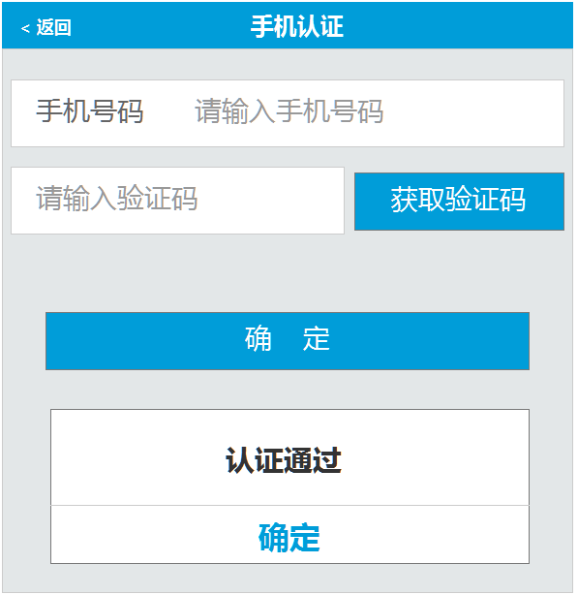

1. 接口名称：

/rest/sendPCodeUserb

1. 输入信息

|  |  |  |  |  |  |  |  |  |
| --- | --- | --- | --- | --- | --- | --- | --- | --- |
| **名称** | **类型** | **必须** | **长度** | **默认值** | **最小值** | **最大值** | **示例值** | **描述** |
| **phoneReg** |  |  |  |  |  |  |  | 手机号码 |

1. 返回信息

|  |  |  |  |  |  |  |  |  |
| --- | --- | --- | --- | --- | --- | --- | --- | --- |
| **名称** | **类型** | **必须** | **长度** | **默认值** | **最小值** | **最大值** | **示例值** | **描述** |
|  |  |  |  |  |  |  |  |  |
|  |  |  |  |  |  |  |  |  |

1. 错误码

|  |  |  |
| --- | --- | --- |
| **错误码** | **错误描述** | **解决方案** |
| **E0001** |  |  |
| **M0008_5** |  |  |
| **M0008_6** |  |  |
| **M0008_8** |  |  |

## 手机号码更改提交



1. 接口名称：

/rest/upPhoneb

1. 输入信息

|  |  |  |  |  |  |  |  |  |
| --- | --- | --- | --- | --- | --- | --- | --- | --- |
| **名称** | **类型** | **必须** | **长度** | **默认值** | **最小值** | **最大值** | **示例值** | **描述** |
| **codeReq** |  |  |  |  |  |  |  | 短信验证码 |
| **phone** |  |  |  |  |  |  |  | 安全密码 |
|  |  |  |  |  |  |  |  |  |

1. 返回信息

|  |  |  |  |  |  |  |  |  |
| --- | --- | --- | --- | --- | --- | --- | --- | --- |
| **名称** | **类型** | **必须** | **长度** | **默认值** | **最小值** | **最大值** | **示例值** | **描述** |
|  |  |  |  |  |  |  |  |  |
|  |  |  |  |  |  |  |  |  |

1. 错误码

|  |  |  |
| --- | --- | --- |
| **错误码** | **错误描述** | **解决方案** |
| **E0002** |  |  |
| **M0008_0** |  |  |
| **M0008_12** |  |  |
| **M0008_1** |  |  |
| **S0002** |  |  |

## 邮箱地址为空时

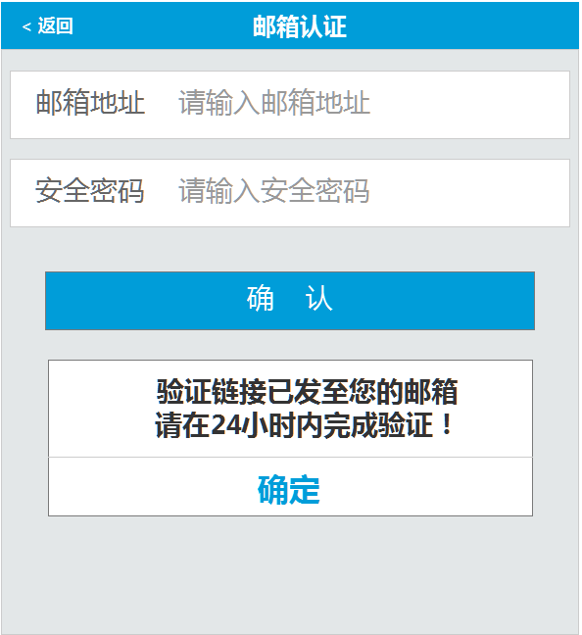

1. 接口名称：

/rest/emailSet

1. 输入

|  |  |  |  |  |  |  |  |  |
| --- | --- | --- | --- | --- | --- | --- | --- | --- |
| **名称** | **类型** | **必须** | **长度** | **默认值** | **最小值** | **最大值** | **示例值** | **描述** |
| **user.email** | user |  |  |  |  |  |  | 认证邮箱 |
| **user.payPassword** | user |  |  |  |  |  |  | 安全密码 |

1. 返回

|  |  |  |  |  |  |  |  |  |
| --- | --- | --- | --- | --- | --- | --- | --- | --- |
| **名称** | **类型** | **必须** | **长度** | **默认值** | **最小值** | **最大值** | **示例值** | **描述** |
| **id** |  |  |  |  |  |  |  | 会员id |
| **emailStatus** |  |  |  |  |  |  | 0-未认证，2-认证中，1-认证成功 | 邮箱认证状态 |

1. 错误码

|  |  |  |
| --- | --- | --- |
| **错误码** | **错误描述** | **解决方案** |
| *S0002* | 安全密码输入错误 |  |

## 邮箱地址不为空时

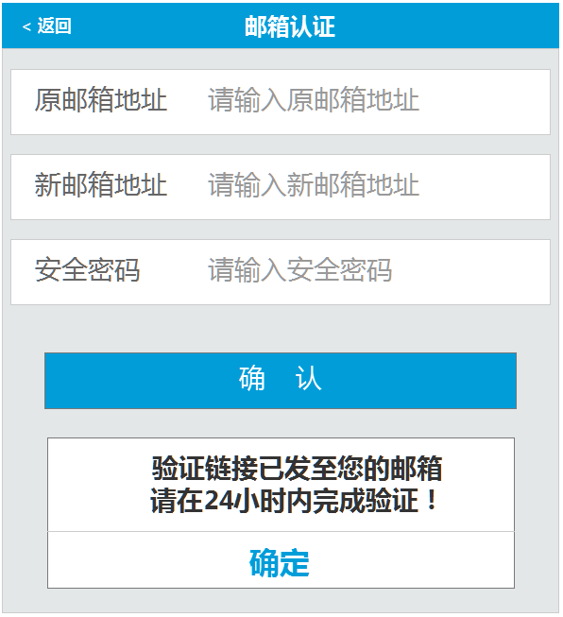

1. 接口名称：

/rest/updateEmail

1. 输入

|  |  |  |  |  |  |  |  |  |
| --- | --- | --- | --- | --- | --- | --- | --- | --- |
| **名称** | **类型** | **必须** | **长度** | **默认值** | **最小值** | **最大值** | **示例值** | **描述** |
| **user.email** | user |  |  |  |  |  |  | 原始认证邮箱 |
| **newEmail** | string |  |  |  |  |  |  | 新认证邮箱 |
| **user.payPassword** | user |  |  |  |  |  |  | 安全密码 |

1. 返回

|  |  |  |  |  |  |  |  |  |
| --- | --- | --- | --- | --- | --- | --- | --- | --- |
| **名称** | **类型** | **必须** | **长度** | **默认值** | **最小值** | **最大值** | **示例值** | **描述** |
| **id** |  |  |  |  |  |  |  | **会员id** |
| **emailStatus** |  |  |  |  |  |  | **0-未认证，2-认证中，1-认证成功** | **邮箱认证状态** |

1. 错误码

|  |  |  |
| --- | --- | --- |
| **错误码** | **错误描述** | **解决方案** |
| *S0002* | 安全密码输入错误 |  |
| *M0008_9* | 原邮箱输入有误 |  |
|  |  |  |

## 获取银行卡信息

未绑定已绑定

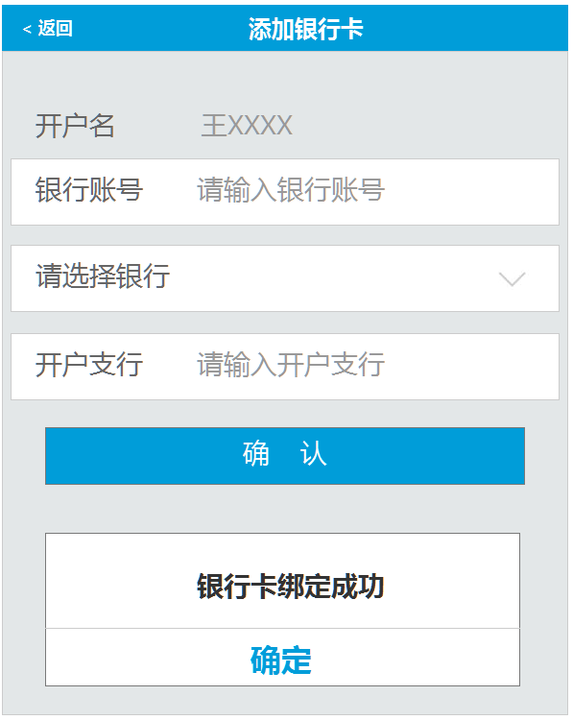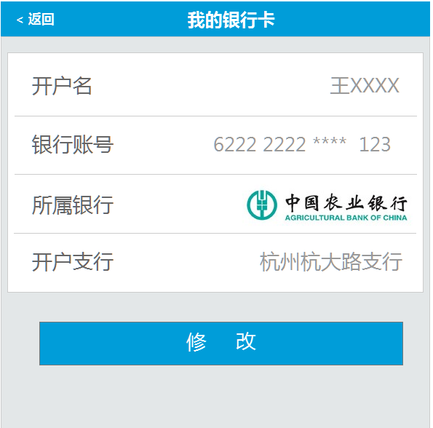

1. 接口名称：

/rest/bankTo

1. 返回

|  |  |  |  |  |  |  |  |  |
| --- | --- | --- | --- | --- | --- | --- | --- | --- |
| **名称** | **类型** | **必须** | **长度** | **默认值** | **最小值** | **最大值** | **示例值** | **描述** |
| **id** |  |  |  |  |  |  |  | 会员id |
| cardNo |  |  |  |  |  |  |  | 银行账号 |
| bankId |  |  |  |  |  |  |  | 银行帐号Id |
| bankName |  |  |  |  |  |  |  | 所属银行名称 |
| **branch** |  |  |  |  |  |  |  | 开户支行 |
| bankCardList |  |  |  |  |  |  |  | 银行列表 |
| **realName** |  |  |  |  |  |  |  | 用户名 |

1. 错误码

|  |  |  |
| --- | --- | --- |
| **错误码** | **错误描述** | **解决方案** |
| *M0008_10* | 同一账户只能添加一张提现银行卡 |  |

## 银行卡提交

1. 接口名称：

/rest/bankSave/

1. 输入

|  |  |  |  |  |  |  |  |  |
| --- | --- | --- | --- | --- | --- | --- | --- | --- |
| **名称** | **类型** | **必须** | **长度** | **默认值** | **最小值** | **最大值** | **示例值** | **描述** |
| **btype** | string |  |  |  |  |  | 0-表示增加，1表示修改 | 操作类型 |
| cardNo | cashBank |  |  |  |  |  |  | 银行账号 |
| bankName | cashBank |  |  |  |  |  |  | 所属银行名称 |
| **bankId** | cashBank |  |  |  |  |  |  | 所属银行id |
| **branch** | cashBank |  |  |  |  |  |  | 开户支行 |

1. 返回

|  |  |  |  |  |  |  |  |  |
| --- | --- | --- | --- | --- | --- | --- | --- | --- |
| **名称** | **类型** | **必须** | **长度** | **默认值** | **最小值** | **最大值** | **示例值** | **描述** |
| **rcd** |  |  |  |  |  |  | R0001表示成功 | 银行卡绑定状态（成功、失败） |

1. 错误码

|  |  |  |
| --- | --- | --- |
| **错误码** | **错误描述** | **解决方案** |
| *M0008_10* | 同一账户只能添加一张提现银行卡 |  |

## 登录密码设置

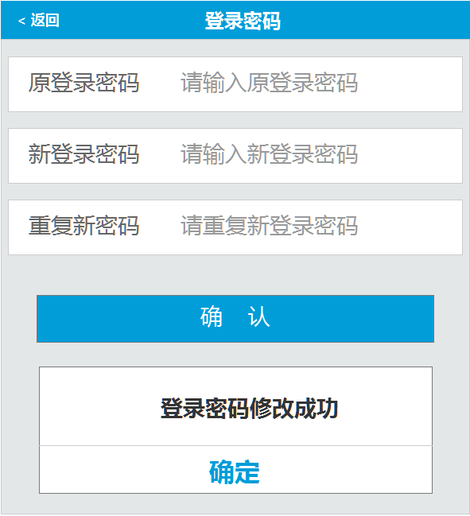

1. 接口名称：

/rest/userLoginPwdUpdate

1. 输入

|  |  |  |  |  |  |  |  |  |
| --- | --- | --- | --- | --- | --- | --- | --- | --- |
| **名称** | **类型** | **必须** | **长度** | **默认值** | **最小值** | **最大值** | **示例值** | **描述** |
|  |  |  |  |  |  |  |  |  |
| **oldPassword** |  |  |  |  |  |  |  | 原登录密码 |
| **newPassword** |  |  |  |  |  |  |  | 新登录密码 |

1. 返回

|  |  |  |  |  |  |  |  |  |
| --- | --- | --- | --- | --- | --- | --- | --- | --- |
| **名称** | **类型** | **必须** | **长度** | **默认值** | **最小值** | **最大值** | **示例值** | **描述** |
|  |  |  |  |  |  |  |  |  |

1. 错误码

|  |  |  |
| --- | --- | --- |
| **错误码** | **错误描述** | **解决方案** |
| **E0002** |  | 参数错误 |
| **S0003** |  | 登录密码输入错误! |

## 安全密码状态

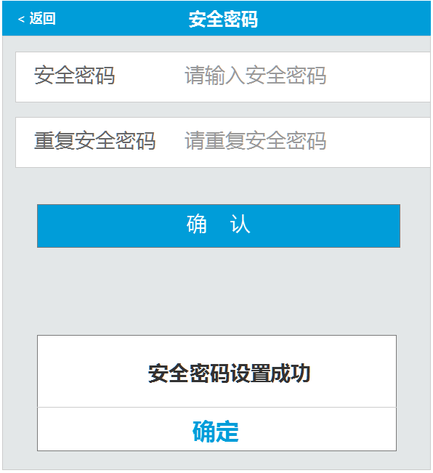

1. 接口名称：

/rest/userSafePwd/${userId}

1. 输入

|  |  |  |  |  |  |  |  |  |
| --- | --- | --- | --- | --- | --- | --- | --- | --- |
| **名称** | **类型** | **必须** | **长度** | **默认值** | **最小值** | **最大值** | **示例值** | **描述** |
| **userId** |  |  |  |  |  |  |  | 会员id |

1. 返回

|  |  |  |  |  |  |  |  |  |
| --- | --- | --- | --- | --- | --- | --- | --- | --- |
| **名称** | **类型** | **必须** | **长度** | **默认值** | **最小值** | **最大值** | **示例值** | **描述** |
| **safePwdStatus** |  |  |  |  |  |  |  | 安全密码是否设置0未设1已设 |

1. 错误码

|  |  |  |
| --- | --- | --- |
| **错误码** | **错误描述** | **解决方案** |
|  |  |  |

## 修改安全密码

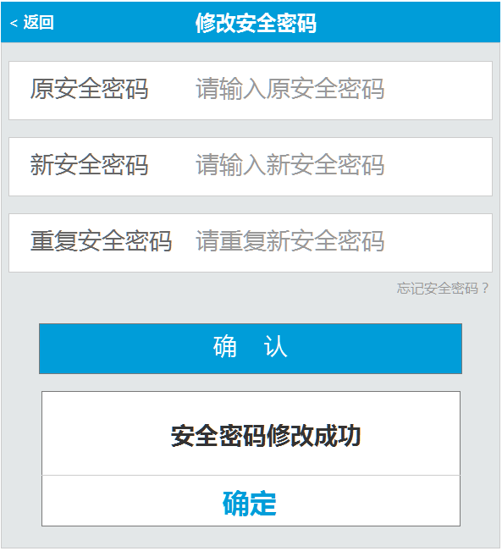

1. 接口名称：

/rest/userSafePwdUpdate

1. 输入

|  |  |  |  |  |  |  |  |  |
| --- | --- | --- | --- | --- | --- | --- | --- | --- |
| **名称** | **类型** | **必须** | **长度** | **默认值** | **最小值** | **最大值** | **示例值** | **描述** |
|  |  |  |  |  |  |  |  |  |
| **oldPassword** |  |  |  |  |  |  |  | 原安全密码(初次设置时，不需要) |
| **newPassword** |  |  |  |  |  |  |  | 新安全密码 |

1. 返回

|  |  |  |  |  |  |  |  |  |
| --- | --- | --- | --- | --- | --- | --- | --- | --- |
| **名称** | **类型** | **必须** | **长度** | **默认值** | **最小值** | **最大值** | **示例值** | **描述** |
|  |  |  |  |  |  |  |  |  |
|  |  |  |  |  |  |  |  |  |

1. 错误码

|  |  |  |
| --- | --- | --- |
| **错误码** | **错误描述** | **解决方案** |
| **S0002** |  | 安全密码输入错误! |

## 忘记安全密码

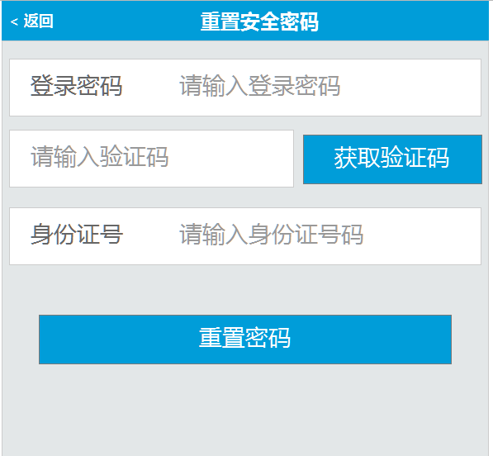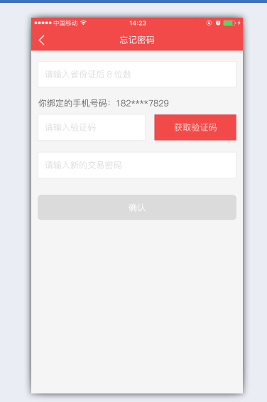

1. 接口名称：

/rest/lostSafePwd

1. 输入

|  |  |  |  |  |  |  |  |  |
| --- | --- | --- | --- | --- | --- | --- | --- | --- |
| **名称** | **类型** | **必须** | **长度** | **默认值** | **最小值** | **最大值** | **示例值** | **描述** |
| **newPassword** |  |  |  |  |  |  |  | 安全密码 |
| **codeReq** |  |  |  |  |  |  |  | 手机验证码 |
| **cardId** |  |  |  |  |  |  |  | 身份证后八位 |

1. 返回

|  |  |  |  |  |  |  |  |  |
| --- | --- | --- | --- | --- | --- | --- | --- | --- |
| **名称** | **类型** | **必须** | **长度** | **默认值** | **最小值** | **最大值** | **示例值** | **描述** |
|  |  |  |  |  |  |  |  |  |

1. 错误码

|  |  |  |
| --- | --- | --- |
| **错误码** | **错误描述** | **解决方案** |
| **M0008_0** |  | 短信验证码不能为空！ |
| **M0008_1** |  | 短信验证码不正确！ |
| **M0008_12** |  | 请获取短信验证码！ |
| **S0003** |  | 登录密码输入错误! |
|  |  |  |

## 忘记登录密码



1. 接口名称：

/rest/lostLoginPwd

1. 输入

|  |  |  |  |  |  |  |  |  |
| --- | --- | --- | --- | --- | --- | --- | --- | --- |
| **名称** | **类型** | **必须** | **长度** | **默认值** | **最小值** | **最大值** | **示例值** | **描述** |
| **phone** |  |  |  |  |  |  |  | 手机号码 |
| **codeReg** |  |  |  |  |  |  |  | 手机验证码 |
|  |  |  |  |  |  |  |  |  |

1. 返回

|  |  |  |  |  |  |  |  |  |
| --- | --- | --- | --- | --- | --- | --- | --- | --- |
| **名称** | **类型** | **必须** | **长度** | **默认值** | **最小值** | **最大值** | **示例值** | **描述** |
|  |  |  |  |  |  |  |  |  |

1. 错误码

|  |  |  |
| --- | --- | --- |
| **错误码** | **错误描述** | **解决方案** |
| **M0008_13** |  | 请输入手机号码！ |
| **M0008_0** |  | 短信验证码不能为空！ |
| **M0008_12** |  | 请获取短信验证码！ |
| **M0008_1** |  | 短信验证码不正确！ |
| **M0008_5** |  | 系统无法获取手机号！ |
| **M0003** |  | 您的账号已被锁定，如有疑问请联系客服人员! |
| **E0002** |  | 参数错误 |

# 六、会员中心-我的投资

## 投资记录

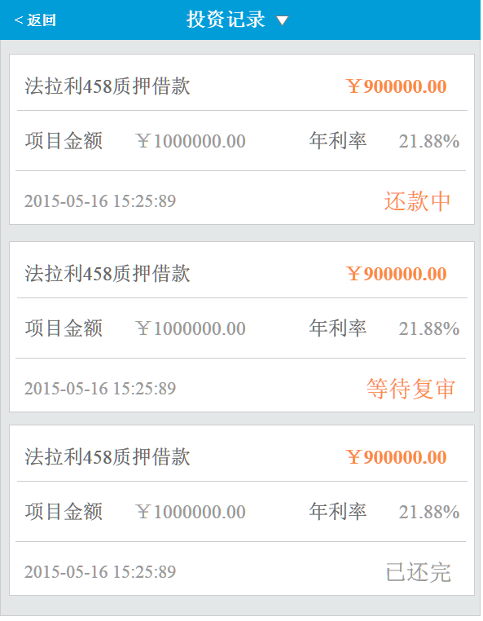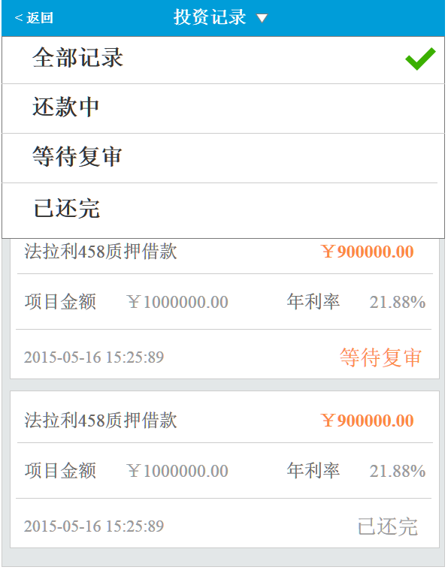

1. 接口名称：

/rest/tzjl

1. 输入

|  |  |  |  |  |  |  |  |  |  |
| --- | --- | --- | --- | --- | --- | --- | --- | --- | --- |
| **名称** | **类型** | | **必须** | **长度** | **默认值** | **最小值** | **最大值** | **示例值** | **描述** |
|  | |  |  |  |  |  |  |  | 会员id |
| **status** | |  |  |  |  |  |  |  | 项目状态  3:还款中  5:等待复审  7:已还完 |
| **pageNumber** | |  |  |  |  |  |  |  | 页数 |
| **pageSize** | |  |  |  |  |  |  |  | 单页条数 |
| **orderBy** | |  |  |  |  |  |  |  | 排序字段 0：投资时间 |
| **orderSort** | |  |  |  |  |  |  |  | 排序方式 0ASC 1DESC |

1. 返回

|  |  |  |  |  |  |  |  |  |  |
| --- | --- | --- | --- | --- | --- | --- | --- | --- | --- |
| **名称** | **类型** | | **必须** | **长度** | **默认值** | **最小值** | **最大值** | **示例值** | **描述** |
| userTenderList | | UserTender |  |  |  |  |  |  | 循环对象 |
|  | |  |  |  |  |  |  |  | --以下循环开始 |
| borrowName | |  |  |  |  |  |  |  | 投资项目名称 |
| borrowAccount | |  |  |  |  |  |  |  | 投资项目总金额 |
| apr | |  |  |  |  |  |  |  | 投资项目年利率 |
| tenderAccount | |  |  |  |  |  |  |  | 投资金额 |
| createDate | |  |  |  |  |  |  |  | 投资时间 |
| borrowStatusShow | |  |  |  |  |  |  |  | 项目状态（文字） |
| borrowStatus | |  |  |  |  |  |  | 1:等待复审  3:还款中  5:等待复审  7:已还完 | 项目状态（数值） |
|  | |  |  |  |  |  |  |  |  |
|  | |  |  |  |  |  |  |  | --以上循环结束 |

1. 错误码

|  |  |  |
| --- | --- | --- |
| **错误码** | **错误描述** | **解决方案** |
|  |  |  |

## 回款明细

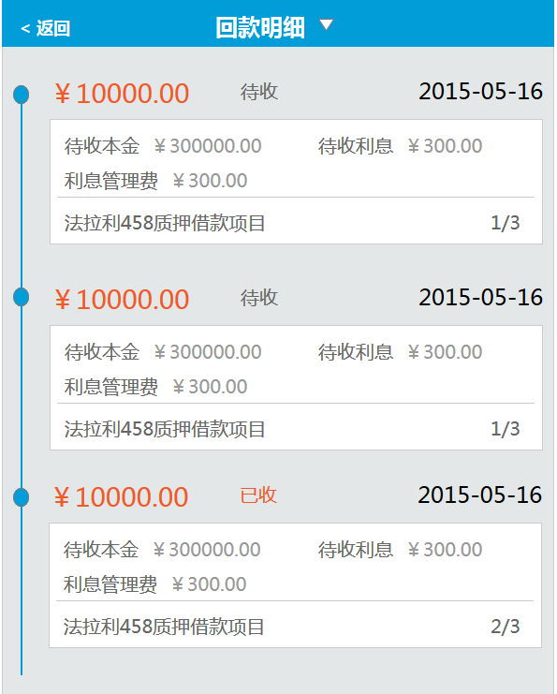

1. 接口名称：

/rest/hkmx

1. 输入

|  |  |  |  |  |  |  |  |  |
| --- | --- | --- | --- | --- | --- | --- | --- | --- |
| **名称** | **类型** | **必须** | **长度** | **默认值** | **最小值** | **最大值** | **示例值** | **描述** |
|  |  |  |  |  |  |  |  | 会员id |

1. 返回

|  |  |  |  |  |  |  |  |  |
| --- | --- | --- | --- | --- | --- | --- | --- | --- |
| **名称** | **类型** | **必须** | **长度** | **默认值** | **最小值** | **最大值** | **示例值** | **描述** |
| userRepaymentList | UserRepayment |  |  |  |  |  |  | 循环对象 |
|  |  |  |  |  |  |  |  | ---以下开始循环 |
| repaymentStatusShow |  |  |  |  |  |  |  | 待收状态（已收、待收） |
| repaymentStatus |  |  |  |  |  |  | 1已收0待收 | 待收状态(数值) |
| repaymentDate |  |  |  |  |  |  |  | 待收时间 |
| waitTotal |  |  |  |  |  |  |  | 待收总额 |
| waitAccount |  |  |  |  |  |  |  | 待收本金 |
| waitInterest |  |  |  |  |  |  |  | 待收利息 |
| serviceCharge |  |  |  |  |  |  |  | 利息管理费 |
| borrowName |  |  |  |  |  |  |  | 项目名称 |
| periods |  |  |  |  |  |  |  | 总期数 |
| repaymentPeriods |  |  |  |  |  |  |  | 当前期数 |
|  |  |  |  |  |  |  |  | ---以上结束循环 |

1. 错误码

|  |  |  |
| --- | --- | --- |
| **错误码** | **错误描述** | **解决方案** |
|  |  |  |

## 自动投资信息

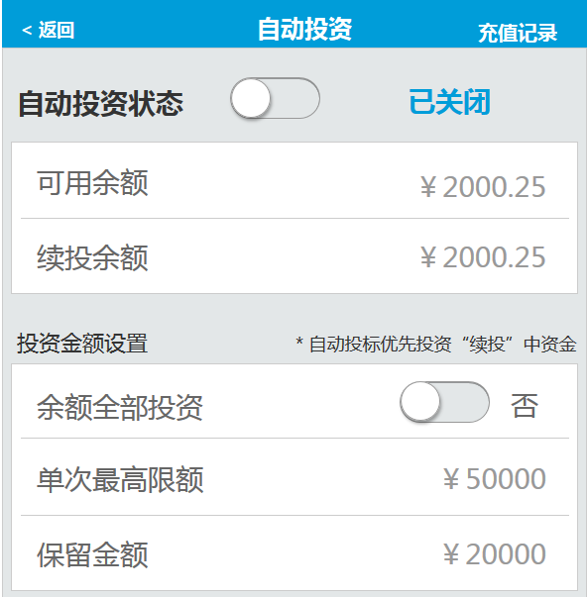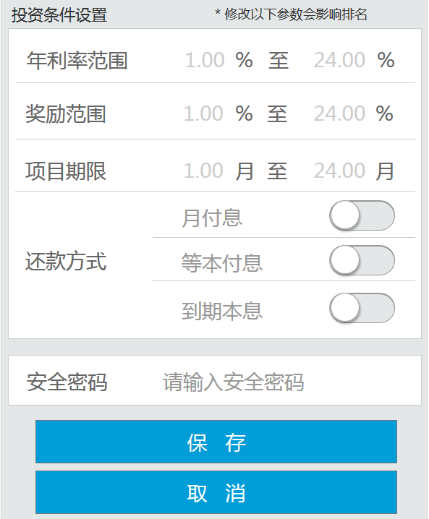

1. 接口名称：

/rest/zdtzTo

1. 输入

|  |  |  |  |  |  |  |  |  |
| --- | --- | --- | --- | --- | --- | --- | --- | --- |
| **名称** | **类型** | **必须** | **长度** | **默认值** | **最小值** | **最大值** | **示例值** | **描述** |
|  |  |  |  |  |  |  |  | 会员id |

1. 返回

|  |  |  |  |  |  |  |  |  |
| --- | --- | --- | --- | --- | --- | --- | --- | --- |
| **名称** | **类型** | **必须** | **长度** | **默认值** | **最小值** | **最大值** | **示例值** | **描述** |
| autoTenderStatus |  |  |  |  |  |  | 1启用0关闭 | 自动投资状态（开启、关闭） |
| ableMoney |  |  |  |  |  |  |  | 可用余额 |
| continueTotal |  |  |  |  |  |  |  | 续投余额 |
| autoTenderRule |  |  |  |  |  |  | 0全投，1设置 | 是否全部余额投资 |
| autoTenderMoneyTop |  |  |  |  |  |  |  | 单次最高限额 |
| autoTenderMoneyLeave |  |  |  |  |  |  |  | 保留金额 |
| autoTenderRateBegin |  |  |  |  |  |  |  | 年利率范围开始 |
| autoTenderRateEnd |  |  |  |  |  |  |  | 年利率范围结束 |
| autoTenderRewardBegin |  |  |  |  |  |  |  | 奖励范围开始 |
| autoTenderRewardEnd |  |  |  |  |  |  |  | 奖励范围结束 |
| autoTenderLimitBegin |  |  |  |  |  |  |  | 项目期限开始 |
| autoTenderLimitEnd |  |  |  |  |  |  |  | 项目期限结束 |
| tenderAutoWayOne |  |  |  |  |  |  | 1启用0关闭 | 还款方式（月付息） |
| tenderAutoWayTwo |  |  |  |  |  |  | 1启用0关闭 | 还款方式（等本） |
| tenderAutoWayThree |  |  |  |  |  |  | 1启用0关闭 | 还款方式（到期本息） |
| autoTenderStatus |  |  |  |  |  |  | 1启用0关闭 | 自动投资状态（开启、关闭） |
| ableMoney |  |  |  |  |  |  |  | 可用余额 |
| continueTotal |  |  |  |  |  |  |  | 续投余额 |
| autoTenderRule |  |  |  |  |  |  | 0全投，1设置 | 是否全部余额投资 |
| autoTenderMoneyTop |  |  |  |  |  |  |  | 单次最高限额 |
| autoTenderMoneyLeave |  |  |  |  |  |  |  | 保留金额 |
| autoTenderRateBegin |  |  |  |  |  |  |  | 年利率范围开始 |
| autoTenderRateEnd |  |  |  |  |  |  |  | 年利率范围结束 |
| autoTenderRewardBegin |  |  |  |  |  |  |  | 奖励范围开始 |
| autoTenderRewardEnd |  |  |  |  |  |  |  | 奖励范围结束 |
| autoTenderLimitBegin |  |  |  |  |  |  |  | 项目期限开始 |
| autoTenderLimitEnd |  |  |  |  |  |  |  | 项目期限结束 |
| tenderAutoWayOne |  |  |  |  |  |  | 1启用0关闭 | 还款方式（月付息） |
| tenderAutoWayTwo |  |  |  |  |  |  | 1启用0关闭 | 还款方式（等本） |
| tenderAutoWayThree |  |  |  |  |  |  | 1启用0关闭 | 还款方式（到期本息） |

1. 错误码

|  |  |  |
| --- | --- | --- |
| **错误码** | **错误描述** | **解决方案** |
|  |  |  |

## 自动投资设置

1. 接口名称：

/rest/zdtzSave

1. 输入

|  |  |  |  |  |  |  |  |  |
| --- | --- | --- | --- | --- | --- | --- | --- | --- |
| **名称** | **类型** | **必须** | **长度** | **默认值** | **最小值** | **最大值** | **示例值** | **描述** |
|  |  |  |  |  |  |  |  | 会员id |
| userAuto.autoTenderStatus |  |  |  |  |  |  | 1启用0关闭 | 自动投资状态（开启、关闭） |
| userAuto.ableMoney |  |  |  |  |  |  |  | 可用余额 |
| userAuto.continueTotal |  |  |  |  |  |  |  | 续投余额 |
| userAuto.autoTenderRule |  |  |  |  |  |  | 0全投，1设置 | 是否全部余额投资 |
| userAuto.autoTenderMoneyTop |  |  |  |  |  |  |  | 单次最高限额 |
| userAuto.autoTenderMoneyLeave |  |  |  |  |  |  |  | 保留金额 |
| userAuto.autoTenderRateBegin |  |  |  |  |  |  |  | 年利率范围开始 |
| userAuto.autoTenderRateEnd |  |  |  |  |  |  |  | 年利率范围结束 |
| userAuto.autoTenderRewardBegin |  |  |  |  |  |  |  | 奖励范围开始 |
| userAuto.autoTenderRewardEnd |  |  |  |  |  |  |  | 奖励范围结束 |
| autoTenderLimitBegin |  |  |  |  |  |  |  | 项目期限开始 |
| autoTenderLimitEnd |  |  |  |  |  |  |  | 项目期限结束 |
| tenderAutoWayOne |  |  |  |  |  |  | 1启用0关闭 | 还款方式（月付息） |
| tenderAutoWayTwo |  |  |  |  |  |  | 1启用0关闭 | 还款方式（等本） |
| tenderAutoWayThree |  |  |  |  |  |  | 1启用0关闭 | 还款方式（到期本息） |

1. 返回

|  |  |  |  |  |  |  |  |  |
| --- | --- | --- | --- | --- | --- | --- | --- | --- |
| **名称** | **类型** | **必须** | **长度** | **默认值** | **最小值** | **最大值** | **示例值** | **描述** |
|  |  |  |  |  |  |  |  | 安全密码是否正确 |
|  |  |  |  |  |  |  |  | 修改是否成功 |

1. 错误码

|  |  |  |
| --- | --- | --- |
| **错误码** | **错误描述** | **解决方案** |
|  |  |  |

# 会员中心-资金管理

# 1.我要充值

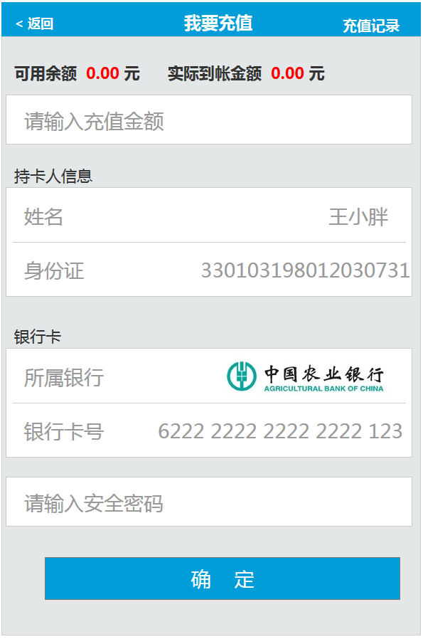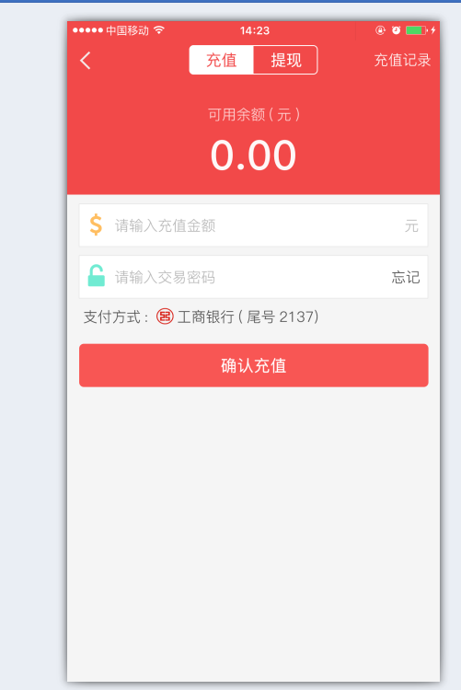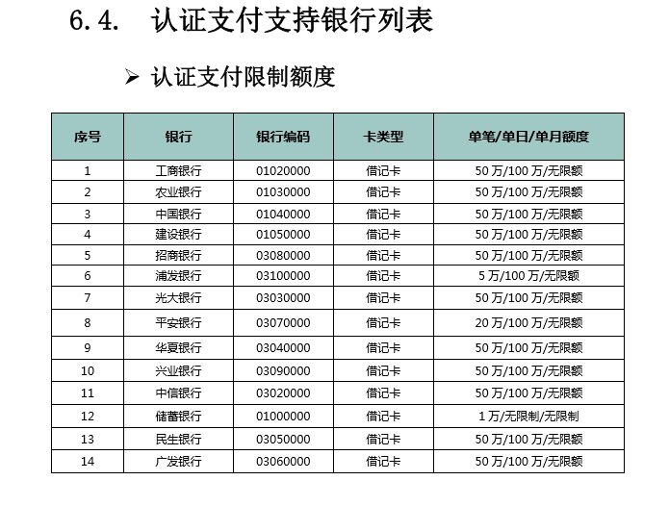

1. 接口名称：

/rest/rechargeTo

1. 输入

|  |  |  |  |  |  |  |  |  |
| --- | --- | --- | --- | --- | --- | --- | --- | --- |
| **名称** | **类型** | **必须** | **长度** | **默认值** | **最小值** | **最大值** | **示例值** | **描述** |
|  |  |  |  |  |  |  |  | 会员id |

1. 返回

|  |  |  |  |  |  |  |  |  |
| --- | --- | --- | --- | --- | --- | --- | --- | --- |
| **名称** | **类型** | **必须** | **长度** | **默认值** | **最小值** | **最大值** | **示例值** | **描述** |
| ableMoney |  |  |  |  |  |  |  | 会员可用余额 |
| registerTime |  |  |  |  |  |  |  | 注册时间 |
| userId |  |  |  |  |  |  |  | 用户ID |
| realName |  |  |  |  |  |  |  | 持卡人姓名 |
| cardId |  |  |  |  |  |  |  | 持卡人身份证 |
| cardNo |  |  |  |  |  |  |  | 银行卡号 |
| bankId |  |  |  |  |  |  |  | 银行编码 |
| bankName |  |  |  |  |  |  |  | 银行名称 |
| feeType |  |  |  |  |  |  | 0：按比例  1：按每笔 | 费用类型 |
| award |  |  |  |  |  |  | 当feeType=0 时  Award = 0.001  当feeType=1 时  Award = 5 | 充值奖励 |
| fee |  |  |  |  |  |  | 当feeType=0 时  fee= 0.001  当feeType=1 时  fee= 5 | 手续费 |

1. 错误码

|  |  |  |
| --- | --- | --- |
| **错误码** | **错误描述** | **解决方案** |
|  |  |  |

## 我要充值提交

1. 接口名称：

/ret/rechargeSave

1. 输入

|  |  |  |  |  |  |  |  |  |
| --- | --- | --- | --- | --- | --- | --- | --- | --- |
| **名称** | **类型** | **必须** | **长度** | **默认值** | **最小值** | **最大值** | **示例值** | **描述** |
| userAccountRecharge.money |  |  |  |  |  |  |  | 充值金额 |
| realName |  |  |  |  |  |  |  | 持卡人姓名 |
| idNo |  |  |  |  |  |  |  | 持卡人身份证 |
| cardNo |  |  |  |  |  |  |  | 银行卡号 |
| safepwd |  |  |  |  |  |  |  | 安全密码 |
| registerTime |  |  |  |  |  |  |  | 注册时间 |

1. 返回

|  |  |  |  |  |  |  |  |  |
| --- | --- | --- | --- | --- | --- | --- | --- | --- |
| **名称** | **类型** | **必须** | **长度** | **默认值** | **最小值** | **最大值** | **示例值** | **描述** |
| postUrl |  |  |  |  |  |  |  | Post提交地址 |
| reqData |  |  |  |  |  |  | Name=”req_data”  value=’${reqData}’ | 提交参数 |

1. 错误码

|  |  |  |
| --- | --- | --- |
| **错误码** | **错误描述** | **解决方案** |
|  |  |  |

## 充值记录

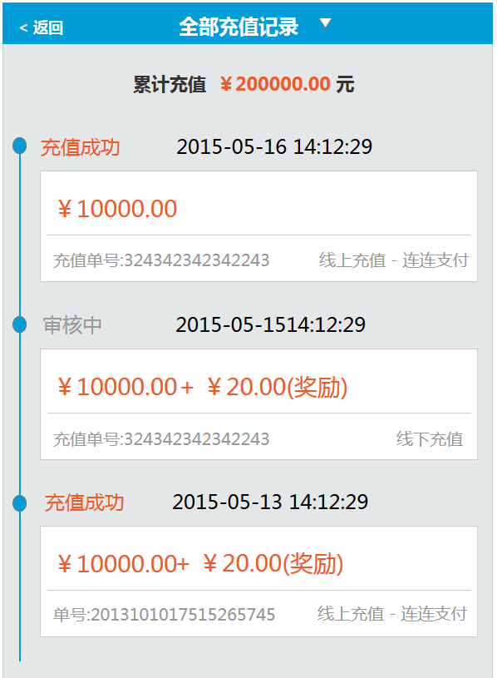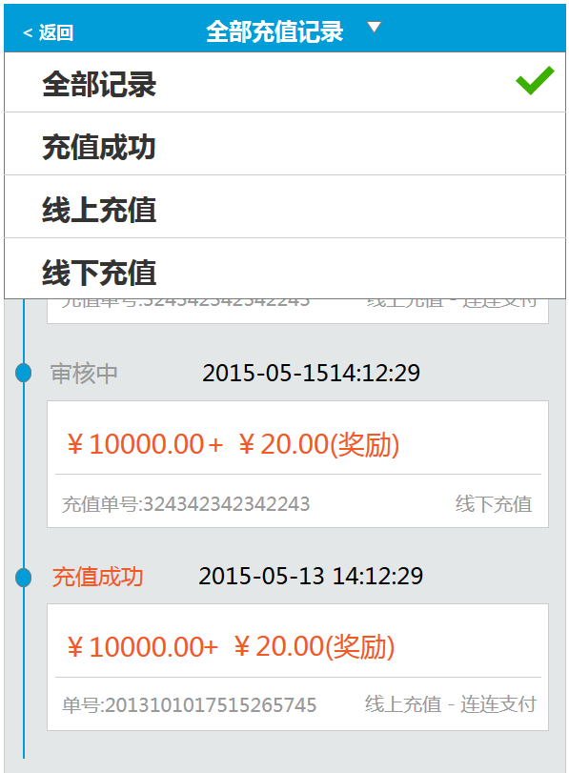

1. 接口名称：

/ret/rechargeList

1. 输入

|  |  |  |  |  |  |  |  |  |
| --- | --- | --- | --- | --- | --- | --- | --- | --- |
| **名称** | **类型** | **必须** | **长度** | **默认值** | **最小值** | **最大值** | **示例值** | **描述** |
|  |  |  |  |  |  |  |  | 会员id |
|  |  |  |  |  |  |  |  | 页数 |
| **type** |  |  |  |  |  |  | 0：全部记录  1：充值成功  2：线上充值  3：线下充值 | 筛选条件 |

1. 返回

|  |  |  |  |  |  |  |  |  |
| --- | --- | --- | --- | --- | --- | --- | --- | --- |
| **名称** | **类型** | **必须** | **长度** | **默认值** | **最小值** | **最大值** | **示例值** | **描述** |
| userRechargesList | UserRecharge |  |  |  |  |  |  | --以下循环开始 |
| id |  |  |  |  |  |  |  | 充值记录id |
| status |  |  |  |  |  |  | 0：失败;  1：成功;  2：审核中 | 充值记录状态 |
| statusShow |  |  |  |  |  |  |  | 充值记录状态(显示) |
| createDate |  |  |  |  |  |  |  | 充值记录创建时间 |
| rechargeDate |  |  |  |  |  |  |  | 充值记录修改时间 |
| money |  |  |  |  |  |  |  | 充值金额 |
| reward |  |  |  |  |  |  |  | 充值奖励金额 |
| tradeNo |  |  |  |  |  |  |  | 充值单号 |
| type |  |  |  |  |  |  | 0：线下充值  1:线上充值 | 充值类型（线上、线下） |
| name |  |  |  |  |  |  |  | 充值途径（第三方支付、银行） |
|  |  |  |  |  |  |  |  | --以上循环结束 |

1. 错误码

|  |  |  |
| --- | --- | --- |
| **错误码** | **错误描述** | **解决方案** |
|  |  |  |

## 我要提现

提现规则修改为：

1、每个月前X笔提现手续费为0

2、第X+1笔开始，每笔收取0.X%手续费及固定X元

3、当日充值，当日可以提现

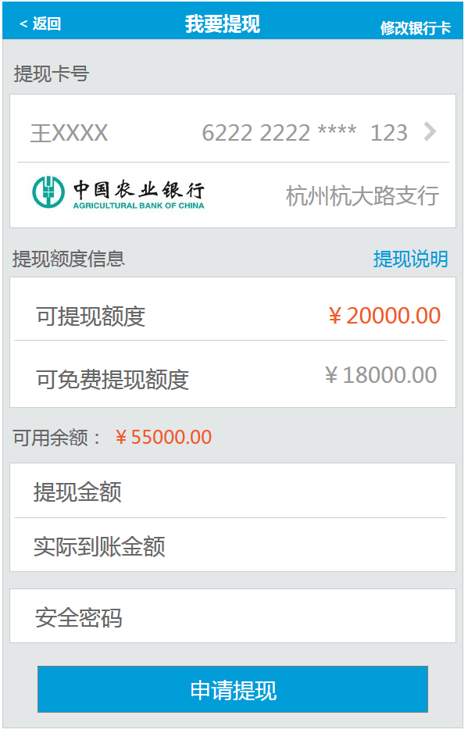

* **载入页面**

1. 接口名称：

/ret/cashTo

1. 输入

|  |  |  |  |  |  |  |  |  |
| --- | --- | --- | --- | --- | --- | --- | --- | --- |
| **名称** | **类型** | **必须** | **长度** | **默认值** | **最小值** | **最大值** | **示例值** | **描述** |
|  |  |  |  |  |  |  |  | 会员id |

1. 返回

|  |  |  |  |  |  |  |  |  |
| --- | --- | --- | --- | --- | --- | --- | --- | --- |
| **名称** | **类型** | **必须** | **长度** | **默认值** | **最小值** | **最大值** | **示例值** | **描述** |
| realname |  |  |  |  |  |  |  | 会员姓名 |
| cardNo |  |  |  |  |  |  |  | 会员银行卡卡号 |
| bankName |  |  |  |  |  |  |  | 银行卡银行 |
| branch |  |  |  |  |  |  |  | 开户行 |
| cashMoney |  |  |  |  |  |  |  | 可提现额度 |
| ableMoney |  |  |  |  |  |  |  | 可用余额 |
| bankId |  |  |  |  |  |  |  | 银行ID |
| feeScale |  |  |  |  |  |  | 0.003 | 提现手续费比例 |
| feeFixed |  |  |  |  |  |  |  | 固定提现手续费 |
| userCashChargeTimes |  |  |  |  |  |  |  | 当月提现次数 |
| cashChargeTimes |  |  |  |  |  |  |  | 免费提现次数 |
|  |  |  |  |  |  |  |  |  |

1. 错误码

|  |  |  |
| --- | --- | --- |
| **错误码** | **错误描述** | **解决方案** |
|  |  |  |

## 我要提现提交

1. 接口名称：

/rest/cashSave

1. 输入

|  |  |  |  |  |  |  |  |  |
| --- | --- | --- | --- | --- | --- | --- | --- | --- |
| **名称** | **类型** | **必须** | **长度** | **默认值** | **最小值** | **最大值** | **示例值** | **描述** |
| cashMoney |  |  |  |  |  |  |  | 提现金额 |
| safepwd |  |  |  |  |  |  |  | 安全密码 |

1. 返回

|  |  |  |  |  |  |  |  |  |
| --- | --- | --- | --- | --- | --- | --- | --- | --- |
| **名称** | **类型** | **必须** | **长度** | **默认值** | **最小值** | **最大值** | **示例值** | **描述** |
| **rcd** |  |  |  |  |  |  | R0001 | 提现申请递交成功 |
| **rmg** |  |  |  |  |  |  |  | 消息描述 |

1. 错误码

|  |  |  |
| --- | --- | --- |
| **错误码** | **错误描述** | **解决方案** |
| M00015_0 | 提现金额必须大于100元 |  |
| M00015_1 | 申请提现金额必须为整数 |  |
| M00015_2 | 申请提现金额大于实际可提现额度 |  |
| S0002 | 安全密码输入错误 |  |
|  |  |  |

* **提现-输入提现金额失去焦点后**

1. 接口名称：

/ret/cashChange

1. 输入

|  |  |  |  |  |  |  |  |  |
| --- | --- | --- | --- | --- | --- | --- | --- | --- |
| **名称** | **类型** | **必须** | **长度** | **默认值** | **最小值** | **最大值** | **示例值** | **描述** |
|  |  |  |  |  |  |  |  | 会员id |
| cashMoney |  |  |  |  |  |  |  | 提现金额 |

1. 返回

|  |  |  |  |  |  |  |  |  |
| --- | --- | --- | --- | --- | --- | --- | --- | --- |
| **名称** | **类型** | **必须** | **长度** | **默认值** | **最小值** | **最大值** | **示例值** | **描述** |
| realMoney |  |  |  |  |  |  |  | 实际到账金额 |
| **rcd** |  |  |  |  |  |  | R0001 | 返回实际到账金额 |
| **rmg** |  |  |  |  |  |  |  | 消息描述 |

1. 错误码

|  |  |  |
| --- | --- | --- |
| **错误码** | **错误描述** | **解决方案** |
| M00015_0 | 提现金额必须大于100元 |  |
| M00015_2 | 申请提现金额大于实际可提现额度 |  |
| M00015_4 | 请输入正确的提现金额 |  |
| M00015_5 | 您账户所有金额为24小时内充值金额，不能提现 |  |
| M00015_6 | 您账户没有可提现金额 |  |
| M00015_7 | 提现金额不能高于XXX元 |  |
| M00015_8 | 您申请提现的金额中包含受15天内充值资金提现规则限制,超出部分将收取(超出额乘以XXX)的提现手续费,还请注意 |  |
|  |  |  |
| S0002 | 安全密码输入错误 |  |

## 提现列表

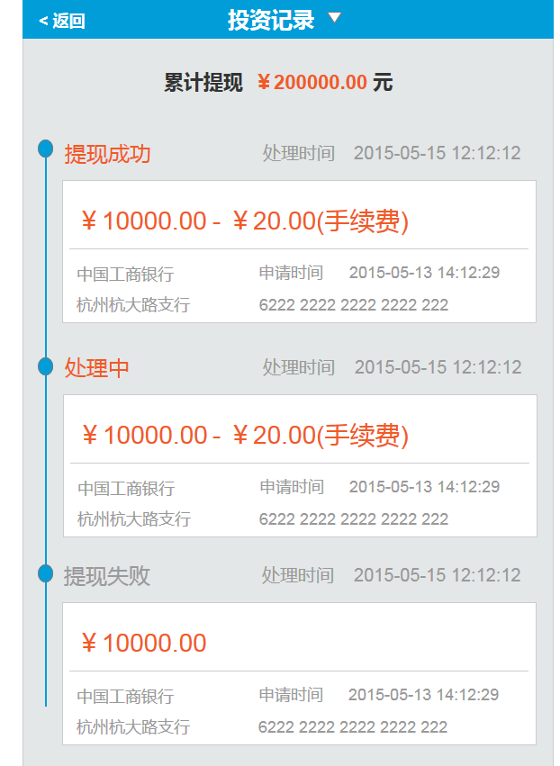

* **载入页面**

1. 接口名称：

/ret/cashList

1. 输入

|  |  |  |  |  |  |  |  |  |
| --- | --- | --- | --- | --- | --- | --- | --- | --- |
| **名称** | **类型** | **必须** | **长度** | **默认值** | **最小值** | **最大值** | **示例值** | **描述** |
|  |  |  |  |  |  |  |  | 会员id |
| **pageNumber** |  |  |  |  |  |  |  | 页数 |
| **pageSize** |  |  |  |  |  |  |  | 单页条数 |
| **orderBy** |  |  |  |  |  |  |  | 排序字段 id |
| **orderSort** |  |  |  |  |  |  |  | 排序方式 DESC |

1. 返回

|  |  |  |  |  |  |  |  |  |
| --- | --- | --- | --- | --- | --- | --- | --- | --- |
| **名称** | **类型** | **必须** | **长度** | **默认值** | **最小值** | **最大值** | **示例值** | **描述** |
| userCashList | UserCash |  |  |  |  |  |  | --以下循环开始 |
| id |  |  |  |  |  |  |  | 提现记录id |
| status |  |  |  |  |  |  | 0-审核中  1-审核成功  2-审核失败  3-用户取消  4-处理中 | 提现记录状态 |
| statusShow |  |  |  |  |  |  |  | 提现记录状态(显示) |
| createDate |  |  |  |  |  |  |  | 提现记录创建时间 |
| rechargeDate |  |  |  |  |  |  |  | 提现记录修改时间 |
| money |  |  |  |  |  |  |  | 提现金额 |
| fee |  |  |  |  |  |  |  | 提现手续费 |
| cardNo |  |  |  |  |  |  |  | 银行卡号 |
| bankName |  |  |  |  |  |  |  | 银行卡银行 |
| branch |  |  |  |  |  |  |  | 开户行 |
|  |  |  |  |  |  |  |  | --以上循环结束 |

1. 错误码

|  |  |  |
| --- | --- | --- |
| **错误码** | **错误描述** | **解决方案** |
|  |  |  |

## 我的红包

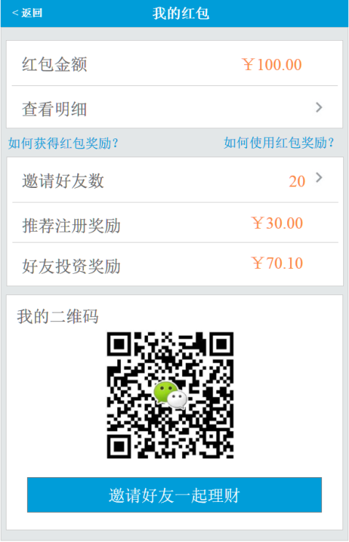

* **载入页面**

1. 接口名称：

/ret/hongbaoTo

1. 输入

|  |  |  |  |  |  |  |  |  |
| --- | --- | --- | --- | --- | --- | --- | --- | --- |
| **名称** | **类型** | **必须** | **长度** | **默认值** | **最小值** | **最大值** | **示例值** | **描述** |
|  |  |  |  |  |  |  |  | 用户id |

1. 返回

|  |  |  |  |  |  |  |  |  |
| --- | --- | --- | --- | --- | --- | --- | --- | --- |
| **名称** | **类型** | **必须** | **长度** | **默认值** | **最小值** | **最大值** | **示例值** | **描述** |
| awardMoney |  |  |  |  |  |  |  | 红包余额 |
| friendsCount |  |  |  |  |  |  |  | 好友数 |
| awardMoneyTj |  |  |  |  |  |  |  | 推荐注册红包总额 |
| awardMoneyTz |  |  |  |  |  |  |  | 好友投资红包总额 |
| tgNo |  |  |  |  |  |  | http://www.xxx.com/p_xxx | 推广链接二维码 |
| sms |  |  |  |  |  |  |  | 分享到短信的内容 |
| weixin |  |  |  |  |  |  |  | 分享到微信好友的内容 |
| weixinFriend |  |  |  |  |  |  |  | 分享到微信朋友圈的内容 |
| sina |  |  |  |  |  |  |  | 分享到新浪微博的内容 |
| tencent |  |  |  |  |  |  |  | 分享到腾讯微博的内容 |
| qq |  |  |  |  |  |  |  | 分享到QQ的内容 |

1. 错误码

|  |  |  |
| --- | --- | --- |
| **错误码** | **错误描述** | **解决方案** |
|  |  |  |

## 红包明细

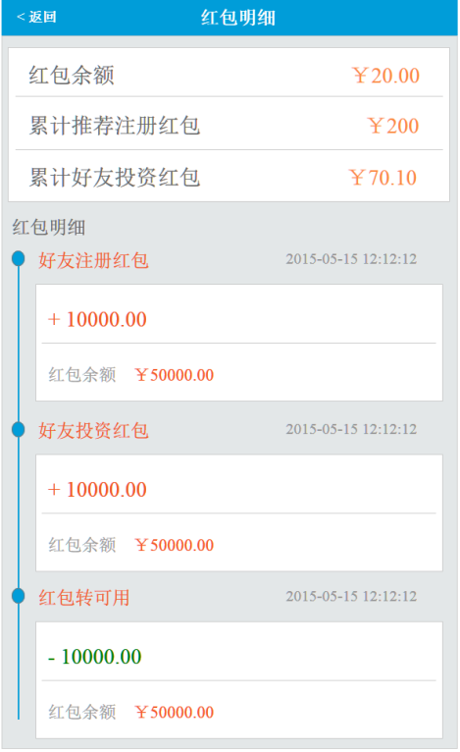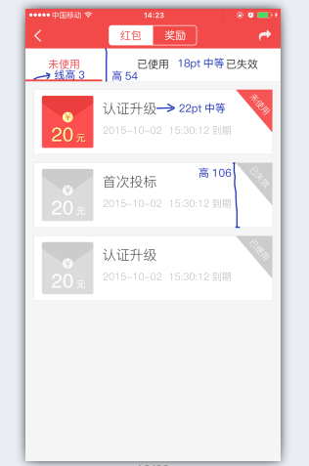

* **载入页面**

1. 接口名称：

/rest/hbList

1. 输入

|  |  |  |  |  |  |  |  |  |
| --- | --- | --- | --- | --- | --- | --- | --- | --- |
| **名称** | **类型** | **必须** | **长度** | **默认值** | **最小值** | **最大值** | **示例值** | **描述** |
| **status** |  |  |  |  |  |  |  | 状态 0未使用1使用2已过期 |
| **pageNumber** |  |  |  |  |  |  |  | 页数 |
| **pageSize** |  |  |  |  |  |  |  | 单页条数 |
| **orderBy** |  |  |  |  |  |  |  | 排序字段create_date |
| **orderSort** |  |  |  |  |  |  |  | 排序方式 DESC |

1. 返回

|  |  |  |  |  |  |  |  |  |
| --- | --- | --- | --- | --- | --- | --- | --- | --- |
| **名称** | **类型** | **必须** | **长度** | **默认值** | **最小值** | **最大值** | **示例值** | **描述** |
|  | userHongbaoItem |  |  |  |  |  |  | 红包列表类型 |
| money |  |  |  |  |  |  |  | 红包金额 |
| endTime |  |  |  |  |  |  |  | 到期时间 |
| sourceString |  |  |  |  |  |  |  | 来源说明 |

1. 错误码

|  |  |  |
| --- | --- | --- |
| **错误码** | **错误描述** | **解决方案** |
|  |  |  |

## 好友列表

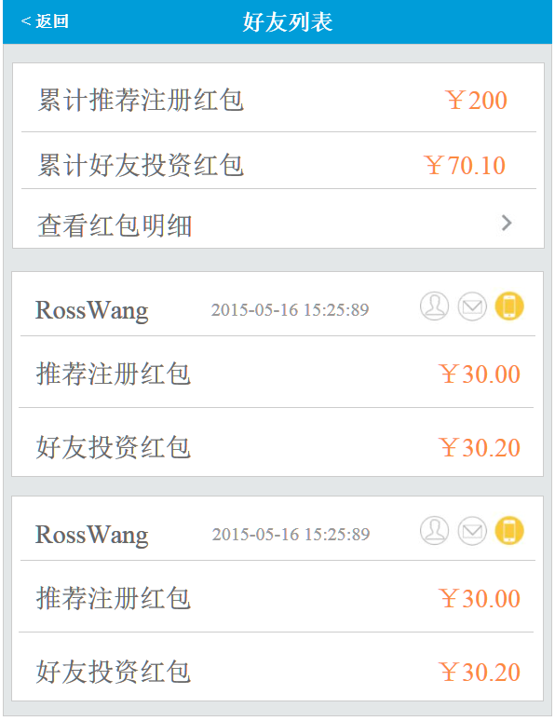

* **载入页面**

1. 接口名称：

/rest/friendsList

1. 输入

|  |  |  |  |  |  |  |  |  |
| --- | --- | --- | --- | --- | --- | --- | --- | --- |
| **名称** | **类型** | **必须** | **长度** | **默认值** | **最小值** | **最大值** | **示例值** | **描述** |
|  |  |  |  |  |  |  |  | 用户id |
| **pageNumber** |  |  |  |  |  |  |  | 页数 |
| **pageSize** |  |  |  |  |  |  |  | 单页条数 |
| **orderBy** |  |  |  |  |  |  |  | 排序字段 id |
| **orderSort** |  |  |  |  |  |  |  | 排序方式 DESC |

1. 返回

|  |  |  |  |  |  |  |  |  |
| --- | --- | --- | --- | --- | --- | --- | --- | --- |
| **名称** | **类型** | **必须** | **长度** | **默认值** | **最小值** | **最大值** | **示例值** | **描述** |
| **awardTotalMoneyTj** |  |  |  |  |  |  |  | 推荐注册红包总额 |
| **awardTotalMoneyTz** |  |  |  |  |  |  |  | 好友投资红包总额 |
| **userFriendList** | UserFriend |  |  |  |  |  |  | --以下循环开始 |
| **friendName** |  |  |  |  |  |  |  | 好友用户名 |
| **createDate** |  |  |  |  |  |  |  | 好友注册时间 |
| **awardMoneyTj** |  |  |  |  |  |  |  | 好友推荐红包金额 |
| **awardMoneyTz** |  |  |  |  |  |  |  | 好友投资红包金额 |
| **realNameStatus** |  |  |  |  |  |  |  | 实名状态 |
| **emailStatus** |  |  |  |  |  |  |  | 邮箱状态 |
| **phoneStatus** |  |  |  |  |  |  |  | 手机状态 |
|  |  |  |  |  |  |  |  | --以上循环结束 |

1. 错误码

|  |  |  |
| --- | --- | --- |
| **错误码** | **错误描述** | **解决方案** |
|  |  |  |

## 资金记录

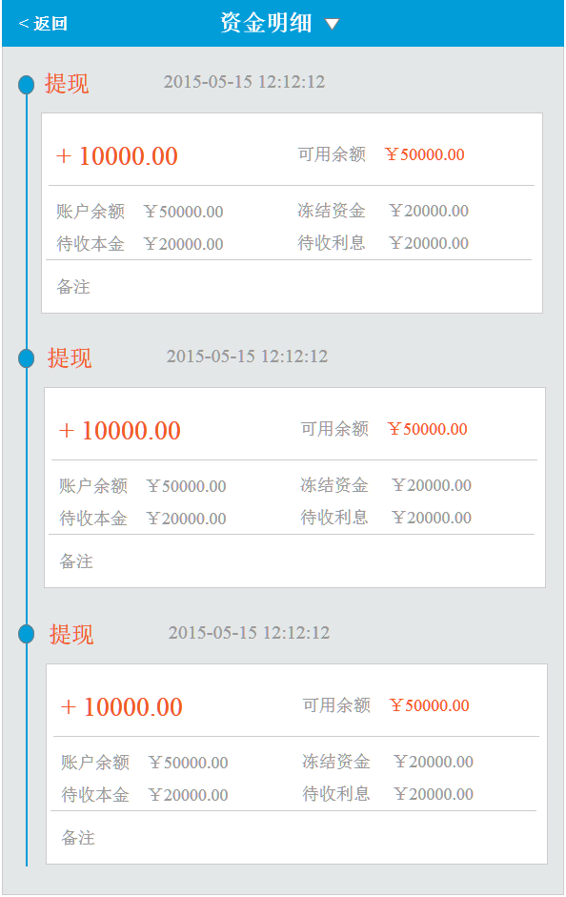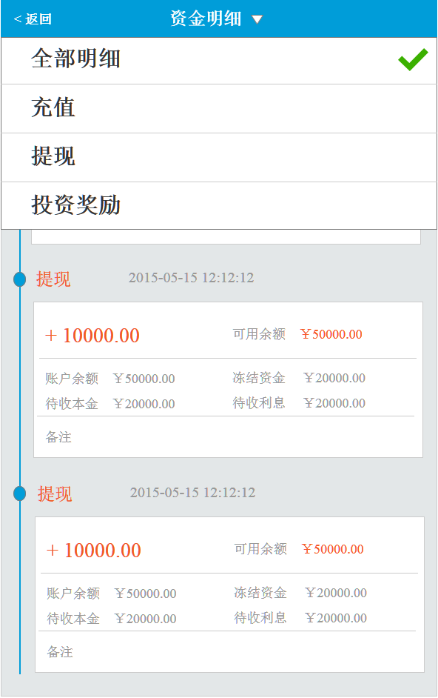

* **载入页面**

1. 接口名称：

/rest/accountDetailList

1. 输入

|  |  |  |  |  |  |  |  |  |
| --- | --- | --- | --- | --- | --- | --- | --- | --- |
| **名称** | **类型** | **必须** | **长度** | **默认值** | **最小值** | **最大值** | **示例值** | **描述** |
|  |  |  |  |  |  |  |  | 用户id |
| **type** |  |  |  |  |  |  | 充值：0  提现:1  投资奖励:2 | 明细类型 |
| **pageNumber** |  |  |  |  |  |  |  | 页数 |
| **pageSize** |  |  |  |  |  |  |  | 单页条数 |
| **orderBy** |  |  |  |  |  |  |  | 排序字段 ID |
| **orderSort** |  |  |  |  |  |  |  | 排序方式 DESC |
|  |  |  |  |  |  |  |  |  |

1. 返回

|  |  |  |  |  |  |  |  |  |
| --- | --- | --- | --- | --- | --- | --- | --- | --- |
| **名称** | **类型** | **必须** | **长度** | **默认值** | **最小值** | **最大值** | **示例值** | **描述** |
| **typeShow** |  |  |  |  |  |  |  | 明细类型 |
| **createDate** |  |  |  |  |  |  |  | 发生时间 |
| **money** |  |  |  |  |  |  |  | 操作金额 |
| **ableMoney** |  |  |  |  |  |  |  | 可用余额 |
| **tasteMoney** |  |  |  |  |  |  |  | 体验金 |
| **total** |  |  |  |  |  |  |  | 账户总额 |
| **unableMoney** |  |  |  |  |  |  |  | 冻结资金 |
| **investorCollectionCapital** |  |  |  |  |  |  |  | 待收本金 |
| **investorCollectionInterest** |  |  |  |  |  |  |  | 待收利息 |
| **remark** |  |  |  |  |  |  |  | 备注 |

1. 错误码

|  |  |  |
| --- | --- | --- |
| **错误码** | **错误描述** | **解决方案** |
|  |  |  |

## 奖励记录

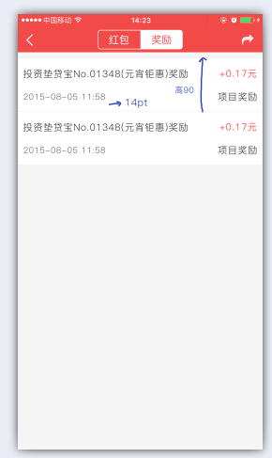

* **载入页面**

1. 接口名称：
2. /rest/awardCash
3. 输入

|  |  |  |  |  |  |  |  |  |
| --- | --- | --- | --- | --- | --- | --- | --- | --- |
| **名称** | **类型** | **必须** | **长度** | **默认值** | **最小值** | **最大值** | **示例值** | **描述** |
| **pageNumber** |  |  |  |  |  |  |  | 页数 |
| **pageSize** |  |  |  |  |  |  |  | 单页条数 |
| **orderBy** |  |  |  |  |  |  |  | 排序字段 ID |
| **orderSort** |  |  |  |  |  |  |  | 排序方式 DESC |
|  |  |  |  |  |  |  |  |  |

1. 返回

|  |  |  |  |  |  |  |  |  |
| --- | --- | --- | --- | --- | --- | --- | --- | --- |
| **名称** | **类型** | **必须** | **长度** | **默认值** | **最小值** | **最大值** | **示例值** | **描述** |
|  | cashList |  |  |  |  |  |  | 列表类型 |
| **createDate** |  |  |  |  |  |  |  | 发生时间 |
| type |  |  |  |  |  |  |  | 类型 |
| typeShow |  |  |  |  |  |  |  | 类型文字 |
| money |  |  |  |  |  |  |  |  |
| **remark** |  |  |  |  |  |  |  | 备注 |

1. 错误码

|  |  |  |
| --- | --- | --- |
| **错误码** | **错误描述** | **解决方案** |
|  |  |  |

# 八、更多

## 更多

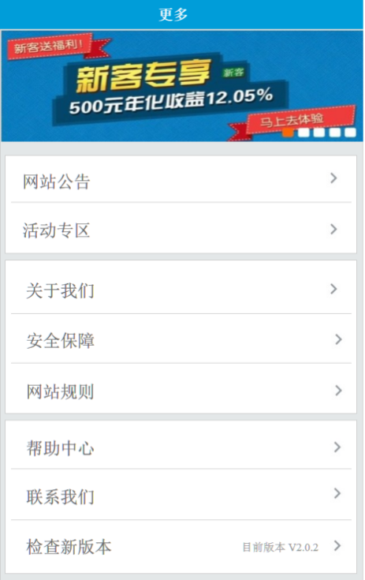

* **载入页面**

1. 接口名称：
2. 输入

|  |  |  |  |  |  |  |  |  |
| --- | --- | --- | --- | --- | --- | --- | --- | --- |
| **名称** | **类型** | **必须** | **长度** | **默认值** | **最小值** | **最大值** | **示例值** | **描述** |
|  |  |  |  |  |  |  |  |  |

1. 返回

|  |  |  |  |  |  |  |  |  |
| --- | --- | --- | --- | --- | --- | --- | --- | --- |
| **名称** | **类型** | **必须** | **长度** | **默认值** | **最小值** | **最大值** | **示例值** | **描述** |
|  |  |  |  |  |  |  |  | 当前版本 |

1. 错误码

|  |  |  |
| --- | --- | --- |
| **错误码** | **错误描述** | **解决方案** |
|  |  |  |

## CMS列表页 – 以帮助中心为例

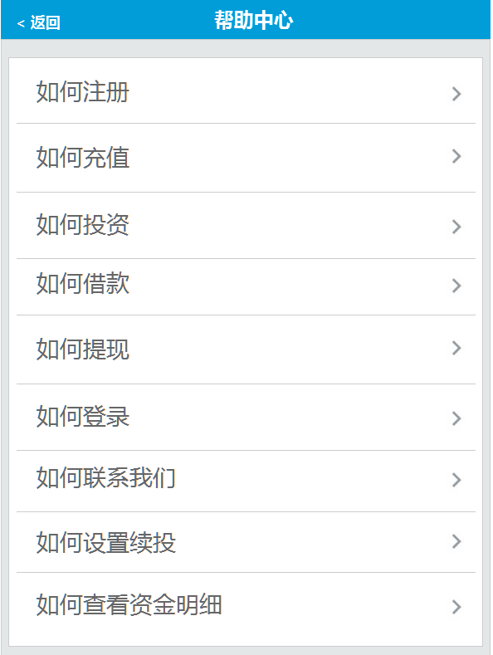

* **载入页面**

1. 接口名称：

/rest/articleList/${type}

1. 输入

|  |  |  |  |  |  |  |  |  |
| --- | --- | --- | --- | --- | --- | --- | --- | --- |
| **名称** | **类型** | **必须** | **长度** | **默认值** | **最小值** | **最大值** | **示例值** | **描述** |
|  |  |  |  |  |  |  |  | 帮助中心类别编码 |
| **pageNumbe** |  |  |  |  |  |  |  | 页数 |
| **pageSize** |  |  |  |  |  |  |  | 单页条数 |
| **way** |  |  |  |  |  |  |  | 请求端类型:0网页，1 H5端,2 Andriod,3 IOSs |

1. 返回

|  |  |  |  |  |  |  |  |  |  |  |  |  |  |  |  |  |
| --- | --- | --- | --- | --- | --- | --- | --- | --- | --- | --- | --- | --- | --- | --- | --- | --- |
| **名称** | | **类型** | | **必须** | **长度** | | **默认值** | | **最小值** | | **最大值** | | **示例值** | | **描述** | |
| **articleItemList** | | ArticleItem | |  |  | |  | |  | |  | |  | | --以下循环开始 | |
| **id** | |  | |  |  | |  | |  | |  | |  | | 文章id | |
| **title** | |  | |  |  | |  | |  | |  | |  | | 文章标题 | |
|  | |  | |  |  | |  | |  | |  | |  | | --以上循环结束 | |
| **pageBean** | |  | |  |  | |  | |  | |  | |  | | 翻页信息 | |
|  | |  | |  |  | |  | |  | |  | |  | | -以下【pageBean】开始 | |
| **pageNumber** | |  | |  |  | |  | |  | |  | |  | | 当前页数 | |
| **totalCount** | |  | |  |  | |  | |  | |  | |  | | 总记录数 | |
| **pageCount** | |  | |  |  | |  | |  | |  | |  | | 总页数 | |
| **pageSize** | |  | |  |  | |  | |  | |  | |  | | 每页记录数 | |
|  | |  | |  |  | |  | |  | |  | |  | | --以上【pageBean】结束 | |
|  |  | |  | | |  | |  | |  | |  | |  | |  |

1. 错误码

|  |  |  |
| --- | --- | --- |
| **错误码** | **错误描述** | **解决方案** |
|  |  |  |

## CMS内容页 – 以网站公告内容页为例

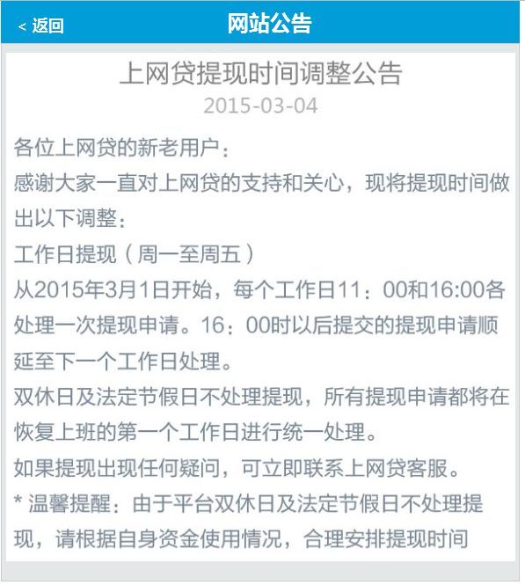

* **载入页面**

1. 接口名称：

/rest/article/${id}

1. 输入

|  |  |  |  |  |  |  |  |  |
| --- | --- | --- | --- | --- | --- | --- | --- | --- |
| **名称** | **类型** | **必须** | **长度** | **默认值** | **最小值** | **最大值** | **示例值** | **描述** |
| **id** |  |  |  |  |  |  |  | 文章id |

1. 返回

|  |  |  |  |  |  |  |  |  |
| --- | --- | --- | --- | --- | --- | --- | --- | --- |
| **名称** | **类型** | **必须** | **长度** | **默认值** | **最小值** | **最大值** | **示例值** | **描述** |
| **title** |  |  |  |  |  |  |  | 文章标题 |
| **title** |  |  |  |  |  |  |  | 发标时间 |
| **content** |  |  |  |  |  |  |  | 文章内容 |

1. 错误码

|  |  |  |
| --- | --- | --- |
| **错误码** | **错误描述** | **解决方案** |
|  |  |  |

## 活动中心列表页

* **载入页面**

1. 接口名称：

/rest/activity

1. 输入

|  |  |  |  |  |  |  |  |  |
| --- | --- | --- | --- | --- | --- | --- | --- | --- |
| **名称** | **类型** | **必须** | **长度** | **默认值** | **最小值** | **最大值** | **示例值** | **描述** |
|  |  |  |  |  |  |  |  | 帮助中心类别编码 |
| **pageNumbe** |  |  |  |  |  |  |  | 页数 |
| **pageSize** |  |  |  |  |  |  |  | 单页条数 |
| **activity.status** |  |  |  |  |  |  |  | 状态：1进行中，2已结束 |

1. 返回

|  |  |  |  |  |  |  |  |  |  |  |  |  |  |  |  |  |
| --- | --- | --- | --- | --- | --- | --- | --- | --- | --- | --- | --- | --- | --- | --- | --- | --- |
| **名称** | | **类型** | | **必须** | **长度** | | **默认值** | | **最小值** | | **最大值** | | **示例值** | | **描述** | |
| **activityList** | |  | |  |  | |  | |  | |  | |  | | --以下循环开始 | |
| **id** | |  | |  |  | |  | |  | |  | |  | | 活动id | |
| **title** | |  | |  |  | |  | |  | |  | |  | | 活动标题 | |
| **startTime** | |  | |  |  | |  | |  | |  | |  | | 开始时间 | |
| **endTime** | |  | |  |  | |  | |  | |  | |  | | 结束时间 | |
| **imgApp** | |  | |  |  | |  | |  | |  | |  | | app列表图片 | |
| **content** | |  | |  |  | |  | |  | |  | |  | | 内容 | |
|  | |  | |  |  | |  | |  | |  | |  | | --以上循环结束 | |
| **pageBean** | |  | |  |  | |  | |  | |  | |  | | 翻页信息 | |
|  | |  | |  |  | |  | |  | |  | |  | | -以下【pageBean】开始 | |
| **pageNumber** | |  | |  |  | |  | |  | |  | |  | | 当前页数 | |
| **totalCount** | |  | |  |  | |  | |  | |  | |  | | 总记录数 | |
| **pageCount** | |  | |  |  | |  | |  | |  | |  | | 总页数 | |
| **pageSize** | |  | |  |  | |  | |  | |  | |  | | 每页记录数 | |
|  | |  | |  |  | |  | |  | |  | |  | | --以上【pageBean】结束 | |
|  |  | |  | | |  | |  | |  | |  | |  | |  |

1. 错误码

|  |  |  |
| --- | --- | --- |
| **错误码** | **错误描述** | **解决方案** |
|  |  |  |

## 活动内容页

* **载入页面**

1. 接口名称：

/rest/activity/${id}

1. 输入

|  |  |  |  |  |  |  |  |  |
| --- | --- | --- | --- | --- | --- | --- | --- | --- |
| **名称** | **类型** | **必须** | **长度** | **默认值** | **最小值** | **最大值** | **示例值** | **描述** |
| **activity** | Activity |  |  |  |  |  |  | 活动对象 |
|  |  |  |  |  |  |  |  | 以下【activity】开始 |
| **id** |  |  |  |  |  |  |  | 编号 |
| **title** |  |  |  |  |  |  |  | 标题 |
| **startTime** |  |  |  |  |  |  |  | 开始时间 |
| **endTime** |  |  |  |  |  |  |  | 结束时间 |
| **imgApp** |  |  |  |  |  |  |  | 图片 |
| **content** |  |  |  |  |  |  |  | 内容 |
|  |  |  |  |  |  |  |  | 以上【activity】结束 |

1. 返回

|  |  |  |  |  |  |  |  |  |
| --- | --- | --- | --- | --- | --- | --- | --- | --- |
| **名称** | **类型** | **必须** | **长度** | **默认值** | **最小值** | **最大值** | **示例值** | **描述** |
| **title** |  |  |  |  |  |  |  | 文章标题 |
| **title** |  |  |  |  |  |  |  | 发标时间 |
| **content** |  |  |  |  |  |  |  | 文章内容 |

1. 错误码

|  |  |  |
| --- | --- | --- |
| **错误码** | **错误描述** | **解决方案** |
|  |  |  |

# 第二章数据结构

1. borrow

描述：包含一个借款项目的全部信息

|  |  |  |  |
| --- | --- | --- | --- |
| **名称** | **类型** | **是否必须** | **描述** |
|  |  |  |  |
|  |  |  |  |
|  |  |  |  |