|  |  |  |  |
| --- | --- | --- | --- |
| 项目名称 |  | | |
| 文档版本 |  | 最后修订时间 |  |

网贷手机APP接口文档

修订控制页

|  |  |  |  |  |  |
| --- | --- | --- | --- | --- | --- |
| **编号** | **版本** | **修订章节** | **修改原因** | **修订日期** | **修订人** |
| 1 | V1.0 |  |  | 20150515 | 王侃涛 |
| 2 | V1.1 |  |  | 20150516 | 王侃涛 |
|  |  |  |  |  |  |
|  |  |  |  |  |  |
|  |  |  |  |  |  |
|  |  |  |  |  |  |
|  |  |  |  |  |  |
|  |  |  |  |  |  |
|  |  |  |  |  |  |
|  |  |  |  |  |  |
|  |  |  |  |  |  |

目 录

第一章 接口 3

一、首页 3

1、首页 3

二、投资中心 3

1、投资中心 3

2、项目详情页 3

3、获取单个项目投资记录 3

4、投资项目 3

三、登录注册 3

1. 登录 3

2. 找回登录密码验证 3

3. 重置登录密码 3

4. 注册 3

5. 短信验证码 3

四、会员中心首页 3

1. 会员中心首页 3

五、会员账户管理 3

1. 账户管理 3

2. 实名认证为“未申请”或“未通过”时 3

3. 实名认证为“审核中”时 3

4. 更改手机认证验证 3

5. 手机认证 3

6. 邮箱地址为空时 3

7. 邮箱地址不为空时 3

8. 银行卡未绑定 3

9. 银行卡已绑定 3

10. 登录密码设置 3

11. 添加安全密码 3

12. 修改安全密码 3

13. 忘记安全密码验证 3

14. 手势密码设置 3

15. 修改手势密码 3

16. 重置手势密码验证 3

六、会员中心-我的投资 3

1. 投资记录 3

2. 回款明细 3

3. 我的转让市场 – 二期 3

4. 自动投资 3

七、会员中心-资金管理 3

1. 我要充值 3

2. 充值记录 3

3. 我要提现 3

4. 我的红包 3

5. 红包明细 3

6. 好友列表 3

7. 资金记录 3

八、更多 3

1. 更多 3

2. CMS列表页 – 以帮助中心为例 3

3. CMS内容页 – 以网站公告内容页为例 3

第二章 数据结构 3

# 第一章 接口

# 一、首页

## 1、首页

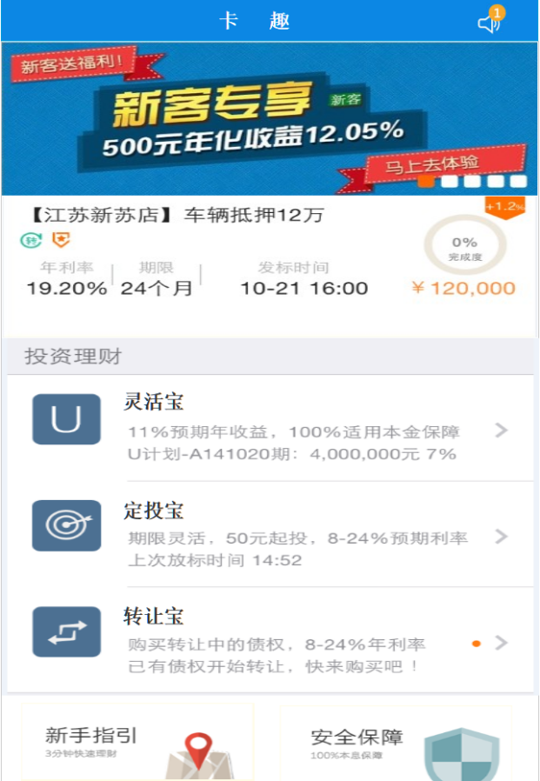

1. 接口名称：

/index/

1. 输入

|  |  |  |  |  |  |  |  |  |
| --- | --- | --- | --- | --- | --- | --- | --- | --- |
| **名称** | **类型** | **必须** | **长度** | **默认值** | **最小值** | **最大值** | **示例值** | **描述** |
|  |  |  |  |  |  |  |  |  |

1. 返回

|  |  |  |  |  |  |  |  |  |
| --- | --- | --- | --- | --- | --- | --- | --- | --- |
| **名称** | **类型** | **必须** | **长度** | **默认值** | **最小值** | **最大值** | **示例值** | **描述** |
|  |  |  |  |  |  |  |  | 滚动图url |
|  |  |  |  |  |  |  |  | 推荐项目id |
|  |  |  |  |  |  |  |  | 推荐项目名称 |
|  |  |  |  |  |  |  |  | 推荐项目类型图片 |
|  |  |  |  |  |  |  |  | 推荐项目编号 |
|  |  |  |  |  |  |  |  | 推荐项目期限 |
|  |  |  |  |  |  |  |  | 推荐项目金额 |
|  |  |  |  |  |  |  |  | 推荐项目年化收益 |
|  |  |  |  |  |  |  |  | 推荐项目奖励 |
|  |  |  |  |  |  |  |  | 推荐项目状态 |
|  |  |  |  |  |  |  |  | 推荐项目状态名称 |
|  |  |  |  |  |  |  |  | 推荐项目进度 |
|  |  |  |  |  |  |  |  | 推荐已投次数 |
|  |  |  |  |  |  |  |  | 推荐新客图片 |
|  |  |  |  |  |  |  |  | 推荐项目发布时间 |
|  |  |  |  |  |  |  |  | 平台项目类型 |
|  |  |  |  |  |  |  |  | 平台项目类型名称 |
|  |  |  |  |  |  |  |  | 平台项目类型图片 |
|  |  |  |  |  |  |  |  | 平台项目类型简介 |
|  |  |  |  |  |  |  |  | 未读网站公告数量 |

1. 错误码

|  |  |  |
| --- | --- | --- |
| **错误码** | **错误描述** | **解决方案** |
|  |  |  |

# 二、投资中心

## 1、投资中心

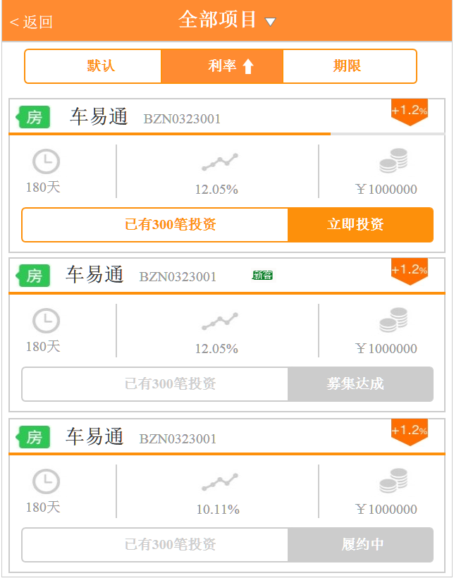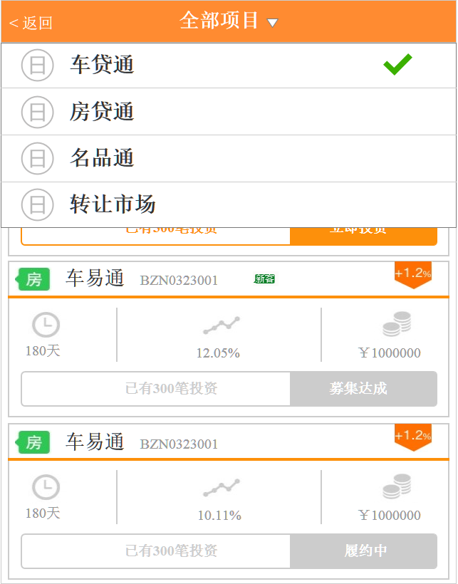

1. 接口名称：

/rest/borrow/

1. 输入

|  |  |  |  |  |  |  |  |  |
| --- | --- | --- | --- | --- | --- | --- | --- | --- |
| **名称** | **类型** | **必须** | **长度** | **默认值** | **最小值** | **最大值** | **示例值** | **描述** |
| **type** |  |  |  |  |  |  |  | 项目类型 |
| **pageNumber** |  |  |  |  |  |  |  | 页数 |
| **pageSize** |  |  |  |  |  |  |  | 单页条数 |
| **orderBy** |  |  |  |  |  |  |  | 排序字段 0无1利率2期限 |
| **orderSort** |  |  |  |  |  |  |  | 排序方式 0 ASC 1DESC |

1. 返回

|  |  |  |  |  |  |  |  |  |
| --- | --- | --- | --- | --- | --- | --- | --- | --- |
| **名称** | **类型** | **必须** | **长度** | **默认值** | **最小值** | **最大值** | **示例值** | **描述** |
| **pageBean** |  |  |  |  |  |  |  | 翻页信息 |
|  |  |  |  |  |  |  |  | -以下【pageBean】开始 |
| **pageNumber** |  |  |  |  |  |  |  | 当前页数 |
| **totalCount** |  |  |  |  |  |  |  | 总记录数 |
| **pageCount** |  |  |  |  |  |  |  | 总页数 |
| **pageSize** |  |  |  |  |  |  |  | 每页记录数 |
|  |  |  |  |  |  |  |  | --以上【pageBean】结束 |
|  |  |  |  |  |  |  |  |  |
| **borrowItemList** | BorrowItem |  |  |  |  |  |  | 项目列表信息 |
|  |  |  |  |  |  |  |  | --以下【项目列表】循环开始 |
| **id** |  |  |  |  |  |  |  | 项目id |
| **type** |  |  |  |  |  |  |  | 项目类型ID |
| **showBorrowType** |  |  |  |  |  |  |  | 项目类型名称 |
| **borImage** |  |  |  |  |  |  |  | 项目图片 |
| **businessCode** |  |  |  |  |  |  |  | 项目编号 |
| **timeLimit** |  |  |  |  |  |  |  | 项目期限 |
| **account** |  |  |  |  |  |  |  | 项目金额 |
| **apr** |  |  |  |  |  |  |  | 项目年化收益 |
| **award** |  |  |  |  |  |  |  | 项目奖励方式 |
| **funds** |  |  |  |  |  |  |  | 项目奖励比例 |
| **status** |  |  |  |  |  |  |  | 项目状态 |
| **showBorrowStatus** |  |  |  |  |  |  |  | 项目状态名称 |
| **schedule** |  |  |  |  |  |  |  | 项目进度 |
| **tenderSize** |  |  |  |  |  |  |  | 已投次数 |
| **tenderSubject** |  |  |  |  |  |  |  | 新客 |
| **validTime** |  |  |  |  |  |  |  | 开放期 |
| **verifyTime** |  |  |  |  |  |  |  | 项目发布时间 |
|  |  |  |  |  |  |  |  | --以上【项目列表】循环结束 |

1. 错误码

|  |  |  |
| --- | --- | --- |
| **错误码** | **错误描述** | **解决方案** |
|  |  |  |

## 2、项目详情页

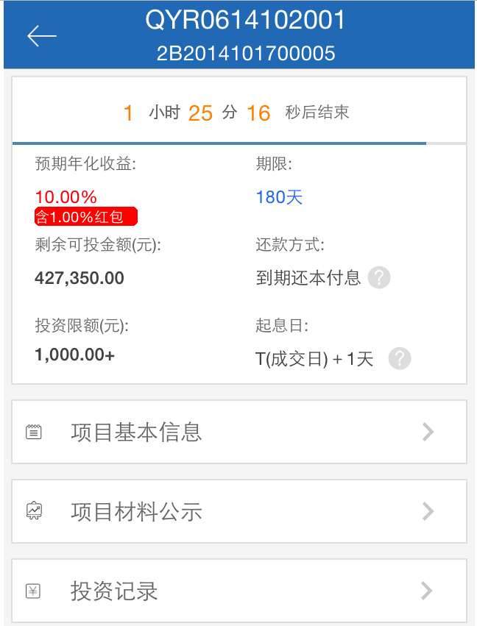

1. 获取单个项目所有信息
2. 接口名称：

/rest/borrow/{id}

1. 输入

|  |  |  |  |  |  |  |  |  |
| --- | --- | --- | --- | --- | --- | --- | --- | --- |
| **名称** | **类型** | **必须** | **长度** | **默认值** | **最小值** | **最大值** | **示例值** | **描述** |
|  |  |  |  |  |  |  |  | 项目id |

1. 返回

|  |  |  |  |  |  |  |  |  |
| --- | --- | --- | --- | --- | --- | --- | --- | --- |
| **名称** | **类型** | **必须** | **长度** | **默认值** | **最小值** | **最大值** | **示例值** | **描述** |
| **id** |  |  |  |  |  |  |  | 项目id |
| **name** |  |  |  |  |  |  |  | 项目名称 |
|  |  |  |  |  |  |  |  | 项目类型图片 |
|  |  |  |  |  |  |  |  | 项目编号 |
| **timeLimit** |  |  |  |  |  |  |  | 项目期限 |
| **account** |  |  |  |  |  |  |  | 项目金额 |
| **apr** |  |  |  |  |  |  |  | 项目年化收益 |
| funds |  |  |  |  |  |  |  | 项目奖励 |
| style |  |  |  |  |  |  |  | 还款方式 |
| lowestAccount |  |  |  |  |  |  |  | 最小投资额 |
| mostAccount |  |  |  |  |  |  |  | 最大投资额 |
| pwd |  |  |  |  |  |  |  | 定向密码 |
|  |  |  |  |  |  |  |  | 续投奖励 |
| verifyTime |  |  |  |  |  |  |  | 发布时间（初审通过时间） |
| status |  |  |  |  |  |  |  | 项目状态 |
| showBorrowStatus |  |  |  |  |  |  |  | 项目状态名称 |
| showSchedule |  |  |  |  |  |  |  | 项目进度 |
| content |  |  |  |  |  |  |  | 项目基本信息 |
|  |  |  |  |  |  |  |  | 项目资料公示（图片）-循环 |
|  |  |  |  |  |  |  |  | 会员登录状态 |
|  |  |  |  |  |  |  |  | 会员可用余额 |

1. 错误码

|  |  |  |
| --- | --- | --- |
| **错误码** | **错误描述** | **解决方案** |
|  |  |  |
|  |  |  |

## 3、获取单个项目投资记录

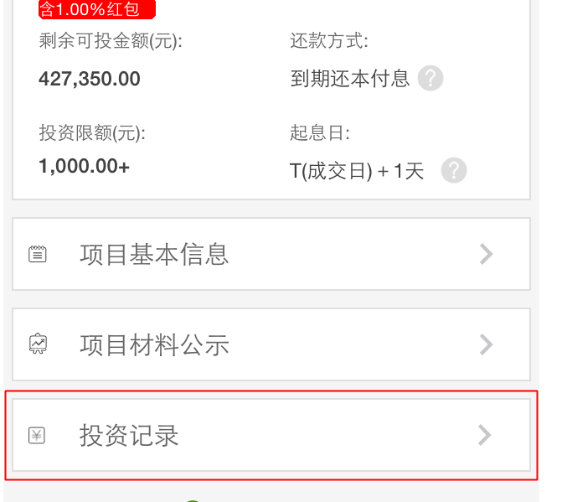

1. 接口名称：
2. 输入

|  |  |  |  |  |  |  |  |  |
| --- | --- | --- | --- | --- | --- | --- | --- | --- |
| **名称** | **类型** | **必须** | **长度** | **默认值** | **最小值** | **最大值** | **示例值** | **描述** |
|  |  |  |  |  |  |  |  | 项目id |
|  |  |  |  |  |  |  |  | 页数 |

1. 返回

|  |  |  |  |  |  |  |  |  |
| --- | --- | --- | --- | --- | --- | --- | --- | --- |
| **名称** | **类型** | **必须** | **长度** | **默认值** | **最小值** | **最大值** | **示例值** | **描述** |
|  |  |  |  |  |  |  |  | 项目id |
|  |  |  |  |  |  |  |  | 投资记录id |
|  |  |  |  |  |  |  |  | 投资会员会员名 |
|  |  |  |  |  |  |  |  | 投资时间 |
|  |  |  |  |  |  |  |  | 投资金额 |
|  |  |  |  |  |  |  |  | 投资成功金额 |
|  |  |  |  |  |  |  |  | 投资类型（手动、自动） |
|  |  |  |  |  |  |  |  | 投资完成度（全部、部分） |
|  |  |  |  |  |  |  |  | 会员登录状态 |
|  |  |  |  |  |  |  |  | 会员可用余额 |

1. 错误码

|  |  |  |
| --- | --- | --- |
| **错误码** | **错误描述** | **解决方案** |
|  |  |  |
|  |  |  |

## 4、投资项目

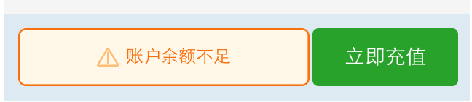

1. 接口名称：
2. 输入

|  |  |  |  |  |  |  |  |  |
| --- | --- | --- | --- | --- | --- | --- | --- | --- |
| **名称** | **类型** | **必须** | **长度** | **默认值** | **最小值** | **最大值** | **示例值** | **描述** |
|  |  |  |  |  |  |  |  | 会员id |
|  |  |  |  |  |  |  |  | 投资金额 |
|  |  |  |  |  |  |  |  | 项目id |
|  |  |  |  |  |  |  |  |  |

1. 返回

|  |  |  |  |  |  |  |  |  |
| --- | --- | --- | --- | --- | --- | --- | --- | --- |
| **名称** | **类型** | **必须** | **长度** | **默认值** | **最小值** | **最大值** | **示例值** | **描述** |
|  |  |  |  |  |  |  |  | 投资状态（成功、失败） |
|  |  |  |  |  |  |  |  | 失败原因 |
|  |  |  |  |  |  |  |  |  |

1. 错误码

|  |  |  |
| --- | --- | --- |
| **错误码** | **错误描述** | **解决方案** |
|  |  |  |

# 三、登录注册

## 登录

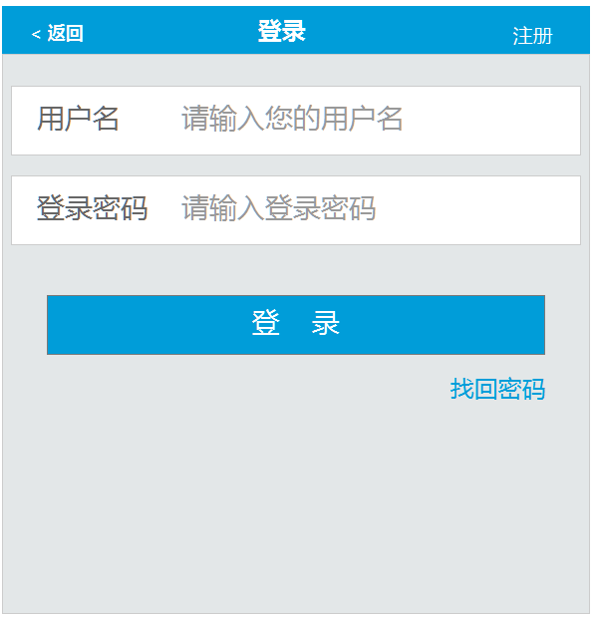

1. 接口名称：
2. 输入

|  |  |  |  |  |  |  |  |  |
| --- | --- | --- | --- | --- | --- | --- | --- | --- |
| **名称** | **类型** | **必须** | **长度** | **默认值** | **最小值** | **最大值** | **示例值** | **描述** |
|  |  |  |  |  |  |  |  | 会员名 |
|  |  |  |  |  |  |  |  | 密码 |

1. 返回

|  |  |  |  |  |  |  |  |  |
| --- | --- | --- | --- | --- | --- | --- | --- | --- |
| **名称** | **类型** | **必须** | **长度** | **默认值** | **最小值** | **最大值** | **示例值** | **描述** |
|  |  |  |  |  |  |  |  | 登录是否成功 |
|  |  |  |  |  |  |  |  | 失败原因 |
|  |  |  |  |  |  |  |  | 成功是否返回sessionid？ |

1. 错误码

|  |  |  |
| --- | --- | --- |
| **错误码** | **错误描述** | **解决方案** |
|  |  |  |

## 找回登录密码验证

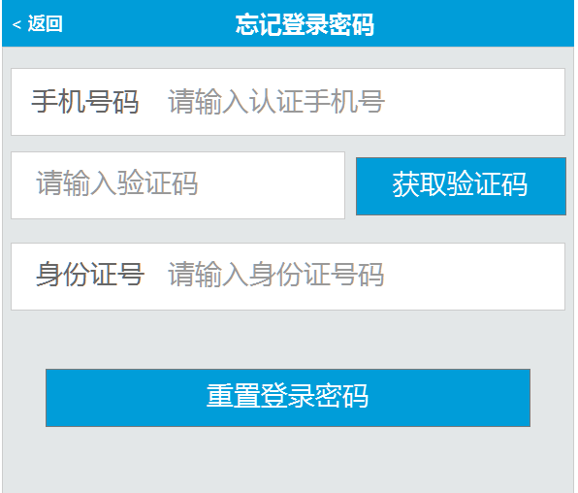

1. 接口名称：

/rest/checklogp/

1. 输入

|  |  |  |  |  |  |  |  |  |
| --- | --- | --- | --- | --- | --- | --- | --- | --- |
| **名称** | **类型** | **必须** | **长度** | **默认值** | **最小值** | **最大值** | **示例值** | **描述** |
| **username** |  |  |  |  |  |  |  | 会员名 |
| **phone** |  |  |  |  |  |  |  | 手机号码 |
| **codeReg** |  |  |  |  |  |  |  | 手机验证码 |
| **cardId** |  |  |  |  |  |  |  | 身份证号码 |

1. 返回

|  |  |  |  |  |  |  |  |  |
| --- | --- | --- | --- | --- | --- | --- | --- | --- |
| **名称** | **类型** | **必须** | **长度** | **默认值** | **最小值** | **最大值** | **示例值** | **描述** |
| **phoneState** |  |  |  |  |  |  | 0正确，1不正确 | 手机号码是否正确 |
| **codeState** |  |  |  |  |  |  | 0正确，1不正确 | 验证码是否正确 |
| **CardStates** |  |  |  |  |  |  | 0正确，1不正确 | 身份证号码是否正确 |

1. 错误码

|  |  |  |
| --- | --- | --- |
| **错误码** | **错误描述** | **解决方案** |
| *M0008_0* | 短信验证码不能为空 |  |

## 重置登录密码

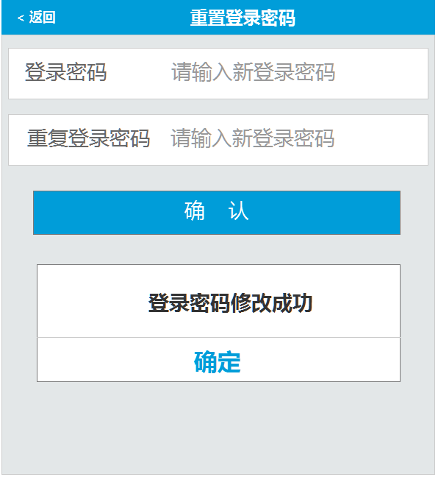

1. 接口名称：

/rest/updatePwd

1. 输入

|  |  |  |  |  |  |  |  |  |
| --- | --- | --- | --- | --- | --- | --- | --- | --- |
| **名称** | **类型** | **必须** | **长度** | **默认值** | **最小值** | **最大值** | **示例值** | **描述** |
| **Id** |  |  |  |  |  |  |  | 会员id |
| **password** |  |  |  |  |  |  |  | 登录密码 |

1. 返回

|  |  |  |  |  |  |  |  |  |
| --- | --- | --- | --- | --- | --- | --- | --- | --- |
| **名称** | **类型** | **必须** | **长度** | **默认值** | **最小值** | **最大值** | **示例值** | **描述** |
| **rcd** |  |  |  |  |  |  | R0001 成功 | 登录密码修改是否正确 |

1. 错误码

|  |  |  |
| --- | --- | --- |
| **错误码** | **错误描述** | **解决方案** |
| **S0003** | 登录密码输入错误 |  |

## 注册

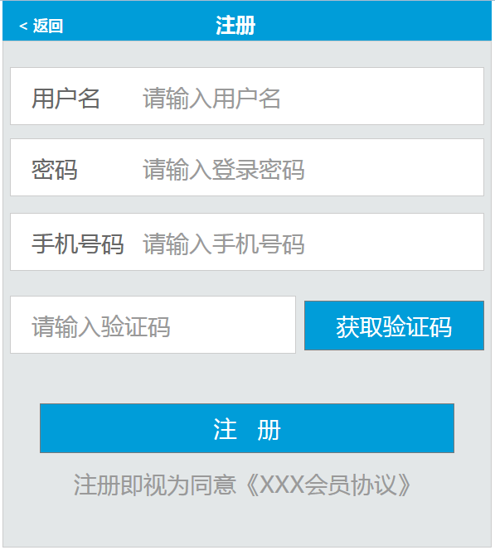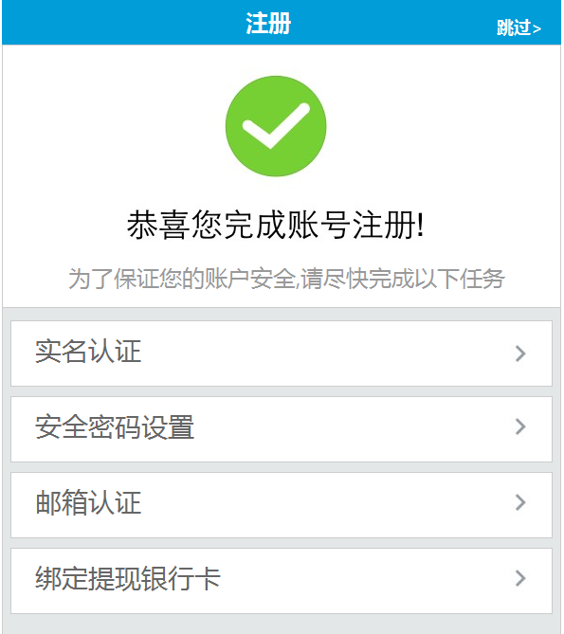

1. 接口名称：

/rest/reg/

1. 输入

|  |  |  |  |  |  |  |  |  |
| --- | --- | --- | --- | --- | --- | --- | --- | --- |
| **名称** | **类型** | **必须** | **长度** | **默认值** | **最小值** | **最大值** | **示例值** | **描述** |
| **username** |  |  |  |  |  |  |  | 会员名 |
| password |  |  |  |  |  |  |  | 密码 |
| phone |  |  |  |  |  |  |  | 手机号 |
| codeReg |  |  |  |  |  |  |  | 手机验证码 |

1. 返回

|  |  |  |  |  |  |  |  |  |
| --- | --- | --- | --- | --- | --- | --- | --- | --- |
| **名称** | **类型** | **必须** | **长度** | **默认值** | **最小值** | **最大值** | **示例值** | **描述** |
| **rcd** |  |  |  |  |  |  | R0001 成功 | 注册是否成功 |
|  |  |  |  |  |  |  |  | 失败原因 |
| **id** |  |  |  |  |  |  |  | 会员id |

1. 错误码

|  |  |  |
| --- | --- | --- |
| **错误码** | **错误描述** | **解决方案** |
| *M0008_0* | 短信验证码不能为空 |  |
| *M0008_1* | 短信验证码不正确 |  |
| *M0008_2* | 用户已存在 |  |
| *M0008_3* | 密码必须包含字母！ |  |
| *M0008_4* | 密码长度必须在8-16个字符之间 |  |

## 短信验证码

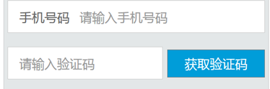

1. 接口名称：

/rest/sendPCode/

1. 输入

|  |  |  |  |  |  |  |  |  |
| --- | --- | --- | --- | --- | --- | --- | --- | --- |
| **名称** | **类型** | **必须** | **长度** | **默认值** | **最小值** | **最大值** | **示例值** | **描述** |
| phone |  |  |  |  |  |  |  | 手机号 |
| Ptype |  |  |  |  |  |  | 0-表示注册，1-其它情况下使用 | 使用手机短信码类型 |

1. 返回

|  |  |  |  |  |  |  |  |  |
| --- | --- | --- | --- | --- | --- | --- | --- | --- |
| **名称** | **类型** | **必须** | **长度** | **默认值** | **最小值** | **最大值** | **示例值** | **描述** |
| **rcd** |  |  |  |  |  |  | R0001 成功 | 注册是否成功 |

1. 错误码

|  |  |  |
| --- | --- | --- |
| **错误码** | **错误描述** | **解决方案** |
| *M0008_5* | 系统无法获取手机号 |  |
| *M0008_6* | 该手机号获取验证码太频繁，请5分钟后再尝试 |  |
| *M0008_7* | 手机号已经注册过帐号 |  |
| *M0008_8* | 此返回值是短信方接口返回信息具体详情取值 |  |
|  |  |  |

# 四、会员中心首页

## 会员中心首页

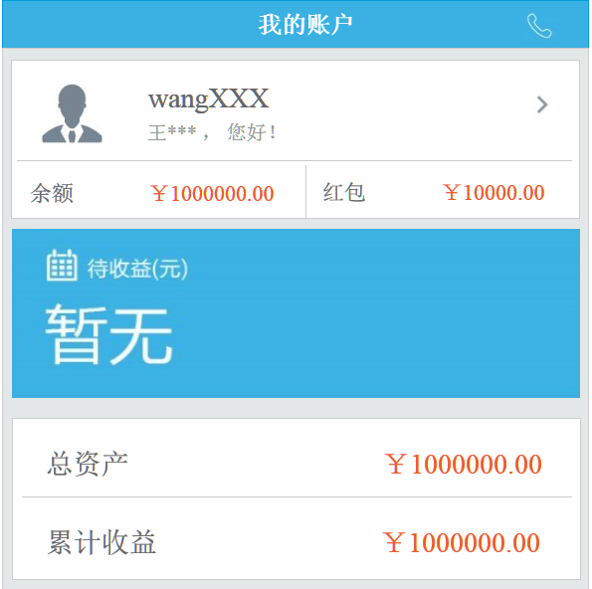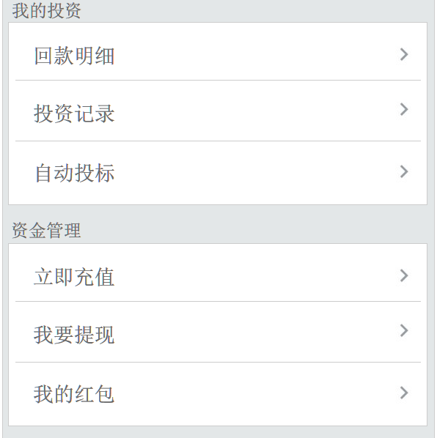

1. 接口名称：
2. 输入

|  |  |  |  |  |  |  |  |  |
| --- | --- | --- | --- | --- | --- | --- | --- | --- |
| **名称** | **类型** | **必须** | **长度** | **默认值** | **最小值** | **最大值** | **示例值** | **描述** |
|  |  |  |  |  |  |  |  | 用户id |

1. 返回

|  |  |  |  |  |  |  |  |  |
| --- | --- | --- | --- | --- | --- | --- | --- | --- |
| **名称** | **类型** | **必须** | **长度** | **默认值** | **最小值** | **最大值** | **示例值** | **描述** |
|  |  |  |  |  |  |  |  | 用户名 |
|  |  |  |  |  |  |  |  | 用户姓名 |
|  |  |  |  |  |  |  |  | 可用余额 |
|  |  |  |  |  |  |  |  | 红包余额 |
|  |  |  |  |  |  |  |  | 待收本金 |
|  |  |  |  |  |  |  |  | 待收利息 |
|  |  |  |  |  |  |  |  | 资金总额 |
|  |  |  |  |  |  |  |  | 累计收益 |

1. 错误码

|  |  |  |
| --- | --- | --- |
| **错误码** | **错误描述** | **解决方案** |
|  |  |  |
|  |  |  |

# 五、会员账户管理

## 账户管理

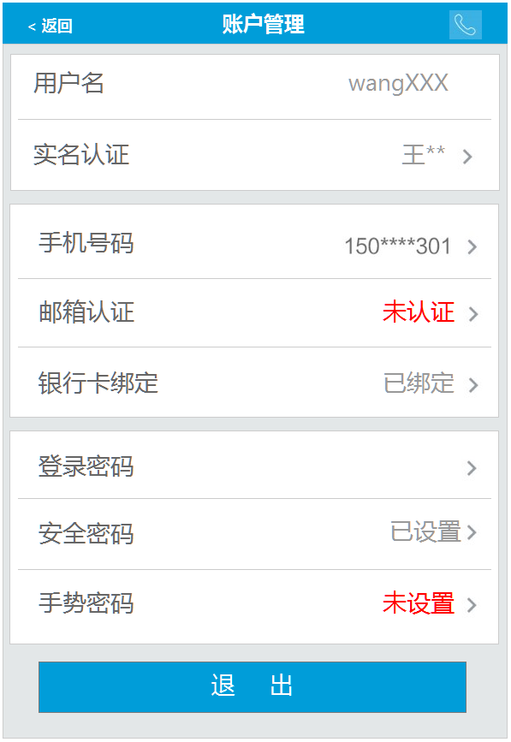

1. 接口名称：
2. 输入

|  |  |  |  |  |  |  |  |  |
| --- | --- | --- | --- | --- | --- | --- | --- | --- |
| **名称** | **类型** | **必须** | **长度** | **默认值** | **最小值** | **最大值** | **示例值** | **描述** |
|  |  |  |  |  |  |  |  | 会员id |

1. 返回

|  |  |  |  |  |  |  |  |  |
| --- | --- | --- | --- | --- | --- | --- | --- | --- |
| **名称** | **类型** | **必须** | **长度** | **默认值** | **最小值** | **最大值** | **示例值** | **描述** |
|  |  |  |  |  |  |  |  | 会员用户名 |
|  |  |  |  |  |  |  |  | 实名认证是否通过 |
|  |  |  |  |  |  |  |  | 会员真实姓名 |
|  |  |  |  |  |  |  |  | 手机认证是否通过 |
|  |  |  |  |  |  |  |  | 手机号码 |
|  |  |  |  |  |  |  |  | 邮箱认证是否通过 |
|  |  |  |  |  |  |  |  | 邮箱 |
|  |  |  |  |  |  |  |  | 银行卡是否设置 |
|  |  |  |  |  |  |  |  | 安全密码是否设置 |
|  |  |  |  |  |  |  |  | 手势密码是否设置 |

1. 错误码

|  |  |  |
| --- | --- | --- |
| **错误码** | **错误描述** | **解决方案** |
|  |  |  |
|  |  |  |

## 实名认证为“未申请”或“未通过”时

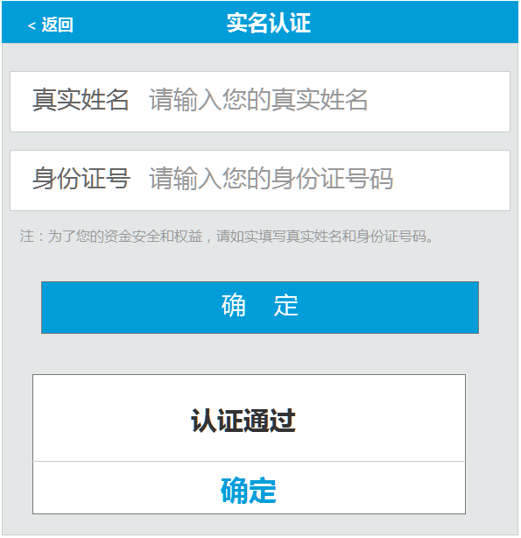

1. 接口名称：
2. 输入信息

|  |  |  |  |  |  |  |  |  |
| --- | --- | --- | --- | --- | --- | --- | --- | --- |
| **名称** | **类型** | **必须** | **长度** | **默认值** | **最小值** | **最大值** | **示例值** | **描述** |
|  |  |  |  |  |  |  |  | 会员id |
|  |  |  |  |  |  |  |  | 会员真实姓名 |
|  |  |  |  |  |  |  |  | 会员身份证号码 |

1. 返回信息

|  |  |  |  |  |  |  |  |  |
| --- | --- | --- | --- | --- | --- | --- | --- | --- |
| **名称** | **类型** | **必须** | **长度** | **默认值** | **最小值** | **最大值** | **示例值** | **描述** |
|  |  |  |  |  |  |  |  | 实名认证状态（成功、审核中、失败） |

## 实名认证为“审核中”时

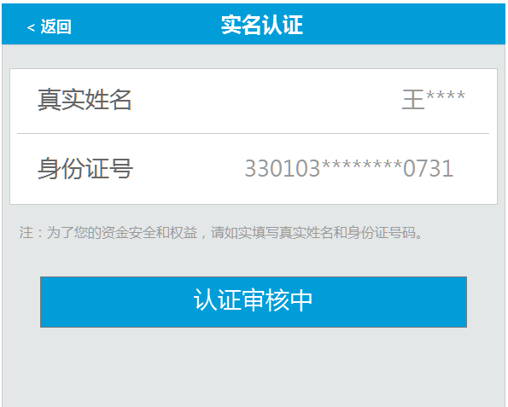

1. 接口名称：
2. 实名认证状态为“审核中”时输入信息

|  |  |  |  |  |  |  |  |  |
| --- | --- | --- | --- | --- | --- | --- | --- | --- |
| **名称** | **类型** | **必须** | **长度** | **默认值** | **最小值** | **最大值** | **示例值** | **描述** |
|  |  |  |  |  |  |  |  | 会员id |

1. 返回信息

|  |  |  |  |  |  |  |  |  |
| --- | --- | --- | --- | --- | --- | --- | --- | --- |
| **名称** | **类型** | **必须** | **长度** | **默认值** | **最小值** | **最大值** | **示例值** | **描述** |
|  |  |  |  |  |  |  |  | 实名认证状态（审核中） |
|  |  |  |  |  |  |  |  | 会员真实姓名 |
|  |  |  |  |  |  |  |  | 会员身份证号码 |

## 更改手机认证验证

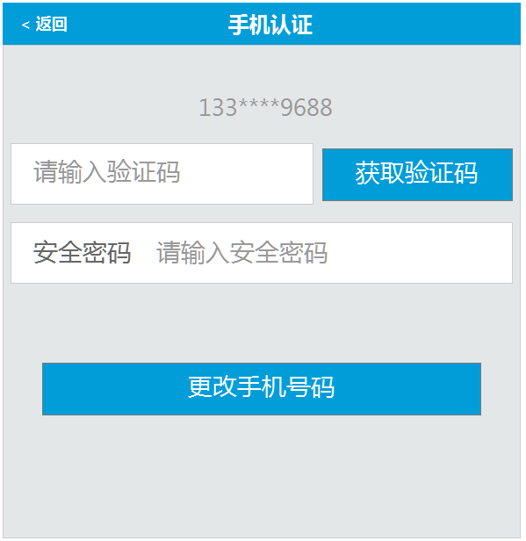

* **载入页面**

1. 接口名称：

/rest/getUserMess

1. 输入信息

|  |  |  |  |  |  |  |  |  |
| --- | --- | --- | --- | --- | --- | --- | --- | --- |
| **名称** | **类型** | **必须** | **长度** | **默认值** | **最小值** | **最大值** | **示例值** | **描述** |
| **id** | String |  |  |  |  |  |  | 会员id |

1. 返回信息

|  |  |  |  |  |  |  |  |  |
| --- | --- | --- | --- | --- | --- | --- | --- | --- |
| **名称** | **类型** | **必须** | **长度** | **默认值** | **最小值** | **最大值** | **示例值** | **描述** |
| **id** |  |  |  |  |  |  |  | 会员id |
| username |  |  |  |  |  |  |  | 用户名 |

1. 错误码

|  |  |  |
| --- | --- | --- |
| **错误码** | **错误描述** | **解决方案** |
|  |  |  |

* **提交接口**

接口名称：

/rest/inspPhone/

1. 输入信息

|  |  |  |  |  |  |  |  |  |
| --- | --- | --- | --- | --- | --- | --- | --- | --- |
| **名称** | **类型** | **必须** | **长度** | **默认值** | **最小值** | **最大值** | **示例值** | **描述** |
| **id** | String |  |  |  |  |  |  | 会员id |
| codeReg | String |  |  |  |  |  |  | 手机验证码 |
| payPassword | user |  |  |  |  |  |  | 安全密码 |

1. 返回信息

|  |  |  |  |  |  |  |  |  |
| --- | --- | --- | --- | --- | --- | --- | --- | --- |
| **名称** | **类型** | **必须** | **长度** | **默认值** | **最小值** | **最大值** | **示例值** | **描述** |
| **id** |  |  |  |  |  |  |  | 会员id |
| codeState |  |  |  |  |  |  | 0-正确，1错误 | 手机验证码是否正确 |
| pwdState |  |  |  |  |  |  | 0-正确，1错误 | 安全密码是否正确 |

1. 错误码

|  |  |  |
| --- | --- | --- |
| **错误码** | **错误描述** | **解决方案** |
|  |  |  |

## 手机认证

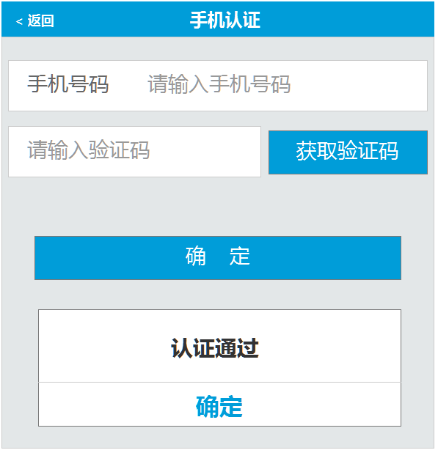

1. 接口名称：

/rest/updatePhone/

1. 输入

|  |  |  |  |  |  |  |  |  |
| --- | --- | --- | --- | --- | --- | --- | --- | --- |
| **名称** | **类型** | **必须** | **长度** | **默认值** | **最小值** | **最大值** | **示例值** | **描述** |
| **id** | String |  |  |  |  |  |  | 会员id |
| **phone** | user |  |  |  |  |  |  | 手机号码 |
| codeReg | String |  |  |  |  |  |  | 手机验证码 |

1. 返回

|  |  |  |  |  |  |  |  |  |
| --- | --- | --- | --- | --- | --- | --- | --- | --- |
| **名称** | **类型** | **必须** | **长度** | **默认值** | **最小值** | **最大值** | **示例值** | **描述** |
| **id** |  |  |  |  |  |  |  | 会员id |
| **rcd** |  |  |  |  |  |  | R0001表示成功 | 手机认证状态（成功、失败） |
| **phone** |  |  |  |  |  |  |  | 手机号码 |

1. 错误码

|  |  |  |
| --- | --- | --- |
| **错误码** | **错误描述** | **解决方案** |
| M0008_1 | 短信验证码不正确 |  |

## 邮箱地址为空时

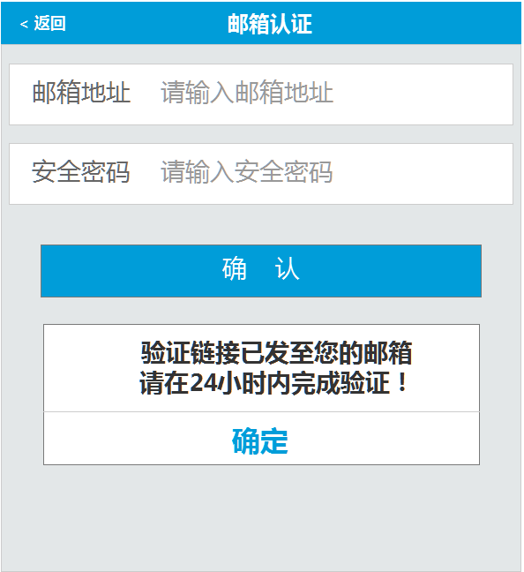

1. 接口名称：

/rest/emailSet/

1. 输入

|  |  |  |  |  |  |  |  |  |
| --- | --- | --- | --- | --- | --- | --- | --- | --- |
| **名称** | **类型** | **必须** | **长度** | **默认值** | **最小值** | **最大值** | **示例值** | **描述** |
| **id** | String |  |  |  |  |  |  | 会员id |
| **email** | user |  |  |  |  |  |  | 认证邮箱 |
| **payPassword** | user |  |  |  |  |  |  | 安全密码 |

1. 返回

|  |  |  |  |  |  |  |  |  |
| --- | --- | --- | --- | --- | --- | --- | --- | --- |
| **名称** | **类型** | **必须** | **长度** | **默认值** | **最小值** | **最大值** | **示例值** | **描述** |
| **id** |  |  |  |  |  |  |  | 会员id |
| **emailStatus** |  |  |  |  |  |  | 0-未认证，2-认证中，1-认证成功 | 邮箱认证状态 |

1. 错误码

|  |  |  |
| --- | --- | --- |
| **错误码** | **错误描述** | **解决方案** |
| *S0002* | 安全密码输入错误 |  |

## 邮箱地址不为空时

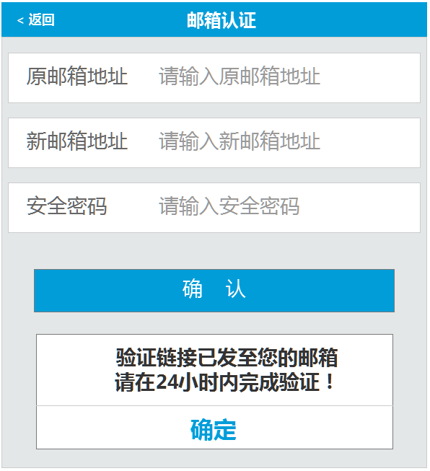

1. 接口名称：

/rest/updateEmail/

1. 输入

|  |  |  |  |  |  |  |  |  |
| --- | --- | --- | --- | --- | --- | --- | --- | --- |
| **名称** | **类型** | **必须** | **长度** | **默认值** | **最小值** | **最大值** | **示例值** | **描述** |
| **id** | string |  |  |  |  |  |  | 会员id |
| **email** | user |  |  |  |  |  |  | 原始认证邮箱 |
| **newEmail** | string |  |  |  |  |  |  | 新认证邮箱 |
| **payPassword** | user |  |  |  |  |  |  | 安全密码 |

1. 返回

|  |  |  |  |  |  |  |  |  |
| --- | --- | --- | --- | --- | --- | --- | --- | --- |
| **名称** | **类型** | **必须** | **长度** | **默认值** | **最小值** | **最大值** | **示例值** | **描述** |
| **id** |  |  |  |  |  |  |  | **会员id** |
| **emailStatus** |  |  |  |  |  |  | **0-未认证，2-认证中，1-认证成功** | **邮箱认证状态** |

1. 错误码

|  |  |  |
| --- | --- | --- |
| **错误码** | **错误描述** | **解决方案** |
| *S0002* | 安全密码输入错误 |  |
| *M0008_9* | 原邮箱输入有误 |  |

## 银行卡未绑定

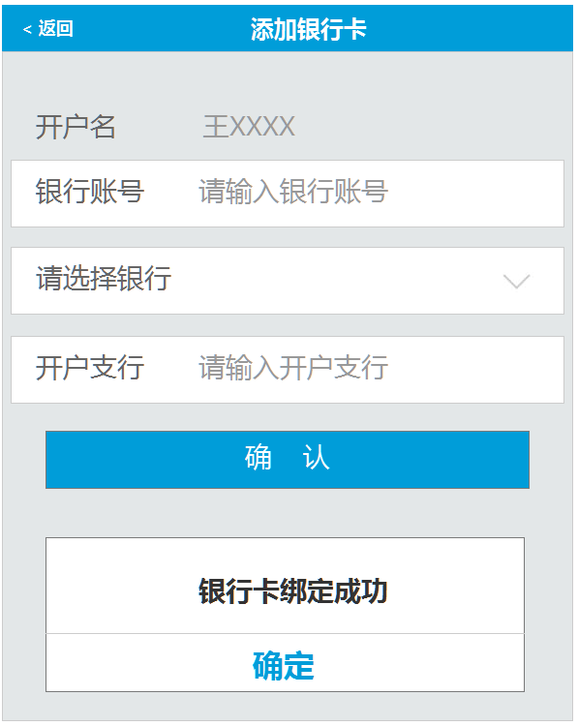

* **载入页面**

1. 接口名称：

/rest/bankTo/

1. 输入

|  |  |  |  |  |  |  |  |  |
| --- | --- | --- | --- | --- | --- | --- | --- | --- |
| **名称** | **类型** | **必须** | **长度** | **默认值** | **最小值** | **最大值** | **示例值** | **描述** |
|  |  |  |  |  |  |  |  | 会员id |

1. 返回

|  |  |  |  |  |  |  |  |  |
| --- | --- | --- | --- | --- | --- | --- | --- | --- |
| **名称** | **类型** | **必须** | **长度** | **默认值** | **最小值** | **最大值** | **示例值** | **描述** |
| **id** |  |  |  |  |  |  |  | 会员id |
| cardNo |  |  |  |  |  |  |  | 银行账号 |
| bankName |  |  |  |  |  |  |  | 所属银行名称 |
| **username** |  |  |  |  |  |  |  | 用户名s |

* **提交接口**

1. 接口名称：

/rest/bankSave/

1. 输入

|  |  |  |  |  |  |  |  |  |
| --- | --- | --- | --- | --- | --- | --- | --- | --- |
| **名称** | **类型** | **必须** | **长度** | **默认值** | **最小值** | **最大值** | **示例值** | **描述** |
| **id** | String |  |  |  |  |  |  | 会员id |
| cardNo | cashBank |  |  |  |  |  |  | 银行账号 |
| bankName | cashBank |  |  |  |  |  |  | 所属银行名称 |
| **bankId** | cashBank |  |  |  |  |  |  | 所属银行id |
| **branch** | cashBank |  |  |  |  |  |  | 开户支行 |

1. 返回

|  |  |  |  |  |  |  |  |  |
| --- | --- | --- | --- | --- | --- | --- | --- | --- |
| **名称** | **类型** | **必须** | **长度** | **默认值** | **最小值** | **最大值** | **示例值** | **描述** |
| **rcd** |  |  |  |  |  |  | R0001表示成功 | 银行卡绑定状态（成功、失败） |

1. 错误码

|  |  |  |
| --- | --- | --- |
| **错误码** | **错误描述** | **解决方案** |
| *M0008_10* | 同一账户只能添加一张提现银行卡 |  |

## 银行卡已绑定

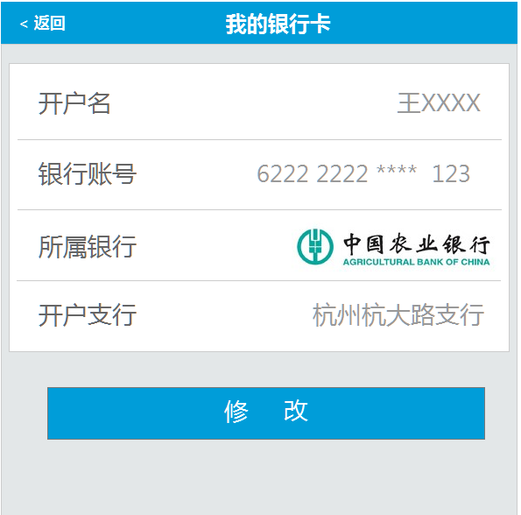

* **载入页面**

1. 接口名称：

/rest/bankTo/

1. 输入

|  |  |  |  |  |  |  |  |  |
| --- | --- | --- | --- | --- | --- | --- | --- | --- |
| **名称** | **类型** | **必须** | **长度** | **默认值** | **最小值** | **最大值** | **示例值** | **描述** |
|  |  |  |  |  |  |  |  | 会员id |

1. 返回

|  |  |  |  |  |  |  |  |  |
| --- | --- | --- | --- | --- | --- | --- | --- | --- |
| **名称** | **类型** | **必须** | **长度** | **默认值** | **最小值** | **最大值** | **示例值** | **描述** |
| **id** |  |  |  |  |  |  |  | 会员id |
| cardNo |  |  |  |  |  |  |  | 银行账号 |
| banId |  |  |  |  |  |  |  | 银行帐号Id |
| bankName |  |  |  |  |  |  |  | 所属银行名称 |
| **username** |  |  |  |  |  |  |  | 用户名s |

* **提交接口**

1. 接口名称：

/rest/bankSave/

1. 输入

|  |  |  |  |  |  |  |  |  |
| --- | --- | --- | --- | --- | --- | --- | --- | --- |
| **名称** | **类型** | **必须** | **长度** | **默认值** | **最小值** | **最大值** | **示例值** | **描述** |
| **id** | String |  |  |  |  |  |  | 会员id |
| **id** | cashBank |  |  |  |  |  |  | 银行账户ID |
| cardNo | cashBank |  |  |  |  |  |  | 银行账号 |
| bankName | cashBank |  |  |  |  |  |  | 所属银行名称 |
| **bankId** | cashBank |  |  |  |  |  |  | 所属银行id |
| **branch** | cashBank |  |  |  |  |  |  | 开户支行 |

1. 返回

|  |  |  |  |  |  |  |  |  |
| --- | --- | --- | --- | --- | --- | --- | --- | --- |
| **名称** | **类型** | **必须** | **长度** | **默认值** | **最小值** | **最大值** | **示例值** | **描述** |
| **rcd** |  |  |  |  |  |  | R0001表示成功 | 银行卡绑定状态（成功、失败） |

## 登录密码设置

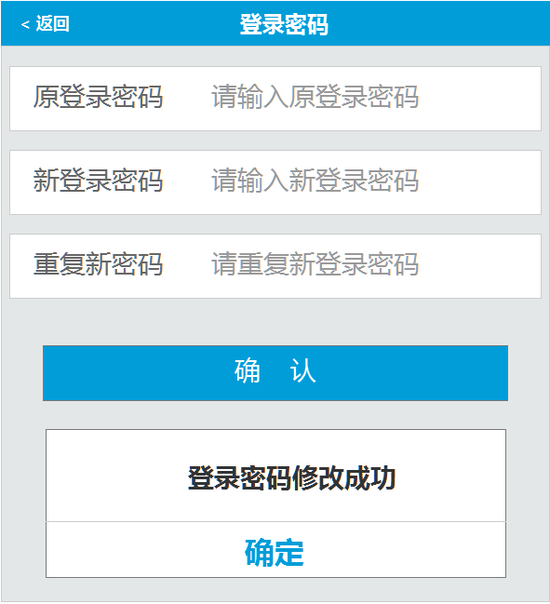

1. 接口名称：
2. 输入

|  |  |  |  |  |  |  |  |  |
| --- | --- | --- | --- | --- | --- | --- | --- | --- |
| **名称** | **类型** | **必须** | **长度** | **默认值** | **最小值** | **最大值** | **示例值** | **描述** |
|  |  |  |  |  |  |  |  | 会员id |
|  |  |  |  |  |  |  |  | 原登录密码 |
|  |  |  |  |  |  |  |  | 新登录密码 |

1. 返回

|  |  |  |  |  |  |  |  |  |
| --- | --- | --- | --- | --- | --- | --- | --- | --- |
| **名称** | **类型** | **必须** | **长度** | **默认值** | **最小值** | **最大值** | **示例值** | **描述** |
|  |  |  |  |  |  |  |  | 原登录密码是否正确 |
|  |  |  |  |  |  |  |  | 修改密码是否成功 |

1. 错误码

|  |  |  |
| --- | --- | --- |
| **错误码** | **错误描述** | **解决方案** |
|  |  |  |

## 添加安全密码

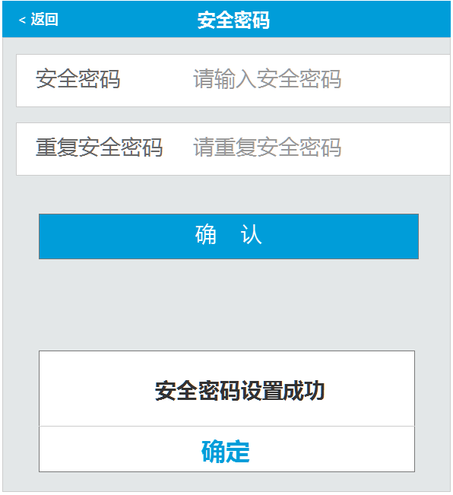

1. 接口名称：
2. 输入

|  |  |  |  |  |  |  |  |  |
| --- | --- | --- | --- | --- | --- | --- | --- | --- |
| **名称** | **类型** | **必须** | **长度** | **默认值** | **最小值** | **最大值** | **示例值** | **描述** |
|  |  |  |  |  |  |  |  | 会员id |
|  |  |  |  |  |  |  |  | 安全密码 |

1. 返回

|  |  |  |  |  |  |  |  |  |
| --- | --- | --- | --- | --- | --- | --- | --- | --- |
| **名称** | **类型** | **必须** | **长度** | **默认值** | **最小值** | **最大值** | **示例值** | **描述** |
|  |  |  |  |  |  |  |  | 安全密码是否设置成功 |

1. 错误码

|  |  |  |
| --- | --- | --- |
| **错误码** | **错误描述** | **解决方案** |
|  |  |  |

## 修改安全密码

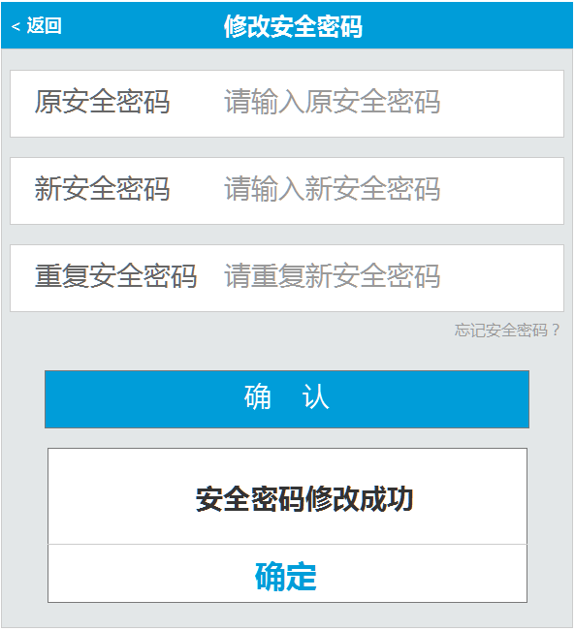

1. 接口名称：
2. 输入

|  |  |  |  |  |  |  |  |  |
| --- | --- | --- | --- | --- | --- | --- | --- | --- |
| **名称** | **类型** | **必须** | **长度** | **默认值** | **最小值** | **最大值** | **示例值** | **描述** |
|  |  |  |  |  |  |  |  | 会员id |
|  |  |  |  |  |  |  |  | 原安全密码 |
|  |  |  |  |  |  |  |  | 新安全密码 |

1. 返回

|  |  |  |  |  |  |  |  |  |
| --- | --- | --- | --- | --- | --- | --- | --- | --- |
| **名称** | **类型** | **必须** | **长度** | **默认值** | **最小值** | **最大值** | **示例值** | **描述** |
|  |  |  |  |  |  |  |  | 原安全密码是否正确 |
|  |  |  |  |  |  |  |  | 安全密码是否设置成功 |

1. 错误码

|  |  |  |
| --- | --- | --- |
| **错误码** | **错误描述** | **解决方案** |
|  |  |  |

## 忘记安全密码验证

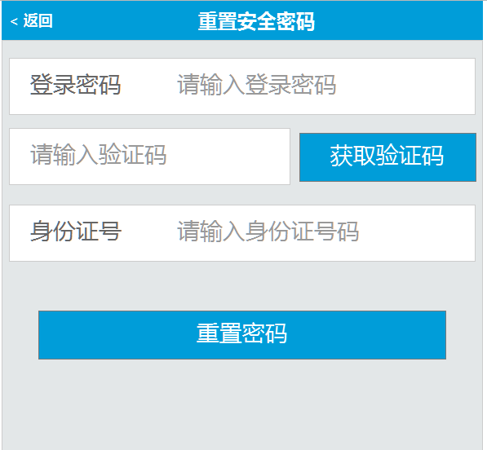

1. 接口名称：
2. 输入

|  |  |  |  |  |  |  |  |  |
| --- | --- | --- | --- | --- | --- | --- | --- | --- |
| **名称** | **类型** | **必须** | **长度** | **默认值** | **最小值** | **最大值** | **示例值** | **描述** |
|  |  |  |  |  |  |  |  | 会员id |
|  |  |  |  |  |  |  |  | 登录密码 |
|  |  |  |  |  |  |  |  | 手机验证码 |
|  |  |  |  |  |  |  |  | 身份证号码 |

1. 返回

|  |  |  |  |  |  |  |  |  |
| --- | --- | --- | --- | --- | --- | --- | --- | --- |
| **名称** | **类型** | **必须** | **长度** | **默认值** | **最小值** | **最大值** | **示例值** | **描述** |
|  |  |  |  |  |  |  |  | 登录密码是否正确 |
|  |  |  |  |  |  |  |  | 手机验证码是否正确 |
|  |  |  |  |  |  |  |  | 身份证号码是否正确 |

1. 错误码

|  |  |  |
| --- | --- | --- |
| **错误码** | **错误描述** | **解决方案** |
|  |  |  |

## 手势密码设置

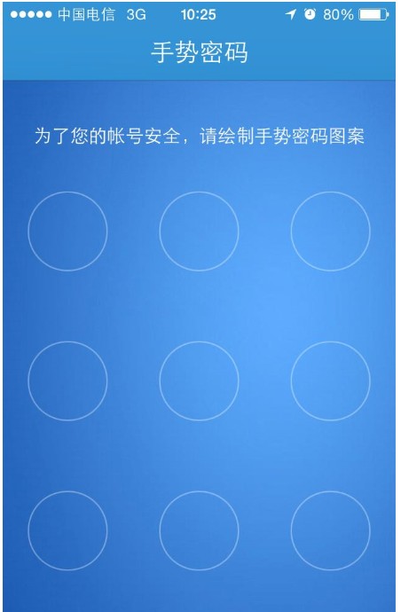

1. 接口名称：
2. 输入

|  |  |  |  |  |  |  |  |  |
| --- | --- | --- | --- | --- | --- | --- | --- | --- |
| **名称** | **类型** | **必须** | **长度** | **默认值** | **最小值** | **最大值** | **示例值** | **描述** |
|  |  |  |  |  |  |  |  | 会员id |
|  |  |  |  |  |  |  |  | 手势密码 |

1. 返回

|  |  |  |  |  |  |  |  |  |
| --- | --- | --- | --- | --- | --- | --- | --- | --- |
| **名称** | **类型** | **必须** | **长度** | **默认值** | **最小值** | **最大值** | **示例值** | **描述** |
|  |  |  |  |  |  |  |  | 手势密码设置是否成功 |

1. 错误码

|  |  |  |
| --- | --- | --- |
| **错误码** | **错误描述** | **解决方案** |
|  |  |  |

## 修改手势密码



1. 接口名称：
2. 输入

|  |  |  |  |  |  |  |  |  |
| --- | --- | --- | --- | --- | --- | --- | --- | --- |
| **名称** | **类型** | **必须** | **长度** | **默认值** | **最小值** | **最大值** | **示例值** | **描述** |
|  |  |  |  |  |  |  |  | 会员id |
|  |  |  |  |  |  |  |  | 原手势密码 |
|  |  |  |  |  |  |  |  | 新手势密码 |

1. 返回

|  |  |  |  |  |  |  |  |  |
| --- | --- | --- | --- | --- | --- | --- | --- | --- |
| **名称** | **类型** | **必须** | **长度** | **默认值** | **最小值** | **最大值** | **示例值** | **描述** |
|  |  |  |  |  |  |  |  | 原手势密码是否正确 |
|  |  |  |  |  |  |  |  | 手势密码设置是否成功 |

1. 错误码

|  |  |  |
| --- | --- | --- |
| **错误码** | **错误描述** | **解决方案** |
|  |  |  |

## 重置手势密码验证

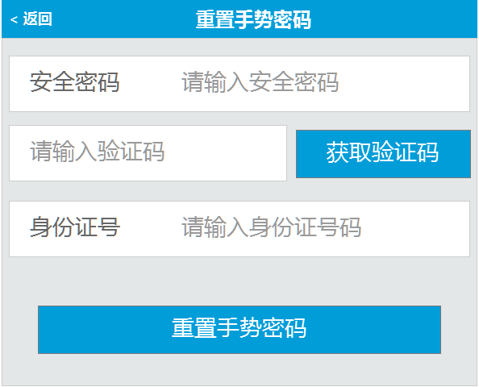

1. 接口名称：
2. 输入

|  |  |  |  |  |  |  |  |  |
| --- | --- | --- | --- | --- | --- | --- | --- | --- |
| **名称** | **类型** | **必须** | **长度** | **默认值** | **最小值** | **最大值** | **示例值** | **描述** |
|  |  |  |  |  |  |  |  | 会员id |
|  |  |  |  |  |  |  |  | 安全密码 |
|  |  |  |  |  |  |  |  | 手机验证码 |
|  |  |  |  |  |  |  |  | 身份证号码 |

1. 返回

|  |  |  |  |  |  |  |  |  |
| --- | --- | --- | --- | --- | --- | --- | --- | --- |
| **名称** | **类型** | **必须** | **长度** | **默认值** | **最小值** | **最大值** | **示例值** | **描述** |
|  |  |  |  |  |  |  |  | 安全密码是否正确 |
|  |  |  |  |  |  |  |  | 手机验证码是否正确 |
|  |  |  |  |  |  |  |  | 身份证号码是否正确 |

1. 错误码

|  |  |  |
| --- | --- | --- |
| **错误码** | **错误描述** | **解决方案** |
|  |  |  |

# 六、会员中心-我的投资

## 投资记录

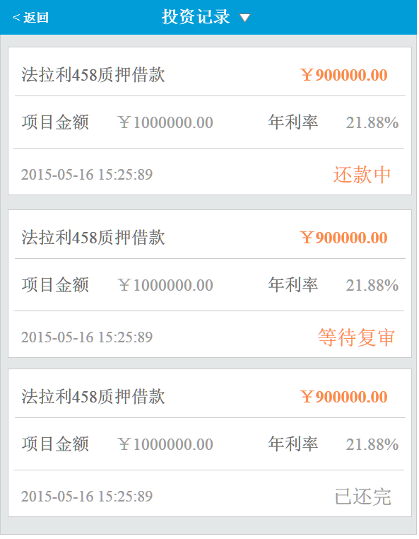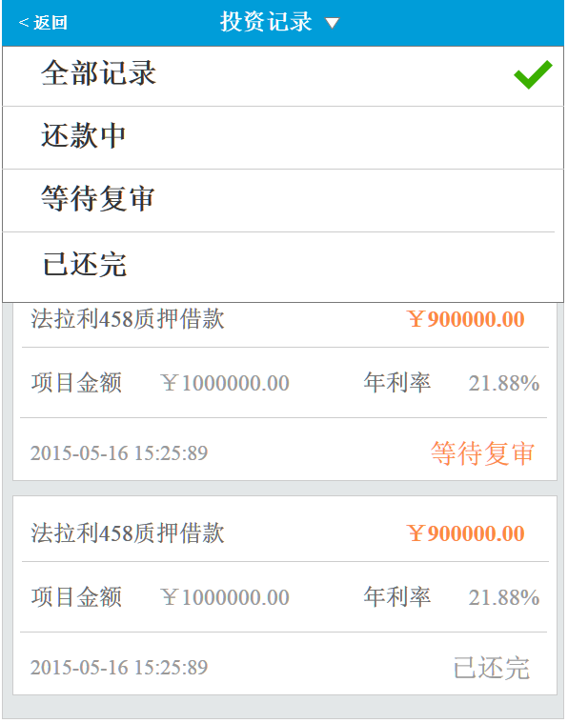

1. 接口名称：
2. 输入

|  |  |  |  |  |  |  |  |  |
| --- | --- | --- | --- | --- | --- | --- | --- | --- |
| **名称** | **类型** | **必须** | **长度** | **默认值** | **最小值** | **最大值** | **示例值** | **描述** |
|  |  |  |  |  |  |  |  | 会员id |
|  |  |  |  |  |  |  |  | 页数 |
|  |  |  |  |  |  |  |  | 项目状态 |

1. 返回

|  |  |  |  |  |  |  |  |  |
| --- | --- | --- | --- | --- | --- | --- | --- | --- |
| **名称** | **类型** | **必须** | **长度** | **默认值** | **最小值** | **最大值** | **示例值** | **描述** |
|  |  |  |  |  |  |  |  | --以下循环开始 |
|  |  |  |  |  |  |  |  | 投资项目名称 |
|  |  |  |  |  |  |  |  | 投资项目总金额 |
|  |  |  |  |  |  |  |  | 投资项目年利率 |
|  |  |  |  |  |  |  |  | 投资金额 |
|  |  |  |  |  |  |  |  | 投资时间 |
|  |  |  |  |  |  |  |  | 项目状态 |
|  |  |  |  |  |  |  |  | --以上循环结束 |

1. 错误码

|  |  |  |
| --- | --- | --- |
| **错误码** | **错误描述** | **解决方案** |
|  |  |  |

## 回款明细

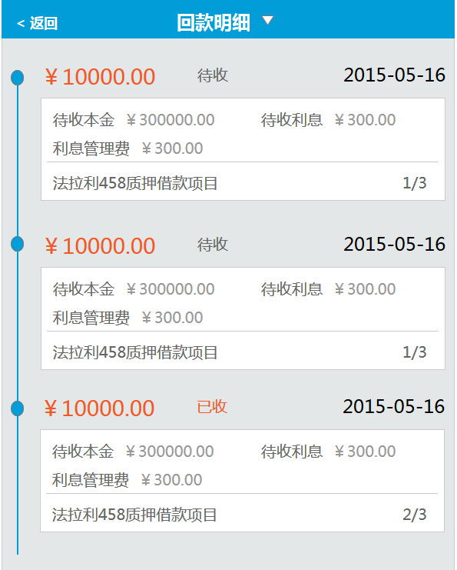

1. 接口名称：
2. 输入

|  |  |  |  |  |  |  |  |  |
| --- | --- | --- | --- | --- | --- | --- | --- | --- |
| **名称** | **类型** | **必须** | **长度** | **默认值** | **最小值** | **最大值** | **示例值** | **描述** |
|  |  |  |  |  |  |  |  | 会员id |

1. 返回

|  |  |  |  |  |  |  |  |  |
| --- | --- | --- | --- | --- | --- | --- | --- | --- |
| **名称** | **类型** | **必须** | **长度** | **默认值** | **最小值** | **最大值** | **示例值** | **描述** |
|  |  |  |  |  |  |  |  | ---以下开始循环 |
|  |  |  |  |  |  |  |  | 待收状态（已收、待收） |
|  |  |  |  |  |  |  |  | 待收时间 |
|  |  |  |  |  |  |  |  | 待收本金 |
|  |  |  |  |  |  |  |  | 待收利息 |
|  |  |  |  |  |  |  |  | 利息管理费 |
|  |  |  |  |  |  |  |  | 项目名称 |
|  |  |  |  |  |  |  |  | 期数 |
|  |  |  |  |  |  |  |  | ---以上结束循环 |

1. 错误码

|  |  |  |
| --- | --- | --- |
| **错误码** | **错误描述** | **解决方案** |
|  |  |  |

## 我的转让市场 – 二期

1. 接口名称：
2. 输入

|  |  |  |  |  |  |  |  |  |
| --- | --- | --- | --- | --- | --- | --- | --- | --- |
| **名称** | **类型** | **必须** | **长度** | **默认值** | **最小值** | **最大值** | **示例值** | **描述** |
|  |  |  |  |  |  |  |  | 会员id |

1. 返回

|  |  |  |  |  |  |  |  |  |
| --- | --- | --- | --- | --- | --- | --- | --- | --- |
| **名称** | **类型** | **必须** | **长度** | **默认值** | **最小值** | **最大值** | **示例值** | **描述** |
|  |  |  |  |  |  |  |  |  |

1. 错误码

|  |  |  |
| --- | --- | --- |
| **错误码** | **错误描述** | **解决方案** |
|  |  |  |

## 自动投资

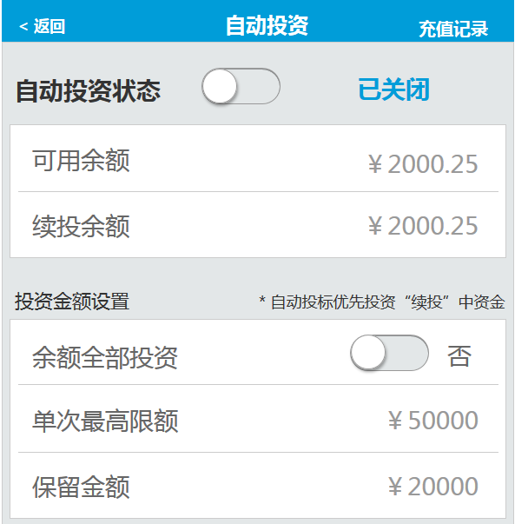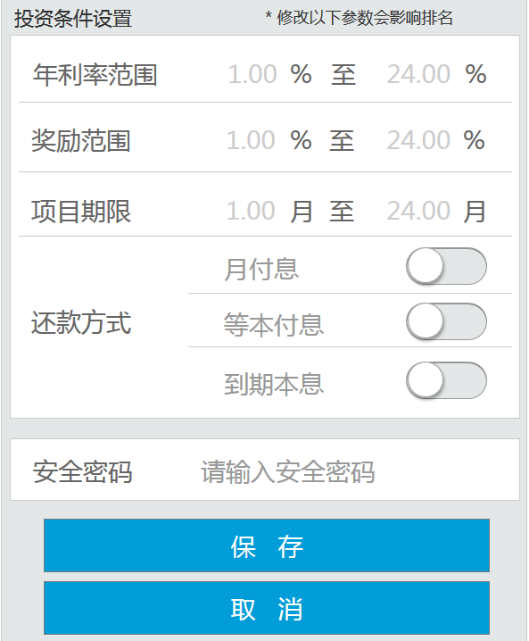

* **载入页面**

1. 接口名称：
2. 输入

|  |  |  |  |  |  |  |  |  |
| --- | --- | --- | --- | --- | --- | --- | --- | --- |
| **名称** | **类型** | **必须** | **长度** | **默认值** | **最小值** | **最大值** | **示例值** | **描述** |
|  |  |  |  |  |  |  |  | 会员id |

1. 返回

|  |  |  |  |  |  |  |  |  |
| --- | --- | --- | --- | --- | --- | --- | --- | --- |
| **名称** | **类型** | **必须** | **长度** | **默认值** | **最小值** | **最大值** | **示例值** | **描述** |
|  |  |  |  |  |  |  |  | 自动投资状态（开启、关闭） |
|  |  |  |  |  |  |  |  | 可用余额 |
|  |  |  |  |  |  |  |  | 续投余额 |
|  |  |  |  |  |  |  |  | 是否全部余额投资 |
|  |  |  |  |  |  |  |  | 单次最高限额 |
|  |  |  |  |  |  |  |  | 保留金额 |
|  |  |  |  |  |  |  |  | 年利率范围 |
|  |  |  |  |  |  |  |  | 奖励范围 |
|  |  |  |  |  |  |  |  | 项目期限 |
|  |  |  |  |  |  |  |  | 还款方式（月付息、等本、到期本息） |

1. 错误码

|  |  |  |
| --- | --- | --- |
| **错误码** | **错误描述** | **解决方案** |
|  |  |  |

* **递交**

1. 接口名称：
2. 输入

|  |  |  |  |  |  |  |  |  |
| --- | --- | --- | --- | --- | --- | --- | --- | --- |
| **名称** | **类型** | **必须** | **长度** | **默认值** | **最小值** | **最大值** | **示例值** | **描述** |
|  |  |  |  |  |  |  |  | 会员id |
|  |  |  |  |  |  |  |  | 自动投资状态（开启、关闭） |
|  |  |  |  |  |  |  |  | 可用余额 |
|  |  |  |  |  |  |  |  | 续投余额 |
|  |  |  |  |  |  |  |  | 是否全部余额投资 |
|  |  |  |  |  |  |  |  | 单次最高限额 |
|  |  |  |  |  |  |  |  | 保留金额 |
|  |  |  |  |  |  |  |  | 年利率范围 |
|  |  |  |  |  |  |  |  | 奖励范围 |
|  |  |  |  |  |  |  |  | 项目期限 |
|  |  |  |  |  |  |  |  | 还款方式（月付息、等本、到期本息） |
|  |  |  |  |  |  |  |  | 安全密码 |

1. 返回

|  |  |  |  |  |  |  |  |  |
| --- | --- | --- | --- | --- | --- | --- | --- | --- |
| **名称** | **类型** | **必须** | **长度** | **默认值** | **最小值** | **最大值** | **示例值** | **描述** |
|  |  |  |  |  |  |  |  | 安全密码是否正确 |
|  |  |  |  |  |  |  |  | 修改是否成功 |

1. 错误码

|  |  |  |
| --- | --- | --- |
| **错误码** | **错误描述** | **解决方案** |
|  |  |  |

# 七、会员中心-资金管理

## 我要充值

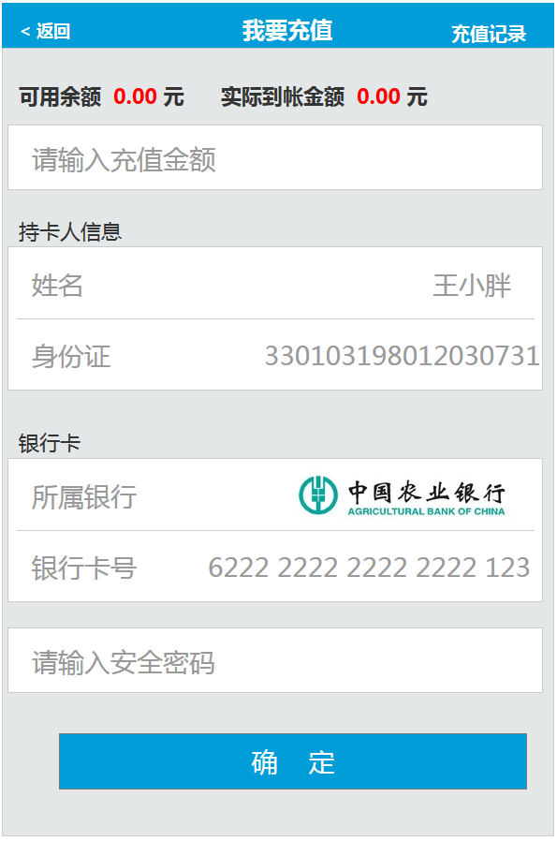

* **载入页面**

1. 接口名称：
2. 输入

|  |  |  |  |  |  |  |  |  |
| --- | --- | --- | --- | --- | --- | --- | --- | --- |
| **名称** | **类型** | **必须** | **长度** | **默认值** | **最小值** | **最大值** | **示例值** | **描述** |
|  |  |  |  |  |  |  |  | 会员id |

1. 返回

|  |  |  |  |  |  |  |  |  |
| --- | --- | --- | --- | --- | --- | --- | --- | --- |
| **名称** | **类型** | **必须** | **长度** | **默认值** | **最小值** | **最大值** | **示例值** | **描述** |
|  |  |  |  |  |  |  |  | 会员可用余额 |
|  |  |  |  |  |  |  |  | 充值奖励 |
|  |  |  |  |  |  |  |  | 充值手续费 |
|  |  |  |  |  |  |  |  | 持卡人姓名 |
|  |  |  |  |  |  |  |  | 持卡人身份证 |

1. 错误码

|  |  |  |
| --- | --- | --- |
| **错误码** | **错误描述** | **解决方案** |
|  |  |  |

* **递交申请**

1. 接口名称：
2. 输入

|  |  |  |  |  |  |  |  |  |
| --- | --- | --- | --- | --- | --- | --- | --- | --- |
| **名称** | **类型** | **必须** | **长度** | **默认值** | **最小值** | **最大值** | **示例值** | **描述** |
|  |  |  |  |  |  |  |  | 会员id |
|  |  |  |  |  |  |  |  | 充值余额 |
|  |  |  |  |  |  |  |  | 充值奖励 |
|  |  |  |  |  |  |  |  | 充值手续费 |
|  |  |  |  |  |  |  |  | 持卡人姓名 |
|  |  |  |  |  |  |  |  | 持卡人身份证 |
|  |  |  |  |  |  |  |  | 充值银行 |
|  |  |  |  |  |  |  |  | 银行卡号 |
|  |  |  |  |  |  |  |  | 安全密码 |

1. 返回

|  |  |  |  |  |  |  |  |  |
| --- | --- | --- | --- | --- | --- | --- | --- | --- |
| **名称** | **类型** | **必须** | **长度** | **默认值** | **最小值** | **最大值** | **示例值** | **描述** |
|  |  |  |  |  |  |  |  | 安全密码是否匹配 |
|  |  |  |  |  |  |  |  | 跳转到第三方支付 |

1. 错误码

|  |  |  |
| --- | --- | --- |
| **错误码** | **错误描述** | **解决方案** |
|  |  |  |

## 充值记录

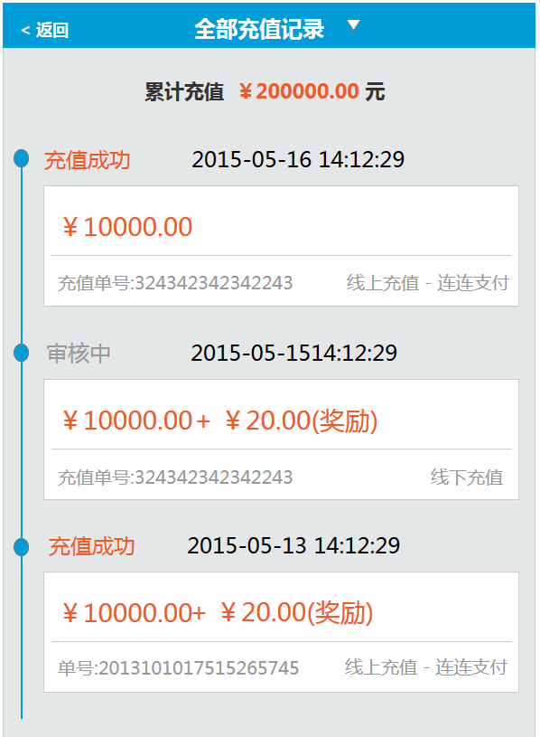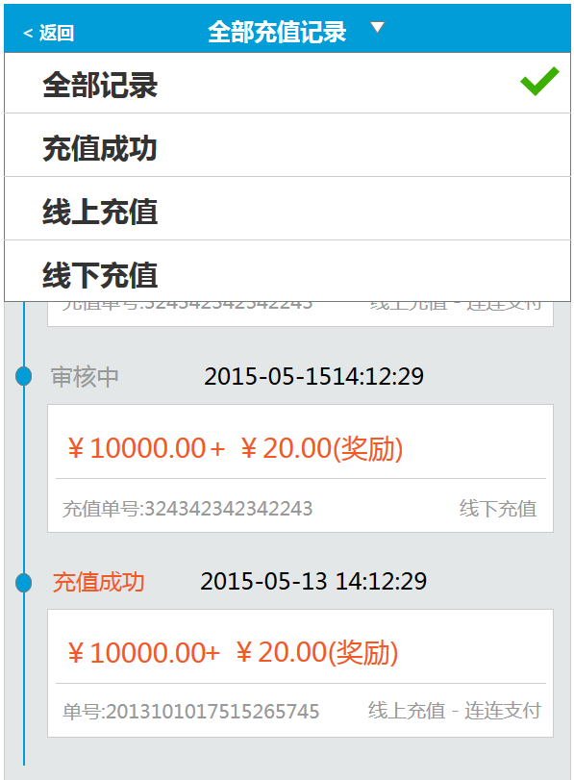

* **载入页面**

1. 接口名称：
2. 输入

|  |  |  |  |  |  |  |  |  |
| --- | --- | --- | --- | --- | --- | --- | --- | --- |
| **名称** | **类型** | **必须** | **长度** | **默认值** | **最小值** | **最大值** | **示例值** | **描述** |
|  |  |  |  |  |  |  |  | 会员id |
|  |  |  |  |  |  |  |  | 页数 |
|  |  |  |  |  |  |  |  | 筛选条件 |

1. 返回

|  |  |  |  |  |  |  |  |  |
| --- | --- | --- | --- | --- | --- | --- | --- | --- |
| **名称** | **类型** | **必须** | **长度** | **默认值** | **最小值** | **最大值** | **示例值** | **描述** |
|  |  |  |  |  |  |  |  | --以下循环开始 |
|  |  |  |  |  |  |  |  | 充值记录id |
|  |  |  |  |  |  |  |  | 充值记录状态 |
|  |  |  |  |  |  |  |  | 充值记录创建时间 |
|  |  |  |  |  |  |  |  | 充值记录修改时间 |
|  |  |  |  |  |  |  |  | 充值金额 |
|  |  |  |  |  |  |  |  | 充值奖励金额 |
|  |  |  |  |  |  |  |  | 充值单号 |
|  |  |  |  |  |  |  |  | 充值类型（线上、线下） |
|  |  |  |  |  |  |  |  | 充值途径（第三方支付、银行） |
|  |  |  |  |  |  |  |  | 项目状态名称 |
|  |  |  |  |  |  |  |  | --以上循环结束 |

1. 错误码

|  |  |  |
| --- | --- | --- |
| **错误码** | **错误描述** | **解决方案** |
|  |  |  |

## 我要提现

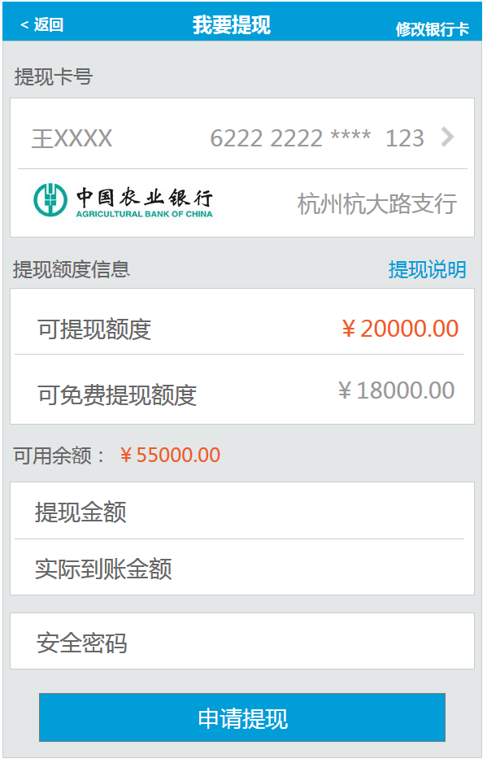

* **载入页面**

1. 接口名称：
2. 输入

|  |  |  |  |  |  |  |  |  |
| --- | --- | --- | --- | --- | --- | --- | --- | --- |
| **名称** | **类型** | **必须** | **长度** | **默认值** | **最小值** | **最大值** | **示例值** | **描述** |
|  |  |  |  |  |  |  |  | 会员id |

1. 返回

|  |  |  |  |  |  |  |  |  |
| --- | --- | --- | --- | --- | --- | --- | --- | --- |
| **名称** | **类型** | **必须** | **长度** | **默认值** | **最小值** | **最大值** | **示例值** | **描述** |
|  |  |  |  |  |  |  |  | 会员姓名 |
|  |  |  |  |  |  |  |  | 会员银行卡卡号 |
|  |  |  |  |  |  |  |  | 银行卡银行 |
|  |  |  |  |  |  |  |  | 开户行 |
|  |  |  |  |  |  |  |  | 可提现额度 |
|  |  |  |  |  |  |  |  | 可免费提现额度 |
|  |  |  |  |  |  |  |  | 可用余额 |

1. 错误码

|  |  |  |
| --- | --- | --- |
| **错误码** | **错误描述** | **解决方案** |
|  |  |  |

* **提现递交**

1. 接口名称：
2. 输入

|  |  |  |  |  |  |  |  |  |
| --- | --- | --- | --- | --- | --- | --- | --- | --- |
| **名称** | **类型** | **必须** | **长度** | **默认值** | **最小值** | **最大值** | **示例值** | **描述** |
|  |  |  |  |  |  |  |  | 会员id |
|  |  |  |  |  |  |  |  | 会员姓名 |
|  |  |  |  |  |  |  |  | 会员银行卡卡号 |
|  |  |  |  |  |  |  |  | 银行卡银行 |
|  |  |  |  |  |  |  |  | 开户行 |
|  |  |  |  |  |  |  |  | 提现金额 |
|  |  |  |  |  |  |  |  | 实际到账金额 |
|  |  |  |  |  |  |  |  | 安全密码 |

1. 返回

|  |  |  |  |  |  |  |  |  |
| --- | --- | --- | --- | --- | --- | --- | --- | --- |
| **名称** | **类型** | **必须** | **长度** | **默认值** | **最小值** | **最大值** | **示例值** | **描述** |
|  |  |  |  |  |  |  |  | 提现申请是否递交成功 |
|  |  |  |  |  |  |  |  | 安全密码是否正确 |

1. 错误码

|  |  |  |
| --- | --- | --- |
| **错误码** | **错误描述** | **解决方案** |
|  |  |  |

## 我的红包

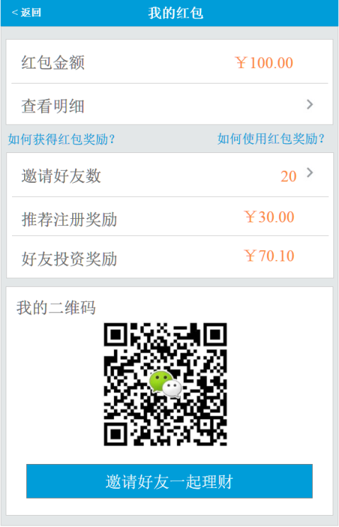

* **载入页面**

1. 接口名称：
2. 输入

|  |  |  |  |  |  |  |  |  |
| --- | --- | --- | --- | --- | --- | --- | --- | --- |
| **名称** | **类型** | **必须** | **长度** | **默认值** | **最小值** | **最大值** | **示例值** | **描述** |
|  |  |  |  |  |  |  |  | 用户id |

1. 返回

|  |  |  |  |  |  |  |  |  |
| --- | --- | --- | --- | --- | --- | --- | --- | --- |
| **名称** | **类型** | **必须** | **长度** | **默认值** | **最小值** | **最大值** | **示例值** | **描述** |
|  |  |  |  |  |  |  |  | 红包余额 |
|  |  |  |  |  |  |  |  | 好友数 |
|  |  |  |  |  |  |  |  | 推荐注册红包总额 |
|  |  |  |  |  |  |  |  | 好友投资红包总额 |
|  |  |  |  |  |  |  |  | 推广链接二维码 |
|  |  |  |  |  |  |  |  | 分享到短信的内容 |
|  |  |  |  |  |  |  |  | 分享到微信好友的内容 |
|  |  |  |  |  |  |  |  | 分享到微信朋友圈的内容 |
|  |  |  |  |  |  |  |  | 分享到新浪微博的内容 |
|  |  |  |  |  |  |  |  | 分享到腾讯微博的内容 |
|  |  |  |  |  |  |  |  | 分享到QQ的内容 |

1. 错误码

|  |  |  |
| --- | --- | --- |
| **错误码** | **错误描述** | **解决方案** |
|  |  |  |

## 红包明细

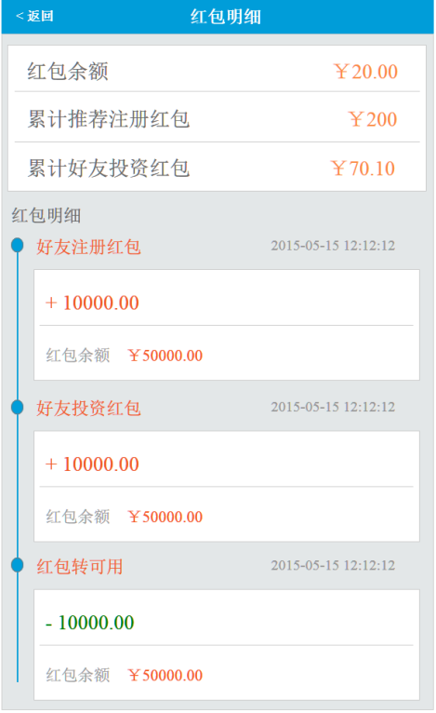

* **载入页面**

1. 接口名称：
2. 输入

|  |  |  |  |  |  |  |  |  |
| --- | --- | --- | --- | --- | --- | --- | --- | --- |
| **名称** | **类型** | **必须** | **长度** | **默认值** | **最小值** | **最大值** | **示例值** | **描述** |
|  |  |  |  |  |  |  |  | 用户id |
|  |  |  |  |  |  |  |  | 红包明细页数 |

1. 返回

|  |  |  |  |  |  |  |  |  |
| --- | --- | --- | --- | --- | --- | --- | --- | --- |
| **名称** | **类型** | **必须** | **长度** | **默认值** | **最小值** | **最大值** | **示例值** | **描述** |
|  |  |  |  |  |  |  |  | 目前红包余额 |
|  |  |  |  |  |  |  |  | 推荐注册红包总额 |
|  |  |  |  |  |  |  |  | 好友投资红包总额 |
|  |  |  |  |  |  |  |  | --以下循环开始 |
|  |  |  |  |  |  |  |  | 类型 |
|  |  |  |  |  |  |  |  | 时间 |
|  |  |  |  |  |  |  |  | 红包进出类型（获得、转出） |
|  |  |  |  |  |  |  |  | 红包进出金额 |
|  |  |  |  |  |  |  |  | 当时红包余额 |
|  |  |  |  |  |  |  |  | --以上循环结束 |

1. 错误码

|  |  |  |
| --- | --- | --- |
| **错误码** | **错误描述** | **解决方案** |
|  |  |  |

## 好友列表

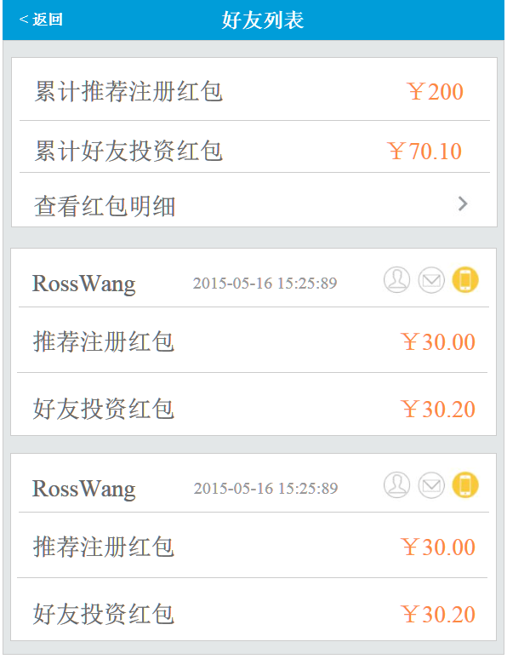

* **载入页面**

1. 接口名称：
2. 输入

|  |  |  |  |  |  |  |  |  |
| --- | --- | --- | --- | --- | --- | --- | --- | --- |
| **名称** | **类型** | **必须** | **长度** | **默认值** | **最小值** | **最大值** | **示例值** | **描述** |
|  |  |  |  |  |  |  |  | 用户id |
|  |  |  |  |  |  |  |  | 好友页数 |

1. 返回

|  |  |  |  |  |  |  |  |  |
| --- | --- | --- | --- | --- | --- | --- | --- | --- |
| **名称** | **类型** | **必须** | **长度** | **默认值** | **最小值** | **最大值** | **示例值** | **描述** |
|  |  |  |  |  |  |  |  | 推荐注册红包总额 |
|  |  |  |  |  |  |  |  | 好友投资红包总额 |
|  |  |  |  |  |  |  |  | --以下循环开始 |
|  |  |  |  |  |  |  |  | 好友用户名 |
|  |  |  |  |  |  |  |  | 好友注册时间 |
|  |  |  |  |  |  |  |  | 好友推荐红包金额 |
|  |  |  |  |  |  |  |  | 好友投资红包金额 |
|  |  |  |  |  |  |  |  | --以上循环结束 |

1. 错误码

|  |  |  |
| --- | --- | --- |
| **错误码** | **错误描述** | **解决方案** |
|  |  |  |

## 资金记录

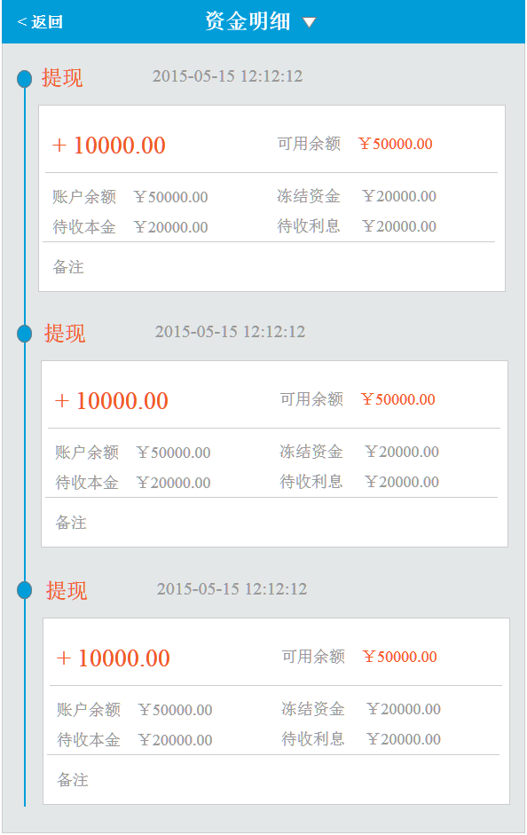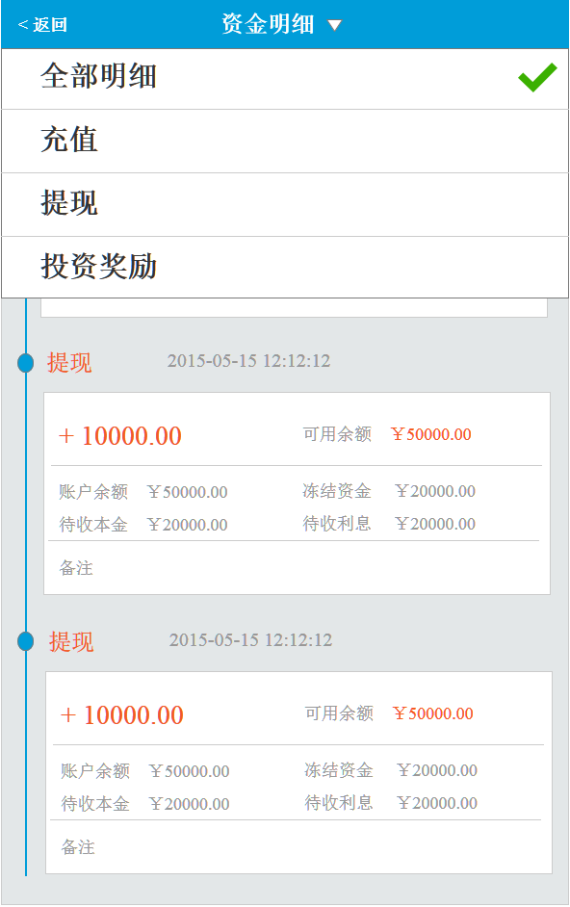

* **载入页面**

1. 接口名称：
2. 输入

|  |  |  |  |  |  |  |  |  |
| --- | --- | --- | --- | --- | --- | --- | --- | --- |
| **名称** | **类型** | **必须** | **长度** | **默认值** | **最小值** | **最大值** | **示例值** | **描述** |
|  |  |  |  |  |  |  |  | 用户id |
|  |  |  |  |  |  |  |  | 页数 |
|  |  |  |  |  |  |  |  | 明细类型 |

1. 返回

|  |  |  |  |  |  |  |  |  |
| --- | --- | --- | --- | --- | --- | --- | --- | --- |
| **名称** | **类型** | **必须** | **长度** | **默认值** | **最小值** | **最大值** | **示例值** | **描述** |
|  |  |  |  |  |  |  |  | 明细类型 |
|  |  |  |  |  |  |  |  | 发生时间 |
|  |  |  |  |  |  |  |  | 操作金额 |
|  |  |  |  |  |  |  |  | 可用余额 |
|  |  |  |  |  |  |  |  | 账户余额 |
|  |  |  |  |  |  |  |  | 冻结资金 |
|  |  |  |  |  |  |  |  | 待收本金 |
|  |  |  |  |  |  |  |  | 待收利息 |
|  |  |  |  |  |  |  |  | 备注 |

1. 错误码

|  |  |  |
| --- | --- | --- |
| **错误码** | **错误描述** | **解决方案** |
|  |  |  |

# 八、更多

## 更多

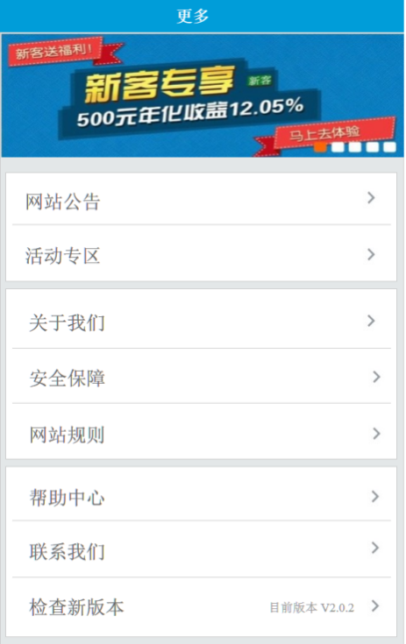

* **载入页面**

1. 接口名称：
2. 输入

|  |  |  |  |  |  |  |  |  |
| --- | --- | --- | --- | --- | --- | --- | --- | --- |
| **名称** | **类型** | **必须** | **长度** | **默认值** | **最小值** | **最大值** | **示例值** | **描述** |
|  |  |  |  |  |  |  |  |  |

1. 返回

|  |  |  |  |  |  |  |  |  |
| --- | --- | --- | --- | --- | --- | --- | --- | --- |
| **名称** | **类型** | **必须** | **长度** | **默认值** | **最小值** | **最大值** | **示例值** | **描述** |
|  |  |  |  |  |  |  |  | 当前版本 |

1. 错误码

|  |  |  |
| --- | --- | --- |
| **错误码** | **错误描述** | **解决方案** |
|  |  |  |

## CMS列表页 – 以帮助中心为例

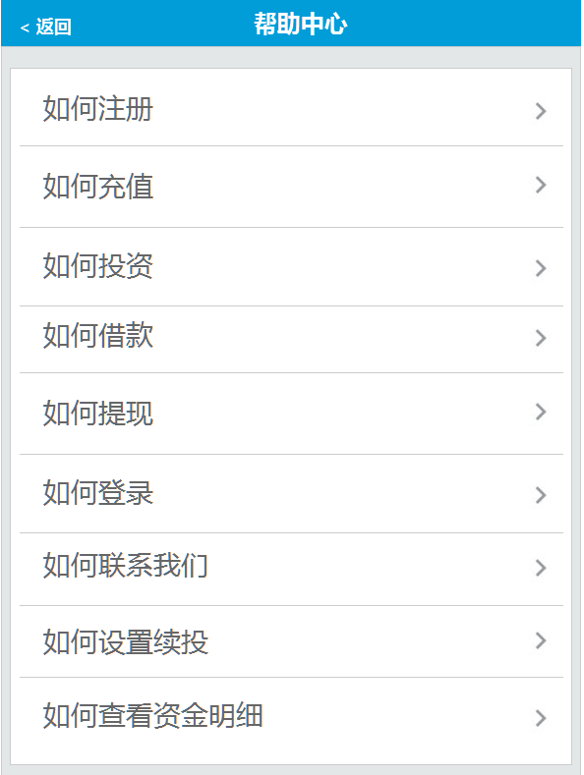

* **载入页面**

1. 接口名称：
2. 输入

|  |  |  |  |  |  |  |  |  |
| --- | --- | --- | --- | --- | --- | --- | --- | --- |
| **名称** | **类型** | **必须** | **长度** | **默认值** | **最小值** | **最大值** | **示例值** | **描述** |
|  |  |  |  |  |  |  |  | 帮助中心类别id |

1. 返回

|  |  |  |  |  |  |  |  |  |
| --- | --- | --- | --- | --- | --- | --- | --- | --- |
| **名称** | **类型** | **必须** | **长度** | **默认值** | **最小值** | **最大值** | **示例值** | **描述** |
|  |  |  |  |  |  |  |  | --以下循环开始 |
|  |  |  |  |  |  |  |  | 文章id |
|  |  |  |  |  |  |  |  | 文章标题 |
|  |  |  |  |  |  |  |  | --以上循环结束 |

1. 错误码

|  |  |  |
| --- | --- | --- |
| **错误码** | **错误描述** | **解决方案** |
|  |  |  |

## CMS内容页 – 以网站公告内容页为例

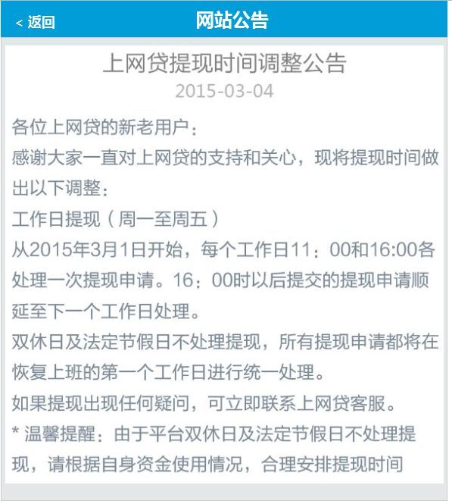

* **载入页面**

1. 接口名称：
2. 输入

|  |  |  |  |  |  |  |  |  |
| --- | --- | --- | --- | --- | --- | --- | --- | --- |
| **名称** | **类型** | **必须** | **长度** | **默认值** | **最小值** | **最大值** | **示例值** | **描述** |
|  |  |  |  |  |  |  |  | 文章id |

1. 返回

|  |  |  |  |  |  |  |  |  |
| --- | --- | --- | --- | --- | --- | --- | --- | --- |
| **名称** | **类型** | **必须** | **长度** | **默认值** | **最小值** | **最大值** | **示例值** | **描述** |
|  |  |  |  |  |  |  |  | 文章标题 |
|  |  |  |  |  |  |  |  | 发标时间 |
|  |  |  |  |  |  |  |  | 文章内容 |

1. 错误码

|  |  |  |
| --- | --- | --- |
| **错误码** | **错误描述** | **解决方案** |
|  |  |  |

# 第二章 数据结构

1. borrow

描述：包含一个借款项目的全部信息

|  |  |  |  |
| --- | --- | --- | --- |
| **名称** | **类型** | **是否必须** | **描述** |
|  |  |  |  |
|  |  |  |  |
|  |  |  |  |