examples of equilibrium calculations (EQU)
The following examples illustrate some equilibrium calculation runs with ARXIM.

titration runs under imposed pH
A typical run of numerical titration (Helgeson, 1969) consists in adding aliquots of a substance of given stoichiometry to a fluid of given composition, and to compute the equilibrium composition of the fluid - mineral system obtained at each increment.
The diagrams hereafter show the results, in mole numbers of minerals for 1 kg H₂O, of several titration runs with ARXIM. Each run is a series of ARXIM / EQU calculations, each calculation being made for 1 kg H₂O plus a fixed amount of KAlSi₃O₈, incremented from 10⁻⁶ to 10. mole /kg H₂O.
Here, at variance with more classical titration, each titration run is computed for a fixed value of pH (pH= 4, 5, 6, 9), the charge being balanced by HCl at low pH or by NaOH at high pH.
Such an equilibrium path is implemented by the following script:
.1. The SYSTEM block lists the constraints on the system:
SYSTEM
TDGC 75
PBAR 200
K MOLE K+ 0.1
SI MOLE SIO2(AQ) 0.3
AL MOLE AL+3 0.1
H PK H+ 6.00
CL BALANCE Cl-
END
.2. The PATH block defines the evolution of the constraints along the path:
PATH CHANGE
SI INITIAL 3.D-6 FINAL 12.00 RATIO 1.2
AL INITIAL 1.D-6 FINAL 4.00 RATIO 1.2
K INITIAL 1.D-6 FINAL 4.00 RATIO 1.2
END

[diagrams, titration runs under imposed pH]

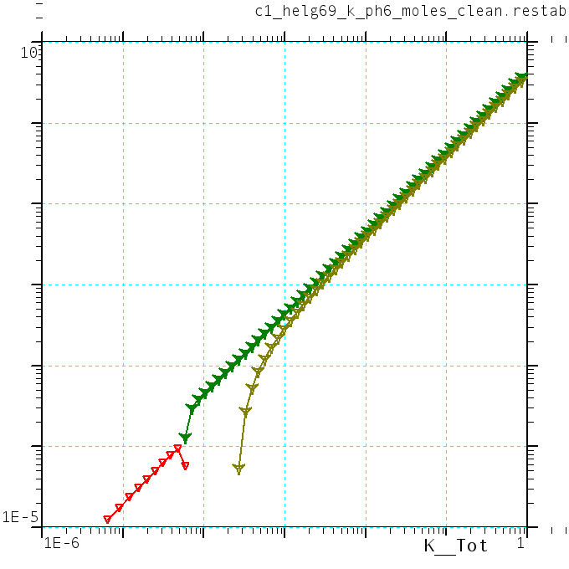
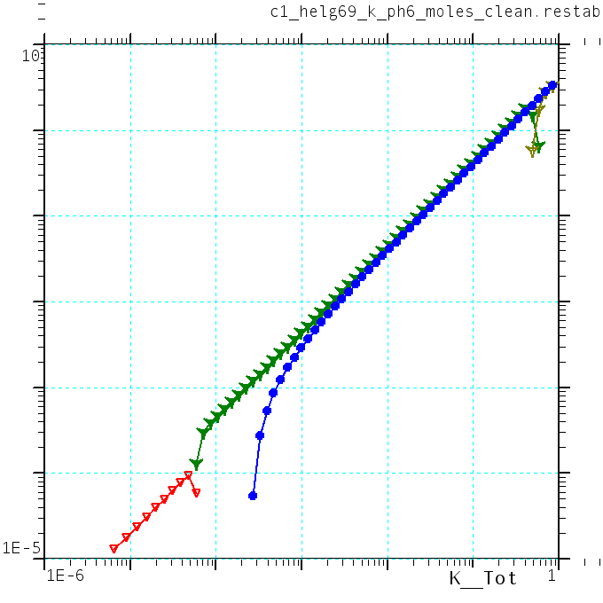
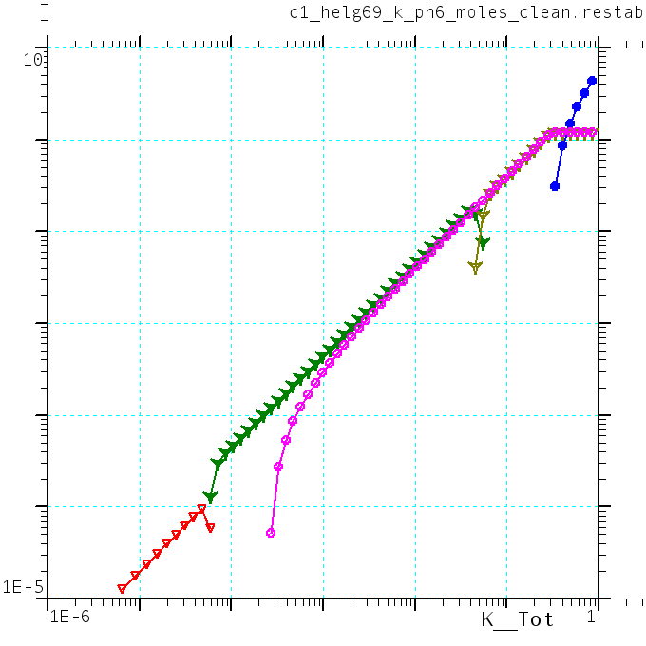
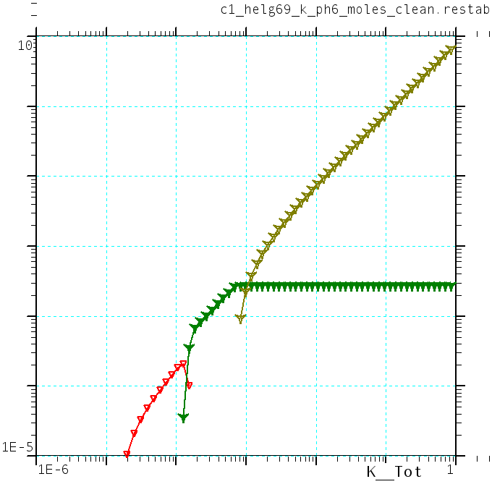
pH=4
Qtz
Dia
Kaol
pH=5
Qtz
Dia
Kaol
Mus
Kfs
Mus
Qtz
Dia
Kaol
pH=6
Kfs
Mus
Dia
pH=9

