global approach to equilibrium computation
LMA methods (formulations based on Law of Mass Action) are well adapted to simulations of water-rock interactions, where the speciation of the aqueous phase plays the central role, and they are actually dominant among hydrochemistry codes, but it appears essential, for a library devoted to multiphase equilibrium computations, to implement also tools for Global (or Gibbs) Energy Minimization (GEM) methods.
Free energy minimization is by far the preferred strategy for solving multiphase equilibrium in material science and chemical engineering, and a large array of numerical schemes have been proposed, such as SOLGASMIX (Eriksson, 1974) and its relatives (e.g. CHEMSAGE, Eriksson and Hack, 1990), or the CALPHAD methods (Saunders and Miodownik AP, 1998).
For petrology also, using GEM rather than LMA methods appears necessary in many situations:
▷ systems with many potential mixture phases, commonly encountered in metamorphic and magmatic petrology,
▷ systems that are not always saturated with respect to the aqueous phase; for example, evaporation processes, such as dessication in the vicinity of CO₂ injection wells and salt scaling.
For metamorphic petrology, a number of GEM programs are available [ THERIAK (de Capitani & Brown, 1987), PERPLEX (Connolly 1990, 2005), FLASK-SG (Takeno, 2001) ], which take into account mixture phases (fluid phases, solid solutions) that follow complex non-ideal EoS.

linear programming
Given a multi-component space and a set of possible phases (minerals and fluids), the objective is to find the stable phase assemblage for a given bulk composition and T,P conditions.
When all phases are of fixed compositions ("pure phases"), the problem becomes a classical problem of linear programming (White et al, 1958; De Capitani & Brown, 1987).
In this case, we have simply to transform the petrological question into a form that fits with standard implementations of linear programming. A systematic implementation of the basic stoichiometric and thermodynamic manipulations on species and phases, such as built in ARXIM, largely simplifies this interfacing task.
The system is defined by:
▷ a list of (1:nC) components, which defines the chemical space of interest;
▷ the bulk composition of the system, given by the vector b(1:nC) of mole numbers of the components,
▷ the T,P conditions;
▷ a set of phases (1:nF) potentially present, having fixed compositions and known Gibbs energy of formation, g(1:nF), at the given (T,P) condition.
The stable phase assemblage is the set of phases (nF<=nC) that, for the given bulk composition, minimizes the Gibbs energy of the system.
The problem is thus to solve for n the following linear programming problem:
▷ minimize the "objective function"

▷ under nC equality constraints
,
▷ and

g_{j} is the molar Gibbs free energy of formation of the phase j at (T,P), and n_{j} its mole number, which will be either positive (phase j is present) or zero (phase j is absent).
b_{i} is the mole number of component i, i.e. a given positive number.
The stoichiometry table α(1:nC,1:nF) describes the compositions of the different phases (1:nF) in terms of the components (1:nC).
To solve this problem using the simplex algorithm according to its implementation in most codes (e.g. Press et al, 1992), the following tableau is built:

linear programming with mixtures
When the system comprises mixtures (e.g. solid solutions), whose molar free energies g_{i} are non-linear functions of their compositions, linear programming can still be used, by discretization of each mixture to a series of phases of fixed composition. That is viable in applications, for example in metamorphic petrology (Connolly, 2005), where each type of mixture potentially present involves a small number of independent composition variables (e.g. Mg-Fe exchange, Tschermak substitution, Na-K exchange). The number of phases may become large, but still within the capabilities of standard linear programming codes.

non-linear optimization
Among the numerous GEM algorithms proposed, the THERIAK method (De Capitani & Brown, 1987) is among the most simple to implement using simple numerical tools. A characteristic of this method is that it adjusts concurrently the composition of the stable assemblage and the compositions of the mixtures that belong to the assemblage.
The THERIAK method combines linear programming and non-linear minimization along the following scheme:
▷ 1. linear minimization: find the assemblage of pure (i.e. invariant) phases that minimizes G;
▷ 2. basis change: compute the free energies of all invariant phases (including the mixtures' end-members) with respect to the stable assemblage found at step 1; this results in a new set of free energy values, which are 0 for the stable phases, and >0 for the others;
▷ 3. non-linear minimization: for each mixture of the chemical space, compute the composition x_{min} that has the lowest free energy of formation from the current stable assemblage, g_{min}=G(x_{min})
▷ 4a. if any mixture has a negative g_{min}, which means the current assemblage is unstable with respect to that mixture, then add that mixture, as a phase of invariant composition x_{min}, to the set of invariant phases, go to step 1;
▷ 4b. if g_{min}>0 for all mixtures, then exit, the current phase assemblage is stable.
The method is illustrated graphically here (adapted from DeCapitani & Brown, 1987) for the case of a binary system of given bulk composition (arrow on diagram). The system comprises 4 species (A1,B1,A2,B2) that can mutually mix to form two distinct mixtures, called A (A1-A2) and B (B1-B2).

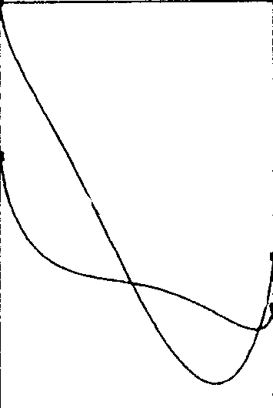
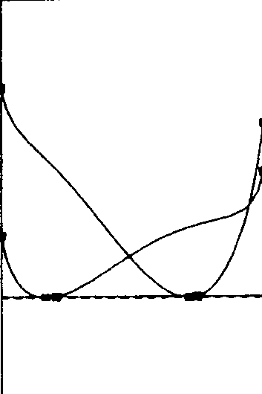
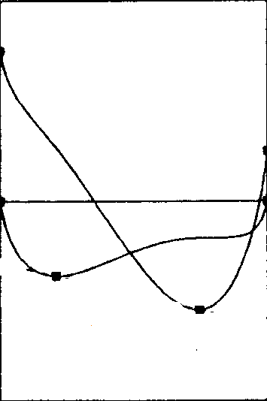
X
0
1
X
0
1
X
0
1
A2
B2
A2
B2
A2
B2
A1
B1
ΔfG
A1
B1
A1
B1
adapted from DeCapitani & Brown , 1987
A3
B3
A4
B4
A3
B3
G(B1)=G(B2)=0
G(B3)=G(A3)=0
Amix
Bmix
.i/ First, if we consider only the pure phase (A1,B1,A2,B2), the stable assemblage is {B1,B2}
.ii/ Then, the free energies of formation of all end-members are computed with assemblage {B1,B2} as basis (i.e. G(B1)=G(B2)=0), and the compositions that minimize the formation energies of the mixtures are computed; it appears that the mixtures A_{mix} and B_{mix}, at compositions A3 and B3 respectively, have negative free energies, which means that a more stable assemblage, for the bulk composition, is {B_{mix} of composition B3, A_{mix} of composition A3}
.iii/ the free energies of formation of the end members are updated, with this new assemblage {B3,A3} as reference (G(B_{mix},B3)=G(A_{mix},A3)=0), and the compositions that minimize the formation energies of the mixtures are computed again, in this new framework; as the free energies of the mixtures at these compositions are still slightly negative, another loop is executed, with the assemblage {B4,A4} as reference.
This algorithm closely associates the search for the stable assemblage and the adjustment of the mixtures' compositions, in contrast with many other methods of free energy minimization in multi-mixture systems, which compute an equilibrium composition for a given set of phases, and develop a separate procedure to check the supersaturation of other phases.

case of ideal mixtures
With ideal mixtures, the minimization (step 3) has an analytical solution, which can be derived as follows, on the example of a simple one-site mixing model:
minimizes.t.
the Lagrangian is
The function is convex and has one minimum, found as the stationary point of the Lagrangian:
;
→ for two components i, j, →

case of non-ideal mixtures
To take account of deviation from ideality, an "excess energy of mixing" is added to G^{ideal}. The different mixing models implemented in ARXIM are described in the chapter on physical models. A form commonly used to described the excess interaction is a Margules polynomial development of the form
.
The compositions minimizing G^{ideal} + G^{XS} of each candidate mixture phase can be found numerically, using publicly available optimization tools, but DeCapitani & Brown (1987) describe in detail a specific algorithm, which takes as input the expressions of the chemical potentials of the end-members as functions of their mole fractions in the mixture. This method has been implemented in ARXIM, and its results have been validated against results obtained with programs for constrained optimization such as SQPlab (Gilbert, 2006) or ALGENCAN (Andreani et al, 2007).

