examples of GEM equilibrium calculations
Codes dedicated to metamorphic petrology are firstly used (THERMOCALC, TWEEQU) for the estimation of the (T,P) conditions of crystallization of a given mineral assemblage. More recently, the utilization of (T,P) pseudo-sections, constructed using GEM code such as THERIAK or PERPLEX, has become very popular.
ARXIM does not currently integrate the routines for mapping T,P domains, which would be used for the construction of pseudo-sections, but it can be used more simply to analyze a phase assemblage evolution along a given T,P path.
In the example illustrated here, the stable phase assemblage is computed for a fixed bulk composition, along two series of T,P conditions:
along a high T/P gradient: from 400°C / 1200 bar to 700°C / 3200 bars
along a medium T/P gradient: from 400°C / 3500 bar to 700°C / 6500 bars
The diagrams illustrate the variations in mole numbers of the minerals (quartz and feldspars not shown).
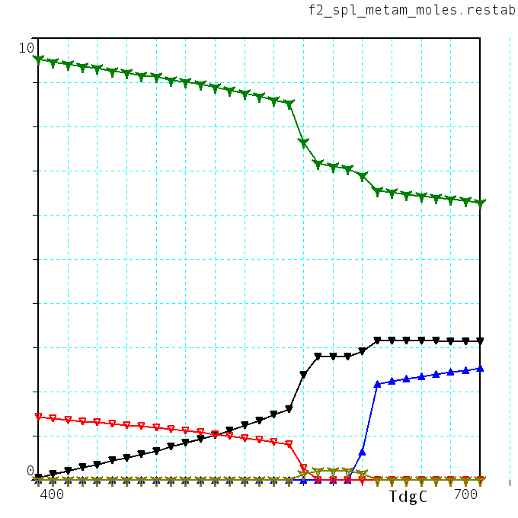
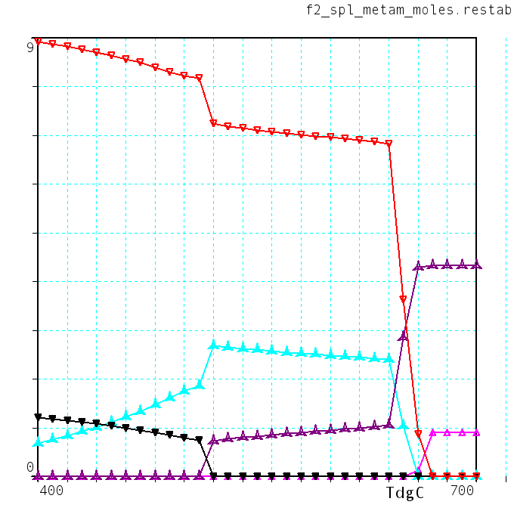
The bulk composition is that of a pelitic rock from the Ryôké belt (Japan), projected on the FMCNKASH system (FeO-MgO-CaO-Na₂O-K₂O-Al₂O₃-SiO₂-H₂O):
Mus(ss)
Chl(ss)
Bio(ss)
Cord(ss)
Sil
Mus(ss)
Chl(ss)
Bio(ss)
Stau(ss)
Sil
high T/P
medium T/P
SYSTEM.GEM
TdgC 600.
Pbar 2300.
H2O 20.0
SiO2 127.
Al2O3 18.3
CaO 1.41
Na2O 2.67
K2O 4.66
FeO 4.80
MgO 3.80
END
The following mixing models have been taken in consideration here:
BIOTITE(PHLOGOPITE,ANNITE,EASTONITE,OBIOTITE) HP,2005
CORDIERITE_SS(CORDIERITE,FE-CORDIERITE,HYDR.CORDIERITE) Avchenko,2006
OPX(ENSTATITE,FERROSILITE,MG-TSCHER.PYX) Avchenko,2006
TALC_SS(TALC,FE-TALC,TSCHERMAK-TALC) Avchenko,2006
CHLORITE(CHLORITE-AF,CLINOCHLORE,AMESITE,DAPHNITE) HP,2005
MUSCOVITE_SS(MUSCOVITE,PARAGONITE,CELADONITE,FE-CELADONITE) HP,2005
GARNET(ALMANDINE,PYROPE) ideal
STAUROLITE(MG-STAUROLITE,FE-STAUROLITE) ideal (4))
CHLORITOID(MG-CHLORITOID,FE-CHLORITOID) ideal
FELDSPAR_SS(ALBITE-LOW,MICROCLINE,ANORTHITE) Fuhrman & Lindsley(1988)

