physical models implemented in arxim
Analyzing the thermodynamics of a chemical system boils down to the evaluation of gradients of chemical potentials of components. We have thus to evaluate changes of free energy attending all possible reactions among the different species of the chemical space. We describe here the methods used for the computation of the free energy of a species in a phase.
The molar free energy, or chemical potential, of a species j in a phase p at given (T,P) can be written as
(1)
where μ⁰_{j} is the chemical potential of the species j at its reference state (e.g. pure phase for a mineral) at (T,P) and a_{j} is the activity of the species in the phase p of composition x_{p}.
The first term is computed from the equation of state (EoS) of the species at (T,P), the second depends on the EoS and composition of the phase.
We will thus consider successively:
► how to obtain the chemical potential μ⁰_{j} of a species in its reference state at the (T,P) condition of interest,
► how to compute the activity a_{j} of a species in a phase, as a function of phase composition x_{p}.

thermodynamic data for reactions
The free energy is written in (1) for an individual species, but, rather than with absolute values, we are actually concerned with relative changes of free energy, ΔG's, for all possible reactions between species of the chemical space.
For a reaction R described by a vector υ^{R} of stoichiometric coefficients, i.e. for a reaction
,
the change in chemical potential is obtained by:

or
,
where
Hence, the database can be reduced to a set of ΔG°'s, or so-called logK's (logK= -ΔG°/RT/ln10) , of all possible independent reactions R among species of the chemical space.

two types of thermodynamic databases: logK and HSV
Programs currently available for thermodynamics of geo-systems are often connected with a specific type of database, which restrict their application to a specific domain (e.g. hydro-geochemistry, metamorphism, ...). One of the objectives of ARXIM is to develop tools with the largest range of applications. Fundamental to this respect is the ability to interface the ARXIM tools with various formats of thermodynamic databases.
Programs for modeling water-rock interaction at sub-surface conditions often rely on databases that contain the logK's of reactions among aqueous species and pure substances (minerals and gases), for a given discrete series of T,P conditions.
On the other hand, programs for metamorphic petrology (e.g. TWEEQU [Berman, 1988], THERMOCALC [Holland & Powell(1998)], THERIAK-DOMINO [DeCapitani & Brown, 1987)], ...) need a more complete dataset, in order to allow the calculations of molar thermodynamic properties at any consistent (T,P) condition, on the basis of dedicated equations of state (EoS) for each pure phase (mineral or fluid) of interest. Such databases are referred here as 'HSV databases', for they allow the separate computation of molar enthalpy H, entropy S and volume V.
To use such data in aqueous geochemistry, we need the same type of approach for species dissolved in aqueous solutions: the Helgeson -Kirkham -Flowers (HKF) equation of state, and its related databases, plays a central role, making a bridge between metamorphic petrology and aqueous geochemistry
The logK approach has the advantage of simplicity, but it presents some limitations: it yields only Gibbs free energy data, relevant for equilibrium analysis at some T,P points, whereas the HSV approach makes possible, within a divariant T,P domain, the calculation of G and of other important functions such as the enthalpy, entropy and volume changes of a reaction.
ARXIM can work directly with logK databases, but it includes also tools for computing the logK's of reactions directly from equations of states of the species involved.
Tools are currently available for calculations on two main types of species:
► pure phases (minerals and gases),
► aqueous species, according to the HKF (Helgeson -Kirkham -Flowers) equation of state.

calculation of thermodynamic properties of minerals from HSV data
A HSV table will typically contain, for each species, molar thermodynamic properties of the pure species at some standard conditions (e.g. T°= 298.15 K / P°= 1 bar): enthalpy of formation ΔH_{f}°, entropy S°, volume V°, heat capacity C_{p}°, and parameters
For minerals, the reference state is the pure phase at the T,P conditions of interest.
Calculation of a thermodynamic state function Ξ (such as G, H, S, V,...) at (T,P), from data "from the table", for the pure phase at some standard conditions (e.g. T°= 298.15 K / P°= 1 bar), can be based on a two step integration:

The following fundamental relations are used for this integration:
♦ for entropy S: and
♦ for enthalpy H: and
♦ for volume V: and
for Gibbs free energy G, and
The thermodynamic databases used in ARXIM contain, on a molar basis, all data necessary to implement such calculations:
→ standard enthalpy of formation from the elements Δ_{f}H_{Tref,Pref},
→ standard entropy S_{Tref,Pref},
→ heat capacity C_{p} as a function T, e.g. Maier-Kelly expression,
→ volume V_{Tref,Pref}, and the compressibility factors α and β , or a polynomial expression V(T,P).
Practically, concerning minerals, ARXIM uses currently two types of 'HSV' databases:
♦ either "SupCrt-compatible", such as used by the program SupCrt92 (Johnson et al, 1992); data on minerals are found in the same file (e.g. slop98.dat) that contain the HKF parameters for aqueous species;
♦ or a "Berman-compatible" format, such as used by TWEEQU or by THERIAK, which are programs for equilibrium calculations of metamorphic assemblages. THERIAK databases include, in addition to the Berman data set, data for the THERMOCALC program by Holland & Powell (1998) formatted à la Berman.
The main differences between the two data sets, SUPCRT vs THERIAK, are:
▻ different forms of polynomial fits for the temperature dependence the heat capacities,
▻ the absence of T,P dependence of molar volumes of minerals in SupCrt92;
▻ more importantly, Gibbs free energy can be either derived from (H_{ref}, S_{ref}) or from (G_{ref}, S_{ref}). SupCrt92 uses Δ_{f}G°(Tref,Pref) to compute Gibbs free energy at (P,T), whereas calculation à la Berman-Theriak uses Δ_{f}H°(Tref,Pref). In the latter case, Δ_{f}G°(Pref,Tref) is tabulated, but not used.

Benson-Helgeson Versus Berman-Brown Convention
As already mentioned concerning databases, a given database is designed, primarily, for the calculation of thermodynamic functions according to a given specific convention.
Whereas SupCrt
Taking as an example the computation of the Gibbs free energy of a mineral of formula A(n)B(m),
▶ one convention, referred to as "Benson-Helgeson convention" (Anderson & Crerar, 1993), is to consider the "apparent ΔG of formation from the elements" of the compound as the difference between G of compound at (P,T) and the G's of the elements A and B at (P_{ref},T_{ref}):

▶ another convention, referred to as "Berman-Brown convention" (Anderson & Crerar, 1993), is to consider the apparent ΔG as the difference between G at (P,T) and the enthalpies of the elements A and B at (P_{ref},T_{ref}):

▶ comparing the two expressions, and writing G°= H° - Tref .S° at (P_{ref},T_{ref}) for the elements, the following relation is obtained between the apparent G's of compounds calculated according to the two conventions:

or

The values of the entropy of the elements at (P_{ref},T_{ref}) are found in the element database. Values tabulated in the file elements.dtb of the distribution are those reported by Robie & Hemingway (USGS report), and are consistent mostly with the CODATA compilation. They have been found to yield consistent values between databases for supcrt92 and databases from Berman or Holland-Powell.

the entropy of the electronic charge
The electron (i.e. the "element" that accounts for the charge on aqueous species) is assigned an entropy, equal to that of hydrogen, which is itself half the entropy of H₂(gas) at (T_{ref},P_{ref}).
This stems from the convention that, at all temperatures, the hydrogen ion H⁺ has zero entropy, as well as zero values of Gibbs energy of formation and heat capacity.
Then, we must also have a zero variation of entropy for the reaction of formation of H⁺, which is written

with,
Then, using the CODATA values, S°(e-, 298.15K) = 65.340 J/K/mol

calculation from G,S vs. calculation from H,S
The "Benson-Helgeson convention", which is that used in SupCrt, is used for calculations with SupCrt-compatible databases. For such databases, G at (T,P) is computed from G, S at (T_{ref}, P_{ref}).
On the contrary, the "Berman-Brown convention" is used with "Berman-compatible" databases. G(P_{ref},T_{ref}) is sometimes tabulated in such files (e.g. files used with TWEEQU), but it is not used: G at (P,T) is computed from H, S at (T_{ref},P_{ref}). Then, the term M%S0Ele is added to M%G to obtain a value compatible with M%G calculated from SupCrt-compatible databases.
In ARXIM, the two different methods are taken into account in modules specific to each type of database.

example, equation of state according to Berman (1988)
For a given mineral, the Berman (1988) database gives:
> molar enthalpy of formation at (T_{ref},P_{ref}),
> molar entropy at (T_{ref},P_{ref}),
> molar heat capacity at P_{ref}, as a polynomial function of temperature:

> molar volume V° at (T_{ref},P_{ref}) and parameters v₁ to v₄ describing its dependence on T and P:

thermodynamic properties of a pure gas
For gases, the conventional reference state is the pure gas at (T,P°), where T is the temperature of interest and P° is a fixed pressure (standard pressure P=1bar, or P= 1 atm = 1.013 bar).
The conventional reference for a gas is not the same as that used for species in mineral or aqueous phases; to be consistent with other species, the reference potential of a gas can be brought from (T,P°) to (T,P), giving a new reference potential μ* defined by the relation:

where the volume function is computed according to the relevant EoS.

thermodynamic properties of aqueous species at reference state
The standard state properties of solute aqueous species are calculated according to the HKF model (Helgeson-Kirkham-Flowers: Helgeson et al., 1981; Tanger & Helgeson, 1988), which, to a large degree, can be considered (Anderson, 2005) as an "equation of state" for aqueous solutions.
Results of ARXIM calculations have been checked for accuracy against results of similar calculations with SUPCRT92 (Johnson et al., 1992), a Fortran 77 program specific for the HKF model.
The HKF model depends on the calculation of the physical properties of H₂O (density and dielectric constant and their derivatives against T and P): in HKF / SUPCRT92, they are computed according to the equation of state of H₂O of Haar et al. (1984), also implemented in ARXIM.

mixing models, mixtures and solutions

Following a IUPAC recommendation, we call "solution" a phase of variable composition where a species, called the solvent, plays a specific role (e.g. it is dominant on the other species, the solute species). The term "mixture" is used for phases where the end-members are all treated in the same way: this is the case for gaseous mixtures and so-called "solid solutions".
To describe the composition of a mixture, a symmetric concentration scale is used, generally the mole fraction scale.

where the n_{j} are the mole numbers of end-members in the mixture φ.
For a solution, an asymmetric scale is used. The preferred concentration scale for solute species in thermodynamics of aqueous solution is the molality:

where n_{j} is the mole number of the solute, n_{w} that of the solvent, M_{w} its molecular weight (in kg).

note on conversions between molality and mole fraction

thus ,
and
And also,→

activity models
The activity of a species, a_{j} = exp((μ_{j} – μ_{j}° )/RT), measures how the potential of a species changes when it is brought from its reference state to its current state in the system.
In other words, the activity model describes how the activity of a species in a given phase depends on the composition of the phase.

activity coefficient :
The activity - composition dependency is described in terms of deviation from some defined ideal behavior, such as, for gases, the perfect gas. This deviation is represented by an activity coefficient, whose definition will depend on the conventions used for the different types of species, especially the concentration scale.

for a mineral species:
the reference state is the pure mineral at (T,P), and the concentration scale is the mole fraction xj.
,
where λ_{j} is the activity coefficient (mole fraction based).

for a gas species:
the reference state is the pure ideal gas at (T,P°), and the concentration scale is the mole fraction xj.
,
where φ_{j} is the fugacity coefficient.

for an aqueous solute species:
the reference state is the ideal (i.e. "at infinite dilution") at one molar concentration, at (T,P), and the concentration scale is the molality.
,
where γ_{j} is the activity coefficient (molality based).

activity models for aqueous species
An aqueous solution containing dissolved charged species is a typical example of "solution". Specific routines for speciation and activity corrections are implemented for the aqueous solutions.
Aqueous solutions being electrolytes, the activity – composition relation is strongly controlled by electrostatic interactions. An essential parameter in that respect is the ionic strength of the electrolyte, which is defined as

where the summation extends on all charged solute species of molality m_{j} and charge z_{j}. For instance, the ionic strength of a fully dissociated 1:1 electrolyte equals molality.
The activity models currently implemented in ARXIM are based either on adaptations of the Debye-Hückel equation, or on the Pitzer's equations.
In ARXIM, the model used in a run is selected by an argument (DH1, DAV_1, PITZER, ...) to the keyword MODEL of the block SOLVENT.

model: ideal
An ideal solution is commonly defined by the condition
activity = concentration (a_{j} = c_{j})
Applied to the dual concentration scale used for aqueous solution, we would have:
♦ for a solute species j,
,
where M_{w} is the molecular weight (in kg) of solvent species w,
♦ for the solvent,

However, the different concentration scales used for solvent and solutes lead to inconsistencies. Actually, the statement "activity = concentration" is valid for an ideal gas, where concentration is mole fraction for all components, it is valid also, to some extent, for other symmetric ideal mixtures, but, when applied to the asymmetric solution model used for electrolytes, it leads to inconsistencies.
Instead of "ideal", the limiting model, corresponding to vanishing interactions between species, is better the "infinitely dilute" condition, where the activity of a solute is its molality, and the solvent activity is 1, which is also the solvent mole fraction in infinitely dilute solutions.
In Arxim, when the aqueous solution model selection is IDEAL, activity is molality for solute species and 1 for the solvent.

the Debye-Hückel equation
Debye & Hückel (1923) derived the following equation for the activity coefficient of a charged solute species:

where
a⁰_{j} is the "ion size parameter" (more precisely, a "distance of closest approach"), specific to the ionic species considered
A_{DH} and B_{DH} are functions of the solvent properties and temperature,

or

where ρ and ε respectively are the density and dielectric constant of pure water at (T,P). These are obtained from the equation of state of water. ARXIM implements the Haar et al. (1984) equation, which is also necessary for the HKF model.
The validity of the equation is known to be limited to very low values of the ionic strength (I<0.005 ?). It is generally not used under this simple form, but with an additional term, function of ionic strength.

model: Davies
This model (Davies, 1962), widely used in subsurface hydrochemistry codes, is a purely empirical adaptation of the Debye-Hückel model; it is supposed to be valid for ionic strength up to around 0.1-0.5 mole/kg (?).
♦ for charged solute species,

Notice the simplified denominator : No size parameter here, the charge is the only species-specific parameter.
Notice also that some texts mention a coefficient of 0.3 instead of 0.2 ...
♦ for neutral solute species, this relation would give unit activity, but, as an option, ARXIM can use an simple empirical correction to take account of the salting-out effect:

♦ for the solvent, this model is commonly used with water activity set to 1 or to its mole fraction.
However, for thermodynamical consistency, the activity can be computed according to an expression derived by Wolery (1992):

where

model: B-dot à la Helgeson (1969)
The B-dot equation implemented in ARXIM is that proposed by Helgeson (1969). It is also an extension of the Debye-Hückel equation, obtained by adding a "B-dot" empirical correction term to the classical DH equation for charged species.
♦ for charged species,

The B-dot parameter is a function of temperature and of the nature of the dominant electrolyte.
The B-dot values tabulated in Helgeson (1969) for NaCl, for temperature from 25°C to 300°C and for m(NaCl)= 0 to 3, are fitted as follows in ARXIM:

♦ for neutral solute species,
the B-dot equation, as B-dot is positive, would fit a "salting out effect", but it is commonly not used for such species.
ARXIM gives the option to use, following the usage in EQ3NR (Wolery, 1992; also used in Xu et al, ), the activity coefficient of CO₂ in a NaCl solution of the same ionic strength, according to an expression proposed by Drummond (1981):

♦ for the solvent,
the activity is computed according to an expression derived by Wolery (1992):

where

model: HKF (Helgeson et al, 1981)
♦ for charged species, [p 1478]
,
where
: is the "ion size parameter" (a minimum distance of charge separation),
: = 3.72 Angstroms for NaCl-dominant electrolyte (Tab.2, p.1298)
:
: is the short range interaction parameter for NaCl,
= (T,P)-dependent [Tab.30, p 1477], -9.77 10⁻² at (25°C / 1 bar)
: is the solvation parameter for NaCl
= (T,P)-dependent [Tab.29, p. 1477], 2.47 10⁻³ at (25°C / 1 bar)
: is the absolute Born coefficient of species j (eq. 130, p.300)

Databases dedicated to the HKF model (e.g. used with SUPCRT92) contain data for ω, the conventional Born coefficient, which is related with ω^{abs} by:
[equ.135, p.1300], with

model: Pitzer
Descriptions of the Pitzer's method are found in many textbooks and papers (e.g. Pitzer, 1973, 1991; Anderson & Crerar, 1982).
Pitzer's model is an "interaction model": interactions between species are modeled by a set of specific interaction coefficients between a limited number of charged species (e.g. Na⁺, Cl⁻, ...). This is in contrast with the "association models" such as the HKF model, where interaction between Na⁺ and Cl⁻ is taken into account by the activity of a complex neutral species NaCl.
____
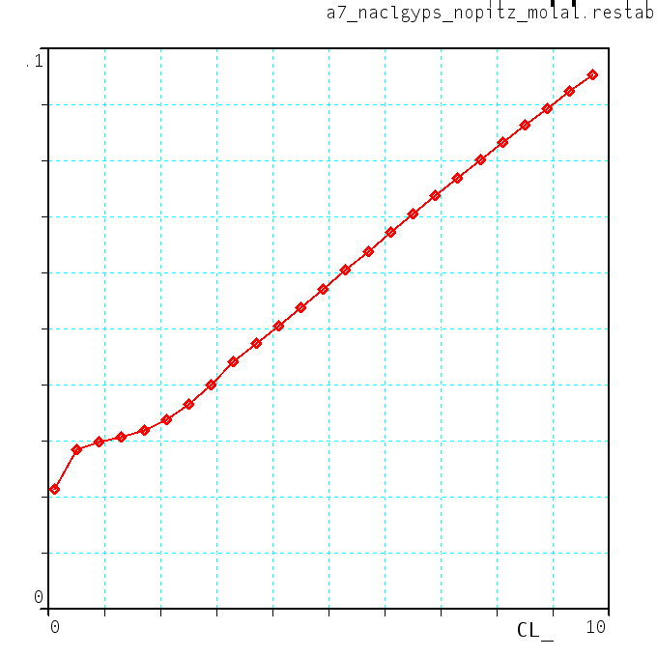
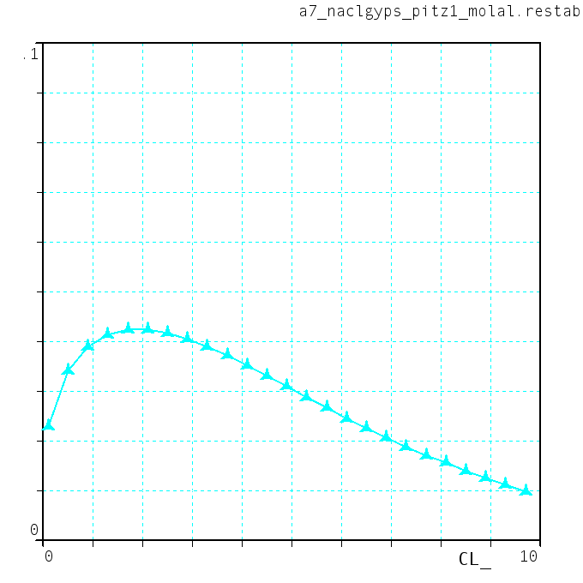
Comparison of gypsum / anhydrite solubility in NaCl at (25°C, 1bar), computed with a Pitzer activity model (left) and with the Davies activity model.
gypsum solubility
(moles/kgH2O)
in NaCl
Pitzer activity model
mole NaCl
mole NaCl
Davies activity model
0.1
0.1
10
10

mixing models for gas mixtures
Note: Activity vs Fugacity
For a species of a gas mixture, the activity can be defined as the ratio of its fugacity in the mixture at (T,P) over the fugacity of the corresponding pure phase at the same (T,P).
The chemical potential of a species j in a gas mixture at T,P is

For gaseous mixtures, some classical cubic equation of states (Redlich & Kwong, Peng & Robinson, Kerrick & Jacobs) are implemented. No generic cubic model is currently available in ARXIM, but, the code being open source , other cubic equations can be programmed by the user , based the existing ones.

mixing models for mineral phases
For mineral mixtures, generic models are currently implemented for two types of mixing models generally encountered in petrology: molecular mixing and site-mixing models (Ganguly, 2008). Excess mixing, when necessary, is modeled by a Margules polynomial expression.
The block structure of the input format, and the modular structure of the code will allow the implementation of other types of models.
Specific models not amenable to these generic models can be added to the code, by writing a routine that takes as input the mole fractions of the independent components of the mixture and gives their activities in the mixture. This routine will be used to compute both the Gibbs free energy of mixing at a given composition and the descent direction for minimization. An expression of the mixing free energy is not needed, but the activity expressions implemented should be thermodynamically consistent: that can be checked, for example, by the results of cross differentiation, which should give:

tests of the implementation of mixing models
The validity of the implementation of a given mixture model can be tested using utility routines that computes the free energy variations upon mixing (ideal mixing, excess mixing) and the activities of two end-members of the mixture, when their relative proportions are incrementally changed.
For example, for the plagioclase mixing model of Fuhrman & Lindsley (1988), the following X-G and X-Activities diagrams are obtained:
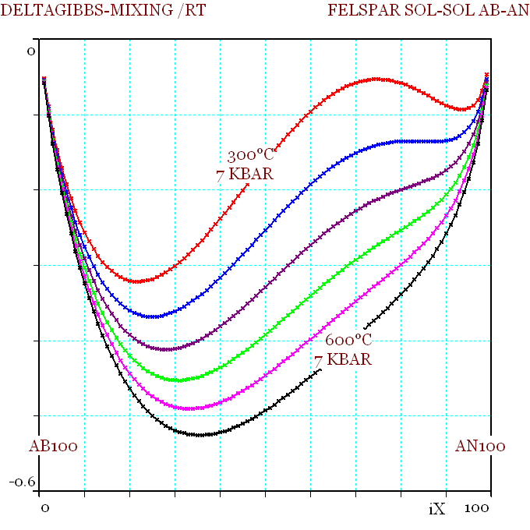 | 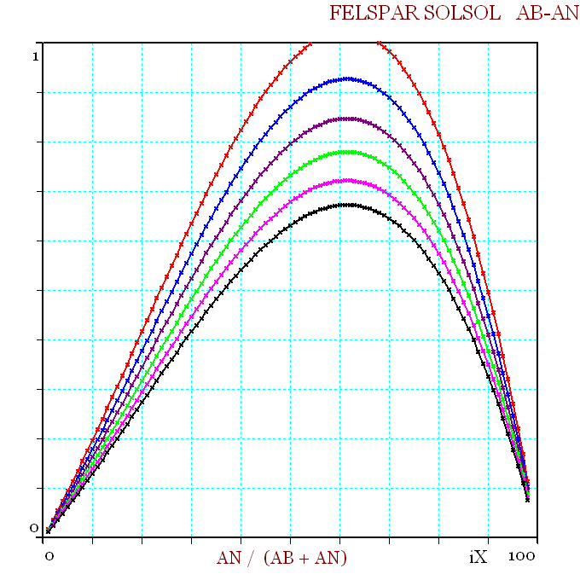
free energy of mixing, plotted against An mole %, for temperatures from 300°C to 700°C at 7 kbar | the excess free energy of mixing, against An mole %, for temperatures from 300°C to 700°C at 7 kbar

This plot of G_{Mixing} versus An/(Ab+An), calculated at various temperatures and at P=7 kbar, shows how the width of the miscibility gap (as defined by the "common tangent" construction) progressively decreases as temperature increases.
The change of convexity in the G-X curves above originates in the excess mixing term, calculated according to the Margules parameters implemented in the mixture model. The diagram on right illustrates the asymmetric shape of the mixing term, and its progressive decrease with increasing T, which results in evolution toward continuous miscibility of the solid solution.

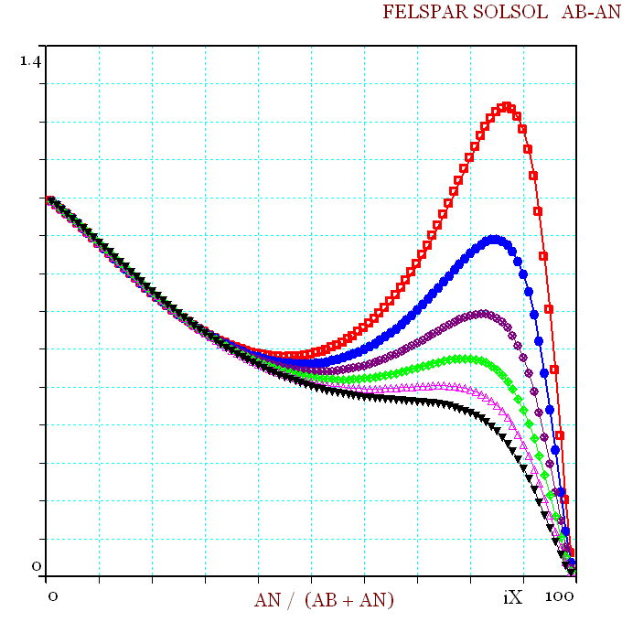 | 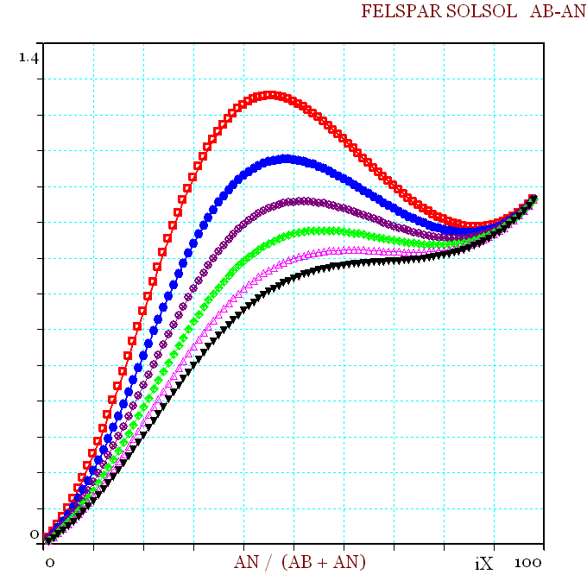
activity of albite in plagioclase as function of mole % anorthite, along the albite - anorthite binary | activity of anorthite in plagioclase, as a function of mole % anorthite, along the albite- anorthite binary

The implementation of a mixing model can also be tested by running equilibrium calculations along a composition path, using the free energy minimization module GEM. An example is given below for the feldspar mixing model of Fuhrman & Lindsley (1988), where the compositions of coexisting alkali-feldspar and plagioclase are shown for a system composition changing from Ab₄₉Or₅₀An₁ to Ab₁Or₅₀An₄₉.

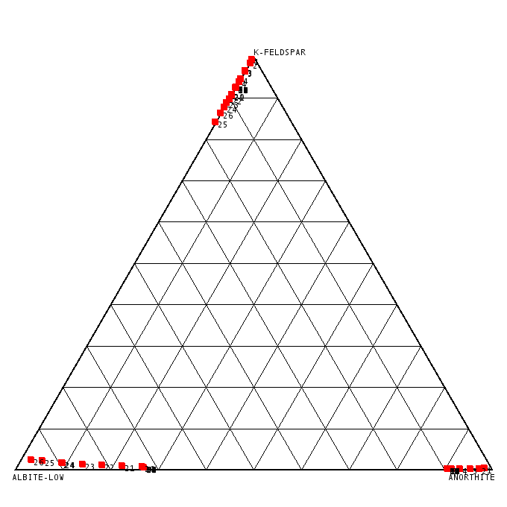
400°C/1kbar

600°C/4kbar
3 phases
Φ=2
Φ=3
Φ=2
Φ=2

_

kinetic database
The kinetic database contains the parameters for the methods that compute the rates of precipitation / dissolution of kinetic phases (minerals) as a function of fluid composition, saturation state with respect to fluid (quantified by Q/K), and temperature.
The specific rate (mole /time /surface) of phase iM is calculated as the product of two factors, R_{Act}(iM). R_{QsK}(iM), where
▷ R_{QsK} is an "affinity factor", which is a function of the saturation state of the phase against the fluid.
▷ R_{Act} is an "activity factor", a function of the chemical characteristics of the fluid (the nature and activities of "inhibitors" and "activators"),
R_{QsK} is computed as (1 - (Q/K)^{α})^{β}, where α and β are parameters with default value 1.
R_{Act} is computed as the sum of up to N terms, each being the product of a temperature-dependent factor, k(T), by the activity of an aqueous species raised to a given power.
The following extract from database kinetic_usgs.dtb illustrates the format used to input the parameters:
ALBITE USGS2004-1068
& DISSOL 1 1 QsK
& DISSOL 10.6 65 H+ 0.457
& DISSOL 15.6 71 H+ -0.572
& DISSOL 12.56 69.8 H2O 0
& PRECIP 1 1 QsK
& PRECIP 10.6 65 H+ 0.457
& PRECIP 15.6 71 H+ -0.572
& PRECIP 12.56 69.8 H2O 0
The keywords DISSOL/ PRECIP signals whether the subsequent parameters are for dissolution or precipitation factor.
Then the line should contain two numbers, followed by either the keyword QSK, or the name of an aqueous species.
If the word is QSK, then the numbers are the parameters α and β of the affinity factor:
, or
If it is a species name, the numbers are the parameters of the "activity factor": successively the colog of coefficient K at 25°C and the activation energy (in kiloJoules) used for computing K at another temperature T (in Kelvin).
In the example given here, the "activity factor" would be computed as follows, as a sum of three terms,

In this example, the rate appears as a combination of three mechanisms, one that dominates in low-pH fluid, one at neutral condition, one at high-pH (exponent to H⁺ activity being negative).
More complex mechanisms, involving up to three species, can be taken into account, as illustrated by the example of pyrite (Palandri and Kharaka, 2004):
PYRITE USGS2004-1068
& DISSOL 7.52 56.9 H+ -0.5 FE+3 0.5
& DISSOL 4.55 56.9 H2O 0 O2(AQ) 0.5

Values currently tabulated in kinetic_usgs.dtb are essentially retrieved from a compilation by Palandri and Kharaka (2004). Experimental data on precipitation kinetics are scarce, most data in this compilation come from dissolution experiments, and parameters for precipitation kinetics are taken identical to dissolution parameters.
The database format, however, allows implementation of distinct laws for precipitation and dissolution, as illustrated by the following example, which reproduces parameters used by Soler & Lasaga (1998):
GIBBSITE
& DISSOL 7 9 QSK
& DISSOL 10.28 60 H+ 0.29
& DISSOL 11.73 60 H2O 0
& DISSOL 9.94 60 H+ -0.3
& PRECIP 1.1 0 QSK
& PRECIP 10.67 60 H+ 0.29
& PRECIP 12.12 60 H2O 0
& PRECIP 10.32 60 H+ -0.3

