SPC: examples of speciation runs
The following examples illustrate some speciation calculations possible with ARXIM.
The text of the actual script is given on left side, results are represented on right side with diagrams drawn with ArximDraw (ARXIM's drawing program).

carbonate speciation as a function of pH ("Sillen diagram")
define the system,  total carbonate = 0.1 mole/kgH2O  SYSTEM  TdgC 25  C MOLE CO2(AQ) 0.1  H PK H+ 7.00  END  program a path,  changing the constraint on H:  PATH CHANGE  H initial 0.00 final 14.0 delta 0.5  END | 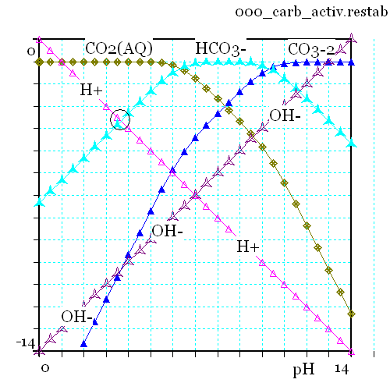

carbonate speciation under fixed CO2 partial pressure
define the system,  SYSTEM  TdgC 25  C PK CO2(G) 3.0  H PK H+ 7.00  END  program a path,  changing the constraint on H:  PATH CHANGE  H initial 4.00 final 10.0 delta 0.5  END | 