
الجامعة السورية الخاصة
كلية الهندسة المعلوماتية
اختصاص هندسة البرمجيات ونظم المعلومات
مشروع التخرج (2)

Electronic Clothing Stores System
Student Preparation:
Moayed Arab Al Halabi Radwan Ajaj
4210293 4210176
supervision:
Dr. Fadi Ibrahim
2026

إقرار المشرف
أشهد بأن إعداد هذا المشروع الموسوم
نظام المتاجر الالكترونية للألبسة
والمعد من قبل الطلاب:
مؤيد مازن عر ب الحلبي-رضوان محمد زهير عجاج
تحت إشرافي في قسم هندسة البرمجيات ونظم المعلومات في كلية هندسة الحاسوب والمعلوماتية والاتصالات وهو جزء من متطلبات نيل الاجازة في هندسة البرمجيات ونظم المعلومات
المرتبة العلمية: ....................
الاسم: ..............................
التوقيع:.............................
التاريخ:.............................

Summary

The "Electronic Marketing System for Clothing" project aims to create a modern digital platform that connects users with store owners under the supervision of a manager. This platform allows users to search for clothing and browse stores and products easily, while simultaneously providing store owners with an effective means to showcase their products and increase their sales online.
The system offers a range of core services such as: account creation and management, advanced search using filters (city, type, size, price), adding stores and products to favorites, rating stores and products, managing stores and products by store owners, and overall supervision and content management by the system manager.

This project aims to:
Facilitating the marketing and sale of clothing through an integrated electronic platform.
Providing an easy and fast shopping experience for users with the ability to compare and choose.
Supporting shop owners with a modern means to reach more customers and increase sales opportunities.

Index

contens
1.2 Project Objectives 7
1.3 Proposed System 7
1.4 Report Organization 8
1.5 Summary 8
Chapter Two - Basic Concepts and Reference Study 10
1: Noon – Fashion Department A multi-vendor marketplace platform in the Middle East, with an Arabic interface, extensive search filters (category, price, size…), wishlist, offers, cash on delivery, and returns in specific countries 10
Existing points: 11
1: Advanced Filtering and Search System 11
2: Customer review system with star ratings and texts. 11
Points not present: 11
1: Lack of an intelligent recommendation engine 11
2: Absence of Augmented Reality feature 11
Link: noon.complay.google.comnoon.complay.google.com 11
2: Namshi A prominent online fashion store in the Gulf (now part of the Noon group), offering mobile applications, wide reach, and numerous brands. 11
Existing points: 11
1: Real-time Notification System 11
2: Personal Recommendation Engine Based on Purchase History 11
Points not present: 11
1: Very limited review system 11
2: No support for third-party sales 12
Link: https://www.namshi.com/uae-enhttps://www.namshi.com/uae-en 12
3: Ounass A luxury store focusing on luxury brands, fast delivery service, and clear return policies in supported countries. 12
Existing points: 12
1: Secure electronic payment with advanced encryption 12
2: Strong integration with actual inventory management 12
Points not present: 12
1: Absence of a loyalty or rewards system 12
2: There is no "Cash on Delivery" option available. 12
Link: en-saudi.ounass.comen-saudi.ounass.com 12
4: Max Fashion (Max Fashion MENA) A regional retailer with an Arabic interface, offering online shopping with Click & Collect from branches, a return policy, and mobile applications. 13
Existing points: 13
1: Order Tracking System 13
2: Cash on Delivery 13
Points not present: 13
1: Lack of an advanced review system 13
2: No loyalty system 13
Link: . https://www.maxfashion.com/ae/en+1https://www.maxfashion.com/ae/en+1 13
Comparison Table Between Sites: 14
Key Conclusions: 15
2.2 Questionnaire 15
2.3 Project Importance 16
2.4 Summary 16
2.5 The percentage for some of the questions mentioned in the questionnaire 17
2.5 Summary of the Insights Gained from the Questionnaire Values: 19
Chapter Three - Analytical Study of the Proposed System 21
1 Introduction 21
2. Project Plan 21
2.1. Gantt Chart 21
2.2. Methodology Followed 22
3- Requirements Document for the Proposed System 23
3.1- SRS Document (IEEE 830) 23
Project Charter 23
Project Objectives: 24
Stakeholders: 24
Statement of Work (SOW): 25
Project Description: 25
Project Scope: 25
Project Objectives: 25
Deliverables: 25
Project Requirements: 25
Assumptions: 25
Human Resources: 26
Timeline: 26
System Description: 26
- Ease of use of the user interface. 26
- Multiple stores on one platform. 26
- A comprehensive product evaluation system. 26
- Ability to customize offers and discounts. 26
- User and Permissions Management. 26
System stakeholders: 26
System Requirements 27
1. Functional Requirements 27
User 27
• Delete a specific product. 28
1- Response Time: 29
- The website page response time must be less than 2 seconds to achieve a smooth and fast user experience. 29
- Content must be loaded quickly and efficiently to avoid delays in content display for users. 29
2- Resource Utilization: 29
- Database usage must be optimized and queries executed efficiently to reduce the time taken to retrieve data and improve the performance of data reading and writing. 29
3- Endurance: 29
- The site must handle a large number of users and requests during peak periods. 29
- Performance and site resilience must be improved when handling large volumes of data. 29
4- Application Response: 29
- The application must have fast performance in executing calculations and operations related to finance and inventory. 29
4- Performance Test: 31
- The system's performance must be thoroughly tested to ensure its rapid and effective responsiveness. 31
- The system's tolerance to high loads must be tested. 31
5- Stability Test: 31
- System stability must be tested when operating for extended periods of time and under different conditions. 31
- Fault handling and data recovery must be tested in the event of system failure. 31
1- Technology Constraints: 32
- 2. Time Constraints: 32
- objectives on time. 32
3. Resource Constraints: 32
4. Security and Privacy Constraints: 32
6. Compatibility and Response Constraints: 32
4. Requirements Modeling 33
4.1 Use Case Diagram 33
4. Requirements Modeling 34
4.2 Use Case Diagram 34
Supervisor Use Cases 47
4.3 Activity Diagram 66
4.2 Sequence Diagram 78
4.2.3 Login Sequence Diagram 78
4.2 Database Schema (ERD Diagram) 84
-5 Database Requirements 85
First: Model (Model) 95
Responsibilities: 95
• Definition of the data structure (tables) in the database. 95
• Defining field types (text, number, date...). 95
• Creating relationships between tables (OneToMany, ManyToMany...). 95
• Performing operations on data using ORM ( 95
• Validate data before saving. 95
Examples of tasks: 95
• Create a product table containing the name, price, and stock. 95
• Link the orders table with users and products. 95
Second: View (View) 96
• Sending data to the template for display. 96
• Specify the response type (HTML, JSON, Redirect) 96
Examples of tasks: 96
• Display the product list. 96
• Login form processing. 96
• Executing an operation to delete an item from the database. 96
Third: Template 96
3 Explanation of the (MVT) Architecture with Client-Server: 97
1 Introduction 99
2. Tools Used 99
2.1-System Tools 99
2.1.1 visual studio code 99
2.1.2 draw.io 99
2.1.3.XAMPP 99
2.2 Languages Used 100
2.2.1 HTML 100
2.2.2 CSS 100
2.2.3 JavaScript 101
2.2.4 MySQL bench 101
2.2.7 Bootstrap 101
3- System Interfaces 102
Login page 3.1 102
3.2 Account Creation 102
3.3 The Main Interface 103
3.14 Product Presentation 108
3.15 Favorites List 109
3.13 Sales Register Interface 109
3.16 Product Creation Interface 110
3.17 Product Modification Interface 110
3.18 Piece Count Specification Interface 111
3.19 Purchase Installation Interface 111
Chapter Six - Conclusions and Future Prospects 113
4.1 Analysis of Results and Conclusions: 113
4.2 Future Prospects 114

List of Abbreviations

HTML | Hypertext Markup Language
CSS | Cascading Style Sheets
PHP | Personal Home Pages
SQL | Structure Query Language
UML | Unified Modeling Language
ERD | Entity Relationship Diagram
MVT | Model ,view, template

Table (1): List of Abbreviations

Chapter One
Introduction
Chapter One – Introduction

1 Introduction
In recent years, the world has witnessed a significant shift towards e-commerce as one of the most important modern methods of marketing and sales, where reliance on digital platforms has become a necessity to keep up with technological developments and meet customer needs. Amid increasing competition among retail stores, the need arose for an integrated electronic system that helps store owners display their products in an organized and attractive manner, while providing users with an easy and fast shopping experience.
From this perspective, the project "Electronic Marketing System for Clothing" was developed to be a digital platform that connects users and store owners under the supervision of a system manager. It allows users to browse products, select the most suitable ones, and provide ratings, while store owners can manage their products and increase their sales, with full supervision ensuring service quality and credibility.

1.2 Project Objectives
- Establishing an integrated electronic platform for online marketing and sales.
- Facilitating the process of searching for clothing using multiple filters such as: type, size, price, and city.
- Providing an effective marketing channel for shop owners to help them reach a larger segment of customers.
- Enabling the product and store rating feature to increase transparency and improve service quality.
- Ensuring a safe and organized environment under the supervision of the system manager to monitor activities and control content quality.

1.3 Proposed System
The proposed system is an electronic marketing platform for clothing that operates via the web. The system also provides an integrated experience that facilitates the buying and selling process and offers an interactive environment that contributes to the development of the electronic marketing sector.

1.4 Report Organization

Chapter One: Introduction
Chapter Two: Basic Concepts and Reference Study
Chapter Three: Analytical Study of the Proposed System
Chapter Four: Design Study of the Proposed System
Chapter Five: Practical Application
Chapter Six: Conclusions and Future Prospects

1.5 Summary

This project resulted in the development of an electronic marketing system for clothing aimed at facilitating the buying and selling process online between store owners and users. Through this system, requirements were analyzed, the system was designed, and implemented in a manner that aligns with user needs. The system also helped enhance store management efficiency, simplify product accessibility, and improve the user experience. This project represents a fundamental step towards developing more integrated systems in the future, contributing to supporting digital transformation and e-commerce on a broader scale.

Chapter Two
Basic Concepts and Reference Studies

Chapter Two - Basic Concepts and Reference Study

2.1 Introduction
Amid the rapid development of e-commerce and the increasing reliance of people on online shopping, it has become essential to provide specialized digital platforms that meet users' needs with greater flexibility and ease. From this perspective, we have created an e-marketing website dedicated to clothing stores, serving as a direct link between store owners on one side and users seeking clothing and suitable offers on the other.
2.2 Similar Systems
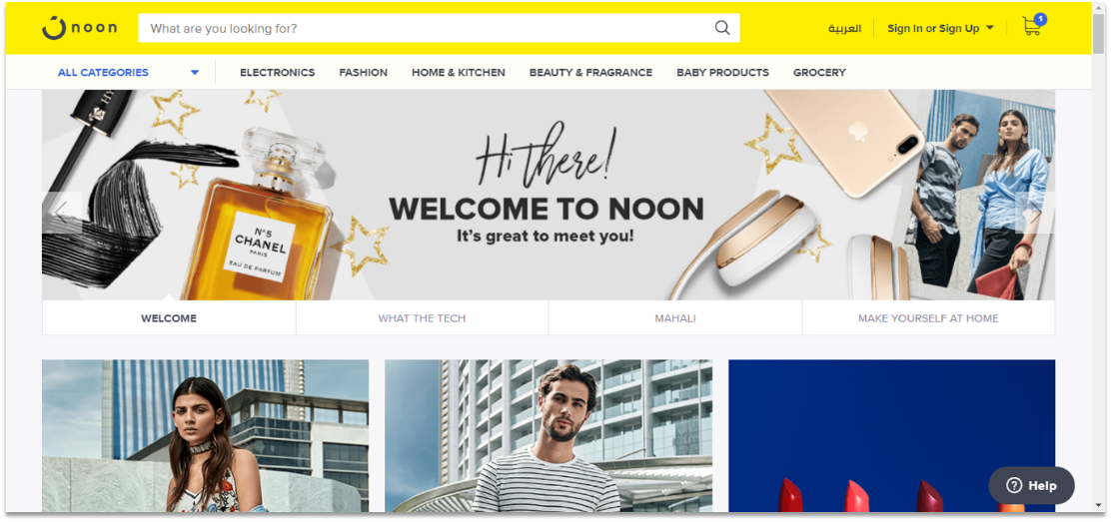

1: Noon – Fashion Department
A multi-vendor marketplace platform in the Middle East, with an Arabic interface, extensive search filters (category, price, size…), wishlist, offers, cash on delivery, and returns in specific countries

Existing points:

1: Advanced Filtering and Search System

2: Customer review system with star ratings and texts.

Points not present:

1: Lack of an intelligent recommendation engine

2: Absence of Augmented Reality feature

Link: noon.complay.google.comnoon.complay.google.com
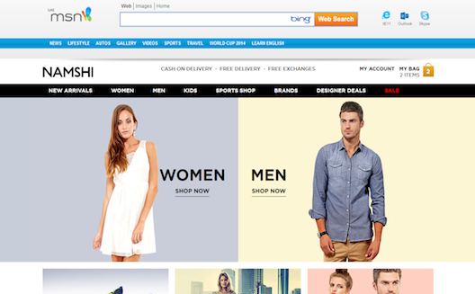

2: Namshi
A prominent online fashion store in the Gulf (now part of the Noon group), offering mobile applications, wide reach, and numerous brands.

Existing points:

1: Real-time Notification System

2: Personal Recommendation Engine Based on Purchase History

Points not present:

1: Very limited review system

2: No support for third-party sales

Link: https://www.namshi.com/uae-enhttps://www.namshi.com/uae-en
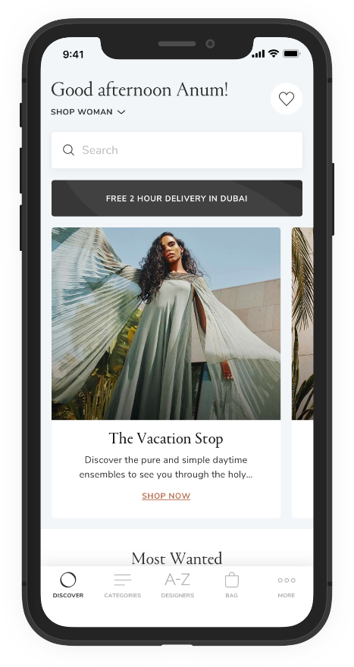

3: Ounass
A luxury store focusing on luxury brands, fast delivery service, and clear return policies in supported countries.

Existing points:

1: Secure electronic payment with advanced encryption

2: Strong integration with actual inventory management

Points not present:

1: Absence of a loyalty or rewards system

2: There is no "Cash on Delivery" option available.

Link: en-saudi.ounass.comen-saudi.ounass.com
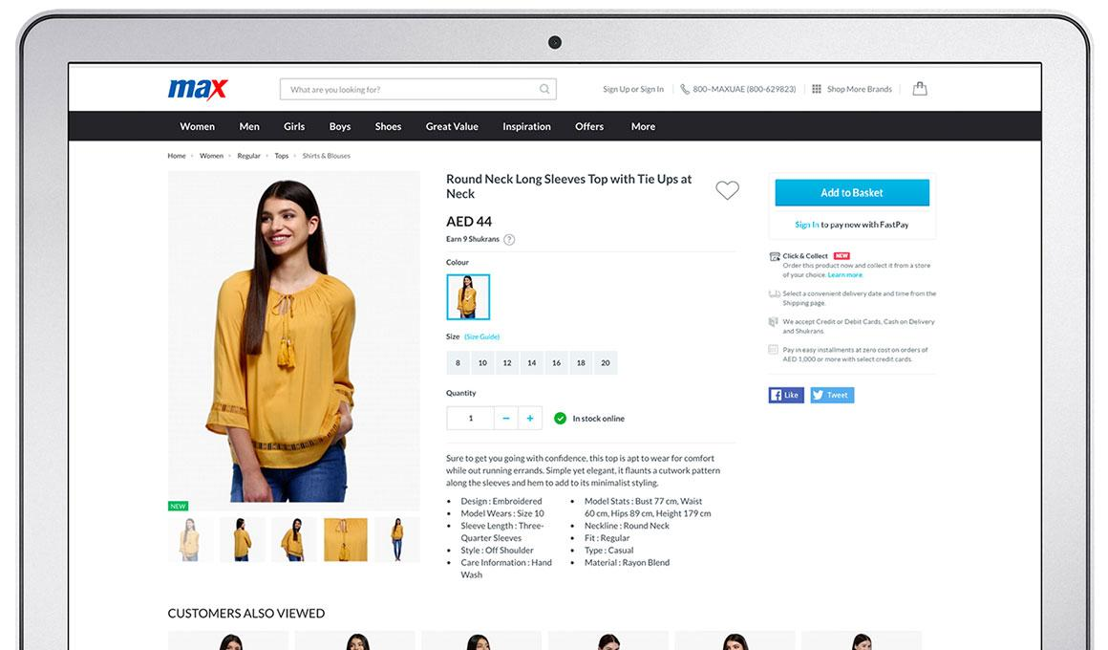

4: Max Fashion (Max Fashion MENA)
A regional retailer with an Arabic interface, offering online shopping with Click & Collect from branches, a return policy, and mobile applications.

Existing points:

1: Order Tracking System

2: Cash on Delivery

Points not present:

1: Lack of an advanced review system

2: No loyalty system

Link: . https://www.maxfashion.com/ae/en+1https://www.maxfashion.com/ae/en+1

Summary
The primary goal of developing this system is to facilitate the process of accessing and comparing products through an organized and user-friendly interface, in addition to enabling store owners to manage their products and offers effectively. This project also aims to address shortcomings found in some other platforms, such as limited search flexibility, restricted filtering options, or the absence of a customized offers feature.

Comparison Table Between Sites:
Ounass | Max  (MAX) | Noon Fashion | Namshi | Site or System
✔ | ✔ | ✔ |  | Easy-to-use Arabic interface
✔ |  | ✔ |  | Supporting Local Shop Owners
✔ | ✔ | ✔ | ✔ | Fashion Variety (Men/Women/Children)
✔ |  | ✔ |  | Cash on delivery payment method
✔ | ✔ | ✔ | ✔ | Evaluation Management System for Stores and Clothing
✔ | ✔ |  | ✔ | Store management capability by the shop owner
 | ✔ |  | ✔ | Availability of a mobile application
✔ | ✔ | ✔ | ✔ | Continuous Offers and Discounts

Key Conclusions:
1: Noon Fashion website: the best in terms of variety and support for store owners
2: Namshi website: Does not have a cash payment method, only through the bank.
3: Max (MAX): The best in terms of offers and discounts
4: Ounass: the best in terms of search and filtering

2.2 Questionnaire
Through the reference study to assist us in building our application, we prepared an electronic questionnaire containing 25 questions to include a segment of the community to identify the information they care about within the site. A total of 125 questionnaires were sent for responses.
Survey Results: The total number of responses reached approximately 100.
The questionnaire included some of the following questions:
- Were you able to find the products you were looking for easily?
- How would you like to receive notifications about available parts offers?
- How important is it to see real images of the available parts in each store?
- Would you prefer to see reviews from users who have the same size and body type as you?
Survey link: https://forms.gle/MgzeK5F8xcCprcZG8https://forms.gle/MgzeK5F8xcCprcZG8

2.3 Project Importance
- Ease of use of the user interface.
- Multiple stores on one platform.
- A comprehensive product evaluation system.
- Ability to customize offers and discounts.
- User and Permissions Management.
- Comprehensive management of parties (Admin – Store Owner – User).

2.4 Summary
This project aims to develop an electronic marketing system for clothing that combines ease of use with management flexibility, allowing store owners to showcase their products through a professional interface, while providing users with a seamless experience for purchasing clothes online. In building the system, the focus was on meeting the requirements of the regular user, system administrator, and store owner, ensuring that each party receives the tools and functionalities they need.

2.5 The percentage for some of the questions mentioned in the questionnaire

1: Were you able to find the products you were looking for easily?

2: How would you like to receive notifications about offers on available parts?

3: How important is it to see real images of the available parts in each store?

4: Do you prefer to see reviews from users who have the same size and body type as you?

2.5 Summary of the Insights Gained from the Questionnaire Values:
This survey aims to analyze user experiences on electronic clothing sales websites similar to the site, with the goal of identifying functional requirements for developing an integrated website.
The results showed that 65% of participants were able to find products easily, indicating the importance of a smart and organized search interface.
Regarding offer notifications, 50% of users preferred to receive them directly through the application, reinforcing the need for an effective internal notification system.
It was also found that 70% consider real product images an essential element for making a purchasing decision, necessitating support for the user image display feature.
In terms of reviews, 75% saw the importance of having evaluations from users with the same size and body type, which is an indicator of the necessity to personalize the shopping experience.
Overall, these results clarify that reliability and personalization are the most prominent factors in user satisfaction.
The study recommends integrating artificial intelligence technologies in recommendations, size customization, and improving search engines within the site.
These indicators represent a strong foundation for designing a more interactive and suitable e-commerce platform for modern user experiences.

Chapter Three
Analytical Study of the Proposed System

Chapter Three - Analytical Study of the Proposed System

1 Introduction
After reviewing similar systems and conducting the survey to gather all the information that would assist us in building our website, and after learning about the services of each site and examining the features that can be added to our site, we analyzed the collected requirements and derived the following:

2. Project Plan

2.1. Gantt Chart
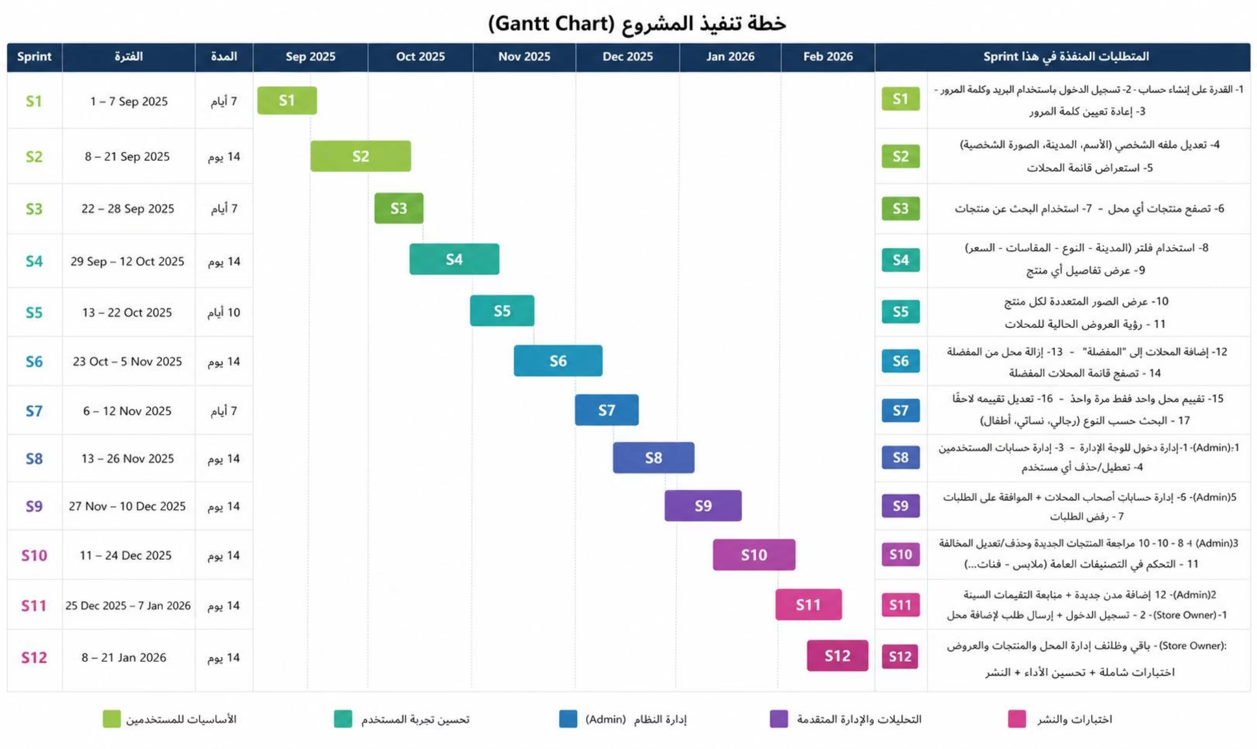
Figure (1): Gantt Chart

2.2. Methodology Followed
Agile methodology is an approach in software and technical project development that involves dividing the development process into a series of short cycles or iterations, where a part of the project is developed in each iteration. The main goal of this methodology is to improve quality, performance, and project control by focusing on the continuous improvement of small parts.

Agile Methodology Stages:
- Basic Planning
- Repetition
- Evaluation
- Planning for the next iteration
- Execution
- Continuous Evaluation and Improvement

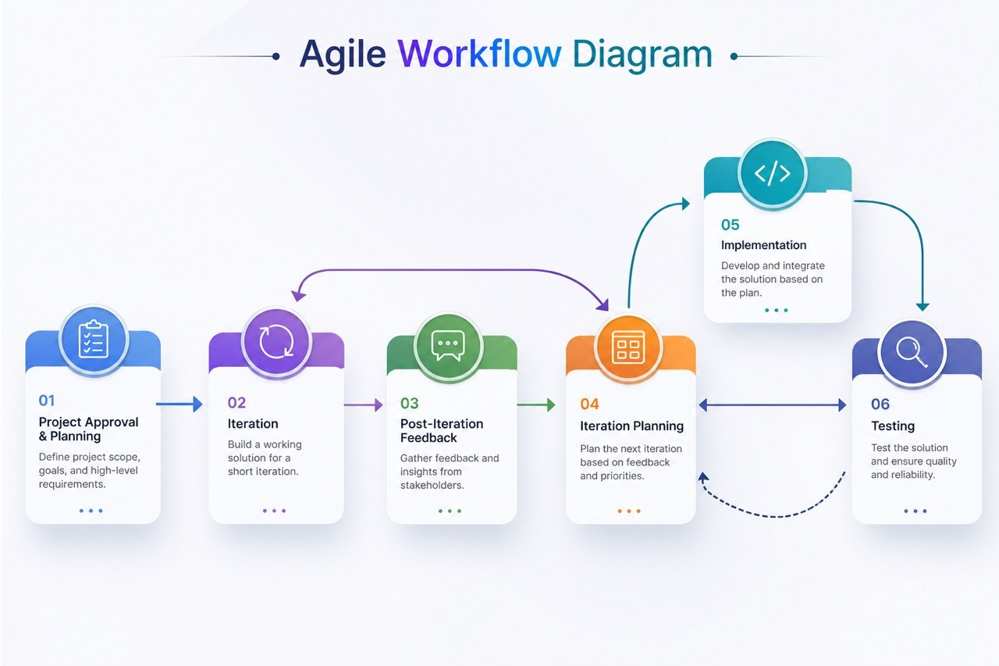

3- Requirements Document for the Proposed System

3.1- SRS Document (IEEE 830)
It is a document that defines the requirements of the software to be developed. This document contains a detailed description of the functions and features that the software must include, in addition to the functional and non-functional requirements and other considerations related to the system.
The SRS contains the following components:
Project Name: Web Application Hosting Multiple Clothing Stores
Introduction:
The primary goal of developing this system is to facilitate the process of accessing and comparing products through an organized and user-friendly interface, in addition to enabling store owners to manage their products and offers effectively.
4- Project Charter and Adopted Approach:

Project Charter

An official document issued to initiate the project, providing a clear understanding of it, and serving as a reference point for decisions and project management.
Project Title: Electronic Stores System for Clothing
Project Start Date: Jan 5, 2026
Project End Date: May 25, 2026
Project Supervisor: Dr. Fadi Ibrahim
Students: Radwan Ajaj, Moayad Arab Al-Halabi
Project Methodology: Scrum + Agile

Project Objectives:

- - Establishing an integrated electronic platform for online marketing and sales.
- Facilitating the process of searching for clothing using multiple filters such as: type, size, price, and city.
- Providing an effective marketing channel for shop owners to help them reach a larger segment of customers.
- Enabling the product and store rating feature to increase transparency and improve service quality.
Project Approach:
1: Defining the project scope and objectives
2: Gathering and Analyzing System Requirements
3: Conducting a detailed system analysis
4: System Design and Architecture with a Focus on User Experience
According to the timeline

Stakeholders:

Stakeholder | Role | Responsibility
Dr. Fadi Ibrahim | Supervisor | Provides guidance and evaluation
Radwan Ajaj | Frontend Developer | Builds and connects user interface
Moayad Arab Alhalabi | Backend Developer | Implements backend logic and manages database

Statement of Work (SOW):

Project Description:
The project aims to build an electronic marketing platform for users and store owners to facilitate buying and selling operations online and enhance the user experience.

Project Scope:
The project involves creating a secure and simple electronic platform that supports clothing display and enhances communication between the manager and shop owners.

Project Objectives:
- Developing an electronic platform that facilitates communication between the manager and shop owners.
Providing an easy-to-use interface for displaying clothing and services.

Deliverables:
Project Plan.
System Requirements Specification (SRS) Document.
Final project report.
An integrated electronic system that includes both the front-end and back-end.

Project Requirements:
Programming Languages: Python, HTML, CSS
Django (Backend), Bootstrap (Frontend)
Database: MySQL

Assumptions:
- Continuous availability of feedback from the supervisor and stakeholders.
- Organized supervision and periodic review by the supervisor.

Human Resources:
Project Supervisor: Dr. Fadi Ibrahim
Student Developers: Radwan Ajaj, Moayad Arab Al-Halabi

Timeline:
Project Start Date: Jan 5 | 2026
Seminar 1: Feb 20 | 2026
Second Seminar: April 26 | 2026
Final Seminar: Jun 2 | 2026

System Description:
- Ease of use of the user interface.
- Multiple stores on one platform.
- A comprehensive product evaluation system.
- Ability to customize offers and discounts.
- User and Permissions Management.
- Comprehensive management of parties (Admin – Store Owner – User).
- Enabling shop owners to manage their businesses efficiently.
- Providing search and filtering features on demand.
- Simplifying content management through control panels for shop owners.

System stakeholders:

    - 1: Admin

    - 2: store owner

    - 3: User

System Requirements

1. Functional Requirements

User
- Ability to create an account.
- Log in using email and password.
- Password Reset.
- Edit profile (name, city, profile picture)
- Store list review.
- Browse products of any store.
- Using search to find products.
- Use filter (City - Type - Sizes - Price).
- Display details of any product.
- Display multiple images for each product.
- Viewing current store promotions.
- Adding stores to "Favorites".
- Remove store from favorites.
- Browse the list of favorite stores.
- Evaluation of only one site once.
- His evaluation will be modified later.
- Search by type (Men, Women, Children).
- Search by category (T-shirts, pants, jackets...).
- Defining a price range for the search.

Admin
- Admin panel login..
- User Account Management.
- Disable/Delete any user.
- Store owners' account management.
- Approval of store addition requests.
- Rejection of store requests.
- Editing any store's data.
- Delete any location.
- Review of new products.
- Delete or modify the violating products.
- Control of general classifications (Clothing – Categories...).
- Adding new cities to the system.
- Follow-up on poor evaluations.

store owner
- Login to the store dashboard.
- Submit a request to add a new store.
- Edit store information (name, city, phone number...).
- Upload a photo of the store or the logo.
- Adding new products.
- Editing existing products.
- Delete a specific product.
- Adding multiple images for each product.
- Determining the price and sizes of the product.
- Product classification by type (Men's, Women's...).
- Add a new offer for any product.
- Modify or delete the offer.
- Specifying the offer validity period.
- Stop the presentation before it ends

.

2. Non-Functional Requirements
- Performance:

- The system must be capable of handling the required number of users without any degradation in performance.
- Security:

- The system must be secure from unauthorized access

-This requirement may be fulfilled in the system through:

- Ease of use:

- The interfaces between the system and the system administrator are user-friendly and clear, which helps the user interact effectively with the system.

-This requirement has been achieved in our system through the design of user interfaces that are easy and comfortable to use.
- Maintainability
- The system must be easy to maintain and update
- The requirement in the system is verified by using the MVT framework, which helps separate the system components from each other, thereby facilitating the application maintenance process.

- Availability:
The operating status of the system or component and its accessibility when needed for use.

Performance Requirements
- Response Time:
- The website page response time must be less than 2 seconds to achieve a smooth and fast user experience.
- Content must be loaded quickly and efficiently to avoid delays in content display for users.
- Resource Utilization:
- Database usage must be optimized and queries executed efficiently to reduce the time taken to retrieve data and improve the performance of data reading and writing.
- Endurance:
- The site must handle a large number of users and requests during peak periods.
- Performance and site resilience must be improved when handling large volumes of data.

- Application Response:
- The application must have fast performance in executing calculations and operations related to finance and inventory.
- The performance and speed of executing search and browsing operations must be improved.

- Scalability:
- The application must be scalable to accommodate an increase in user volume and future requirements.
- The application architecture must be scalable, allowing additional modules and components to be added easily without affecting overall performance.

System Requirements

- User Interface:
- The user interface must be simple and easy to use to enable system actors to navigate and interact easily.
- The user interface must be compatible with various devices and screens used, including desktop computers, tablets, and smartphones.
- Page Design and Structural System:
- Page design must be structurally organized and orderly to enable users to easily find content and functions.
- Pages must be designed to allow fast and flexible navigation between the different sections of the system.
- Database Design:
- The database must be reliable and secure to protect sensitive data and prevent data loss or corruption.
- System Security:
- A system must be designed with high-security standards to protect user data and ensure the confidentiality of personal information.
- Mechanisms must be implemented to combat intrusion and protect the system from cyber attacks.

Test Requirements

1- Functional Test:
- Login and new account creation must be tested to verify the validity of the process.

2- Compatibility Test:
- The system compatibility must be tested with common web browsers and different operating systems.
- The system's responsiveness and responsive design must be tested on various devices and screens used.

3- Security Test:
- User data protection must be tested and the confidentiality of personal information ensured.
- The protection and security mechanism must be tested to prevent unauthorized access.

4- Performance Test:
- The system's performance must be thoroughly tested to ensure its rapid and effective responsiveness.
- The system's tolerance to high loads must be tested.

5- Stability Test:
- System stability must be tested when operating for extended periods of time and under different conditions.
- Fault handling and data recovery must be tested in the event of system failure.

Project Constraints
- Technology Constraints:
- There may be technical constraints related to programming requirements or the tools and technologies used in system development. We may have specific limitations regarding the scope of technical support, computers, and internet connectivity.

- 2. Time Constraints:
- We may face time constraints regarding the scheduling and execution of the project. We must take into account the specified timeline for project delivery and achieving the set objectives on time.

3. Resource Constraints:
- We may have constraints on financial, human, and material resources available for the project. We must manage resource utilization effectively and achieve project objectives with the best use of the available resources.

4. Security and Privacy Constraints:
- We may face security and privacy constraints within the system. We must adhere to data security practices, protect user privacy, and provide a secure environment.

6. Compatibility and Response Constraints:
- We may face limitations regarding platform compatibility with various devices, browsers, and operating systems. We must ensure system compatibility with a wide range of devices and provide a fast and appropriate response for the user experience.

4. Requirements Modeling

4.1 Use Case Diagram
The following figure illustrates the relationships between the functional requirements we have collected and the system stakeholders:
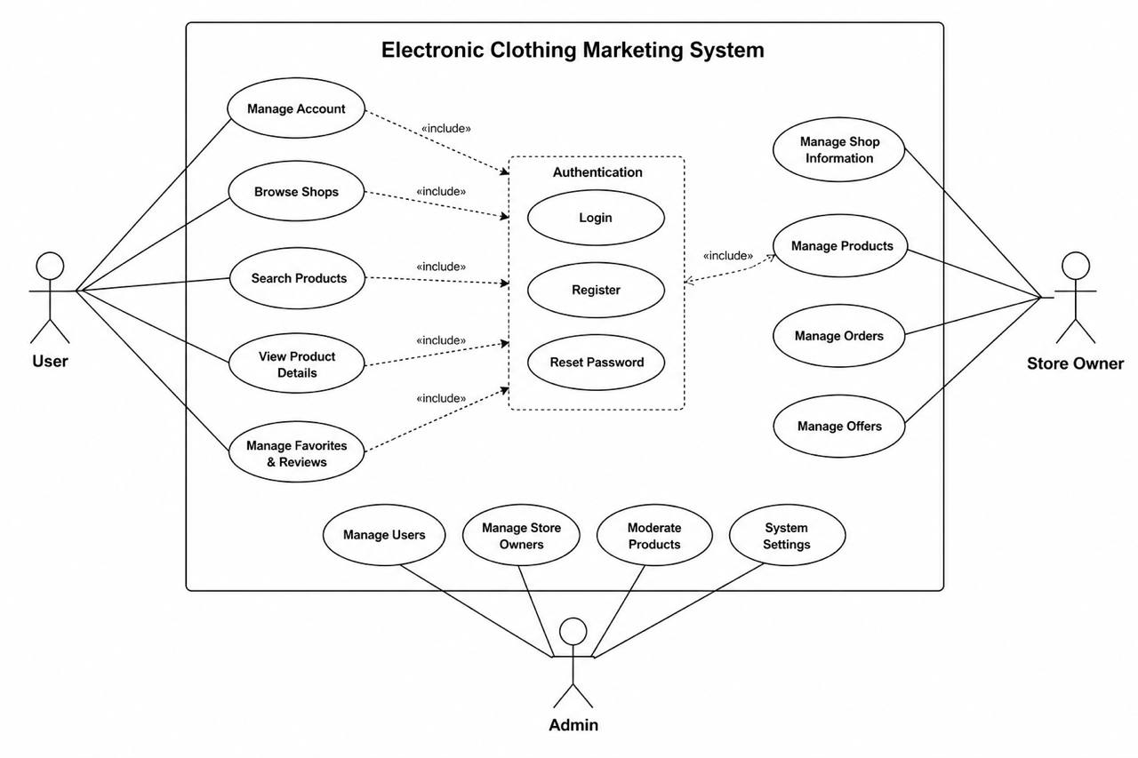
Figure (2): Use Case Diagram
(high level use cases diagram)

4. Requirements Modeling

4.2 Use Case Diagram
The following figure illustrates the relationships between the functional requirements we have collected and the system stakeholders:
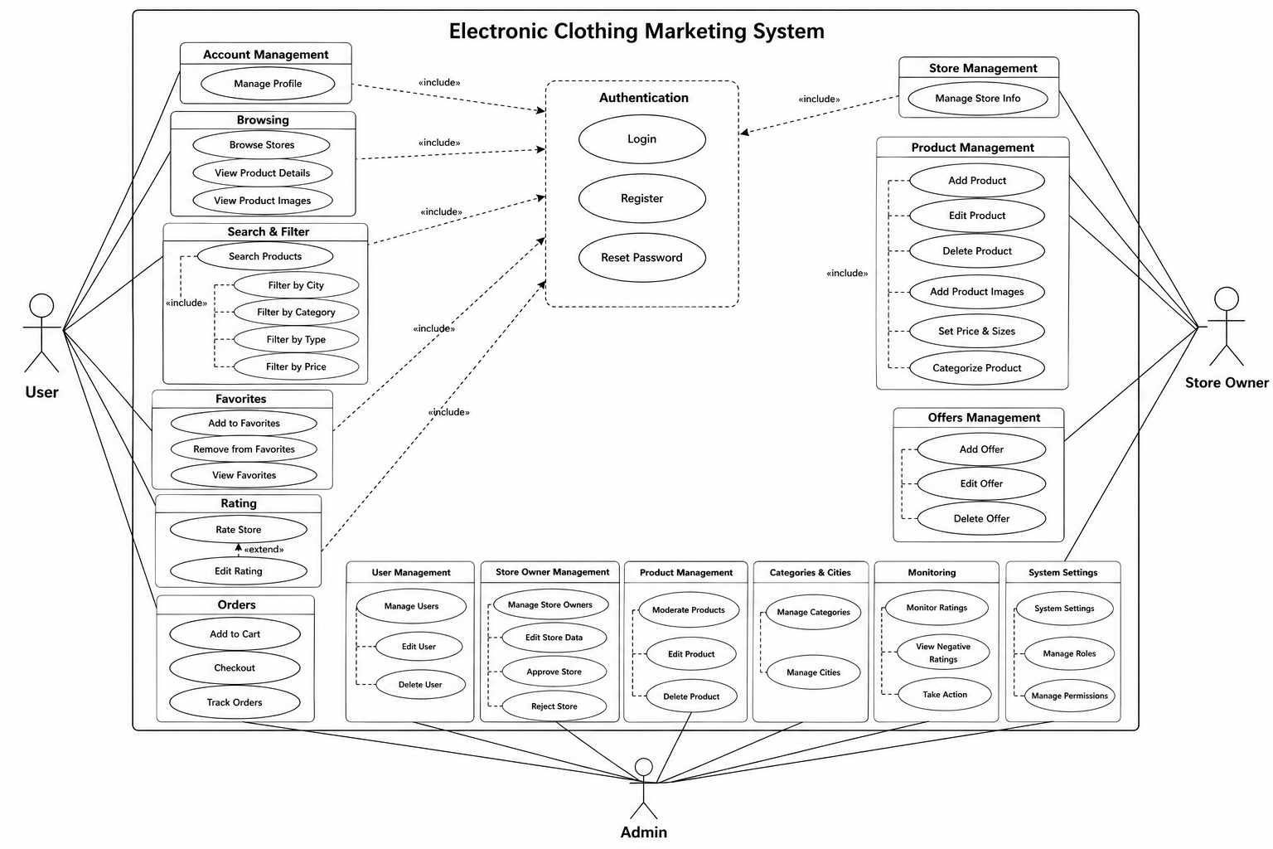
Figure (2): Use Case Diagram
(low level use cases diagram)

Use Case Documentation

4.2.1 Use Case: Create a New Account
Use Case ID | UC-U-001
Use Case Name | Create a New Account
Actors | User
Description | Allows the user to create a new account in the system to access features.
Precondition | The user does not currently have an account in the system.
Main Flow | 1. The user enters the registration information (email, password, confirm password, name, city).  2. The system verifies the validity of the entered data.  3. The system sends an activation email (optional).  4. The account is successfully created.
Alternative Flow | In case of an already registered email: the system displays an error message indicating that the email is already in use.  In case of password mismatch: the system displays an error message indicating that the passwords do not match.
Postconditions | A new account has been created for the user, and they can log in.

4.2.2 Use Case: Login
Use Case ID | UC-U-002
Use Case Name | Login
Actors | User
Description | Allows the user to log in to their account using email and password.
Precondition | The user has a registered account in the system.
Main Flow | 1. The user enters the email and password.  2. The system verifies the validity of the credentials.  3. The user is directed to the homepage or their dashboard.
Alternative Flow | In case of entering incorrect credentials: the system displays an error message stating that the email or password is incorrect.  In case of forgetting the password: the user can click on the 'Forgot Password' link to proceed to the reset process.
Postconditions | The user has successfully logged into the system.

4.2.3 Use Case: Reset Password
Use Case ID | UC-U-003
Use Case Name | Reset Password
Actors | User
Description | Allows the user who forgot their password to reset it.
Precondition | The user forgot their password and has access to the registered email.
Main Flow | 1. The user clicks on the 'Forgot Password' link.  2. The user enters the registered email address.  3. The system sends a password reset link to the email.  4. The user clicks on the link in the email.  5. The user enters and confirms the new password.  6. The password is successfully updated.
Alternative Flow | In case an unregistered email is entered: the system displays an error message indicating that the email does not exist.  In case the link has expired: the system asks the user to request a new link.
Postconditions | The password has been successfully reset, and the user can log in with the new password.

4.2.4 Use Case: Edit Profile
Use Case ID | UC-U-004
Use Case Name | Edit Profile
Actors | User
Description | Allows the user to edit their profile information such as name, city, and profile picture.
Precondition | The user is logged into their account.
Main Flow | 1. The user navigates to the Edit Profile page.  2. The user modifies the required fields (name, city, upload a new image).  3. The user clicks the 'Save Changes' button.  4. The system validates the data.  5. The profile is successfully updated.
Alternative Flow | In case of uploading an invalid image: the system displays an error message indicating that the image format is not supported or the size is too large.  In case of leaving mandatory fields empty: the system displays an error message requesting the completion of the fields.
Postconditions | User profile information has been successfully updated.

4.2.5 Use Case: Store List Review
Use Case ID | UC-U-005
Use Case Name | Store List Review
Actors | User
Description | Allows the user to browse a list of all stores registered in the system.
Precondition | Nothing.
Main Flow | 1. The user navigates to the 'Stores' page.  2. The system displays a list of available stores with basic information (store name, city, rating).
Alternative Flow | In case there are no stores: the system displays a message indicating that there are currently no stores.  In case of a problem connecting to the server: the system displays an error message.
Postconditions | The list of stores was displayed to the user.

4.2.6 Use Case: Browsing Any Store's Products
Use Case ID | UC-U-006
Use Case Name | Browse Aihal Products
Actors | User
Description | Allows the user to browse the products displayed inside a specific store.
Precondition | The user is browsing the list of stores and has selected a specific store.
Main Flow | 1. The user clicks on the store name or its image from the list of stores.  2. The system displays the store page containing all the products offered by this store.
Alternative Flow | In case there are no products for the store: the system displays a message indicating that there are currently no products for this store.  In case the store is not available: the system displays an error message indicating that the store does not exist or is unavailable.
Postconditions | The specified store's products have been displayed to the user.

4.2.7 Use Case: Using Search to Find Products
Use Case ID | UC-U-007
Use Case Name | Using search to find products
Actors | User
Description | Allows the user to search for specific products using keywords.
Precondition | Nothing.
Main Flow | 1. The user enters the search term(s) in the search bar.  2. The user clicks the search button or presses Enter.  3. The system displays a list of products that match the search terms.
Alternative Flow | In case no matching results are found: the system displays a message indicating that there are no products matching the search terms.  In case invalid search terms are entered: the system prompts the user to enter valid search terms.
Postconditions | The search results for the products have been displayed.

4.2.8 Use Case: Using the Filter (City - Type - Sizes – Price)
Use Case ID | UC-U-008
Use Case Name | Using the filter (City - Type - Sizes - Price)
Actors | User
Description | Allows the user to narrow down the product search using multiple filters (city, type, sizes, price).
Precondition | The user is browsing a product list (either from search or navigation).
Main Flow | 1. The user selects the required filters from the available options (e.g., city, type, sizes, price range).  2. The system applies the filters and redisplays the list of products that match the specified criteria.
Alternative Flow | In case no results are found after applying the filters: the system displays a message indicating that there are no products matching the specified criteria.  In case invalid values are entered for the filter: the system displays an error message and requests the entry of valid values.
Postconditions | The filtered product list was displayed to the user.

4.2.9 Use Case: Display Details of Any Product
Use Case ID | UC-U-009
Use Case Name | Display details of any product
Actors | User
Description | Allows the user to view the full details of a specific product, such as the description, price, and available sizes.
Precondition | The user is browsing a product list and has selected a specific product.
Main Flow | 1. The user clicks on the product image or its name from the product list.  2. The system displays the product details page containing the full description, price, available sizes, and more information.
Alternative Flow | In case product details are not available: the system displays an error message indicating that details for this product are currently unavailable.  In case the product does not exist: the system displays an error message indicating that the product does not exist or has been deleted.
Postconditions | The product details page was displayed to the user.

4.2.10 Use Case: Display Multiple Images for Each Product
Use Case ID | UC-U-010
Use Case Name | Display multiple images for each product
Actors | User
Description | Allows the user to view all available images for a specific product.
Precondition | The user is viewing the product details page.
Main Flow | 1. The user clicks on the main product image or browses the thumbnail image gallery.  2. The system displays multiple product images in a large image gallery or allows navigation between them.
Alternative Flow | In case there are no additional images: the system displays a message indicating that there are no additional images for this product.  In case of an issue loading the images: the system displays an error message.
Postconditions | Multiple images of the product were displayed to the user.

4.2.11 Use Case: Viewing Current Store Offers
Use Case ID | UC-U-011
Use Case Name | Viewing current store promotions
Actors | User
Description | Allows the user to browse all currently available offers and discounts from various stores.
Precondition | Nothing.
Main Flow | 1. The user navigates to the 'Offers' section.  2. The system displays a list of all active offers, with details such as the offer name, discount percentage, and included products.
Alternative Flow | In case there are no current offers: the system displays a message indicating that there are no offers available at the moment.  In case an offer has expired: the offer does not appear in the list or appears as 'Expired'.
Postconditions | The current offers list was displayed to the user.

4.2.12 Use Case: Adding Stores to Favorites
Use Case ID | UC-U-012
Use Case Name | Adding stores to favorites
Actors | User
Description | Allows the user to add their favorite stores to a special list for quick access.
Precondition | The user is logged in and is viewing a specific store page.
Main Flow | 1. The user clicks on the 'Add to Favorites' icon (such as a star or heart) on the store page.  2. The system confirms the addition of the store to the user's favorites list.
Alternative Flow | If the store is already in the favorites: the icon changes to indicate that it is already a favorite, or the system displays a message stating this.  If not logged in: the system requires the user to log in first.
Postconditions | The store has been added to the user's favorites list.

4.2.13 Use Case: Remove Store from Favorites
Use Case ID | UC-U-013
Use Case Name | Remove store from favorites
Actors | User
Description | Allows the user to remove a store from their list of favorite stores.
Precondition | The user is logged in and the store is in their favorites list.
Main Flow | 1. The user navigates to the 'Favorites' list.  2. The user clicks on the 'Remove from Favorites' icon (such as a filled star or heart) next to the store to be removed.  3. The system confirms the removal of the store from the Favorites list.
Alternative Flow | If the store is not in favorites: the removal icon does not appear or the system displays an error message.  If not logged in: the system prompts the user to log in first.
Postconditions | The store has been removed from the user's favorites list.

4.2.14 Use Case: Browsing the Favorite Stores List
Use Case ID | UC-U-014
Use Case Name | Browse the list of favorite stores
Actors | User
Description | Allows the user to view the list of stores they have added to their favorites.
Precondition | The user is logged in and has stores in the favorites list.
Main Flow | 1. The user navigates to the 'Favorites' section.  2. The system displays a list of all stores that the user has added to favorites.
Alternative Flow | If there are no stores in the favorites: the system displays a message indicating that the favorites list is empty.  If not logged in: the system prompts the user to log in first.
Postconditions | The user's list of favorite stores was displayed.

4.2.15 Use Case: Evaluate Only One Site Once
Use Case ID | UC-U-015
Use Case Name | Evaluation of only one store once
Actors | User
Description | Allows the user to rate a specific store only once.
Precondition | The user is logged in and has not rated this store before.
Main Flow | 1. The user navigates to the store page to be reviewed.  2. The user selects the rating (e.g., number of stars).  3. The user can add a comment (optional).  4. The user clicks the 'Submit Rating' button.  5. The system confirms receipt of the rating.
Alternative Flow | In case of attempting to evaluate a store that has been previously evaluated: the system displays a message indicating that this store has already been evaluated and suggests the option to edit.  In case of not being logged in: the system requires the user to log in first.
Postconditions | A new rating has been added for the store.

4.2.16 Use Case: Modify Evaluation Later
Use Case ID | UC-U-016
Use Case Name | Modify its evaluation later
Actors | User
Description | Allows the user to edit the rating they previously submitted for a specific store.
Precondition | The user is logged in and has previously rated this store.
Main Flow | 1. The user navigates to the page of the store they have reviewed.  2. The user finds their previous review and selects the 'Edit Review' option.  3. The user modifies the review (star rating) and the comment (optional).  4. The user clicks the 'Save Changes' button.  5. The system confirms the review update.
Alternative Flow | In the absence of a previous evaluation: the edit option does not appear.  If not logged in: the system prompts the user to log in first.
Postconditions | The user rating for the store has been successfully updated.

4.2.17 Use Case: Search by Type (Men, Women, Children)
Use Case ID | UC-U-017
Use Case Name | Search by type (Men, Women, Children)
Actors | User
Description | Allows the user to search for products based on their type (Men's, Women's, Children's).
Precondition | Nothing.
Main Flow | 1. The user selects the search option by type.  2. The user specifies the desired type (Men, Women, or Children).  3. The system displays a list of products that match the specified type.
Alternative Flow | In case there are no products for the specified type: the system displays a message indicating that there are no products for this type.  In case of selecting a non-existent type: the system displays an error message.
Postconditions | The search results for products were displayed by type.

4.2.18 Use Case: Search by Category (T-shirts, Pants, Jackets)
Use Case ID | UC-U-018
Use Case Name | Search by category (T-shirts, Pants, Jackets)
Actors | User
Description | Allows the user to search for products based on their category (such as T-shirts, pants, jackets).
Precondition | Nothing.
Main Flow | 1. The user selects the search option by category.  2. The user specifies the desired category (e.g., T-shirts, pants, jackets).  3. The system displays a list of products that match the specified category.
Alternative Flow | In case there are no products for the specified category: the system displays a message indicating that there are no products for this category.  In case a non-existent category is selected: the system displays an error message.
Postconditions | The search results for products were displayed according to the category.

4.2.19 Use Case: Defining a Price Range for Search
Table: Use Case for Defining a Price Range for Search
Use Case ID | UC-U-019
Use Case Name | Defining a Price Range for the Research
Actors | User
Description | Allows the user to set a minimum and maximum price when searching for products.
Precondition | The user is performing a product search or browsing.
Main Flow | 1. The user enters the minimum and maximum price in the filtering fields.  2. The system applies the price filter and displays the products whose prices fall within the specified range.
Alternative Flow | In case an illogical price range is entered (e.g., the minimum is greater than the maximum): the system displays an error message.  If there are no products within the price range: the system displays a message indicating that no matching products are found.
Postconditions | Search results for products within the specified price range have been displayed.

Supervisor Use Cases

4.2.21 Use Case: Admin Panel Login
Use Case ID | UC-A-001
Use Case Name | Login to the Admin Panel
Actors | Supervisor
Description | Allows the supervisor to log in to the admin panel to access control tools.
Precondition | The supervisor has valid credentials (username and password).
Main Flow | 1. The supervisor enters the username and password on the login page.  2. The system verifies the validity of the credentials and the supervisor's permissions.  3. The supervisor is directed to the administrative control panel.
Alternative Flow | In case of entering incorrect credentials: the system displays an error message stating that the username or password is incorrect.  In case of lack of permissions: the system displays a message indicating that there is no permission to access.
Postconditions | The supervisor has successfully logged into the administration panel.

4.2.22 Use Case: User Account Management
Use Case ID | UC-A-002
Use Case Name | User Account Management
Actors | Supervisor
Description | Allows the supervisor to view and edit the account information of users registered in the system.
Precondition | The supervisor is logged into the admin panel.
Main Flow | 1. The supervisor navigates to the 'User Management' section.  2. The system displays a list of all user accounts.  3. The supervisor can search for a specific user or browse the list.  4. The supervisor selects a user account to modify its information (such as name, city).  5. The supervisor saves the changes.
Alternative Flow | In the absence of users: the system displays a message indicating that there are no registered users.  In case of attempting to modify invalid data: the system displays an error message.
Postconditions | User accounts have been successfully managed.

4.2.23 Use Case: Disable/Delete Any User
Use Case ID | UC-A-003
Use Case Name | Disable/Delete Any User
Actors | Supervisor
Description | Allows the supervisor to disable or delete any user's account from the system permanently or temporarily.
Precondition | The supervisor is logged into the admin panel.
Main Flow | 1. The supervisor navigates to the 'User Management' section.  2. The supervisor selects the user to be disabled/deleted.  3. The supervisor confirms the disable/delete action.  4. The system disables/deletes the user account.
Alternative Flow | In case of attempting to delete the administrator's own account: the system prevents this operation.  In case the user does not exist: the system displays an error message.
Postconditions | The user account has been successfully disabled/deleted.

4.2.23 Use Case: Store Owners' Account Management
Use Case ID | UC-A-004
Use Case Name | Shop Owners Account Management
Actors | Supervisor
Description | Allows the supervisor to view and edit the account information of shop owners registered in the system.
Precondition | The supervisor is logged into the admin panel.
Main Flow | 1. The supervisor navigates to the 'Shop Owners Management' section.  2. The system displays a list of all shop owner accounts.  3. The supervisor can search for a specific shop owner or browse the list.  4. The supervisor selects a shop owner account to edit its information.  5. The supervisor saves the changes.
Alternative Flow | In the absence of shop owners: the system displays a message indicating that no registered shop owners exist.  In case of attempting to modify invalid data: the system displays an error message.
Postconditions | Store owners' accounts have been successfully managed.

4.2.24 Use Case: Approval of Store Addition Requests
Use Case ID | UC-A-005
Use Case Name | Approval of Store Addition Requests
Actors | Supervisor
Description | Allows the supervisor to review and approve shop owners' requests to add new shops to the system.
Precondition | The supervisor is logged into the admin panel and there are pending requests to add stores.
Main Flow | 1. The supervisor navigates to the 'Store Requests' section.  2. The supervisor reviews the order details (store name, contact information, documents).  3. The supervisor verifies the accuracy of the information.  4. The supervisor clicks the 'Approve' button.  5. The store is added to the system and activated.
Alternative Flow | In the absence of pending requests: the system displays a message indicating that there are currently no requests.  In case of missing or incorrect information: the supervisor can request additional information or reject the request.
Postconditions | The request to add the store has been approved, and the store has been activated in the system.

4.2.25 Use Case: Rejecting Store Requests with Reason Provided
Use Case ID | UC-A-006
Use Case Name | Rejection of store requests with reasons stated
Actors | Supervisor
Description | The supervisor is allowed to reject requests for adding new stores with a reason for the rejection provided.
Precondition | The supervisor is logged into the admin panel and there are pending requests to add stores.
Main Flow | 1. The supervisor navigates to the 'Store Requests' section.  2. The supervisor reviews the order details.  3. The supervisor clicks the 'Reject' button.  4. The supervisor enters the reason for rejection in a designated field.  5. The supervisor confirms the rejection.  6. A notification is sent to the store owner regarding the rejection.
Alternative Flow | In case the reason for rejection is not entered: the system requests the supervisor to enter the reason.  In case there are no pending requests: the system displays a message indicating that there are currently no requests.
Postconditions | The request to add the store was rejected, and the store owner was informed of the reason.

4.2.26 Use Case: Modify Any Store Data
Use Case ID | UC-A-007
Use Case Name | Edit Any Store Data
Actors | Supervisor
Description | Allows the supervisor to modify any data related to any store registered in the system.
Precondition | The supervisor is logged into the admin panel.
Main Flow | 1. The supervisor navigates to the 'Store Management' section.  2. The supervisor selects the store whose data needs to be modified.  3. The supervisor edits the required fields (such as name, city, phone number, description).  4. The supervisor clicks the 'Save Changes' button.  5. The store data is successfully updated.
Alternative Flow | In case of attempting to modify invalid data: the system displays an error message.  In case the store does not exist: the system displays an error message.
Postconditions | The store data has been updated successfully.

4.2.27 Use Case: Delete Any Store
Use Case ID | UC-A-008
Use Case Name | Delete any location
Actors | Supervisor
Description | Allows the supervisor to permanently delete any store registered in the system.
Precondition | The supervisor is logged into the admin panel.
Main Flow | 1. The supervisor navigates to the 'Store Management' section.  2. The supervisor selects the store to be deleted.  3. The supervisor confirms the deletion process (additional confirmation may be required).  4. The system deletes the store along with all associated products and offers.
Alternative Flow | In case the store does not exist: the system displays an error message.  In case the deletion process is canceled: the store is not deleted.
Postconditions | The store and all its associated data have been successfully deleted.

4.2.28 Use Case: Reviewing New Products
Use Case ID | UC-A-009
Use Case Name | New Product Review
Actors | Supervisor
Description | Allows the supervisor to review new products added by shop owners before displaying them to the public.
Precondition | The supervisor is logged into the admin panel, and there are new products awaiting review.
Main Flow | 1. The supervisor navigates to the 'Product Review' section.  2. The supervisor reviews the new product details (images, description, price).  3. The supervisor decides to approve or reject the product.  4. If approved, the product is displayed to the public. If rejected, the supervisor can provide a reason.
Alternative Flow | In the absence of products for review: the system displays a message indicating that there are no new products.  In the case of a non-compliant product: the supervisor can reject or modify it.
Postconditions | The product has been reviewed and the appropriate action has been taken (approval/rejection).

4.2.29 Use Case: Deleting or Modifying Non-Compliant Products

Use Case ID | UC-A-010
Use Case Name | Deletion or Modification of Non-Compliant Products
Actors | Supervisor
Description | The supervisor is allowed to delete or modify products that violate system policies or contain inappropriate content.
Precondition | The supervisor is logged into the admin panel and there are violating products.
Main Flow | 1. The supervisor identifies the violating product (through review or reports).  2. The supervisor selects the 'Delete' or 'Edit' option.  3. In the case of deletion, the supervisor confirms the operation. In the case of editing, the supervisor corrects the content.  4. The changes are applied to the product.
Alternative Flow | In case there are no violating products: No action is required.  If it is not possible to modify the product: The supervisor can delete it.
Postconditions | The non-compliant product has been handled (deleted or modified) to comply with system policies.

4.2.30 Use Case: Managing General Classifications (Clothing – Categories...)
Use Case ID | UC-A-011
Use Case Name | Control of General Classifications (Clothing – Categories...)
Actors | Supervisor
Description | Allows the supervisor to manage the main and subcategories of products (add, edit, delete).
Precondition | The supervisor is logged into the admin panel.
Main Flow | 1. The supervisor navigates to the 'Category Management' section.  2. The supervisor can add a new category (such as 'Clothing', 'Shoes').  3. The supervisor can edit the name of an existing category.  4. The supervisor can delete a category (ensuring there are no products linked to it or transferring them).  5. The supervisor saves the changes.
Alternative Flow | In case of attempting to delete a category linked to products: the system prevents deletion and requires transferring the products first.  In case of entering a duplicate category name: the system displays an error message.
Postconditions | The general classifications in the system have been successfully updated.

4.2.31 Use Case: Adding New Cities to the System
Use Case ID | UC-A-012
Use Case Name | Adding New Cities to the System
Actors | Supervisor
Description | Allows the supervisor to add new cities to the list of cities supported by the system.
Precondition | The supervisor is logged into the admin panel.
Main Flow | 1. The supervisor navigates to the 'City Management' section.  2. The supervisor enters the name of the new city.  3. The supervisor clicks the 'Add' button.  4. The city is added to the list of available cities in the system.
Alternative Flow | In case an already existing city name is entered: the system displays an error message.  In case an invalid city name is entered: the system requests entering a valid name.
Postconditions | A new city has been successfully added to the system.

4.2.32 Use Case: Monitoring Poor Evaluations
Use Case ID | UC-A-013
Use Case Name | Monitoring poor evaluations
Actors | Supervisor
Description | Allows the supervisor to monitor the negative evaluations received by stores or products in order to take the necessary actions.
Precondition | The supervisor is logged into the admin panel.
Main Flow | 1. The supervisor navigates to the 'Evaluations' section.  2. The system filters and displays evaluations below a certain level (poor evaluations).  3. The supervisor reviews the details of the evaluations and the relevant stores/products.  4. The supervisor can contact the store owner or take other actions.
Alternative Flow | In the absence of negative reviews: the system displays a message indicating this.  In the case of fraudulent reviews: the administrator can delete them.
Postconditions | The negative evaluations were monitored and the necessary actions were taken.

Use Cases for the Shop Owner

4.2.33 Use Case: Registering as a Store Owner
Use Case ID | UC-SO-001
Use Case Name | Registration as a Shop Owner
Actors | Shop owner
Description | Allows the user to register in the system as a shop owner to create and manage their own shop.
Precondition | The user does not currently have a store owner account.
Main Flow | 1. The user selects the option 'Register as a Shop Owner'.  2. The user enters the registration information (email, password, contact information, business information).  3. The system verifies the data validity.  4. The shop owner account is successfully created.
Alternative Flow | In case of a previously registered email: the system displays an error message.  If the conditions are not met: the system requires all conditions to be fulfilled.
Postconditions | A new shop owner account has been created, and they can log in.

4.2.34 Use Case: Logging into the Store Dashboard
Use Case ID | UC-SO-002
Use Case Name | Login to the store dashboard
Actors | Shop owner
Description | The shop owner is allowed to log in to their control panel to manage their operations.
Precondition | The shop owner has an account registered in the system.
Main Flow | 1. The store owner enters the email address and password on the store owners' login page.  2. The system verifies the validity of the credentials.  3. The store owner is directed to their store's control panel.
Alternative Flow | In case of entering incorrect credentials: the system displays an error message.  In case of forgetting the password: the store owner can use the 'Forgot Password' option.
Postconditions | The shop owner has successfully logged into their shop's control panel.

4.2.35 Use Case: Submit a Request to Add a New Store

Use Case ID | UC-SO-003
Use Case Name | Send a request to add a new store
Actors | Shop owner
Description | The store owner is allowed to submit a request to add a new store to the system for review by the supervisors.
Precondition | The shop owner is logged in and currently does not have a registered shop or wishes to add another shop.
Main Flow | 1. The store owner navigates to the 'Add New Store' section.  2. The store owner enters all the required information about the store (name, address, city, phone number, description, category).  3. Uploads a store image or logo.  4. Clicks the 'Submit Request' button.  5. The system confirms receipt of the request and sends it for review.
Alternative Flow | In case all mandatory fields are not completed: the system requests their completion.  In case an invalid image is uploaded: the system displays an error message.
Postconditions | The request to add a new store has been successfully sent and is awaiting supervisor review.

4.2.36 Use Case: Edit Store Data (Name, City, Phone Number...)
Use Case ID | UC-SO-004
Use Case Name | Edit store information (name, city, phone number...)
Actors | Shop owner
Description | The shop owner is allowed to modify the basic information of their shop registered in the system.
Precondition | The shop owner is logged in and has a shop registered in the system.
Main Flow | 1. The store owner navigates to the 'Store Data Management' section.  2. They modify the required fields (name, city, phone number, description, working hours).  3. They click the 'Save Changes' button.  4. The system confirms the data update.
Alternative Flow | In case of entering invalid data: the system displays an error message.  If there is no registered store: the edit option does not appear.
Postconditions | The store data has been updated successfully.

4.2.37 Use Case: Upload Store Image or Logo
Use Case ID | UC-SO-005
Use Case Name | Upload a photo of the store or the logo
Actors | Shop owner
Description | The shop owner is allowed to upload a main image of the shop or a custom logo.
Precondition | The shop owner is logged in and has a shop registered in the system.
Main Flow | 1. The store owner navigates to the 'Store Data Management' section.  2. Selects the 'Upload Image/Logo' option.  3. Chooses the image from their device.  4. Clicks the 'Upload' button.  5. The system confirms the image upload and update.
Alternative Flow | In case of uploading an invalid image (format, size): the system displays an error message.  In case of upload failure: the system displays an error message.
Postconditions | The store image or logo has been successfully updated.

4.2.38 Use Case: Adding New Products
Use Case ID | UC-SO-006
Use Case Name | Adding New Products
Actors | Shop owner
Description | Allows the shop owner to add new products to their shop's product list.
Precondition | The shop owner is logged in and has a shop registered in the system.
Main Flow | 1. The store owner navigates to the 'Product Management' section.  2. Clicks on the 'Add New Product' button.  3. Enters all product details (name, description, price, sizes, type, category).  4. Uploads the initial product images.  5. Clicks the 'Save Product' button.  6. The system confirms the product addition and sends it for review (if there is a review system).
Alternative Flow | In case all mandatory fields are not completed: the system requests their completion.  In case of uploading invalid images: the system displays an error message.
Postconditions | A new product has been successfully added to the store.

4.2.39 Use Case: Modify Existing Products
Use Case ID | UC-SO-007
Use Case Name | Modify existing products
Actors | Shop owner
Description | The store owner is allowed to modify the details of products that have been previously added.
Precondition | The shop owner is logged in and has products registered in his shop.
Main Flow | 1. The store owner navigates to the 'Product Management' section.  2. Selects the product to be edited from the list.  3. Modifies the required fields (name, description, price, sizes, images).  4. Clicks the 'Save Changes' button.  5. The system confirms the product update.
Alternative Flow | In case the product is not available: the system displays an error message.  In case of entering invalid data: the system displays an error message.
Postconditions | Product details have been updated successfully.

4.2.40 Use Case: Delete a Specific Product
Use Case ID | UC-SO-008
Use Case Name | Delete a specific product
Actors | Shop owner
Description | The shop owner is allowed to delete a specific product from their shop's product list.
Precondition | The shop owner is logged in and has the product to be deleted in his shop.
Main Flow | 1. The store owner navigates to the 'Product Management' section.  2. Selects the product to be deleted.  3. The store owner confirms the deletion process.  4. The system deletes the product from the store's list.
Alternative Flow | In case the product does not exist: the system displays an error message.  In case the deletion process is canceled: the product is not deleted.
Postconditions | The product has been successfully removed from the store list.

4.2.41 Use Case: Adding Multiple Images for Each Product
Use Case ID | UC-SO-009
Use Case Name | Adding multiple images for each product
Actors | Shop owner
Description | The store owner is allowed to add additional images for a specific product to enhance its display.
Precondition | The store owner is logged in and has the product for which images are to be added.
Main Flow | 1. The store owner navigates to the product edit page.  2. Selects the 'Add Images' option.  3. Uploads new images from their device.  4. Clicks the 'Save Images' button.  5. The system confirms the addition of images to the product.
Alternative Flow | In case of uploading invalid images: the system displays an error message.  In case of exceeding the maximum number of images: the system displays an error message.
Postconditions | Multiple images for the product have been added successfully.

4.2.42 Use Case: Determining the Price and Sizes of the Product
Use Case ID | UC-SO-010
Use Case Name | Determining the product price and sizes
Actors | Shop owner
Description | Allows the store owner to set the price and available sizes for a specific product.
Precondition | The store owner is logged in and has the product whose price and sizes need to be modified.
Main Flow | 1. The store owner navigates to the product edit page.  2. Enters the new product price.  3. Selects the available sizes for the product (e.g., S, M, L, XL).  4. Clicks the 'Save Changes' button.  5. The system confirms the price and size updates.
Alternative Flow | In case of entering an invalid price: the system displays an error message.  In case no sizes are selected: the system requires selecting at least one size.
Postconditions | The price and available sizes for the product have been successfully updated.

4.2.43 Use Case: Product Classification by Type (Men's, Women's...)
Use Case ID | UC-SO-011
Use Case Name | Product classification by type (Men's, Women's...)
Actors | Shop owner
Description | The store owner is allowed to classify the product by type (Men, Women, Children) for easy searching.
Precondition | The store owner is logged in and has the product to be classified.
Main Flow | 1. The store owner navigates to the product edit page.  2. Selects the appropriate product type from the options list (Men, Women, Children).  3. Clicks the 'Save Changes' button.  4. The system confirms the product category update.
Alternative Flow | In case no type is selected: the system requests to select a type.  In case a non-existent type is selected: the system displays an error message.
Postconditions | The product has been successfully classified by type.

4.2.44 Use Case: Add a New Offer for Any Product
Use Case ID | UC-SO-012
Use Case Name | Add a new offer for any product
Actors | Shop owner
Description | Allows the store owner to create a new promotional offer for a specific product.
Precondition | The shop owner is logged in and has a product on which he wants to make an offer.
Main Flow | 1. The store owner navigates to the 'Offers Management' section.  2. Selects the product to create an offer for.  3. Enters the offer details (discount percentage, price after discount, validity period).  4. Clicks the 'Save Offer' button.  5. The system confirms the addition and activation of the offer.
Alternative Flow | In case of entering invalid offer data: the system displays an error message.  If there is already an active offer on the product: the system requires modifying the current offer or deleting it first.
Postconditions | A new product offer has been added successfully.

4.2.45 Use Case: Modify or Delete Offer
Use Case ID | UC-SO-013
Use Case Name | Modify or delete the offer
Actors | Shop owner
Description | The store owner is allowed to modify the details of an existing offer or delete it entirely.
Precondition | The store owner is logged in and has an active offer on a product.
Main Flow | 1. The store owner navigates to the 'Offers Management' section.  2. Selects the offer to be edited or deleted.  3. In case of editing, changes the details (discount rate, price, validity period) and saves the changes.  4. In case of deletion, confirms the deletion process.  5. The system confirms the update/deletion of the offer.
Alternative Flow | In case the offer does not exist: the system displays an error message.  In case of entering invalid data for modification: the system displays an error message.
Postconditions | The offer has been successfully modified or deleted.

4.2.46 Use Case: Specify Offer Validity Period
Use Case ID | UC-SO-014
Use Case Name | Determining the validity period of the offer
Actors | Shop owner
Description | The store owner is allowed to specify the start and end date of the promotional offer validity.
Precondition | The shop owner is logged in and is creating or editing an offer.
Main Flow | 1. During the creation or modification of the offer, the store owner specifies the start date and end date of the offer.  2. Clicks the 'Save' button.  3. The system confirms the assignment of the validity period.
Alternative Flow | In case of entering invalid dates (e.g., expiration date before start date): the system displays an error message.  If the validity period is not specified: the system requests its specification.
Postconditions | The offer validity period has been successfully set.

Activity Diagram

Activity diagram for login

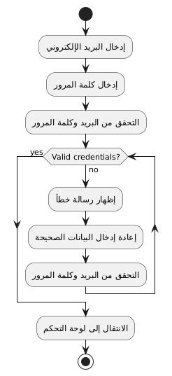
Figure (3): Activity Diagram for Login

Activity Diagram for Password Reset

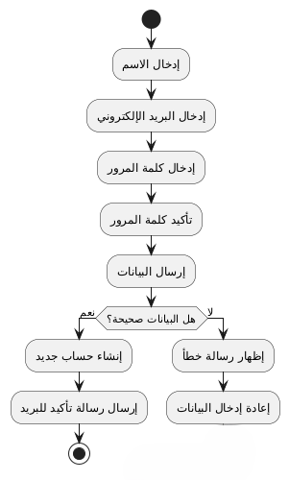
Figure (4): Activity diagram for password reset

4.2.4 Activity Diagram for Editing the Profile
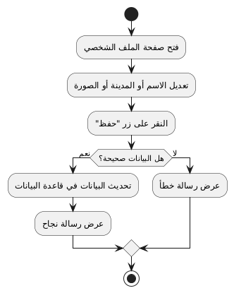
Figure (5): Activity Diagram for Editing the Profile

4.2.5 Activity Diagram for Reviewing the Store List
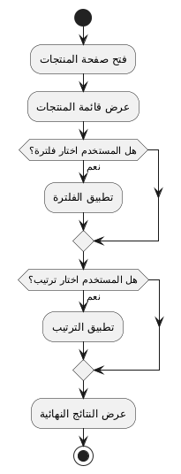
Figure (6): Activity diagram for reviewing the list of stores

4.2.6 Activity Diagram for Displaying Details of a Specific Store

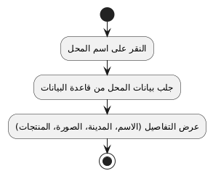
Figure (7): Activity diagram for displaying the details of a specific store

4.2.7 Activity Diagram for Adding a New Product
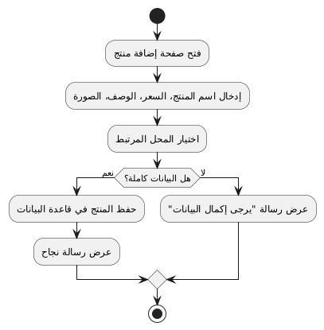
Figure (8): Activity diagram for adding a specific product

4.2.8 Activity Diagram for Product Modification

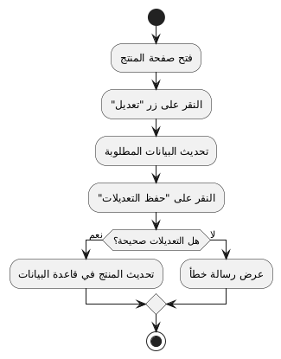
Figure (9): Activity diagram for mine modification

4.2.9 Activity Diagram for Deleting a Product
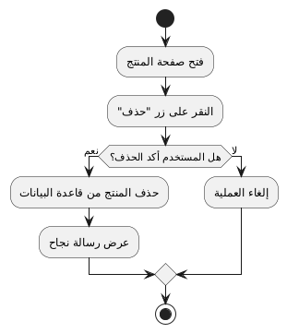
Figure (10): Activity diagram for deleting the mine

4.2.10 Activity Diagram for Sending a Purchase Request
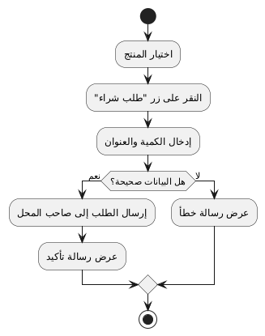
Figure (11): Activity Diagram for Sending a Purchase Request

4.2.11 Activity Diagram for Displaying Product Details
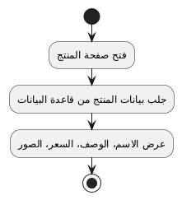
Figure (12): Activity diagram for displaying product details
4.2.12 Activity Diagram for Displaying Multiple Product Images
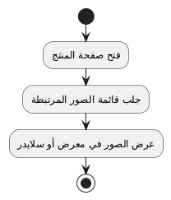
Figure (13): Activity diagram for displaying multiple product images
4.2.13 Activity Diagram for Displaying Current Store Offers
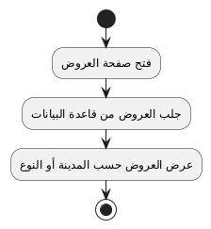
Figure (14): Activity diagram for displaying current offers of stores

4.2.14 Activity Diagram for Adding a Store to Favorites
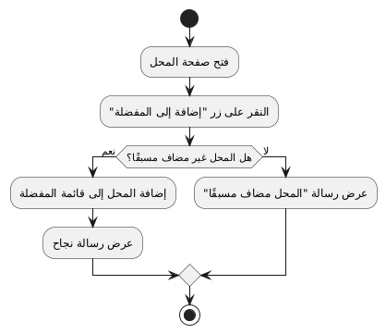
Figure (15): Activity diagram for adding a store to favorites

4.2.15 Activity Diagram for Removing a Store from Favorites
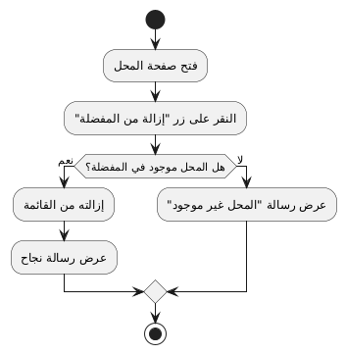
Figure (16): Activity diagram for adding a store to favorites

4.2.16 Activity Diagram for Browsing the Favorite Stores List
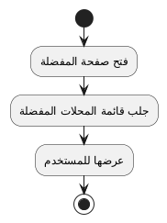
Figure (17): Activity diagram for browsing the favorite stores list

4.2.17 Activity Diagram for One-Time Local Evaluation
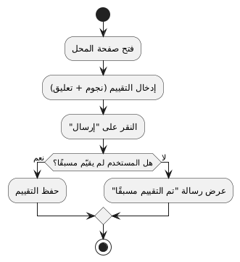

Figure (18): Activity diagram for one-time location evaluation

4.2.18 Activity Diagram for Post-Evaluation Modification
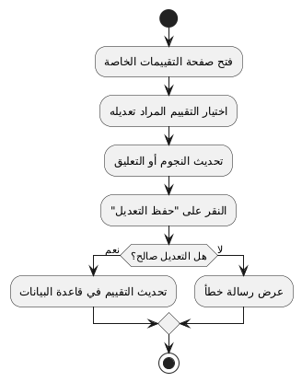
Figure (19): Activity diagram for modifying the evaluation later
4.2.19 Activity Chart for Research by Type (Men, Women, Children)
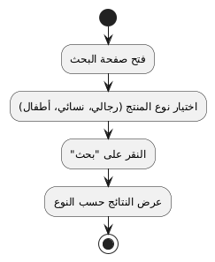
Figure (20): Activity diagram for search by type

4.2.20 Activity Diagram for Defining a Price Range for Research
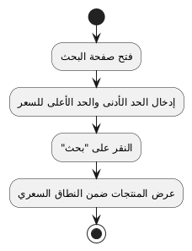
Figure (21): Activity diagram for determining a price range for research
4.2.21 Activity Diagram for Adding a New Product
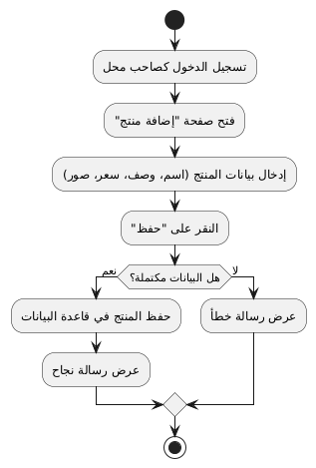
Figure (22): Activity diagram for adding a new product

4.2.22 Activity Diagram for Product Data Modification
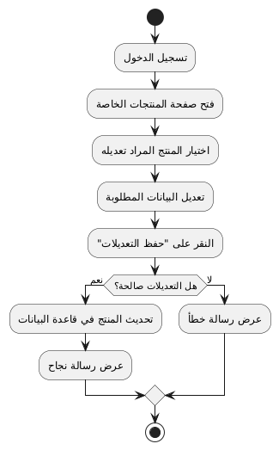
Figure (23): Activity diagram for modifying product data
4.2.23 Activity Diagram for Deleting a Product
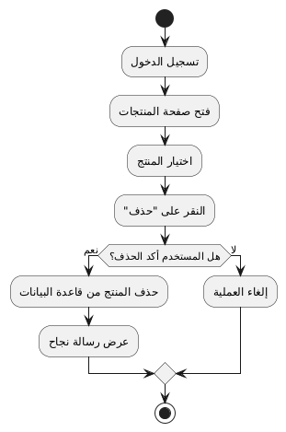
Figure (24): Activity diagram for deleting a product

4.2.24 Activity Diagram for Reviewing Membership Requests
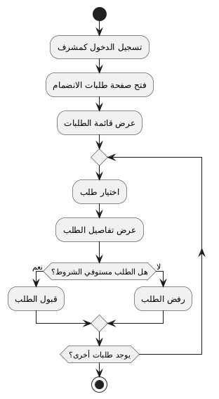
Figure (25): Activity diagram for reviewing membership requests
4.2.25 Activity Diagram for Suspending a Store Account
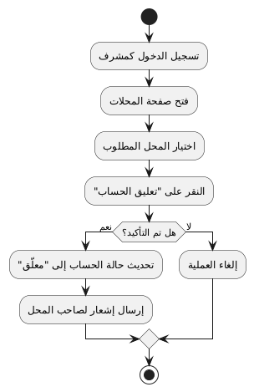
Figure (26): Activity diagram for suspending the store account

Sequence Diagram

Login Sequence Diagram
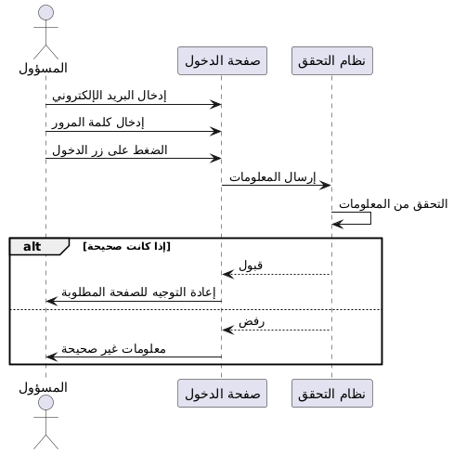
Figure (26): Sequence diagram for login process
4.2.3 Password Reset
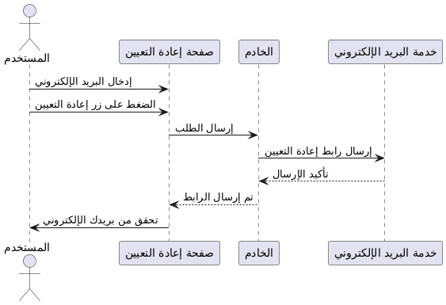

Figure (27): Sequence diagram for password reset
4.2.4 Edit Profile
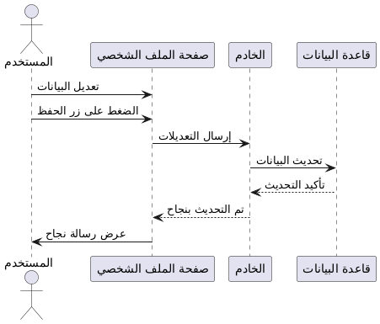
Figure (28): Sequence diagram for profile editing
4.2.5 Store List Review
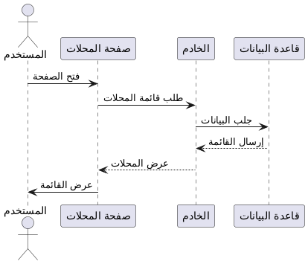
Figure (29): Sequence diagram for browsing the list of stores
4.2.6 Browsing Products of a Specific Store
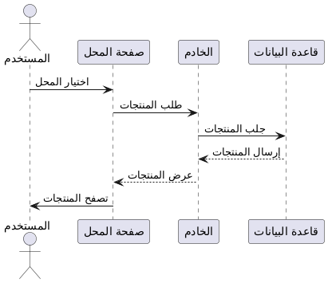
Figure (30): Traceability Diagram Browsing Products of a Specific Store

4.2.7 Product Search
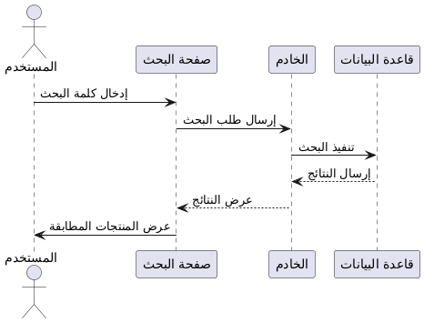
Figure (31): Trace diagram for product search
4.2.8 Use of Filters
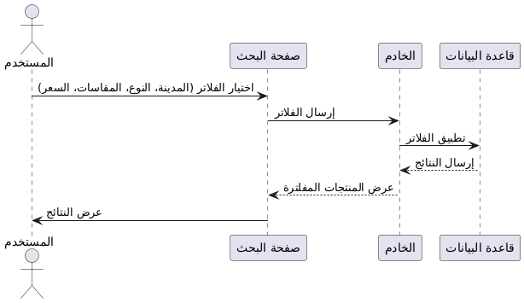
Figure (32): Trace diagram for filter usage
4.2.9 Product Details Display
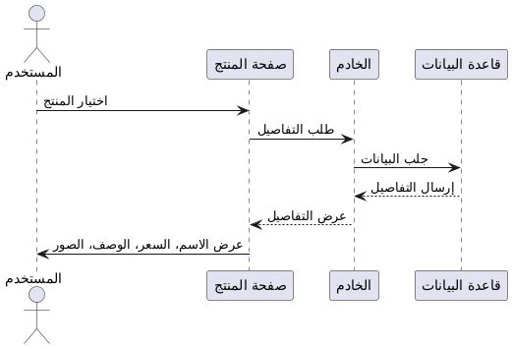
Figure (33): Trace diagram for displaying product details

4.2.10 Display Multiple Images of the Product
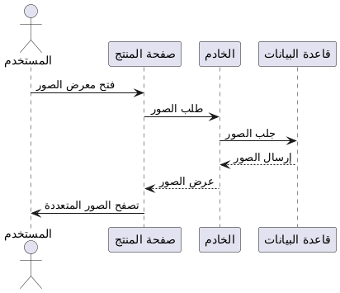
Figure (34): Trace diagram for displaying multiple images of the product

4.2.11 Display Current Bids
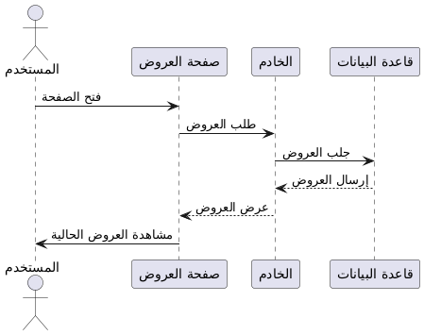
Figure (35): Trace diagram for displaying current offers
4.2.12 Add a Store to Favorites
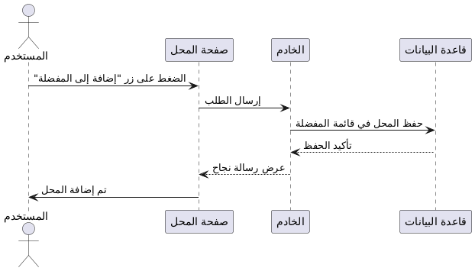
Figure (36): Trace diagram for adding a store to favorites

4.2.13 Browsing the Favorite Stores List
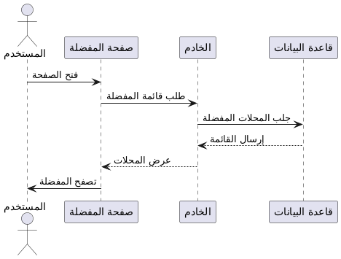
Figure (37): Trace diagram for browsing the favorite stores list

Database Schema (ERD Diagram)

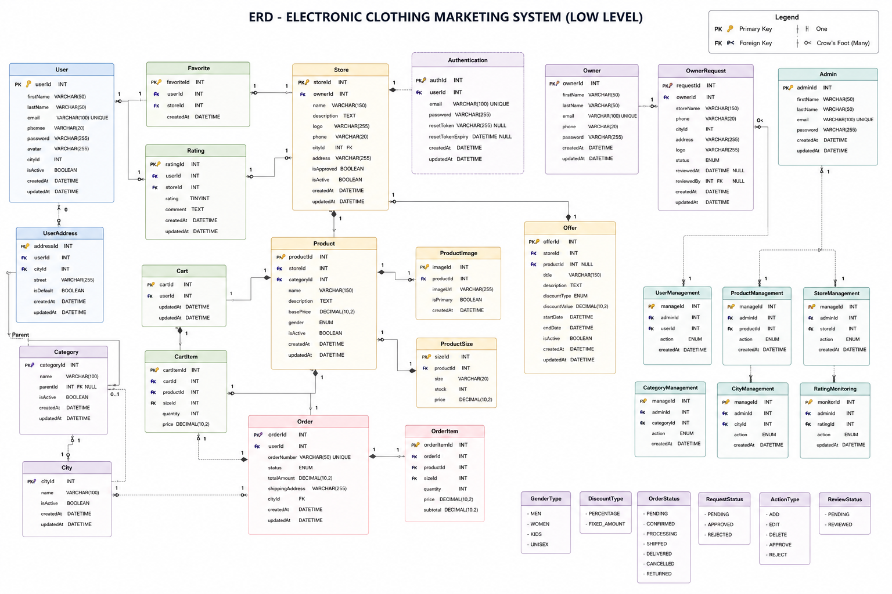

Figure (38): Database Schema

-5 Database Requirements

ID | Title | Description | Type | Source
1 | User Registration | The user must be able to create a new account. | Functional | System
2 | Login | The user must be able to log in using either email or username. | Functional | System
3 | Change Password | The user must be able to change the password. | Functional | User
4 | Manage Profile | The user must be able to edit their personal data. | Functional | User
5 | Create Store | The store owner must be able to create a store | Functional | Store Owner
6 | Store Approval | The manager must be able to approve the stores. | Functional | Admin
7 | Reject Store | The manager must be able to reject a store with the reason stated. | Functional | Admin
8 | Manage Categories | The store owner must be able to manage the sections of their store. | Functional | Store Owner
9 | Add Product | The store owner must be able to add a product. | Functional | Store Owner
10 | Edit Product | The store owner must be able to edit a product. | Functional | Store Owner
11 | Delete Product | The store owner must be able to delete a product. | Functional | Store Owner
12 | Manage Product Sizes | The store owner must be able to specify the sizes and quantities for each product. | Functional | Store Owner
13 | View Stores | The user must be able to browse the authorized stores. | Functional | User
14 | View Store Products | The user must be able to view the products of a specific store. | Functional | User
15 | Filter Products | The user must be able to filter products by price and size. | Functional | User
16 | Add to Cart | The user must be able to add products to the cart. | Functional | User
17 | Update Cart | The user must be able to modify the quantity of a product in the cart. | Functional | User
18 | Remove from Cart | The user must be able to delete a product from the cart. | Functional | User
19 | Checkout | The user must be able to complete the purchase process. | Functional | User
20 | Stock Update | The quantity must be automatically deducted from the inventory after the purchase process. | Functional | System
21 | Sales Recording | Every sale must be recorded in the database. | Functional | System
22 | Sales Dashboard | The store owner must be able to view sales statistics. | Functional | Store Owner
23 | Favorite Stores | The user must be able to add a store to favorites. | Functional | User
24 | Manage Users | The manager must be able to manage users. | Functional | Admin
25 | Create Admin | The manager must be able to create a new manager account. | Functional | Admin
26 | Role-Based Access | The system must apply different permissions according to the user type. | Non-Functional | System
27 | Data Integrity | Unique constraints must be ensured. | Non-Functional | Database
28 | Secure Authentication | Passwords must be encrypted and user sessions secured. | Non-Functional | System
29 | CSRF Protection | All POST operations must be protected against CSRF attacks. | Non-Functional | System
30 | Database Relationships | The database must support the relationships between users, stores, products, and sales. | Non-Functional | Database

Table (39): Database Requirements

6. Preliminary Requirements List

System capability test to detect an unregistered user

Case Number | Type of test | Requirement Number | Case Name | Case Description | Income | Expected Output | Test Result
Test.001 | Functional (Negative) | Req.001 | Unregistered user | System capability test for detecting unregistered users | Email: sondus@gmail.com<br>Password: 12345 | Error message: Invalid login credentials | Successful
Test.002 | Functional (Negative) | Req.001 | Incorrect password | System rejection test for an incorrect password for a registered user | Email: admin@store.com<br>Password: wrongpass | Error message: Invalid login credentials | Successful
Test.003 | Functional (Positive) | Req.001 | General Administrator Login | Login success test and directing the user to the General Administrator dashboard | Email: admin@store.com<br>Password: correctpass | Opening the General Administrator Control Panel and displaying the username | Successful
Test.004 | Functional (Positive) | Req.001 | Local Administrator Login | Login success test and redirecting the user to the local admin dashboard | Email: local@store.com<br>Password: correctpass | Opening the local administrator control panel for the assigned site | Successful
Test.005 | Functional (Negative) | Req.001 | Empty fields | System response test when fields are left empty | Email: Empty<br>Password: Empty | A validation message indicating that the fields are required | Successful
Test.006 | Functional (Negative) | Req.001 | Invalid email format | Email Format Validation Test | Email: invalid-email<br>Password: anypass | A validation message indicating that the email format is incorrect | Successful
Test.007 | Functional (Negative) | Req.001 | Banned user | Login rejection test for a disabled account | Email: blocked@store.com<br>Password: correctpass | Message: "The account has been disabled, please contact support" | Successful
Test.008 | Functional (Negative) | Req.001 | Number of attempts exceeded | Account lock test after repeated failed attempts | Email: user@store.com<br>Password: Incorrect × 6 | Message: "The account has been temporarily locked" | Successful
Test.009 | Functional (Negative) | Req.001 | Login from an untrusted device | Test additional verification request when logging in from a new device | Email: user@store.com<br>Password: correctpass | Request verification code via email or phone | Successful
Test.010 | Functional (Positive) | Req.002 | Login after password change | Login success test after password change | Email: user@store.com<br>New password: newpass123 | Successful login and control panel access | Successful
Table (40): Task Test List

Requirements Traceability Matrix List
It is a matrix used in managing and tracking requirements during the software development process and engineering projects. This matrix contains rows and columns representing different requirements, their status, and details.
The rows in the matrix represent functional and non-functional requirements, while the columns represent the status and details of each requirement. Different values can be used in the columns to specify the requirement's status, such as "Completed," "In Progress," or "Incomplete." Additional details can also be added, such as notes or the person responsible for the requirement.

Requirement Number | Requirement Description | Components and Associated Dependency (Model / View / Form) | Linked Design | Associated Tests | Execution Status
Req-01 | Register a New Account | User Model | Register Page | Account Creation Test | Executed
Req-02 | Login | User Model | Login Page | Login Test | Executed
Req-03 | Log out | User logout | Logout button | Logout Test | Executed
Req-04 | Edit Profile | User Profile Model | Profile Page | Data Modification Test | Executed
Req-05 | Change Password | User Model | Change Password Page | Password Change Test | Executed
Req-06 | Create Store | Store Model | Create Store Page | Store Creation Test | Executed
Req-07 | Store Approval | Store Model | Store Requests Page | Store Approval Test | Executed
Req-08 | Store Rejection | Store Model | Store Requests Page | Store Rejection Test | Executed
Req-09 | Add Product | Product Size Stock Model | Add Product Page | Product Addition Test | Executed
Req-10 | Product Modification | Product Model | Edit Product Page | Product Modification Test | Executed
Req-11 | Delete Product | Product Model | Product Management Page | Product Deletion Test | Executed
Req-12 | Size and Inventory Management | Product Size Stock Model | Add/Edit Product Page | Inventory Management Test | Executed
Req-13 | Browse authorized stores | Store Model | Home Page | Storefront Display Test | Executed
Req-14 | Store Product Display | Store Model | Store Front Page | Product Display Test | Executed
Req-15 | Product Filtering | Product Model | Category Detail Page | Filtering Test | Executed
Req-16 | Add Product to Cart | Cart Item Model | Purchase Product Page | Add to Cart Test | Executed
Req-17 | Update quantity in the basket | Cart Item Model | Cart Page | Quantity Update Test | Executed
Req-18 | Remove an item from the cart | Cart Item Model | Cart Page | Element Removal Test | Executed
Req-19 | Executing the Checkout process | Product Size Stock Model | Checkout Page | Checkout Test | Executed
Req-20 | Inventory update after sale | Product Size Stock Model | View checkout logic | Inventory Update Test | Executed
Req-21 | Add store to favorites | Favorite Store Model | Favorite button | Add to Favorites Test | Executed
Req-22 | Remove store from favorites | Favorite Store Model | Favorite button | Unfavorite Test | Executed
Req-23 | Sales Statistics Display | Sale Model | Sales Dashboard Page | Statistics Display Test | Executed
Req-24 | User Management | User Model | Manage Users Page | User Management Test | Executed
Req-25 | Create a New Manager | User Model | Create Admin Page | Manager Creation Test | Executed
Req-26 | Role-Based Access Control Implementation | User Model | All pages | Role-Based Access Test | Executed
Req-27 | CSRF Protection | User Model | All POST models | CSRF Test | Executed
Req-28 | Password Encryption | User Model | Authentication System | Password Encryption Test | Executed
Table (41): Requirements Traceability Matrix List

Chapter Four
Design Study of the Proposed System

Chapter Four - Design Study of the Proposed System

1 Introduction
In this chapter, we will present diagrams illustrating the interface layouts.

2- Design Models

2.1-Class Diagram
Class diagrams are widely used to describe the types of objects in the system and the mutual relationships between them.
The following figure illustrates the categories in our system:

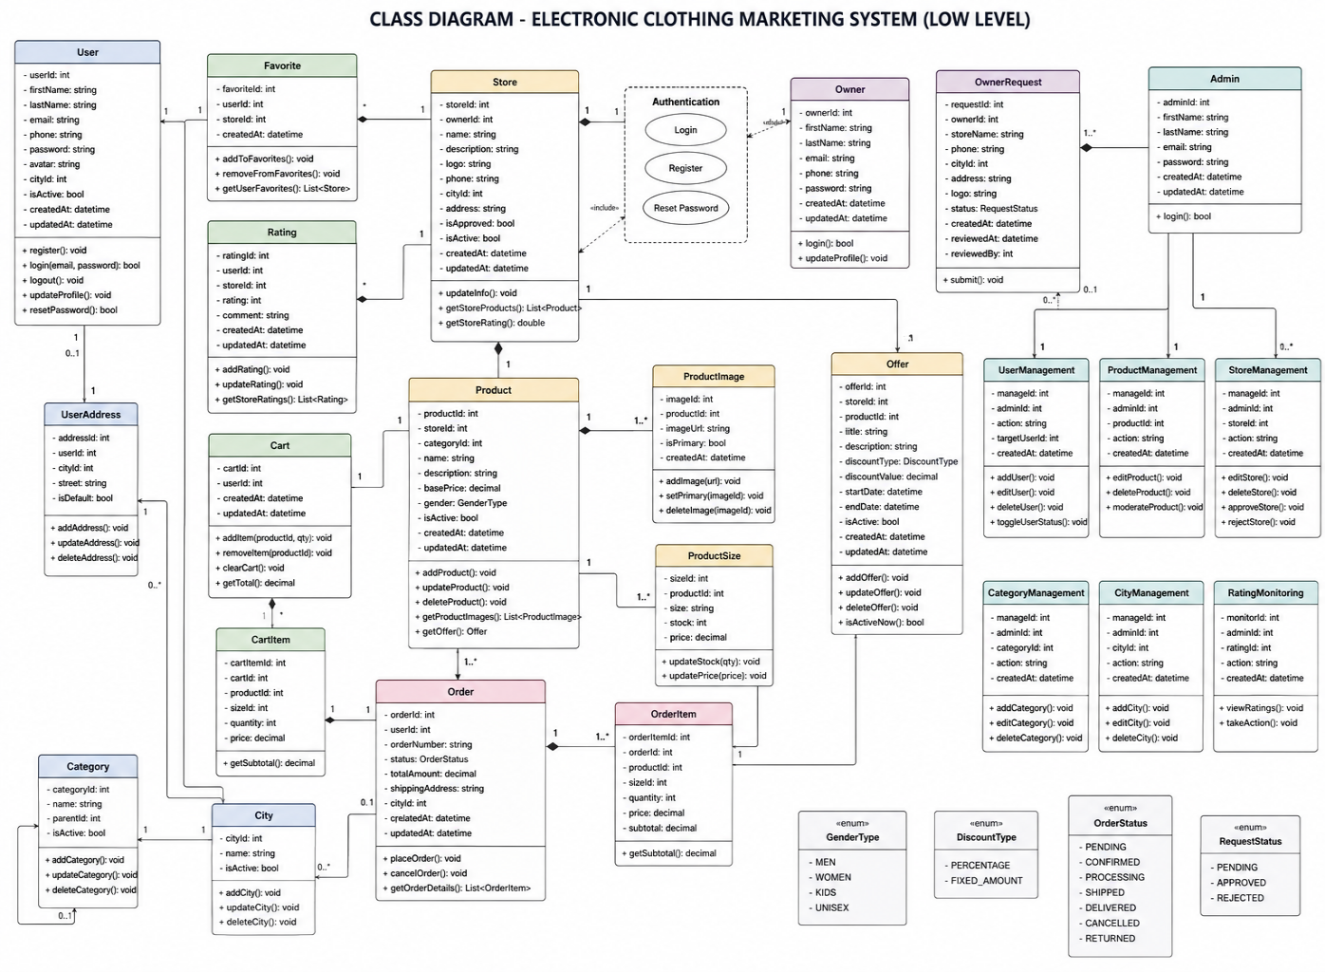

Figure (42): Class Diagram

3- Physical Level Design Models

Example of the physical level design model for the Aswaqi project:

Devices used:
- The server is used to host the application and databases.
- Computers: Used by administrators to access the site

Software and Technologies Used:
- Programming Languages: Using programming languages such as Python, CSS, HTML to develop user interfaces and interaction processes in the application.
- Databases: Use a database management system such as MySQL to store user and store owner data present on the website.
- Web Servers: Using a web server such as Apache to run the application and connect it to browsers.
- Framework: Django

Technical Infrastructure:
- Internet Network: The project relies on having an internet connection to allow users to access the application.
- Security and Protection: Security technologies are used in login.

The above-mentioned model contains technical details about the hardware, software, and infrastructure used in implementing the web application hosting multiple stores at the physical level. You can provide further details and specific technologies according to the project's needs and technical requirements.

2.2 System Interface Tree
A Sitemap diagram in software is a visual representation that illustrates the overall structure of the system or website, showing the different pages or screens and the relationships and navigation between them, with the aim of facilitating the understanding of content organization and user flow within the system.
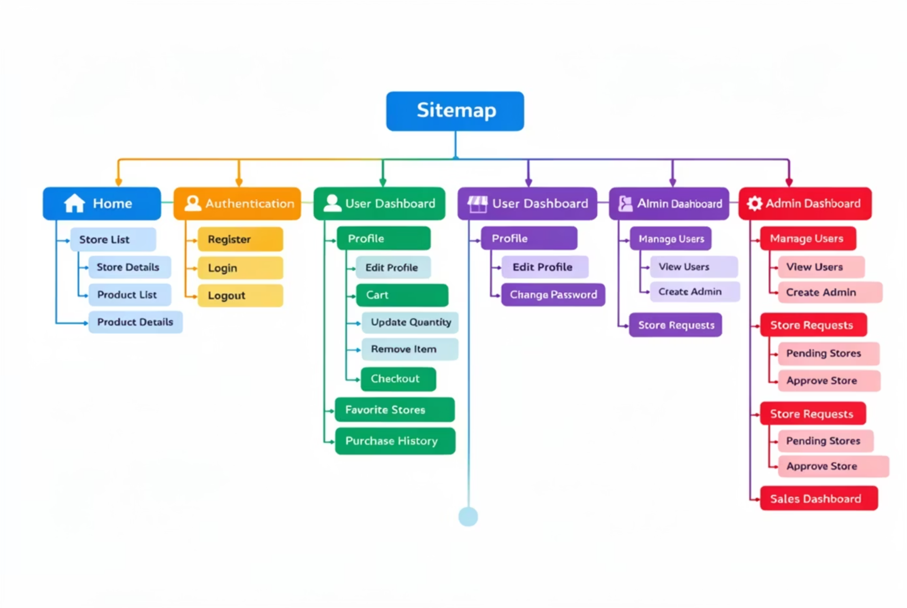
Diagram Figure (43) Sitema

4- System Architecture (system Architect)
1 Introduction:
The Model-View-Template (MVT) software architecture is one of the fundamental concepts in software engineering, used to organize the components of a software system in a way that facilitates its understanding, development, testing, and maintenance. It serves as the engineering blueprint that defines how each part of the system will interact with the others.
The primary goal of using software architecture is
- Separation of duties and responsibilities within the system.
- Facilitating collaboration among team members (UI designer, backend developer, data analyst)
- Enhancing reusability and flexibility in development.
- Simplification of testing and maintenance.
- Improving the overall performance and organization of the application.

2 Explanation of Each Layer:

First: Model (Model)

Responsibilities:
- Definition of the data structure (tables) in the database.
- Defining field types (text, number, date...).
- Creating relationships between tables (OneToMany, ManyToMany...).
- Performing operations on data using ORM (
- Validate data before saving.

Examples of tasks:
- Create a product table containing the name, price, and stock.
- Link the orders table with users and products.

Second: View (View)

Responsibilities:
- Receiving requests from the user (HTTP Request).
- Execution of processing logic (such as fetching data or performing an operation).
- Calling the model to retrieve the data.
- Sending data to the template for display.
- Specify the response type (HTML, JSON, Redirect)

Examples of tasks:
- Display the product list.
- Login form processing.
- Executing an operation to delete an item from the database.

Third: Template

Responsibilities:
- Displaying data to the user in an organized and attractive manner.
- Using Django Instructions Inside HTML
- No complex programming logic included (display only).
- Support for translation and content formatting according to the language.

Examples of tasks:
- Display a table containing the products.
- Display a welcome message to the user after logging in.
- Data Entry Form Display

3 Explanation of the (MVT) Architecture with Client-Server:

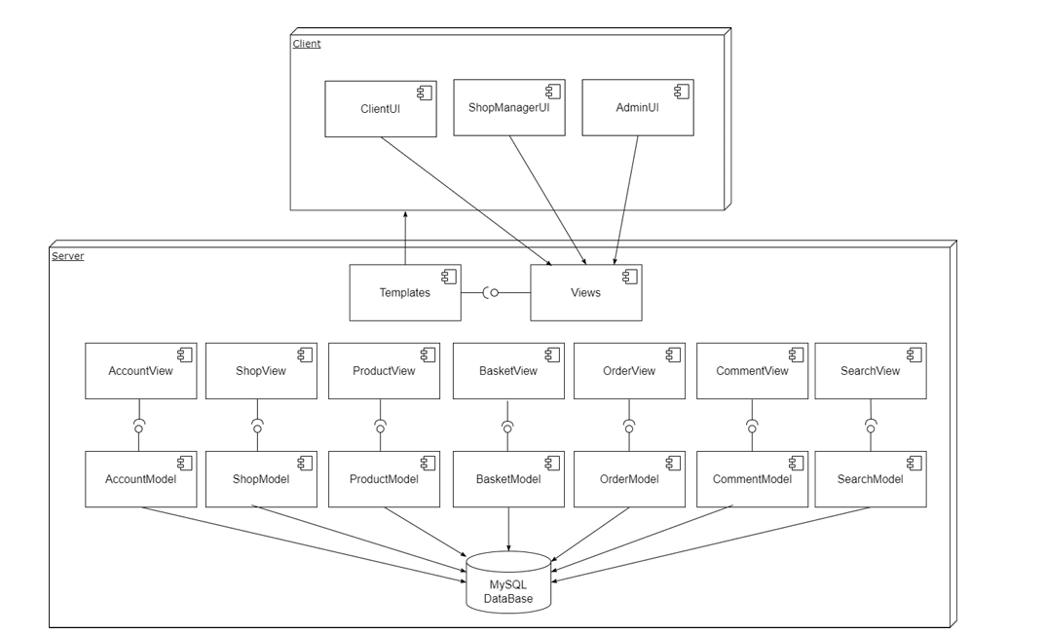
Diagram Figure (44) MVT

Chapter Five
Practical application

1 Introduction
In this chapter, we will discuss the tools we used to build the system, as well as present the main system interfaces.

2. Tools Used

2.1-System Tools


2.1.1 visual studio code
Visual Studio Code is a source code editor from Microsoft. The editor is open-source and runs on Windows, macOS, and Linux operating systems. The editor is based on the Electron framework and was launched by Microsoft in April 2015.


2.1.2 draw.io
It is a free and open-source program for drawing charts.
The platform was developed using HTML5 and JavaScript. Its interface can be used to create diagrams such as flowcharts, wireframes, UML diagrams, organizational charts, and network diagrams.


2.1.3.XAMPP
It is a free and open-source application package that primarily includes a server (HTTP Apache, Mari DB (formerly MySQL), and an interpreter for applications written in programming languages Perl, PHP. The software is used to turn your device into a (virtual) server (miniature) with many features, allowing you to create a local website on your device for programming, testing, and news, or a public site for a limited number of visitors depending on your device's resources and internet connection speed.

2.2 Languages Used

2.2.1 HTML
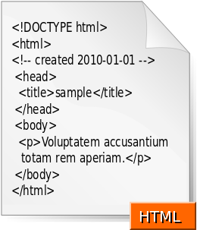

It is a markup language used in creating and designing web pages and websites. This language is considered one of the oldest and most widely used languages in web page design.
HTML is the structure of the web page and provides the web browser with a description of how to display its contents. It informs the browser that this is a main heading, that is a paragraph, and much more.

2.2.2 CSS
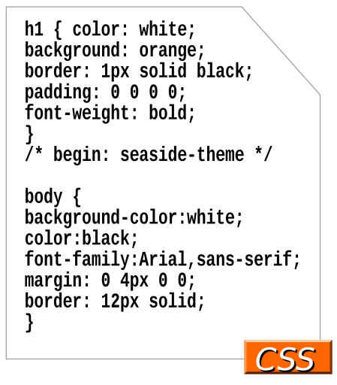
It is a styling language for web pages that focuses on the appearance and design of websites. It is specifically designed to separate styling (colors - fonts - buttons...) from the content of the document written in HTML (this applies to colors, fonts, images, and backgrounds used in pages) with complete flexibility and ease.
This technology concerns the overall appearance of web pages.
Of colors, images, and others.


2.2.3 JavaScript
It is a high-level programming language primarily used in web browsers to create more interactive pages. It is currently being developed by Netscape and Mozilla. JS was originally aimed at amateur and non-professional programmers, but interest in it has grown and it has attracted professional programmers after the addition of new technologies such as the Ajax technology, which led to faster interaction between the server and the client. JavaScript is used to create interactive web pages and to provide web applications including games; it is employed by the majority of websites and is supported by
Almost all browsers without the need for add-ons
External.


2.2.4 MySQL bench
MYSQL is a tool for visual database design that includes SQL development, database management, database design, creation, and maintenance within a single integrated development environment for a database system.


2.2.7 Bootstrap
It is a set of open-source tools for designing website interfaces, developed by Twitter. It was created to help designers and developers build amazing products quickly and efficiently. Its goal is to provide a wide, flexible, and well-documented library of reusable designs built using HTML, CSS, and JavaScript.
So that developers can use it and be creative with it

3- System Interfaces

Login page 3.1

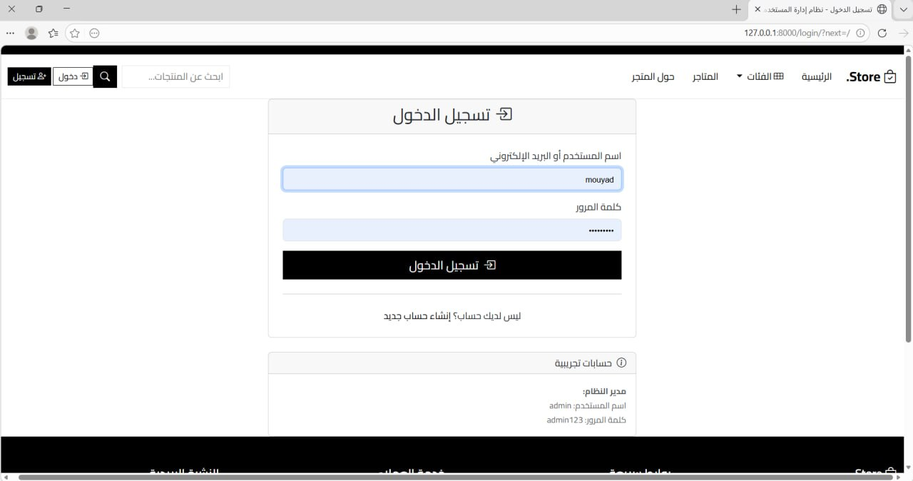

3.2 Account Creation

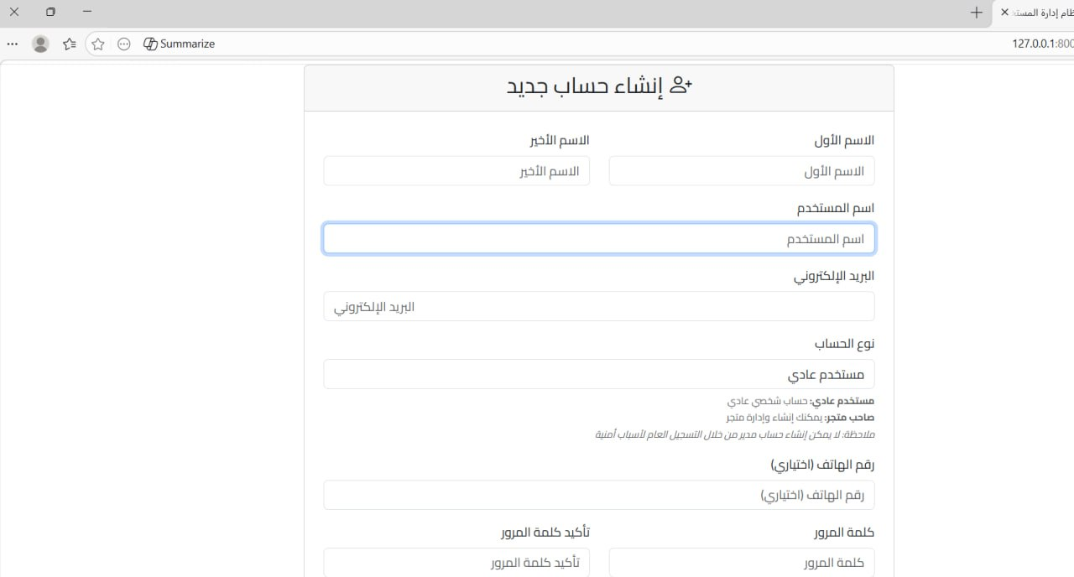

3.3 The Main Interface

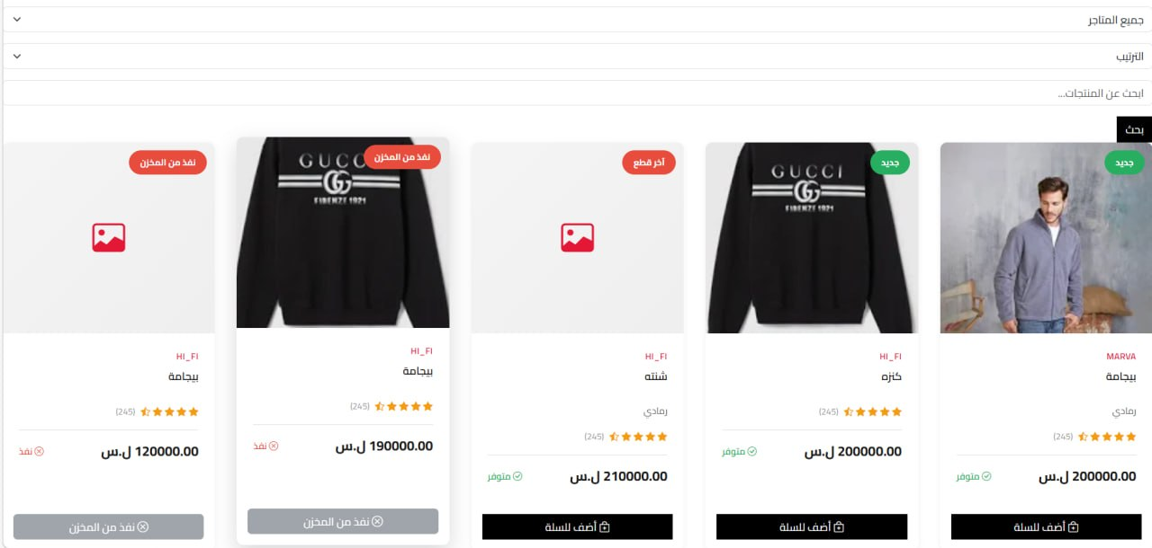

3.4 Store Display

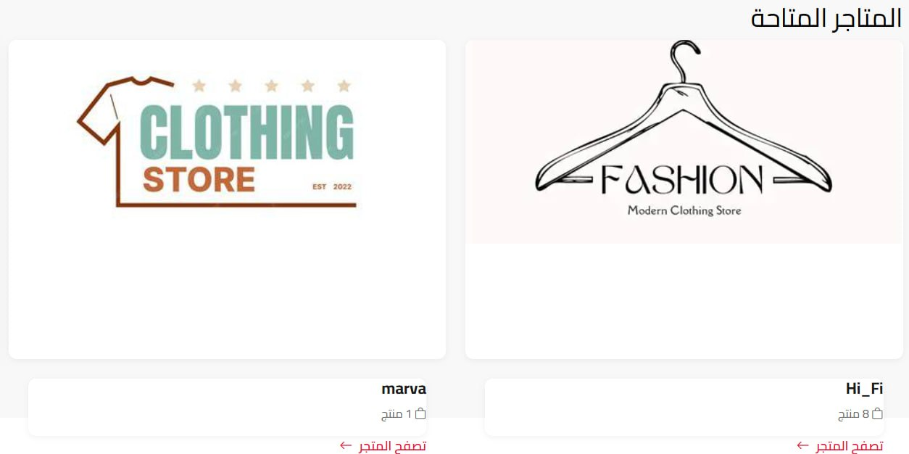

3.5 Store Details Display

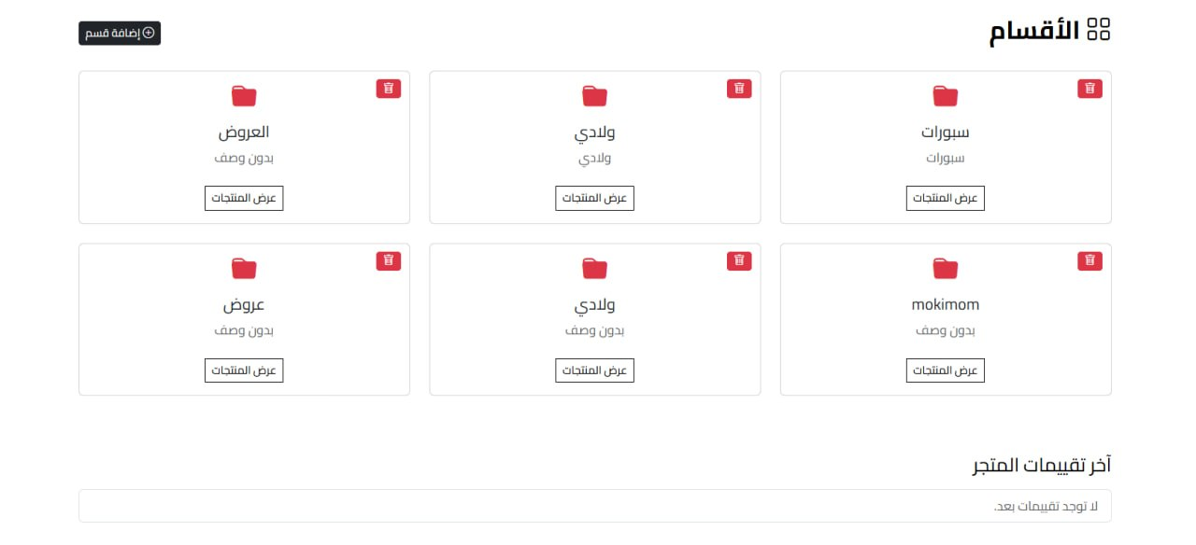

3.6 Admin panel

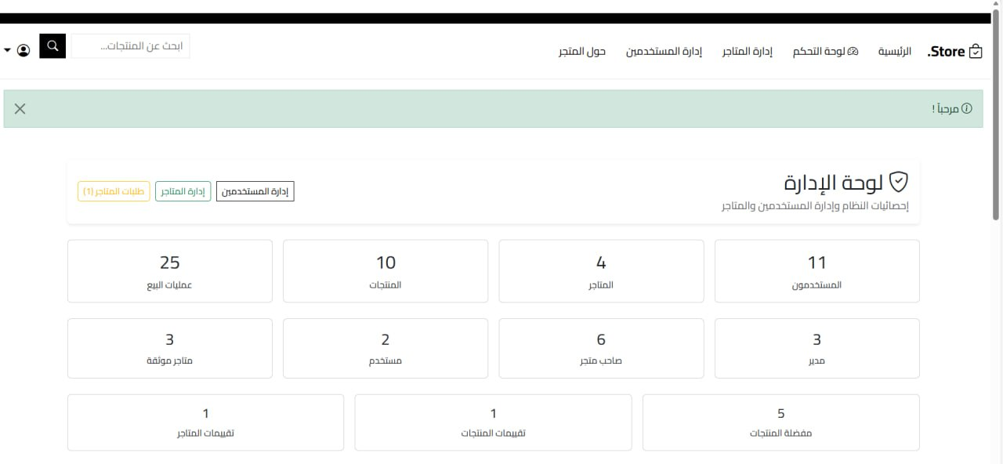

3.7 Profile Modification

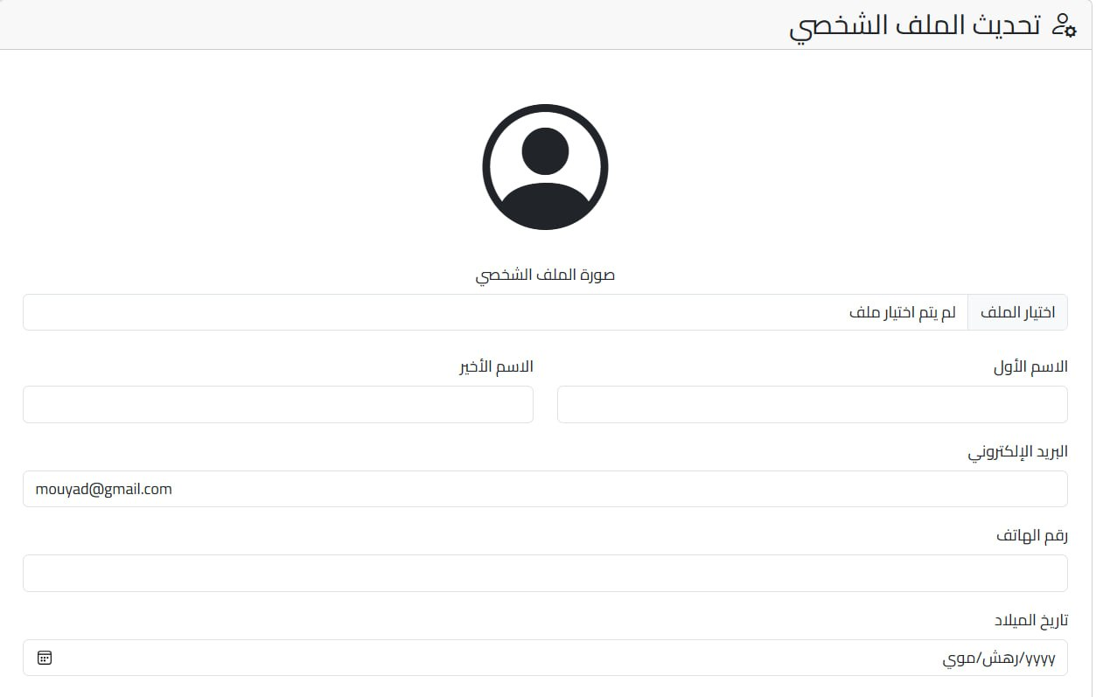

3.8 Offers Page

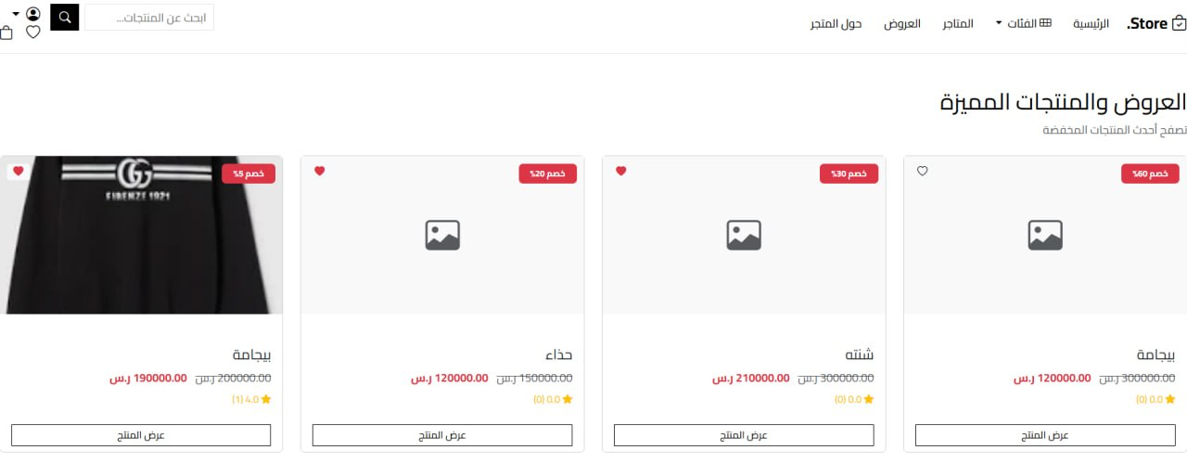

3.9 Displaying the User List
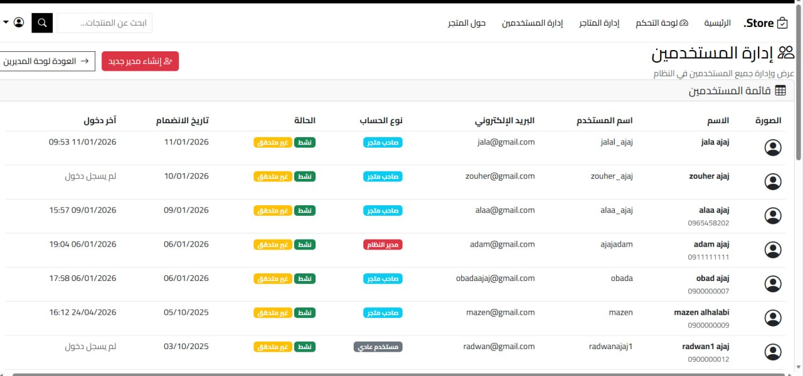

3.10 Store Details
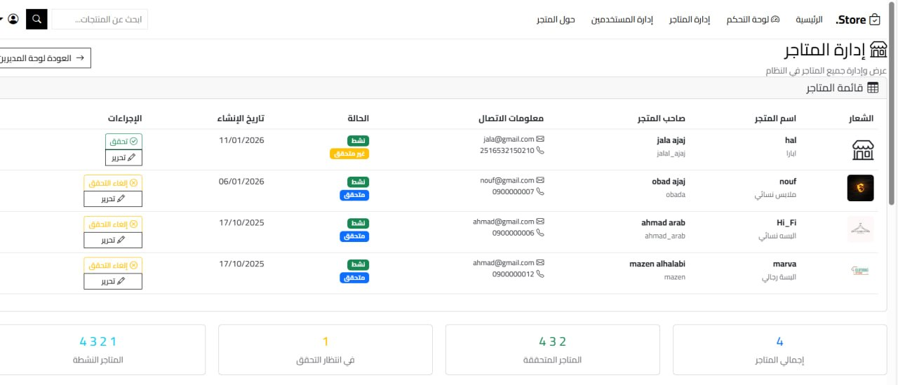

3.11 Store Creation Requests

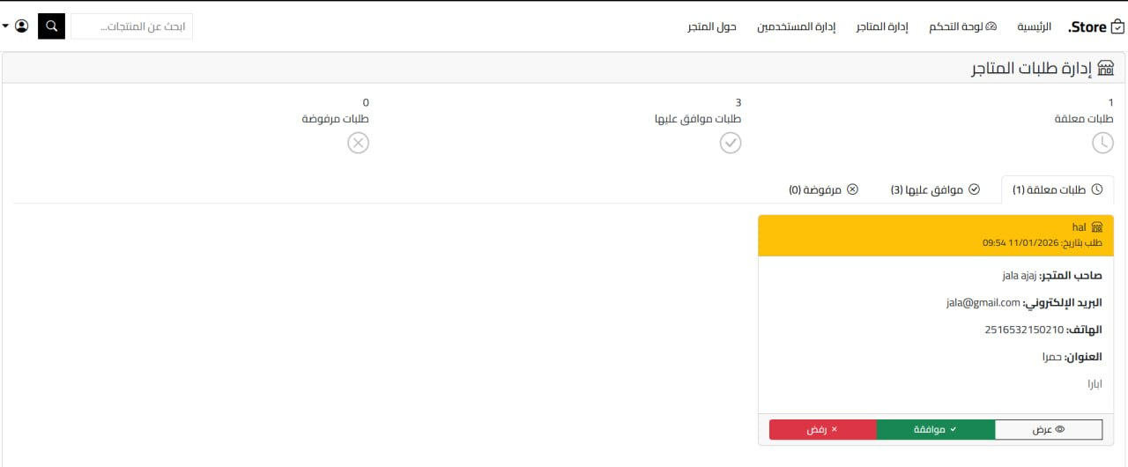

3.12 Store Details

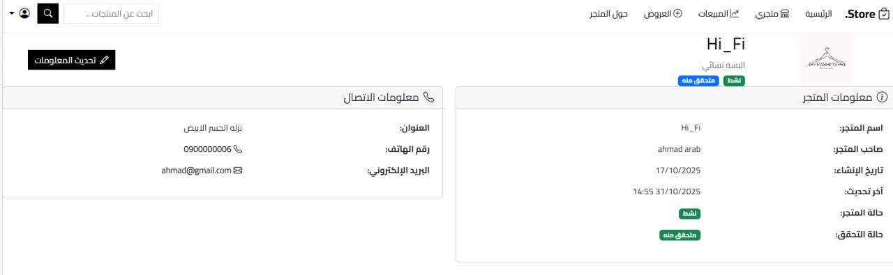

3.13 Filters page by item

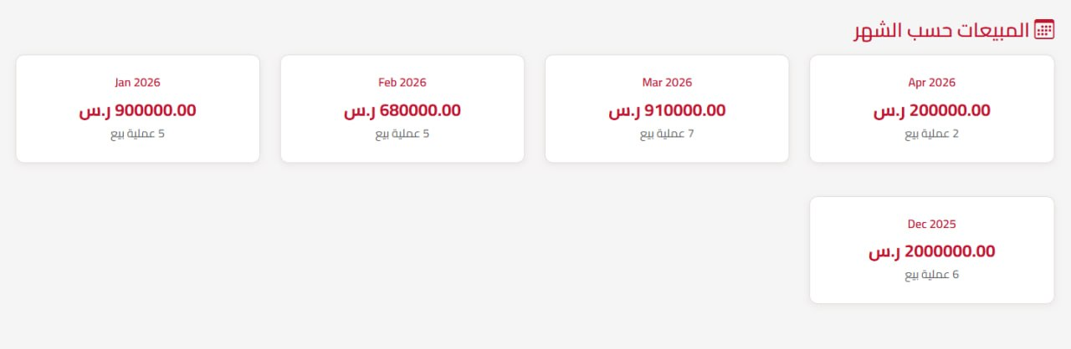

3.14 Product Presentation

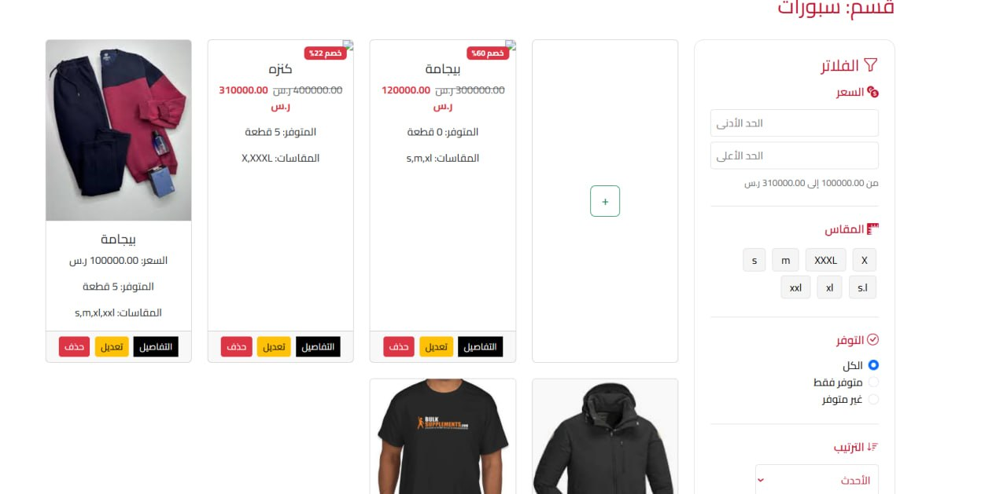

3.15 Favorites List

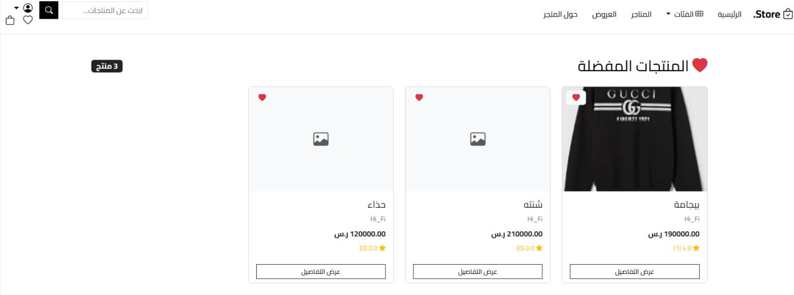

3.13 Sales Register Interface

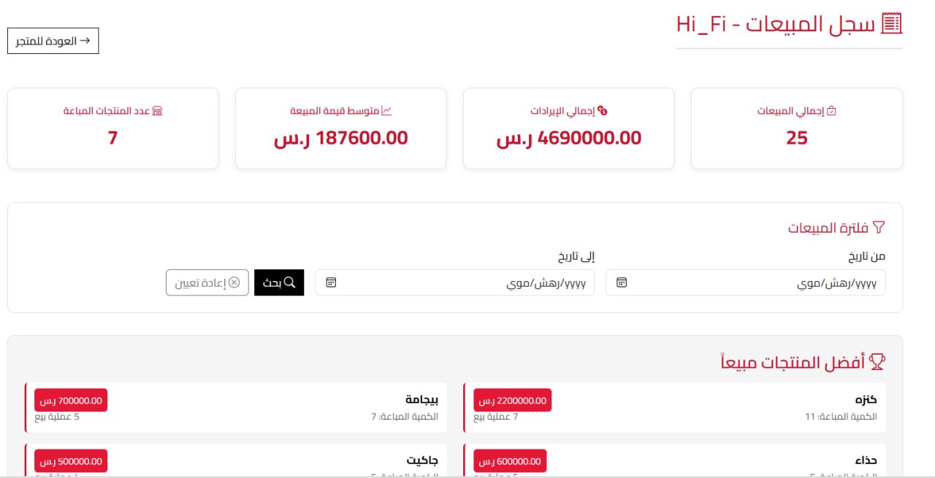

3.16 Product Creation Interface

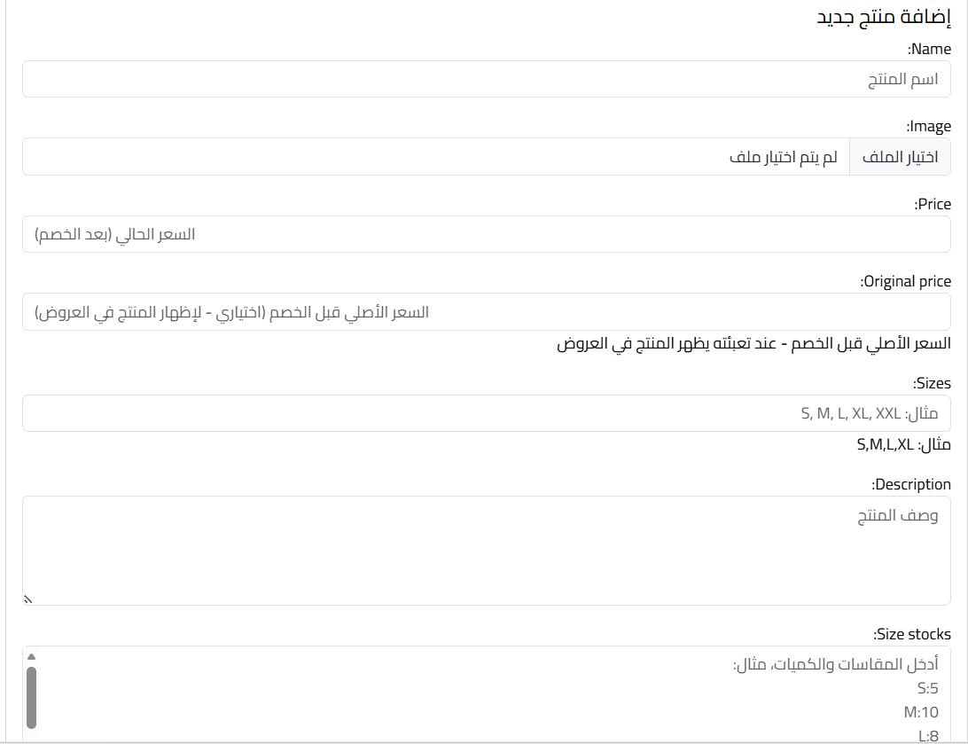

3.17 Product Modification Interface

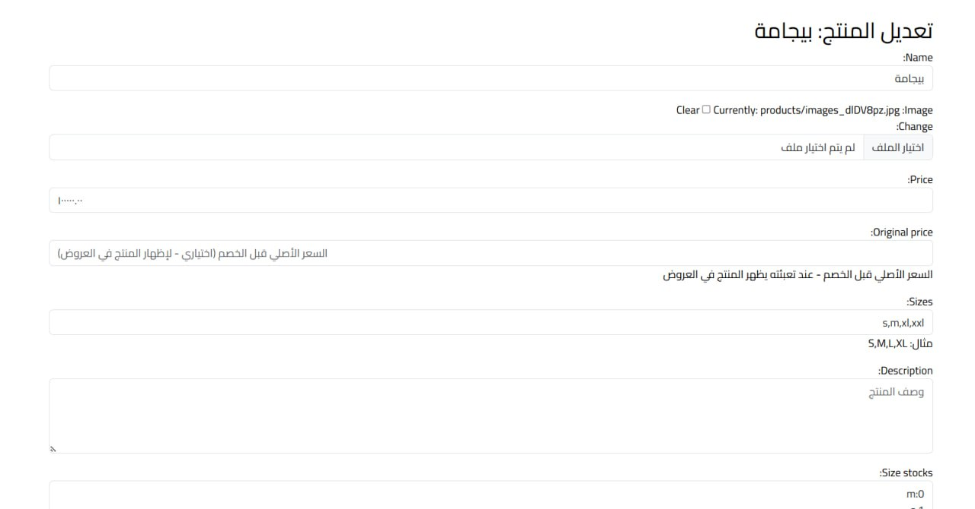

3.18 Piece Count Specification Interface

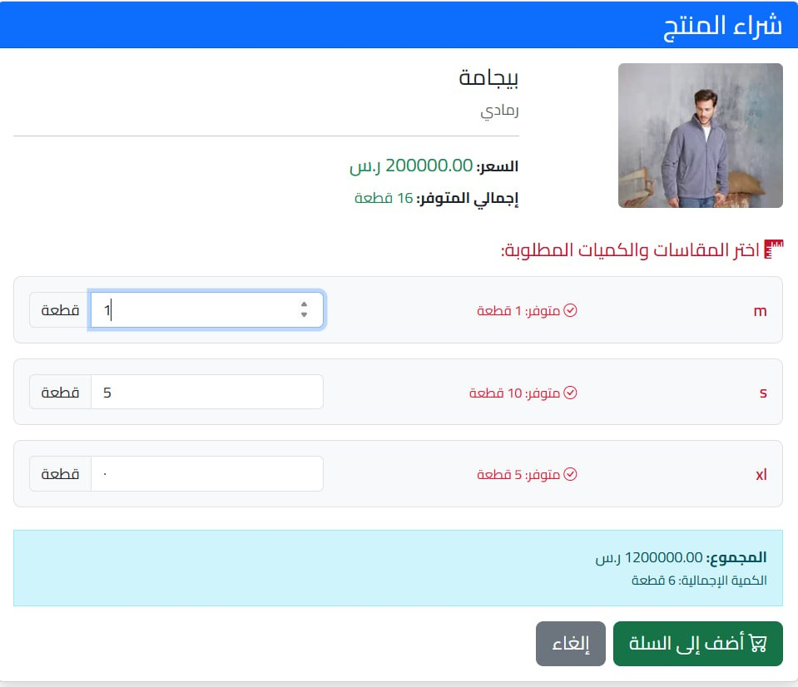

3.19 Purchase Installation Interface

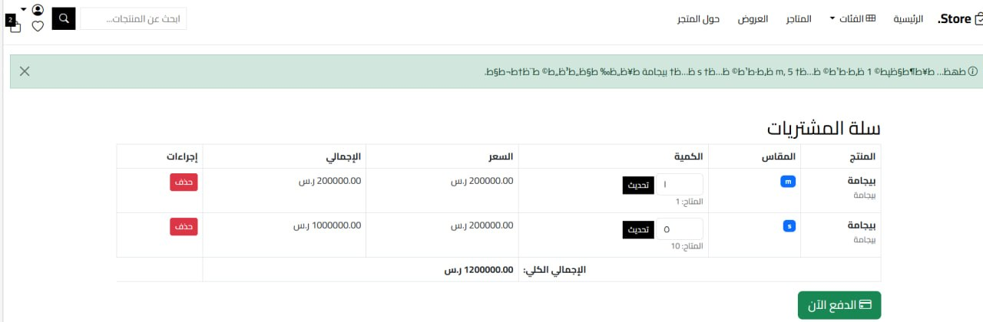

Chapter Six
Conclusions and Future Prospects

Chapter Six - Conclusions and Future Prospects

4.1 Analysis of Results and Conclusions:
After thoroughly studying and analyzing the system, designing the database, and building the various system models, in addition to conducting a survey on a sample of users to understand their needs and requirements for the clothing sales website, it became clear that the proposed system achieves the primary objective for which it was developed, which is to facilitate the process of searching for, viewing, and selecting clothing in a fast and easy manner.
The survey results also showed that users need a unified platform that enables them to browse different stores, compare products, and use search and filtering tools to accurately find the suitable product, thereby enhancing the user experience and saving time and effort.
On the other hand, the system provides store owners with an integrated environment to manage their products and display them in an organized manner, with the ability to add promotions and continuously update data, which contributes to improving the marketing process and increasing sales opportunities.
As for the system administrator (Admin), the system allows full control over managing users, stores, and categories, as well as monitoring content and reviews, which helps maintain the system's quality and organization.
The database used has proven its efficiency in storing data in an organized and secure manner, linking different entities (users, products, stores, orders) in a way that ensures easy access to information and quick retrieval when needed, in addition to efficiently supporting various operations.

4.2 Future Prospects
- Mobile application development.
- Support for electronic payment.
- Intelligent Recommendation System.
- Notification support.
- Two-Factor Authentication (2FA).
- Performance improvement using caching.
- Deployment of the system on the Cloud.
- Intelligent Chatbot for Customer Service.
- Improving search results using artificial intelligence.

