**PART 1**

1. **1 Queries based on student, course database;**
   1. **Queries based on Hospital Database**

**Student Relation:-**

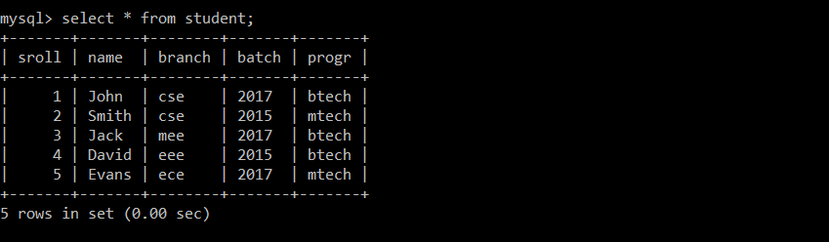

**Course Relation:-**

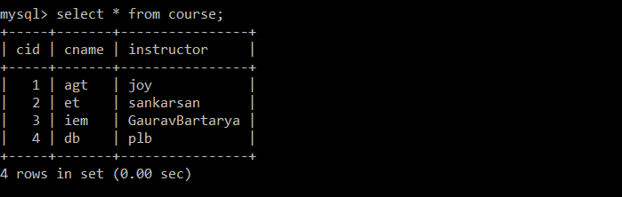

**Attendance Relation:-**

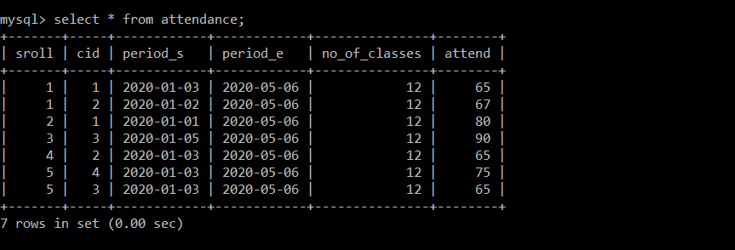

**Part(1.1) Q.1**

**package** fdsa;

**import** java.sql.Connection;

**import** java.sql.DriverManager;

**import** java.sql.PreparedStatement;

**import** java.sql.ResultSet;

**import** java.sql.Statement;

**import** java.util.Scanner;

**public** **class** Sdfg {

**public** **static** **void** main(String[] args) {

**try** {

Scanner reader = **new** Scanner(System.***in***); // Reading from System.in

System.***out***.println("Enter the course id : ");

// Taking inputs from user

**int** n1 = reader.nextInt();

System.***out***.println("Enter the attendance bound ");

**int** n2 = reader.nextInt();

Class.*forName*("com.mysql.cj.jdbc.Driver");

Connection con=DriverManager.*getConnection*(

"jdbc:mysql://localhost:3306/studb","him","8562083552");

String query = "Select s.name from student s where s.sroll in (Select a.sroll from attendance a where a.attend>? and cid=?)";

PreparedStatement ps = con.prepareStatement(query);

ps.setInt(1,n2);

ps.setInt(2,n1);

ResultSet rs = ps.executeQuery ();

System.***out***.println("Student_name");

**while**(rs.next())

System.***out***.println(rs.getString(1));

con.close();

reader.close();

}

**catch**(Exception e){ System.***out***.println(e);}

}

}

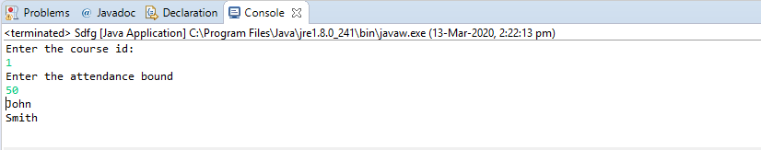

**Part(1.1) Q.2**

**package** fdsa;

**import** java.sql.Connection;

**import** java.sql.DriverManager;

**import** java.sql.PreparedStatement;

**import** java.sql.ResultSet;

**import** java.sql.Statement;

**import** java.util.Scanner;

**public** **class** Sdfg {

**public** **static** **void** main(String[] args) {

**try** {

Scanner reader = **new** Scanner(System.***in***); // Reading from System.in

System.***out***.println("Enter the instructor's name ");

// Taking inputs from user

String n1 = reader.nextLine();

Class.*forName*("com.mysql.cj.jdbc.Driver");

Connection con=DriverManager.*getConnection*(

"jdbc:mysql://localhost:3306/studb","him","8562083552");

String query = "Select s.name,a.attend from student s,attendance a where s.sroll=a.sroll and "

+" a.cid in(Select c.cid from course c where c.instructor=?)" ;

PreparedStatement ps = con.prepareStatement(query);

ps.setString(1,n1);

ResultSet rs = ps.executeQuery ();

System.***out***.println("Student_name"+" "+"Attendance");

**while**(rs.next())

System.***out***.println(rs.getString(1)+" "+rs.getInt(2));

con.close();

reader.close();

}

**catch**(Exception e){ System.***out***.println(e);}

}

}

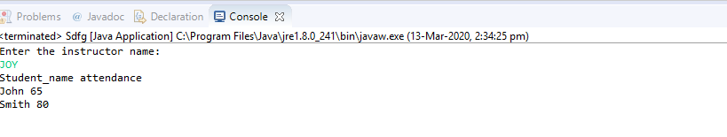

**Patient Relation:-**

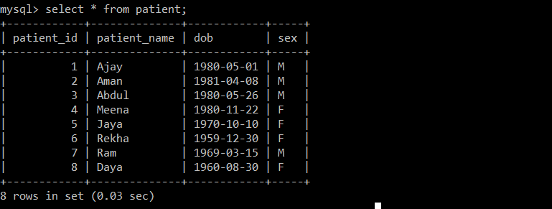

**Doctor Relation:-**

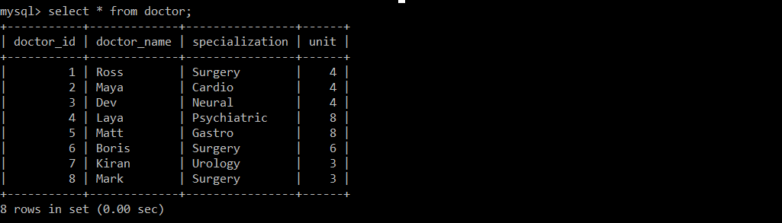

**Opd_schedule:-**

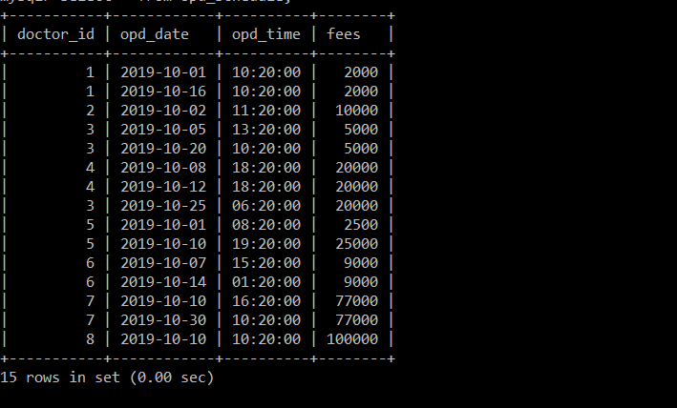

**Appointment:-**

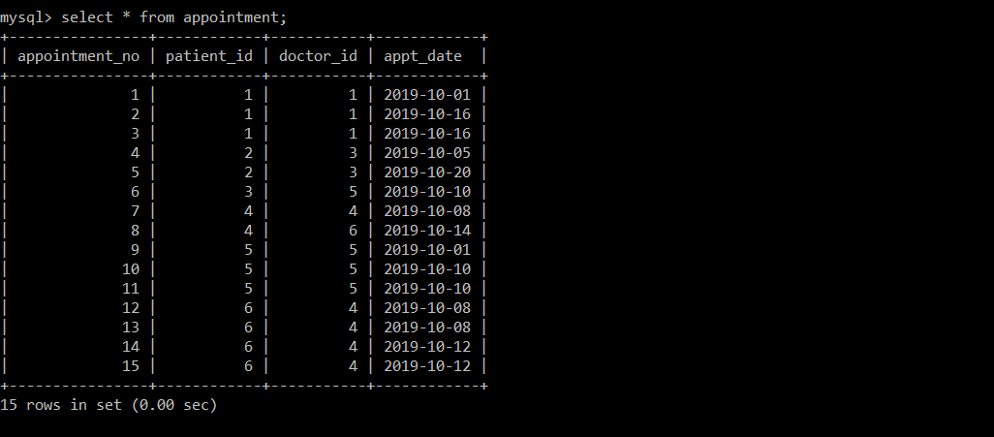

**Part(1.2) Q.3**

**package** fdsa;

**import** java.sql.Connection;

**import** java.sql.DriverManager;

**import** java.sql.PreparedStatement;

**import** java.sql.ResultSet;

**import** java.sql.Statement;

**import** java.util.Scanner;

**public** **class** Sdfg {

**public** **static** **void** main(String[] args) {

**try** {

Scanner reader = **new** Scanner(System.***in***); // Reading from System.in

System.***out***.println("Enter the date ");

// Taking inputs from user

String n1 = reader.nextLine();

System.***out***.println("Enter the amount threshold- ");

**int** n2 = reader.nextInt();// Scans the next token of the input as an int.

//once finished

//System.out.println(n1);

//System.out.println(n1);

Class.*forName*("com.mysql.cj.jdbc.Driver");

Connection con=DriverManager.*getConnection*(

"jdbc:mysql://localhost:3306/studb","him","8562083552");

String query = "select distinct D.unit from doctor D where (select sum(O.fees) from opd_schedule O, appointment A where A.doctor_id=O.doctor_id and A.appt_date=O.opd_date and A.appt_date=? and A.doctor_id in (select D1.doctor_id from doctor D1 where D1.unit=D.unit))>?";

PreparedStatement ps = con.prepareStatement(query);

ps.setString(1,n1);

ps.setString(2,String.*valueOf*(n2));

ResultSet rs = ps.executeQuery ();

System.***out***.println("\nUnit");

**while**(rs.next())

System.***out***.println(rs.getInt(1));

con.close();

reader.close();

}

**catch**(Exception e){ System.***out***.println(e);}

}

}

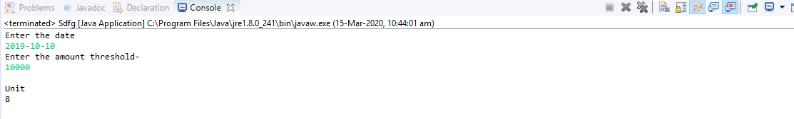

**Part(1.2) Q.4**

**package** fdsa;

**import** java.sql.Connection;

**import** java.sql.DriverManager;

**import** java.sql.PreparedStatement;

**import** java.sql.ResultSet;

**import** java.sql.Statement;

**import** java.util.Scanner;

**public** **class** Sdfg {

**public** **static** **void** main(String[] args) {

**try** {

Scanner reader = **new** Scanner(System.***in***); // Reading from System.in

System.***out***.println("Enter the patient_id: ");

// Taking inputs from user

//String n1 = reader.nextLine();

//System.out.println("Enter the attendance bound ");

**int** n1 = reader.nextInt();// Scans the next token of the input as an int.

//once finished

//System.out.println(n1);

//System.out.println(n1);

Class.*forName*("com.mysql.cj.jdbc.Driver");

Connection con=DriverManager.*getConnection*(

"jdbc:mysql://localhost:3306/studb","him","8562083552");

String proce_dure =

"CREATE PROCEDURE appointments_for_patient (IN patieent_id Integer) Select (Select doctor_name from doctor where doctor_id = a.doctor_id),a.appt_date from appointment a where a.patient_id = patieent_id";

Statement stmt=con.createStatement();

**int** rt = stmt.executeUpdate(proce_dure);

String query = "call appointments_for_patient(?)" ;

PreparedStatement ps = con.prepareStatement(query);

//ps.setString(1,n1);

ps.setString(1,String.*valueOf*(n1));

ResultSet rs = ps.executeQuery();

//System.out.println("Student_name"+" "+"attendance");

System.***out***.println("Doctor_name"+" "+"Appointment_date");

**while**(rs.next())

System.***out***.println(rs.getString(1)+" "+rs.getString(2));

con.close();

reader.close();

}

**catch**(Exception e){ System.***out***.println(e);}

}

}

Procedure created through java interface:-

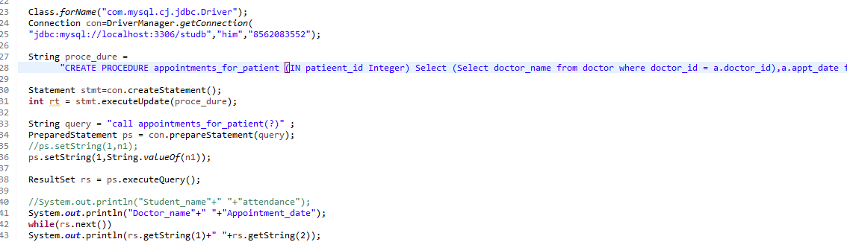

Query Output:

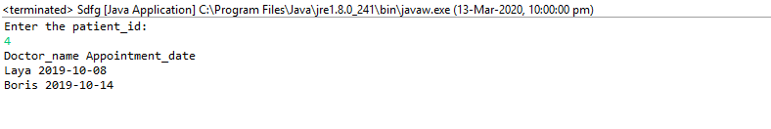

**PART – 2 (Based on Assignment 2)**

**Mostly used relations:-**

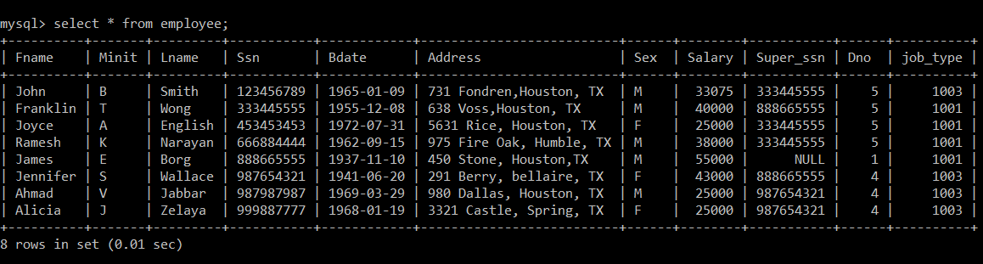

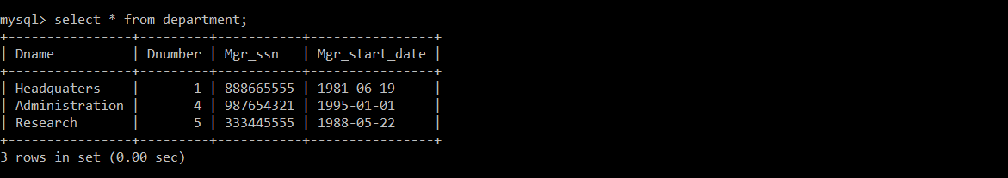

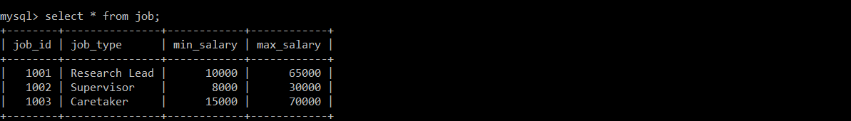

**Part(2) Q.1**

**package** fdsa;

**import** java.sql.Connection;

**import** java.sql.DriverManager;

**import** java.sql.PreparedStatement;

**import** java.sql.ResultSet;

**import** java.sql.Statement;

**import** java.util.Scanner;

**public** **class** Sdfg {

**public** **static** **void** main(String[] args) {

**try** {

Scanner reader = **new** Scanner(System.***in***); // Reading from System.in

System.***out***.println("Enter the employee_ssn: ");

// Taking inputs from user

//String n1 = reader.nextLine();

//System.out.println("Enter the attendance bound ");

**int** n1 = reader.nextInt();// Scans the next token of the input as an int.

//once finished

//System.out.println(n1);

//System.out.println(n1);

Class.*forName*("com.mysql.cj.jdbc.Driver");

Connection con=DriverManager.*getConnection*(

"jdbc:mysql://localhost:3306/studb","him","8562083552");

//Statement stmt=con.createStatement();

//int rt = stmt.executeUpdate(proce_dure);

String query = "Select job_id,job_type from job where min_salary < (select Salary from EMPLOYEE where Ssn = ? )";

PreparedStatement ps = con.prepareStatement(query);

//ps.setString(1,n1);

ps.setString(1,String.*valueOf*(n1));

ResultSet rs = ps.executeQuery();

//System.out.println("Student_name"+" "+"attendance");

System.***out***.println("Doctor_name"+" "+"Appointment_date");

**while**(rs.next())

System.***out***.println(rs.getString(1)+" "+rs.getString(2));

con.close();

reader.close();

}

**catch**(Exception e){ System.***out***.println(e);}

}

}

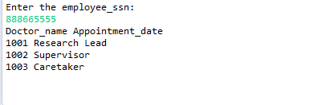

**Part(2) Q.2**

**package** fdsa;

**import** java.sql.Connection;

**import** java.sql.DriverManager;

**import** java.sql.PreparedStatement;

**import** java.sql.ResultSet;

**import** java.sql.Statement;

**import** java.util.Scanner;

**public** **class** Sdfg {

**public** **static** **void** main(String[] args) {

**try** {

Scanner reader = **new** Scanner(System.***in***); // Reading from System.in

System.***out***.println("Enter the employee_ssn: ");

// Taking inputs from user

//String n1 = reader.nextLine();

//System.out.println("Enter the attendance bound ");

**int** n1 = reader.nextInt();// Scans the next token of the input as an int.

//once finished

//System.out.println(n1);

//System.out.println(n1);

Class.*forName*("com.mysql.cj.jdbc.Driver");

Connection con=DriverManager.*getConnection*(

"jdbc:mysql://localhost:3306/studb","him","8562083552");

Statement stmt=con.createStatement();

String proce_dure = "CREATE PROCEDURE is_manager (IN emp_ssn int) Select e.Fname,e.Lname,d.Dname from Employee e,Department d where e.ssn=d.Mgr_ssn and e.ssn=emp_ssn";

**int** rt = stmt.executeUpdate(proce_dure);

String query = "call is_manager(?)";

PreparedStatement ps = con.prepareStatement(query);

//ps.setString(1,n1);

ps.setString(1,String.*valueOf*(n1));

ResultSet rs = ps.executeQuery();

//System.out.println("Student_name"+" "+"attendance");

System.***out***.println("Employee Name"+" "+"Department");

**while**(rs.next())

System.***out***.println(rs.getString(1)+" "+rs.getString(2)+" "+rs.getString(3));

con.close();

reader.close();

}

**catch**(Exception e){ System.***out***.println(e);}

}}

**Procedure made through Java Interface**

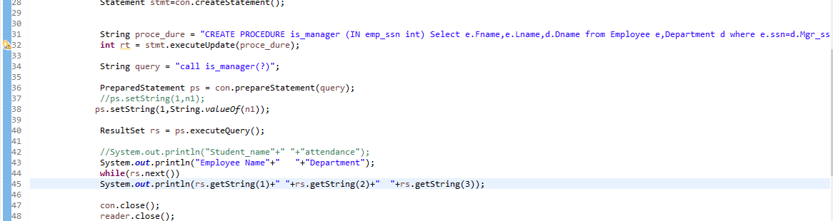

Query Result:-

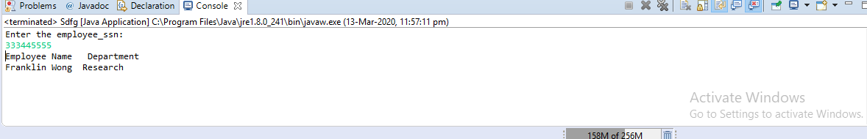

**Part(2) Q.3**

**package** fdsa;

**import** java.sql.Connection;

**import** java.sql.DriverManager;

**import** java.sql.PreparedStatement;

**import** java.sql.ResultSet;

**import** java.sql.Statement;

**import** java.util.Scanner;

**public** **class** Sdfg {

**public** **static** **void** main(String[] args) {

**try** {

Scanner reader = **new** Scanner(System.***in***); // Reading from System.in

System.***out***.println("Enter the employee_hiring_date: ");

// Taking inputs from user

String n1 = reader.nextLine();

//System.out.println("Enter the attendance bound ");

//int n1 = reader.nextInt();// Scans the next token of the input as an int.

//once finished

//System.out.println(n1);

//System.out.println(n1);

Class.*forName*("com.mysql.cj.jdbc.Driver");

Connection con=DriverManager.*getConnection*(

"jdbc:mysql://localhost:3306/studb","him","8562083552");

Statement stmt=con.createStatement();

//String proce_dure = "CREATE PROCEDURE is_manager (IN emp_ssn int) Select e.Fname,e.Lname,d.Dname from Employee e,Department d where e.ssn=d.Mgr_ssn and e.ssn=emp_ssn";

//int rt = stmt.executeUpdate(proce_dure);

//String query = "call is_manager(?)";

String query = "Select e.Fname,e.Lname, j.job_type from Employee e, job j where e.job_type = j.job_id and e.Bdate > ? and exists(Select * from Department d where e.Dno = d.Dnumber)";

//PreparedStatement pstmt = connection.prepareStatement(query);

PreparedStatement ps = con.prepareStatement(query);

//ps.setString(1,n1);

ps.setString(1,String.*valueOf*(n1));

ResultSet rs = ps.executeQuery();

//System.out.println("Student_name"+" "+"attendance");

System.***out***.println("Employee Name"+" "+"Department");

**while**(rs.next())

System.***out***.println(rs.getString(1)+" "+rs.getString(2)+" "+rs.getString(3));

con.close();

reader.close();

}

**catch**(Exception e){ System.***out***.println(e);}

}

}

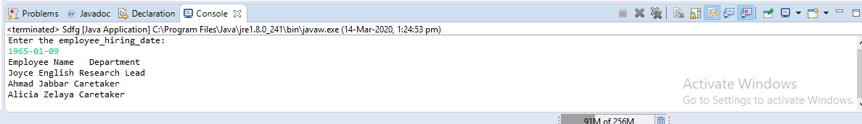

**Part(2) Q.4(With Trigger)**

1. ***Mysql***

DELIMITER //

Create Trigger salary_cheking BEFORE UPDATE ON employee FOR EACH ROW

BEGIN

DECLARE max_sal INTEGER;

IF (NEW.salary > 65000 or NEW.salary<10000) and NEW.job_type=1001 then SIGNAL SQLSTATE '42927' SET MESSAGE_TEXT = 'Exceeded the salary limit for job type 1001 MAX:65000 MIN:10000';

ELSEIF (NEW.salary > 30000 or NEW.salary<8000) and NEW.job_type=1002 then SIGNAL SQLSTATE '42928' SET MESSAGE_TEXT = 'Exceeded the salary limit for job type 1002 MAX:30000 MIN:8000';

ELSEIF (NEW.salary > 70000 or NEW.salary<15000) and NEW.job_type=1003 then SIGNAL SQLSTATE '42929' SET MESSAGE_TEXT = 'Exceeded the salary limit for job type 1003 MAX:70000 MIN:15000';

END IF;

END; //

DELIMITER ;

create table empchange(ssn int, ojt int, njp int, osal int, nsal int, cdate date, cuser varchar(50));

DELIMITER //

Create Trigger emp_change BEFORE UPDATE ON employee FOR EACH ROW

BEGIN

insert into empchange values(NEW.Ssn, OLD.job_type, NEW.job_type, OLD.salary,NEW.salary,SYSDATE(), user());

END; //

DELIMITER ;

***JAVA***

**package** fdsa;

**import** java.sql.Connection;

**import** java.sql.DriverManager;

**import** java.sql.PreparedStatement;

**import** java.sql.ResultSet;

**import** java.sql.Statement;

**import** java.util.Scanner;

**public** **class** Sdfg {

**public** **static** **void** main(String[] args) {

**try** {

Scanner reader = **new** Scanner(System.***in***); // Reading from System.in

System.***out***.println("Enter Job_id: ");

**int** n1 = reader.nextInt();

// Taking inputs from user

System.***out***.print("Enter Employee_SSn: ");

**int** n2 = reader.nextInt();

//String n1 = reader.nextLine();

//System.out.println("Enter the attendance bound ");

//int n1 = reader.nextInt();// Scans the next token of the input as an int.

//once finished

//System.out.println(n1);

//System.out.println(n1);

Class.*forName*("com.mysql.cj.jdbc.Driver");

Connection con=DriverManager.*getConnection*(

"jdbc:mysql://localhost:3306/studb","him","8562083552");

Statement stmt=con.createStatement();

System.***out***.println("Information of employee before update\n");

String query1 = "Select Fname,Lname,Salary from employee where Ssn=? ";

PreparedStatement ps1 = con.prepareStatement(query1);

ps1.setString(1,String.*valueOf*(n2));

ResultSet rs = ps1.executeQuery();

System.***out***.println("Employee Name"+" "+"Salary");

**while**(rs.next())

System.***out***.println(rs.getString(1)+" "+rs.getString(2)+" "+rs.getInt(3));

String query = "update Employee set Salary = Salary*1.05, job_type = ? where Ssn = ?";

PreparedStatement ps = con.prepareStatement(query);

ps.setString(1,String.*valueOf*(n1));

ps.setString(2, String.*valueOf*(n2));

**int** count = ps.executeUpdate();

System.***out***.println("\nNo of rows affected: "+count);

System.***out***.println("Information of employee after update\n");

String query2 = "Select Fname,Lname,Salary from employee where Ssn=? ";

PreparedStatement ps2 = con.prepareStatement(query2);

ps2.setString(1,String.*valueOf*(n2));

ResultSet rs1 = ps2.executeQuery();

System.***out***.println("Employee Name"+" "+"Salary");

**while**(rs1.next())

System.***out***.println(rs1.getString(1)+" "+rs1.getString(2)+" "+rs1.getInt(3));

con.close();

reader.close();

}

**catch**(Exception e){ System.***out***.println(e);}

}

}

* Original Relations

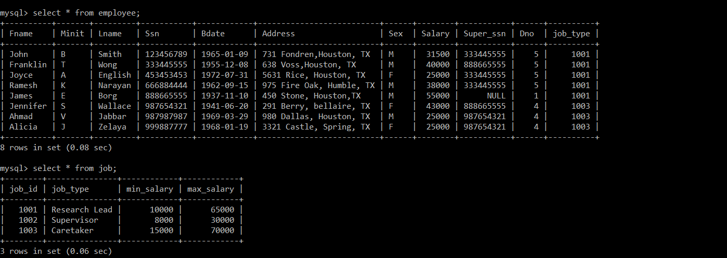

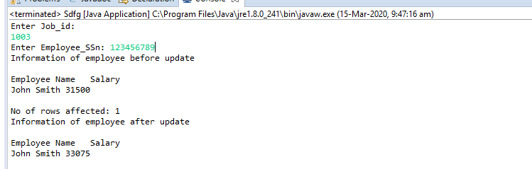

Error message when we are trying for salary higher then constrained salray:-

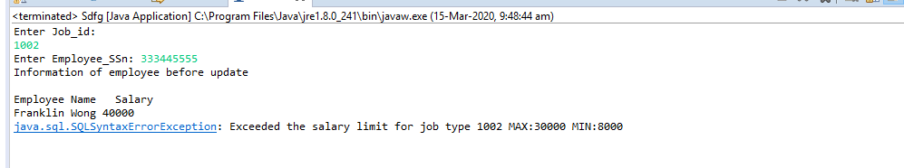

Content of the empchange table after successful updation of salary:

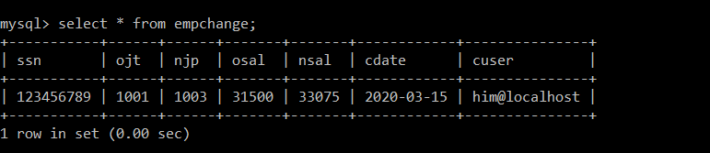

**Part(2) Q.5**

**package** fdsa;

**import** java.io.File;

**import** java.io.FileWriter;

**import** java.sql.Connection;

**import** java.sql.DriverManager;

**import** java.sql.ResultSet;

**import** java.sql.ResultSetMetaData;

**import** java.sql.Statement;

**import** java.util.Scanner;

**public** **class** Sdfg {

**public** **static** **void** main(String[] args) {

**try** {

Class.*forName*("com.mysql.cj.jdbc.Driver");

Connection con=DriverManager.*getConnection*(

"jdbc:mysql://localhost:3306/studb","him","8562083552");

Statement stmt=con.createStatement();

String query = "select e.Dno,d.Dname, sum(e.salary) total_expenditure from employee e, department d where e.Dno=d.Dnumber group by d.Dnumber, d.Dname order by d.Dnumber;";

stmt = con.createStatement();

ResultSet rs = stmt.executeQuery (query);

String directory = "C:\\Users\\dell\\Desktop\\DBMS_LAB_4_17CS02011";

String fileName = "results_q5.txt";

String absolutePath = directory + File.***separator*** + fileName;

System.***out***.print("File Location: "+absolutePath+"\n");

//System.getProperty( "line.separator" );

FileWriter fileWriter = **new** FileWriter(absolutePath);

String rr;

ResultSetMetaData rmsd = rs.getMetaData();

fileWriter.write(rmsd.getColumnName(1)+"\t"+rmsd.getColumnName(2)+"\t"+rmsd.getColumnName(3)+System.*getProperty*( "line.separator" ));

**while**(rs.next())

{

rr = "\n"+rs.getInt(1)+"\t"+rs.getString(2)+"\t"+rs.getInt(3)+System.*getProperty*( "line.separator" );

System.***out***.print(rr);

fileWriter.write(rr);

}

fileWriter.close();

System.***out***.print("\n-------------File Created Successfully---------------\n");

con.close();

//reader.close();

}

**catch**(Exception e){ System.***out***.println(e);}

}

}

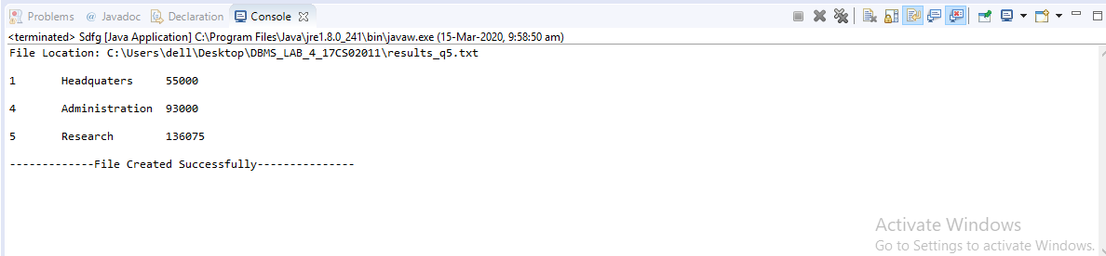

External file created for this query(asked to do so)

