S1007 – Intro to CS. Summer 2003 Practice Final Exam
2. (8 points) What is a type in Java? What are the primitive types? What is a

user-defined type? How does Java use types to make programming easier and more robust?

3. (10 points) Find ten errors (there are more than ten) in the following Java class. The

errors are both syntactic (compiler errors) and logical (bugs). For each error, identify the

line number and briefly explain how to fix it.
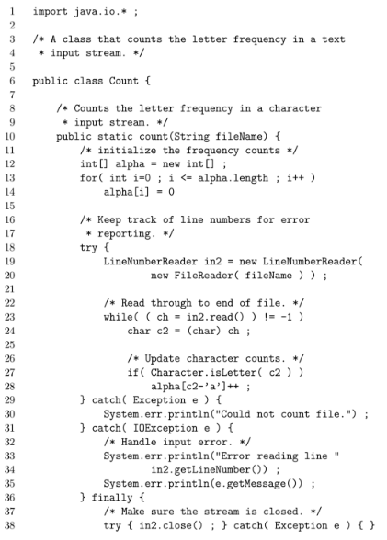 | 1  2  3  4  5  6  7  8  9  10  11  12  13  14  15  16  17  18  19  20  21  22  23  24  25  26  27  28  29  30  31  32  33  34  35  36  37  38

4. (12 points) Write the output of the following method called with the parameters

q(nums,0,nums.length-1), where nums is an array initialized as follows:

int[] nums = {5, 7, 3, 1, 4, 7} ;

Include all output from entrance to the method to final exit, including the output of all

recursive calls.

CS 102/CS 107 Intro to Programming Midterm#1, Fall 2010

36. What is the output of the code given in the column below when an object of type Confuse is created and used to call method startUp()?

class Confuse
{
private int x;
private int y;

public Confuse(){
x = 3; y = 6;
}
private void first(int z){
x = z; y++;
}
private void second(int s, int t){
setXY( (y+t), (x-s));
s = 1; t = 3;
}
private void setXY( int s, int y){
x = s;
this.y = y;
first( y);
}
private void display(){
System.out.println(x + y);
}
public void startUp(){
first( y);
second( y, x);
display();
}

}//end class Confuse
a) 7

b) 6

c) 12

d) 11

e) None of the above

39. Consider ClassA given below, along with the driver class ClassADriver for it.
class ClassA{
private int x;
public ClassA(){
x = 1;
}
public ClassA( int x){
this.x = x+1;
}
public void changeValue(int val){
x = x + val;
}

}//end ClassA

class ClassADriver{
public void doIt(){
int value = 7;
ClassA instance1 = new ClassA( value);
instance1.x = value - 1;
instance1.changeValue( 2);
System.out.println("value is: " +
instance1.x);
}
}//end ClassADriver
When running method doIt() in the ClassADriver class, the output will be:

a) value is: 5

b) value is: 6

c) value is: 7

d) doesn’t compile

e) None of the above

40. Consider the method shown below. When passed a String, what does it return?
public String method40( String theWord){
char c;
String newWord = "";
for( int i=0; i<theWord.length(); i++) {
c = theWord.charAt( i);
newWord = "";
for( int j=0; j<theWord.length(); j++){
if( (j<=i)) {
newWord = newWord + theWord.charAt( j);
}
else if( theWord.charAt( j) == c) {
newWord = newWord + theWord.charAt( j);
}
}
theWord = newWord;
}
return newWord;
}
Every other letter of the original String, starting with the first

b) Every other letter of the original String, starting with the second

c) The original String with all duplicate letters eliminated

d) Only the letters from the original String that had duplicates

e) None of the above

600.107 Intro to Programming in Java Practice Midterm
Code Tracing: After each code segment below, write down the exact output it would produce in

the box provided. Show work for partial credit. Assume the following variables have been

defined for use in each segment. Also assume that each segment is independent of the others.

Warning: the indentation is purposely misleading in some cases. [58 points total]
int intA, intB;

double db1, db2;

char ch;
10.
String line = “A”;

for (ch = ‘B’; ch <= ‘C’; ch++)

line = ch + line + ch + “\n“;

System.out.println(line);
11.
String phrase = "Fall Break!";

String part = phrase.substring(2,7);

intA = phrase.length();

ch = phrase.charAt(1);

System.out.println(intA + " " + part + " " + ch);
12.
String s = "midterm time";

intA = 11;

while ( intA > 0 ) {

switch (s.charAt(intA)) {

case 'd': case ' ': System.out.print(" a "); break;

case 'e': System.out.print(" b ");

case 't': System.out.print(" c "); break;

case 'r': System.out.print(" d ");

case 'm': System.out.print(" e "); break;

case 'I': case 'y':

default: System.out.print(" + ");

}

intA = intA - 2;

}
13.
for (intA = 1; 10 > intA ; intA *= 2) {

System.out.print(intA);

for (intB = 5; intB < 10 ; intB += intA)

System.out.print(“ o “);

System.out.println();

}
14.
14) Assume that variable word has been declared as a String and initialized with user input. This

Java statement is supposed to output whether or not the string stored in variable word

contains the character 'p'. However, it contains three errors. What are they and how

would you fix them? [3]
if (word.substring('p') >= 0);
System.out.println("p is in ", word);
else
System.out.println("not there");

16) Suppose you want to read input similar to this example from the keyboard:

X 20 $23.99 some sort of text

The first data value will be a single character item code, then an integer quantity, followed by

a price including the '$', then some more text, all separated by spaces. You must store this

data in four variables: a character called "type", an integer called “quantity”, a real number

called "price" (without the $), and for all the rest, a string called “what”. Write all the Java

variable declarations and statements necessary to make this happen, in the main method

below. Do not overly complicate this! [14]

public static void main(String[] args) {

}

ComS 207: Programming I, Midterm 1, Fall 2006
(d) URLs to E-mail Addresses (20p)

Write a program that asks the user to enter a web link (URL) to a person’s web site and uses that link to

guess the person’s e-mail address. For example, if the user entered “http://www.cs.iastate.edu/ ̃john” the

program should output “john@cs.iastate.edu”. You can assume that the user will always enter the URL in

the following format: the first character typed in will be the first letter of the URL; the URL always starts

with “http://www.”; there is only one ’ ̃’ in the URL’s name; the last character typed in will be the last

character of the URL; finally, there will be no spaces in the URL’s name. The program must then format

and print the e-mail address on the screen. The “www” in the URL must be omitted from the e-mail address

as in the example given above.

Hint: Use the methods of the String class to find the positions of the separators in the original string. Then

chop that string into separate pieces and print them in the desired order and format.

Java Practice Midterm
1.Consider the following method:

public static double solve(int n){
double answer = 1.0;
for (int k = 1; k < n; k++)
answer *= (double) k/(k + 1);
return answer;
}

What value is returned by a call to method solve?

a. 0.0

b. the kth root of n
c. 1/n
d. 1/(n – 1)
e. (1/2)^n

2. Suppose the method int sign(int x) returns 1 if x is positive, -1 if x is negative, and 0 if x is 0. Given

int[] nums = {-2, -1, 0, 1, 2};

what are the values of the elements of nums after the following code is executed?

for (int k = 0; k < nums.length; k++){
nums[k] -= sign(nums[k]);
nums[k] += sign(nums[k]);
}

a. -2, -1, 0, 1, 2

b. -1, 0, 0, 0, 1

c. 0, 0, 0, 0, 0

d. -2, 0, 0, 0, 2

e. -2, 0, 0, 2, 3

8. Consider the following method:

public static int mystery(int n){
int a, b, c = 0;
while (n > 0){
a = n / 10;
b = n % 10;
c *= 10;
c += b;
n = a;
}
return c;

}

Which statement best describes the value that is returned by mystery?

a. Ten to the nth power is returned.

b. The number of digits in n is returned.

c. The number of times 10 is a factor of n is returned.

d. The number whose digits are reversed of n is returned.

e. The sum of the digits in n is returned.

