Exercise 9.2. 1. For the following program, draw a stack diagram show- ing the state of the program just before distance returns. Include all variables and parameters and the objects those variables refer to.
2. What is the output of this program? 5
public static double distance(Point p1, Point p2) {
int dx = p1.x - p2.x;
int dy = p1.y - p2.y;
return Math.sqrt(dx*dx + dy*dy);
}
public static Point findCenter(Rectangle box) {
int x = box.x + box.width/2;
int y = box.y + box.height/2;
return new Point(x, y);
}
public static void main(String[] args) {
Point blank = new Point(5, 8);
Rectangle rect = new Rectangle(0, 2, 4, 4);
Point center = findCenter(rect);
double dist = distance(center, blank);
System.out.println(dist);
}

Which one is the answer for (1)?

A  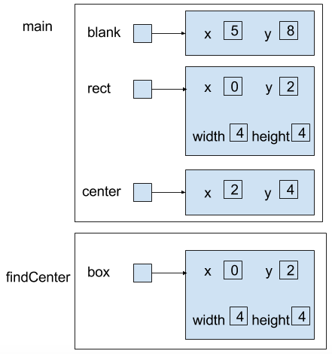  All the contents of main first and then the findCenter | B  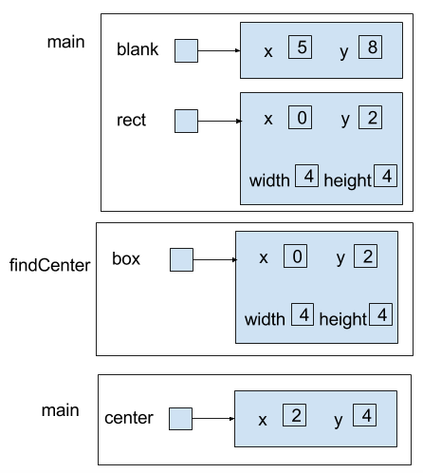  The first 2 lines of main happen, then findCenter, then the Point center is created. | C  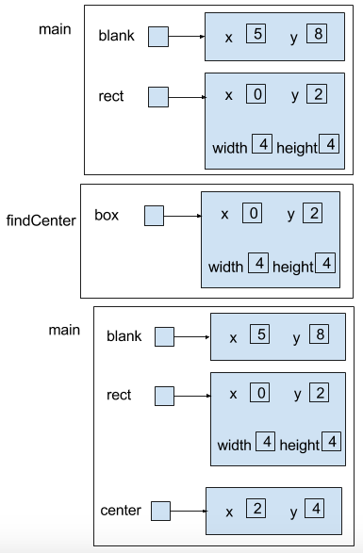  All the contents of main happen up to line 3, then findCenter happens, and then the Point center is added.
What terms do you use to explain this?

