TNE - Trusted Network Engine

Executive Summary

You may pick any of the modern day's shared-economy business solutions ranging from ride-hailing apps (Uber, Lyft, etc. ), to accommodation sharing (Airbnb) while travelling, there is one serious issue that has been spooking the users - 'Trust deficit' (User not knowing the Provider and vice-versa)! There have been various methods where companies tried to build processes to ensure "Trust" and they surely have done wonders in conventional business models.
But as shared economies are increasing in volumes and penetration, the width and depth of problems related to 'Trust' is growing at an unprecedented pace.
Taking a step back from technology and thinking how humans behave in real world would enable us to think through how this problem can be addressed.
Simply speaking, in our non-digital lives, we trust people who we know or who our acquaintances know.
We have tried to formulate this "human chain" into a system which can be used to build trust for shared-economy systems.
Below is graphical illustration of concept.
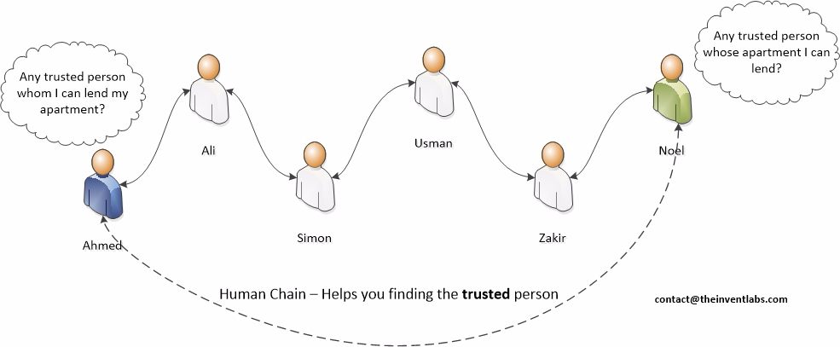

Table of Contents
Executive Summary 2
Table of Contents 3
How TNE works? 4
Use Cases 5
Balloted Committee 5
Trusted Short Rental 5
Trusted Ride Sharing 5
Trusted Domestic Staff 5

How TNE works?
TNE works in a very simple manner as follows
- Register yourself to make a trusted network (based on two properties)
  - Properties are of two type
    - Mandatory (fixed and can`t update) like trusted network can be based on cell phone numbers or email addresses or National Identification Number (like Social Security Number, etc.)
    - Optional (can update in future) like your age, location, employer, books you own, anything you can think of which can be associated to a human. This depends on application you are planning to make based on trusted network engine

- Add people from your contact list as friend using Mandatory property as defined above – We need to build a network.

- Block contact whom you feel is not trust worthy anymore – There will be times when you don’t want to utilize or provide services to certain people. So, this can be done.

- Unblock contact – This can be done as well.

- Remove a contact from your contact list – You want to unfriend someone; you can do it.

- Update your properties (only optional properties can be updated) – This is interesting bit; assume you have built a ride sharing app among trusted users. You can have properties from location and to location. You can then use these fields to find rides available or people interested in traveling to same destination.

- Find a contact(friend) on basis of some property(s) – This can help you locate someone based on your application’s scenario as explained above.

- Find mutual friends between you and any of your friend – This is interesting bit and more like Facebook or LinkedIn when combined with your application’s data you can find very interesting results like in a trusted short accommodation rental system, you can find how many times your friends (direct or indirect) have lend a property from a landlord.

- Find path between you and any contact in your network – This will bring up a whole chain of people as to how person A is connected to person B

Use Cases
There can be many use cases one can think of

Balloted Committee
(ROSCA) Rotating savings and credit association is very popular, and it runs in communities based on trust. One can built next great lending app among friends and families where only those people are included who can be trusted. TNE would help you find those people with right set of characteristics and their social chain.

Trusted Short Rental
Airbnb is great, how about a trusted rental system so you know that I am going to stay in Simon’s house and Simon is connected to you as “You->Friend A->Friend B->Friend C->Simon” and connections of Friend A, Friend B, Friend C gives an exact score of how Simon has been. So, your trust is multiplied before you even see Simon.

Trusted Ride Sharing
Lyft, Uber and alike have done a pretty good job but at least once in a lifetime we can surely say you want to take ride, or your loved ones needs to take ride by someone you trust. We believe, human chain of TNE can add this missing piece.

Trusted Domestic Staff
When you hire your drivers, maids, watchman based on references. How about you post a job for domestic staff and it gets referred by a close friend of your direct friend. We are sure, you will hire with more confidence.

One can think of many things which can be built around Human Chain concept.

