**Requirement 1.** Load the content from a file and check the spelling.

**Test case 1** – Load the content from a file and check the spelling. Misspelled words shall be highlighted.

Initial load of the content with 4 words misspelled. They are highlighted in RED

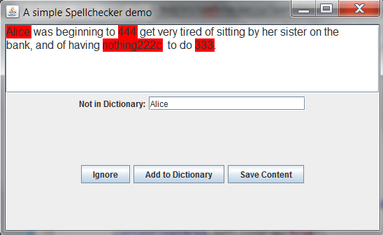

**Requirement 2:** Check if each word of the loaded text is spelled properly (if the word is in the dictionary or not

**Test case 2.1.** The test content has 4 words misspelled. They are highlighted in RED (see above)

**Requirement 3:** Operator through an HMI (GUI) to propose a new spelling for each word of the text that is not spelled properly (word that is not in the dictionary).

**Test case 3.1.**

Operator can add a new word to a dictionary. Next time when the same content is loaded, the word that used to be misspelled is now considered correct.

Step 1. Use selects ‘Alice’ – it is not in the dictionary.

Step 2. User hits ‘Add to Dictionary’ button (the system saves new word into file on the disk)

Step 3. User loads the same content.

Step 4. – Observe, ‘Alice’ is not highlighted in red (not considered as misspelled)

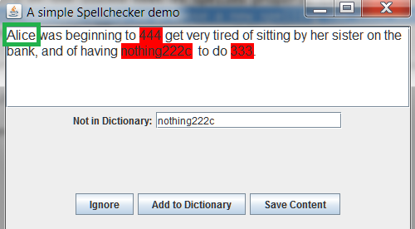

**Requirement 4.** - Provide the ability to save the text on disk with all the operator modifications

**test case 4.1**

Step 1. Load a text with misspelled content.

Step 2. Observe ‘nothing222’ is misspelled (highlighted in red)

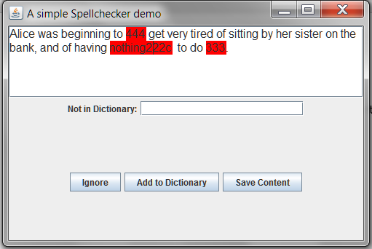

Step 3. Make a correction – replace ‘nothing222’ by ‘nothing’

Step 4. Hit ‘Save Content’ Button

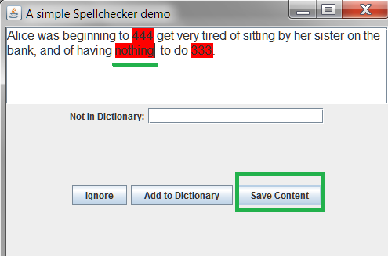

Step.5 Reload the content (restart app)

Step 6 – observe the new content has ‘nothing’ spelled properly.

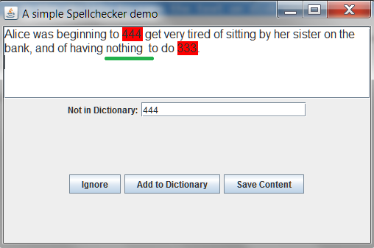

Step 7 Check content.text file