HELP – iDesk

This document makes use of material in the README file in /usr/share/idesk.

Idesk is a program developed in 2005. It draws desktop icons for users of minimal window managers such as fluxbox. Each icon will execute a shell command on a configurable action. The icons can be moved on the desktop by dragging them, and the icons will remember their positions on start-up.

It is distinguished from wmalauncher, also installed by default, in that the icons can be located anywhere on the desktop, not just in a slit position, and moved at will.

Usage
iDesk requires a configuration file ~/.ideskrc, which is installed and configured by MX-Fluxbox. Many options are available, see details in the Wiki (from the README file).
Each icon created is defined in a *.lnk file located in ~/.idesktop. There are many options avabilable such as tooltips, colors, etc. (> Wiki).The general format is like this:
table Icon
Caption: Home
Command: /home/you
Icon: ~/.idesktop/home.png
Width: 48
Height: 48
X: 680
Y: 174
end

Though icons can be set up manually, MX Linux Devs and users have modernized and adapted an old tool to produce mx-idesktool.
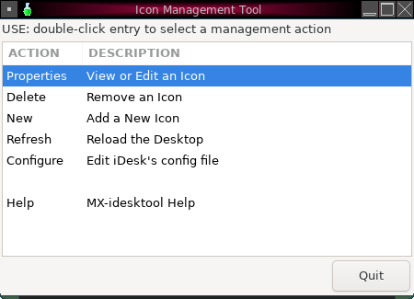mx-idesktool dashboard
Using this tool greatly facilitates the use of iDesk on MX-Fluxbox. It is very straightforward and should raise no questions about its use.

Dragging
Because defaults did not work as described, basic use of a desktop icon (set up in ~.ideskrc) is different in MX-Fluxbox than stated in the README file:
Action | Mouse
Execute | Left click
Drag | Right click hold, release to stop

