

MX-Fluxbox Documentation

MX-Fluxbox 2.1

Table of Contents
I. Fluxbox 1
II. iDesk 8
III. Wmalauncher 10
IV. Links 13

I. Fluxbox

What is Fluxbox?
Fluxbox is a Window Manager (unlike Xfce, which is a Desktop Environment) that controls the placement and appearance of windows. For history and overview, consult the Wikipedia.

How do I start?
- Use the desktop menu: right-click anywhere on the desktop. This menu is restricted to 1) common apps, 2) fluxbox settings and 3) session actions. It is set by ~/.fluxbox/menu-mx.
- Use the default dock at the bottom.
The user can see the entire MX-Xfce (Whisker) menu by clicking “All apps” in the desktop menu, pressing F6 or using the MX Linux icon on the left end of the dock.

What is that dock across the top?
That is called the toolbar, and it’s not really a dock (see Docks, below). Its width and placement can be set with the options available by middle-clicking (=scroll wheel) the clock or pager on the toolbar—if that doesn’t work for some reason, click Menu > Settings > Window, slit and toolbar > Toolbar. Height is set in ~/.fluxbox/init/ :

session.screen0.toolbar.height: 0

If a zero is there, it means that the selected style will set the height. Otherwise, a value of 20 to 25 is often comfortable.

The toolbar contains the following default components (L-R):

pager
- Allows you to switch workspace up (right click) or down (left click); same as Control + F1/F2/ etc., or using the scroll wheel over an empty section of the desktop. Number and name are set in the ~/.fluxbox/init. “W” stands for “Workspace.”
iconbar
- Here open apps will show an icon, with various window options available by right-clicking the relevant icon (including the toolbar itself) > iconbar mode. Default for MX-Fluxbox is All Windows.

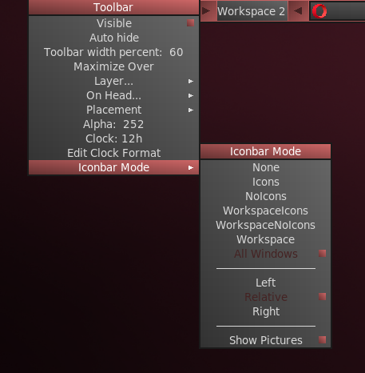Window options available with a middle click

systemtray AKA systray
- Equivalent of Notification Area in Xfce. Default components set in ~/.fluxbox/init; apps that have a systemtray option will show there when launched.

clock
- To adjust the clock to 12h or 24h, right-click and click 12h or 24h, whichever shows. If that doesn’t work, select "Edit clock format."
- 24h: %H:%M, 12h: %I:%M.
- The default is 12h time and date in day/short month format: %I:%M %b %d. Many other time/date options are available: https://mxlinux.org/wiki/other/time-formats-in-scripts/

You can move or delete any of the toolbar components in ~/.fluxbox/init/ , which by default are set up in this way:

workspacename, iconbar, systemtray, clock

How can I make it look like other legacy systems such as Windows?
Click Menu > Look > Toolbar > Legacy

How can I get rid of desktop items I don’t want?
Menu > Out of sight > ...

This section includes:
- Actual kill entries that stop the entire program. The next time you log in anything enabled in the startup file will re-appear except the default dock, which will be disabled.
- A disable entry to remove the default dock.
- Toggle entries, which can kill or re-launch a program.

How can I change or add a menu entry?
Menu > Settings > Configure > Menu. The syntax is: [category] (name) {command} – be sure to use brackets, parentheses and braces correctly.
Example 1: change “Browser” to open Opera instead of Firefox
- Find the line with the word Browser (use Ctrl+F if necessary)
[exec] (Browser) {firefox}
- Double-click the word “firefox” in the command part so it is highlighted, then type “opera” and save, producing this result:
[exec] (Browser) {opera}
Example 2: add Skype to the menu
- Decide where you want it to show up; for this example, let’s assume you want to add a new category “Communicate” in the Common apps section and enter it there
- Create the category using the submenu commands (see below), introduce a new line and follow the pattern: [exec] (menu entry) {command}
- The result will look something like this:
[submenu] (Communicate)
[exec] (Skype) {skypeforlinux}
[end]
NOTE: as the second example shows, the command to use may not always be obvious, so if necessary open All apps (F6), right-click the entry you are interested in > Edit and copy the correct full command for the menu.

What else should I know about the windows?
Properties
- Resize: Alt + right click near the corner you want to change and drag.
- Move: Alt + left click and drag.
- Stick: use the little square in the top left corner to limit the window to the current desktop.

You can combine multiple windows into one window with tabs across the top by simply Ctrl-Clicking and holding the titlebar of one window and dragging and dropping it on another window. Reverse the procedure to separate them again.
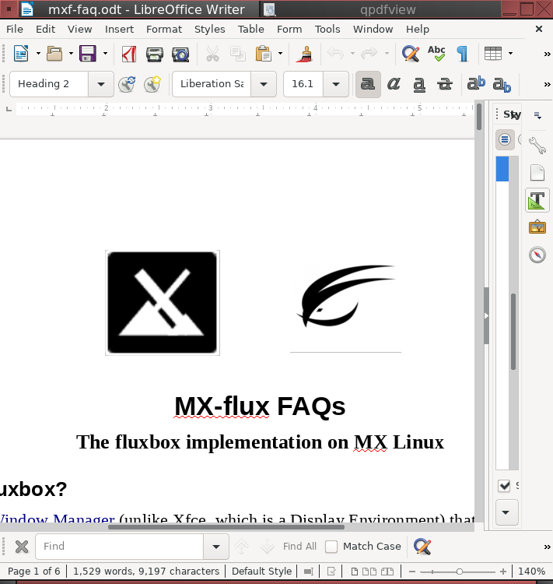Writer and qpdfview grouped together, tabs on top

More: http://fluxbox.sourceforge.net/docbook/en/html/chap-tabs.html

I see styles in the menu, what are those?
Styles are simple text files that tell fluxbox how to generate the appearance of the window and toolbar components. Fluxbox ships with a large number in /usr/share/fluxbox/styles/ that show in Menu > Look > Style, and many more can be found online with a web search on "fluxbox styles."

Styles can include a background image, but that is blocked in MX-Fluxbox by default with the top lines in Menu > Settings > Configure > Overlay. To allow the style to determine the background, place a hash mark in front to the line so that it looks like this:

! The following line will prevent styles from setting the background.
#background: none

If you like a style but want to change certain traits, copy it to ~/.fluxbox/styles, rename it, and make your changes (consult Ubuntu style guide under Links, below). One of the default styles for MX-Fluxbox in that folder, for instance, is a modified form of “Twice” copied and renamed “MX-Twice,” then modified to center the window titles.

What are themes and how do I manage them?
The theme selector showing the selection of Arc-Darker
Themes in MX-Fluxbox are GTK 2.0 themes; a number are installed by default and others can be found with a web search. A GTK theme controls items such as the panel color, the backgrounds for windows and tabs, how an application will look when it is active vs. inactive, buttons, check-boxes, etc. They range from very dark to very light.
The default theme for MX-Fluxbox is Greybird-dark-mx. It can be changed by clicking Menu > Look > Theme, bringing up a theme selector (lxappearance) which makes it very easy to see and choose the other possibilities.

I can’t read some of the texts, can I do something about that?
You can ajust the font being used by a theme using the theme selector; default for MX-Fluxbox is Sans 11. More detailed control is available by using the ~/.fluxbox/overlay file. For instance, this set of commands might be tried to make the text generally larger:
# fonts------------------------------------------
menu.frame.font: PT Sans-12:regular
menu.title.font: PT Sans-12:regular
toolbar.clock.font: PT Sans-11:regular
toolbar.workspace.font: PT Sans-11:regular
toolbar.iconbar.focused.font: PT Sans-11:regular
toolbar.iconbar.unfocused.font: PT Sans-11:regular
window.font: Lato-9

For other font options, consult the Links at the end of this document.

Can I change the background?
First make sure the overlay file is blocking the style from determining the background. Then click Menu > Look > Backgrounds to see the available choices. Backgrounds whose name begins with “mxfb-” carry the MX-Fluxbox logo. The list that pops up from the menu entry includes any user backgrounds (~/.fluxbox/backgrounds) and system backgrounds (/usr/share/backgrounds), separated by a horizontal line. This setup allows you to add backgrounds in the user folder and then be able to select them from the menu.

Conky
MX-Fluxbox users can make use of the default conky set for MX Linux by clicking Menu > Look > Conky to bring up Conky Manager 2 , which handles conkies in both the old and new format.
For more complicated conkies, you may need to make use of a compositor. Click Menu > Settings > Config > Startup, and uncomment the line about a compositor so it looks like this: compton &
To autostart a specific conky, open Menu > Settings > Configure > Startup, look for the line that starts with conky -p 5 (it may be commented out), change the conky location to the one you want and uncomment if necessary.

What terminals are available?
- F4 (or Menu > Terminal) = Drop-down Xfce4-terminal
- F2 (or: Menu > Run…) = little command terminal (fbrun)
- F2, and enter xfce4-terminal to get a movable Xfce terminal.

Can I use my own keystroke combinations?
Yes. Many are listed by default in Menu > Settings > Configure > Keys, though not clear that [all of them work. The names of a couple of the keys are a bit obscure:
- Mod1 = Alt
- Mod4 = Logo key (Windows, Apple)
More: http://fluxbox.sourceforge.net/docbook/en/html/c296.html

There are 6 dedicated function keys in MX-Fluxbox (see top of keys file to change):
- F1: MX-Fluxbox documentation
- F2: Run command
- F3: File manager
- F4: Drop-down terminal
- F5: MX Tools
- F6: All apps

Are there options available for apps that I launch?
When an app is open, you can right-click the title bar and set any of the options available. For instance, you can select to remember size and location. Your choices are recorded in ~/.fluxbox/apps and allow you to control many window specifics.

What screen options exist?
- Brightness: right-click the battery icon in the systray
- Capture: if you have a Print Screen (AKA Print, PrtSc, etc.) key, try using that; if that doesn’t work or exist, click Menu > Accessories > Capture
- Screensaver: Menu > Accessories > Screensaver
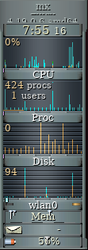 Gkrellm monitors

I have read about the slit: what is that?
The slit is a container for dockapps that can be located at various locations on the desktop:
- TopLeft, TopCenter, TopRight
- LeftCenter, RightCenter
- BottomLeft, BottomCenter, BottomRight
These small applications came originally from Window Maker and can fit into those areas. You can search the default repo for dockapps with this terminal command:
apt-cache search dockapp
Many available in the repos may not work well, but it’s worth taking a look.
One very interesting and useful dockapp not found with that apt-cache search is the monitor stack gkrellm, installed by default in MX-Fluxbox. It is available by clicking Menu > System > Monitors and has many configuration options (right-click on the top label or on one of the charts), many skins and many plugins. A few skins are installed by default, and can be reviewed and selected by clicking Shift-PageUp. A handy plugin can be installed from the repos gkrellweather, which works well when the version in the MX repos is installed (the Debian one is broken at the moment).

Are docks possible?
External docks such as plank often do not work easily with fluxbox. But a new tool MX Dockmaker makes it easy for the user to create docks. A default dock appears on the desktop when the user logs in to MX-Fluxbox 2.1 for the first time:
Default dock

For details on using this app, consult the Help file.

II. iDesk

This document makes use of material in the README file in /usr/share/idesk.

Idesk is a program developed in 2005. It draws desktop icons for users of minimal window managers such as fluxbox. Each icon will execute a shell command on a configurable action. The icons can be moved on the desktop by dragging them, and the icons will remember their positions on start-up.

It is distinguished from wmalauncher, also installed by default, in that the icons can be located anywhere on the desktop, not just in a slit position, and moved at will.

Usage
iDesk requires a configuration file ~/.ideskrc, which is installed and configured by MX-Fluxbox. Many options are available, see details in the Wiki (from the README file).
Each icon created is defined in a *.lnk file located in ~/.idesktop. There are many options available such as tooltips, colors, etc. (> Wiki).For the general format, consult the default Home link.
Though icons can be set up manually, MX Linux Devs and users have modernized and adapted an old tool to produce mx-idesktool.
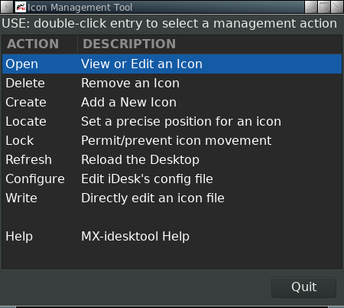mx-idesktool dashboard
Using this tool greatly facilitates the use of iDesk on MX-Fluxbox. It is very straightforward and should raise no questions about its use.

Dragging
Basic use of a desktop icon (set up in ~.ideskrc) is as follows.
Action | Mouse
Execute | Left single click
Execute alt | Middle single click
Drag | Right click hold, release to stop

Locking
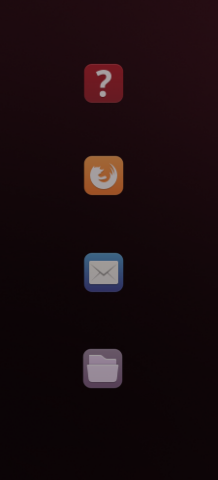Default icon group
Though individual icons can’t be locked, all icons can be.
For example, the default desktop contains four icons in the upper left corner It is easy to move them by mistake when clicking, and then the symmetry is ruined. So they are locked in place using mx-idesktool.
The original X,Y values for the default icons in MX-Fluxbox 2.0 can be restored manually by editing them in ~/.idesktop:
FAQ 90, 60
Firefox 90, 160
Thunderbird 90, 260
Thunar 90, 360
Alternatively, the user can click Menu > Look > Desktop icons and double-click the entry “Permit/Prevent icon movement.” Double-click the entry again to unlock.

III. Wmalauncher

This document is based on an excerpt from the README file in the installation folder and also material from the man file (in a terminal: man wmalauncher).

Description
Developed by Sébastien Ballet, wmalauncher is an easy-to-use and highly configurable command-line application launcher especially designed for fluxbox, but which also works well under blackbox, openbox and windowmaker. Features:
- Provides support for
  - PNG, SVG, XPM icons
  - .desktop files
  - Configuration files
  - Mouse hover event
  - Icon color/grayscale mode
  - Color gradient
- Permits customization of
  - Button appearance
  - Icon brightness/contrast/gamma
  - Tooltip
It creates one or more icons in the slit, whose location is defined in the init file.

Usage
There are three ways to create a launcher for a given application with
wmalauncher:

1. Probably the easiest for everyday use is to pass the .desktop file of the target application on the command line :

$ wmalauncher --desktop-file mozilla-firefox:firefox &

In the example above, wmalauncher will use the first .desktop file found in the "desktop file search path" that matches mozilla-firefox.desktop or firefox.desktop. Note: as in the above example, it easier is to omit the extension (i.e., just firefox instead of firefox.desktop).

2. Pass the command to execute and the icon to display on the command
line, as in example below :

$ wmalauncher --command /usr/bin/firefox --icon firefox.png &

In the example above, wmalauncher will use the first icon found in the "icon search paths" that match firefox.png (note: the extension can be omitted).

3. Pass a configuration file (details below) containing the settings for the target application on the command line :

$ wmalauncher --config /usr/share/wmalauncher/lighting.conf \
--prefix mozilla-firefox &

In the example above, wmalauncher loads the settings from the configuration file /usr/share/wmalauncher/lighting.conf, then, configures the command, icon and tooltip-text according to the settings dedicated to the application firefox.

TIP: if you have multiple launchers and want them to remain in the same order, add a small time delay “sleep 0.1” after the final “&” of each line. (Thanks to user PPC for this solution!)

MX-Fluxbox
To facilitate everyday use, a template is made available (~/.fluxbox/scripts/wmalauncher-menu). With this template, users can easily create a single launcher as well as a string of them to serve as a “dock.”

For instance, MX-Fluxbox uses the template to create a default menu icon when the toolbar is in legacy mode using this command:

wmalauncher --command xfce4-appfinder --icon /usr/local/share/icons/mxfcelogo-rounded.png -w 48 -x &

That produces this launcher which, when clicked, opens the menu:

A launcher may be deleted by right-clicking it, if created by including the switch “-x” as above, or by clicking Menu > Out of sight > Kill docks (in a terminal: killall wmalauncher). Details on that new delete feature can be found in the Wiki. Note that the default dock does not contain that switch.

Configuration files
For more about wmalauncher configuration files, see the section "CONFIGURATION FILE FORMAT" in the man page.

Wmalauncher comes with the following pre-defined configuration files in /usr/share/wmalauncher:

- lighting.conf
- multi-effects.conf
- old-school.conf
- frame-onthefly.conf
- wmaker-style.conf

Applying those in the order above to Pulse Audio Volume Control (pavucontrol) gives these different looks:


Each of the predefined configuration files includes a global section for visual settings, along with entries for a large group of applications (details in the Wiki).:

IV. Links

The man files (in terminal or https://linux.die.net/man/):
- fluxbox
- fluxbox-keys
- fbrun
- fluxstyle
- fluxbox-remote
http://fluxbox.sourceforge.net/docbook/en/pdf/fluxbook.pdf
Basic handbook, somewhat dated but still useful

https://bbs.archlinux.org/viewtopic.php?id=77729
Some good general explanations with examples

https://wiki.archlinux.org/index.php/Fluxbox
Some commands are Arch-specific

https://wiki.ubuntu.com/HowToFluxboxStyles

https://ubuntuforums.org/showthread.php?t=617812
Excellent thread on fluxbox keys

https://wiki.debian.org/FluxBox

https://wiki.debian.org/FluxboxIcon

https://github.com/jerry3904/mx-fluxbox
The GitHub repo of MX-Fluxbox

https://mxlinux.org/wiki/help-files/help-mx-fluxbox/
The MX-Fluxbox Wiki entry

v. 20200409

