


MX-Fluxbox Documentation
The fluxbox implementation on MX Linux
Available FAQ translations can be found in /doc/tr/

Table of Contents
I. Fluxbox 1
II. iDesk 8
III. Wmalauncher 10

I. Fluxbox

What is Fluxbox?
Fluxbox is a Window Manager (unlike Xfce, which is a Display Environment) that controls the placement and appearance of windows. For history and overview, consult the Wikipedia.

How do I start?
Right-click anywhere on the desktop to get a menu.
- The menu is set by ~/.fluxbox/menu-mx. Alternative menus in ~/.fluxbox/menus_other/
- For further menus, do a web search on "fluxbox menu example"

What is that dock across the top?
That is called the toolbar, and it’s not really a dock (see Docks, below). Its width and placement can be set with the options available by right-clicking an empty space (or the workspace arrow icon) on the toolbar—if that doesn’t work for some reason, click the middle or scroll button if you have one or work in the init file. Height is set in ~/.fluxbox/init/ :

session.screen0.toolbar.height: 0

If a zero is there, it means that the selected style will set the height. Otherwise, a value of 20 to 25 is often comfortable.

The toolbar contains the following default components (L-R):

clock
- To adjust the clock to 12h or 24h, right-click and click 12h or 24h, whichever shows. If that doesn’t work, select "Edit clock format."
- 24h: %H:%M, 12h: %I:%M.
- The default is 12h time and date in day/short month format: %I:%M %b %d. Many other time/date options are available: https://mxlinux.org/wiki/other/time-formats-in-scripts/
pager
- Allows you to switch workspace; same as Control + F1/F2/ etc., or using the scroll wheel over an empty section of the desktop. Number and name are set in the ~/.fluxbox/init. “W” stands for “Workspace.”
iconbar
- Here open apps will show an icon, with various window options available by right-clicking the relevant icon (including the toolbar itself) > iconbar mode. Default for MX-Fluxbox is All Windows.

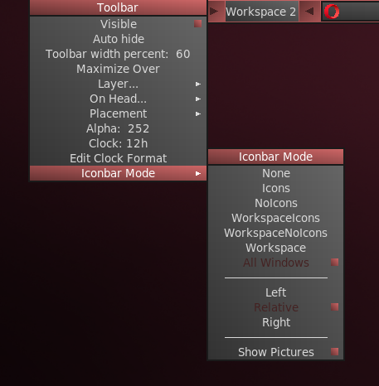Window options available with a right click

systemtray AKA systray
- Equivalent of Notification Area in Xfce. Default components set in ~/.fluxbox/init; apps that have a systemtray option will show there when launched.

You can move or delete any of the toolbar components in ~/.fluxbox/init/ , which by default are set up in this way:

clock, prevworkspace, workspacename, nextworkspace, iconbar, systemtray

How can I make it look like other legacy systems such as Windows?
Click Menu > Toolbar > Legacy

How can I get rid of desktop items I don’t want?
Menu > Out of sight

The FAQ icon can be restored by clicking Menu > Settings > Configure > Startup and removing the comment sign (= the “#”) at the beginning of the line idesk &. For the conky or monitors, click Menu > System > Conky or Monitors and select the one you want.

How can I change or add a menu entry?
Menu > Settings > Configure > Menu. The syntax is: [category] (name) {command} – be sure to use brackets, parentheses and braces correctly.
Example 1: change “Browser” to open Opera instead of Firefox
- Find the line with the word Browser (use Ctrl+F if necessary)
[exec] (Browser) {firefox}
- Double-click the word “firefox” in the command part so it is highlighted, then type “opera” and save, producing this result:
[exec] (Browser) {opera}
Example 2: add Skype to the menu
- Decide where you want it to show up; for this example, let’s assume you want to put it under “Communicate” and that you want to label it as “video”
- Introduce a new line and follow the pattern: [exec] (menu entry) {command}
- The result will look something like this:
[submenu] (Communicate)
[exec] (Email) {thunderbird}
[exec] (Chat) {hexchat}
[exec] (Video) {skypeforlinux}
[end]
NOTE: as the second example shows, the command to use may not always be obvious, so if necessary open All apps (F6), right-click the entry you are interested in > Edit and copy the correct full command for the menu.
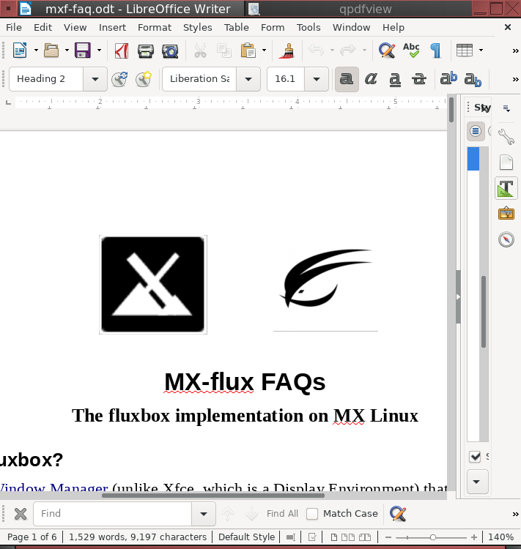Writer and qpdfview grouped together, tabs on top

What else should I know about the windows?
Properties
- Resize: Alt + right click near the corner you want to change and drag.
- Move: Alt + left click and drag.

You can combine multiple windows into one window with tabs across the top by simply Ctrl-Clicking and holding the titlebar of one window and dragging and dropping it on another window. Reverse the procedure to separate them again.

More: http://fluxbox.sourceforge.net/docbook/en/html/chap-tabs.html

I see styles in the menu, what are those?
Styles are simple text files that tell fluxbox how to generate the appearance of different components of the window manager. Fluxbox ships with a large number in /usr/share/fluxbox/styles/ that show in Menu > Look > Style, and many more can be found online with a web search on "fluxbox styles."

Styles can include a background image, but that is blocked in MX-flux by default with the top lines in Menu > Settings > Configure > Overlay. To allow the style to determine the background, place a hash mark in front to the line so that it looks like this:

! The following line will prevent styles from setting the background.
#background: none

If you like a style but want to change certain traits, copy it to Menu > Settings > Configure > Styles, rename it, and make your changes (consult Ubuntu style guide under Links, below). One of the default styles for MX-flux in that folder, for instance, is a modified form of “Twice” copied and renamed “MX-Twice,” then modified to center the window titles.

I can’t read some of the texts, can I do something about that?
You can ajust the font being used within the ~/.fluxbox/overlay file. For instance, this set of commands will make the text generally larger:
# fonts------------------------------------------
menu.frame.font: PT Sans-12:regular
menu.title.font: PT Sans-12:regular
toolbar.clock.font: PT Sans-11:regular
toolbar.workspace.font: PT Sans-11:regular
toolbar.iconbar.focused.font: PT Sans-11:regular
toolbar.iconbar.unfocused.font: PT Sans-11:regular
window.font: Lato-9

For other font options, consult the Links at the end of this document.

Can I change the background?
First make sure the overlay file is blocking the style from determining the background. Then click Menu > Look > Backgrounds to see the available choices. The list that pops up from the menu entry includes any user backgrounds (~/.fluxbox/backgrounds) and system backgrounds (/usr/share/backgrounds), separated by a horizontal line. This setup allows you to put your preferred backgrounds in the user folder and be able to select among the group with a simple click.

Conky
MX-flux users can make use of the default conky set for MX Linux by clicking Menu > Look > Conky to bring up a selection box for MX-Conky. NOTE: using MX-Conky while in fluxbox instead of Conky Manager prevents the fluxbox settings from overriding the Xfce ones—and vice versa.
For more complicated conkies, you may need to make use of a compositor. Click Menu > Settings > Config > Startup, and uncomment the line about a compositor so it looks like this: compton &
Users on MX-19 will likely need to change a setting to gain transparency, and that setting may unfortunately not be the same for all conkies. One that often works is this: after opening the conky in MX-Conky, click on the Edit button and search the text that pops up for the line:
own_window_transparent no

and replace it with:
own_window_transparent yes

Another that works sometimes is to change (if present) own_window yes instead of own_window yes.
Save any changed text with the ending “_fb” so that you will not override that conky for Xfce users.
To autostart a specific conky, open Menu > Settings > Configure > Startup, look for the line that starts with conky -p 5 (it may be commented out), change the conky location to the one you want and uncomment if necessary.

What terminals are available?
- F4 (or Menu > Terminal) = Drop-down Xfce4-terminal
- F2 (or: Menu > Run…) = little command terminal (fbrun)
- F2, and enter xfce4-terminal to get a movable Xfce terminal.

Can I use my own keystroke combinations?
Yes. Many are listed by default in Menu > Settings > Configure > Keys, though not clear that [all of them work. The names of a couple of the keys are a bit obscure:
- Mod1 = Alt
- Mod4 = Logo key (Windows, Apple)
More: http://fluxbox.sourceforge.net/docbook/en/html/c296.html

There are 6 dedicated function keys in MX-flux (see top of keys file to change):
- F1: fluxbox FAQs
- F2: Run command
- F3: File manager
- F4: Drop-down terminal
- F5: MX Tools
- F6: All apps

Are there options available for apps that I launch?
When an app is open, you can right-click the title bar and set any of the options available. For instance, you can select to remember workspace, size, location, etc. Your choices are recorded in ~/.fluxbox/apps and allow you to control many window specifics.

What screen options exist?
- Brightness: right-click the battery icon in the systray
- Capture: if you have a Print Screen (AKA Print, PrtSc, etc.) key, try using that; if that doesn’t work or exist, click Menu > Accessories > Capture
- Screensaver: Menu > Accessories > Screensaver

I have read about the slit: what is that?
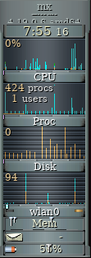 Gkrellm monitors
The slit is a container for dockapps that can be located at various locations on the desktop:
- TopLeft, TopCenter, TopRight
- LeftCenter, RightCenter
- BottomLeft, BottomCenter, BottomRight
Dockapps are small applications coming originally from Window Maker that can fit into those areas. You can search the default repo for dockapps with this terminal command:
apt-cache search dockapp
Many available in the repos may not work well, but it’s worth taking a look.
One very interesting and useful dockapp not found with that apt-cache search is the monitor stack gkrellm, installed by default in MX-flux. It is available by clicking Menu > System > Monitors and has many configuration options (right-click on the top label or on one of the charts), many skins and many plugins.
A handy plugin can be installed from the repos gkrellweather, which works well when the version in the MX repos is installed (the Debian one is broken at the moment).
A new and powerful command-line app for creating desktop launchers in the slit called wmalauncher is available. For details consult the Help file: Menu > Look > Slit lanuchers > Doc.
Dock5

Are docks possible?
External docks such as plank often do not work easily with fluxbox. But three ready-made docks created with wmalauncher are available by default: Menu > Look > Docks. Those ready-made docks come in small (3 launchers), medium (5) and large (7)--you can just right-click the ones you don’t want to remove tham. Furthermore, you can easily make your own using the Dock Template: Menu > Look > Slit launchers > Create. This template exploits the ability to use simple application names (pointing to the desktop files in /usr/share/applications).
There are other ways to use wmalauncher to make a dock and many possible options—consult the wmalauncher Help file: Look > Slit launchers > Doc.

Can I make use of bluetooth devices?(7
Yes. It is disabled by default, but to set it up click menu > Settings > Bluetooth. An icon will appear in the systray that you can right click to see a menu with many options, including Exit.

Do you have useful links to recommend?
http://fluxbox.sourceforge.net/docbook/en/pdf/fluxbook.pdf
Basic handbook, somewhat dated but still useful

https://bbs.archlinux.org/viewtopic.php?id=77729
Some good general explanations with examples

https://wiki.archlinux.org/index.php/Fluxbox
Some commands are Arch-specific

https://wiki.ubuntu.com/HowToFluxboxStyles

https://wiki.debian.org/FluxBox

https://wiki.debian.org/FluxboxIcon

v. 20200128

II. iDesk

This document makes use of material in the README file in /usr/share/idesk.

Idesk is a program developed in 2005. It draws desktop icons for users of minimal window managers such as fluxbox. Each icon will execute a shell command on a configurable action. The icons can be moved on the desktop by dragging them, and the icons will remember their positions on start-up.

It is distinguished from wmalauncher, also installed by default, in that the icons can be located anywhere on the desktop, not just in a slit position, and moved at will.

Usage
iDesk requires a configuration file ~/.ideskrc, which is installed and configured by MX-Fluxbox. Many options are available, see details in the Wiki (from the README file).
Each icon created is defined in a *.lnk file located in ~/.idesktop. There are many options avabilable such as tooltips, colors, etc. (> Wiki).The general format is like this:
table Icon
Caption: Home
Command: /home/you
Icon: ~/.idesktop/home.png
Width: 48
Height: 48
X: 680
Y: 174
end

Though icons can be set up manually, MX Linux Devs and users have modernized and adapted an old tool to produce mx-idesktool.
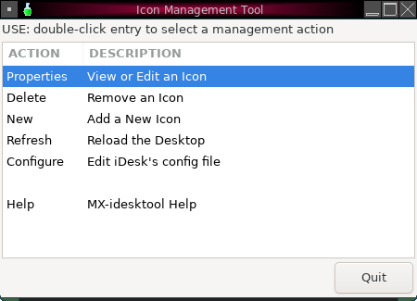mx-idesktool dashboard
Using this tool greatly facilitates the use of iDesk on MX-Fluxbox. It is very straightforward and should raise no questions about its use.

Dragging
Because defaults did not work as described, basic use of a desktop icon (set up in ~.ideskrc) is different in MX-Fluxbox than stated in the README file:
Action | Mouse
Execute | Left click
Drag | Right click hold, release to stop

III. Wmalauncher

This document is based on an excerpt from the README file in the installation folder and also material from the man file (in a terminal: man wmalauncher).

Description
Developed by Sébastien Ballet, wmalauncher is an easy-to-use and highly configurable command-line application launcher especially designed for fluxbox, but which also works well under blackbox, openbox and windowmaker. Features:
- Provides support for
  - PNG, SVG, XPM icons
  - .desktop files
  - Configuration files
  - Mouse hover event
  - Icon color/grayscale mode
  - Color gradient
- Permits customization of
  - Button appearance
  - Icon brightness/contrast/gamma
  - Tooltip
It creates one or more icons in the slit, whose location is defined in the init file.

Usage
There are three ways to create a launcher for a given application with
wmalauncher:

1. Probably the easiest for everyday use is to pass the .desktop file of the target application on the command line :

$ wmalauncher --desktop-file mozilla-firefox.desktop:firefox.desktop &

In the example above, wmalauncher will use the first .desktop file found in the "desktop file search path" that matches mozilla-firefox.desktop or firefox.desktop. Note: even easier is to omit the extensions (i.e., just firefox instead of firefox.desktop).

2. Pass the command to execute and the icon to display on the command
line, as in example below :

$ wmalauncher --command /usr/bin/firefox --icon firefox.png &

In the example above, wmalauncher will use the first icon found in the
"icon search paths" that match firefox.png (note: the extension can be
omitted).

3. Pass a configuration file (details below) containing the settings for the target application on the command line :

$ wmalauncher --config /usr/share/wmalauncher/lighting.conf \
--prefix mozilla-firefox &

In the example above, wmalauncher loads the settings from the configuration file /usr/share/wmalauncher/lighting.conf, then, configures the command, icon and tooltip-text according to the settings dedicated to the application firefox.

MX-Fluxbox
To faciliatate everyday use, a template is made available (~/.fluxbox/scripts/wml-dock-template). With this template, users can easily create a single launcher as well as a string of them to serve as a “dock.”

For instance, MX-Fluxbox uses the template to create a default menu icon when the toolbar is in legacy mode using this command:

wmalauncher --command xfce4-appfinder --icon /usr/local/share/icons/mxfcelogo-rounded.png -w 48 -x &

That produces this launcher which, when clicked, opens the menu:

A launcher may be deleted by right-clicking it, if created by including the switch “-x” as above, or by clicking Menu > Out of sight > Slit launcher (in a terminal: killall wmalauncher).

Configuration files
For more about wmalauncher configuration files, see the section "CONFIGURATION FILE FORMAT" in the man page.

Wmalauncher comes with the following pre-defined configuration files in /usr/share/wmalauncher:

- lighting.conf
- multi-effects.conf
- old-school.conf
- frame-onthefly.conf
- wmaker-style.conf

Applying those in the order above to Pulse Audio Volume Control (pavucontrol) gives these different looks:


Each of the predefined configuration files includes a global section for visual settings, along with entries for the following applications :

Development
- emacs
- geany
- gvim

Games
- darkplaces
- dhewm3
- gzdoom
- ioquake3
- iortcw
- quake2
- xboard

Graphics
- geeqie
- gimp
- gwenview
- krita
- libreoffice-draw
- xsane

Internet
- gftp
- google-chrome
- mozilla-firefox
- mozilla-thunderbird
- pan
- pidgin
- seamonkey
- transmission-gtk
- transmission-qt

Multimedia
- amarok
- audacious
- k3b
- kplayer
- mplayer
- pavucontrol
- xine
- xmms

Office
- libreoffice
  - base
  - calc
  - impress
  - math
  - startcenter
  - writer
- okular
- qpdfview
- scribus
- xpdf

System
- dolphin
- grsync
- htop
- konsole
- ksysguard
- thunar
- uxterm
- virtualbox
- xfce4-terminal
- xfe
- xterm
- xfce4-taskmanager

Utilities
- galculator
- gucharmap
- kate
- kcalc
- kwrite
- leafpad
- xarchiver
- xfce4-screenshooter

v. 20200128

