BRIEFING

Voltage Division in Series Resistor Networks
A worked analysis
Mowr · 10 October 2026
Executive summary
This report derives the voltage divider relation, verifies it on a 12 V network and discusses loading effects.

1 Introduction
Series resistors share the source voltage in proportion to their resistance [1]. The circuit in Figure 1 is analysed throughout.
- Ohm's law applies to each resistor.
- Kirchhoff's voltage law closes the loop.
  - Nested point one.
- Measure the source.
- Compute the current.
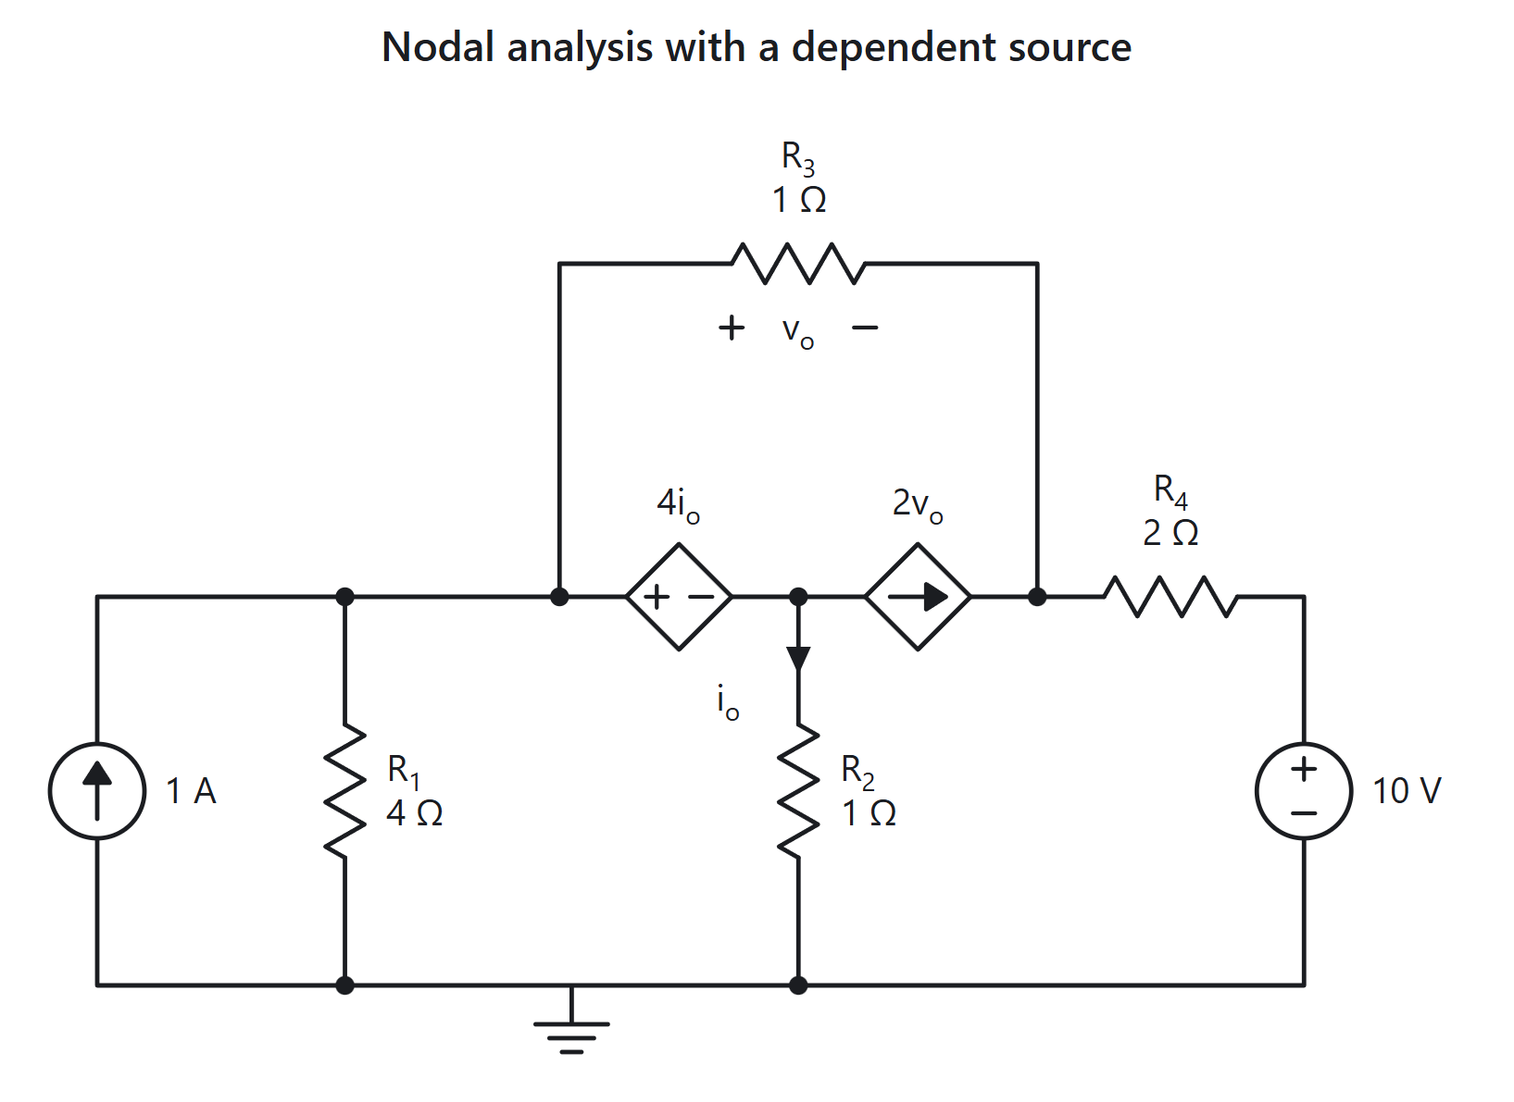
Figure 1. A 12 V source driving $R_{1}$ and $R_{2}$ in series.

2 Theory
The current is $I=\frac{V}{R_{1}+R_{2}}$, so the voltage across $R_{2}$ is
$V_{2}=V\frac{R_{2}}{R_{1}+R_{2}}$
Definition 2.1 (Voltage divider). A network of series impedances whose output is a fixed fraction of its input.

2.1 Energy view
The power is $P=\sum_{k=1}^{n}{I^{2}}R_{k}$ and the matrix form is
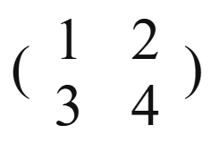
Table 1. Measured and predicted voltages
Resistor | Predicted (V) | Measured (V)
R1 | 4.00 | 3.98
R2 | 8.00 | 8.01

A footnote appears here.

3 Worked example
Charging a capacitor stores energy, much as 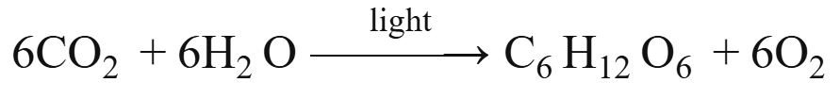 stores it in sugar; inline, water is $H_{2}O$ and the vector is $\overset{→}{AB}$.
With $V=12 V$, $R_{1}=100 Ω$ and $R_{2}=200 Ω$: $I=40 mA$ and $V_{2}=8 V$.
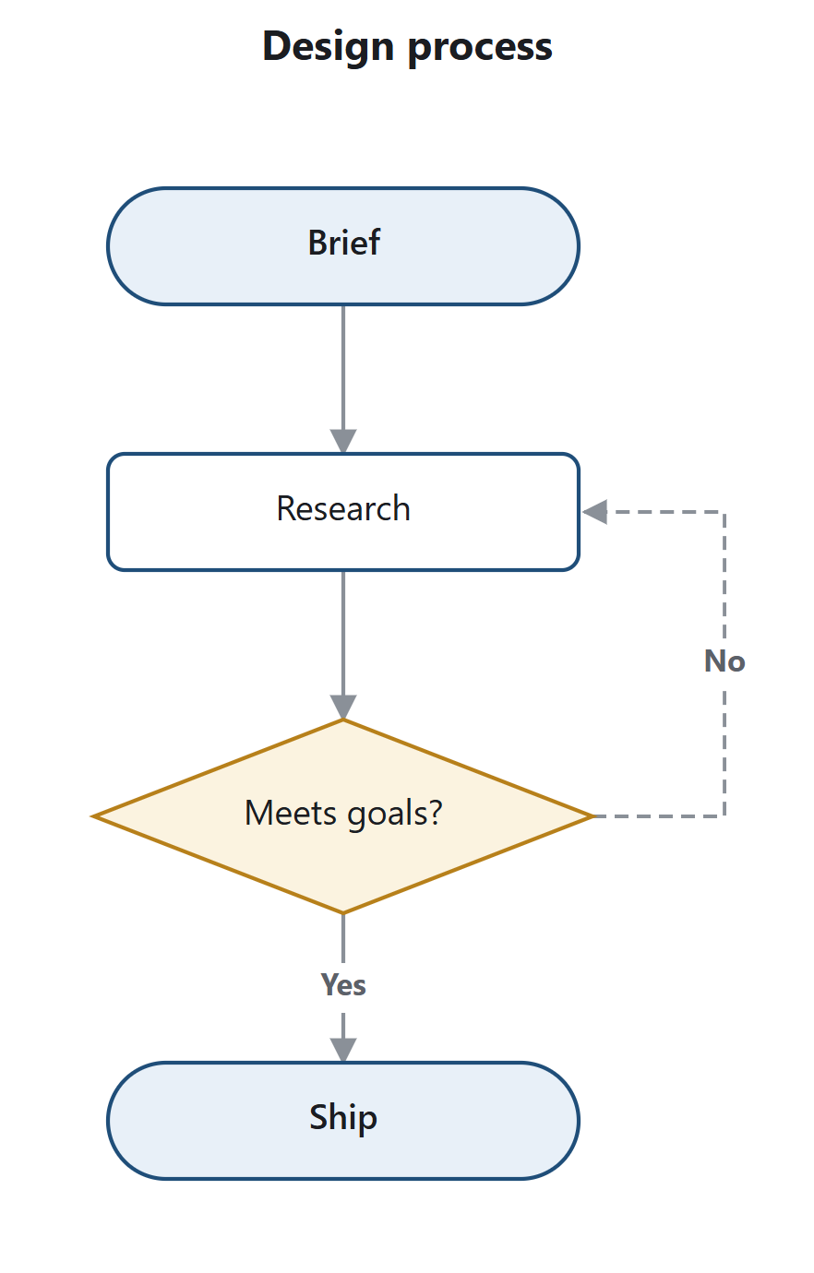
Figure 2. Analysis procedure.

4 Discussion
Caution (Loading). A load in parallel with $R_{2}$ lowers $V_{2}$.

Conclusion. The divider is exact for an unloaded output.

References
[1] Horowitz, P. and Hill, W. The Art of Electronics, 3rd ed., 2015.

Measurements used a 4½-digit meter.

