NA 599 – Final Project

To: Kevin Maki

From: Marc Woolliscroft

December 17, 2012

**Introduction**

This report contains the descriptions and results of three studies: a hydrofoil in a constant velocity flow producing non-breaking waves at the free-surface, a scalability study of this same case, and a hydrofoil in a constant velocity flow producing a breaking wave at the free-surface. All studies were conducted using a volume-of-fluid (VOF) interface-capturing method. The initial set-up for each study, as well as final results, will be discussed. When applicable, some results will be compared with those acquired by James H. Duncan in his experiments on towed hydrofoils.

**Case One – Non-Breaking Waves**

As previously mentioned, the first case involves a hydrofoil producing non-breaking waves at the free-surface. The geometric parameters of the case are shown below. These parameters were chosen for comparison to Duncan’s experimental results.

|  |  |
| --- | --- |
| **Parameter** | **Value** |
| chord length, *c* | 0.203 m |
| chord-based Froude number, *Fr* | 0.567 |
| chord-based Reynolds number, *Re* | 1.624x105 |
| angle of attack, α | 5 degrees |
| free-surface to mid chord ratio, *d/c* | 1.034 |
| bottom to mid chord ratio, *h/c* | 0.862 |

In addition to the parameters dictated by Duncan’s experiments, a computational domain needed to be created. First, using the equation below, distances for both upstream and downstream domain extents were computed.

$$λ=\frac{2πU^{2}}{g}$$

It was desired to have about 20 wavelengths downstream and four wavelengths upstream. This led to computational domain 9.6 meters long, with the mid chord of the hydrofoil located 1.6 meters downstream of the inlet. In addition, the air portion of the domain extended a height of 0.4 meters (about one wavelength) above the calm free-surface. A structured mesh was chosen due to the ability to fine tune certain aspects of the domain, such as spacing and elliptic solver methods. Cells of the mesh were clustered near the calm free-surface and the hydrofoil. All results presented correspond to a mesh with 338,614 cells. Turbulence was not a great focus, so y+ values were not confirmed to be less than one.

The following plot shows the free-surface wave profile of the numerical simulation plotted with the results from Duncan’s experiment. The origin corresponds to the point on the calm water surface directly vertical from the mid chord of the hydrofoil. As can be seen, the hydrofoil is far enough from the surface of the water so that the low pressure side does not create a wave that is steep enough to break.

Qualitatively, the OpenFOAM results are similar to Duncan’s; in particular, the wavelengths seem to match quite well. However, the wave amplitudes of the OpenFOAM results are smaller than those recorded by Duncan. In addition, the first trough observed by Duncan is further downstream than observed with OpenFOAM. A discussion of possible causes for these discrepancies appears in the conclusion of the report.

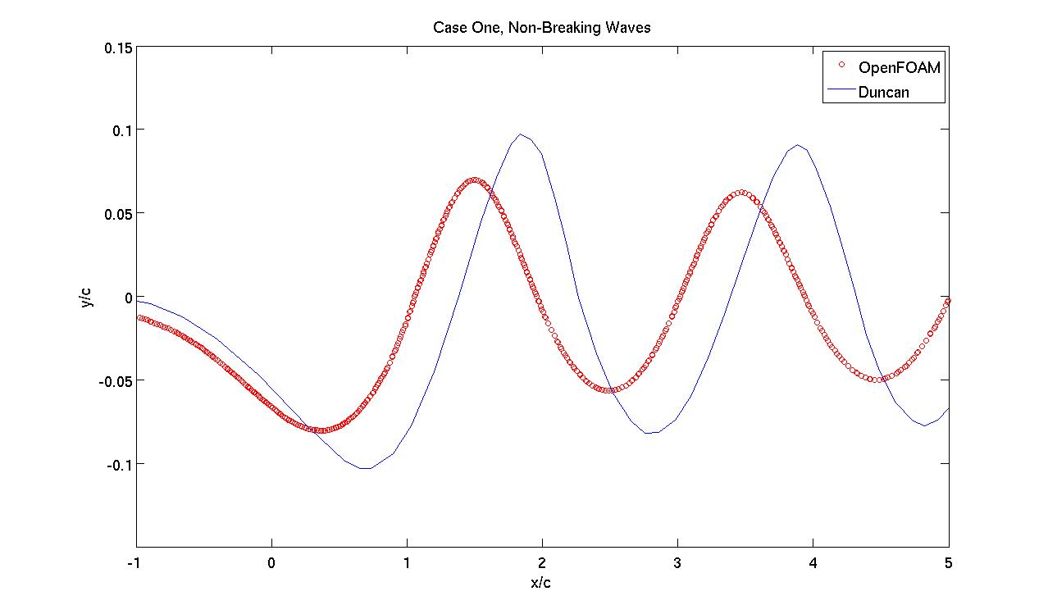

**Scalability**

The strong scalability of case one was tested using a varying number of cores with both the PCG and GAMG linear system solvers. Both solvers were implemented with the same grid, initial conditions, and boundary conditions as case one, but the simulations were run using 2, 4, 8 and 12 cores. The following plot shows the wall time, in hours, necessary for all simulations to reach an identical solution time using the same time step against the number of processors used for the simulations. As can be seen, the computational time is decreased as the number of cores is increased. However, the diminishing return can be seen when comparing the wall times corresponding to eight cores with those corresponding to 12 cores. It may be that the wall time reaches some asymptotic range where increasing the number of processors no longer provides a decrease in wall time, although further investigation would need to be performed to verify this claim. One could do this by continuing to increase the number of cores and view the data on a log vs. log plot.

It is also interesting to note that, for this particular study, the GAMG linear system solver method becomes faster than the PCG method with eight or more cores. This may be because the GAMG solver generates an initial solution on a coarser grid than that which is actually being solved. Then, this solution is projected onto a finer grid and refined. Therefore, when the domain is allocated among many cores, each core begins with a smaller domain and may have less refining to perform before obtaining a final solution for each time step. Admittedly, the user does not have a deep understanding of these solvers, and this is simply a hypothesis.

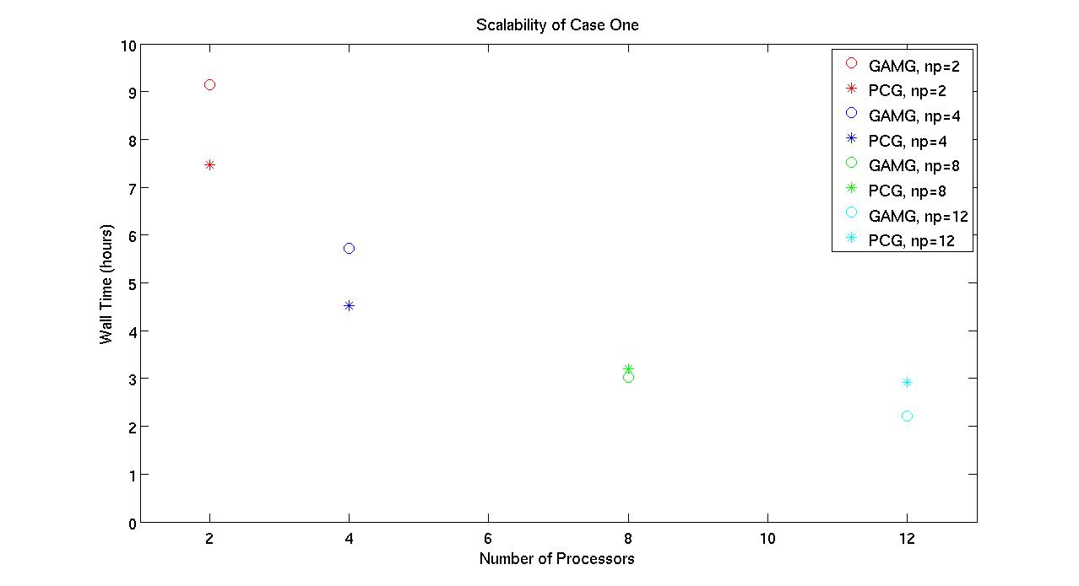

**Case Two – Breaking Waves**

As previously mentioned, the first case involves a hydrofoil producing non-breaking waves at the free-surface. The geometric parameters of the case are shown below. These parameters were chosen for comparison to Duncan’s experimental results.

|  |  |
| --- | --- |
| **Parameter** | **Value** |
| chord length, *c* | 0.203 m |
| chord-based Froude number, *Fr* | 0.567 |
| chord-based Reynolds number, *Re* | 1.624x105 |
| angle of attack, α | 5 degrees |
| free-surface to mid chord ratio, *d/c* | 0.783 |
| bottom to mid chord ratio, *h/c* | 0.862 |

The computational domain of this case was the same as that for case one, except for the reduced distance from the hydrofoil to the free-surface. The mesh for case two also contained 338,614 cells. The following plots show the free-surface profile of a breaking wave in the simulation. The times shown simply correspond to the time from the inception of breaking to the completion, not the actual time in the simulation. Furthermore, Duncan’s single profile is plotted at inception and completion of wave-breaking. Only these two times were chosen because it is unclear when Duncan captured his free-surface profile, but it does not show a broken wave, so it seemed reasonable (if that) to compare only with unbroken waves from the OpenFOAM data. Again the origin corresponds to the point on the calm water surface directly vertical from the mid chord of the hydrofoil.

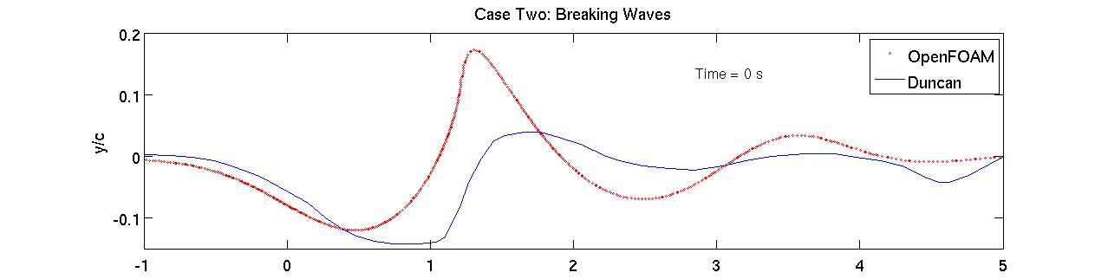

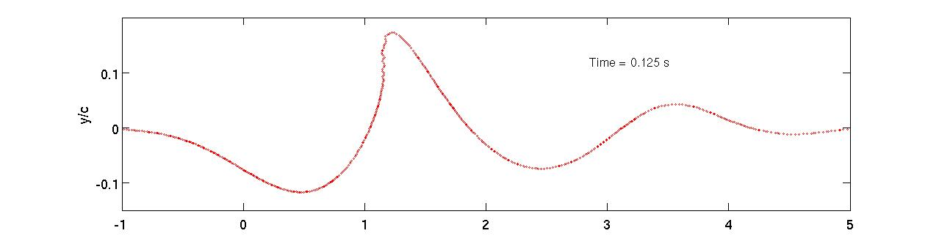

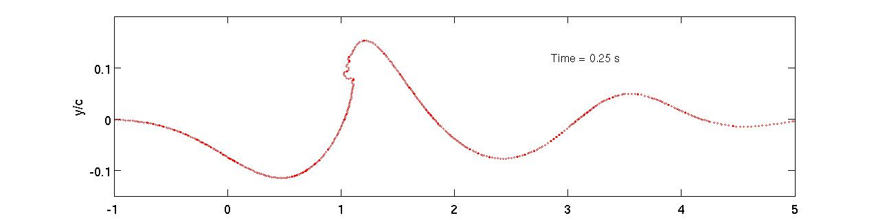

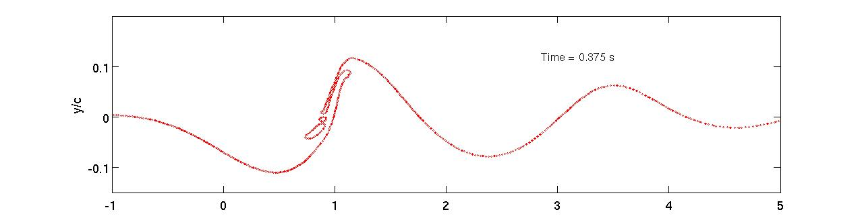

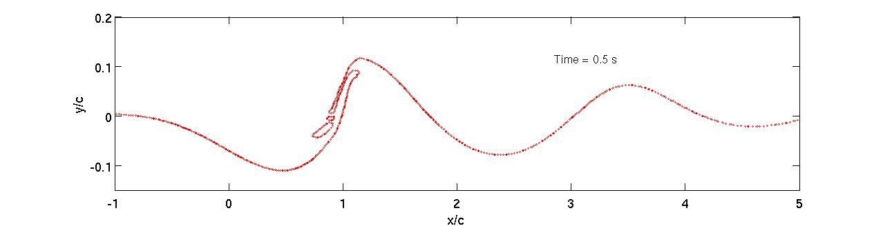

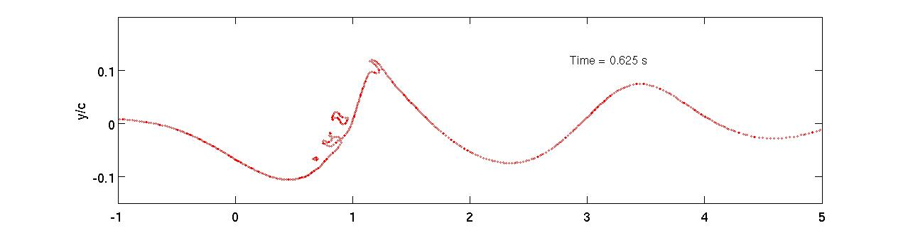

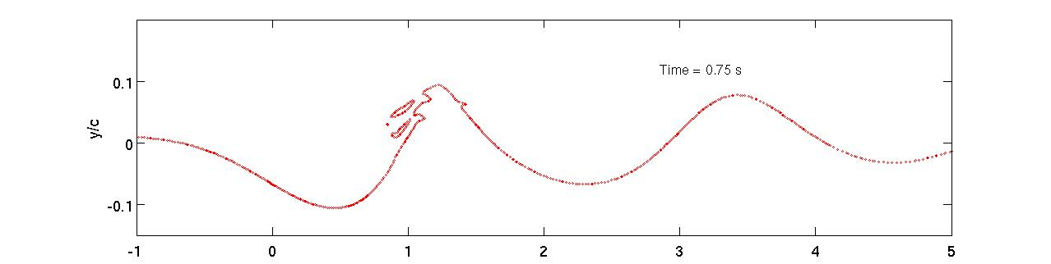

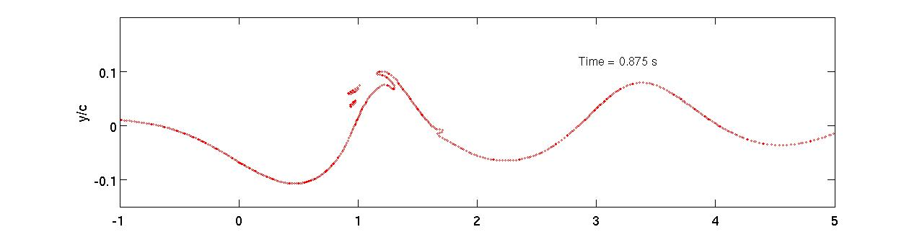

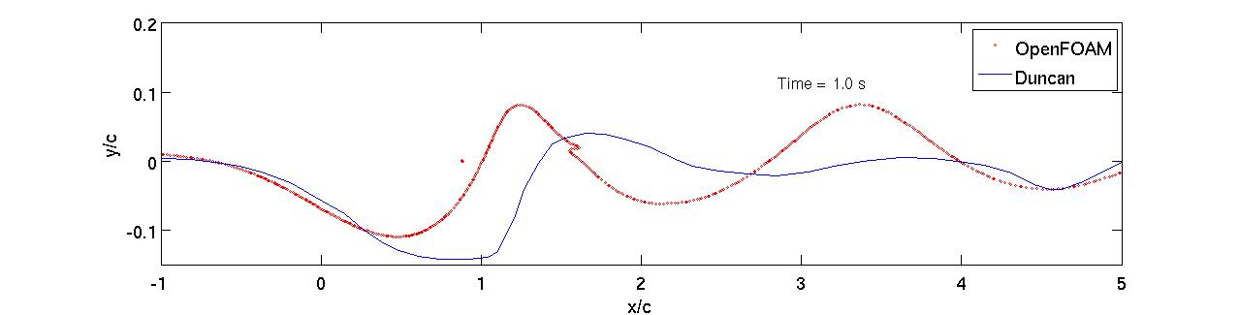

Similar to case one, the profile from Duncan possesses an initial trough further downstream than the OpenFOAM profile. On the other hand, case two shows wave amplitudes that are either larger than or comparable to Duncan’s data. Again, this is stated warily, since the time of Duncan’s profile capture is not known. The OpenFOAM data appears as a more regular wave profile, whereas Duncan’s data appears as a wall of water with more irregular waves downstream.

**Conclusion**

A number of factors play in to the discrepancies seen between the numerical simulations conducted with OpenFOAM and the physical experiments performed by James H. Duncan. The boundary conditions of the numerical simulation, as well as the extents of the computational domain, influence the solution. Grid quality and discretization schemes can affect stability, which can be partially controlled with adaptive time stepping and under relaxation. Interface compression may change the location of a sampled interface, especially during wave-breaking cases. Even differences in viscosity and density will have an effect on solutions. The numerical error inherent to CFD calculations is most definitely present here as well.

However, the experiments also contain error. Vibration from the rails in the tank produced oscillations in testing equipment, which have a finite level of sensitivity. Post processing requires the removal of noise from transducer signals through some averaging method. Even when performed with great care, physical experiments contain error.

Overall, it may still be concluded that the numerical simulations compare reasonably well with the physical experiments. They do not differ wildly, and certain characteristics are present in both. Improvements could still be made in the numerical simulations and the physical experiments.

REFERENCE:

Duncan, James H. 1982 The Breaking and Non-Breaking Wave Resistance of a Two-Dimensional Hydrofoil. *J. Fluid Mech. (1983), vol. 126, pp. 507-520*