Marc Woolliscroft

NA 620 – HW 4

**Question 1**

Water flowing at a free stream velocity of 10 m/s was modeled over a plate of 1 m in length. This flow speed and size of plate corresponds to a Reynolds number of 10 million. The Spalart-Allmaras turbulence model and two variations were used to examine the shear stress on the plate and the velocity distribution (u+ vs. y+). In order to capture the boundary layer, with a height on the order of 10-6, an appropriate block had to be created in the space above the plate. *Table 1* displays the block definition for this space. The block satisfied the condition of y+ < 1 for all variations on the turbulence model.

|  |  |  |  |
| --- | --- | --- | --- |
| **Cells in X** | **Cells in Y** | **Cells in Z** | **Grading in Z** |
| 100 | 1 | 200 | 15,000 |

*Table 1 – Summary of block above plate*

The shear stress along the plate was obtained for all variations of the turbulence model – standard OpenFOAM implementation, original Spalart-Allmaras, and the NASA LaRC formulation. The shear stresses were plotted with the estimate from White, appearing in *Equation 1*. *Figure 1* shows the plots of the shear stress.

$τ_{w}=\frac{0.455U^{2}ρ}{2ln\left(0.06R_{x}^{2}\right)}$*Eqn. 1*

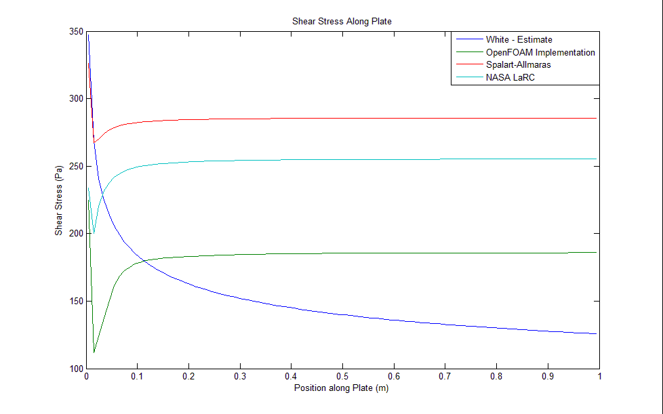

*Figure 1 – Shear stress along plate*

As seen in *Figure 1*, all variations of the turbulence model over-predict the estimate from White. Furthermore, the estimate form White displays a continually decreasing distribution, as it is dependent on Rx. On the other hand, the three variations level out beyond approximately 0.4 meters.

The velocity distribution at a Reynolds number of 9 million for the variations was plotted along with u+ = y+ and the log law. The equations used to develop these distributions, as well as the axes, are found in *Equations 2-5*.

$u_{τ}=\sqrt{{τ_{w}}/ρ}$*Eqn. 2*

$u^{+}=\frac{U}{u_{τ}}$*Eqn. 3*

$y^{+}=\frac{yu_{τ}}{υ}$*Eqn. 4*

$\log{law=\frac{1}{0.41}ln\left(y^{+}\right)+5.5}$*Eqn. 5*

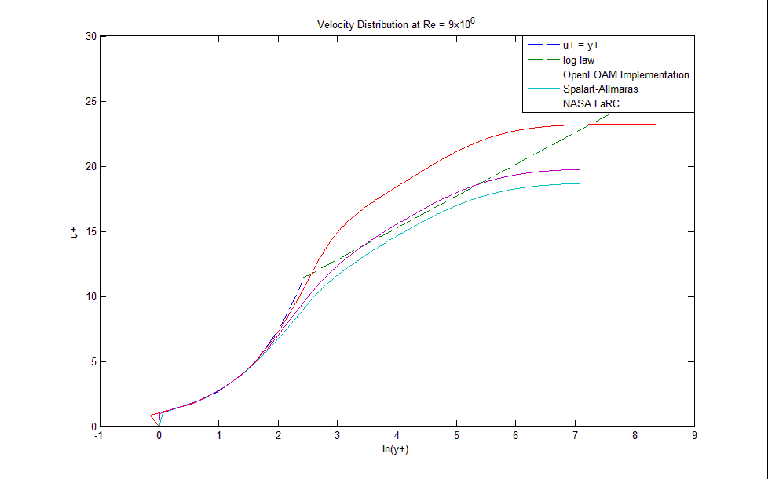

*Figure 2 – Velocity distribution at Reynolds number of 9 million*

According to the data seen in *Figure 1*, the NASA LaRC formulation appears to follow the u+ = y+ and log law distributions the best. Experimental data also tend to follow these trends. For this reason, the NASA LaRC formulatiom is preferred over the other variations.

**Question 2**

The k – ω SST turbulence model was used to investigate the flow over the 1 meter long plate. Various near-wall spacings in the region of 10 < y+ < 500 were used. *Table 2* displays the blocks used to define the space above the plate and obtain these near-wall spacings.

|  |  |  |  |  |
| --- | --- | --- | --- | --- |
| **Cells in X** | **Cells in Y** | **Cells in Z** | **Grading in Z** | **Average y+** |
| 100 | 1 | 100 | 1,550 | 10.3 |
| 100 | 1 | 100 | 50 | 157.3 |
| 100 | 1 | 100 | 20 | 310.8 |
| 100 | 1 | 100 | 11 | 472.9 |

*Table 2 – Summary of blocks above plate*

The shear stress along the plate was obtained using the different y+ values. *Figure 3* shows them plotted along with the estimate from White.

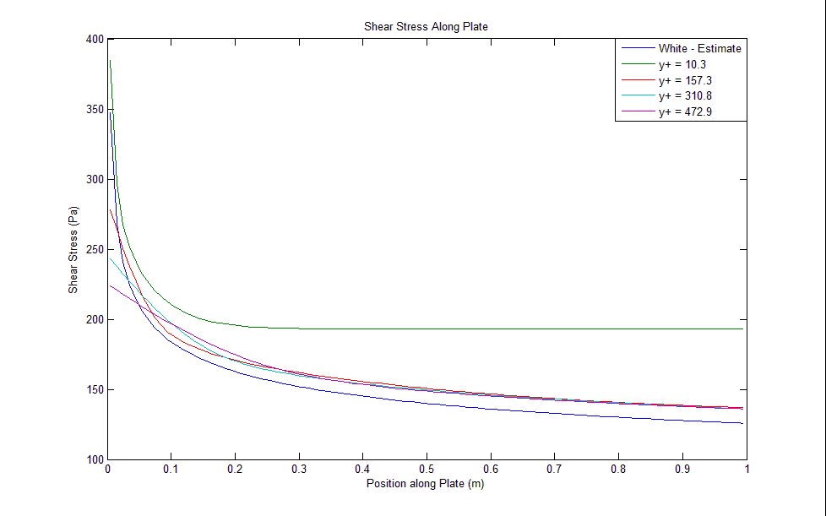

*Figure 3 – Shear stress with various y+ values along plate*

All near-wall spacings appear to follow White’s estimate relatively well except for the spacing corresponding to y+ = 10.3. However, it should be noted that White’s estimate should not be treated as an analytical solution. Therefore, the y+ = 10.3 solution may still be a good approximation.

The velocity distribution at a Reynolds number of 9 million for the near-wall spacings was plotted along with u+ = y+ and the log law. This plot appears in *Figure 4*.

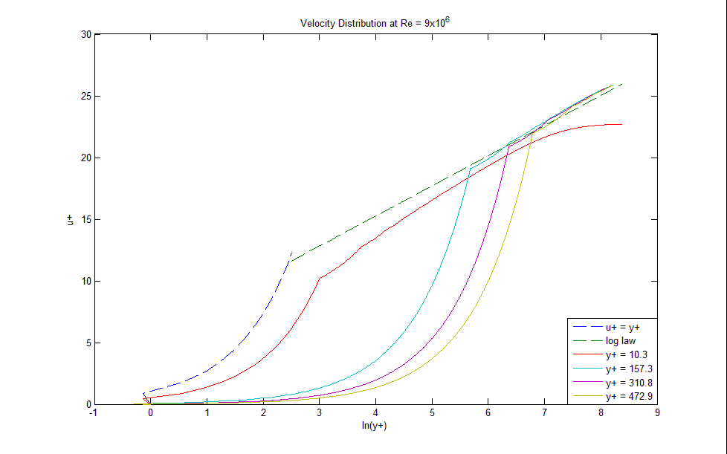

*Figure 4 – Velocity distribution with various y+ values at Reynolds number of 9 million*

As seen in *Figure 4*, the solution with the smallest near-wall spacing most closely resembles the u+ = y+ and log law distributions. The others resemble a similar general shape, but they do not follow the u+ = y+ and log law distributions near the plate.

Therefore, it appears as though the k – ω SST model requires a grid with a small near-wall spacing – preferably, at most 10. As the data show in *Figure 4*, it is assumed that even smaller near-wall spacings would continue to more closely resemble the u+ = y+ and log law distributions.