Marc Woolliscroft

November 5, 2012

NA 599 056

Homework 5

1) DIRICHLET PROBLEM

Required iterations for convergence:

The table below summarizes the required number of iterations for the Dirichlet problem. As can be seen, when using OpenFOAM (finite volume method) the number of required iterations is more heavily dependent on the number of unknowns rather than the gradient approximation method, at least for this particular comparison. In addition, the implementation of the finite difference method, using MATLAB, can require more than ten times as many iterations.

|  |  |  |  |  |  |  |
| --- | --- | --- | --- | --- | --- | --- |
|  | **OpenFOAM 20x20 (Gauss)** | **OpenFOAM 40x40 (Gauss)** | **OpenFOAM 20x20 (Least Squares)** | **OpenFOAM 40x40 (Least Squares)** | **MATLAB (30x30)** | **MATLAB (60x60)** |
| **No. of Iterations** | 45 | 79 | 52 | 101 | >800 | >6000 |

The following two plots show the solution of T at x=0.5 for both the finite volume method and the finite difference method. In order to compare the two at a similar number of iterations, the solution was obtained using OpenFOAM. Then, the finite difference code was executed using the same number of iterations as were required by OpenFOAM (those presented in the table above). It should be noted that the two methods were solving for a different number of unknowns, since the meshes used in OpenFOAM were unstructured and those used in MATLAB were structured. However, the structured meshes were discretized to achieve a similar number of unknowns as present in the unstructured meshes. As shown, the finite difference method does not converge with the finite volume method when both use the same number of iterations. One can also see that the finite difference method is further from converging as the grid is refined.

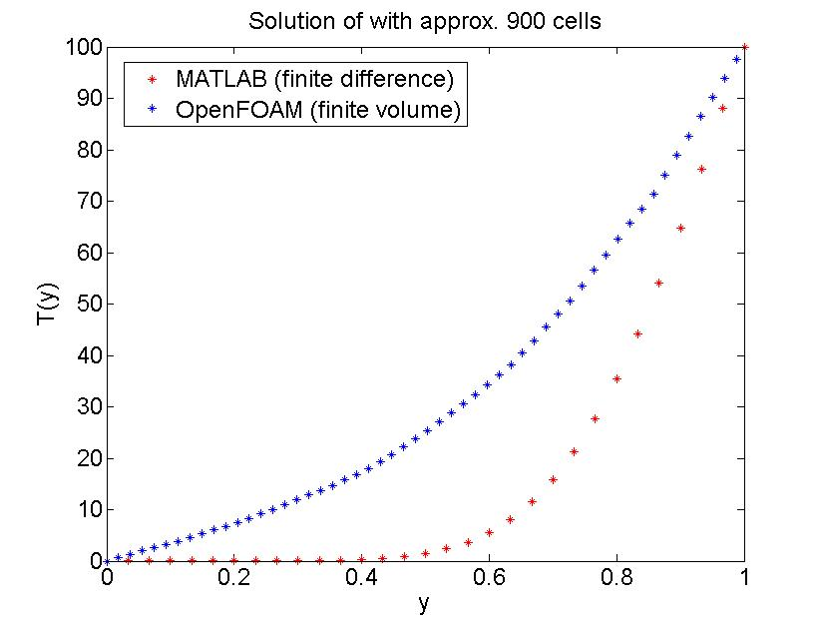

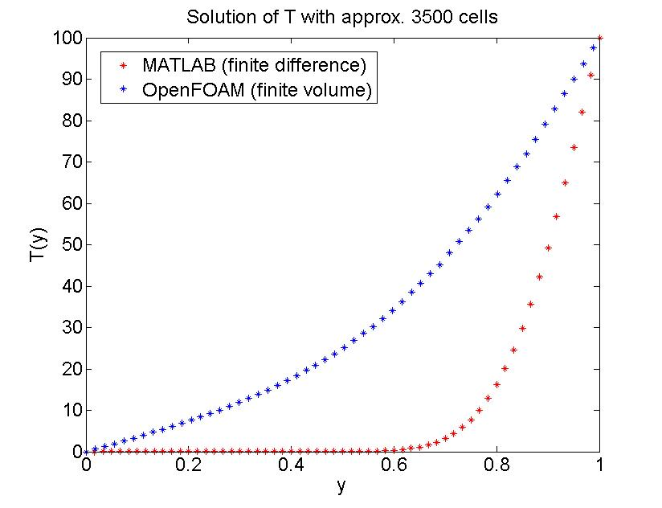

The following two plots demonstrate that, with a sufficient number of iterations, the two methods will converge.

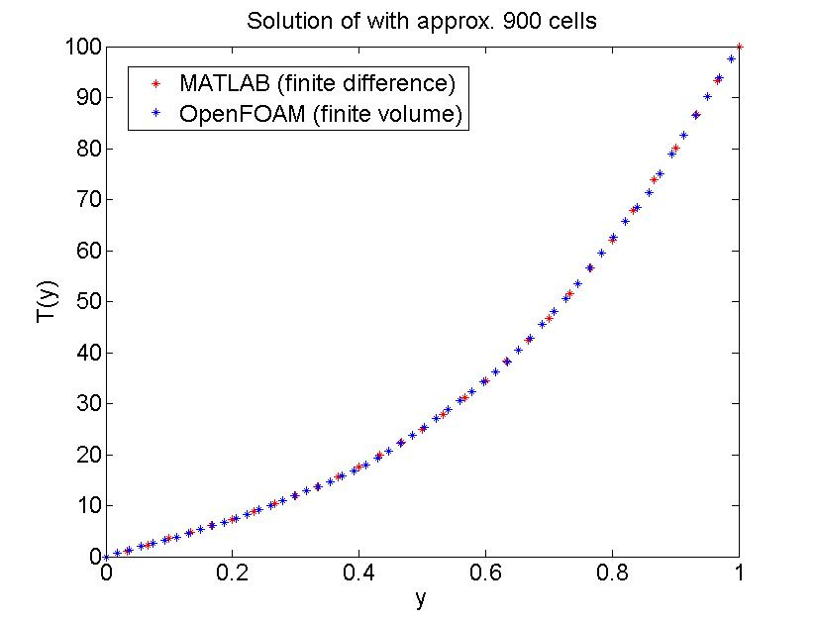

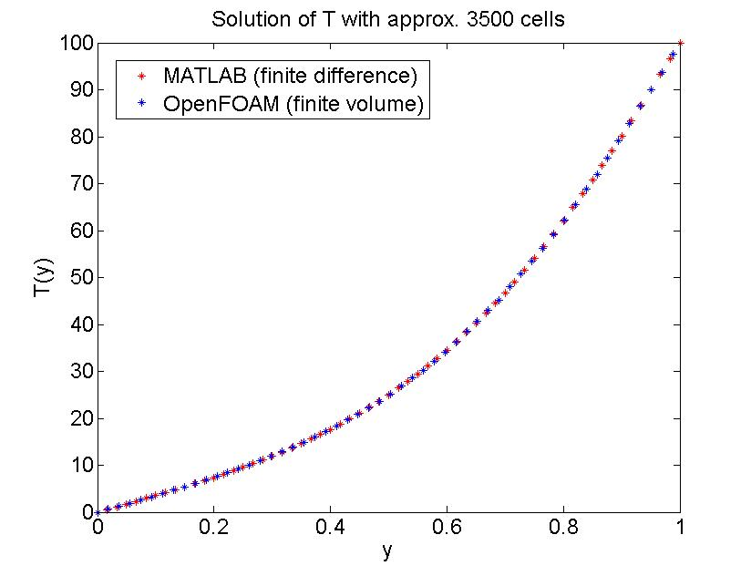

The following two plots show the approximation of the y-component of the gradient at x=0.5 using the Guass and least squares methods. As seen in homework 4, the least squares method seems to perform better than the Gauss method. However, both methods seem to converge with grid refinement, as one can see in the second plot (the finer grid). There, the data points are indistinguishable.

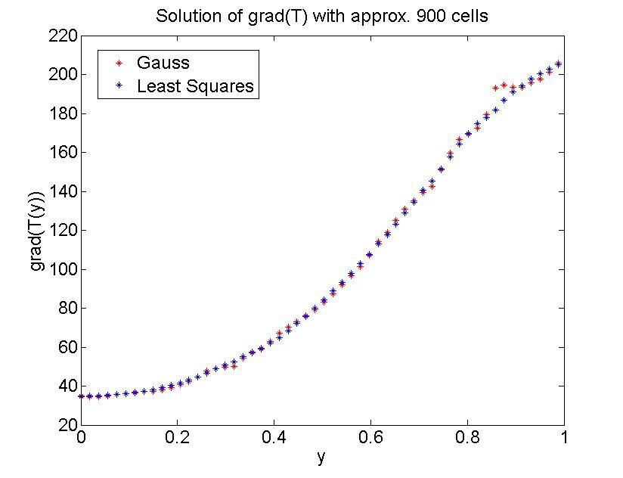

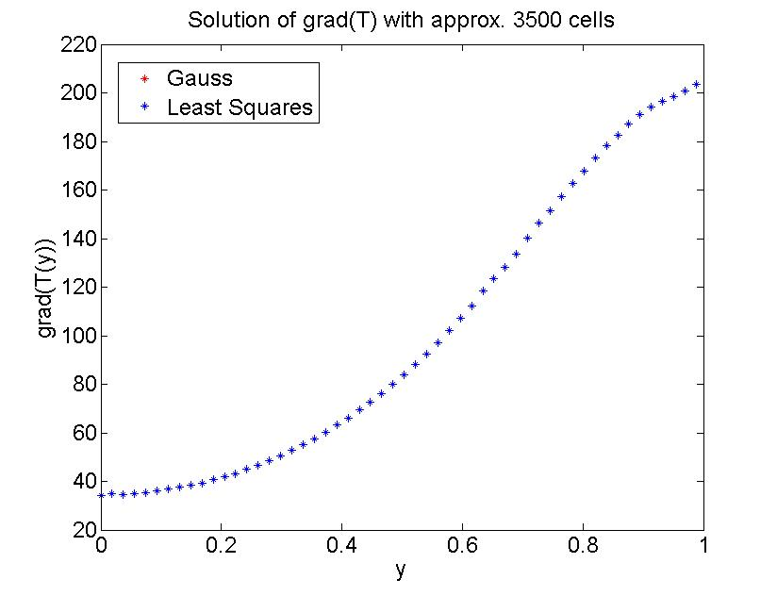

1) NEUMANN PROBLEM

Required iterations for convergence:

The table below summarizes the required number of iterations for the Neumann problem. The results are very similar to those obtained in the Dirichlet problem. As can be seen, when using OpenFOAM (finite volume method) the number of required iterations is more heavily dependent on the number of unknowns rather than the gradient approximation method, at least for this particular comparison. In addition, the implementation of the finite difference method, using MATLAB, can require more than ten times as many iterations.

|  |  |  |  |  |  |  |
| --- | --- | --- | --- | --- | --- | --- |
|  | **OpenFOAM 20x20 (Gauss)** | **OpenFOAM 40x40 (Gauss)** | **OpenFOAM 20x20 (Least Squares)** | **OpenFOAM 40x40 (Least Squares)** | **MATLAB (30x30)** | **MATLAB (60x60)** |
| **No. of Iterations** | 45 | 79 | 52 | 101 | >800 | >3500 |

The following two plots show the solution of T at x=0.5 for both the finite volume method and the finite difference method. In order to compare the two at a similar number of iterations, the solution was obtained using OpenFOAM. Then, the finite difference code was executed using the same number of iterations as were required by OpenFOAM (those presented in the table above). It should be noted that the two methods were solving for a different number of unknowns, since the meshes used in OpenFOAM were unstructured and those used in MATLAB were structured. However, the structured meshes were discretized to achieve a similar number of unknowns as present in the unstructured meshes. As shown, the finite difference method is far from converging with the finite volume method when both use the same number of iterations. One can also see that the finite difference method is further from converging as the grid is refined.

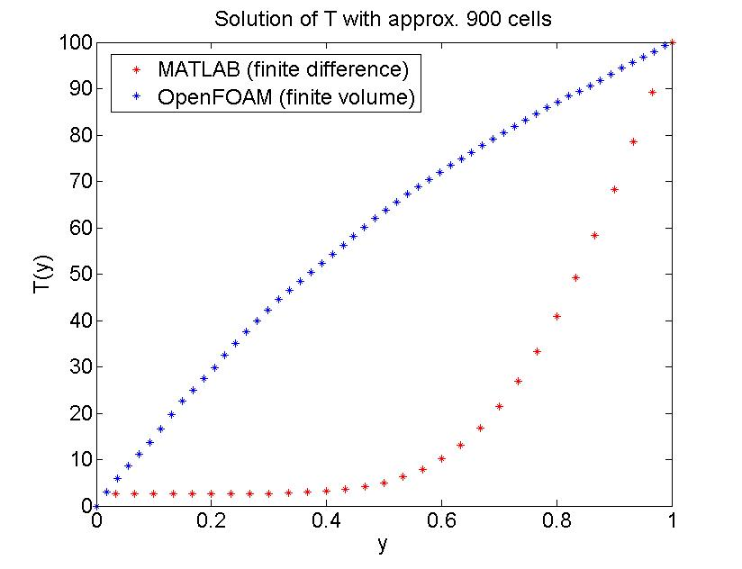

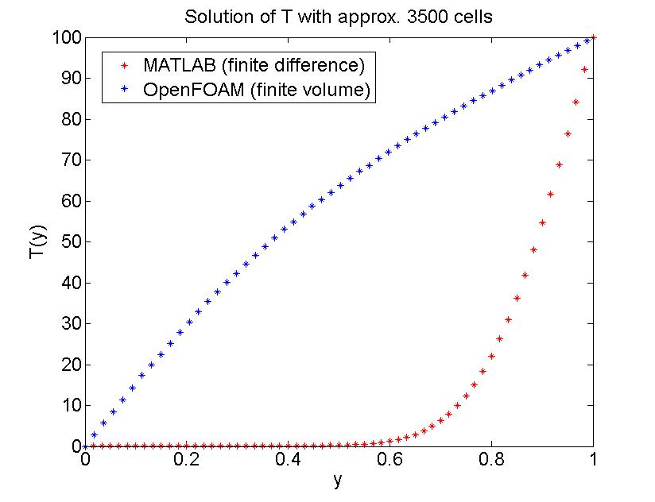

The following two plots demonstrate that, with a sufficient number of iterations, the two methods will converge.

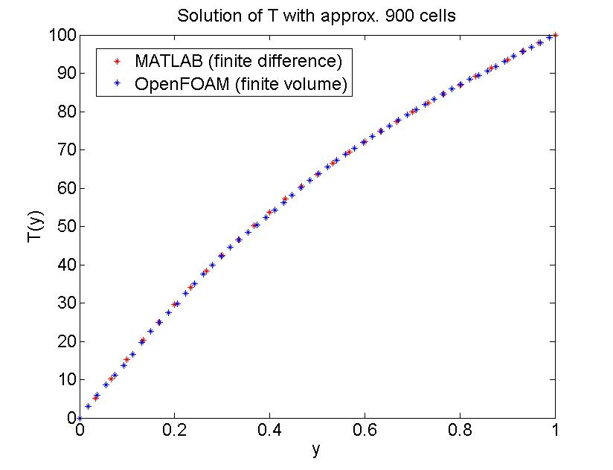

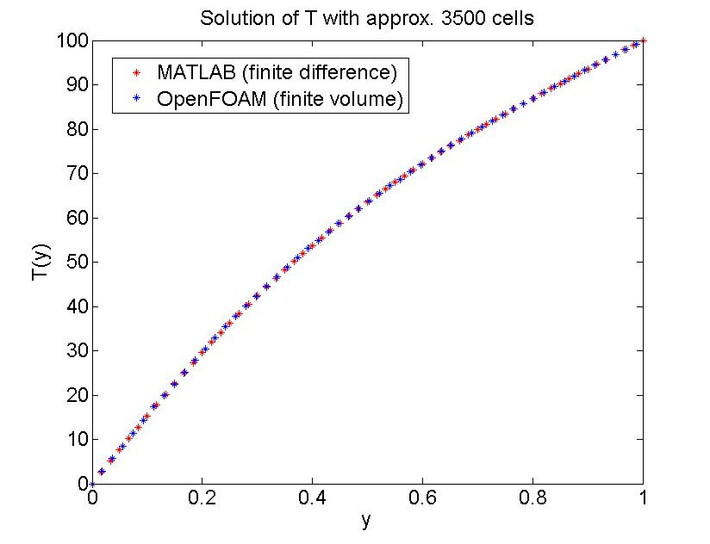

The following two plots show the approximation of the x-component of the gradient at x=0.5 using the Guass and least squares methods. As seen in homework 4, the least squares method seems to perform better than the Gauss method. The approximations are improved with grid refinement. However, they do not become indistinguishable as they did for the Dirichlet problem.

