Marc Woolliscroft

November 12, 2012

NA 599 056

Homework 6

1) LINEAR ADVECTION EQUATION, 1-DIMENSIONAL

The following six plots show samples of the solution to the linear advection equation with constant velocity (1 m/s), sampled at t = 1 s. Three Courant numbers were used. Two plots are shown for each Courant number; the first of each pair shows all the schemes that were used for approximating the divergence, and it is clear that some are unstable. Therefore, the second plot of each pair limits the viewing window to only the stable schemes.

Note for all plots: Some plots contain curves in addition to data points. The solutions were only sampled where a data point exists. The curves are present only to assist the reader in identifying certain schemes. The curves should not be used for interpolation purposes.

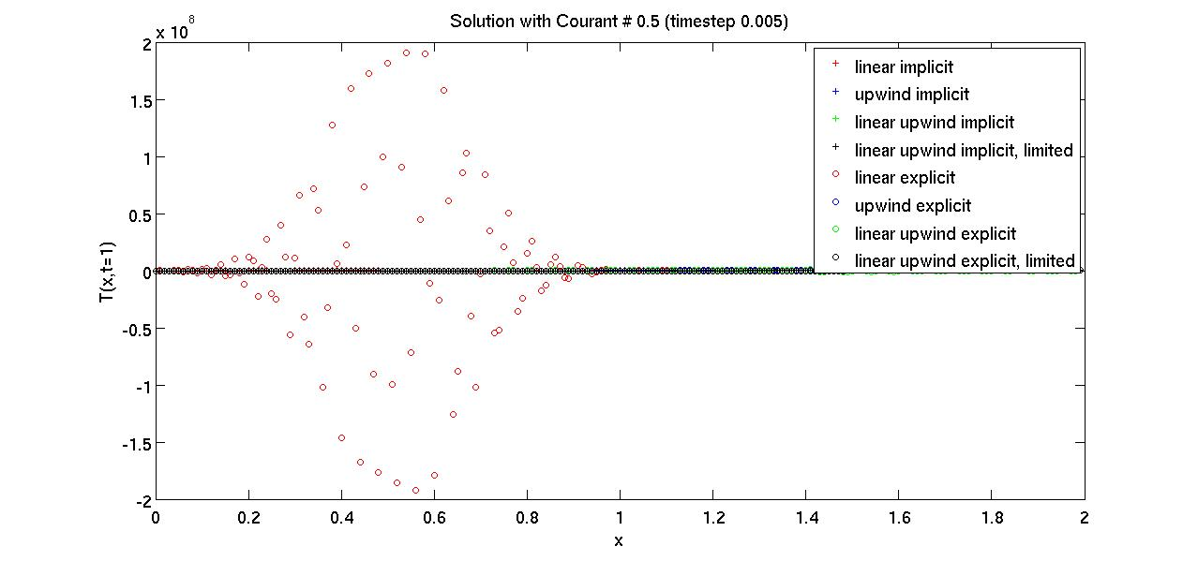

As seen above, the linear explicit scheme is highly unstable for this problem. In fact, it is unconditionally unstable, as noted in lecture. It cannot be seen on this scale, but the linear upwind explicit scheme is also unstable. So, only the remaining six stable schemes will be presented in the next figure for the Courant number of 0.5.

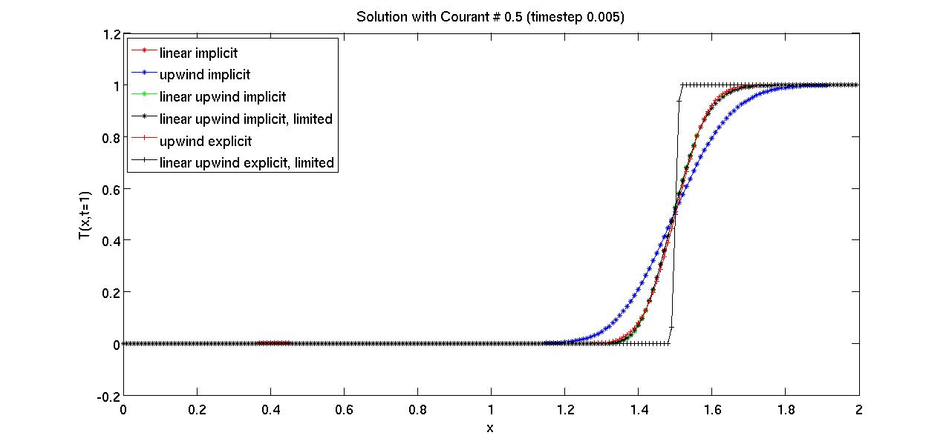

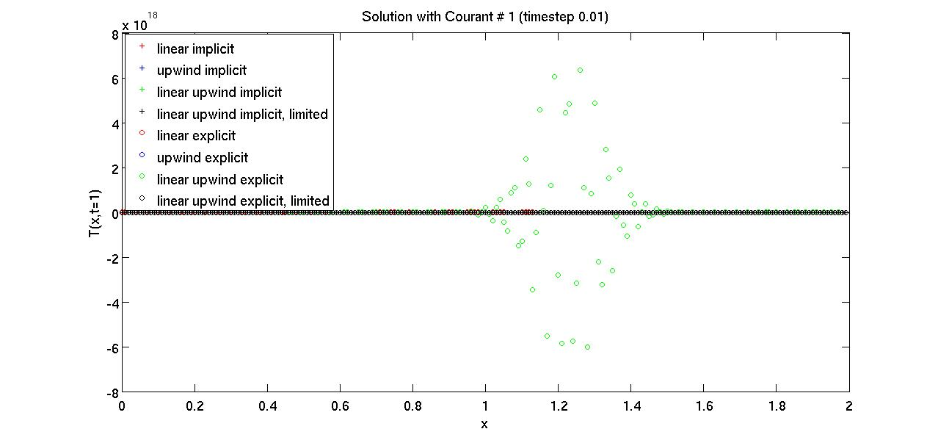

Now for a Courant number of 1, it can be seen in the plot above that the linear upwind explicit scheme is again unstable. The linear explicit scheme is also unstable, and the implicit schemes are again all stable.

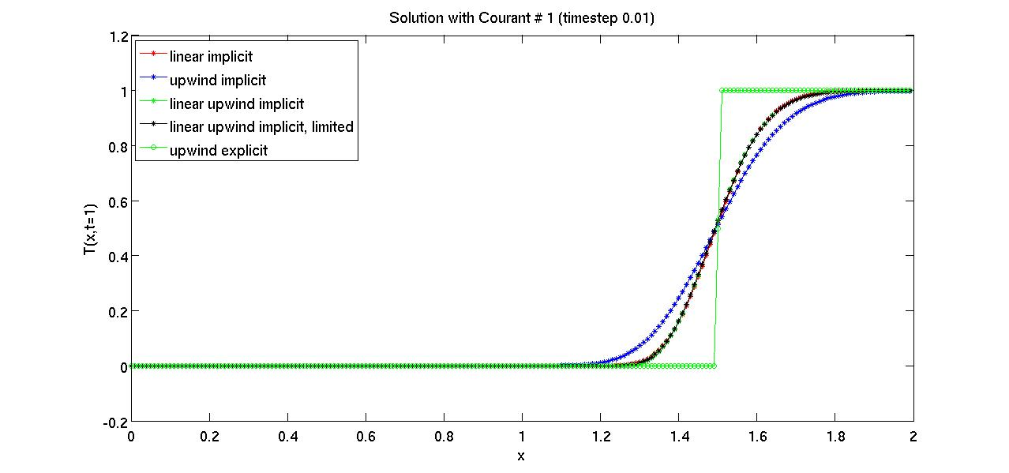

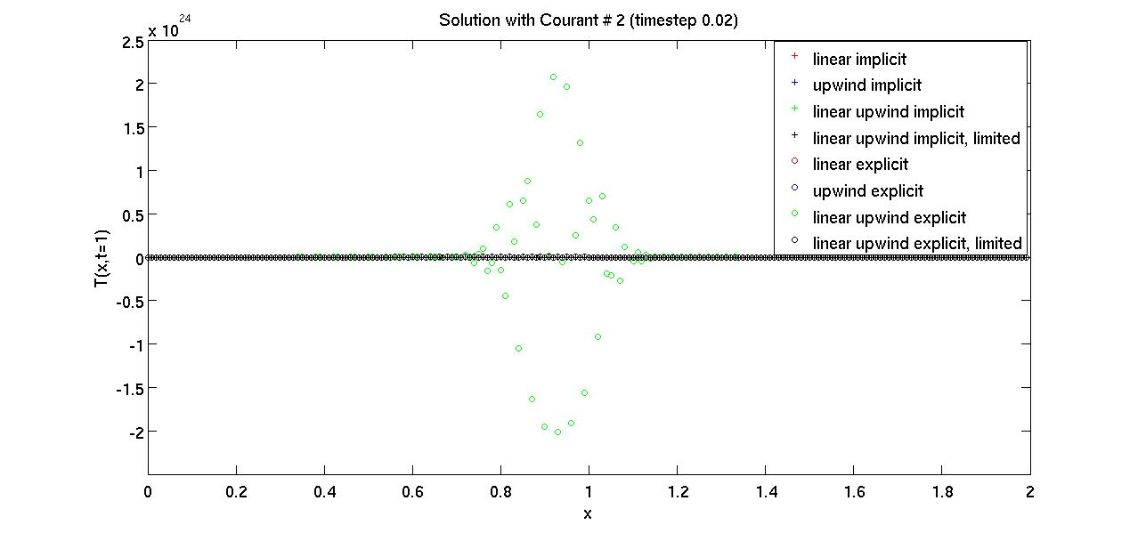

Lastly, for a Courant number of 2, none of the explicit schemes were stable. However, all four of the implicit schemes remained stable.

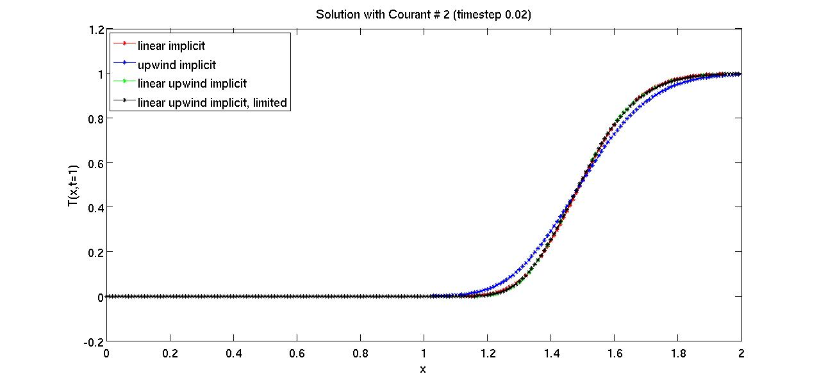

All schemes considered, I prefer the linear upwind implicit scheme for approximating divergence in this particular problem. The use of a limiter does not seem to be necessary in this case. However, that scheme is also appealing. The linear upwind scheme seems to behave well, and the 2nd order accuracy is an additional benefit over the upwind interpolation scheme.

1) LINEAR ADVECTION EQUATION, 2-DIMENSIONAL

For the linear advection equation solved on a square unstructured domain, the linear upwind scheme with a gradient limiter seemed to behave well when compared to the upwind scheme for both the implicit and explicit solvers. The time step used for these simulations was t = 0.005 which corresponds to a Courant number of 0.564 for this grid. Plots for these two comparisons appear below.

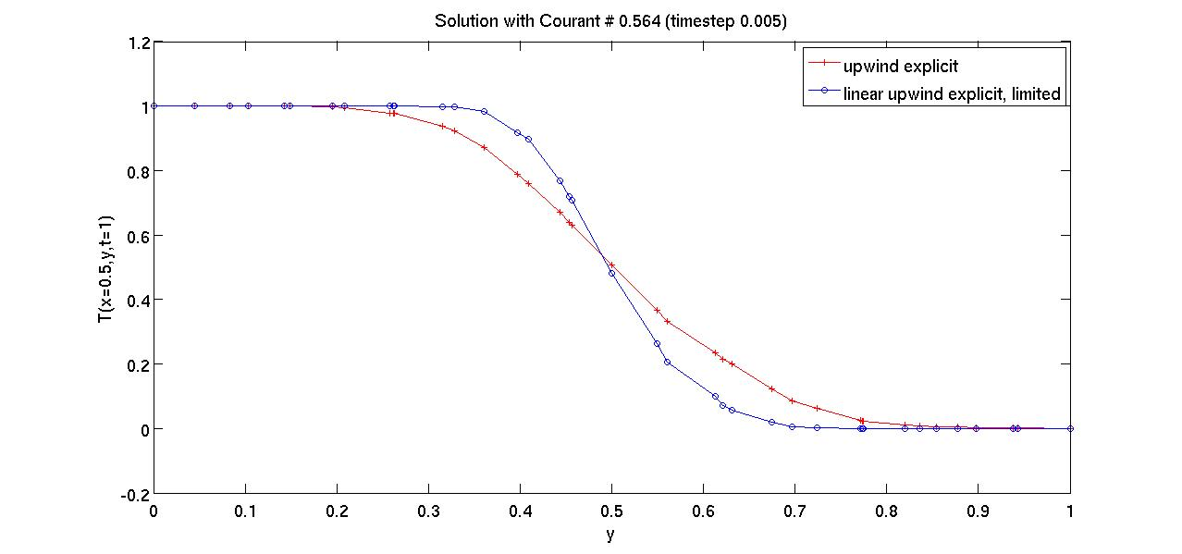

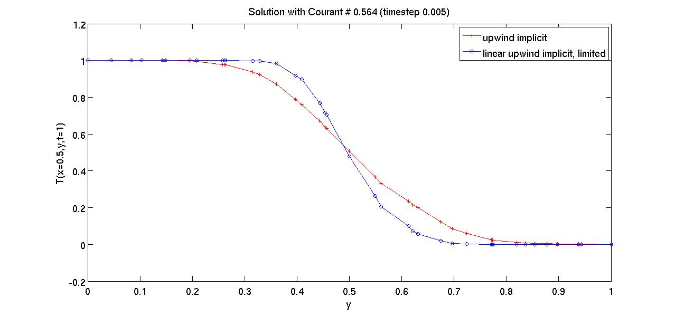

Unlike the 1-dimensional case, the gradient limiter was necessary with the unstructured square domain. Solutions with the linear upwind schemes produced false extrema data points (greater than T = 1 and less than T = 0).