Marc Woolliscroft

November 19, 2012

NA 599 056

Homework 7

**1) Necessary Runtime Length**

To investigate the length of runtime necessary to reach a steady solution, one may plot results from several flow times and monitor them for convergence. In this case, sampling was done with a vertical line located downstream of the step at $x=7$. A structured grid with 54,999 cells and no non-orthogonality was used. This is the fine grid for this assignment. The linear upwind scheme was chosen for the divergence approximation.

Note about plots: For all plots of OpenFOAM solutions in this assignment, flow values were only sampled where a data point marker exists. Any curves through these markers are used for readability purposes only. Therefore, they should not be used for interpolation purposes.

The following two plots show the horizontal and vertical velocity at the aforementioned downstream location for various flow times. For the horizontal velocity, the flow profiles seem to converge at about 75 seconds into the solution.

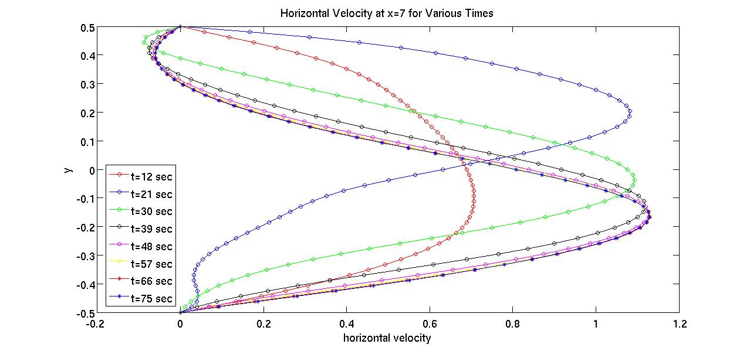

On the other hand, the vertical velocity profiles do not seem to converge until about 291 seconds into the solution. It is possible that the profile continues to change well beyond 291 seconds. However, the flow was solved for only 300 seconds, so the scope of this assignment cannot currently entertain this discussion.

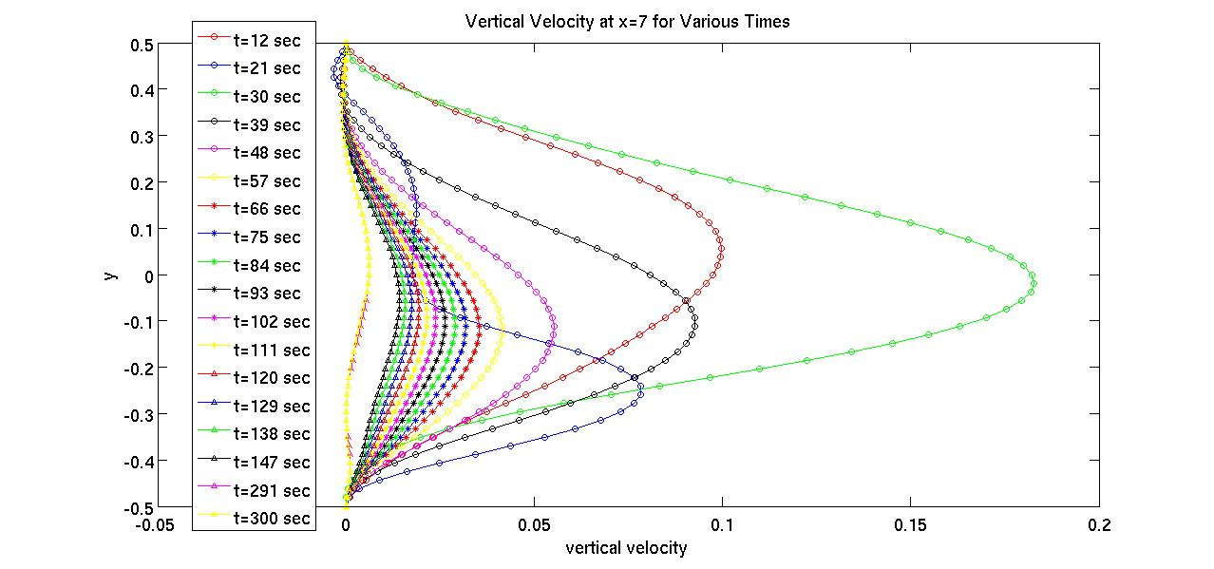

**2) Grid Dependence**

All grids are structured, uniform, and contain no non-orthogonality. A grid refinement ratio of two was used. A grid summary appears in the table below.

|  |  |
| --- | --- |
| **Grid** | **No. of Cells** |
| Coarse | 13,221 |
| Medium | 27,417 |
| Fine | 54,999 |

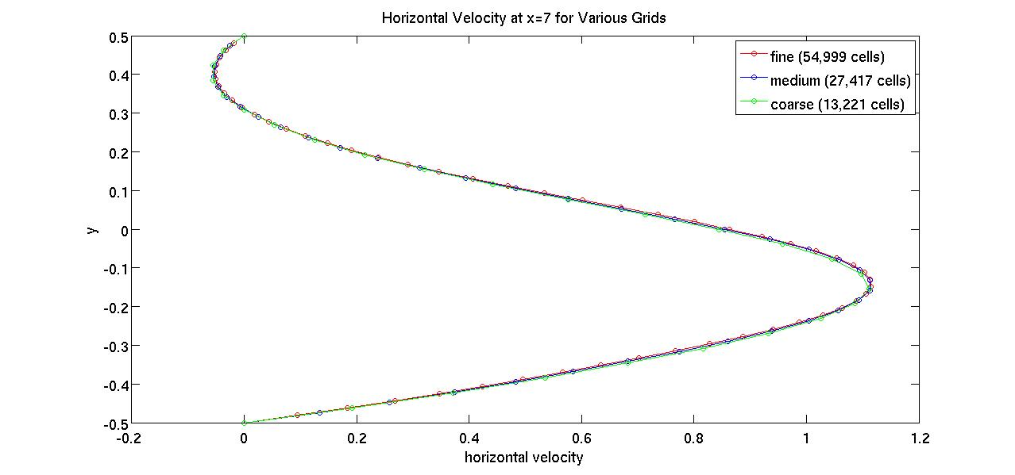

As can be seen in the plot above, when $t=300$, the grids produce very similar results. One can see a converging trend, but it could be said that the coarse and medium grids are too fine to display the converging behavior that grid refinement will possess.

**3) Discretization Settings**

Since the grids were perfectly orthogonal, only different divergence schemes were implemented   
(as opposed to gradient schemes too). Three discretization schemes were used: linear, upwind, and linear upwind. The results from the coarse grid and these three schemes appear in the plot below.

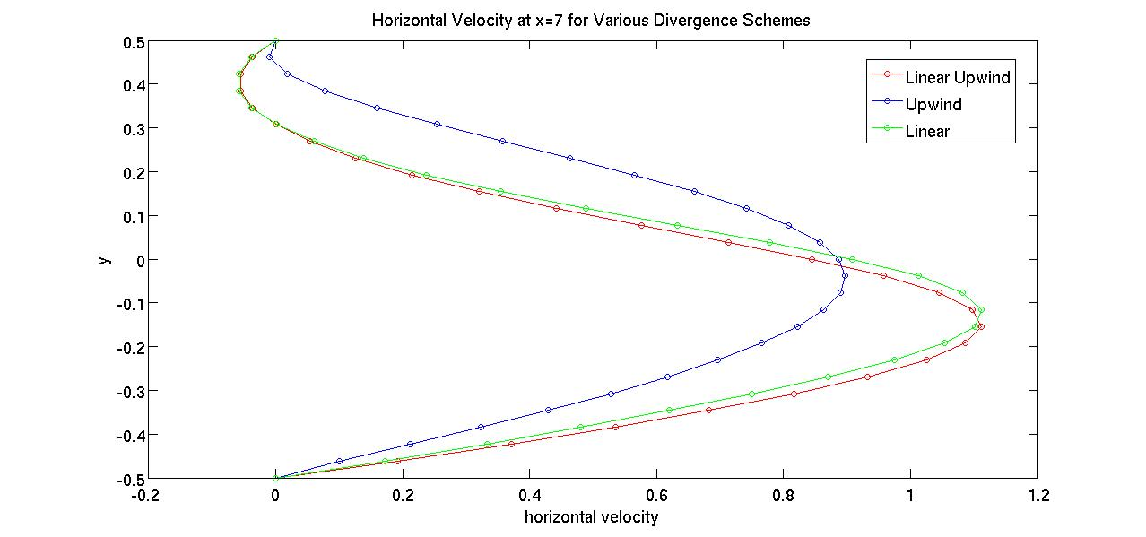

The three schemes give fairly different results, especially the upwind scheme. The previous homework assignment showed similar results for a diffusion problem. Due to the results from homework 6, the linear upwind scheme was chosen for the majority of solutions in this current assignment. The linear and upwind schemes were investigated only in this small section of the report.

**4) Comparison with Gartling**

The following plots show Gartling’s results and the results generated with OpenFOAM. Both the horizontal and vertical velocities at the downstream location are compared, as well as the flow profile at the step. All OpenFOAM results come from the fine grid of this assignment when $t=300$.

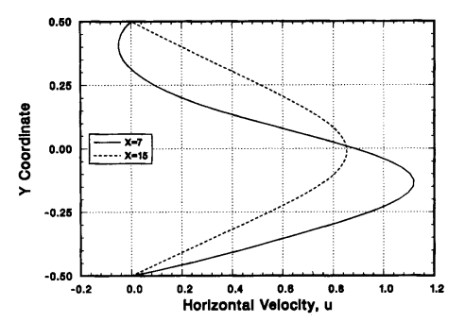

*Results from Gartling*

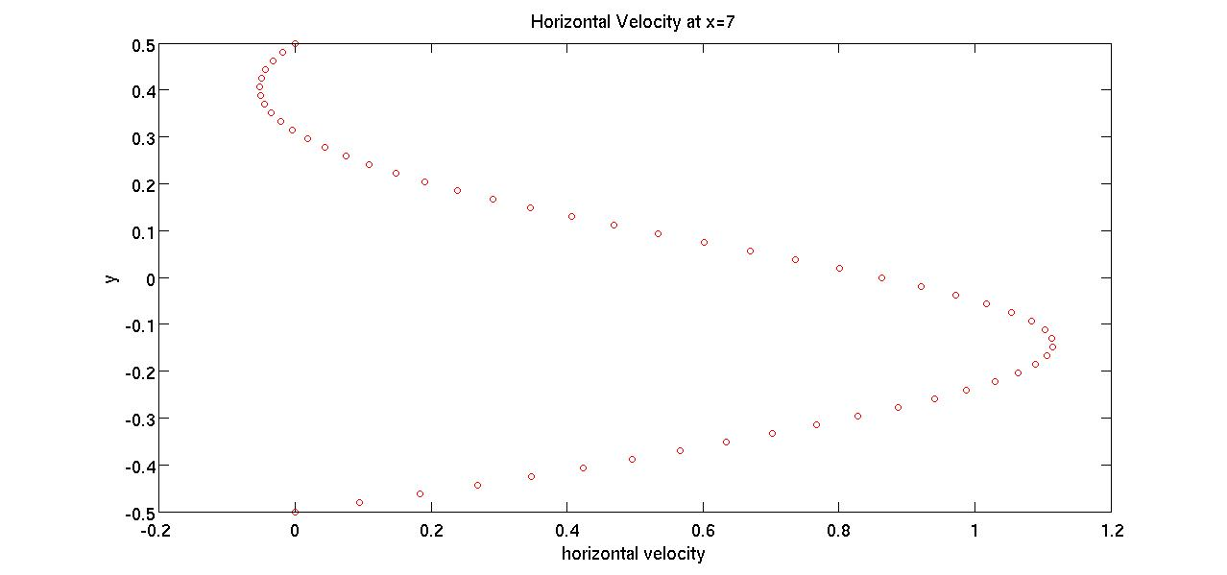

*Results from OpenFOAM*

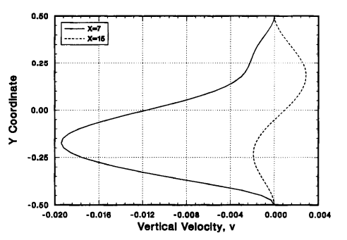

*Results from Gartling*

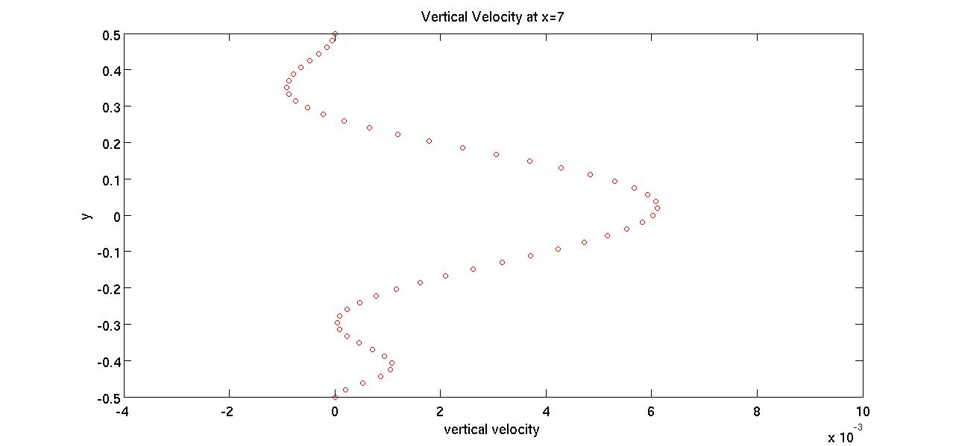

*Results from OpenFOAM*

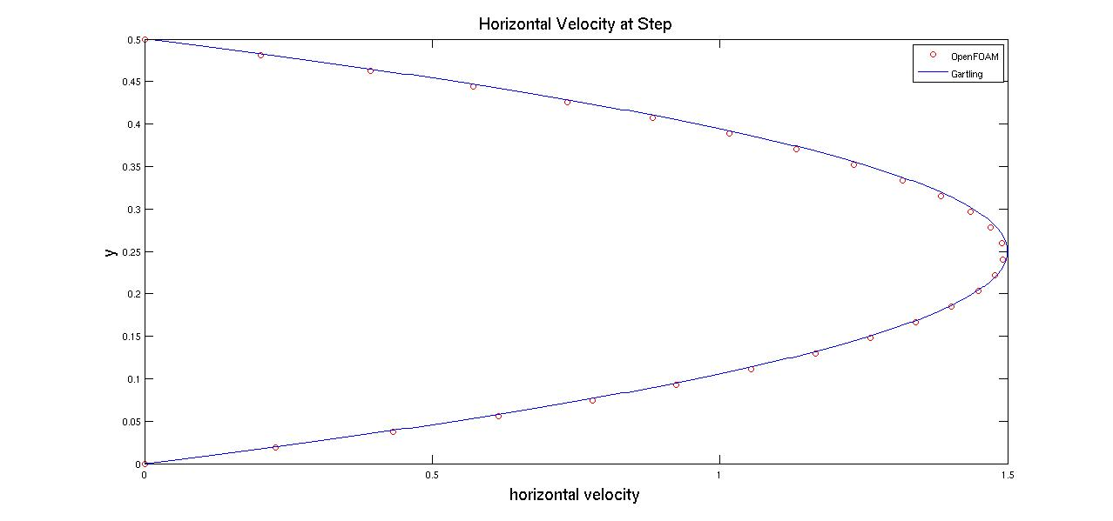

When comparing the OpenFOAM results to those of Gartling, the horizontal velocity at the downstream location compares very well both quantitatively and qualitatively. There is a portion of negative velocity near the top wall and the maximum positive velocity occurs below the vertical midpoint of the channel. On the other hand, the vertical velocities at the downstream location do not compare well. Gartling reports a significant negative velocity below the vertical midpoint of the channel, whereas the OpenFOAM results only show a small negative velocity near the top wall. In fact, qualitatively, one may say that the two results for vertical velocity profiles are almost opposite (mirrored about $x=7$). Lastly, the horizontal velocity profiles at the step compare well. In Gartling’s simulations, he used a parabolic velocity profile as an upstream boundary condition. This helped model boundary layers without having to have any actual upstream cells in his domain (upstream meaning upstream of the step). However, the domain used in the OpenFOAM simulations had an upstream portion as long as the downstream portion. In addition, the upstream boundary condition for velocity consisted of uniform flow in the horizontal direction. Therefore, the presence of the upstream section in the domain allowed for the development of the boundary layers within the solution. As can be seen in the plot above, there are differences, but the profiles at the step from Gartling and OpenFOAM compare well.

**5) Descriptive, Colorful Picture**

Below appears a colorful picture that is useful in describing this flow. The position of the step is indicated by the vertical yellow line. One can see the smaller velocity magnitudes near the walls (boundary layers) and the larger velocity magnitudes near the vertical midpoint of the upstream and downstream sections. Also, the maximum velocity appropriately decreases in the downstream section, compared to the upstream section, where the cross-sectional area is twice as large. Lastly, separation downstream of the step can be seen where the streamlines circulate and the velocity magnitudes are small.

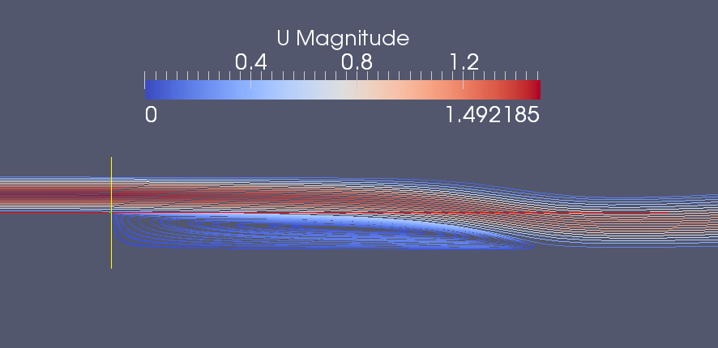

*Streamlines of flow in region approximately x ϵ [-1,6]*