Marc Woolliscroft

November 30, 2012

NA 599 056

Homework 8

**1) VELOCITY PROFILE**

The following two plots present velocity profiles of flow over a flat at a location 75% the length of the plate downstream from the leading edge. All solutions implemented the linear upwind scheme for the divergence approximation. Four sets of numerical data are shown corresponding to four grids each with a different y+ value at the plate. Theoretical curves may also be shown. Below is a table showing the average y+ values for a converged solution on the grids. These values were obtained by running the yPlusRAS utility.

|  |  |  |  |  |
| --- | --- | --- | --- | --- |
| **Grid** | 1 | 2 | 3 | 4 |
| **y+** | 0.55 | 5.2 | 47.0 | 501.1 |

Below, the first plot shows the velocity profiles in terms of non-dimensional vertical position and horizontal velocity (y+ and u+, respectively). In addition, the theoretical log-of-wall and log-law curves are shown. As can be seen, the grid corresponding to a y+ of approximately 0.5 was the only grid that was able to capture the velocity profile of the portion of the boundary layer closest to the plate. This viscous sub-layer section matches well with the theoretical law-of-wall curve. For the most part, the other grids do not capture the viscous sub-layer. They correspond relatively well with the log-law, so they do capture some characteristics of the boundary layer. However, the grids with the two largest y+ values have few points in this region.

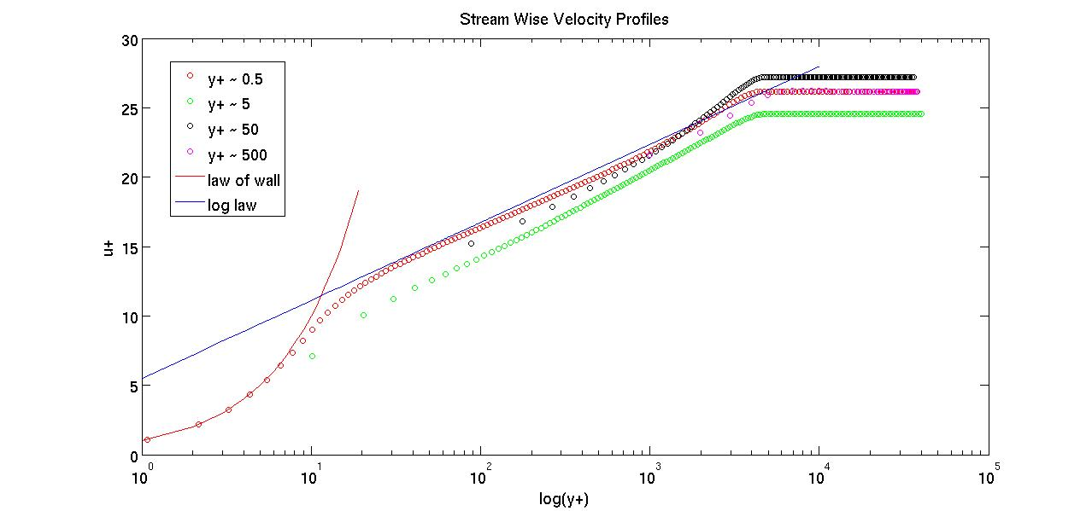

The second plot, below, shows the velocity profiles from the four grids in terms of dimensional vertical position and horizontal velocity (y and u, respectively). It is somewhat interesting to look at these profiles, as each grid produces roughly the same shape of the profile curve. Yet, one can still see that the grid with a y+ value of approximately 0.5 contains many more points very close to the plate (where the profile is nearly vertical in this plot) than any other grid. In fact, for the grid with y+ of approximately 500, there are only four points total in the boundary layer (where the profile is not horizontal in this plot).

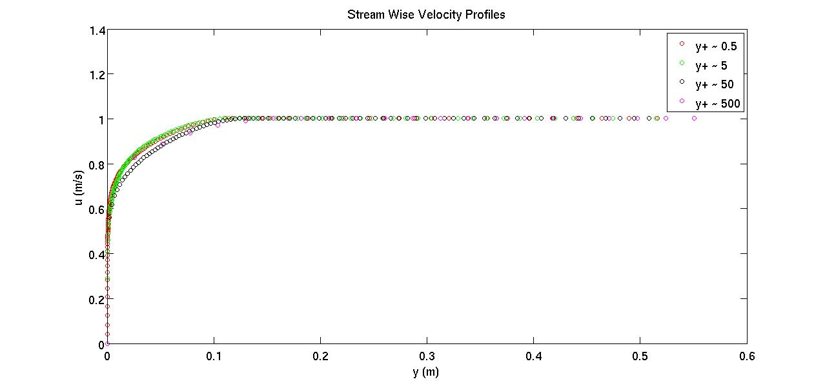

**2) WALL SHEAR STRESS**

The following plot shows the coefficient of friction computed with the formula below for the four grids.

$$c_{f}=\frac{2t_{w}}{ρU^{2}}$$

These are also plotted with the estimate from White, which was computed with the formula below.

$$c_{f}=\frac{0.455}{\ln^{2}\left(0.06{Re}_{x}\right)}$$

It is interesting to see that, despite only one grid successfully capturing the viscous sub-layer, the grid with a y+ of approximately 50 corresponds best to the estimate from White. Granted, this is still an estimate and it would be worthwhile to investigate White’s procedure in creating it. In addition, no grid convergence study was performed, and many steps implemented before arriving at these solutions were chosen based on experience and not a rigorous analysis. Among others, these include grid sizes, boundary conditions, turbulence modeling, under-relaxation, and discretization schemes.

