计算方法实验

实验二：数值积分

姓 名：
学 号：
班 级：
实验地点： 计算机楼304
实验时间： 2020.10
- 实验目的和要求
实验目的：
- 熟悉复化梯形方法、复化Simpson方法、梯形递推算法、龙贝格算法；
- 能编程实现复化梯形方法、复化Simpson方法、梯形递推算法、龙贝格算法；
- 理解并掌握自适应算法和收敛加速算法的基本思想；
- 分析实验结果体会各种方法的精确度，建立计算机求解定积分问题的感性认识
程序任务：
- 设计复化梯形公式求积算法，编制并调试相应的函数子程序
- 设计复化辛浦生求积算法，编制并调试相应的函数子程序
- 用龙贝格算法计算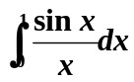
输入：积分区间，误差限
输出：序列Tn，Sn，Cn，Rn及积分结果（参考书本P81的表2-5）
取n=2，4，8，16，精确解为0.9460831
- 实验环境和工具
用C++语言实现，Vscode + Dev-c进行代码编写及调试。
- 实验结果
  - 算法流程图
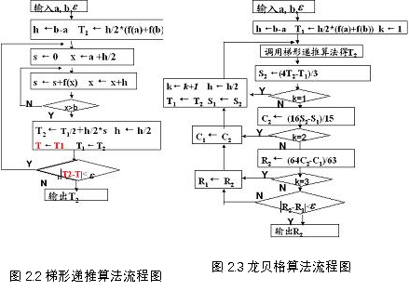

  - 程序核心代码
/**
* @author: Li Haporan
* @date: 2020.10.20
* @details: 实验二,数值积分.{1.包括复化梯形公式2.复化辛普森公式3.龙贝格算法}
*/
#include <iostream>
#include <math.h>

using namespace std;

double fx(double x)
{
if(x == 0)
return 1;
double y;
y = sin(x) / x;
return y;
}
//1.包括复化梯形公式
double Trapezoid(double a, double b,double epsilon)
{
double h = b - a; //复化梯形公式的系数
double T1 = ( h / 2 ) * (fx(a) + fx(b)), T2 = 0;
double T = 0;
double s;
double x;
// cout << T1 << endl;
while (fabs(T2 - T) < epsilon)
{
// cout << "yes" << endl;
s = 0;
x = a + ( h / 2.0 );
if (x <= b)
{
s = s + fx(x);
x = x + h;
}
// cout << s << endl;
T2 = ( T1 / 2.0) + ( h / 2.0 ) * s;

T = T1;
T1 = T2;
}
return T2;
}
double Trapezoid(double a, double b,int k)
{
double h = b - a; //复化梯形公式的系数
double T1 = ( h / 2 ) * (fx(a) + fx(b)), T2 = 0;
double T = 0;
double s;
double x;
// cout << T1 << endl;
for(int i = 0;i < k; i++)
{
// cout << "yes" << endl;
s = 0;
x = a + ( h / 2.0 );
if (x <= b)
{
s = s + fx(x);
x = x + h;
}
// cout << s << endl;
T2 = ( T1 / 2.0) + ( h / 2.0 ) * s;

T = T1;
T1 = T2;
}
return T2;
}
//2.复化辛普森公式
double Simpson(double a, double b,double epsilon)
{
//Page 65 2-1
double h = b - a; //复化梯形公式的系数
double T1 = ( h / 6.0 ) * (fx(a) + fx(b));
double T = 0;
double T2 = 0;
double s;
double x;
while (fabs(T2 - T) < epsilon)
{
// cout << "yes" << endl;
s = 0;
x = a + ( h / 2.0 );
if (x <= b)
{
s = s + 2 * fx(x);
x = x + (h / 2);
s = s + 4 * fx(x);
x = x + (h / 2);
}

T2 = ( T1 / 6.0 ) + ( h / 6.0 ) * s;
T = T1;
T1 = T2;
}
return T2;

}
//3.龙贝格算法
double Romberg(double a, double b,double epsilon)
{
double h = b - a;
double T1 = ( h / 2 ) * (fx(a) + fx(b)),T2;
double S1, S2;
double C1, C2;
double R1 = 0, R2 = 0;
int k = 1;
cout << "0" << "\t" << T1 << "\t";
while (fabs(R2 - R1) < epsilon)
{
T2 = ( h / 2 ) * (fx(a) + fx(b));
cout << endl;
cout << k << "\t";
C1 = C2;
R1 = R2;
T2 = Trapezoid(a, b, k);
cout << T2 << "\t";
S2 = (4 * T2 - T1) / 3;
cout << S2 << "\t";
if (k == 1)
{
k = k + 1;
h = h / 2;
T1 = T2;
S1 = S2;
continue;
}
C2 = (16 * S2 - S1) / 15;
cout << C2 << "\t";
if (k == 2)
{
k = k + 1;
h = h / 2;
T1 = T2;
S1 = S2;
C1 = C2;
continue;
}
R2 = (64 * C2 - C1) / 63;
cout << R2 << "\t";
if (k == 3)
{
k = k + 1;
h = h / 2;
T1 = T2;
S1 = S2;
C1 = C2;
R1 = R2;
continue;
}
}
cout << endl;

return R2;
}

int main (void)
{
// cout << "start" << endl;
cout << "Trapezoid = "<<Trapezoid(0.0,1.0,1e-6) << endl;
cout << "Simpson = "<<Simpson(0.0,1.0,1e-6) << endl;
cout << "Romberg = "<<Romberg(0.0,1.0,1e-6) << endl;
// cout << "Trapezoid = "<<Trapezoid(0.0,1.0,32) << endl;
return 0;

}

  - 运行结果
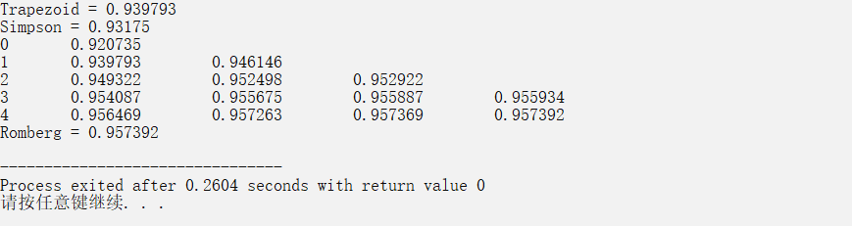
  - 运行结果分析
符合题目所需要的答案，并在误差范围内。
- 实验心得
- 步长会明显影响算法的结果，并且通过控制步长可以对答案进行调整。

