ASSIGNMENT NO. 11
PROBLEM STATEMENT:
Write a program in C to accept a number from the user and compute the following:
a) Square root of the number
b) Square of the number
c) Cube of the number
d) Check whether the number is prime
e) Factorial of the number
f) Prime factors of the number

OBJECTIVE:
• To understand the use of mathematical operations in C.
• To implement loops and conditional statements
. • To perform number-based computations.
• To enhance logical thinking using menu-driven programs.

THEORY:
Numbers and their mathematical properties play a vital role in programming. Operations such as square, cube, and square root are basic mathematical computations. Prime number checking involves verifying whether a number has exactly two divisors. Factorial is calculated by multiplying a sequence of integers. Prime factorization breaks a number into its prime components. In C programming, these operations can be efficiently implemented using loops, conditional statements, and mathematical functions.

PLATFORM:
Linux

CODE:
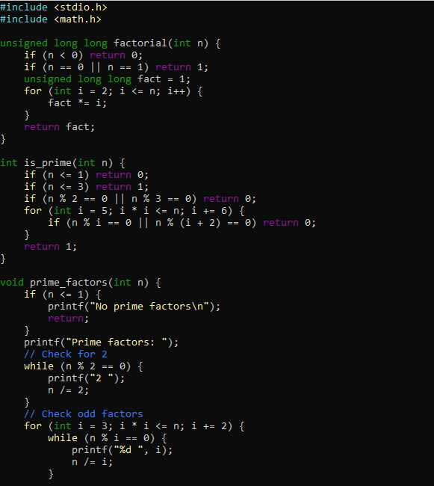
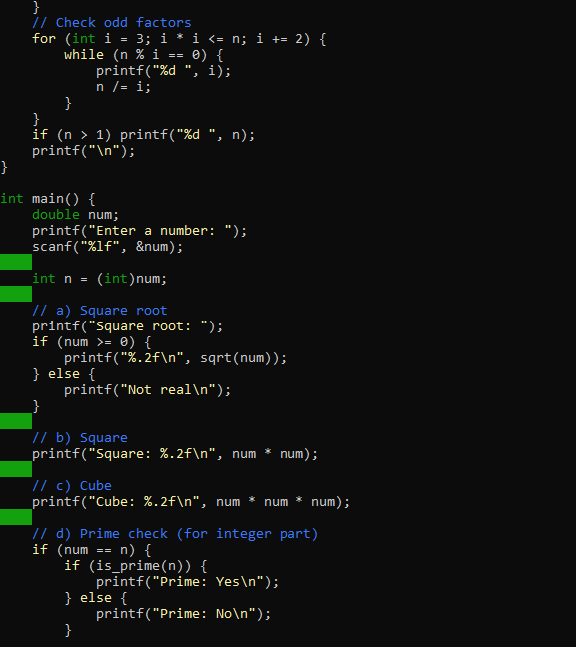
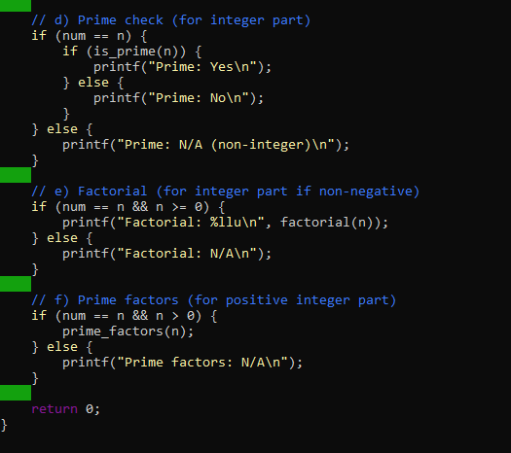
OUTPUT:
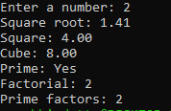
CONCLUSION:
Thus, the program to perform various mathematical operations on a number was successfully implemented using C programming. This program demonstrates the use of loops, conditional statements, switch-case, and mathematical functions.

