

Foundations of Programming
Assignment No. : 12

PROBLEM STATEMENT:
Write a program in C to accept two numbers from the user and compute:
- The smallest common divisor of the two numbers (other than 1, if any)
- The Greatest Common Divisor (GCD) of the two numbers

OBJECTIVE:
• To understand the use of mathematical operations in C.
• To implement loops and conditional statements
. • To perform number-based computations.
• To enhance logical thinking using menu-driven programs.

THEORY:
Divisors and the Greatest Common Divisor (GCD) are fundamental concepts in number theory. The smallest common divisor of two numbers is the smallest positive integer greater than 1 that divides both numbers. The GCD of two numbers is the largest positive integer that divides both numbers without leaving a remainder. In C programming, these operations can be efficiently implemented using loops and the Euclidean algorithm, which repeatedly applies the modulo operation until the remainder becomes zero.

PLATFORM:
Linux

ALGORITHM:
Step-1: Start

Step -2: Declare integer variables num1, num2, i, GCD, smallest divisor.

Step-3: Accept two integers from users

Step-4: Convert numbers to positive if they are negative

Step-6: Initialize smallest divisor == 1.

Step-6: Find smallest common divisor using loop.

Step-7: Find GCD using Euclidean algorithm.

Step-8: Print result

Step-9: Stop

FLOWCHART:

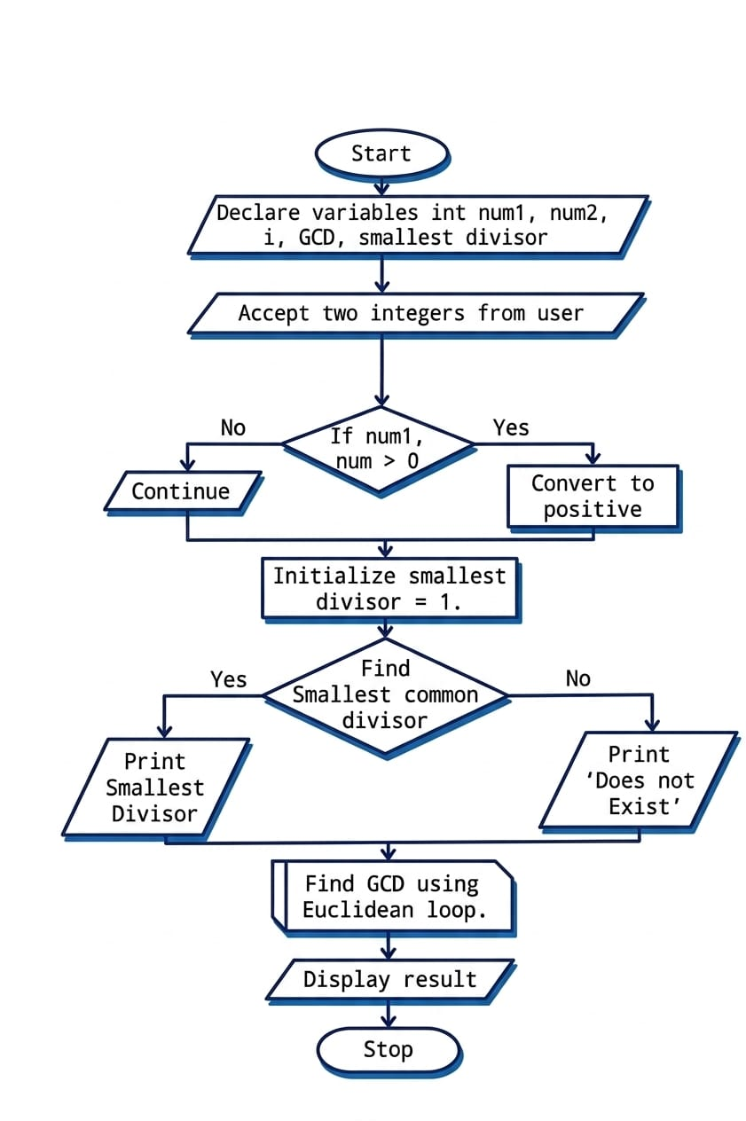

INPUT:
#include <stdio.h>

int main() {
int num1, num2;
int scd = -1;
int gcd, a, b;

printf("Enter first number: ");
scanf("%d", &num1);
printf("Enter second number: ");
scanf("%d", &num2);

int smaller;
if (num1 < num2) {
smaller = num1;
} else {
smaller = num2;
}

for (int i = 2; i <= smaller; i++) {
if (num1 % i == 0 && num2 % i == 0) {
scd = i;
break;
}
}

a = num1;
b = num2;
while (b != 0) {
int temp = b;
b = a % b;
a = temp;
}
gcd = a;

printf("\nSmallest Common Divisor (other than 1): ");
if (scd == -1) {
printf("None\n");
} else {
printf("%d\n", scd);
}

printf("Greatest Common Divisor (GCD): %d\n", gcd);

return 0;
}

OUTPUT:

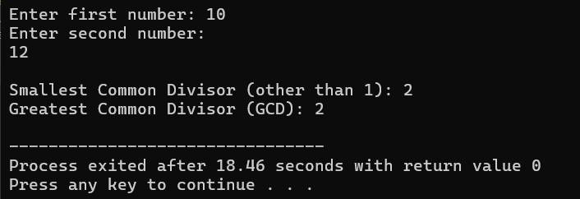

CONCLUSION:
Thus, the program to find the smallest common divisor and the Greatest Common Divisor of two numbers was successfully implemented using C programming. This program demonstrates the use of loops, conditional statements, and the Euclidean algorithm.

FAQs:
- What is meant by the Greatest Common Divisor (GCD)?
- Why does the Euclidean algorithm efficiently compute the GCD?
- How can this program be modified to handle negative numbers?
- What changes are required to compute the Least Common Multiple (LCM) using the GCD?
- How can this program be extended to find the LCM of two numbers?

