

Foundations of Programming
Assignment No. : 13

PROBLEM STATEMENT:
Write a program in C to accept a number from the user and print the digits of the number in reverse order.

OBJECTIVE:
• To understand number manipulation using loops
. • To learn the use of modulo (%) and division (/) operators.
• To implement logic for reversing digits of a number.
• To improve problem-solving skills using iterative structures.

THEORY:
To understand number manipulation using loops. • To learn the use of modulo (%) and division (/) operators. • To implement logic for reversing digits of a number. • To improve problem-solving skills using iterative structures.

PLATFORM:
Linux

ALGORITHM:
Step-1:Start

Step-2:Declare an integer variable n

Step-3:Read the value of n from the user.

Step-4: Check if n is equal to 0 If yes, print "0" and go to step 8

Step-5: Loop while n Is not equal too:
- Find the remainder: remainder = n%10
- Print the remainder
- Update n: n != n /10

Step-5: End Loop

Step-6: Stop.

FLOWCHART:
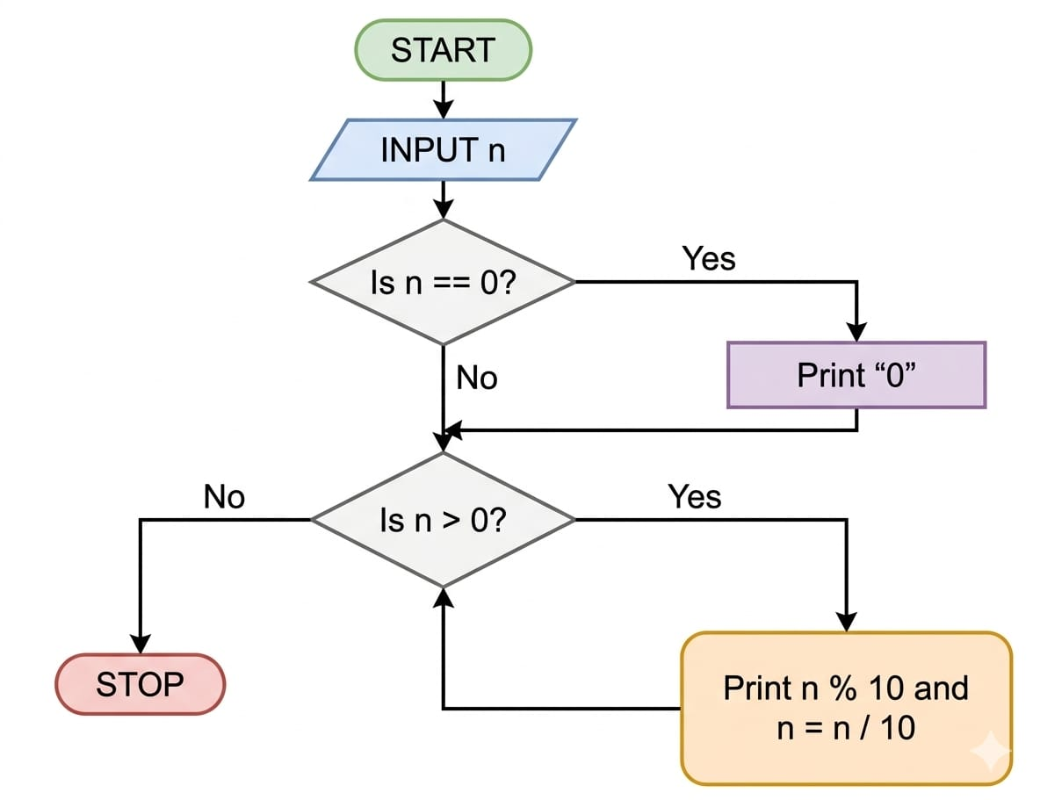

INPUT:
#include <stdio.h>

int main() {
int num, digit;

printf("Enter a number: ");
scanf("%d", &num);

printf("Digits in reverse order: ");

if (num == 0) {
printf("0");
}

if (num < 0) {
printf("-");
num = -num;
}

while (num > 0) {
digit = num % 10;
printf("%d", digit);
num = num / 10;
}

printf("\n");

return 0;
}

OUTPUT:
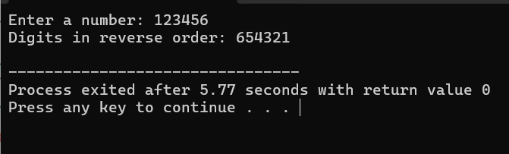

CONCLUSION:
Thus, the program to print the digits of a number in reverse order was successfully implemented using C programming. The program demonstrates the effective use of loops, modulo operator, and division operator.

FAQs:
- Why is the modulo operator (%) used in this program?
- Why is division by 10 used after extracting each digit?
- What happens if the input number is zero?
- How will the program behave for negative numbers?
- Why is a while loop preferred for this operation?

