

Foundations of Programming

Assignment No.: 14
PROBLEM STATEMENT: Write a C program to input a binary number from the user and convert it into a decimal number.

OBJECTIVE:

- To understand number system conversions.
- To learn how to convert binary numbers to decimal numbers in C.
- To practice the use of loops and arithmetic operations.
- To develop logical thinking for number system problems.

THEORY:
A binary number system uses only two digits: 0 and 1. Each digit of a binary number represents a power of 2 depending on its position. To convert a binary number into its decimal equivalent, each digit is multiplied by 2 raised to the power of its position and the results are added together. In C programming, this conversion can be implemented using loops and arithmetic operations.

PLATFORM: Linux
ALGORITHM:
Step 1: Start
Step 2: Input the binary number binary
Step 3: Initialize
decimal = 0
i = 0
Step 4: Repeat while binary ≠ 0
a. Find remainder → rem = binary % 10
b. Calculate → decimal = decimal + rem × (2^i)
c. Update binary → binary = binary / 10
d. Increment → i = i + 1
Step 5: Display decimal
Step 6: Stop
FLOWCHART:
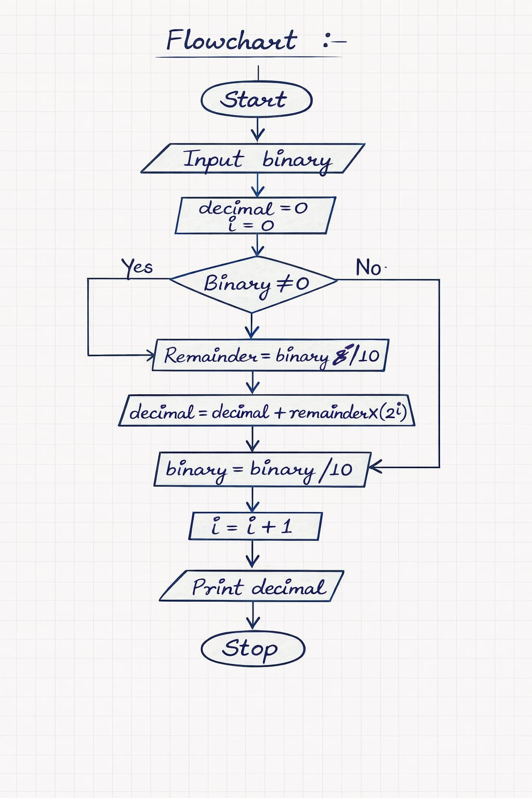

INPUT:

#include <stdio.h>
#include <math.h>

int main() {
long long binary;
int decimal = 0, remainder, i = 0;

printf("Enter a binary number: ");
scanf("%lld", &binary);

while (binary != 0) {
remainder = binary % 10; // get last digit
decimal += remainder * pow(2, i); // multiply with 2^position
binary = binary / 10; // remove last digit
i++;
}

printf("Decimal equivalent = %d", decimal);

return 0;
}

OUTPUT:

Enter a binary number: 1101
Decimal equivalent = 13
CONCLUSION: Thus, the C program successfully converts a binary number entered by the user into its decimal equivalent using loops and arithmetic operations.

FAQs:
- What is a binary number system?
- How is a binary number converted into a decimal number?
- What is the role of loops in binary to decimal conversion?
- What is the role of the pow() function in this program?
- What is the data type used to store binary and decimal numbers in this program?

