ASSIGNMENT NO. 2
PROBLEM STATEMENT:
Write a menu driven program in C to implement the basic arithmetic operations such as Addition, Subtraction, Multiplication, and Division.

OBJECTIVES:
• To understand the concept of menu driven programming in C.
• To apply conditional statements and switch–case control structures.
• To perform basic arithmetic operations using user-defined input.
• To enhance logical thinking and problem-solving skills.

THEORY:
if–else ladder statements syntax and sample program
switch–case or if–else ladder statement syntax and sample progrM
Basic arithmetic operations include Addition, Subtraction, Multiplication, and Division. Division by zero should be avoided.

CODE:
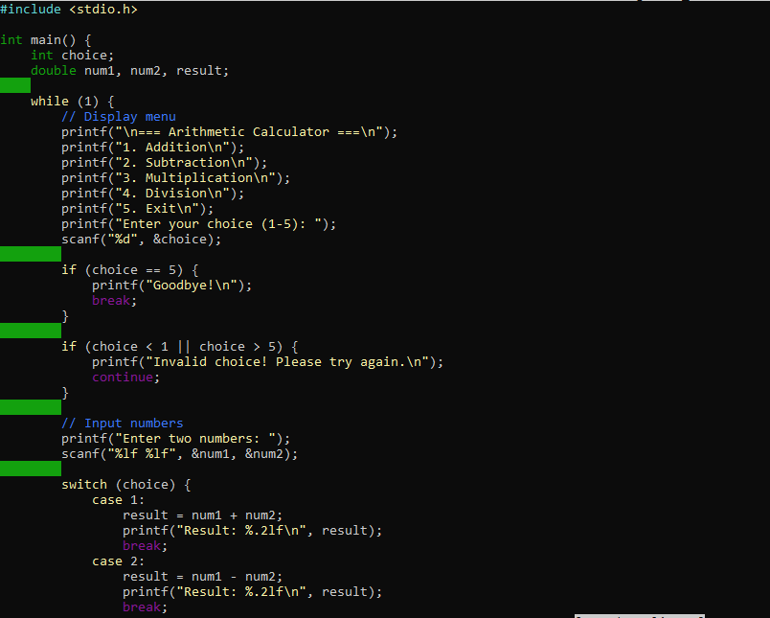
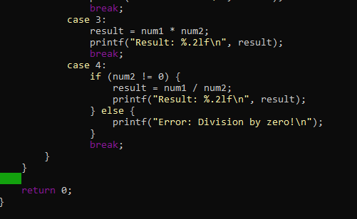
OUTPUT:
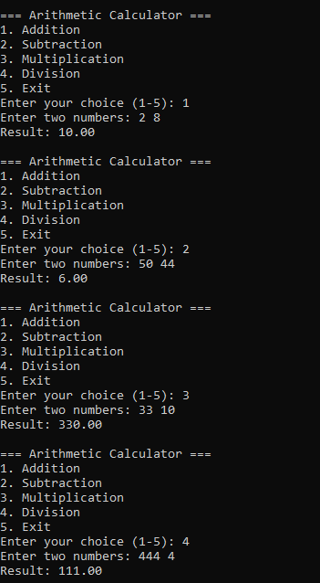
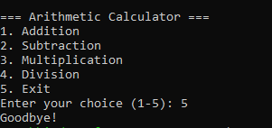

CONCLUSION:
Thus, the menu driven program in C successfully performs basic arithmetic operations using switch–case statements.

