移动平台应用开发
实 验 报 告

课程设计名称：Xcode开发Swift应用程序

课程设计题目：篮球计分器

院（系）：计算机与信息工程学院
专 业：软件工程
班 级：2013级软件工程班
学 号：20131105832
姓 名：黄倩倩
指导教师：朝力萌
完成日期：2016年6月30日
目 录

第1章 概要设计 1
1.1题目的内容与目的 1
1.2运行环境 1
第2章 详细设计 2
2.1 界面设计 2
2.2功能实现 3
2.2.1 记录球队信息及比赛场次 3
2.2.1.1 绑定所有控件 3
2.2.1.2 节次按钮与节次Label显示的关系 4
2.2.1.3 建立数据库表 4
2.2.2 比分记录 6
2.2.2.1 绑定所有控件 6
2.2.2.2 实现比分累加及撤销功能 7
2.2.2.3 建立数据库表 8
2.2.3 计时记录 10
2.2.3.1 绑定所有控件 10
2.2.3.2 实现计时功能 10
2.2.3.3 实现暂停次数累计功能 13
2.2.3.4 建立数据库表 14
2.2.4 犯规记录 16
2.2.4.1 绑定所有控件 16
2.2.4.2 实现犯规累加功能 17
2.2.4.3 建立数据库表 20
2.2.4 比赛记录 22
2.2.4.1 绑定所有控件 22
2.2.4.2 定义变量初始化 22
2.3 设计思想 25
第3章 调试分析 25
第4章 使用说明与执行结果 26
第5章 实验小结 29

第1章 概要设计

1.1题目的内容与目的
内容：了解Xcode开发环境，学习Swift语言，创建项目，在storyboard中利用Button、Label、TextField快速搭建起篮球计分器的界面，并在viewController中用代码完成篮球计分器的业务逻辑以及排除部分隐含的bug，能够在比赛中进行计分、计时、记录暂停次数、记录犯规次数、查看历史记录等功能。
目的：
- 熟悉Xcode开发环境和Swift语言。
- 加强编程的思维逻辑，可制作简单的计分器。
- 对应用程序的开发奠定一定的基础。

1.2运行环境
1、ios系统
2、Xcode（版本7以上）
3、Swift语言。

第2章 详细设计

2.1 界面设计
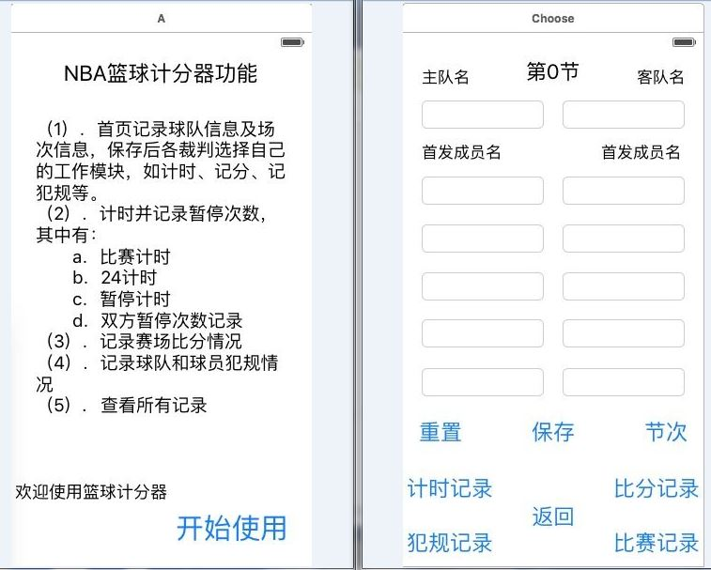
图 1 篮球计分器首页面及主界面
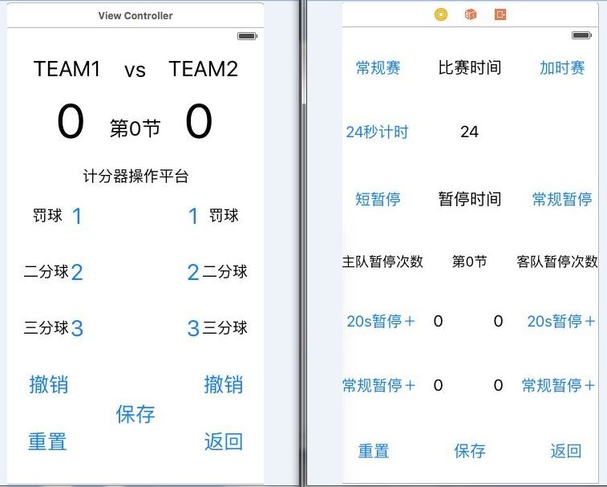
图 2 篮球计分器比分记录界面和计时（暂停记录）界面
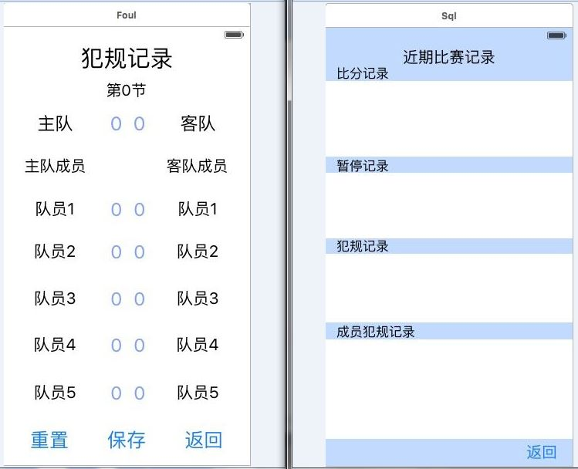
图 3 篮球计分器犯规记录界面和查看比赛记录界面

2.2功能实现

2.2.1 记录球队信息及比赛场次

2.2.1.1 绑定所有控件
@IBOutlet weak var Team1: UITextField!
@IBOutlet weak var YQ1: UITextField!
@IBOutlet weak var YQ2: UITextField!
@IBOutlet weak var YQ3: UITextField!
@IBOutlet weak var YQ4: UITextField
@IBOutlet weak var YQ5: UITextField!
@IBOutlet weak var Team2: UITextField!
@IBOutlet weak var EQ1: UITextField!
@IBOutlet weak var EQ2: UITextField!
@IBOutlet weak var EQ3: UITextField!
@IBOutlet weak var EQ4: UITextField!
@IBOutlet weak var EQ5: UITextField!
@IBOutlet weak var jie: UILabel!
@IBAction func Jie(sender: UIButton) {}
@IBAction func Save(sender: UIButton) {}
@IBAction func Reset(sender: UIButton) {}

2.2.1.2 节次按钮与节次Label显示的关系
@IBOutlet weak var jie: UILabel!
var j1:String = ""
@IBAction func Jie(sender: UIButton) {
var jstr = ""
var result = 0
var jtext = ""
var jc = 0
jtext = jie.text!
jstr = (jtext as NSString).substringWithRange(NSMakeRange(1,1))
//print(jstr)
if jstr == "时"
{
jie.text = "第1节"
}else
{
jc = Int(jstr)!
result = jc + 1
if result<5
{
j1 = String(result)
jie.text = "第"+j1+"节"
}else if result==5
{
j1 = "加时赛"
jie.text = "加时赛"
}
}
}

2.2.1.3 建立数据库表
var db:SQLiteDB!
override func viewDidLoad() {
super.viewDidLoad()
//获取数据库实例
db = SQLiteDB.sharedInstance()
//如果表还不存在则创建表（其中uid为自增主键）
//db.execute("drop table t_chengyuan")
db.execute("create table if not exists t_chengyuan(uid integer primary key,team1 varchar(20),yq1 varchar(20),yq2 varchar(20),yq3 varchar(20),yq4 varchar(20),yq5 varchar(20),team2 varchar(20),eq1 varchar(20),eq2 varchar(20),eq3 varchar(20),eq4 varchar(20),eq5 varchar(20),j varchar(20))")
//如果有数据则加载
initChengyuan()
}
2.2.1.4 保存数据库
func saveChengyuan() {
let team1 = self.Team1.text!
let yq1 = self.YQ1.text!
let yq2 = self.YQ2.text!
let yq3 = self.YQ3.text!
let yq4 = self.YQ4.text!
let yq5 = self.YQ5.text!
let team2 = self.Team2.text!
let eq1 = self.EQ1.text!
let eq2 = self.EQ2.text!
let eq3 = self.EQ3.text!
let eq4 = self.EQ4.text!
let eq5 = self.EQ5.text!
let j = self.jie.text!
let cysql = "insert into t_chengyuan(team1,yq1,yq2,yq3,yq4,yq5,team2,eq1,eq2,eq3,eq4,
eq5,j)values('\(team1)','\(yq1)','\(yq2)','\(yq3)','\(yq4)','\(yq5)','\(team2)','\(eq1)','\(eq2)','\(eq3)','\(eq4)','\(eq5)','\(j)')"
print("cysql: \(cysql)")
//通过封装的方法执行sql
let cyresult = db.execute(cysql)
print(cyresult)
}
2.2.1.5 加载数据库
func initChengyuan() {
let cydata = db.query("select * from t_chengyuan")
if cydata.count > 0 {
//获取最后一行数据显示
let chengyuan = cydata[cydata.count - 1]
Team1.text = chengyuan["team1"] as? String
YQ1.text = chengyuan["yq1"] as? String
YQ2.text = chengyuan["yq2"] as? String
YQ3.text = chengyuan["yq3"] as? String
YQ4.text = chengyuan["yq4"] as? String
YQ5.text = chengyuan["yq5"] as? String
Team2.text = chengyuan["team2"] as? String
EQ1.text = chengyuan["eq1"] as? String
EQ2.text = chengyuan["eq2"] as? String
EQ3.text = chengyuan["eq3"] as? String
EQ4.text = chengyuan["eq4"] as? String
EQ5.text = chengyuan["eq5"] as? String
jie.text = chengyuan["j"] as? String
}

}
2.2.1.6 重置
@IBAction func Reset(sender: UIButton) {
Team1.text = ""
YQ1.text = ""
YQ2.text = ""
YQ3.text = ""
YQ4.text = ""
YQ5.text = ""
Team2.text = ""
EQ1.text = ""
EQ2.text = ""
EQ3.text = ""
EQ4.text = ""
EQ5.text = ""
jie.text = "第0节"

}

2.2.2 比分记录

2.2.2.1 绑定所有控件
@IBOutlet weak var mark1: UITextField!
@IBOutlet weak var mark2: UITextField!
@IBOutlet weak var zhuname: UILabel!
@IBOutlet weak var kename: UILabel!
@IBAction func YDel(sender: UIButton) {}
@IBAction func EDel(sender: UIButton) {}
@IBAction func Ymark(sender: UIButton) {}
@IBAction func Emark(sender: UIButton) {}
@IBOutlet weak var jie: UILabel!
@IBAction func reset(sender: UIButton) {}
@IBAction func saveClicked(sender: AnyObject) {}

2.2.2.2 实现比分累加及撤销功能
var operand1:String = ""//缓存的字符串
var operand2:String = ""
var huan1 = 0
var huan2 = 0
var che1:String = ""
var che2:String = ""

@IBAction func YDel(sender: UIButton) {
let m = Int(mark1.text!)
let result = m! - Int(che1)!
mark1.text = String(result)

}

@IBAction func EDel(sender: UIButton) {
let m = Int(mark2.text!)
let result = m! - Int(che2)!
mark2.text = String(result)
}

@IBAction func Ymark(sender: UIButton) {
var m = 0
let value = sender.currentTitle//提取每次取的值
m = Int(mark1.text!)!
che1 = value!
huan1 = m + Int(value!)!
operand1 = String(huan1)
//operand1 = String(Int(operand1)!+Int(value!)!)
mark1.text = operand1
}

@IBAction func Emark(sender: UIButton) {
var m = 0
let value = sender.currentTitle//提取每次取的值
m = Int(mark2.text!)!
che2 = value!
huan2 = m + Int(value!)!
operand2 = String(huan2)
mark2.text = operand2
}

2.2.2.3 建立数据库表
var db:SQLiteDB!
override func viewDidLoad() {
super.viewDidLoad()
//获取数据库实例
db = SQLiteDB.sharedInstance()
//如果表还不存在则创建表（其中uid为自增主键）
db.execute("create table if not exists t_user(uid integer primary key,ci varchar(20),uname varchar(20),mobile varchar(20))")
//如果有数据则加载
initUser()
initChengyuan()
}
2.2.2.4 保存数据库
func saveUser() {
let ci = self.jie.text!
let uname = self.mark1.text!
let mobile = self.mark2.text!
//插入数据库，这里用到了esc字符编码函数，其实是调用bridge.m实现的
let sql = "insert into t_user(ci,uname,mobile) values('\(ci)','\(uname)','\(mobile)')"
print("sql: \(sql)")
//通过封装的方法执行sql
let result = db.execute(sql)
print(result)
}
2.2.2.5 加载数据库
func initChengyuan() {
let cydata = db.query("select * from t_chengyuan")
if cydata.count > 0 {
//获取最后一行数据显示
let chengyuan = cydata[cydata.count - 1]
zhuname.text = chengyuan["team1"] as? String
kename.text = chengyuan["team2"] as? String
jie.text = chengyuan["j"] as? String
}
}
func initUser() {
let data = db.query("select * from t_user")
if data.count > 0 {
//获取最后一行数据显示
let user = data[data.count - 1]
mark1.text = user["uname"] as? String
mark2.text = user["mobile"] as? String
}
}

2.2.2.6 重置
@IBAction func reset(sender: UIButton) {
mark1.text = "0"
mark2.text = "0"
operand1 = ""//缓存的字符串
operand2 = ""
huan1 = 0
huan2 = 0
che1 = ""
che2 = ""
cc = ""
}

2.2.3 计时记录

2.2.3.1 绑定所有控件
@IBOutlet weak var SaiTime: UILabel!
@IBOutlet weak var StopTime: UILabel!
@IBOutlet weak var Time24s: UILabel!
@IBOutlet weak var ChangGui: UIButton!
@IBAction func ChangGuiTime(sender: UIButton) {}
@IBOutlet weak var Add: UIButton!
@IBAction func AddTime(sender: UIButton) {}
@IBOutlet weak var times: UIButton!
@IBAction func TIME24s(sender: UIButton) {}
@IBOutlet weak var stop20s: UIButton!
@IBAction func Stop20s(sender: UIButton) {}
@IBOutlet weak var cstop: UIButton!
@IBAction func Cstop(sender: UIButton) {}
@IBOutlet weak var Ystop: UILabel!
@IBOutlet weak var YCstop: UILabel!
@IBOutlet weak var Estop: UILabel!
@IBOutlet weak var ECstop: UILabel!
@IBAction func YStop(sender: UIButton) {}
@IBAction func YCStop(sender: UIButton) {}
@IBAction func EStop(sender: UIButton) {}
@IBAction func ECStop(sender: UIButton) {}
@IBOutlet weak var jie: UILabel!
@IBAction func JishiReset(sender: UIButton) {}
@IBAction func StopSave(sender: UIButton) {}

2.2.3.2 实现计时功能
var ChangDing:NSTimer!//倒计时定时器
var Ctimesec:Int = 720
//var Ctimesec:Int = 61
var ChangClick:Int = 0

@IBOutlet weak var ChangGui: UIButton!

@IBAction func ChangGuiTime(sender: UIButton) {
var cgt = ""
if ChangClick == 0{
ChangDing=NSTimer.scheduledTimerWithTimeInterval(1, target: self, selector: Selector("changguiDown"), userInfo: nil, repeats: true)
ChangClick = 1
ChangGui.setTitle("常规赛暂停",forState:UIControlState.Normal)
}else if ChangClick==1
{
cgt = SaiTime.text!
if cgt == "0:0"
{
ChangDing.invalidate()//停止计时器
ChangGui.setTitle("常规赛",forState:UIControlState.Normal)
ChangClick=0
Ctimesec = 720
SaiTime.text! = "12:00"
}else{
ChangDing.invalidate()//停止计时器
ChangGui.setTitle("常规赛",forState:UIControlState.Normal)
ChangClick=0
}
}

}
func changguiDown()
{
if Ctimesec>0{
Ctimesec -= 1
let sec = Ctimesec%60
let min = Ctimesec/60
SaiTime.text = String(min)+":"+String(sec)}
}

以上代码为常规计时，加时赛计时、24秒计时等原理同上，就不再给予说明了。

var stopDing:NSTimer!//倒计时定时器
var stoptimesec:Int = 20
var stopClick:Int = 0

@IBOutlet weak var stop20s: UIButton!
@IBAction func Stop20s(sender: UIButton) {
var st = ""
if stopClick == 0
{
stopDing=NSTimer.scheduledTimerWithTimeInterval(1, target: self, selector: Selector("stopDown"), userInfo: nil, repeats: true)
stopClick = 1
stop20s.setTitle("短stop",forState:UIControlState.Normal)
if ChangClick == 1
{
ChangDing.invalidate()//停止计时器
ChangGui.setTitle("常规赛",forState:UIControlState.Normal)
ChangClick=0
}else if AddClick == 1{
AddDing.invalidate()//停止计时器
Add.setTitle("加时赛",forState:UIControlState.Normal)
AddClick=0
}
}else if stopClick==1
{
st = StopTime.text!
if st == "0"
{
stopDing.invalidate()//停止计时器
stop20s.setTitle("短暂停",forState:UIControlState.Normal)
stopClick=0
stoptimesec = 20
StopTime.text! = "20"
}else{
stopDing.invalidate()//停止计时器
stop20s.setTitle("短暂停",forState:UIControlState.Normal)
stopClick=0
}
}

}

func stopDown()
{

if stoptimesec>0{
stoptimesec -= 1
let sec = stoptimesec
StopTime.text = String(sec)}
}
以上为短暂停（20s）计时功能，长暂停原理一样，不再给予说明。

2.2.3.3 实现暂停次数累计功能
var stop1:String = ""
var cstop1:String = ""
var stop2:String = ""
var cstop2:String = ""
@IBAction func YStop(sender: UIButton) {
var s = 0
var result = 0
s = Int(Ystop.text!)!
result = s + 1
stop1 = String(result)
Ystop.text = stop1
}

@IBAction func YCStop(sender: UIButton) {
var s = 0
var result = 0
s = Int(YCstop.text!)!
result = s + 1
cstop1 = String(result)
YCstop.text = cstop1
}

@IBAction func EStop(sender: UIButton) {
var s = 0
var result = 0
s = Int(Estop.text!)!
result = s + 1
stop2 = String(result)
Estop.text = stop2
}

@IBAction func ECStop(sender: UIButton) {
var s = 0
var result = 0
s = Int(ECstop.text!)!
result = s + 1
cstop2 = String(result)
ECstop.text = cstop2
}

2.2.3.4 建立数据库表
override func viewDidLoad() {
super.viewDidLoad()
//获取数据库实例
db = SQLiteDB.sharedInstance()
//db.execute("drop table t_stop")
db.execute("create table if not exists t_stop(uid integer primary key,j varchar(20),ydstop varchar(20),ycstop varchar(20),edstop varchar(20),ecstop varchar(20))")
//如果有数据则加载
initStop()
initChengyuan()
}
2.2.3.5 保存数据库
func saveStop() {
let j = self.jie.text!
let ydstop = self.Ystop.text!
let ycstop = self.YCstop.text!
let edstop = self.Estop.text!
let ecstop = self.ECstop.text!
//插入数据库，这里用到了esc字符编码函数，其实是调用bridge.m实现的
let stopsql = "insert into t_stop(j,ydstop,ycstop,edstop,ecstop) values('\(j)','\(ydstop)','\(ycstop)','\(edstop)','\(ecstop)')"
print("stopsql: \(stopsql)")
//通过封装的方法执行sql
let result = db.execute(stopsql)
print(result)
}
2.2.3.6 加载数据库
func initStop() {
let sdata = db.query("select * from t_stop")
if sdata.count > 0 {
//获取最后一行数据显示
let stop = sdata[sdata.count - 1]
Ystop.text = stop["ydstop"] as? String
YCstop.text = stop["ycstop"] as? String
Estop.text = stop["edstop"] as? String
ECstop.text = stop["ecstop"] as? String
}

}
func initChengyuan() {
let cydata = db.query("select * from t_chengyuan")
if cydata.count > 0 {
//获取最后一行数据显示
let chengyuan = cydata[cydata.count - 1]
jie.text = chengyuan["j"] as? String
}

}
2.2.3.7 重置
@IBAction func JishiReset(sender: UIButton) {
SaiTime.text = "比赛时间"
Time24s.text = "24"
StopTime.text = "暂停时间"
Ystop.text = "0"
YCstop.text = "0"
Estop.text = "0"
ECstop.text = "0"

if ChangClick == 1{
ChangDing.invalidate()
ChangGui.setTitle("常规赛",forState:UIControlState.Normal)
}
Ctimesec = 720
ChangClick = 0

if AddClick == 1{
AddDing.invalidate()
Add.setTitle("加时赛",forState:UIControlState.Normal)
}
Addtimesec = 300
AddClick = 0

if TimeClick == 1{
TimeDing.invalidate()
times.setTitle("24秒计时",forState:UIControlState.Normal)
}
timesec = 24
TimeClick = 0

if stopClick == 1{
stopDing.invalidate()
stop20s.setTitle("短暂停",forState:UIControlState.Normal)
}
stoptimesec = 20
stopClick = 0

if CstopClick == 1{
CstopDing.invalidate()
cstop.setTitle("常规暂停",forState:UIControlState.Normal)
}
Cstoptimesec = 100
CstopClick = 0

stop1 = ""
cstop1 = ""
stop2 = ""
cstop2 = ""
}

2.2.4 犯规记录

2.2.4.1 绑定所有控件
@IBOutlet weak var YTeam: UILabel!
@IBOutlet weak var ETeam: UILabel!
@IBOutlet weak var YQM1: UILabel!
@IBOutlet weak var YQM2: UILabel!
@IBOutlet weak var YQM3: UILabel!
@IBOutlet weak var YQM4: UILabel!
@IBOutlet weak var YQM5: UILabel!
@IBOutlet weak var YQM: UILabel!
@IBOutlet weak var EQM: UILabel!
@IBOutlet weak var EQM1: UILabel!
@IBOutlet weak var EQM2: UILabel!
@IBOutlet weak var EQM3: UILabel!
@IBOutlet weak var EQM4: UILabel!
@IBOutlet weak var EQM5: UILabel!
@IBOutlet weak var yq1: UILabel!
@IBOutlet weak var yq2: UILabel!
@IBOutlet weak var yq3: UILabel!
@IBOutlet weak var yq4: UILabel!
@IBOutlet weak var yq5: UILabel!
@IBOutlet weak var eq1: UILabel!
@IBOutlet weak var eq2: UILabel!
@IBOutlet weak var eq3: UILabel!
@IBOutlet weak var eq4: UILabel!
@IBOutlet weak var eq5: UILabel!
@IBAction func Yq1(sender: UIButton) {}
@IBAction func Yq2(sender: UIButton) {}
@IBAction func Yq3(sender: UIButton) {}
@IBAction func Yq4(sender: UIButton) {}
@IBAction func Yq5(sender: UIButton) {}
@IBAction func Eq1(sender: UIButton) {}
@IBAction func Eq2(sender: UIButton) {}
@IBAction func Eq3(sender: UIButton) {}
@IBAction func Eq4(sender: UIButton) {}
@IBAction func Eq5(sender: UIButton) {}
@IBOutlet weak var jie: UILabel!
@IBAction func FoulSave(sender: UIButton) {}
@IBAction func FoulReset(sender: UIButton) { }

2.2.4.2 实现犯规累加功能
var Yqf1:String = ""
@IBAction func Yq1(sender: UIButton) {
var f = 0
var result = 0
f = Int(YQM1.text!)!
result = f + 1
Yqf1 = String(result)
YQM1.text = Yqf1
YQM.text = String(Int(YQM.text!)!+1)
}

var Yqf2:String = ""
@IBAction func Yq2(sender: UIButton) {
var f = 0
var result = 0
f = Int(YQM2.text!)!
result = f + 1
Yqf2 = String(result)
YQM2.text = Yqf2
YQM.text = String(Int(YQM.text!)!+1)
}

var Yqf3:String = ""
@IBAction func Yq3(sender: UIButton) {
var f = 0
var result = 0
f = Int(YQM3.text!)!
result = f + 1
Yqf3 = String(result)
YQM3.text = Yqf3
YQM.text = String(Int(YQM.text!)!+1)
}

var Yqf4:String = ""
@IBAction func Yq4(sender: UIButton) {
var f = 0
var result = 0
f = Int(YQM4.text!)!
result = f + 1
Yqf4 = String(result)
YQM4.text = Yqf4
YQM.text = String(Int(YQM.text!)!+1)
}

var Yqf5:String = ""
@IBAction func Yq5(sender: UIButton) {
var f = 0
var result = 0
f = Int(YQM5.text!)!
result = f + 1
Yqf5 = String(result)
YQM5.text = Yqf5
YQM.text = String(Int(YQM.text!)!+1)
}

var Eqf1:String = ""
@IBAction func Eq1(sender: UIButton) {
var f = 0
var result = 0
f = Int(EQM1.text!)!
result = f + 1
Eqf1 = String(result)
EQM1.text = Eqf1
EQM.text = String(Int(EQM.text!)!+1)
}

var Eqf2:String = ""
@IBAction func Eq2(sender: UIButton) {
var f = 0
var result = 0
f = Int(EQM2.text!)!
result = f + 1
Eqf2 = String(result)
EQM2.text = Eqf2
EQM.text = String(Int(EQM.text!)!+1)
}

var Eqf3:String = ""
@IBAction func Eq3(sender: UIButton) {
var f = 0
var result = 0
f = Int(EQM3.text!)!
result = f + 1
Eqf3 = String(result)
EQM3.text = Eqf3
EQM.text = String(Int(EQM.text!)!+1)
}

var Eqf4:String = ""
@IBAction func Eq4(sender: UIButton) {
var f = 0
var result = 0
f = Int(EQM4.text!)!
result = f + 1
Eqf4 = String(result)
EQM4.text = Eqf4
EQM.text = String(Int(EQM.text!)!+1)
}

var Eqf5:String = ""
@IBAction func Eq5(sender: UIButton) {
var f = 0
var result = 0
f = Int(EQM5.text!)!
result = f + 1
Eqf5 = String(result)
EQM5.text = Eqf5
EQM.text = String(Int(EQM.text!)!+1)
}

2.2.4.3 建立数据库表
override func viewDidLoad() {
super.viewDidLoad()
//获取数据库实例
db = SQLiteDB.sharedInstance()
db.execute("create table if not exists t_foul(uid integer primary key,j varchar(20),yqf varchar(20),yqf1 varchar(20),yqf2 varchar(20),yqf3 varchar(20),yqf4 varchar(20),yqf5 varchar(20),eqf varchar(20),eqf1 varchar(20),eqf2 varchar(20),eqf3 varchar(20),eqf4 varchar(20),eqf5 varchar(20))")
//如果有数据则加载
initChengyuan()
initFoul()
}
2.2.4.4 保存数据库
func saveFoul() {
let yqf = self.YQM.text!
let yqf1 = self.YQM1.text!
let yqf2 = self.YQM2.text!
let yqf3 = self.YQM3.text!
let yqf4 = self.YQM4.text!
let yqf5 = self.YQM5.text!
let eqf = self.EQM.text!
let eqf1 = self.EQM1.text!
let eqf2 = self.EQM2.text!
let eqf3 = self.EQM3.text!
let eqf4 = self.EQM4.text!
let eqf5 = self.EQM5.text!
let j = self.jie.text!
//插入数据库，这里用到了esc字符编码函数，其实是调用bridge.m实现的
let foulsql = "insert into t_foul(j,yqf,yqf1,yqf2,yqf3,yqf4,yqf5,eqf,eqf1,eqf2,eqf3,eqf4,
eqf5)values('\(j)','\(yqf)','\(yqf1)','\(yqf2)','\(yqf3)','\(yqf4)','\(yqf5)','\(eqf)','\(eqf1)','\(eqf2)','\(eqf3)','\(eqf4)','\(eqf5)')"
print("foulsql: \(foulsql)")
//通过封装的方法执行sql
let result = db.execute(foulsql)
print(result)
}
2.2.4.5 加载数据库
func initChengyuan() {
let cydata = db.query("select * from t_chengyuan")
if cydata.count > 0 {
//获取最后一行数据显示
let chengyuan = cydata[cydata.count - 1]
jie.text = chengyuan["j"] as? String
YTeam.text = chengyuan["team1"] as? String
yq1.text = chengyuan["yq1"] as? String
yq2.text = chengyuan["yq2"] as? String
yq3.text = chengyuan["yq3"] as? String
yq4.text = chengyuan["yq4"] as? String
yq5.text = chengyuan["yq5"] as? String
ETeam.text = chengyuan["team2"] as? String
eq1.text = chengyuan["eq1"] as? String
eq2.text = chengyuan["eq2"] as? String
eq3.text = chengyuan["eq3"] as? String
eq4.text = chengyuan["eq4"] as? String
eq5.text = chengyuan["eq5"] as? String
}

}

func initFoul() {
let fdata = db.query("select * from t_foul")
if fdata.count > 0 {
//获取最后一行数据显示
let foul = fdata[fdata.count - 1]
YQM.text = foul["yqf"] as? String
YQM1.text = foul["yqf1"] as? String
YQM2.text = foul["yqf2"] as? String
YQM3.text = foul["yqf3"] as? String
YQM4.text = foul["yqf4"] as? String
YQM5.text = foul["yqf5"] as? String
EQM.text = foul["eqf"] as? String
EQM1.text = foul["eqf1"] as? String
EQM2.text = foul["eqf2"] as? String
EQM3.text = foul["eqf3"] as? String
EQM4.text = foul["eqf4"] as? String
EQM5.text = foul["eqf5"] as? String
}

}
2.2.4.6 重置
@IBAction func FoulReset(sender: UIButton) {
YQM.text = "0"
YQM1.text = "0"
YQM2.text = "0"
YQM3.text = "0"
YQM4.text = "0"
YQM5.text = "0"
EQM.text = "0"
EQM1.text = "0"
EQM2.text = "0"
EQM3.text = "0"
EQM4.text = "0"
EQM5.text = "0"
}

2.2.4 比赛记录

2.2.4.1 绑定所有控件
@IBOutlet weak var cyfoultable: UITextView!
@IBOutlet weak var foultable: UITextView!
@IBOutlet weak var stoptable: UITextView!

@IBOutlet weak var cyfoultable2: UITextView!
@IBOutlet weak var table: UITextView!

2.2.4.2 定义变量初始化
var db:SQLiteDB!
var Team1:String = ""
var YQ1:String = ""
var YQ2:String = ""
var YQ3:String = ""
var YQ4:String = ""
var YQ5:String = ""
var Team2:String = ""
var EQ1:String = ""
var EQ2:String = ""
var EQ3:String = ""
var EQ4:String = ""
var EQ5:String = ""
2.2.4.5 加载数据库
override func viewDidLoad() {
super.viewDidLoad()
db = SQLiteDB.sharedInstance()
//如果有数据则加载
initChengyuan()
initUser()
initFoul()
initStop()
}

func initChengyuan() {
let cydata = db.query("select * from t_chengyuan")
if cydata.count > 0 {
//获取最后一行数据显示
let chengyuan = cydata[cydata.count - 1]
Team1 = (chengyuan["team1"] as? String)!
YQ1 = (chengyuan["yq1"] as? String)!
YQ2 = (chengyuan["yq2"] as? String)!
YQ3 = (chengyuan["yq3"] as? String)!
YQ4 = (chengyuan["yq4"] as? String)!
YQ5 = (chengyuan["yq5"] as? String)!
Team2 = (chengyuan["team2"] as? String)!
EQ1 = (chengyuan["eq1"] as? String)!
EQ2 = (chengyuan["eq2"] as? String)!
EQ3 = (chengyuan["eq3"] as? String)!
EQ4 = (chengyuan["eq4"] as? String)!
EQ5 = (chengyuan["eq5"] as? String)!
}
}
//从SQLite加载数据
func initUser() {
let data = db.query("select * from t_user")
var ji:String = ""
for(var i=0;i<data.count;i++)
{
let user = data[i]
let m1:String = (user["uname"] as? String)!
let m2:String = (user["mobile"] as? String)!
let c:String = (user["ci"] as? String)!
ji = c+Team1+"比分："+m1+" "+Team2+"比分："+m2;
table.text! += ji+"\r"
}
}

func initFoul() {
let fdata = db.query("select * from t_foul")
var jilu:String = ""
var y:String = ""
var e:String = ""
for(var i=0;i<fdata.count;i++){
let foul = fdata[i]
let j = (foul["j"] as? String)!
let YQM:String = (foul["yqf"] as? String)!
let EQM:String = (foul["eqf"] as? String)!
jilu = j+Team1+"犯规："+YQM+" "+Team2+"犯规："+EQM
foultable.text! += jilu+"\r"

}
if fdata.count > 0 {
//获取最后一行数据显示
let foul = fdata[fdata.count - 1]
let j = (foul["j"] as? String)!
let Y1:String = (foul["yqf1"] as? String)!
let Y2:String = (foul["yqf2"] as? String)!
let Y3:String = (foul["yqf3"] as? String)!
let Y4:String = (foul["yqf4"] as? String)!
let Y5:String = (foul["yqf5"] as? String)!
let E1:String = (foul["eqf1"] as? String)!
let E2:String = (foul["eqf2"] as? String)!
let E3:String = (foul["eqf3"] as? String)!
let E4:String = (foul["eqf4"] as? String)!
let E5:String = (foul["eqf5"] as? String)!
y = j+"\r"+Team1+"队成员："+"\r"+YQ1+"犯规："+Y1+"\r"+YQ2+"犯规："+Y2+"\r"+YQ3+"犯规："+Y3+"\r"+YQ4+"犯规："+Y4+"\r"+YQ5+"犯规："+Y5
e = j+"\r"+Team2+"队成员："+"\r"+EQ1+"犯规："+E1+"\r"+EQ2+"犯规："+E2+"\r"+EQ3+"犯规："+E3+"\r"+EQ4+"犯规："+E4+"\r"+EQ5+"犯规："+E5
cyfoultable.text! += y
cyfoultable2.text! += e
}
}

func initStop() {
let sdata = db.query("select * from t_stop")
var ji:String = ""
var lu:String = ""
for(var i=0;i<sdata.count;i++){
let stop = sdata[i]
let j:String = (stop["j"] as? String)!
let Ystop:String = (stop["ydstop"] as? String)!
let YCstop:String = (stop["ycstop"] as? String)!
let Estop:String = (stop["edstop"] as? String)!
let ECstop:String = (stop["ecstop"] as? String)!
ji = j+Team1+"短停:"+Ystop+" "+"长停:"+YCstop
lu = " "+Team2+"短停:"+Estop+" "+"长停:"+ECstop
stoptable.text! += ji+lu+"\r"
}
}

2.3 设计思想
篮球计分器，首先要有计分、计时功能。
在做了一个计算器实验后，我对编写分数累加的代码有一定的基础，在完成计算功能后，考虑到客户可能操作失误的情况，我做了一个撤销功能，用当前label值减去获取的上一步操作的value值，从而还原到上一步操作结果。当所有计分结束后，可保存到数据库中。
计时器是使用定时器的原理编写的，给定指定的时间，开始倒计时，当用户按下短暂停（常规暂停）按钮时，倒计时暂停，同时，暂停计时开始计时。用户可记录主队（客队）的暂停次数，并存入数据库。PS：本计时器还有24s计时功能，当球员拿到球以后需要在24秒内进攻。
完成了计时、计分的基本功能，我根据客户的需求，增添了记录球队信息、记录球队、球员犯规情况以及查看比赛历史记录的功能。
通过手动编辑球队和球员信息，保存到数据库当中，其他界面可调用数据库当中的信息，显示所需要的内容。球员犯规情况通过计算累加，每有人犯规一次，犯规的球员犯规次数+1，他所属的球队犯规次数+1，最后通过保存按钮，保存到数据库当中。
当点击比赛记录时，会获取数据库存放的所有历史记录：比分记录、暂停次数记录、球队犯规记录。而球员犯规记录只获取数据库表中的最后一行，也就是最近一次的球员犯规记录。

第3章 调试分析
分析本应用程序还有许多未完善的地方，如计时记录页面控件太多，影响用户操作，不够简洁，我会在下一次修改时将记录暂停次数单独立一个界面，减少影响。还有犯规次数只能重置，不能撤销上一步操作，不利于用户使用，下次会将它改成像比分记录那样，可撤销、可保存、可重置。进一步完善应用程序。

第4章 使用说明与执行结果
运行操作及结果:
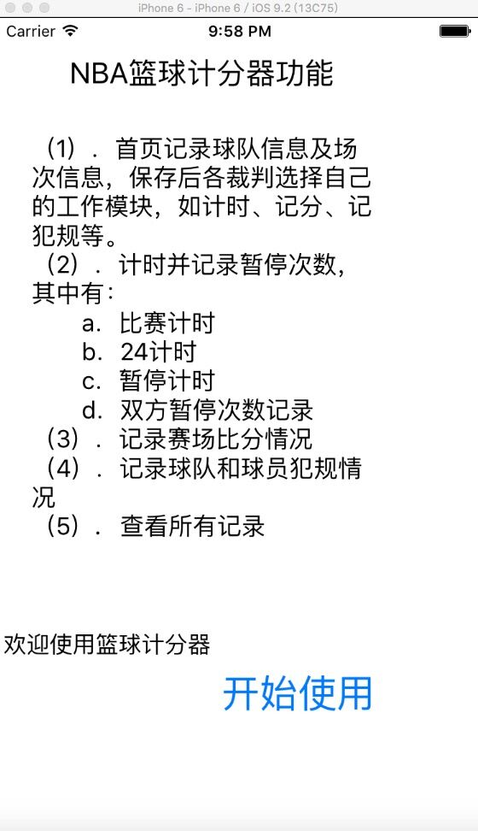
图4 应用程序首页
首界面介绍了本应用程序的一些功能，欢迎用户使用本应用程序，点击开始使用，进入下一界面。
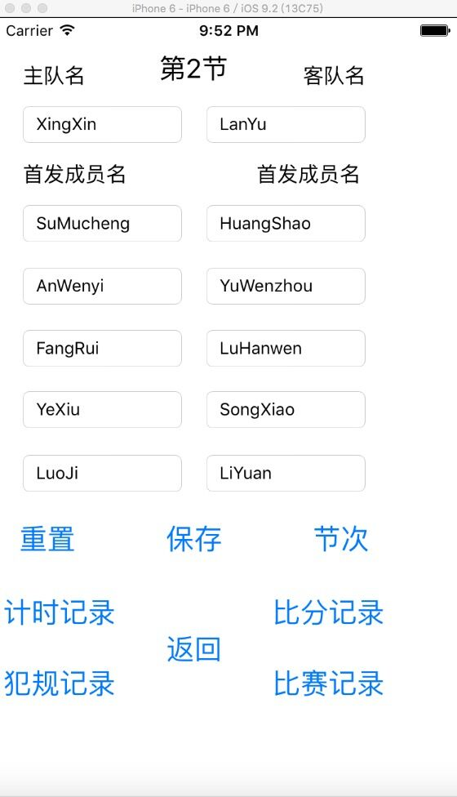
图5 第2界面（主界面）
第二界面也就是本程序的主界面，裁判通过记录球队、成员以及节次信息，保存以后，选择自己的工作，如专门计分的裁判就选比分记录，计时的裁判选计时记录......选择好可进入下一界面。若是人员缺乏也可以一身多值，当记录完当前界面的内容，返回主界面选择其他工作界面记录。

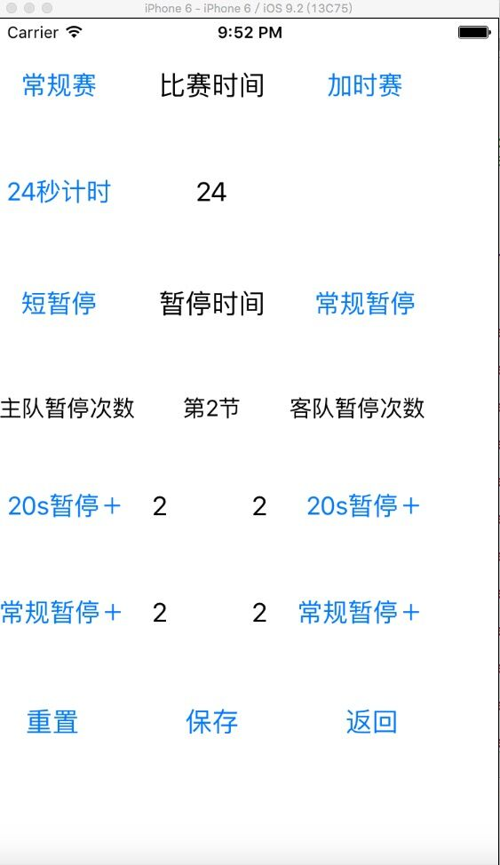
图6 计时界面
计时界面，可进行24s进攻计时，常规赛、加时赛计时，20秒短暂停，100秒常规暂停，各队暂停次数记录。
通过点击计时按钮开始计时，点击暂停按钮进行暂停，并开始暂停计时，点击记录暂停次数的按钮，对暂停次数进行累加，点击保存，将数据存入数库，重置，回到当前界面的最初模样，清楚所有操作，点击返回，返回上一界面（主界面）。
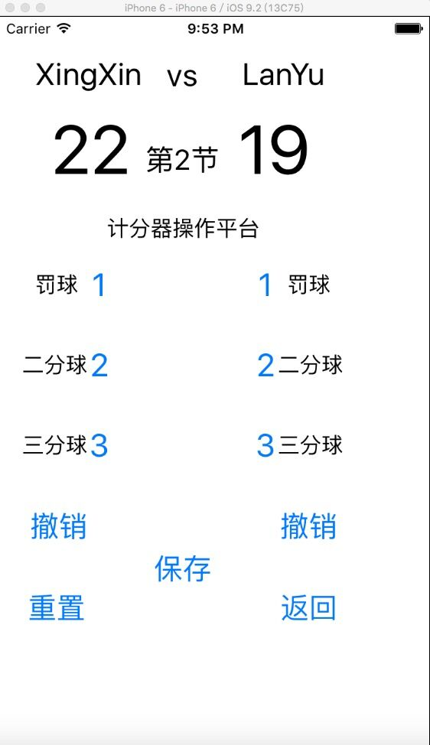
图7 比分记录界面
比分记录界面，点击1（罚球）、2（二分球）、3（三分球）等按钮时，会进行分数累加，点击撤销，可回到上一步操作结果，点击重置，则消除所有记录，比分回到0:0。PS：队名和节次是通过数据库获取的，不受重置干扰。
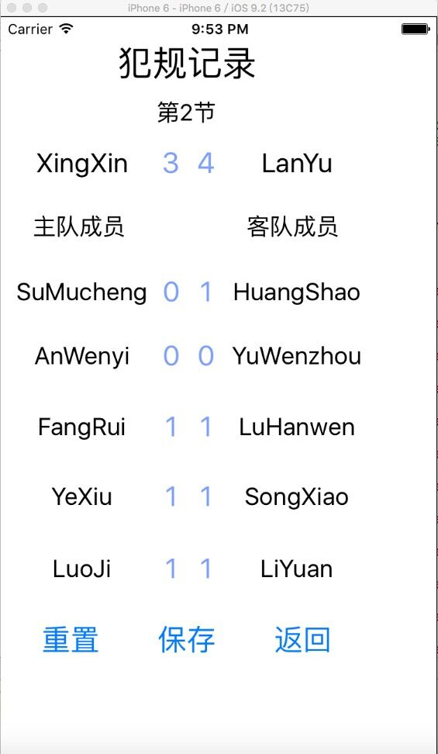
图8 犯规记录界面
比分记录界面，点击写有球员名字的按钮时，会进行分数+1的累加计算，点击保存，将所记录数据保存到数据库当中，点击重置，则消除所有记录，所有犯规记录为0。PS：队名和队员名以及节次是通过数据库获取的，不受重置干扰。
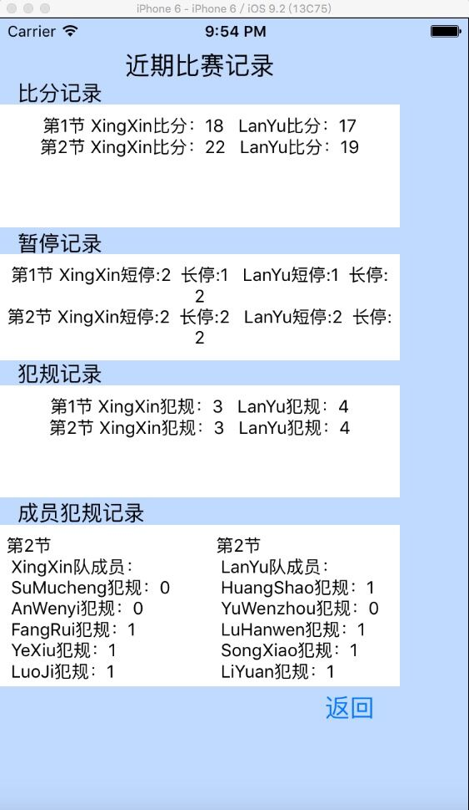
图9 比赛记录界面（历史记录）
比赛记录界面，可查看近期比赛的所有记录，比分、暂停、犯规等从第一节比赛到现在的记录而成员犯规记录是最后一次保存的记录(也就是当前比赛记录).

第5章 实验小结
5.1 在实验中发现的问题
- 比赛计时的时候，按下暂停键，计时未停止，两种计时同时进行。若是按加时赛计时，暂停没反应。
- 进行撤销功能的时候，撤销到上一步的值，再次累加时，计算结果并没有因为撤销收到影响。也就是计算错误。
3、计时记录界面当中，按下重置按钮，计时显示成初始界面，但是计时还在继续，时间和“比赛时间”相互切换显示，出现bug。第二次改进，计时停止，显示正常，但是当再次计时的时候，发现计时没有被重置，而是继续计时。
5.2 分析错误原因
- 按下暂停键，虽将时间显示变成文字“比赛时间”，但是没有对定时器进行停止。按下加时赛后，按暂停按钮无反应是因为没有写停止加时赛定时器的代码。
解决方案：先识别是加时赛计时还是常规赛计时被启动，识别完成后，停止当前定时器，开启暂停计时。
- 计算逻辑出错，获取上一步value值以后，用累加的结果减去value值，从而改变界面显示比分值，虽然得到了撤销的效果，但是累加计算是通过获取当前操作值，加上上一次操作计算的缓存值得到的结果，所以界面显示比分改变了，缓存值未改变，计算还是按照以前的累加，并未因撤销有所改变。
解决方案：改变计算逻辑，首先获取界面显示的比分，再获取操作值，进行累加，这样撤消后，比分才会真正的受到改变。
- 计时记录界面当中，时间和“比赛时间”相互切换显示，出现bug是因为没有停止计时，只是改变了计时的显示，没有从本质解决问题。第二次改进，再次计时的时候，发现计时没有被重置是因为没有进行初始化。
解决方案：首先判断是否在计时，若有计时，判断是常规计时还是加时赛计时，针对不同的计时来进行操作，彻底停止定时器，初始化定时器的所有值。
5.3 总结
编写程序时，一定要注重格式，每完成一个功能运行一次，及时调试分析发现错误，对于字符转换要多加注意。做应用程序，多从客户的角度着想，以及应用程序的实际应用是否可行，而不是为了完成某个功能而做程序。界面要简单易懂，方便操作，多考虑用户的需求，从用户的角度思考问题，一个简单的操作也许需要复杂的代码来实现，对于我来说，简单的代码就能实现这个功能，但是操作起来并不简单。以前的我可能会用简单的代码去实现，经过这次实验，我明白了，用户永远在第一位，用户所需要的才是我应该做的，一个真正的应用程序，用户操作简单才是最重要的，让用户用的舒心是我们编程的责任。
通过本次实验，不仅让我对Xcode环境以及swift语言有了一定的了解，奠定了我的编程基础。更多的是让我懂得了什么是应用程序，什么是做作业。一个优秀的程序员，会有良好的编程习惯，而我也会向真正的程序员的方向努力。
感谢本次实验中帮助我的同学和指导老师！

