**RULES FOR THE AI CARD GAME:**

The aim of the game is to craft a recipe, as shown on the Book cards. The recipe below depicts three paper, two gold, and three crystal are needed to craft.



The player gets a series of input materials, and must put all of the materials required by the recipe on to the CRAFT card, and the rest onto the DISCARD card. The materials on the CRAFT card must match the recipe exactly.

However, in order to sort the materials that should be crafted, from the materials that should be discarded, the player must place Desk cards.

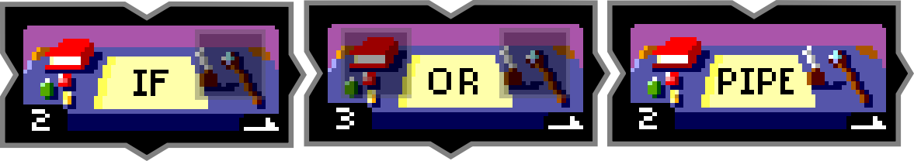

Desk cards will take an input material from either above, or beside, and, depending on the card, move the material to the right, up or down. Desk cards form a grid, and slot together much like a jigsaw puzzle. Players are encouraged to physically move materials across the cards, as if they were game pieces on a board game.

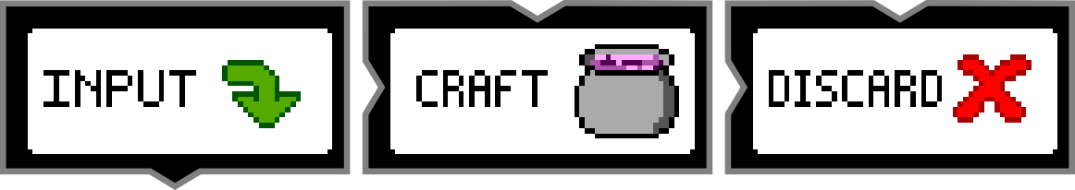

Input materials begin at the INPUT card, and move down. They then move across the various cards the player places down, until eventually ending up on either the CRAFT or DISCARD card.

The recipe is not considered crafted until all of the materials are either on the CRAFT or DISCARD cards, and the CRAFT card matches the recipe with it’s materials, and amounts.

QUICK RECAP:

* Materials are moved across the cards, like game pieces on a board.
* Cards are to be placed in a grid like fashion, interlocking like a jigsaw puzzle.
* CRAFT card must have the same materials on it, and the same amounts, as in the recipe.
* All other materials should end up on DISCARD.

DESK CARDS:

A basic rule of thumb for how Desk cards work is this: if it matches the written condition, move right. Else move down.

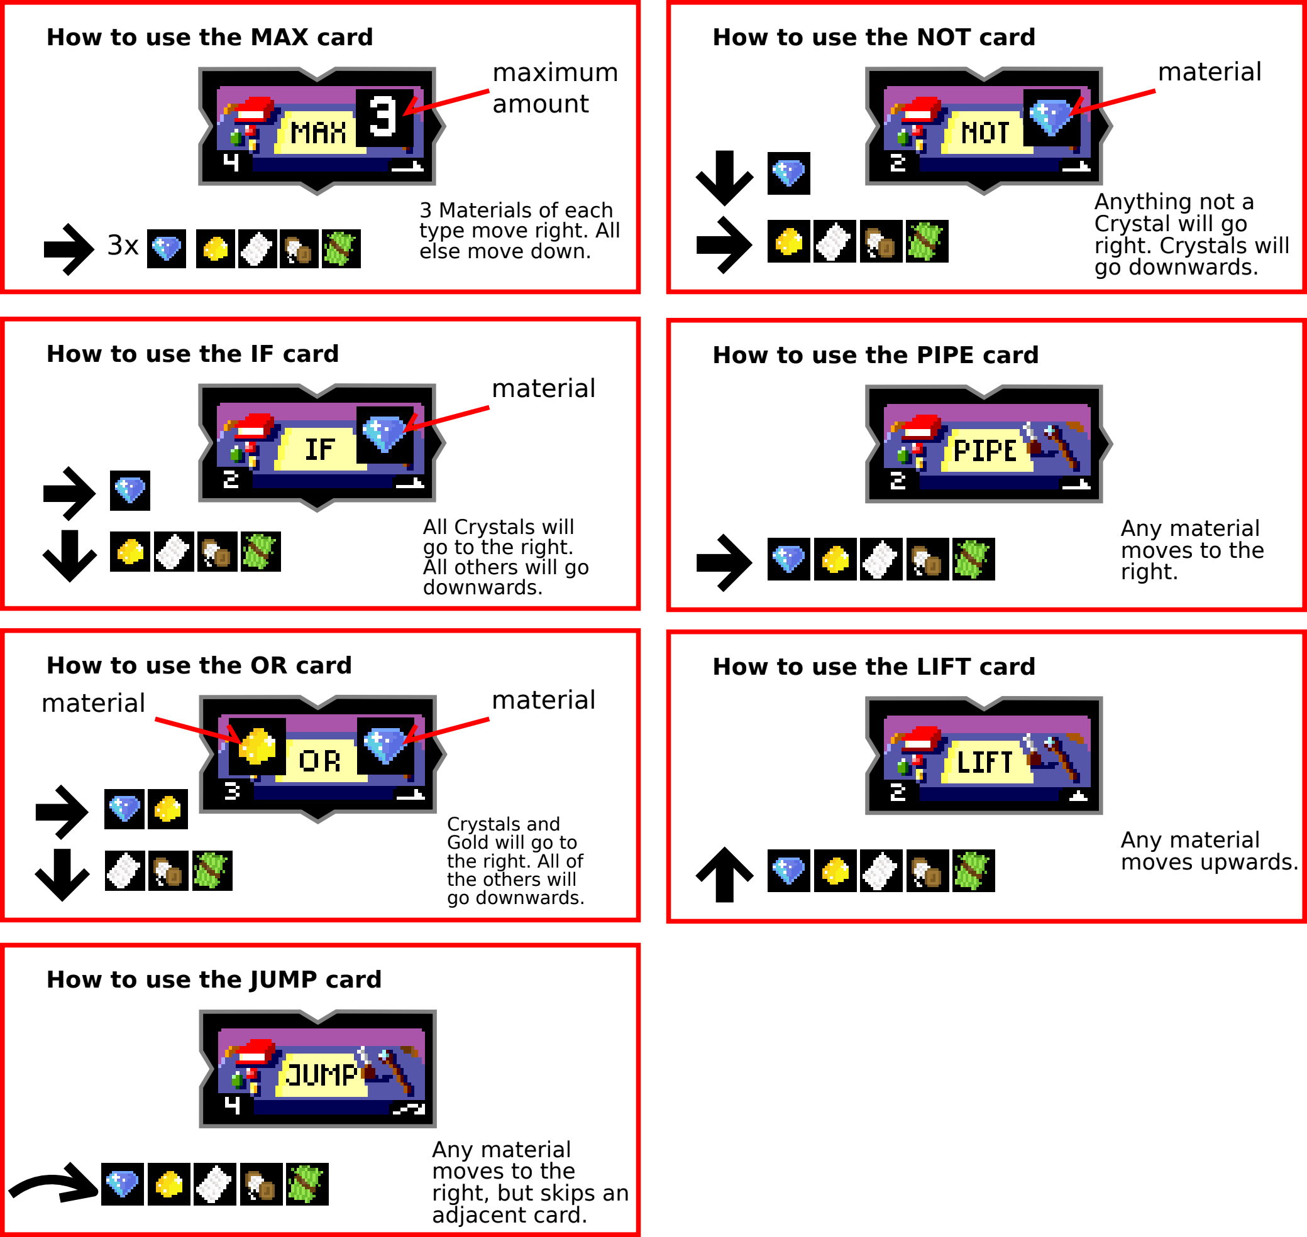

Most cards have one or more slots for a material to be placed. This material is relevant to the card, and the condition will check against the specified material. For example, IF moves right any material that is the same as the one placed in the slot.

UNUSUAL CARDS:

Notice how the NOT card is inverse of IF. Anything that matches it moves down, and all else goes right. MAX is another interesting card. It will only allow a certain number of any given material through it. The maximum amount resets per material, so it would allow 3 Crystals to the right, as well as 3 Gold. JUMP, LIFT and PIPE are all cards to assist movement. JUMP skips the card to the right of it, but still moves right. LIFT moves upwards, and PIPE to the right.