QuPath GUI instructions

--Liqiang Huang

University of Houston, ECE department

* Requirements:

The image is 76G, please make sure a least of 32G RAM in your desktop. (64GB or larger is recommended), all experiments work on QuPath 0.5.1, new version should work but not sure.

* Preparation

1. Color/memory setting: Settings -- > search ‘color’ -- > set the color as shown below, so the retrieval results will show as green and default objects will be white; search ‘memory’, and set both max memory and percentage memory to 85. 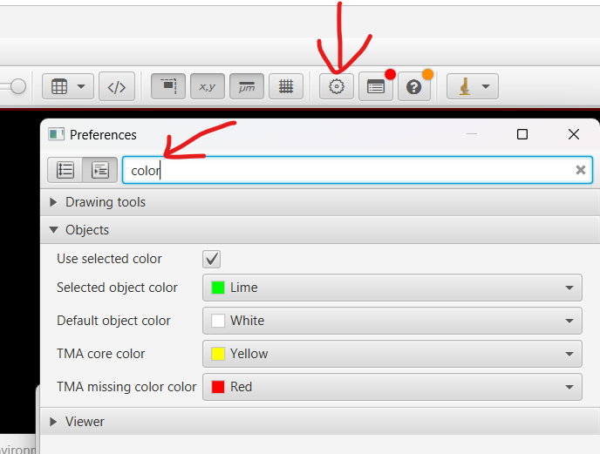
2. Load search engine extension: Open QuPath -- > extensions -- > Manage extensions -- > Open extension directory, copy the .jar files (electronic_data > scripts) into the opening directory. **Close and restart QuPath**. You will see the Cell Search Engine under the Extensions after restart.
3. Create project: Open QuPath -- > Create project, create a new empty folder, and select the directory, -- > Add images -- > choose file: (electronic_data > brain_S1_alln.ome.tif) -- > import
4. Load segmentation objects (required for viewing results in QuPath, not for deep learning): Open the image shown left, then File -- > Import objects form file: (electronic_data > segmentations.geojson), it will take time.
5. Channel selection: To make a better appearance, you can pick a few interested channels, or only pick DAPI, this will make the viewer clean and save some memory.

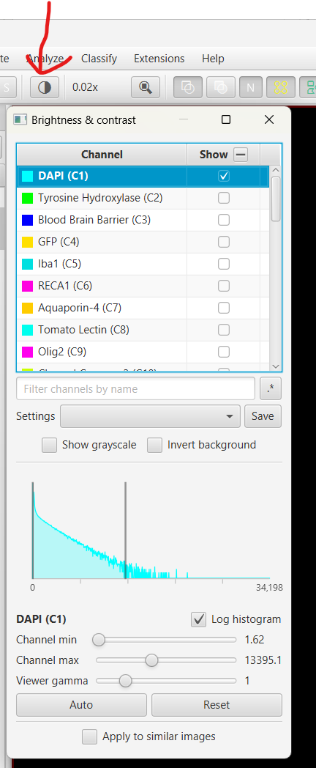

* Community Search by cell
  1. Find the Microenvironment Search panel shown below, load the (electronic_data > Community_indexes > myelo_type_glial_community.csv)

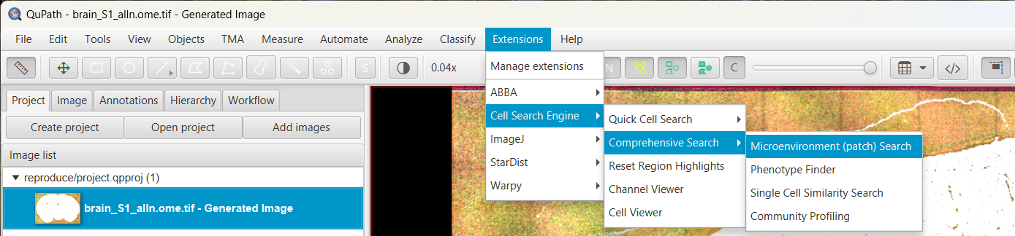

* 1. Zoom in the image, double click a cell object, after shown green (1)[**\*make sure ‘Community Search by index’ are empty**], click Run(2), you will see the retrieval results.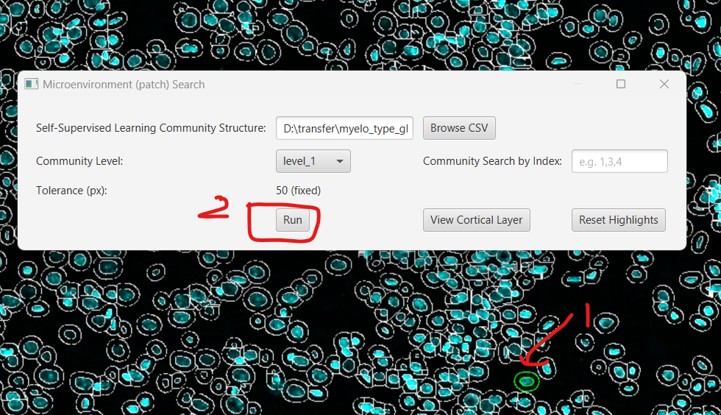

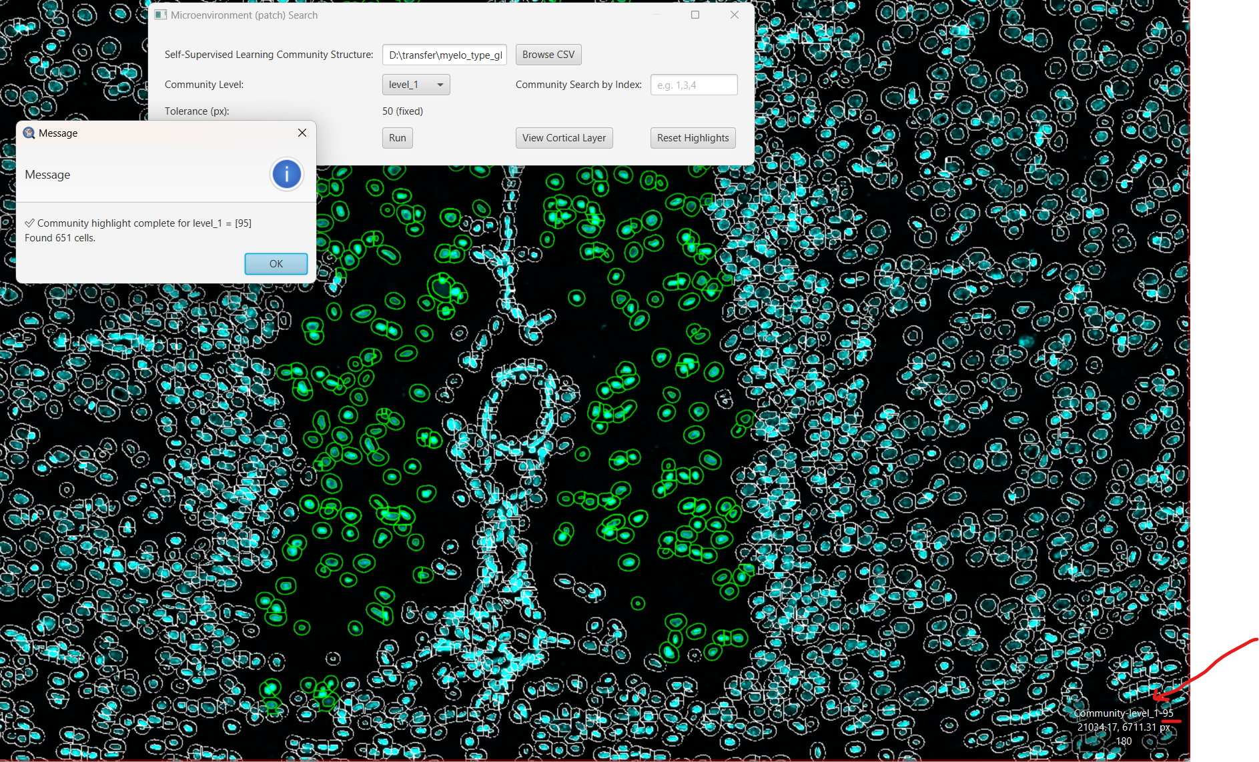

Remember the similarity is based on a region of 175 x 175, but results are shown as a cell for convenience. Click OK, it will pop out a window and tell you the community index. Also, when you move cursor on retrieved cells, the right-bottom text will show the community index (behind community_level_1). When zoom out, you will see the global view of the searching.

Now, you can double click another cell and ‘Run’, the color of previous retrievals will automatically change, if you don’t want to keep it, just click the Reset Highlights.

Additionally, these two icons will make the viewer cleaner, you can toggle them to select the best visualization. 

* 1. Community Search by community index

Once you have several target community-indexes, you don’t need to click the cell for each time, you can just type the community index value in the ‘Community Search by index; e.g. 1,3,4’, (either from the pop-out window or the right-bottom text, or a record), and click the Run, you can search several communities at the same time in this way. Alternatively, you can double click the target cell, hold ‘CTRL’, and click other cells you are interested in, this operation also support you query multiple cells.

***\*Please note that if your searching results look bad, it means you click the blood vessel cell that not region-related, so you can check with the RECA channel, and pick another cell for searching.***

* Profiling

Extensions -- > Cell Search Engine -- > Comprehensive Search -- > Community Profiling, upload the file (electronic_data > Community_indexes > myelo_glial_type_profiling.csv). Then select the markers of showing, and type the community index that you are interested in, it supports the individual comparing [2,4,9,6] or the grouped comparing [2,4], [9,6].

* Single cell search

Extensions -- > Cell Search Engine -- > Comprehensive Search -- > Single Cell community search.

Upload the file (electronic_data > Single Cell > single_cell_simatrix.json),double click the target cell, and select the top N number you want to show,(500 or larger is recommended), click run.

* Channel viewer and Cell viewer

After selecting several cells, or with the retrieved objects, click Extensions -- > Channel viewer or Cell viewer to visualize the 175 x 175 region or 75 x 75 region for each channel respectively.