Customer Churn & Segmentation Analysis
Telco customer base - CRM retention analytics | Python, Orange Data Mining, Power BI
Prepared by: Anurag Moyal

1. Executive summary
- 26.5% of the 7,043 customers churned, taking $139,131 of $456,117 monthly revenue (30.5%) with them.
- Segmentation (RFM-style, K-Means) found 2 high-risk segments - New Fiber Switchers, Mid-Tenure Fiber At-Risk - holding 43% of customers but 71% of churn and 76% of lost revenue.
- A gradient-boosting model separates churners from stayers with AUC 0.85 (5-fold out-of-fold). The riskiest 20% of customers contain 51% of churners (lift 2.5x); the riskiest 30% contain 66%.
- Targeting customers above the 0.18 risk threshold yields about 76% more net benefit than contacting everyone (test set, under stated assumptions); it flags 1,799 still-active customers worth $1,575,468 annual revenue.
- Biggest levers: move month-to-month customers to 1-2 year contracts, fix the first-year fibre experience, bundle security/tech support, and migrate electronic-check payers to auto-pay.

2. Data and cleaning
The IBM Telco Customer Churn dataset: 7,043 customers, 21 attributes (demographics, services, contract, billing, tenure, churn flag). No duplicates. The 11 blank TotalCharges values all belong to customers with tenure 0 (just joined) and were set to 0. 'No internet/phone service' values were merged into 'No' for add-on flags, and NumServices (count of products held) was derived.
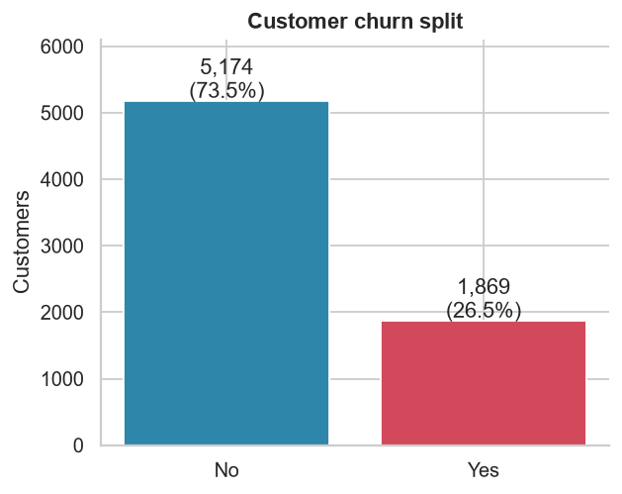
Figure 1 - Churn split

3. What drives churn
Association strength with churn (Cramer's V, all chi-square tests significant except gender and phone service):
feature | cramers_v | highest_churn_level | highest_rate | lowest_churn_level | lowest_rate
Contract | 0.41 | Month-to-month | 43% | Two year | 3%
InternetService | 0.32 | Fiber optic | 42% | No | 7%
PaymentMethod | 0.3 | Electronic check | 45% | Credit card (automatic) | 15%
PaperlessBilling | 0.19 | Yes | 34% | No | 16%
OnlineSecurity | 0.17 | No | 31% | Yes | 15%
TechSupport | 0.16 | No | 31% | Yes | 15%
Dependents | 0.16 | No | 31% | Yes | 15%
SeniorCitizen | 0.15 | Yes | 42% | No | 24%

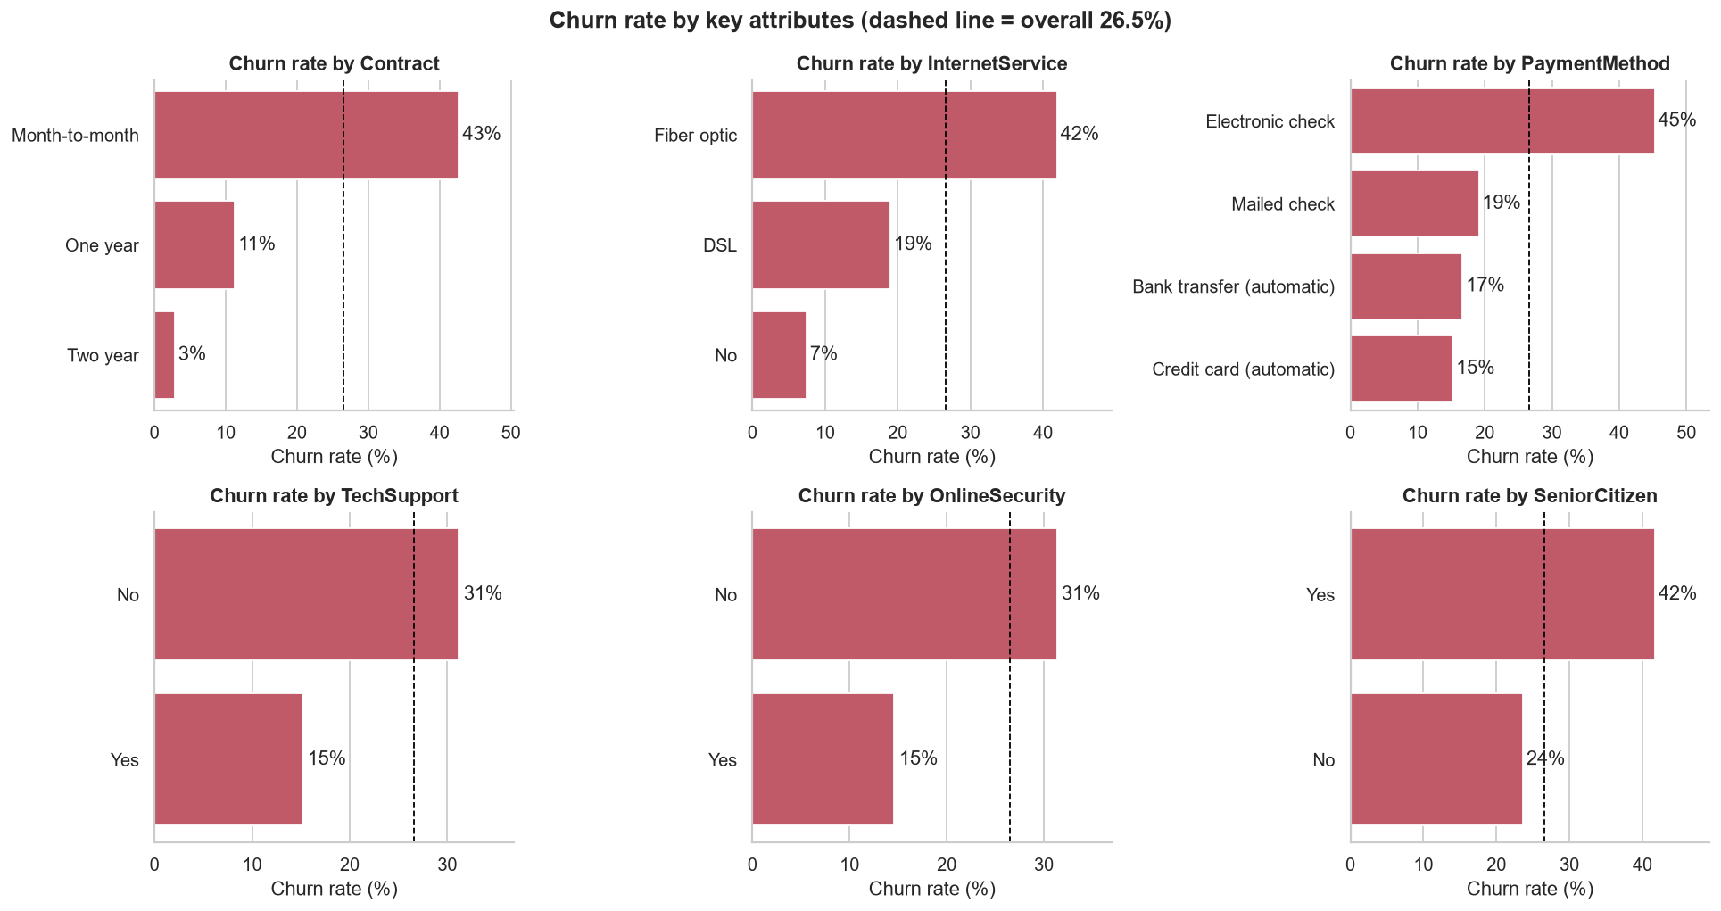
Figure 2 - Churn rate by key attributes
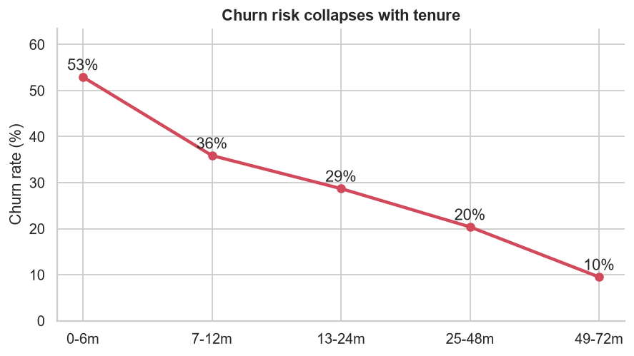
Figure 3 - Churn falls steeply with tenure
- Contract is the strongest driver: month-to-month churns at 43% versus 3% on two-year contracts.
- Fibre-optic customers churn at 42% versus 7% for customers with no internet - a price/quality issue worth investigating.
- Electronic-check payers churn at 45% versus 15% for automatic card payers.
- Customers without Tech Support or Online Security churn about twice as often as those with them.
- Gender and phone service have no meaningful effect.
- Churners have a median tenure of 10 months versus 38 for stayers - risk is concentrated in the first year.
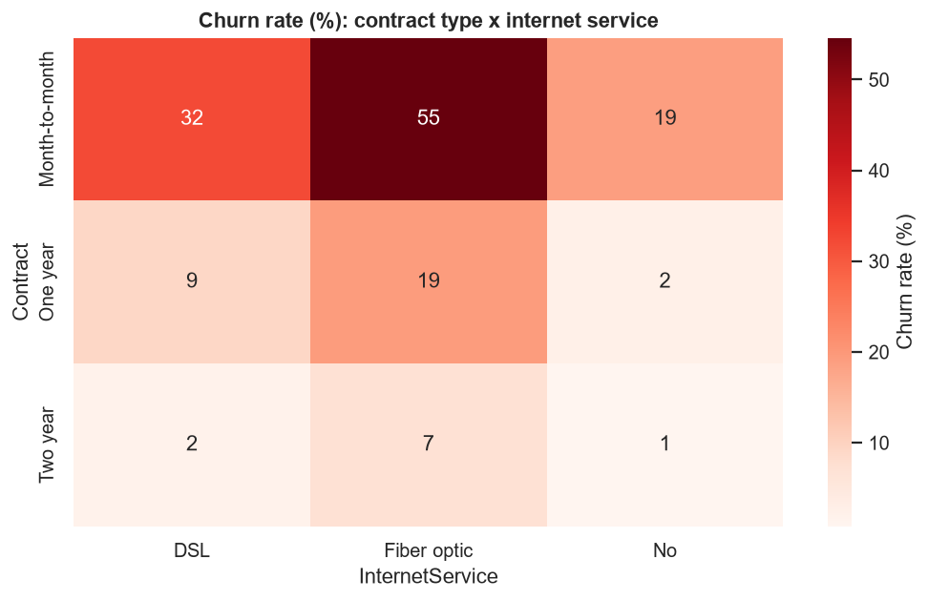
Figure 4 - Contract x internet service

4. Customer segmentation
Because the data has no purchase history, RFM was adapted: Recency = tenure (relationship length), Frequency = number of services held, Monetary = monthly charge. Features were standardised and clustered with K-Means. k=5 was chosen: silhouette scores are close for k=3-6 (about 0.39-0.43), and k=5 is the smallest solution that separates two distinct high-risk groups that k=4 merges.
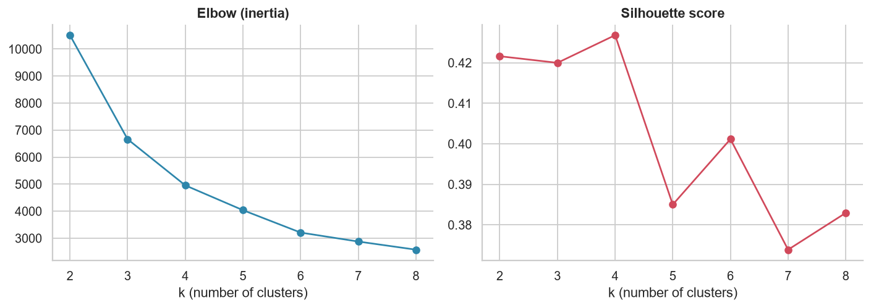
Figure 5 - Choosing k
Segment | Customers | Tenure (m) | Services | Monthly $ | Churn | % of churn | % of rev lost
New Fiber Switchers | 1603 | 10.3 | 3.4 | 67.3 | 47% | 41% | 39%
Mid-Tenure Fiber At-Risk | 1425 | 25.4 | 5.5 | 86.8 | 40% | 30% | 38%
New Budget Starters | 1280 | 10.6 | 1.4 | 25.6 | 21% | 15% | 6%
Premium Loyalists | 1768 | 61.6 | 6.9 | 91.9 | 13% | 12% | 16%
Loyal Basic Savers | 967 | 54.7 | 2.1 | 30.3 | 4% | 2% | 1%

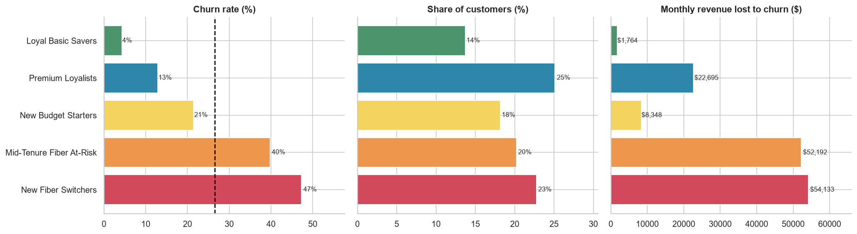
Figure 6 - Segment churn, size and revenue lost
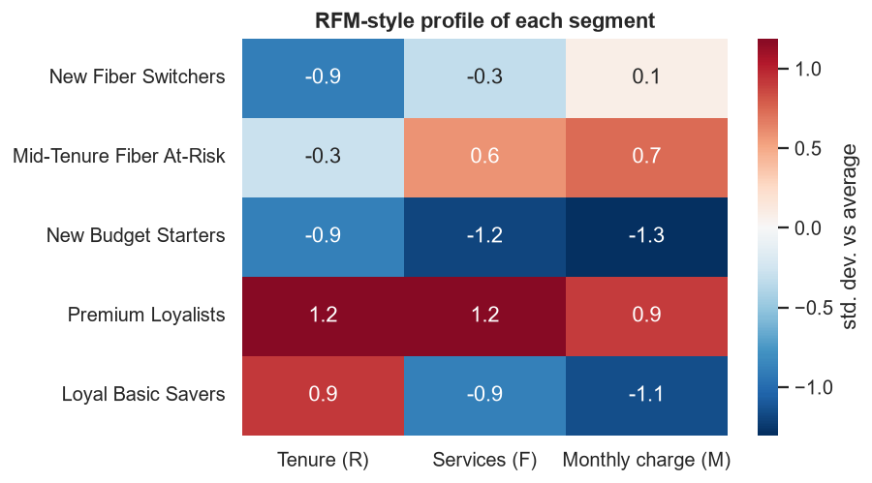
Figure 7 - RFM-style profile (std. deviations from average)

5. Churn prediction model
Four models were trained on a stratified 80% split with 5-fold CV and evaluated on the held-out 20%:
Model | CV AUC | Test AUC | Test PR-AUC | Brier
Gradient Boosting | 0.849 | 0.844 | 0.659 | 0.137
XGBoost | 0.849 | 0.846 | 0.664 | 0.163
Logistic Regression | 0.846 | 0.842 | 0.635 | 0.168
Random Forest | 0.845 | 0.842 | 0.651 | 0.151

All four models perform within about 0.005 AUC of each other, a sign that the signal is mostly captured by contract, tenure and internet service. Gradient boosting had the best CV AUC and best probability calibration (lowest Brier score) and was selected; its out-of-fold probabilities score every customer in the dashboard, so reported risk is not inflated by training on the same rows.
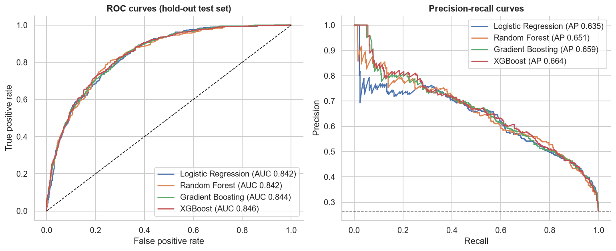
Figure 8 - ROC and precision-recall curves (test set)
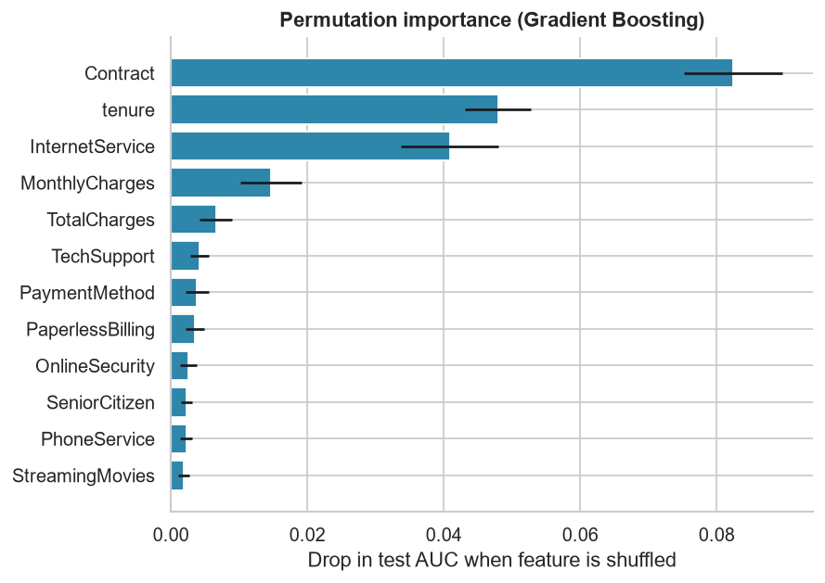
Figure 9 - What the model relies on
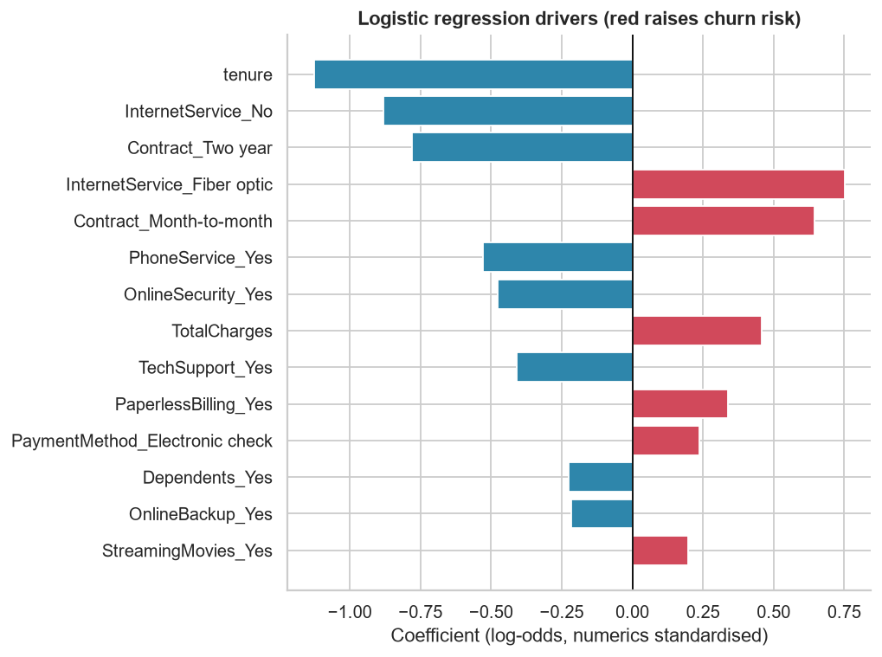
Figure 10 - Logistic regression drivers (interpretable cross-check)
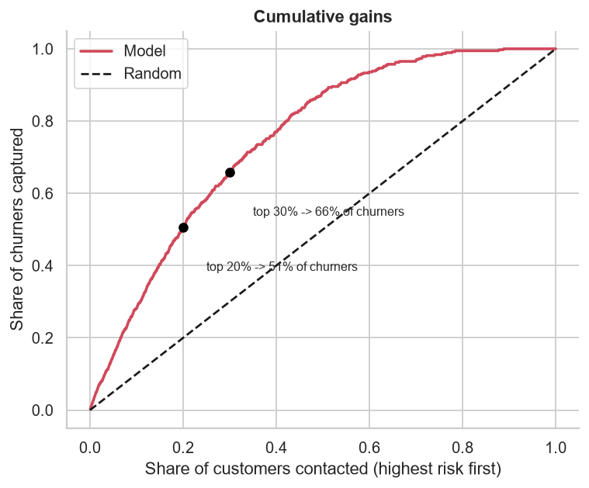
Figure 11 - Cumulative gains

6. Turning predictions into decisions
A default 0.5 cut-off is wrong for retention: missing a churner costs far more than a wasted call. Assuming $40 per outreach, 25% acceptance among would-be churners and 12 months of retained revenue, the net-benefit-maximising threshold (chosen on training out-of-fold scores, not the test set) is 0.18. On the test set this gives precision 47% and recall 87%, and net benefit $44,422 versus $25,285 for contacting everyone. These assumptions are placeholders; replace them with the company's real figures.
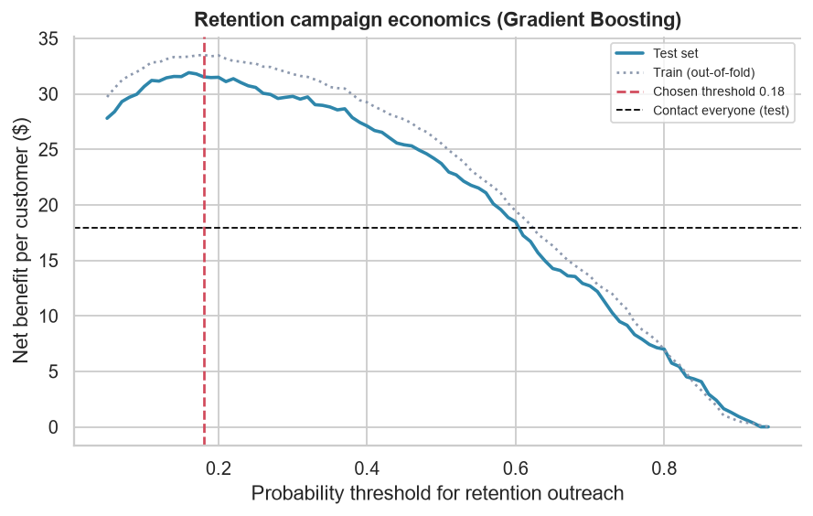
Figure 12 - Net benefit by threshold
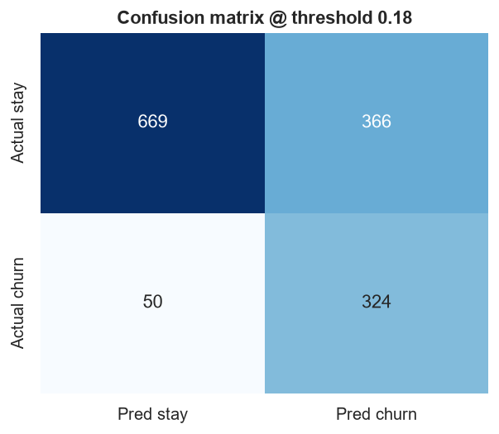
Figure 13 - Confusion matrix at the chosen threshold

7. Who to target and what to do
Priority | Segment | Programme | Action
1 - Critical | New Fiber Switchers | Early-life onboarding | Month-to-month fiber customers in their first year: 47% churn. Run a 90-day onboarding journey, offer a 12-month contract with a bill credit, add free Online Security / Tech Support trial, and move them off electronic check to auto-pay.
2 - Critical | Mid-Tenure Fiber At-Risk | Contract upgrade + service bundling | High-value (~$87/mo) fiber customers, 75% month-to-month, only 37% have Tech Support. Offer price-lock 1-2 year contracts and a bundled security/support add-on; proactive service-quality check for fiber faults.
3 - Nurture | New Budget Starters | Low-cost digital nurture | Low-spend DSL/phone-only newcomers (21% churn). Automated emails/SMS, upsell one add-on, avoid expensive discounts - limited revenue at stake.
4 - Protect | Premium Loyalists | Loyalty and VIP care | Largest revenue pool ($163K/mo) with 13% churn. Protect with loyalty rewards, priority support and renewal reminders; watch the month-to-month minority.
5 - Maintain | Loyal Basic Savers | Maintain | Very sticky (4% churn). No retention spend; occasional cross-sell only.

8. Limitations and next steps
- Snapshot data: no time dimension, so real recency and time-to-churn (survival analysis) cannot be modelled.
- Business assumptions (cost, acceptance rate, months saved) are illustrative; validate with finance/CRM.
- Findings are associations. Run an A/B test of the retention offers (control group vs treated) to measure true uplift, ideally with an uplift model.
- Next: add usage, complaint and support-ticket data; monitor model drift monthly; refresh the target list weekly.

Resume line
Analysed 7,043 telecom customers (Python, Orange, Power BI): identified 2 high-risk segments driving 71% of churn and 76% of lost revenue; built a churn model (AUC 0.85) capturing 51% of churners in the top 20% of customers and proposed segment-specific retention actions.

