Li, Moyan
09/30/2026
Data Analysis of Academic Performance of Engineering Students
Case study 1
Introduction
This report utilizes the connection data of 12,411 engineering students during their high school graduation stage and their university graduation stage, to analyze the relationship between students’ family background, socioeconomic conditions, educational paths and their overall academic performance at the university graduation stage. This article takes the Global Score of Saber Pro (‘G_SC’) as the main outcome variable. The purpose of this study is to identify which student groups are more likely to require additional support and accordingly provide more targeted educational suggestions for students of different engineering majors.
1. Assumptions and data processing
‘G_SC’ is regarded as an indicator of the overall academic performance during the university stage. The original file contains 12,411 rows and 45 columns. All substantive variables have no missing values. The ‘Not sure’ and records coded as ‘0’ in the parental education variables cannot be interpreted as clear educational levels, so they are excluded from the main analysis of parental education levels.

The dataset provides no information on how “SEL” and “SEL_IHE” are constructed, their level-determining thresholds. This paper assumes the validity of the ranking (1 = low socioeconomic status, 4 = high). Given unknown gaps between adjacent ranks, SEL and SEL_IHE are treated as ordinal categorical.
2. Descriptive Statistics
2.1 Numerical descriptive statistics
The complete descriptive statistics of numerical variables are presented in Appendix Table A1. The average score of the overall performance at the graduation stage, ‘G_SC’, is 162.71 points, the median is 163 points, the standard deviation is 23.11 points, the interquartile range is 32 points, and the range of values is from 37 to 247 points. The average scores of the five subjects in the high school stage range from 60.71 points (for civic competence) to 64.32 points (for mathematics). In the general ability section at the graduation stage, quantitative reasoning has the highest average score (77.42), while written communication has the lowest average score (53.70); these individual tests differ from the scale of ‘G_SC’, so they should not be directly compared in terms of superiority or inferiority using the original means.
2.2 Visualize score distributions
Appendix Figure A1 presents the histogram and kernel density curve of ‘G_SC’, the skewness of ‘G_SC’ is -0.095, and the mean is nearly the same as the median, indicating that the overall distribution is close to symmetry.
2.3 Outliers and robust statistics
According to the 1.5 times interquartile range rule of ‘G_SC’, there are 67 records that are below 99 points or above 227 points, accounting for 0.54% of the sample. These values are still within the legal range of this standardized test. Therefore, they were not deleted. As a robustness check, the 5% trimmed mean is 162.84 points, which is only 0.13 points different from the original mean of 162.71 points; the median is also 163 points. This indicates that the central position of the overall scores has not been significantly affected by a small number of extreme scores, and it is reasonable to retain all valid records. See Appendix Table A2 and Figure A2
2.4 Categorical descriptive statistics
Among the sample, there were 7,368 males (59.37%) and 5,043 females (40.63%). The social strata were mainly composed of Stratum 2 (4,029 people) and Stratum 3 (4,045 people); Stratum 6 had only 403 people. The complete frequency table can be found in Appendix Table A3.
3. Compare groups with descriptive statistics
3.1 Association Between Parental Education and Global Academic Performance
From the group means, the correlation shows a clear educational gradient. The average ‘G_SC’ for students whose mothers have postgraduate education is 175.64 points, while for those whose mothers have no education, the average is 149.71 points, and the observed mean difference is 25.93 points; however, the sample size of the latter group is only 34 people, so it should be interpreted with caution. For students whose fathers have postgraduate education, the average score is 176.99 points, while for those whose fathers have no education, the average is 156.63 points, and the observed mean difference is 20.35 points. The average scores of students whose parents have completed professional education are also significantly higher than those of students whose parents have completed secondary education. See more information in Appendix B Table B1 and Figure B1.
Therefore, a higher level of parental education is associated with higher overall academic performance at the graduation stage, but this result cannot prove that parental education itself causes the difference in academic performance. Parental education may also reflect factors such as family income, learning resources, school opportunities and early academic support that have not been fully observed.
3.2 Differences in Global Academic Performance Across Socioeconomic Strata
The association between social class and overall performance is the clearest. One-way ANOVA revealed significant differences in the average ‘G_SC’ among different strata, F = 238.77, p < .001, η² = .104. This indicates that strata are associated with approximately 10.4% of the overall performance variance, with an effect size close to a large level.
From the average performance, Stratum 6 performed the best, with an average ‘G_SC’ of 181.51 points; Stratum 1 performed the worst, at 152.35 points, with a difference of 29.16 points. The scores generally increased from stratum 1 to 6. Tukey HSD post hoc comparisons showed that each pair of comparisons between Stratum 1 and Stratum 6 was significant, with an adjusted p < .001. The group coded as ‘0’ had only 14 people and its meaning was not that of a normal social class, so it should not be used for policy decisions based on its mean. See Table B2, Table B3 and Figure B2.
This result indicates that there is a significant social and economic gradient in educational performance. A more reasonable policy explanation is not to lower expectations for students from lower socioeconomic backgrounds, but to identify and reduce the obstacles they may face in terms of academic support, digital resources and learning environment.
3.3 Gender Differences in Global Score
The average ‘G_SC’ score for male students was 163.69 points, while for female students it was 161.28 points. The result of the Welch independent sample t-test was t = -5.78, p < .001; calculated as “female mean minus male mean”, the average difference was -2.41 points, and Cohen's d = -0.105.
Given the large sample size, this very small mean difference still achieved statistical significance; however, |d| = 0.105 is less than the usual reference value of 0.20 for small effects. Therefore, it is not recommended to make general resource allocation or ability judgments based on gender. To further understand the gender differences, further checks should be conducted in specific ability subjects and different engineering specialties, rather than expanding the interpretation of the minor difference in overall scores. See Table A4 and Figure B3.
3.4 Interesting discovery: Differences in global scores among students in different projects and recommendations
In addition to the above findings, this sample also reveals that there are differences in the average ‘G_SC’ among different engineering disciplines. After retaining 13 disciplines with a sample size of no less than 30 people, the differences between the disciplines were significant. The average score was the highest in Chemical Engineering, followed by Electrical and Mechanical Engineering. See Table B5 and Figure B4 for more information.
Based on the above results, it is recommended that universities adopt a targeted support plan: establish ability diagnoses based on specific majors instead of distributing resources solely based on overall rankings. For majors such as industrial engineering, civil engineering, etc., where there are a large number of students and a relatively low average score, the specific distribution of QR_PRO, CR_PRO, etc. should be checked first, and then corresponding courses should be arranged to strengthen the deficiencies. High average score majors can be used as an experience reference, but it should not be assumed that their practices can be directly replicated in all majors.
Conclusion
The core conclusion of this report is that there is a systematic correlation between the overall academic performance of engineering students during their graduation stage and their socio-economic environment. There are significant differences in ‘G_SC’ between parents' educational attainment, stratum, the individual socio-economic level of the students, and the socio-economic level of the higher education institutions. Among them, the association between stratum and the institutional socio-economic level is particularly prominent. In contrast, the actual magnitude of the overall gender differences is very small and should not be the main basis for resource allocation or the judgment of students' abilities. Moreover, the average academic performance of different engineering majors is indeed different, but this cannot simply be attributed to the teaching quality of a particular major or school. Therefore, it is recommended that the education department implement a monitoring mechanism that stratifies resources by profession, ability domain, and student background.
References
Delahoz-Dominguez, Enrique, Rohemi Zuluaga, and Tomas Fontalvo-Herrera. “Dataset of Academic Performance Evolution for Engineering Students.” *Data in Brief*, vol. 30, 2020, article 105537. *ScienceDirect*, https://doi.org/10.1016/j.dib.2020.105537
Appendix A. Descriptive Statistics and Diagnostic Figures
Table A1 Numerical descriptive statistics
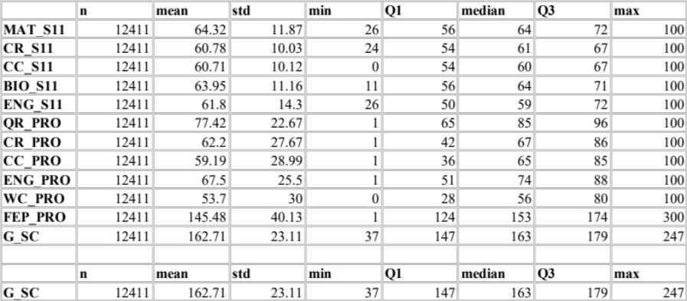
Table A2: Global Score Robust Statistics and Outlier Check
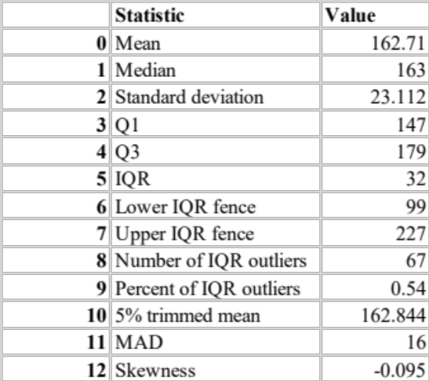

Table A3: Categorical descriptive statistics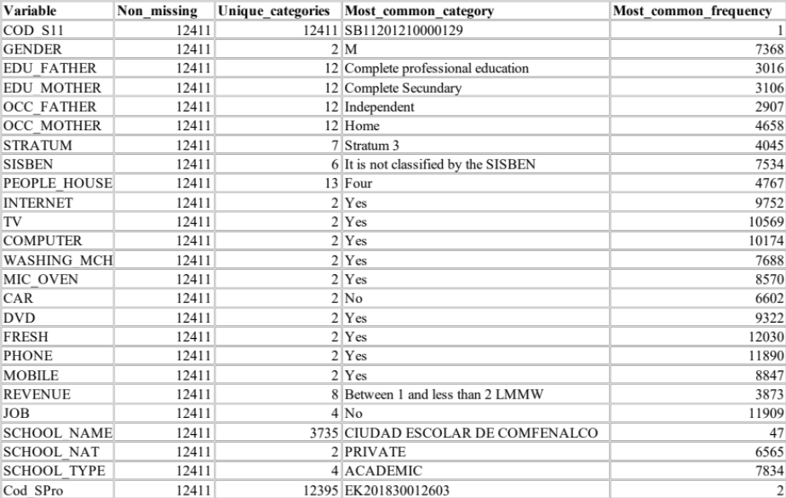
Figure A1: Distribution of Global Score
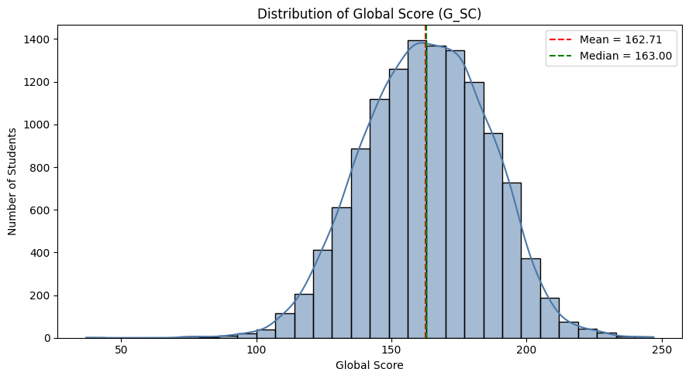
Figure A2: Boxplot of Global Score
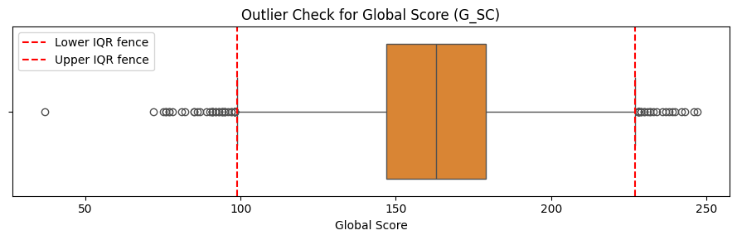
Appendix B. Group Comparisons
Table B1. Global Score by Parental Education Level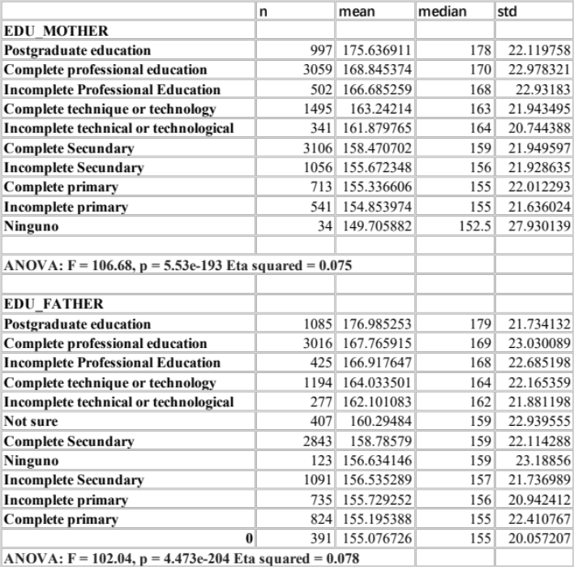

Table B2 Global Score by Socioeconomic Stratum
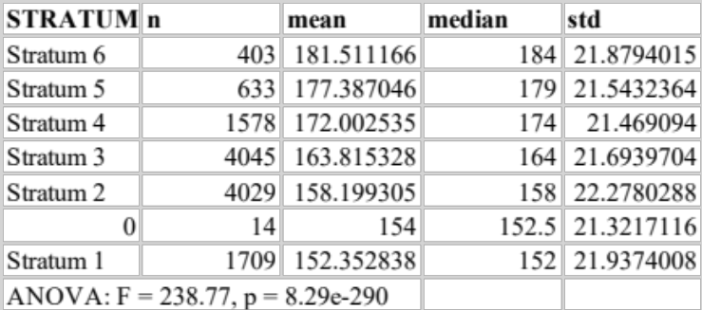

Table B3: Tukey HSD Pairwise Comparisons for Stratum
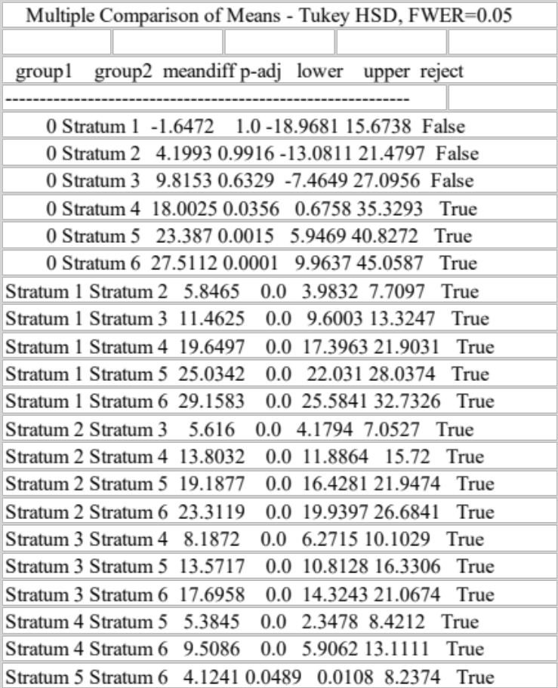

Table B4. Global Score by Gender
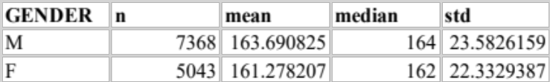

Table B5: Global Score by Academic Program
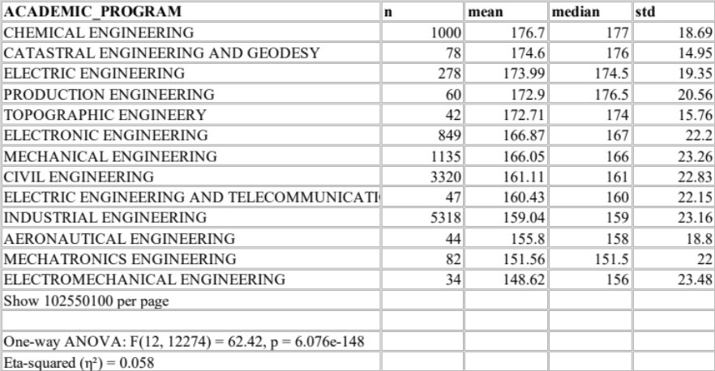

Figure B1. Mean Global Score by Maternal and Paternal Education
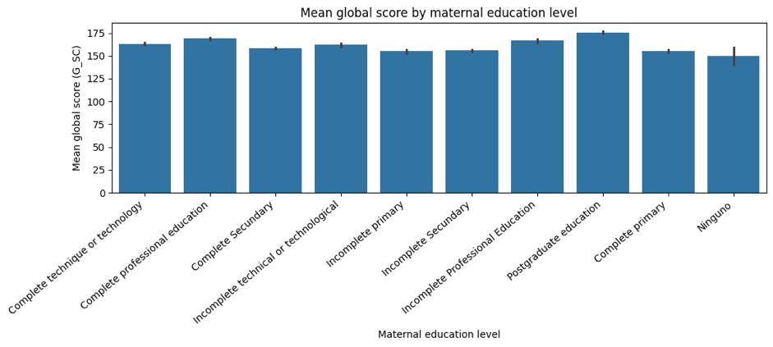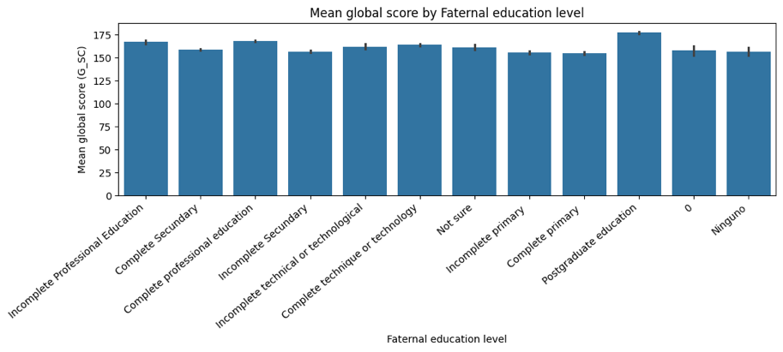
Figure B2: Mean Global Score by Stratum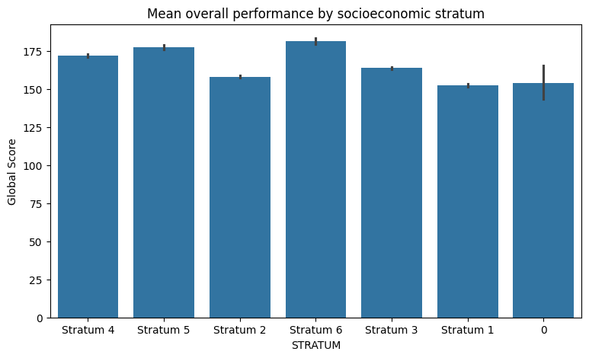
Figure B3. Mean Global Score by Gender
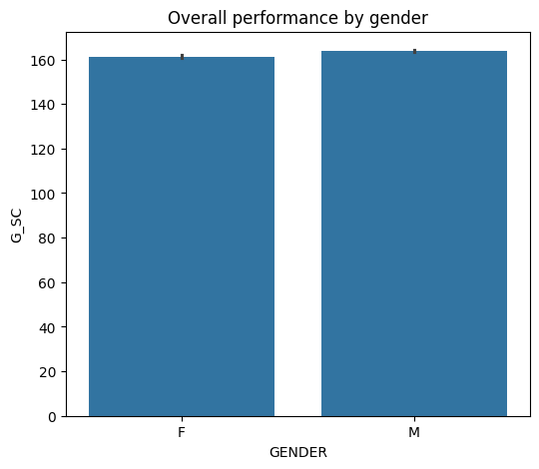
Figure B4: Mean Global Score by Academic Program
