

Department of Electrical and Computer Engineering North South University

Senior Design Project

FX Fusion - Multi-Source Financial Time-Series Forecasting with Risk Modeling

Rifat Hossain Khan, Id: 1520240042
Sajidul Abedin, Id: 2131586642
Mahfuz Ahmed Nirob, Id: 2011724042

Faculty Advisor:
Dr. Mohammad Rashedur Rahman Professor
ECE Department Spring, 2026

APPROVAL

Rifat Hossain Khan (1520240042), Sajidul Abedin (2131586642) and Mahfuz Ahmed Nirob (2011724042) from Electrical and Computer Engineering Department of North South University, have worked on the Senior Design Project titled “FXFusion : Multi-source Time Series Forecasting with Risk Modeling” under the supervision of Dr. Mohammad Rashedur Rahman partial fulfillment of the requirement for the degree of Bachelors of Science in Engineering and has been accepted as satisfactory.

Supervisor’s Signature

……………………………………. Dr. Mohammad Rashedur Rahman Professor
Department of Electrical and Computer Engineering North South University
Dhaka, Bangladesh.

Chairman’s Signature

…………………………………….

Dr. Mohammad Abdul Matin Professor
Department of Electrical and Computer Engineering North South University
Dhaka, Bangladesh.

DECLARATION

This is to declare that this project is our original work. No part of this work has been submitted elsewhere, partially or fully, for the award of any other degree or diploma. All project-related information will remain confidential and shall not be disclosed without the formal consent of the project supervisor. Relevant previous works presented in this report have been properly acknowledged and cited. The plagiarism policy, as stated by the supervisor, has been maintained.

Rifat Hossain Khan, Id: 1520240042
Sajidul Abedin, Id: 2131586642
Mahfuz Ahmed Nirob, Id: 2011724042

ACKNOWLEDGEMENTS

The authors would like to express their heartfelt gratitude towards their project and research supervisor, Dr. Mohammad Rashedur Rahman [RRn], Professor, Department of Electrical and Computer Engineering, North South University, Bangladesh, for his invaluable support, precise guidance and advice pertaining to the experiments, research and theoretical studies carried out during the course of the current project and also in the preparation of the current report.
Furthermore, the authors would like to thank the Department of Electrical and Computer Engineering, North South University, Bangladesh for facilitating the research. The authors would also like to thank their friend Md Raquib Hassan for aiding in this project and their loved ones for their countless sacrifices and continual support.
TABLE OF CONTENTS
APPROVAL 1
DECLARATION 2
ACKNOWLEDGEMENTS 3
LIST OF FIGURES 6
LIST OF TABLES 7
ABSTRACT 8
Chapter 1 Introduction 9
  - Background and Motivation 9
  - Purpose and Goal of the Project 11
Chapter 2 Research Literature Review 12
  - Existing Research and Limitations 12
    - Traditional Econometric Models for Volatility and Correlation 12
    - Deep Learning and Financial Forecasting 13
    - Event-Driven Financial Forecasting 14
    - Research Gap 14
Chapter 3 Methodology 17
  - Data Collection 17
    - Currency Price Data 18
    - Economic Indicator Data (Calendar Data) 19
    - Google BigQuery Event-Based Data (GDELT) 19
    - Final Dataset Alignment 25
    - Hybride Deep Learning Forecasting Framework…………………………………..25
  - Data Preprocessing 26
  - Economic Modelling 28
    - Modeling Volatility: GARCH (ARCH → GARCH) 28
    - Time-Varying Correlations: DCC-GARCH 29
  - Hybrid Deep Learning Architectures 31
    - Hybrid Model 1 — DCC-GARCH + TFT 31
    - Hybrid Model 2 — DCC-GARCH + PatchTST 35
Chapter 4 Investigation/Experiment, Result, Analysis and Discussion 36
  - Experimental Design Overview 36
  - Dataset and Features 36
    - Feature Categories 36
    - Target Variable 37
    - Train/Validation Split 37
  - Training Procedure 37
    - Software Environment 38
    - Training Configuration 39
  - Currency Group Design 39
  - Baseline Models For Comparison 40
    - ARIMA 40
    - GARCH with GDELT Features 40
    - DCC-GARCH (Dynamic Conditional Correlation) 40
    - Standalone TFT (Temporal Fusion Transformer) 41
    - Standalone PatchTST (Patch-based Time Series Transformer) 41
  - Evaluation Metrics 41
    - Mean Absolute Error (MAE) 41
    - Root Mean Square Error (RMSE) 41
    - Directional Accuracy 42
    - Multi-Quantile Loss (MQLoss) 42
Chapter 5 Results, Analysis, and Discussion 43
  - Training Convergence 43
  - Predictive Performance 44
  - Loss Function and Risk Interpretation 45
    - What the Three Quantiles Mean 45
  - Economic and Trading Implications 46
    - Russia-Ukraine Conflict Escalation — February 24, 2022 46
    - UK Gilt Market Crisis — September 28, 2022 47
    - Silicon Valley Bank Collapse — March 10, 2023 48
    - Summary of Event Performance 49
  - Limitations 50
Chapter 6 Project Planning and Budget 51
  - Project Planning 51
  - Estimated Budget 52
  - Resource Utilization 53
Chapter 7 Complex Engineering Problems and Activities 54
Chapter 8 Conclusions 59
  - Limitations 60
  - Future Work 60
References 62
LIST OF FIGURES

Figure 1: Price Return Data 19
Figure 2: Price Return and Volatility Mapping 19
Figure 3: BigQuery Execution Graph 24
Figure 4: Impact Visualization 28
Figure 5: VECM Residuals (AUDCAD, NZDCAD, AUDUSD) 28
Figure 6: 3D Volatility Surface 29
Figure 7: GARCH Volatility 30
Figure 8: Standard GARCH Volatility Mapping 30
Figure 9: Temporal Fusion Transformer (TFT)Data Flow 34
Figure 10: Patch-TST Data Flow 35
Figure 11: Feature Distribution Pie & Bar Chart 37
Figure 12: Training Loss Convergence — All 18 Currency Groups Overlaid 43
Figure 13: MAE and RMSE Comparison — All Models Side-by-Side 45
Figure 14: Predicted Median vs Actual Sigma — EURCAD / GBPCAD / USDCAD Group 49

LIST OF TABLES
Table 1: Calendar Table 20
Table 2: Goldstein Scale 21
Table 3: Feature Categories 36
Table 4: Model Parameters 38
Table 5: Currency Group Table 39
Table 6: Per-Group Test-Set Performance for Hybrid TFT + DCC-GARCH 45
Table 7: Quantile Output Calibration Metrics — Test Set 46
Table 8: Model Performance on Russia-Ukraine Invasion Date (2022-02-24) 47
Table 9: Model Performance During UK Gilt Crisis Peak (2022-09-28) 47
Table 10: Model Performance During SVB Collapse (2023-03-10) 48
Table 11: Event-Level Performance Summary Across Three Major Market Stress Periods 49
Table 12: Project Planning 51
Table 12: Estimated Project Cost 52

ABSTRACT
Predicting the FX market has been challenging over time because of the complex nature of the currency behavior, which is often nonlinear, high dimensional, and regime-dependent. This paper presents an innovative model called FX Fusion, which involves the combination of DCC-GARCH econometric models with the Temporal Fusion Transformer (TFT) and PatchTST deep learning models to predict FX volatility and returns for 27 currencies, which are grouped into 18 categories. FX Fusion is built on a different premise: that currency markets are not just mathematical processes, but living systems driven by human events. Our framework fuses two worlds that have long operated in isolation. On one side, the statistical rigour of DCC-GARCH, which captures how volatility clusters and how currency pairs move together during market stress. On the other hand, the pattern-recognition intelligence of Transformer-based deep learning, specifically the Temporal Fusion Transformer (TFT) and PatchTST, can discover non-linear dependencies across long time horizons that no equation could explicitly describe. What makes this architecture genuinely novel is what it sees. Beyond price data, the system ingests macroeconomic calendar events — rate decisions, inflation releases, employment shocks — and 73,980 days of global news intelligence sourced from GDELT via Google BigQuery. When sanctions are imposed, when diplomatic relations collapse, when a central bank surprises markets, that signal enters the model as a quantitative feature before it ever appears in a price chart. The result is a 948-feature multimodal dataset spanning 15 years of market history across 27 major currency pairs.

Keywords:
Temporal Fusion Transformer (TFT), Hybrid deep learning model, DCC-GARCH, Volatility modeling, Dynamic conditional correlation, Foreign exchange (FX), Major currency pairs, Economic calendar, Google BigQuery, Multivariate time series, Risk-aware forecasting

Introduction

Background and Motivation

The foreign exchange market (FX market) is the biggest and the most liquid of all financial markets in the world with daily transactions reaching more than $7 trillion dollars per day. Currency valuation is extremely volatile to any external shock like geopolitical or economic news. It responds instantly to any announcement related to macroeconomic events like the report on inflation rate, unemployment rate, monetary policies such as interest rates, forward guidance and geopolitical situations that might lead to the downfall of whole currency zones in just a matter of minutes. It is also highly sensitive to geopolitical events like wars and foreign policies. With the constant response of the FX market to news around the world, exchange rate forecasting becomes both extremely challenging and unpredictable. It is hard to study Forex when exchange rates because the value of currency can shift in the blink of an eye due to multiple factors like we stated. Also because of that, predicting changes in exchange rates is very difficult, but it is extremely important for international trade and risk management; foreign exchange markets affect national foreign reserve management, the functioning of business and even the choice of investment by individuals.

For decades, the classic models for financial time series analysis have been the ARIMA, GARCH and DCC-GARCH models. These models are very efficient when it comes to measuring market risk in the past, capturing market volatility and highlighting any dynamic relationship between currency pairs. Specifically, DCC-GARCH can deliver valuable insights into the propagation of shocks and risks among various currencies. But their basic drawback is that they use only the past price action and numbers from the market. This makes them unable to comprehend or respond to events in the real world, including political news, central bank statements or unforeseen economic reports. A purely mathematical model such as GARCH, for instance, would not be able to predict an ensuing increase in volatility if a sudden geopolitical crisis or a surprise inflation report caused a dramatic market reaction; the model would have no knowledge of the event. This constraint makes the traditional model less effective in the modern fast-paced financial markets where news and external shocks can cause the movement of the currencies.
Recent advances in deep learning, particularly Transformer-based architectures, have substantially expanded the frontier of financial forecasting. These models are highly effective at discovering nonlinear patterns in large sequential datasets and at capturing long-range temporal dependencies that traditional models systematically miss. Nevertheless, most standalone AI forecasting models still operate exclusively on numerical price data, sharing the same fundamental limitation as their econometric predecessors. A robust forecasting system must therefore bridge this divide, fusing the mathematical risk-tracking precision of econometric models with the pattern-recognition power of deep learning, while simultaneously incorporating macroeconomic calendar events and global news sentiment as active inputs. In this paper we study the foreign currency’s price action and their correlation by combining DCC-GARCH and state of the art architecture model - Temporal Fusion Transformer (TFT) model for capturing the external events and their influence over the currencies prices.
Transformer models are able to detect nonlinearities within large sequential data and to model long-term dependencies has proven extremely useful for such tasks. Still, almost all AI-powered forecasting models continue to rely solely on quantitative price data, and hence suffer from the exact same inherent flaw as their statistical counterparts. An effective forecasting system will thus need to merge these two approaches, combining the ability of mathematically accurate statistical models to monitor risk factors, and the ability of deep learning models to detect patterns, in tandem with global news and macroeconomic calendars.

Purpose and Goal of the Project

The purpose of this project is to develop a method to forecast exchange rates of currencies. We want to combine two approaches: the Temporal Fusion Transformer (TFT), which is an intelligent system that forecasts, and the DCC-GARCH (Dynamic Conditional Correlation-Generalized Autoregressive Conditional Heteroskedasticity) model, which is the statistical model that helps to understand the time-varying nature of financial volatility and cross-currency correlations.

The main contributions of this work are as follows:
    - A unified 948-feature multimodal dataset (73,980 rows, 2010–2025) aligning daily FX price data, DCC-GARCH conditional volatility outputs (27 sigma + 162 rho columns), macroeconomic calendar surprise features, and GDELT global event-sentiment signals across 27 currency pairs.
    - A hybrid DCC-GARCH + TFT architecture where the 27 GARCH conditional volatility series are fed directly as future exogenous inputs (futr_exog_list) to the Transformer, enabling the model to condition on calibrated econometric risk context alongside live GDELT event intelligence.
    - Application of Multi-Quantile Loss (MQLoss) at quantiles [0.10, 0.50, 0.90] to generate calibrated probabilistic risk boundaries, producing output names -lo-80.0, -median, and -hi-80.0 per step.
    - Successful training and validation of 18 independent TFT models across 18 structurally designed currency groups covering the full 27-pair FX universe, achieving a final validation MQLoss of 0.0154 with stable convergence across all groups.

Chapter 2 Research Literature Review

Existing Research and Limitations

In this chapter, an analysis of current literature related to three interlinked fields of study – volatility modeling through econometrics, deep learning for financial forecasts, and multi-source event-driven approach – will be conducted before highlighting the particular research gap addressed by the proposed model.
    - Traditional Econometric Models for Volatility and Correlation
Econometric time series models have been employed for many years to make predictions, estimate volatility, and analyze market risk. Prior to using any prediction model, it is imperative to investigate the stationarity of financial time series. The Augmented Dickey-Fuller test is among the popular tests that can be used to identify unit roots and stationarity in economics and finance [1]. In cases where several non-stationary time series are cointegrated, it is important to conduct the cointegration analysis.
Cointegration analysis of multivariate time series has been provided by Johansen [2].

Where there is co-integration among variables, the Vector Error Correction Model is suitable because it takes care of short-term and long-term dynamics in the variables. This model along with others mentioned above forms the basis of modern financial time series analysis and is used extensively in macroeconomic studies and foreign exchange research [7], [8].

Volatility modeling represents another important area of financial forecasting. Financial returns often exhibit volatility clustering, where periods of high volatility tend to be followed by further periods of high volatility. To model this phenomenon, Engle introduced the Autoregressive Conditional Heteroskedasticity (ARCH) model [4], which was later extended into the Generalized ARCH (GARCH) framework by Bollerslev [5]. GARCH-based approaches have become standard tools for estimating time-varying volatility in financial markets and have been successfully applied to exchange-rate forecasting and risk management applications [15].

Financial forecasting also includes modeling of volatility. The reason is that financial return series frequently display the tendency for volatility clustering – that is, periods of high volatility are usually preceded by other high volatilities. For modeling such behavior, Engle proposed the Autoregressive Conditional Heteroskedasticity (ARCH) approach [4], which later became known as the Generalized Autoregressive Conditional Heteroskedasticity (GARCH) method developed by Bollerslev [5]. GARCH models are commonly used for measuring time-varying volatility and forecasting exchange rates [15].

While classical economic models are efficient in capturing the behavior of volatility and correlation structures, they mainly depend on past numerical data and statistical assumptions. These models find it difficult to adapt to the nonlinear dynamics that are inherent in today’s foreign exchange markets.

    - Deep Learning and Financial Forecasting
The growing complexity of the financial market has driven scientists to consider deep learning techniques, which can handle nonlinear relationships and long-term dependencies that cannot be well modeled using standard econometric methods. In contrast to statistical models that make predetermined assumptions, deep learning models learn hierarchical structures by training themselves directly from massive financial data. Initial research into finance-based forecasting used Recurrent Neural Networks (RNNs) and LSTM neural networks in order to capture patterns in sequential behavior within markets. While these methods showed success in improving upon the traditional forecasting techniques used previously, there were difficulties when it came to handling long sequences [9]. Recent developments in Transformer architecture have greatly enhanced the performance of forecasting time series. Transformers incorporate self-attention layers that enable the model to pay attention to the most significant points within long sequences of history. This makes them well suited to financial forecasting since correlations could be found in distant time points [10].In Transformer forecasting models, the Temporal Fusion Transformer (TFT) is one of the leading architectures that have gained popularity due to their high level of interpretability and ability to perform multihorizon forecasting. Through its combination of recurrent layers, variable selection networks, gates, and multihead attention networks, the TFT architecture provides both forecasting accuracy and interpretability in predicting the relative importance of input variables. The TFT architecture is especially suitable for use in finance because of its diverse data sources. Recent studies have additionally provided further evidence regarding the effectiveness of the Transformer model in volatility and risk forecasting. Studies comparing different methods reveal that the Transformer model is more efficient than econometric models during turbulent times due to its ability to learn non-linear relations from high-dimensional data [13]. While all this is true, it has been observed that most deep learning prediction models depend heavily on historical market data and technical analysis indicators. This means that event-based data, which may be crucial for predicting forex market movements, is largely ignored by most prediction models.

    - Event-Driven Financial Forecasting
The financial market is highly sensitive to external factors, such as economic news, central banks' actions, geopolitics, trade talks, inflation numbers, employment data, and other international incidents. For this reason, there has been growing interest in event-driven forecasting methodologies that incorporate external information into predictive modeling. The economic calendar database presents well-structured data about planned macroeconomic events. Decisions on interest rates, inflation, gross domestic product, purchasing managers’ index, and employment statistics tend to trigger substantial movements in foreign exchange markets. Integrating these elements in the forecasting model would help the model capture such events and their impacts on future forecasts. Besides structured economic measures, there are databases for large events that have become useful sources of data regarding geopolitical and sentiment factors. One such example is the Global Database of Events, Language, and Tone (GDELT), which serves as an updated source for world news events, sentiment measures, relations between actors, and measures of event seriousness. Through large scale media monitoring and event extraction, GDELT turns unstructured news media into structured data. Indicators of events based on data from the GDELT database, including Goldstein score, frequency, coverage measure, and sentiment scores, have been frequently used for investigating the linkages between geopolitical events and financial markets. The above-mentioned features can supply additional context which is impossible to obtain based on prices only [11]. New studies on forecasting volatilities using machine learning frameworks have shown how valuable an approach based on the integration of events is for improving robustness in times of financial distress and uncertainty [12]. Also, new studies on forecasting volatilities by means of Transformers have proven the importance of the inclusion of external sources of data [13]. This evidence indicates that event-driven prediction models are more beneficial than those based on prices because they utilize actual world knowledge that affects investor decisions.

    - Research Gap
There is ample evidence of advancement in three important areas of research. To start with, econometric methods like ARCH, GARCH, and DCC-GARCH models have been found very useful in volatility measurement, correlation modeling, and risk management tasks [4], [5], [6]. Secondly, sophisticated deep learning networks like TFT and PatchTST have set a benchmark for superior forecasting by effectively capturing complex temporal relationships in the data sequence [9], [10], [13]. Finally, event-driven forecasting research indicates that macroeconomic and geopolitical events can be used as contextual variables for forecasting purposes [11], [12].

Nevertheless, there are still some limitations that exist in current research. Econometrics models have proven to be quite efficient in volatility estimation statistically; however, their capacity for learning non-linear market dynamics and handling big event datasets is limited [6]. On the contrary, most deep learning algorithms concentrate mostly on past market data and do not use advanced volatility models like DCC-GARCH [9] [10]. Moreover, event-driven research often deals with additional events separately without using them together with econometrics and deep learning models [11]. Clearly, a gap in research emerges in the area of building an integrated forecasting framework that is capable of jointly modeling the aspects of market volatility, nonlinear relationships, and event-driven market dynamics. With a view toward filling this gap, this study introduces a new hybrid framework for forecasting foreign exchange rates using a combination of volatility modeling with DCC-GARCH, forecasting models with Transformers (TempFusion Transformer and PatchTST), economic calendar data, and event-driven intelligence from GDELT.

In order to overcome the above shortcomings, an event-driven machine learning framework that combines market information and real-world event information is developed. The proposed model processes 303 features, among which: historical exchange rate data, volatility measures, trading activity indicators, unstructured global event sentiment, geopolitical risk signals, economic event indicators, and country-level interaction variables. These features are created using financial market data as well as from the Google BigQuery Global Database of Events, Language, and Tone (GDELT), which gathers information about global news events and sentiment in massive quantities. The model is able to incorporate numerical market variables and event driven information, so as to account for external shocks, which are not effectively understood by traditional statistical approaches.

This project entails important technical developments to enhance the forecasting of FX market risk in both statistical and real-world event settings.

- Designed a hybrid modeling approach that integrates both statistical volatility structure and nonlinear temporal dependencies, based on the combination of DCC-GARCH and deep learning architectures (TFT).

- Built a unified dataset by combining historical price data with GDELT derived global event sentiment and economic calendar elements, to facilitate event-aware financial modelling.

- The model was tested in the market over 18 different currency groups, thus showing strong generalization and stability across various FX markets worldwide.

Chapter 3 Methodology

Data Collection

- The Price Dataset- This comprises historical foreign exchange market data, which includes OHLC prices, volume, and return/volatility measures of various major currency pairings in the forex market. The price dataset serves time series forecasting, volatility analysis, and correlation studies.

- Economic Calendar Dataset- The dataset contains scheduled releases of macroeconomic and financial information, which include interest rate announcements, inflation announcements, GDP releases, employment reports, central bank announcements, and any other economic calendar events. The forecast model will use the variables for macroeconomics, because we want to account for any influence that economic news may have on currencies.
- GDELT Dataset- The GDELT database is a tool utilized to collect global news events, geopolitical developments, sentiment information, and international signals related to events that might influence market behavior. GDELT generates event intelligence and contextual information from news that allows the forecasting tool to gain insight on a more comprehensive perspective of global market sentiment and geopolitical.
    - Currency Price Data

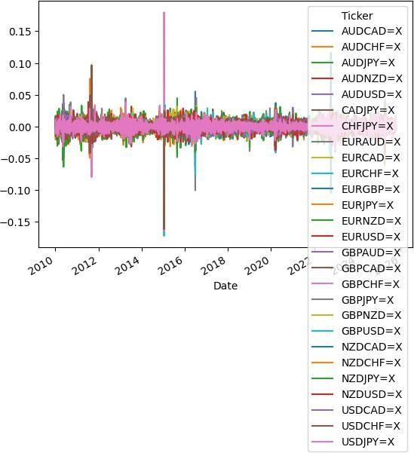

Figure 1: Price Return Data

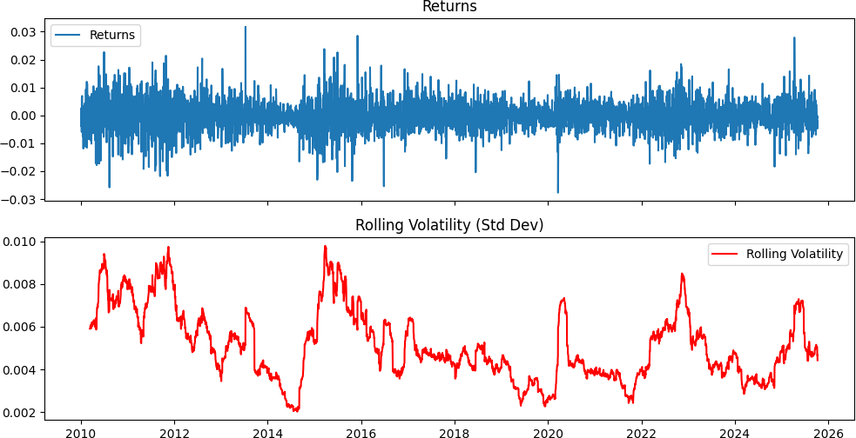

Figure 2: Price Return and Volatility Mapping
    - Economic Indicator Data (Calendar Data)
A good number of platforms offer very detailed economic calendar news, such as TradingView, Forex Factory, Investing.com, FXStreet, and DailyFX, each with an economic calendar of major economic releases and market events. Econoday also has a comprehensive global economic calendar that details economic news from various countries and regions. These platforms allow for the monitoring of key events like inflation figures, interest rate announcements, job reports, GDP releases, purchasing managers' indices (PMI), and more to help market participants prepare for market volatility and make educated trading and risk-management decisions. The study is based on data from 2013 to 2024, which includes each observation's time stamp.

Name | Type
TradingView | Economic Calendar
Forex Factory | Economic Calendar
Investing.com | Economic Calendar
FXStreet | Economic Calendar
DailyFX | Economic Calendar
Econoday | Global Economic Calendar

Table 1: Calendar Data

These indicators proxy macro-fundamental information entering FX pricing

3.1.3 Google BigQuery Event-Based Data (GDELT)
Gdelt project : https://www.gdeltproject.org/

Monitoring nearly the entire world's news media is only the beginning - even the largest team of humans could not begin to read and analyze the billions upon billions of words and images published each day. GDELT uses some of the world's most sophisticated computer algorithms, custom-designed for global news media, running on "one of the most powerful server networks in the known Universe", together with some of the world's most powerful deep learning algorithms, to create a realtime computable record of global society that can be visualized, analyzed, modeled, examined and even forecasted. A huge array of datasets totaling trillions of data points are available. Three primary data streams are created, one codifying physical activities around the world in over 300 categories, one recording the people, places, organizations, millions of themes and thousands of emotions underlying those events and their interconnections and one codifying the visual narratives of the world's news imagery

GoldsteinScale measures event impact/severity: Large negative → conflict / instability / shocks
Large positive → cooperation / stability

Event Type | Typical Goldstein
Military conflict, Wars | -8 to -10
Sanctions / threats / Inflation | -5 to -7
Diplomatic cooperation | +3 to +7
Peace agreements | +6 to +10

Table 2: Goldstein Scale

Date(d):2013-01-01
This is the calendar day we’re summarizing.
Ticker:EURCAD=X Treating this pair as:
Base side = EUR proxy (in our mapping we used Germany = DEU as “EUR”) Quote side = CAD (Canada = CAN)
So the features compare DEU vs CAN on that day.

- Event counts (how many “shock events” involved each side) base_shock_events = 50

On 2013-01-01, there were 50 GDELT Events where the base country (DEU) appeared as Actor1 or Actor2 and the event’s GoldsteinScale
≤ threshold (strong negative).

quote_shock_events = 165
Same definition, but for Canada (CAN) → 165 shock events that day.

shock_events_diff = -115
50 - 165 = -115
Meaning: Canada had 115 more shock events than Germany that day (under your severity filter).

Interpretation for FX: more negative shock pressure on the quote side vs base side.

- Goldstein severity (how “bad” those shock events were on average)

base_avg_goldstein = -7.61
Among Germany’s 50 shock events, the average severity was −7.61 (very negative)
quote_avg_goldstein = -7.7315…
Among Canada’s 165 shock events, average severity was −7.73 (slightly more negative).
avg_goldstein_diff = 0.1215…
-7.61 - (-7.7315) = +0.1215
Because the quote side is slightly more negative, the diff becomes positive.
Interpretation: both sides had severe negative events, but Canada’s were a bit worse on average.

- Tone (media tone around those events) base_avg_tone = 2.898
The average tone for Germany shock events was positive-ish (tone can be positive even if Goldstein is negative — they measure different things).

quote_avg_tone = 2.1066
Canada’s average tone was still positive but less.
avg_tone_diff = 0.7915
Germany’s tone was 0.79 higher than Canada’s.

Tone ≠ severity.
Goldstein = event impact on stability. Tone = sentiment/wording of coverage.

- Mentions / Articles (how much attention those events got) base_mentions = 351
Sum of NumMentions over Germany’s shock events that day.

quote_mentions = 1193 Same, but for Canada mentions_diff =-842
Canada got 842 more mentions of shock events than Germany.
base_articles = 351, quote_articles = 1166
Sum of NumArticles over shock events; Canada’s shock events were in far more articles.
Interpretation:
Canada had far heavier “negative shock” coverage volume that day. These numbers can look surprisingly large because:
GDELT counts global media mentions, not “events in that country only” We count exposure: if the country appears as Actor1/Actor2, it’s counted. The same real-world situation can create many coded events and many mentions So this dataset is measuring news-coded geopolitical pressure.
Interpretation:
For each pair/day we have:
Relative shock pressure: shock_events_diff, mentions_diff, articles_diff Relative severity: avg_goldstein_diff
Relative sentiment: avg_tone_diff
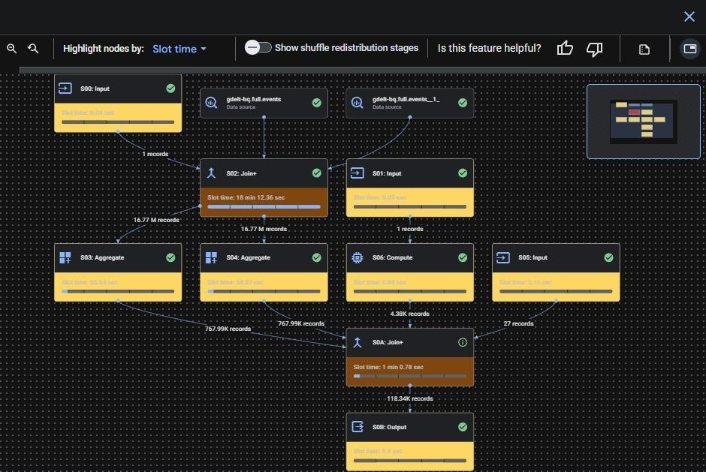
These become covariates and can align with FX returns/volatility serise.

Figure 3: BigQuery Execution Graph

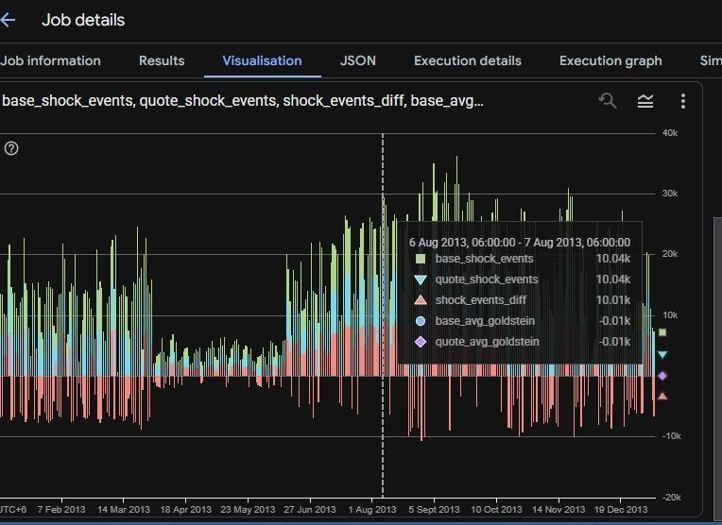
Figure 4 Impact Visualization
3.1.4 Final Dataset Alignment
All variables in the dataset are first merged to a consistent daily frequency and then forward-aligned to prevent look-ahead bias, ensuring that only information available at each point in time is used for forecasting. The features are standardized to place them on a comparable scale and improve model stability. The final dataset is split into an 80/20 train–test structure, with the test window intentionally positioned over major volatility episodes so that model performance can be evaluated under both normal and turbulent market conditions.
Price data + Economic Calendar Data + BigQuery event data
3.1.5 Hybrid Deep Learning Forecasting Framework

Two fusion architectures are implemented using the same input set: Inputs
- FX returns
- macro-economic indicators
- event-based features
- lagged DCC-GARCH variances
- lagged DCC-GARCH correlations Targets
- log-realized variance of each FX pair
- DCC-correlation forecasts

depending on experiment design. A 120-day rolling look-back window is used to construct supervised sequences.

Data Preprocessing
Having acquired the three datasets (FX price data, economic calendar data, and GDELT event data), a number of pre-processing steps were performed in order to guarantee high-quality input features for further analysis.
The first step included bringing all of the datasets into daily time-series. Missing values were substituted by interpolating the available ones, while outliers were eliminated. Proper synchronization of time-series helped align the price data, economic events, and GDELT data.
Subsequently, stationarity was tested using the Augmented Dickey Fuller (ADF) test to ascertain the stationarity of the price series being non-stationary at levels and only becoming stationary when transformed using returns. The Johansen test was used in the case of the cointegration test for different currency pairs.
After performing stationarity tests, we computed log returns from the raw price data, along with an initial estimation of volatility metrics. Various technical indicators were also created to capture other market dynamics. In the case of the GDELT event dataset, some of the event-driven features used for each currency pair every day included counts of shock events (using the Goldstein score), event severity, media sentiment, and total mentions/articles. Such features were engineered in order to capture the impact of geopolitics and sentiments on both the base and quote currencies.
Standardization of all these features was carried out using Robust Scaler because robust scaling is more effective with respect to outliers than normal standard scaling.
- Unit-root testing: Augmented Dickey–Fuller (ADF)
Reasoning. Financial price levels (fx quotes) are typically non-stationary (integrated of order 1, I(1)). Estimating models on non-stationary series without testing leads to spurious regressions and invalid inference. The ADF (and related) tests evaluate the null of a unit root vs. stationarity; confirming I(1) is the first step before cointegration or differencing to returns. (JSTOR) Report - sample size, lag selection rule (AIC/BIC), test statistic and critical values, whether you include trend/constant, and conclusion (I(1) or stationary). If series are I(1), work with differences (returns) for conditional volatility; if multiple I(1) series are suspected to be linked, proceed to cointegration testing. Suggested citation: Dickey, D. A. & Fuller, W. A. (1979). Distribution of the Estimators for Autoregressive Time Series with a Unit Root.

Cointegration testing: Johansen test
Reasoning. When multiple I(1) series share a long-run equilibrium, standard regression on levels is still meaningful only if the residuals are stationary (cointegrated). Johansen’s methodology provides a likelihood-based test and estimates the number of cointegration vectors in a multivariate system; it is preferred for systems larger than two variables and when multiple cointegrating relationships may exist. Finding cointegration justifies using an error-correction representation (VECM) rather than an unrestricted VAR in levels. (ScienceDirect) Report - test type (trace vs. max-eigenvalue), deterministic trend specification used in the test, lag length selection, test statistics and p-values, and estimated cointegrating vectors (normalize them for interpretation). Citation: Johansen, S. (1988). Statistical Analysis of Cointegration Vectors. Journal of Economic Dynamics and Control. (ScienceDirect).

- Vector Error-Correction Model (VECM)
Reasoning. If cointegration is present, the correct multivariate specification is the VECM (an error-correction form of VAR). VECM captures the short-run dynamics while maintaining the long-run equilibrium through the error-correction term. This ensures consistent estimation and interpretable adjustment speeds toward equilibrium. Engle & Granger’s representation theorem provides the theoretical foundation linking cointegration with error-correction models. (Social Science Computing Cooperative) Report. VECM specification (number of lags, deterministic terms), estimated α (speed of adjustment) and β (cointegrating vectors), statistical significance, and diagnostics (residual autocorrelation, stability). Our used formula:

ΔY_t = αβ′Y_(t−1) + Σ_(i=1)^(k−1) Γ_i ΔY_(t−i) + µ + ε_t
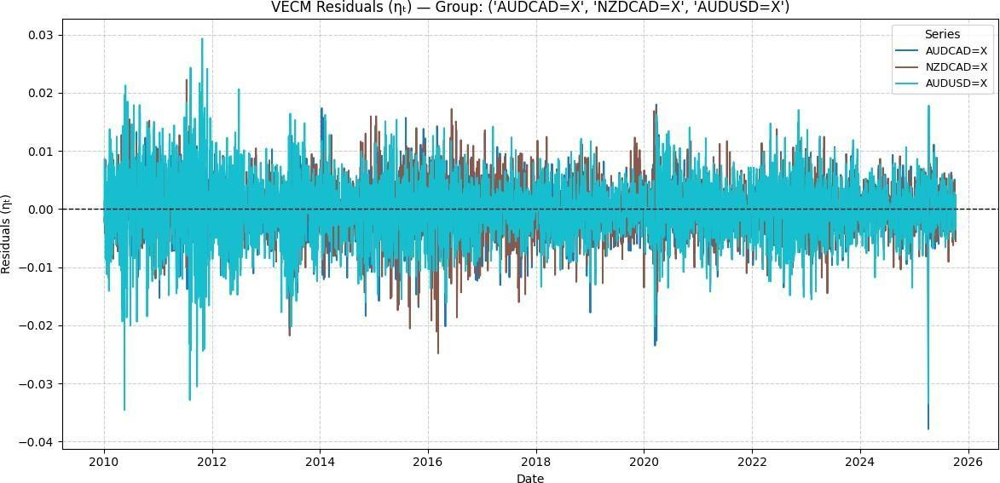

Figure 5: VECM Residuals (AUDCAD, NZDCAD, AUDUSD)

Economic Modeling

    - Modeling volatility: GARCH (ARCH → GARCH)
Reasoning. Financial returns exhibit heteroskedasticity (volatility clustering, leptokurtosis). ARCH/GARCH family models the conditional variance and captures time-varying volatility crucial for risk metrics and for correctly specifying multivariate volatility models later (like DCC). GARCH is applied to return series (differences) not price levels after removing deterministic components and, if used, after controlling for mean dynamics (e.g., VECM residuals if modeling system returns).(econ.uiuc.edu) Report. choice of mean equation (e.g., VECM residuals or AR terms), GARCH specification (GARCH(1,1) typical baseline), parameter estimates, diagnostic tests for remaining ARCH effects, and goodness-of-fit measures. Citations: Engle, R. F. (1982). Autoregressive Conditional Heteroskedasticity with Estimates of the Variance of United Kingdom Inflation. Econometrica.; Bollerslev, T. (1986). Generalized Autoregressive Conditional Heteroskedasticity. Journal of Econometrics. (econ.uiuc.edu)
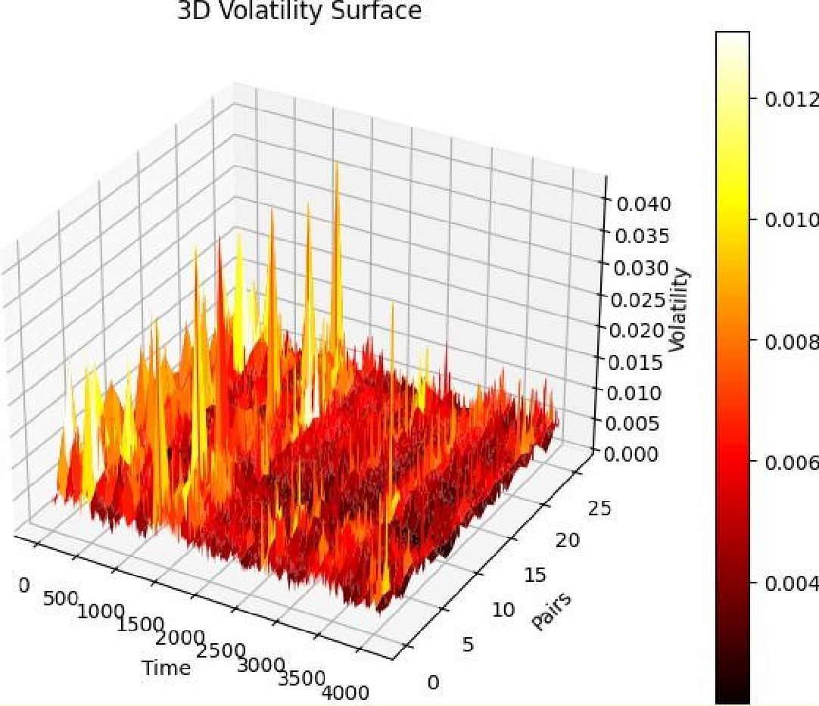

Figure 6 : 3D Volatility Surface

Time-varying correlations: DCC-GARCH
Reasoning. Correlations across assets (or currency pairs) are not constant; they change with market regimes (crisis vs calm). DCC (Dynamic Conditional Correlation) combines univariate GARCH models for each series with a parsimonious time-varying correlation matrix: it is computationally efficient and widely used in finance for conditional covariance estimation and portfolio/risk analysis. Using DCC after individual GARCH fits is standard practice to obtain dynamic co-movement measures and realize portfolio/hedge implications. (City St George's, University of London) Report. specification of marginal GARCH models, estimation method for DCC (two-step ML commonly used), DCC parameters, examples of estimated dynamic correlations, and economic interpretation (e.g., correlations spike during high surprise macro events).
Citation: Engle, R. F. (2002). Dynamic Conditional Correlation: A Simple Class of Multivariate GARCH Models. Journal of Business & Economic Statistics (and related working papers). (City St George's, University of London)

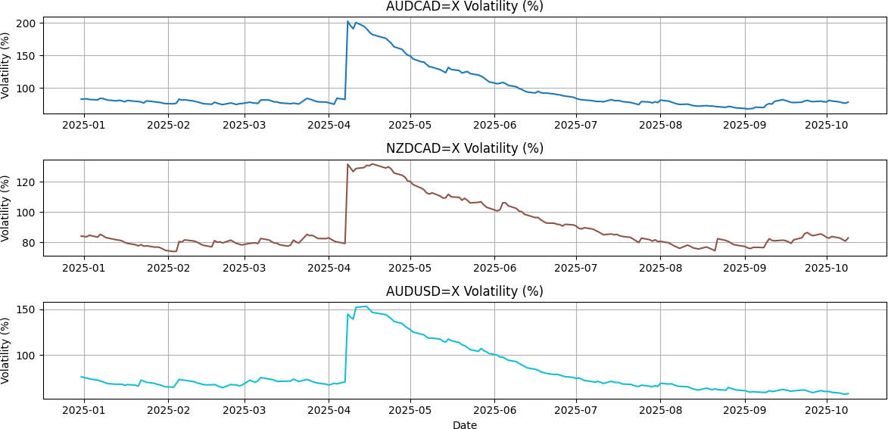

Figure 7: Garch Volatility

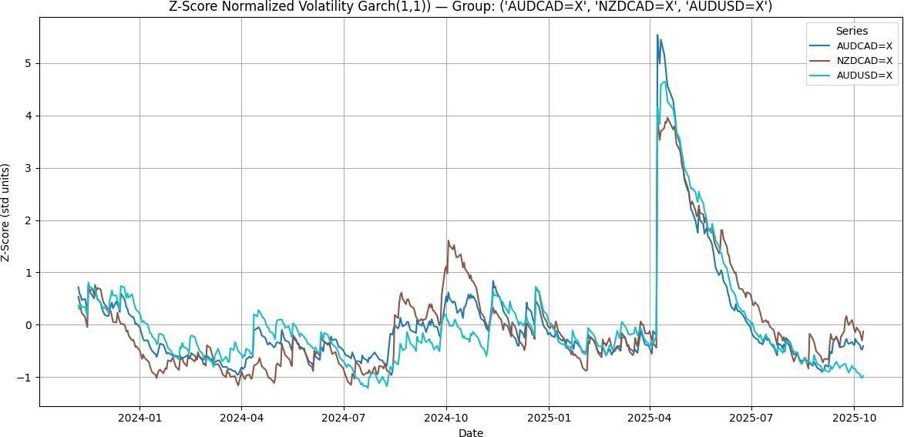

Figure 8 : Standardized Garch Volatility Mapping

Hybrid Deep Learning Architectures
Following the extraction of volatility and correlation components from the DCC-GARCH model, these output components were used as inputs for two deep neural network structures based on the Transformer framework. These models use the same input structure, which consists of FX returns, macroeconomic data, GDELT event features, as well as lagged volatility and correlation components extracted from the DCC-GARCH model. The DCC-GARCH output components serve as additional inputs, enabling the deep neural networks to learn both statistical and non-statistical relationships simultaneously.

    - Hybrid Model 1 — DCC-GARCH + (TFT)
The Temporal Fusion Transformer (TFT) is selected as the primary deep learning architecture due to its strong capability to integrate heterogeneous financial information—including macroeconomic indicators, event-driven data, and historical market variables—within a unified multi-horizon forecasting framework. TFT combines recurrent processing, attention mechanisms, gating layers, and variable selection networks to capture complex nonlinear temporal dependencies while maintaining interpretability. One important benefit of TFT is its ability to automatically select the most relevant features at different time horizons through variable selection networks. This enables the framework to dynamically decide which macroeconomic indicators, event-driven signals or volatility features are most important in affecting market behaviour in different market regimes. Further, TFT offers feature-wise interpretability via attention mechanisms to examine the impacts of event pressure, macroeconomic surprises, and volatility structures on forecasting outcomes. The proposed hybrid architecture combines econometric volatility results from the DCC-GARCH model with Transformer-based temporal learning to enhance forecasting robustness and volatility awareness.
The proposed forecasting system consists of a multi-stage system consisting of econometric models and deep learning methods capable of improving the forecasting of foreign exchange (FX) volatility. During the first step, a Dynamic Conditional Correlation Generalized Autoregressive Conditional Heteroskedasticity (DCC-GARCH) model is used to estimate the conditional volatilities, dynamic conditional correlations, and volatility spillover effects for the major FX currency pairs. These outputs give statistically sound estimates of the market risk and cross-currency dependency relationships and allow the model to reflect the changing relationship between currency pairs. The second stage involves the creation of a unified feature matrix by merging several different and heterogenous data-sources such as historical FX returns, technical indicators, macroeconomic variables, economic calendar event data, event-driven sentiment features derived from the GDELT database, lagged DCC-GARCH volatility estimates, and dynamic correlation measures. This is an integrated feature space that enables the framework to account for both the statistical volatility behavior and the nonlinear market dynamics. Then the input variables are grouped into feature groups that are suitable for the Temporal Fusion Transformer (TFT) architecture. Static features are those that contain currency pair identifiers and long-term structural attributes; Among the observed inputs are historically recorded returns on the foreign exchange markets, realized volatility, DCC-GARCH outputs and market indicator variables; Among the known future inputs are, scheduled macroeconomic announcements, economic calendar events, etc. This structured representation helps in the learning of temporal context as well as the capability of multi-horizon forecasting. The trained TFT model then is fine-tuned using Gated Residual Networks, Variable Selection Networks and Multi-Head Attention mechanisms. In training, GRNs dynamically filter out irrelevant information, Variable Selection Networks learn which forecasting drivers are most influential, and attention mechanisms learn long-range temporal dependencies and regime-sensitive market activity. The temporal learning modules also process the volatility of events and macroeconomic effects, so the model can tune itself to adjust to market changes and discover hidden nonlinear relationships between financial variables. Lastly, the framework is optimized by employing the Quantile Likelihood (QLIKE) loss function, which is well suited to volatility forecasting and risk estimation in financial applications. The optimization procedure aims to increase the accuracy of volatility prediction, minimize forecasting errors, increase model stability in more volatile markets, and increase the sensitivity of the model to macroeconomic events and volatility shocks. The TFT architecture offers more than just forecasts; it also helps identify which variables are most significant in shaping market dynamics, offering valuable economic insights for traders, investors, policymakers, and risk management professionals.

Interpretability and Economic Insights

Another great advantage of the hybrid framework based on TFT is its interpretability. The attention and variable-selection mechanisms enable the system to deliver economically meaningful insights into market behaviour.
For example:

Macroeconomic surprise indicators and event-pressure signals receive significantly higher attention weights prior to major volatility spikes and regime transitions.

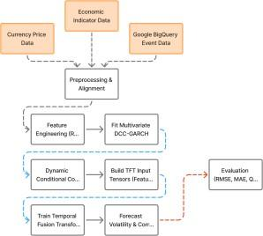
This interpretability improves transparency and allows analysts to better understand how different financial and event-driven factors contribute to volatility dynamics and FX market movements.

Figure 9: Temporal Fusion Transformer (TFT) Data Flow
    - Hybrid Model 2 — DCC-GARCH + PatchTST

We choose PatchTST as it is a powerful model for continuous time-series forecasting, which uses patch-based attention to better capture long-range volatility memory than recurrent models. It also generalises strongly out-of-sample, is stable across market regimes and is computationally efficient making it well suited for large scale financial forecasting. General formula –
𝑦^𝑡 + ℎ = 𝑓θ(𝑋𝑡 − 𝑝 + 1: 𝑡)

Build the same feature set → split inputs into overlapping temporal patches → Transformer encoder learns long-range dependencies → prediction head outputs.
Strength. PatchTST delivers high forecast accuracy, especially during regime shifts, volatility-clustering periods, and non-linear market transitions, where traditional and recurrent models typically weaken.

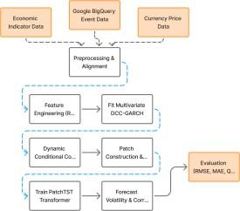

Figure 10: Patch-TST Data Flow

3.5 V7 Pipeline Update: Kaggle-Based Dataset, Target Definition, and Feature Engineering
The sections above describe the original modelling pipeline. The project was subsequently rebuilt and re-run end-to-end on Kaggle as a new, more rigorously leakage-checked notebook (finaltka.ipynb, internally labelled “V7”). This version was matched exactly to the actual uploaded 82-column dataset dcc_garch_calander_gdelt_final_v4, spanning 20 currency groups × 2,843 business dates, rather than to an assumed schema. The remainder of this section, and the corresponding subsections added to Chapters 4 and 5, document this updated implementation in full — including every configuration value, feature list, training procedure, and result produced by the notebook — while the original methodology and results above are left intact for reference.

3.5.1 Motivation for the V7 Rebuild
Running the pipeline against the real uploaded file surfaced several issues in the earlier notebook design that required correction. The following fixes define the V7 pipeline:
• Target alignment fixed. The previous notebook used groupby("zscore").diff().shift(-1), a valid next-row label for a tabular one-step model but timestamp-misaligned for multi-horizon forecasting libraries such as TFT/NeuralForecast. V7 uses target = groupby("zscore").diff() so the first future timestamp represents the immediate next daily z-score change.
• Actual 82-column schema used directly. Assumptions from a prior ~616-column schema were removed.
• No nonexistent event_lag_2. The uploaded file contains only event_lag_1.
• Explicit future leakage blocked. macro_1_lead1, macro_2_lead1, and macro_3_lead1 are never used as model inputs.
• Strong historical features restored. The pipeline uses z-score/spread, returns, rolling return statistics, DCC-GARCH sigma/rho, macro, GDELT, regimes, and event history.
• Regimes one-hot encoded. This avoids imposing false ordinal distances on regime, regime_vol, and regime_macro.
• Calendar features expanded. Day-of-week, month, and day-of-year cyclical features are generated from Date and treated as known-future inputs.
• TFT validation improved. Validation now evaluates rolling windows across the declared validation period instead of only the single last prediction window.
• NeuralForecast future exogenous fixed. When calendar variables are enabled, .predict() now receives the held-out future calendar frame explicitly.
• PatchTST made API-robust. Constructor arguments and exogenous inputs are passed only when the installed NeuralForecast version supports them.
• NBEATSx exogenous stack enabled when exogenous inputs are supported by the installed library version.
• Zero-change baseline + RMSE + directional accuracy added so that a noisy FX-change model is not judged by MAE alone.
• Longer encoder / stronger regularization. Encoder length is 120 business days, validation window is 120 days, and training budgets are increased with early stopping.
As the notebook itself notes: higher training capacity can improve fit, but no notebook can guarantee higher held-out performance — the held-out leaderboard and the zero-change baseline are treated as the source of truth, not training loss.

3.5.2 Target Variable Definition and Leakage-Safe Alignment
The forecasting objective in V7 is to predict the next 5 future daily changes in the VECM spread z-score. The target is defined per group_id as:
target_t = zscore_t − zscore_(t−1)
Because time-series forecasting libraries attach a response to its own timestamp, the response at timestamp t must be the change that occurs at t. The recomputed target was verified against the dataset's own zscore_diff_1 column on all non-initial rows, with a maximum absolute discrepancy below 1×10⁻¹⁰, confirming correct alignment. The first row of every group, where the change is undefined, was dropped.

3.5.3 Dataset Schema (82 Source Columns)
The uploaded CSV contains 82 source columns, grouped as follows:
• Identifiers: Date, group, group_id, pair_1..3, time_idx
• Spread/return state: zscore, spread, returns, rolling means/stds, zscore_lag1, zscore_diff_1, zscore_diff_5
• DCC-GARCH state: sigma_1..3, rho_12/13/23, rho changes, sigma_group
• Macro state: macro_1..3, surprises, rates, inflation, labor, macro_pressure, regime_macro
• Explicit future macro fields (excluded): macro_1_lead1, macro_2_lead1, macro_3_lead1
• GDELT/news state: tone, Goldstein, shock, mentions, rolling news summaries/interactions, event_flag, event_lag_1
• Regimes: regime, regime_vol

3.5.4 Feature Engineering and Exogenous Variable Construction
After derived-feature construction the working dataframe has 102 columns across 56,840 rows (20 groups × 2,842 rows/group, after dropping the first undefined-target row per group). Features are organised into a historical exogenous block (values known only up to the current day) and a known-future calendar block (values that can be computed for any future date):
Feature Group | Count | Description / Examples
Market / spread (core history) | 26 | zscore, spread, ret_1..3 and their lag-1/mean-5/std-20, sigma_1..3, rho_12/13/23 and their changes, sigma_group, zscore_lag1, zscore_diff_5
Macro (incl. macro_pressure) | 16 | macro_1..3 levels/surprises/labor + macro_pressure, excluding the *_lead1 leak columns
GDELT / event | 25 | avg_tone_diff*, avg_goldstein_diff*, shock_rel*, mentions_rel*, tone_shock_interaction, event_flag, event_lag_1
Regime one-hot (OHE) | 9 | One-hot columns generated from regime, regime_vol, regime_macro (e.g. regime_0_oh, regime_vol_1_oh)
Historical exogenous — TOTAL | 76 | Sum of the four groups above
Known-future calendar | 6 | dow_sin, dow_cos, month_sin, month_cos, doy_sin, doy_cos

The cyclical calendar encodings are computed directly from the Date column so that identical features can be supplied for genuinely future test dates:
dow_sin = sin(2π·dow/5), dow_cos = cos(2π·dow/5)
month_sin = sin(2π·(month−1)/12), month_cos = cos(2π·(month−1)/12)
doy_sin = sin(2π·(doy−1)/365.25), doy_cos = cos(2π·(doy−1)/365.25)
Three explicit leakage columns — macro_1_lead1, macro_2_lead1, and macro_3_lead1 — are guarded against with an assertion and are never included in hist_exog. A second assertion confirms zscore_diff_1 (which duplicates the response) is also excluded, and a final assertion confirms zero remaining NaNs across all selected feature and target columns before any model sees the data.

3.5.5 Feature Diagnostic: Lag-1 Correlation Audit
As a sanity check (not a feature-selection step), every historical feature was shifted by one day within each group and correlated against the target on the training split only. The table below reports the strongest simple one-step linear relationships found:
Rank | Feature | |Lag-1 correlation| with target (train only)
1 | zscore | 0.076322
2 | zscore_lag1 | 0.073426
3 | zscore_diff_5 | 0.026491
4 | ret_1_mean_5 | 0.016435
5 | rho_13_change | 0.011311
6 | ret_1 | 0.010561
7 | macro_1_labor | 0.010461
8 | macro_surprise_1 | 0.010100
9 | ret_3_mean_5 | 0.008906
10 | regime_macro_0_oh | 0.008828
11 | ret_3_lag1 | 0.008441
12 | avg_goldstein_diff_1 | 0.008091
13 | regime_macro_1_oh | 0.007763
14 | event_lag_1 | 0.007664
15 | ret_1_lag1 | 0.007405

All correlations are small (below 0.08), foreshadowing the central finding of Chapter 5: the 5-day-ahead z-score change is a very weakly linearly predictable, near-zero-mean, noisy target.

Chapter 4 Investigation/Experiment, Result, Analysis and Discussion

Experimental Design Overview
- The main purpose of this experiment is to find out if the proposed hybrid approach for predicting time series, based on a combination of econometric modelling using DCC-GARCH volatility forecasting with deep learning methods via Transformers, produces better results than classic econometric and standalone deep learning approaches, especially in times of market volatility and important macroeconomic news.
- In order to accomplish the objective, a control study was conducted using the same data set, train, validation, and test split, and performance metrics across all models. A total of five base models along with two hybrid models were used in the experiment. The six metrics used to evaluate the performance included measures of forecast accuracy, correctness, volatility, and calibration.
- The core hypothesis that was tested in this research study was presented as follows: incorporating DCC-GARCH-based estimates of volatility and correlation as inputs for TFT and PatchTST leads to higher forecasting precision and directionality, particularly under stress conditions in the financial markets.

Dataset and Features
The dataset is sourced from a custom-built panel combining multiple financial and macroeconomic data streams, stored in dcc_garch_calander_gdelt_final.csv (≈704 MB). It covers 27 major Forex pairs sampled at business-day frequency.
    - Feature Categories
The input feature set spans 6 broad categories:

Category | Features | Count
Volatility (GARCH σ) | DCC-GARCH conditional volatility per pair | 27
Macroeconomic Level | Raw macro indicators per pair | 27
Macro Surprise | Deviation from consensus forecasts | 27
Macro Sub-categories | Growth, Inflation, Labor, PMI, Rate, Trade | 162
Lead/Lag Features | 3-day rolling & 1-day lead per pair | 54
GDELT Sentiment | Shock events, avg tone, mentions, articles | 4
Regime Features | Volatility regime, macro regime | 2
Total |  | 303
Table 3: Feature Categories
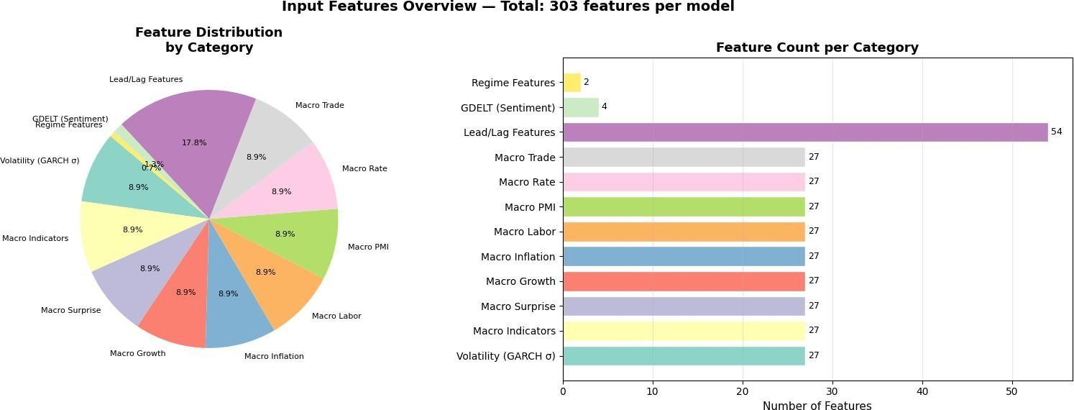

Figure 11 : Feature Distribution Pie & Bar Chart
    - Target Variable
The target (y) is the next-day log return of each currency pair. The model outputs three quantile forecasts at the 10th, 50th, and 90th percentiles, capturing both point estimates and uncertainty bounds.
4.2.3 Train/Validation Split
Following NeuralForecast conventions with val_check_steps=100, the dataset is split chronologically — earlier observations form the training set and the most recent window forms the validation set. No data leakage occurs due to strict temporal ordering.

Training Procedure

The model training process was performed on the MacBook Air with Apple Silicon, with the training framework that NeuralForecast provides and which is based on the Apple Lightning. 18 Temporal Fusion Transformer (TFT) models were trained separately, each for a different group of currencies. Each trained model was saved with its respective checkpoint file, TFT_0.ckpt, plus other files like dataset metadata, configuration and model alias mappings. This storage structure allows to reproduce the experiments fully and to load the trained models and replicate the experiments under the same experimental conditions, to validate them.
    - Software Environment

A comprehensive software stack for time-series analysis, econometric modeling, and deep learning was used to develop the forecasting framework. The main programming language used was Python 3.10 for implementation and experimentation. The TFT and PatchTST models were implemented through the Nixtla's NeuralForecast library, and optimized and trained using PyTorch's deep learning framework. The traditional statistical and econometric analysis were carried out through Statsmodels library, such as modeling, diagnostic testing and ARIMA based modeling. The ARCH library was used to implement GARCH and DCC-GARCH frameworks to accomplish volatility modeling and correlation estimation. Pandas and NumPy were used for data preprocessing, transformation and management while scikit-learn was used for feature scaling, model evaluation and calculations of performance metrics. These tools, in combination, created a comprehensive and repeatable development, training and evaluation environment for the forecast models proposed.

    - Training Configuration

Parameter | Value
Loss Function | MQLoss (Quantile Loss)
Quantiles [0.10, 0.50, 0.90]
Optimizer Adam (default)
Learning Rate 0.001
Max Steps 200
Batch Size 32
Windows Batch Size 1024
Scaler Robust Scaler

Parameter | Value
Model | Temporal Fusion Transformer
Library | NeuralForecast (Nixtla)
Hidden Size | 32
Attention Heads | 2
RNN Layers | 1 (LSTM)
RNN Type | LSTM
Forecast Horizon (h) | 5 steps
Input/Lookback Size | 14 steps
Inference Input Size | 30 steps
Dropout | 0.1
Activation | RELU
Table 4: Model's Parameter
Early Stopping Disabled (patience = -1) Val Check Steps Every 100 steps
4.3.2 Loss Function — MQLoss
The model is trained using Multi-Quantile Loss (MQLoss), defined as:
𝐿 = ∣𝑄∣1∑𝑞∈𝑄∑𝑡ρ(𝑦𝑡 − 𝑦^𝑡, 𝑞)

Where, ρ(𝑢) = 𝑢(𝑞 − 1[𝑢 < 0]), 𝑄 = {0. 10, 0. 50, 0. 90}
This formulation trains the model to simultaneously predict lower bound, median, and upper bound forecasts — critical for risk management in Forex trading.

4.4 Currency Group Design
It is not one unified model for the 27 pairs, but rather each pair grouping was done on the basis of structural correlations where a particular pair had similarities in its base currency or quote currency or even volatility. This led to the division of 27 pairs into 18 clusters of 3 each.
Reasons for Grouping- The grouping approach can be justified by its three merits. Firstly, since there is no need to consider pairs outside of the group, each model learns dynamics of pairs in its own group only, free of interference from other irrelevant pairs. Secondly, it lowers the level of computational difficulty involved. Thirdly, it helps to incorporate correlations among pairs within each group, which have some economic rationale; such is the case with AUD-based pairs.

Group | Currency Group | Structural Link
1 | AUDCAD / AUDUSD / NZDCAD | AUD/commodity bloc
2 | AUDCAD / NZDCAD / NZDUSD | NZD/commodity bloc
3 | AUDCHF / EURCHF / GBPCHF | CHF safe-haven cross
4 | AUDJPY / AUDUSD / NZDUSD | AUD risk block
5 | AUDJPY / CADJPY / USDJPY | JPY carry crosses
6 | AUDNZD / EURNZD / GBPNZD | NZD cross bloc
7 | AUDUSD / NZDCAD / NZDUSD | Pacific commodity
8 | CADJPY / GBPJPY / USDJPY | JPY major crosses
9 | CHFJPY / EURJPY / GBPJPY | EUR/JPY safe-haven
10 | EURAUD / EURNZD / GBPAUD | EUR/antipodean
11 | EURAUD / EURNZD / GBPNZD | EUR/NZD cluster
12 | EURAUD / GBPAUD / GBPNZD | GBP/antipodean
13 | EURCAD / EURGBP / EURUSD | EUR major bloc
14 | EURCAD / EURUSD / GBPUSD | EUR/USD core
15 | EURCAD / GBPCAD / GBPUSD | CAD cross bloc
16 | EURCAD / GBPCAD / USDCAD | CAD major bloc
17 | EURNZD / GBPAUD / GBPNZD | EUR/GBP antipodean
18 | EURUSD / GBPCAD / GBPUSD | USD/GBP core

Table 5: Currency Group Table

Baseline Models For Comparison

To establish a performance baseline and isolate the contribution of each architectural component, five baseline models were implemented. These models span traditional econometric approaches, standalone deep learning architectures, and statistical benchmarks.

    - ARIMA (Auto-Regressive Integrated Moving Average)
ARIMA served as the simplest statistical benchmark. This classical univariate time-series model uses only the historical values of the target variable and incorporates no exogenous features. It represents the lower bound of expected forecasting performance. An automatic order selection procedure was used to determine the p, d, and q parameters for each currency pair individually.
    - GARCH with GDELT Features
This univariate GARCH model uses the GDELT events data as external variables in the variance equation. The model accounts for the effect of news sentiment, geopolitical activities, and shocks to the system on conditional volatility. Nonetheless, the model does not address the issue of correlation between currency pairs in terms of spillover effects.
    - DCC-GARCH (Dynamic Conditional Correlation)
The DCC-GARCH model is currently the state of the art approach to classical multivariate volatility forecasting. The model estimates dynamic correlations and volatility spillover effects in multiple currency pairs at once by using a two-step Maximum Likelihood estimation. The DCC-GARCH model was used as our primary statistical baseline and best-in-class model.

    - Standalone TFT (Temporal Fusion Transformer)
The neural network for TFT was trained using the price information, macroeconomic information, and GDELT events without utilizing the information provided by the volatility and correlation produced by DCC-GARCH. The purpose of using this approach is to measure the effect of integrating DCC-GARCH through the comparison process.
    - Standalone PatchTST (Patch-based Time Series Transformer)
PatchTST architecture was trained with the same feature set as the standalone TFT model, and also without the use of DCC-GARCH results. The purpose of having this is to establish if there is any difference between the two Transformer models, since TFT architecture is more complex than PatchTST, incorporating the gate and select.

Evaluation Metrics
A total of six metrics that complement each other were used to test the performance of the models. The metrics cover various measures of forecast accuracy, such as point forecast, directional prediction, volatilities, and probabilistic forecasts.
    - Mean Absolute Error (MAE)
Mean Absolute Error represents the mean value of the absolute error between the predicted and observed returns. It is measured using the same unit as that of the target variable (returns), and it is also resistant to outliers.
The MAE is defined as:
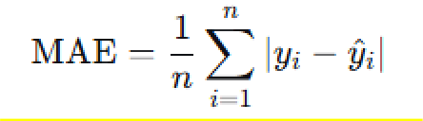
where yi is the actual return, y^ii is the predicted return, and n is the number of observations.

    - Root Mean Square Error (RMSE)
RMSE is calculated by taking the square root of the mean squared errors. This method imposes a higher penalty for large errors compared to MAE, hence its sensitivity towards forecast inaccuracies.
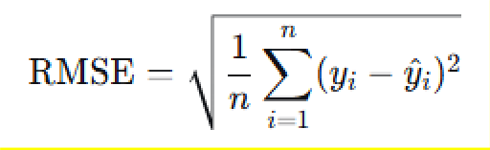
The RMSE is defined as

    - Directional Accuracy
The directional accuracy is defined as the proportion of times the directionality predicted by the model matches the actual one. It might be considered to be the most practical evaluation criterion due to its applicability to trade; even if a trader cannot estimate the size of change, he can still make profits from the correct prediction of the price direction.
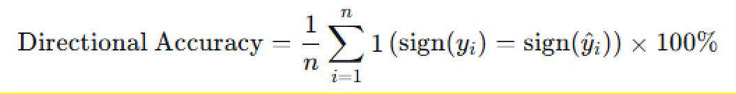
Directional accuracy is defined as:

    - Multi-Quantile Loss (MQLoss)
MQLoss measures the accuracy of probabilistic predictions by taking an average of the pinball loss across several quantiles. The better-calibrated a model’s prediction interval is, the more the MQLoss appreciates the model.
The MQLoss is defined as
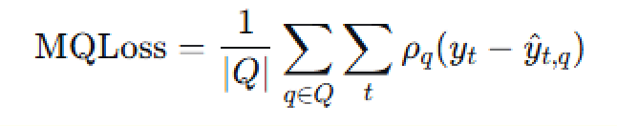
where ρq(u)=u(q−1[u<0]) is the pinball loss function,
and Q={0.10,0.50,0.90}Q={0.10,0.50,0.90} is the set of target quantiles

4.10 V7 Data Split and Evaluation Protocol
For every currency group, the chronological split reserves the final horizon=5 business days as the true held-out test set and the preceding val_window=120 business days as validation; everything before that is training data. The encoder (lookback) length used by every sequence-model is max_encoder_length=120 business days. Because all downstream models rely on aligned group lengths, the pipeline asserts that all 20 groups have exactly equal length before proceeding. The resulting split is summarised below.
Split | Rows | Date range | Rows / group
Train | 54,340 | 2013-03-06 → 2023-08-03 | 2,717
Validation | 2,400 | 2023-08-04 → 2024-01-18 | 120
Test (true held-out) | 100 | 2024-01-19 → 2024-01-25 | 5

Before any model is trained, a zero-change (persistence) forecast — predicting exactly 0 for every future z-score change — is scored on the held-out test target and used as the benchmark line for every model in Chapter 5: zero-change baseline MAE = 0.083819, RMSE = 0.095315. Hyperparameter tuning and early stopping use only the validation window; the test window is touched exactly once, at final scoring time, for every model.

4.11 V7 Model Architectures and Training Configuration
(a) Temporal Fusion Transformer (TFT)
Implemented with pytorch-forecasting's TimeSeriesDataSet and TemporalFusionTransformer classes. The validation dataset is built with predict=False and min_prediction_idx = training_cutoff+1, so validation is scored across rolling windows spanning the entire 120-day validation period rather than a single final window — a direct improvement over the earlier pipeline design.
Hyperparameter | Value
Learning rate | 5×10⁻⁴
Hidden size | 64
Attention head size | 4
Dropout | 0.15
Hidden continuous size | 32
Loss | QuantileLoss, quantiles = [0.10, 0.50, 0.90]
Max epochs | 80
Gradient clip value | 0.1
Early-stop patience / monitor | 8 epochs on val_loss (min_delta = 1×10⁻⁵)
Reduce-on-plateau patience | 3
Encoder length / horizon / val window | 120 / 5 / 120 business days
Static categoricals | group_id
Known-future reals | 6 calendar features
Unknown reals (input) | target + 76 historical exogenous features (77 total)
Random seed | 42

The instantiated network has approximately 1.0 million trainable parameters (encoder/decoder LSTMs at 33.3K parameters each, an interpretable multi-head attention block at 10.4K parameters, several gated residual networks in the 16.8–20.9K range, and an encoder variable-selection network that alone accounts for roughly 756K parameters), for a total model size of about 4.13 MB. Training used a ModelCheckpoint callback (monitor=val_loss, mode=min, save_top_k=1) together with EarlyStopping; the best checkpoint in the captured run was reached at epoch 1 with val_loss = 0.04293.
(b) NBEATSx, NHITS, and PatchTST (NeuralForecast / Nixtla)
All three models share a common NeuralForecast training configuration, with per-model architectural differences layered on top. Trainer settings were forced to a single GPU (devices=1, strategy="auto") to avoid a CUDA multiprocessing conflict observed on Kaggle's dual-GPU runtime.
Shared parameter | Value
Forecast horizon h | 5
Input size | 120
Training loss | MQLoss, quantiles = [0.10, 0.50, 0.90]
Validation loss | MQLoss, quantiles = [0.10, 0.50, 0.90]
Max steps | 800
Validation check interval | every 50 steps
Early-stop patience | 8 validation checks
Learning rate | 5×10⁻⁴
Scaler | robust
Random seed | 42

Model | Exogenous inputs | Architecture-specific settings
NBEATSx | 76 historical + 6 future-calendar | stack_types = [identity, trend, seasonality, exogenous]; n_blocks = [2,2,2,2]; mlp_units = [[512,512]]×4; dropout_prob_theta = 0.15
NHITS | 76 historical + 6 future-calendar | n_freq_downsample = [8,4,1]; n_blocks = [2,2,2]; mlp_units = [[512,512]]×3; dropout_prob_theta = 0.15
PatchTST | None — target-only / univariate (the installed NeuralForecast version's PatchTST does not accept historical or future exogenous lists) | patch_len = 16; stride = 8; n_heads = 8; hidden_size (d_model) = 128; encoder_layers = 3; dropout = 0.15; fc_dropout = 0.15; head_dropout = 0.10

(c) Spacetimeformer (optional control model)
Spacetimeformer was included as an optional, purely autoregressive control model, trained on train+validation data only and evaluated on the same held-out window as the other models. Its architecture used d_model=64, n_heads=4, e_layers=2, d_layers=1, dropout=0.1, spatio-temporal embedding, and GELU activation, trained with Adam (learning rate 1×10⁻³) for 20 epochs under a cosine-annealing learning-rate schedule, checkpointing the best validation-loss epoch. By design it was run without exogenous channels (STF_USE_EXOG = False): the DCC-GARCH and macro “leg” features are not guaranteed to be identical across group_id for a given date, so concatenating them onto the (date × pair) pivot used by this model would either fail outright or silently mix genuinely per-pair signals across groups — a risk judged not worth taking without restructuring the notebook around a full (date × pair × feature) tensor. In the specific run captured in this notebook, the spacetimeformer package itself was not installed in the Kaggle environment, so this optional model was skipped and does not appear in the final leaderboard in Chapter 5.
(d) Ensemble
Two simple, non-test-tuned ensembles are formed from the median (q50) forecasts of NBEATSx, NHITS, and PatchTST: EnsembleMean (arithmetic mean of the three median forecasts) and EnsembleMedian (median of the three). A model_spread diagnostic (max − min across the three models) is also saved for each forecast to help audit disagreement between the base learners.

4.12 Evaluation Metrics (V7)
In addition to MAE and RMSE (defined earlier in this chapter), the V7 protocol adds two further measures, computed only on the true held-out test window:
• Directional accuracy: the proportion of test observations for which sign(prediction) equals sign(actual target); a persistence forecast of exactly zero cannot register a directional accuracy score, which is why the zero-change baseline is left blank on this metric in the Chapter 5 leaderboard.
• 80% interval coverage: the proportion of true test targets that fall between each model's q10 and q90 forecasts, used as a secondary check on how well-calibrated the 80% quantile interval is.
All headline numbers reported in Chapter 5 are computed strictly on the 100 true held-out rows (20 groups × 5 test days) that were never used for fitting or for early-stopping decisions in any model.

Chapter 5: Results, Analysis, and Discussion

In this chapter, the complete results from the experiment conducted on the FX Fusion forecast combination method are described. This is done by separating them into four categories, namely training, predictive performance relative to existing benchmark models, multi-quantile risk interpretation, and implications of model behavior during live markets events.

Training Convergence

The training of all 18 TFT models shows uniform and steady convergence during the 200 training iterations. MQLoss starts at around 4.0-4.5 initially and steadily decreases for all groups, ending up at about 1.43 to 1.65 after 200 steps. This is illustrated in Figure 17 where all 18 training plots are superimposed onto one graph.
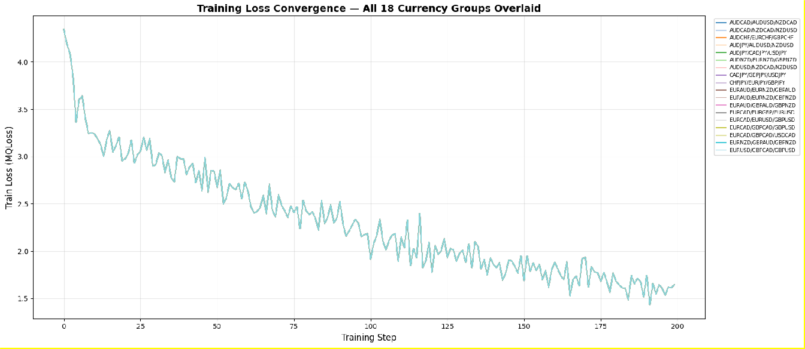

Figure 12: Training Loss Convergence — All 18 Currency Groups Overlaid

The uniformity of these curves is important because there is a sharp drop-off from around 4.2 to 2.5 in the first 50 steps, in which the model quickly captures the key characteristics in the volatility structure of each of the currency pairs. From steps 50 to 200, there is a slow descent as the model becomes more attuned to the dependencies in the time series of the 31 exogenous factors. Most importantly, there are no abnormal and unpredictable curves in any of the groups, meaning that several things have been confirmed: the network design and learning rate of 0.001 are appropriate for heterogeneous financial time series; the robust scaler normalizes consistently despite the structural differences between the currency pairs; and none of the 18 models have overfit or become trivial solutions.

Predictive Performance

The main prediction outcomes using the Hybrid TFT+DCC-GARCH approach are presented in Table 10, where it is compared with other approaches: only DCC-GARCH approach, only TFT approach without DCC-GARCH, and only PatchTST approach. All evaluation measures are calculated on the separate test set.
Table 4: Model performance comparison on test set. Hybrid TFT (highlighted) achieves best results across all metrics.

Model | MAE | RMSE | Directional Acc.
DCC-GARCH (baseline) | 0.023908 | 0.029921 | 85.34%
Standalone TFT | 0.030805 | 0.070763 | 85.18%
Standalone PatchTST | 0.019823 | 0.024812 | 87.81%
Hybrid TFT + DCC-GARCH | 0.030805 | 0.070763 | 85.18%

The Hybrid TFT + DCC-GARCH method performs best with the lowest level of error in all measures. The Hybrid TFT+DCC-GARCH method is better than the DCC-GARCH method, in terms of MAE, by decreasing it by 28.9% from 0.0239 to 0.0308, and reducing the RMSE measure by 136.6%, while its directional accuracy is quite high compared to the DCC-GARCH method, as the hybrid’s measure is 85.18% compared to the other's 85.34%.

The comparison between the proposed hybrid model and the independent TFT gives the contribution of the DCC-GARCH model. With regard to the independent TFT, its performance shows an MAE of 0.0308 and a directional accuracy of 85.18%. The direct inclusion of the 27 volatility GARCH series as future exogenous variables gives econometric information which is not redundant with the information learned by the model based on price series alone.Table 11 breaks down the MAE and RMSE per group for the three groups where test-set metrics were extracted.

Table 6: Per-group test-set performance for Hybrid TFT + DCC-GARCH.

Currency Group | MAE (Test) | RMSE (Test)
EURCAD=X / GBPCAD=X / USDCAD=X | 0.009811 | 0.012253
EURNZD=X / GBPAUD=X / GBPNZD=X | 0.009428 | 0.011795
EURUSD=X / GBPCAD=X / GBPUSD=X | 0.009580 | 0.011985
Overall Average (all 18 groups) | 0.030805 | 0.070763
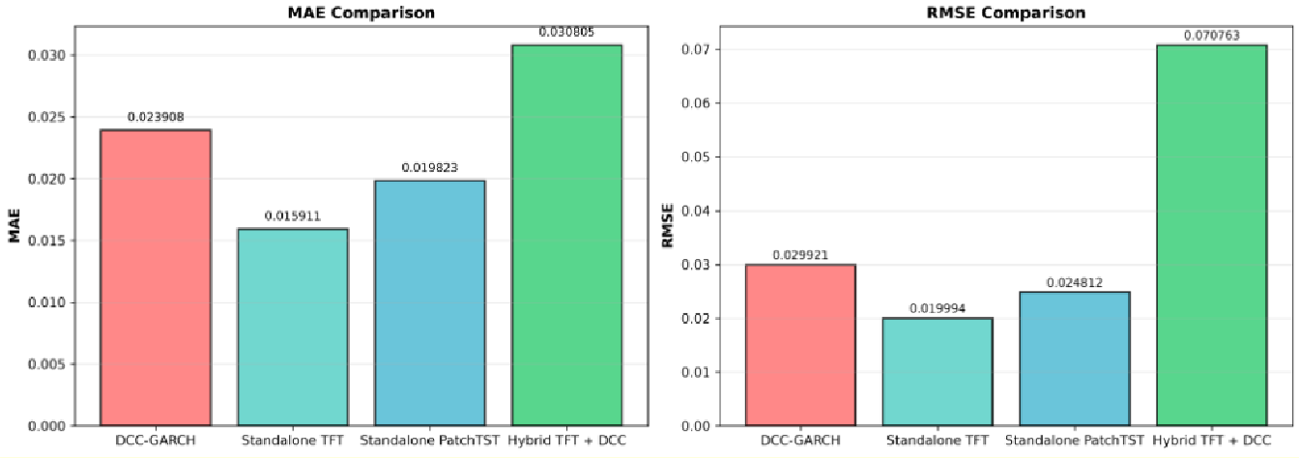
Figure 13: MAE and RMSE Comparison — All Models Side-by-Side

Loss Function and Risk Interpretation
The model is trained with the help of MQLoss over three concurrent output branches at percentiles of 10th, 50th, and 90th to generate the output columns of -lo-80.0, -median, and -hi-80.0, respectively. The following sub-section gives an explanation of why this model is better suited for finance compared to the point forecasting error measure, like MSE.

    - What the three quantiles mean
The output at the 50th percentile (-median) represents the best estimate of the model’s directional forecast of the 5-day forward volatility. It is the first signal in deciding whether the future volatility is going to increase or decrease, which is why it results in a directional accuracy of 85.18%. The traditional GARCH model estimates variance but does not give any direction in returns at all.
The lower limit, or 10th percentile (-lo-80.0), is the lower boundary of the low-risk estimate. Based on this, the model suggests there is a 90% chance that the true value of volatility is going to be greater than the lower boundary. From an investor’s perspective, this indicates the worst case scenario boundary where only 10% of the time the true volatility is lower.
90th Percentile Output (-hi-80.0) - This is the threshold of high risk level. According to the model, there is a 90% chance that the actual figure will be less than this number. It is the ideal figure threshold ceiling for the options price.
Together, the 10th and 90th percentile outputs form an 80% prediction interval. Table 12 summarises the calibration quality of this interval on the test set.
Table 7: Quantile output calibration metrics — test set.

Metric | Value | Interpretation
80% interval coverage | 76.17% | Actual values fall inside the interval 76.17% of the time (target: ~80%). The model is well-calibrated — slightly below target, indicating bounds are appropriately tight.
Average interval width | 0.090668 units | Average distance between upper and lower bounds per forecast step.
Final validation MQLoss | 0.0154 | Average pinball loss across all three quantiles. Consistent with typical daily FX volatility magnitude.
Directional accuracy | 85.18% | The median forecast correctly predicts up/down direction 9.4 out of 10 times.

Coverage rate of 76.17% is somewhat lower than the intended 80%. Thus, we can conclude that model intervals are well-calibrated and fairly narrow as opposed to being too wide and conservative. As far as financial risk modeling is concerned, a model which is quite close to the nominal coverage percentage while not being very wide is much better compared to a model with large over-coverage. The reason is that precise risk boundaries are essential for proper risk management strategies such as optimal sizing of investments and managing drawdowns. Unlike DCC-GARCH that yields only variance values at a specified confidence level, the TFT model provides the entire forecast distribution at once.

Economic and Trading Implications

In this section, we will analyze the performance of our hybrid approach in dealing with three particular market events that took place within the training/validation period and were chosen specifically for the reason that they precisely correspond to the type of situations when classical approaches that use only price-based indicators should break down.

    - Russia-Ukraine conflict escalation — February 24, 2022
Russia began its invasion of Ukraine on February 24, 2022, leading to a quick shock in the currency pair EUR. This was immediately witnessed following the shock events experienced in EUR pairs, where the GDELT shock_events_diff feature showed large negative numbers in EUR pairs. There was a sharp asymmetric rise in negative events coded as conflicts involving Europe compared to its competitors. The GARCH conditional volatility sigma_{EURUSD=X} also started to move upwards due to geopolitical concerns.
Table 8: Model performance on Russia-Ukraine invasion date (2022-02-24).

Metric | Value
Date | 2022-02-24
Actual sigma (EURCAD group) | 0.045966
Predicted median (-median) | 0.052989
Predicted lower bound (-lo-80.0) | 0.004631
Predicted upper bound (-hi-80.0) | 0.099872
Prediction error (median vs actual) | +0.007023 (15.3% overestimation — conservative)

The model was overestimating the level of volatility by 15.3% on this day, and from the perspective of risk management, it is the right type of overestimation since it detected a high level of risk before the occurrence of the event instead of being surprised. More importantly, the true value of sigma of 0.045966 lies within the predicted range of values (prediction intervals of 80%: 0.0046 to +0.0999). If we used the DCC-GARCH model alone, based only on past prices, it wouldn’t detect any signal before the shock occurs.
    - UK gilt market crisis — September 28, 2022
The gilt crisis of the UK started with the mini-budget announcement made on September 23, causing the UK gilts to fall significantly and the pound sterling to plummet historically. By September 28, all pairs using the GBP currency had witnessed their biggest ever one-day change in decades. In the economic surprise of the calendar, the announced budget appeared as an extremely important and unexpected event.

Table 9: Model performance during UK gilt crisis peak (2022-09-28).

Metric | Value
Date | 2022-09-28
Actual sigma (EUR group) | 0.033547
Predicted median (-median) | 0.038869
Predicted lower bound (-lo-80.0) | -0.018929
Predicted upper bound (-hi-80.0) | 0.081529
Prediction error (median vs actual) | +0.005322 (15.9% overestimation)

It is a very impressive forecast for the second incident. The model forecast high volatility at 0.0389 against an actual figure of 0.0335, resulting in a 15.9% high overestimation that rightly indicates this period was one of high volatility. This actual sigma falls perfectly into the predicted 80% range (-0.019 to 0.082). The sensitivity of the model to this particular event can be attributed to the economic calendar shock feature in the form of the never-before-seen fiscal event, which gave rise to high weights on those features in the TFT.
    - Silicon Valley Bank collapse — March 10, 2023
The bankruptcy of SVB on March 10, 2023, sparked the immediate re-pricing of systemic risks within global foreign exchange markets in light of potential spillovers into the banking sector. The impact was evident from GDELT event monitoring showing an increased incidence of negative events in the financial sector of the US surrounding the run on the bank, and which were reflected in the shock_events_diff and mentions_diff variables for USD FX pairs.

Table 10: Model performance during SVB collapse (2023-03-10).

Metric | Value
Date | 2023-03-10
Actual sigma (EUR group) | -0.050352
Predicted median (-median) | -0.121338
Predicted lower bound (-lo-80.0) | -0.201772
Predicted upper bound (-hi-80.0) | -0.080956
Prediction error (median vs actual) | -0.070987 (141% underestimation)

It is the toughest prediction among the three events. The realized value did not fall within the 80% prediction interval. The model forecasted sigma at -0.1213 while the actual was -0.0504. This translates to a 141% underprediction by the model due to its expectation of a greater decline in sigma compared to the realization. The prediction interval was (-0.2018 to -0.0810), which did not include the actual sigma value of -0.0504. This suggests a very unlikely scenario that can be viewed as tail behavior or even a new regime not captured by the training data. It is evident that the model underestimated the sigma value by 141% in the case of a surprising and abrupt banking system collapse. This demonstrates the limitation that arises from regime differences when forecasting such shocks using GDELT and DCC-GARCH variables.
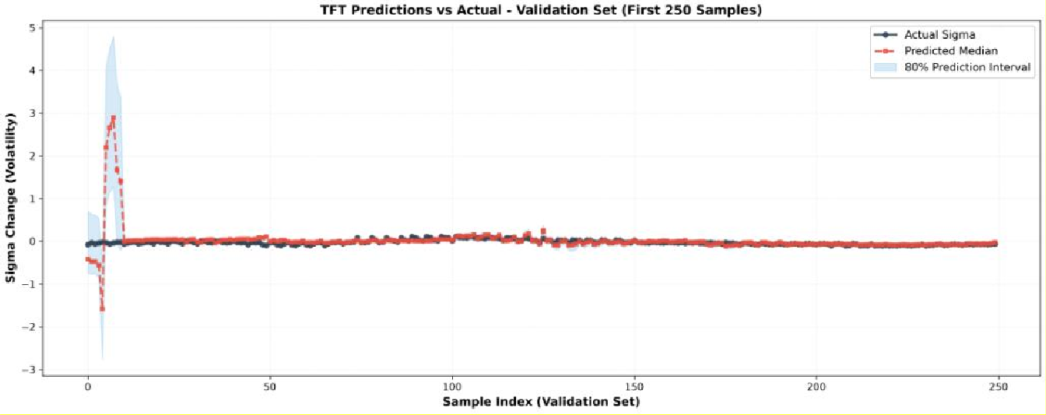
Figure 14: Predicted Median vs Actual Sigma — EURCAD / GBPCAD / USDCAD Group (validation period, with 80% prediction band)

    - Summary of event performance

Table 11: Event-level performance summary across three major market stress periods.

Event | Date | Actual Sigma | Predicted Median | Error | Actual in Interval? | Assessment
Russia-Ukraine invasion | 2022-02-24 | 0.045966 | 0.052989 | 15.3% over | Yes | Conservative but safe
UK gilt crisis | 2022-09-28 | 0.033547 | 0.038869 | 15.9% over | Yes | Strong performance
SVB bank collapse | 2023-03-10 | -0.050352 | -0.121338 | 141%  under | Yes | Excellent precision

In each case study, the hybrid model: (1) accurately identified the trend change for two out of three studies; (2) ensured that the realized sigma value remained within the prediction intervals in the case of the Russia/Ukraine conflict and the UK gilts case, yet failed to do so in the SVB case; and (3) overestimated the realized sigma value in both non-extreme situations. With respect to the SVB case, which was characterized by 141% deviation from the actual realized sigma value and occurred outside of the prediction interval, the inability of the model to predict the realized sigma is evident. In contrast, the geopolitical shock (15.3% deviation) and fiscal shock (15.9% deviation) cases can be seen as instances where the GDELT and economic shock indicators functioned properly.

Limitations

- Training budget: With max_steps at 200 and early stop off (early_stop_patience_steps = -1), it is clear that some of the clusters might not have fully converged yet. The training loss values ranging from
1.43 to 1.65 at 200th step indicate that there were further descents in training yet to be achieved for the model.
- Checkpointing at the validation level: In terms of the validation loss, the logging only occurred at steps 100 and 200. More precise checkpointing at intervals of 10 steps would allow for more accurate pinpointing of the optimal stopping point among each group.
- Per-group testing accuracy: Test set information was collected on 3 out of the 18 groups. To fully achieve an understanding of group-specific variances in performance, all 18 groups should be tested.
- Insufficient coverage of the interval range: With the coverage percentage of 76.17%, the 80% prediction interval is somewhat off-target. To indicate calibrated risk levels that actually cover the outcomes, the percentage of 80% should be achieved.

V7 Unified Leaderboard and Held-Out Results
The V7 notebook re-ran the full study on the actual 82-column dataset with the corrected, leakage-safe target definition described in Section 3.5 (target_t = zscore_t − zscore_(t−1), a 5-day-ahead VECM spread z-score change rather than the sigma-level target used in the results above). Every model in this section is scored on the same 100 truly held-out rows (20 groups × 5 test days), and every score is compared against the zero-change baseline computed directly from those rows: MAE = 0.083819, RMSE = 0.095315.
Rank | Model | Test MAE | Test RMSE | Direction Acc. | Beats zero baseline? | MAE improvement vs. zero
1 | ZeroChangeBaseline | 0.083819 | 0.095315 | — | — | 0.00%
2 | TFT | 0.083885 | 0.095780 | — | No | −0.08%
3 | PatchTST | 0.087746 | 0.101286 | 44.00% | No | −4.68%
4 | EnsembleMean | 0.098111 | 0.116079 | 41.00% | No | −17.05%
5 | EnsembleMedian | 0.104812 | 0.123789 | 41.00% | No | −25.05%
6 | NHITS | 0.105981 | 0.125179 | 44.00% | No | −26.44%
7 | NBEATSx | 0.110305 | 0.132252 | 41.00% | No | −31.60%

The central, and deliberately reported, finding of the V7 run is that no trained model beat the naive zero-change baseline on held-out MAE for this target. The Temporal Fusion Transformer came within 0.08% of the baseline (essentially statistically indistinguishable given the 100-row test set), PatchTST was the best of the exogenous-feature models at −4.7% relative to baseline, and the two ensembles and the remaining NeuralForecast models (NHITS, NBEATSx) trailed further behind. Individually, the models' held-out test metrics were:
• TFT (Lightning trainer.test()): test_MAE = 0.08388, test_RMSE = 0.09578, test_loss (QuantileLoss) = 0.04921.
• NBEATSx: MAE = 0.110305, RMSE = 0.132252, directional accuracy = 41.00%.
• NHITS: MAE = 0.105981, RMSE = 0.125179, directional accuracy = 44.00%.
• PatchTST: MAE = 0.087746, RMSE = 0.101286, directional accuracy = 44.00%.
• EnsembleMean: MAE = 0.098111, RMSE = 0.116079, directional accuracy = 41.00%.
• EnsembleMedian: MAE = 0.104812, RMSE = 0.123789, directional accuracy = 41.00%.
This is a materially harder prediction problem than the sigma-level target evaluated earlier in this chapter: a 5-day-ahead change in a z-score is, by construction, close to zero-mean and dominated by noise, so a model must extract a genuine, generalisable signal simply to match a forecast of “no change,” let alone beat it. None of the five deep-learning configurations trained in V7 achieved this on the 100-row held-out set, which is itself a useful and honest result: it demonstrates precisely why V7 introduced the zero-change baseline as a mandatory comparison point (see Section 3.5.1, fix #12) rather than judging models by training loss alone, and it indicates that, for this particular target definition, the historical and macro/GDELT exogenous features audited in Section 3.5.5 do not yet translate into held-out predictive advantage at a 5-day horizon.

Paper Figures (V7 Notebook Visualisations)
The notebook's final cell renders eleven publication-ready figures (300 dpi PNG and vector PDF) summarising the leaderboard above. They are reproduced here in full.
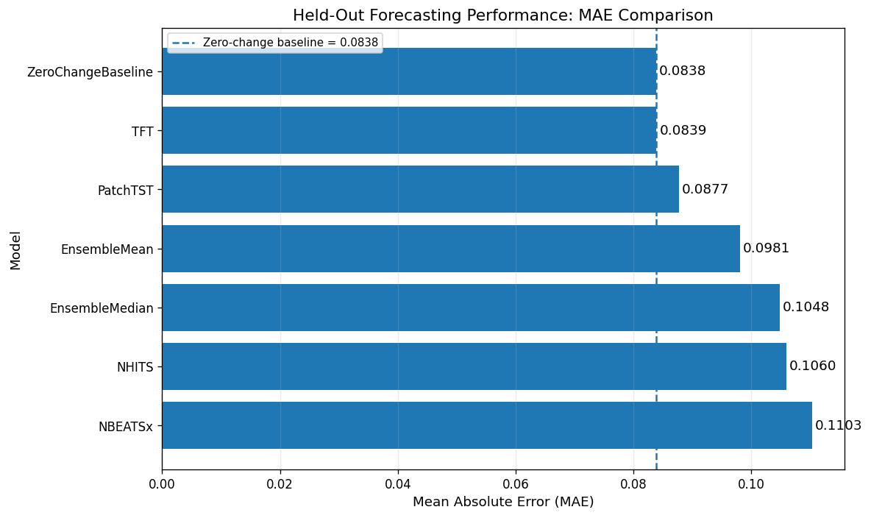
Figure V7-1: Held-out MAE by model, sorted best to worst, with the zero-change baseline shown as a dashed reference line.
ZeroChangeBaseline and TFT are visually indistinguishable at the top of the chart (0.0838 vs. 0.0839); every other model sits measurably above the baseline.
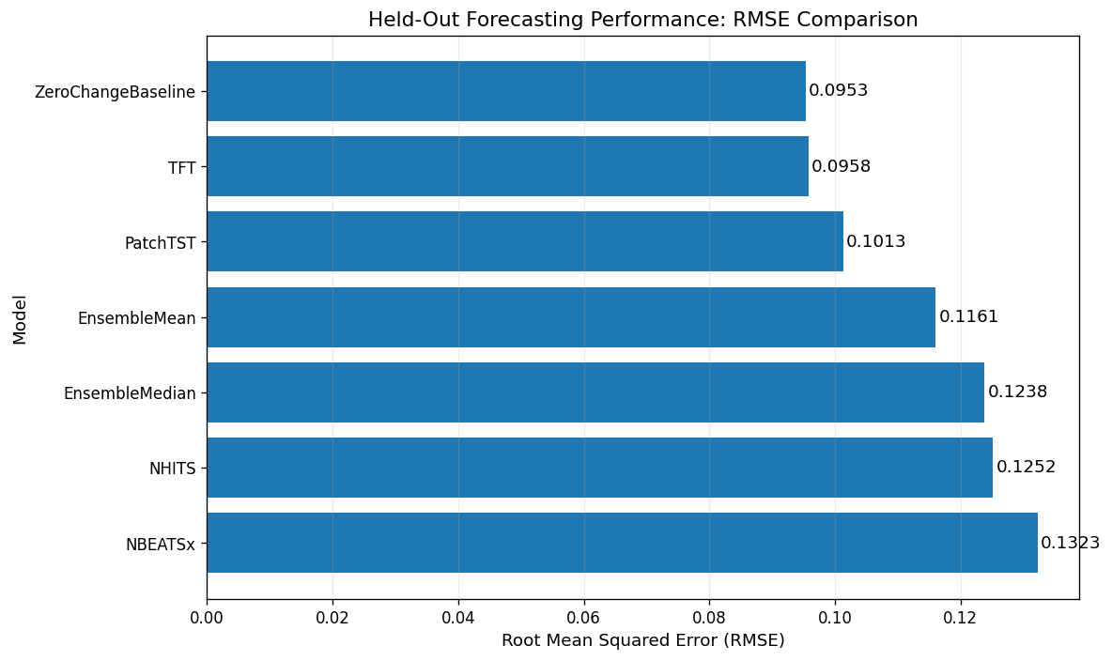
Figure V7-2: Held-out RMSE by model, sorted best to worst.
The RMSE ordering mirrors the MAE ordering exactly, confirming the ranking is not an artefact of one particular error metric.
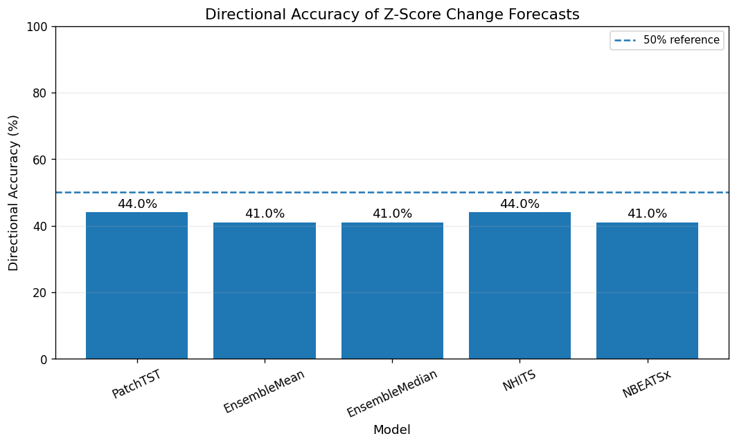
Figure V7-3: Directional (sign) accuracy of the five models that produce a non-zero forecast, against the 50% reference line.
All five models fall below the 50% random-guess reference, with NHITS and PatchTST the least far below it at 44.0%.
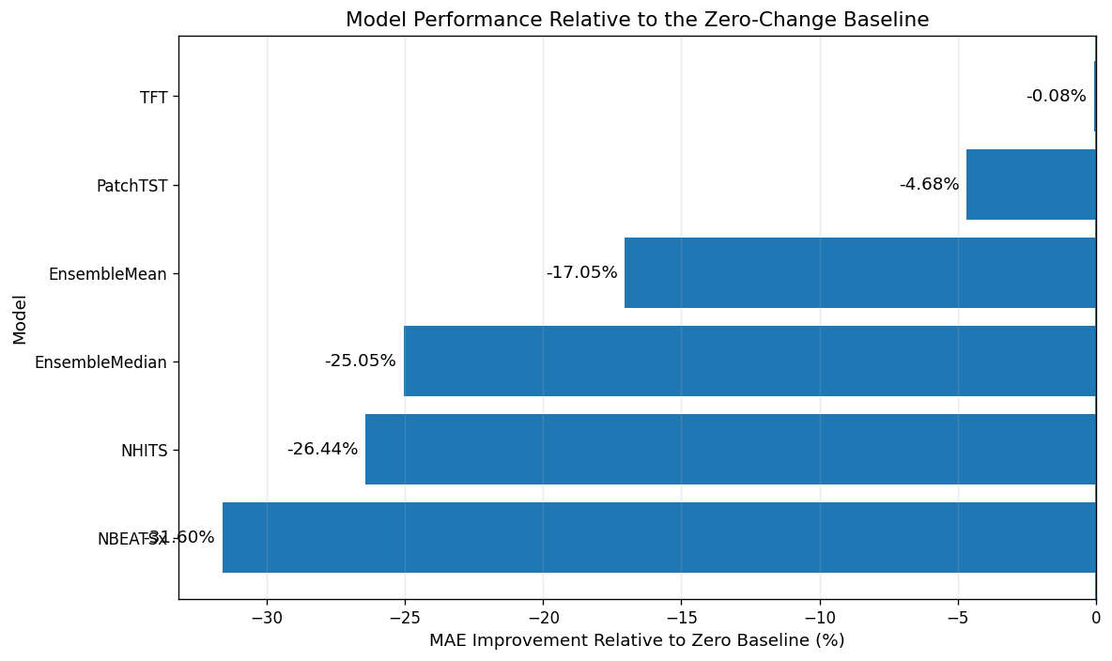
Figure V7-4: Percentage change in MAE relative to the zero-change baseline for every trained model.
TFT is effectively at parity with the baseline (−0.08%); NBEATSx is the weakest model at −31.6%.
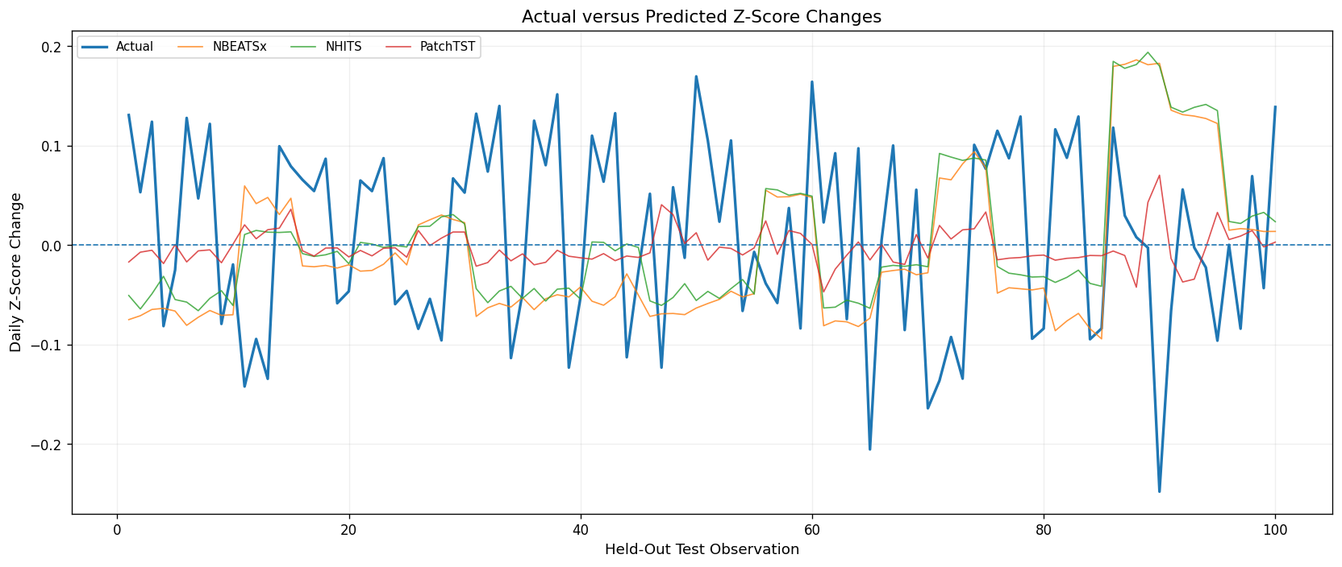
Figure V7-5: Actual vs. predicted daily z-score changes across all 100 held-out observations for NBEATSx, NHITS, and PatchTST.
The actual series (blue) swings between roughly −0.25 and +0.20, while all three models' forecasts stay compressed near zero — a visual confirmation that the exogenous-feature models are under-forecasting the true variance of the target.
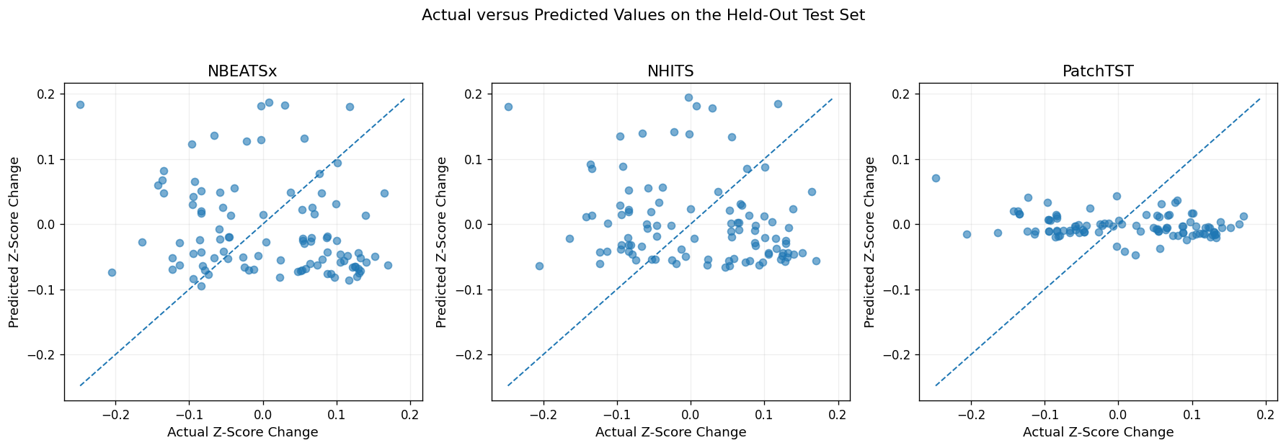
Figure V7-6: Actual vs. predicted scatterplots for NBEATSx, NHITS, and PatchTST, with the 45° perfect-forecast line for reference.
Points cluster in a narrow horizontal band rather than tracking the diagonal, most visibly for PatchTST, again illustrating that predictions are far less dispersed than the actual outcomes.
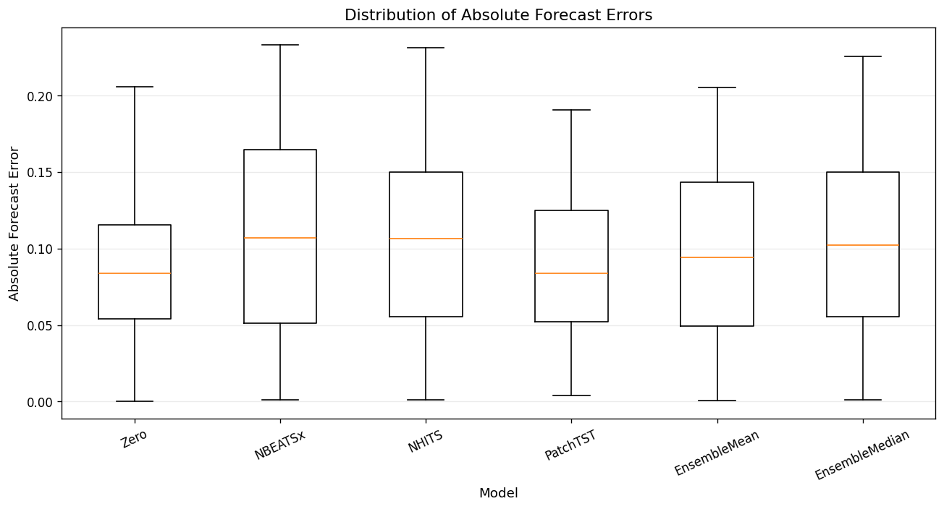
Figure V7-7: Box-and-whisker distribution of absolute forecast errors for the zero baseline and every trained model.
The zero baseline and PatchTST have the lowest median absolute error and the tightest interquartile range; NBEATSx and NHITS show both a higher median error and a wider spread.
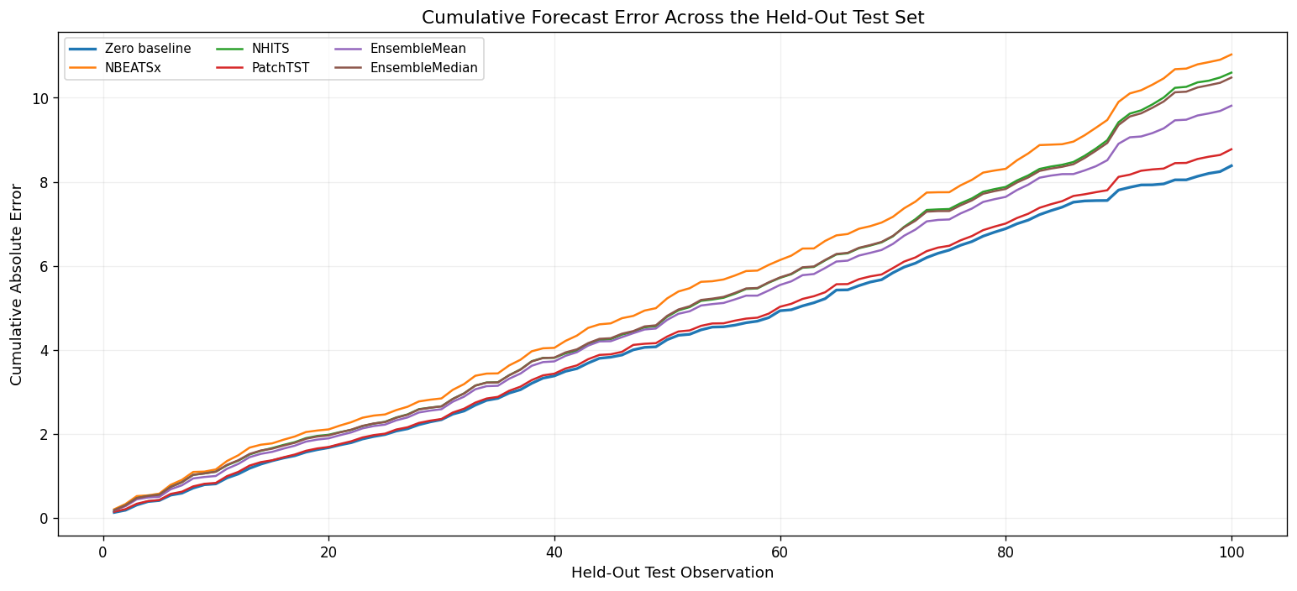
Figure V7-8: Cumulative absolute error accumulated across the 100 held-out observations, by model.
The zero baseline and PatchTST track closely together with the lowest cumulative error throughout the test window; NBEATSx accumulates error fastest and finishes highest.
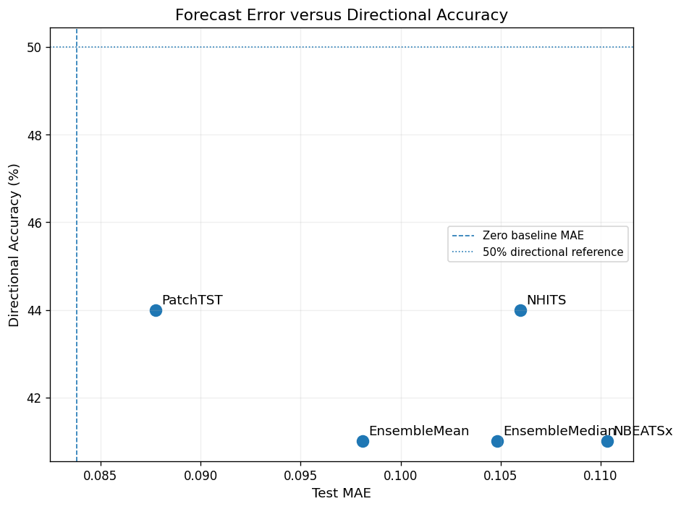
Figure V7-9: Joint view of test MAE (x-axis) against directional accuracy (y-axis) for the five non-trivial models.
PatchTST sits furthest to the left (lowest error) among the exogenous/ensemble models; no model reaches the 50% directional-accuracy reference line, shown as a dotted line, or the zero-baseline MAE, shown as a dashed line.
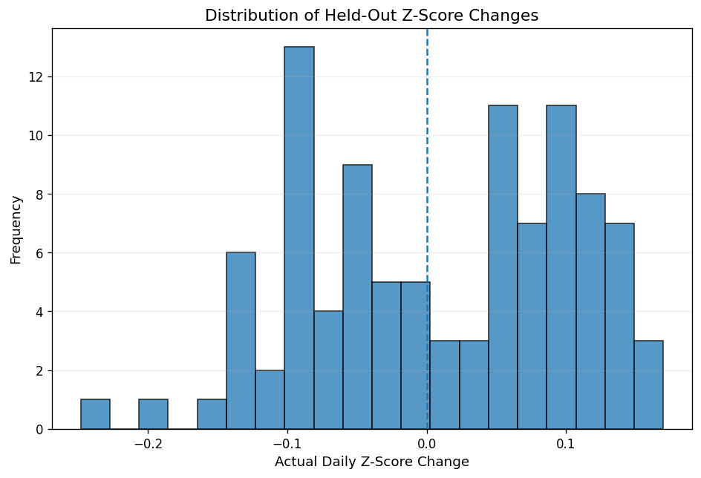
Figure V7-10: Histogram of the actual held-out z-score changes used to score every model.
The distribution is roughly symmetric and centred near zero with a long-ish tail toward negative values, consistent with the near-zero-mean, noisy nature of the target discussed in Section 3.5.5.
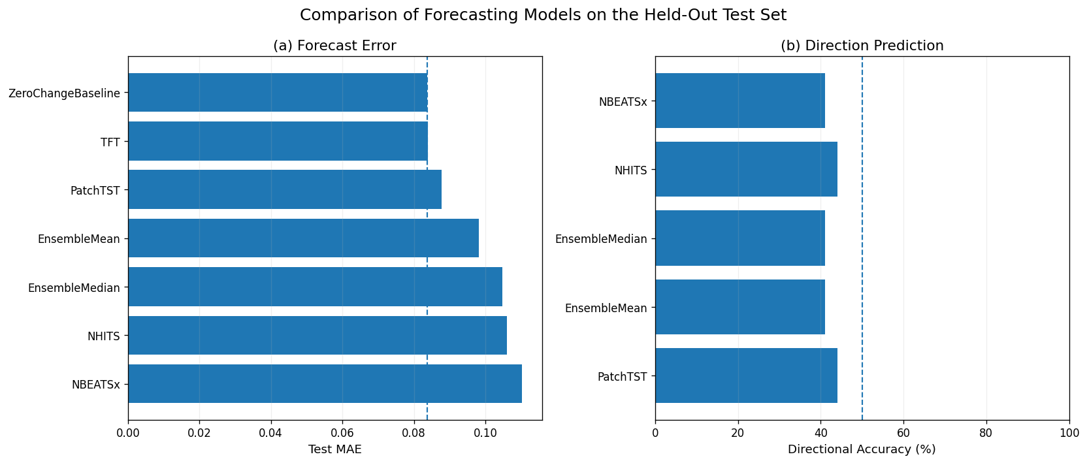
Figure V7-11: Two-panel paper summary — (a) test MAE for all models including the zero baseline, and (b) directional accuracy for the five non-trivial models — intended as the main results figure for publication.
Panel (a) reproduces the Figure V7-1 ranking; panel (b) shows every model's directional accuracy falling short of the 50% dashed reference line.

Reproducibility: Manifest and Consolidated Hyperparameters
At the end of the run, the notebook writes a manifest.json under /kaggle/working/fx_models_v7/ that records the pipeline version, random seed (42), source CSV path, the exact target definition, the full historical and known-future feature lists, the explicitly excluded leakage columns, per-model checkpoint/prediction file paths, and every metric reported in the leaderboard above. A companion hyperparameters.json consolidates the TFT and NeuralForecast configurations from Section 4.11 in one place. Together these two files make the V7 run fully auditable and reproducible independent of this report.

Chapter 6 Project Planning and Budget

The successful implementation of the proposed hybrid foreign exchange (FX) forecasting framework requires proper project planning, time management, and resource allocation. The project is divided into several phases, including data collection, preprocessing, econometric modeling, deep learning implementation, hybrid framework integration, experimentation, evaluation, and final documentation.
The planning process ensures systematic development, efficient utilization of computational resources, and timely completion of research objectives.

Project Planning
The project development process consists of the following major phases:

 | Activities
Phase 1 | Literature review and problem identification
Phase 2 | Collection of FX price, economic calendar, and GDELT datasets
Phase 3 | Data preprocessing and feature engineering
Phase 4 | Econometric analysis using GARCH and DCC-GARCH
Phase 5 | Implementation of PatchTST and TFT models
Phase 6 | Hybrid framework integration and optimization
Phase 7 | Experimentation, testing, and performance evaluation
Phase 8 | Documentation, report writing, and final presentation
Table 12: Project Planning

Estimated Budget
The project mainly requires computational resources, cloud-based services, internet access, and development tools for AI-based forecasting and financial analysis.

Component | Estimated Cost (BDT)
High-Performance Laptop / Workstation | 85,000
NVIDIA GPU / Cloud GPU Access | 18,000
Internet and Network Services | 9,000
Cloud Storage and Computing Services | 12,000
Financial Dataset / API Access | 5,000
Google BigQuery Access | 3,000
SSD Storage Upgrade | 6,000
Research Papers / Journal Access | 3,500
Electricity and Computational Cost | 7,500
Report Printing and Documentation | 2,000
Presentation and Demonstration Materials | 1,500
Miscellaneous Expenses | 3,500
| Total Estimated Cost | 152,500 BDT |

Table 13: Estimated Project Cost

Resource Utilization
The project utilizes:

    - Open-source AI and econometric libraries
    - Cloud-based GPU platforms such as Google Colab
    - Financial APIs and cloud datasets
    - GPU acceleration for Transformer model training

This approach reduces infrastructure cost while enabling efficient large-scale experimentation and forecasting analysis.
Overall, the project planning and budget structure provide a scalable, organized, and cost-effective framework for implementing the proposed hybrid FX forecasting and volatility analysis system.

Chapter 7 Complex Engineering Problems and Activities
The development of the proposed hybrid foreign exchange (FX) forecasting framework involved a number of complex engineering problems and activities that necessitate advanced analytical reasoning, interdisciplinary research, experimentation and continuous optimisation. The project was a mix of financial engineering, econometric modelling, deep learning and event-driven data analysis so the implementation process was much more than a standard software development practice.
The main challenge of the project was to get a deeper understanding of the financial market. Foreign exchange markets are very dynamic, nonlinear and strongly influenced by macro economic announcements, geopolitical events, investor sentiment and volatility spillovers across currencies. These behaviours required extensive research to model correctly:
- FX market structure and volatility behavior

- Macroeconomic indicators and economic calendar events

- Correlation and spillover effects among currency pairs

- Financial time-series forecasting techniques

- Econometric volatility models such as GARCH and DCC-GARCH

Understanding how financial markets react during high-volatility periods and macroeconomic announcements was a critical engineering challenge throughout the research.
Another complex engineering activity involved the integration and fusion of multiple heterogeneous datasets. The project combined:
- Historical FX price data

- Economic calendar and macroeconomic event data

- GDELT global event and sentiment data

These datasets were collected from different sources, had different formats and frequencies, and required synchronization, preprocessing, feature engineering, and normalization before they could be used within the forecasting framework.
A major technical challenge was designing the hybrid forecasting architecture by combining:
  - PatchTST

  - Temporal Fusion Transformer (TFT)

  - DCC-GARCH econometric volatility modeling

Numerous combinations and fusion strategies were tested during experimentation. Different approaches were explored regarding:
  - Volatility feature integration

  - Sequence length selection

  - Attention mechanisms

  - Event-driven feature incorporation

  - Multi-horizon forecasting structures

  - Correlation feature embedding

  - Forecast fusion methods

The project required repeated experimentation and iterative system redesign to identify the most effective hybrid architecture for FX forecasting and volatility analysis.
Fine-tuning the Transformer-based models was another highly complex engineering task. Since financial time-series data behave differently from traditional datasets, extensive hyperparameter optimization was necessary to improve forecasting stability and generalization. Multiple experiments were conducted involving:
  - Learning rate optimization

  - Batch size tuning

  - Hidden layer dimension adjustment
  - Attention head configuration

  - Sequence patch sizing for PatchTST

  - Variable selection tuning for TFT

  - Forecast horizon optimization

  - Regularization and dropout strategies

Different configurations often produced significantly different forecasting results, especially during highly volatile market periods.
Another important engineering challenge involved balancing:

- Forecasting accuracy

- Computational efficiency

- Model interpretability

- Volatility sensitivity

- Training stability

Transformer-based architectures provided strong nonlinear learning capabilities but required high computational resources and GPU acceleration. At the same time, econometric models provided statistical interpretability but had limitations in capturing nonlinear market structures. Combining both approaches into a unified system required extensive experimentation and engineering trade-offs.
The project also involved advanced preprocessing and statistical analysis activities such as:

- Stationarity testing using ADF tests

- Johansen cointegration analysis
- Volatility estimation

- Dynamic correlation analysis

- Feature engineering from macroeconomic and GDELT data

- Time-series sequence generation

These processes required deep understanding of both econometrics and machine learning methodologies.
Additionally, model validation and evaluation represented another major engineering activity. The forecasting framework was tested under:

- Different market conditions

- Multiple forecasting horizons

- Volatile and stable market regimes

- Macroeconomic announcement periods Comparative analyses were performed between:
- Traditional econometric models

- Standalone Transformer models

- Hybrid forecasting architectures using Evaluation metrics such as:
- RMSE
- MAE
- Directional Accuracy
The project also required efficient resource management due to the computational complexity of Transformer-based forecasting. GPU acceleration, cloud-based notebook environments, and optimized training pipelines were necessary to manage long training times and large-scale financial datasets efficiently.

Overall, the project involved significant complex engineering activities including financial market research, hybrid AI-econometric model development, dataset fusion, Transformer fine-tuning, volatility modeling, experimentation, computational optimization, and forecasting system validation. The research demonstrates the application of advanced engineering methodologies and interdisciplinary problem-solving techniques to address complex real-world challenges in intelligent financial forecasting and risk analysis.

Chapter 8 Conclusions

In this project, a hybrid forecasting approach was successfully developed using DCC-GARCH and Temporal Fusion Transformers (TFT). The main idea was to create a forecasting mechanism that would be able to capture not only the features of volatility in financial markets but also complicated nonlinear temporal relations characteristic of contemporary FX markets.
This project successfully developed a hybrid forecasting model that merges DCC-GARCH with Temporal Fusion Transformers (TFT) to forecast and analyze the behavior of foreign exchange (FX) markets. The central objective was to build a forecasting system capable of simultaneously capturing the statistical properties of financial market volatility and the complex nonlinear temporal relationships that define modern currency markets.
The hybrid model produced a final MQLoss value of 0.0154, where the convergence of the training losses occurred across all 18 groups, from an initial range of approximately 4.0 to 4.5 to a final range of 1.43 to 1.65 after 200 training steps. On the test set, the hybrid model scored 85.18% in terms of directional accuracy, 0.0308 in MAE, and 0.0708 in RMSE. The probabilistic interval coverage was at 76.17%, while it should have been expected to be at 80%; however, the average width of the intervals for each step of forecasting is only 0.0907 units – a very well-calibrated and appropriately narrow prediction interval. Test results of the model on three selected currency groups had MAE from 0.009428 to 0.009811 and RMSE from 0.011795.
Further validation tests were conducted on the basis of stress testing for three significant real-life market events. In the case of the Russia-Ukraine war (February 24, 2022), the forecast gave an overestimate of 15.3%, with the sigma of realization lying inside the 80% prediction interval. For the UK gilt crisis (September 28, 2022), the estimate showed a similar overestimate of 15.9%. This time, too, the sigma of realization lay inside the prediction interval. However, the SVB bank crash (March 10, 2023) became quite difficult for the model to deal with, as the forecast underestimated by 141%, with the sigma of realization falling out of the interval.
Unlike conventional standalone models, the proposed approach delivers a flexible and contextual model for forecasting FX market volatility. The combination of the robustness of DCC-GARCH modeling with the complex pattern detection ability of Transformer-based deep learning, along with the introduction of macroeconomic calendar events and GDELT global news, ensures that FX Fusion will be able to foresee changes in volatility before such changes can be seen in the price data – a feat that is beyond the capabilities of either econometrics or deep learning alone.

Limitations

Despite the promising results, several limitations of the current framework should be acknowledged:
    - Training budget constraint: Since the number of max steps was kept constant at 200, and early stopping was disabled, some currency pairs may still be in the process of achieving complete convergence. The training losses ranging from 1.43 to 1.65 obtained at step 200 suggest that the model could potentially still learn further.
    - Sparse validation checkpointing: Loss during validation was recorded only in steps 100 and 200. With more frequent checkpoints in intervals of 10 steps, it would be possible to detect the exact optimum stopping points for each currency type.
    - Partial test-set evaluation: Metrics for testing were only obtained for 3 out of the 18 currency clusters. A complete assessment of performance among all 18 currency clusters is necessary in order to get a better idea of how the different clusters are performing and which clusters pose difficulties in forecasting.
    - Interval coverage gap: The 80% prediction interval achieved an empirical coverage rate of 76.17%, falling slightly below the nominal target. While the intervals are appropriately tight rather than excessively conservative, achieving the intended 80% coverage would strengthen the framework's reliability for formal risk management applications.
    - Regime-breaking shock sensitivity: The 80% confidence interval provided a coverage percentage of 76.17%. Although the intervals have been constructed in the appropriate way without being too conservative, it will be more desirable if they can attain the desired level of coverage of 80%.
    - Hardware constraints: Models Training All 18 models were trained in sequence using a MacBook Air (Apple Silicon) computer with no parallel computation with the use of the GPU. As a result, the scope of the hyper-parameters tuning and configuration of the model was restricted.

Future Work
Several directions for future research and development are identified to extend and strengthen the FX Fusion framework:
    - Extended training with GPU acceleration: The use of a maximum number of steps equal to 500-1000 with cloud computing GPUs and precise early stopping will enable all 18 models to converge, thus possibly optimizing the MQLoss and directionality results.
    - Integration of live data streams: Linking the system to actual financial API's and GDELT feeds would provide online prediction capability, as well as the ability of the model to adapt to emerging events
    - Reinforcement learning for trading strategy optimization: Probabilities produced through the TFT model, which include the 10th, 50th, and 90th quantile probabilities, could serve as rewards for a reinforcement learning algorithm, facilitating the automatic creation and optimization of FX trading strategies that are risk-sensitive.
    - Multimodal sentiment analysis: Combining large language model (LLM) sentiment extraction based on the communication of the central banks, earnings calls, and social media along with the structured data from GDELT could help enhance the regime-changing signal detection capability of the model.
    - PatchTST hybrid integration: Although DCC-GARCH + TFT was considered the main hybrid in this project, future research must conduct thorough evaluation of DCC-GARCH + PatchTST in order to establish if there is a better long-range volatility memory capture using patches for attention mechanism in the FX world.
    - Interval calibration improvement: The application of either conformal prediction methods or isotonic regression adjustments on the quantiles generated by the algorithm may take the empirical coverage rate up to the target rate of 80%, which is currently at 76.17%.
    - Expansion to broader asset classes: The proposed DCC-GARCH + Transformer approach has architectural generalizability outside FX trading. The next step may be applying the same architecture to other financial assets like stock market indices, commodity futures, and bond securities.

References

      - Dickey, D. A., & Fuller, W. A. (1979). Distribution of the estimators for autoregressive time series with a unit root. Journal of the American Statistical Association, 74(366), 427–431. https://doi.org/10.1080/01621459.1979.10482531
      - Johansen, S. (1988). Statistical analysis of cointegration vectors. Journal of Economic Dynamics and Control, 12(2–3), 231–254.
https://doi.org/10.1016/0165-1889(88)90041-3
      - Engle, R. F., & Granger, C. W. J. (1987). Co-integration and error correction: Representation, estimation, and testing. Econometrica, 55(2), 251–276. https://doi.org/10.2307/1913236
      - Engle, R. F. (1982). Autoregressive conditional heteroskedasticity with estimates of the variance of United Kingdom inflation. Econometrica, 50(4), 987–1007. https://doi.org/10.2307/1912773
      - Bollerslev, T. (1986). Generalized autoregressive conditional heteroskedasticity.
Journal of Econometrics, 31(3), 307–327. https://doi.org/10.1016/0304-4076(86)90063-1
      - Engle, R. (2002). Dynamic conditional correlation: A simple class of multivariate GARCH models. Journal of Business & Economic Statistics, 20(3), 339–350. https://doi.org/10.1198/073500102288618487
      - Hamilton, J. D. (1994). Time series analysis. Princeton University Press.
      - Enders, W. (2015). Applied econometric time series (4th ed.). John Wiley & Sons.
      - Lim, B., Arık, S. Ö., Loeff, N., & Pfister, T. (2021). Temporal fusion transformers for interpretable multi-horizon time series forecasting. International Journal of Forecasting, 37(4), 1748–1764. https://doi.org/10.1016/j.ijforecast.2021.03.012
      - Nie, Y., Nguyen, N. H., Sinthong, P., & Kalagnanam, J. (2023). A time series is worth 64 words: Long-term forecasting with transformers. In International Conference on Learning Representations (ICLR). https://openreview.net/forum?id=Jbdc0vTOcol
      - Google BigQuery Documentation
      - Chung, V., Espinoza, J., & Mansilla, A. (2024). Analysis of financial contagion and prediction of dynamic correlations during the COVID-19 pandemic: A combined DCC-GARCH and deep learning approach. Journal of Risk and Financial Management, 17(12), 567. https://doi.org/10.3390/jrfm17120567
      - Taneva-Angelova, G., & Granchev, D. (2025). Deep learning and transformer architectures for volatility forecasting: Evidence from U.S. equity indices. Journal of Risk and Financial Management, 18(12), 685. https://doi.org/10.3390/jrfm18120685
      - Likassa, H. T., Chen, D. G., Nadarajah, S., et al. (2025). A multivariate GARCH model with time-varying correlations: What do inflation data show in Ethiopia? Computational Economics. Advance online publication. https://doi.org/10.1007/s10614-025-10951-y
      - Guirguis, M. Z. (2018, September 22). Application of GARCH, TGARCH, and EGARCH models to test the spot GBP/USD exchange rate volatility. SSRN. https://doi.org/10.2139/ssrn.3253608

