Superstore Sales Analysis
Business Intelligence Report
January 02, 2026

Executive Summary
This comprehensive analysis examines sales performance data from a superstore spanning 2022-2025. The analysis employs advanced business intelligence techniques including regional deep-dives, product portfolio classification, and seasonality indexing to provide actionable insights for revenue optimization.
Key findings reveal:
• Strong overall sales growth trajectory with strategic seasonal patterns
• Regional performance varies significantly, with West region leading
• Technology category dominates revenue at 36.4%, followed by balanced Furniture (32.3%) and Office Supplies (31.3%)
• Product portfolio analysis identifies distinct strategic categories requiring tailored discount and inventory strategies
• Seasonality analysis reveals predictable patterns for timing promotional campaigns

Methodology

Data Preprocessing
The dataset underwent rigorous preprocessing:
1. Date standardization and temporal feature engineering (year, month, quarter, week)
2. Removal of irrelevant columns (Postal Code, Country)
3. Duplicate record elimination
4. Data validation (negative values, shipping date logic)
5. Temporal adjustment to current period (2022-2025)

Analytical Framework
Three-phase analytical approach:
Phase 1: Exploratory Data Analysis (EDA)
- Temporal trend analysis (yearly, quarterly, monthly, weekly)
- Time series decomposition (trend, seasonality, residuals)
- Regional and product category segmentation
Phase 2: Strategic Product Classification
- 2x2 Matrix: Value (Revenue) × Volume (Transaction Frequency)
- Five strategic categories: Star, Luxury, Traffic Builder, Dead Zombie, New/Niche
- Recency-based classification (6-month cutoff for zombie identification)
- Median-based thresholds for peer comparison within sub-categories
Phase 3: Seasonality Indexing
- Monthly sales patterns by sub-category and state
- Seasonality Index = Monthly Sales / Average Monthly Sales
- Peak Season (>1.2), Valley (<0.8), Normal (0.8-1.2)
- Coefficient of Variation (CV) for pattern stability assessment

Key Findings

Overall Performance Metrics
Total Sales Revenue | $2,261,536.78
Total Orders | 4,922
Average Order Value | $459.48
Sales Growth (2022-2025) | 50.5%
Analysis Period | 2022 - 2025

Sales Trends Analysis
Figure 1: Yearly Sales Performance
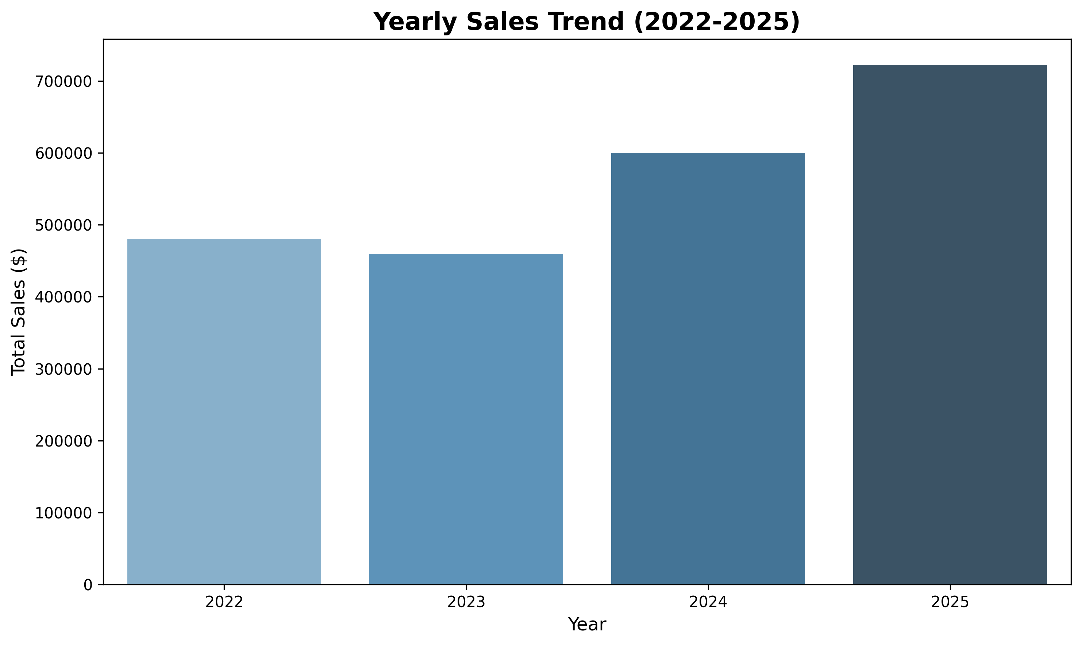
Insight: The data shows a consistent growth trajectory from 2022 to 2025, with a slight dip in 2023 followed by strong recovery. This indicates resilient market performance and effective sales strategies.
Figure 2: Monthly Sales Seasonality
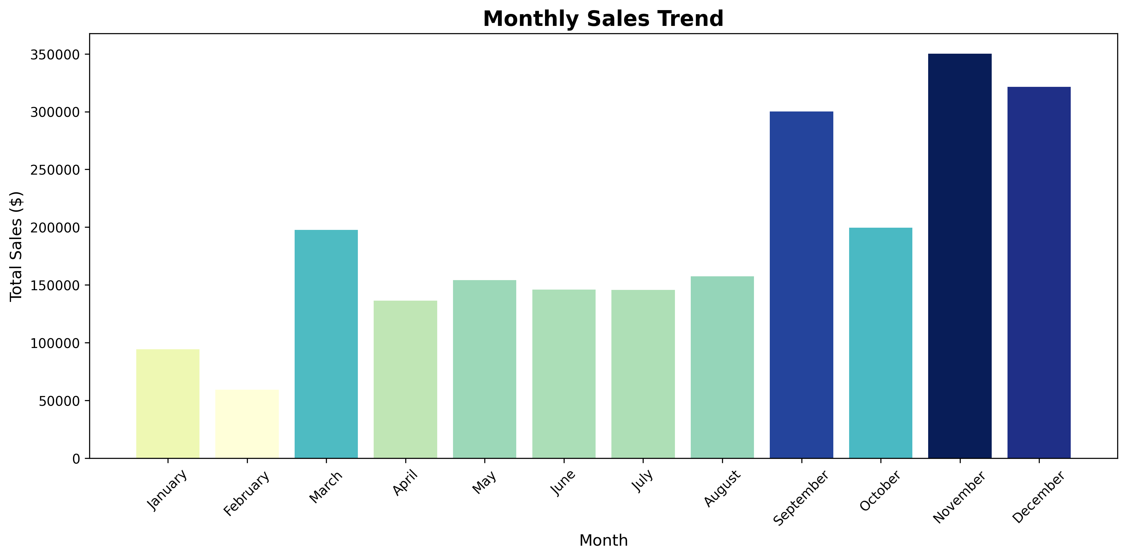
Insight: September, November, and December consistently show peak sales, driven by back-to-school and holiday shopping. Q1 months (January-March) represent valley periods suitable for clearance promotions.

Regional Performance Analysis
Figure 3: Sales by Region
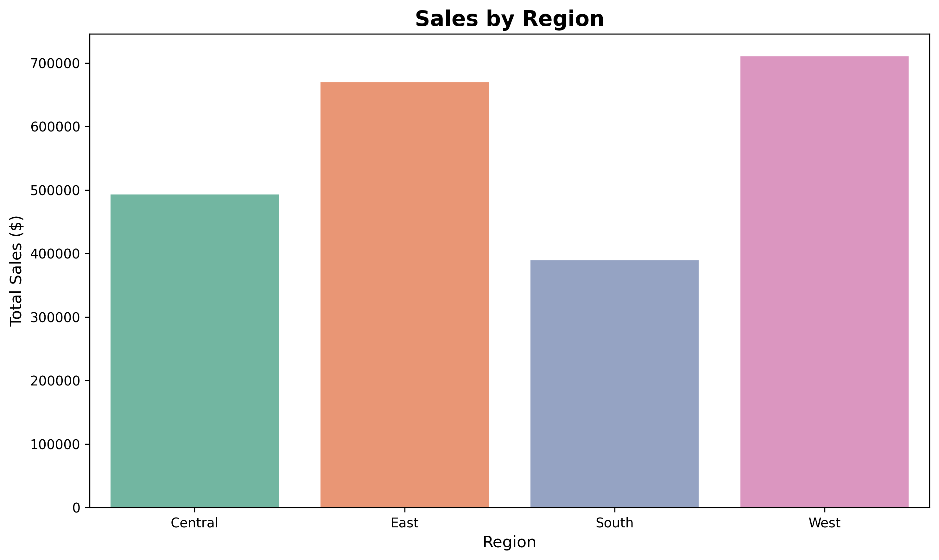
Regional Revenue Distribution:
• West: $710,219.68 (31.4%)
• East: $669,518.73 (29.6%)
• Central: $492,646.91 (21.8%)
• South: $389,151.46 (17.2%)
Strategic Implication: West region leadership suggests strong market penetration. Central region's lower performance indicates expansion opportunities.
Figure 4: Top States by Region
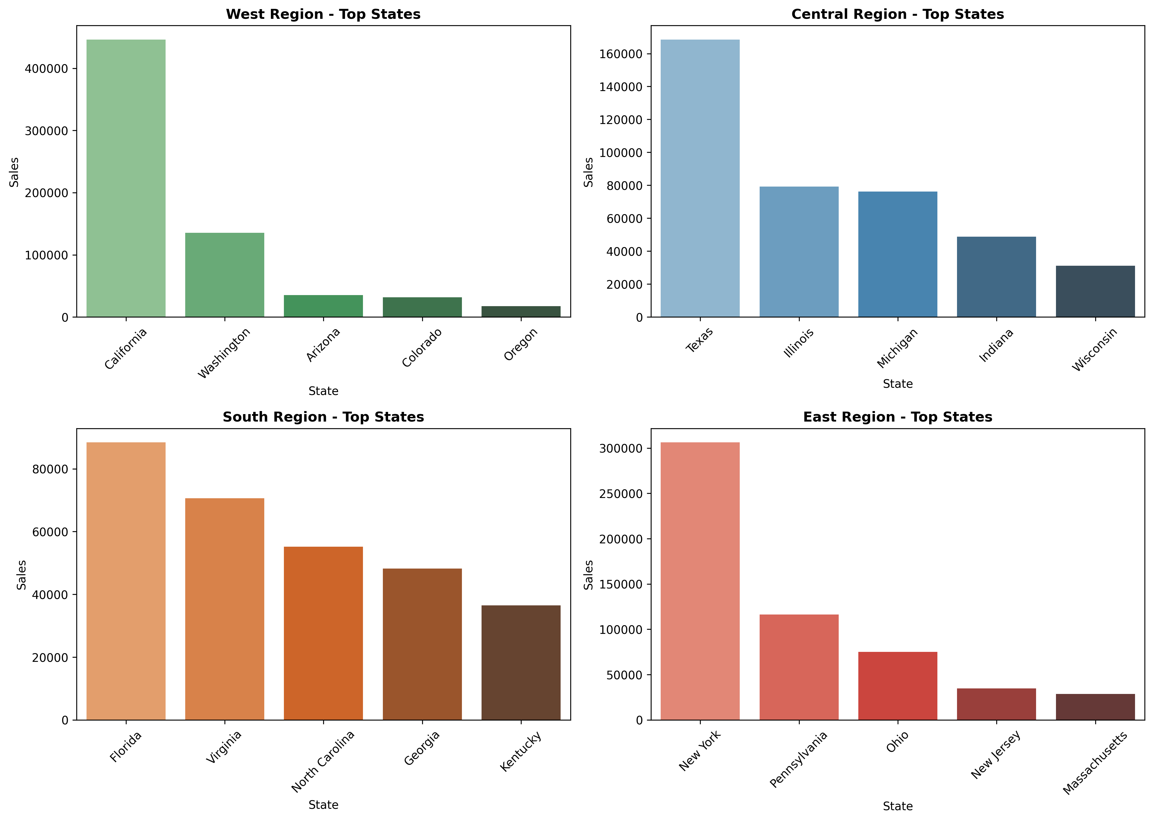

Product Portfolio Analysis
Figure 5: Sales Distribution by Category
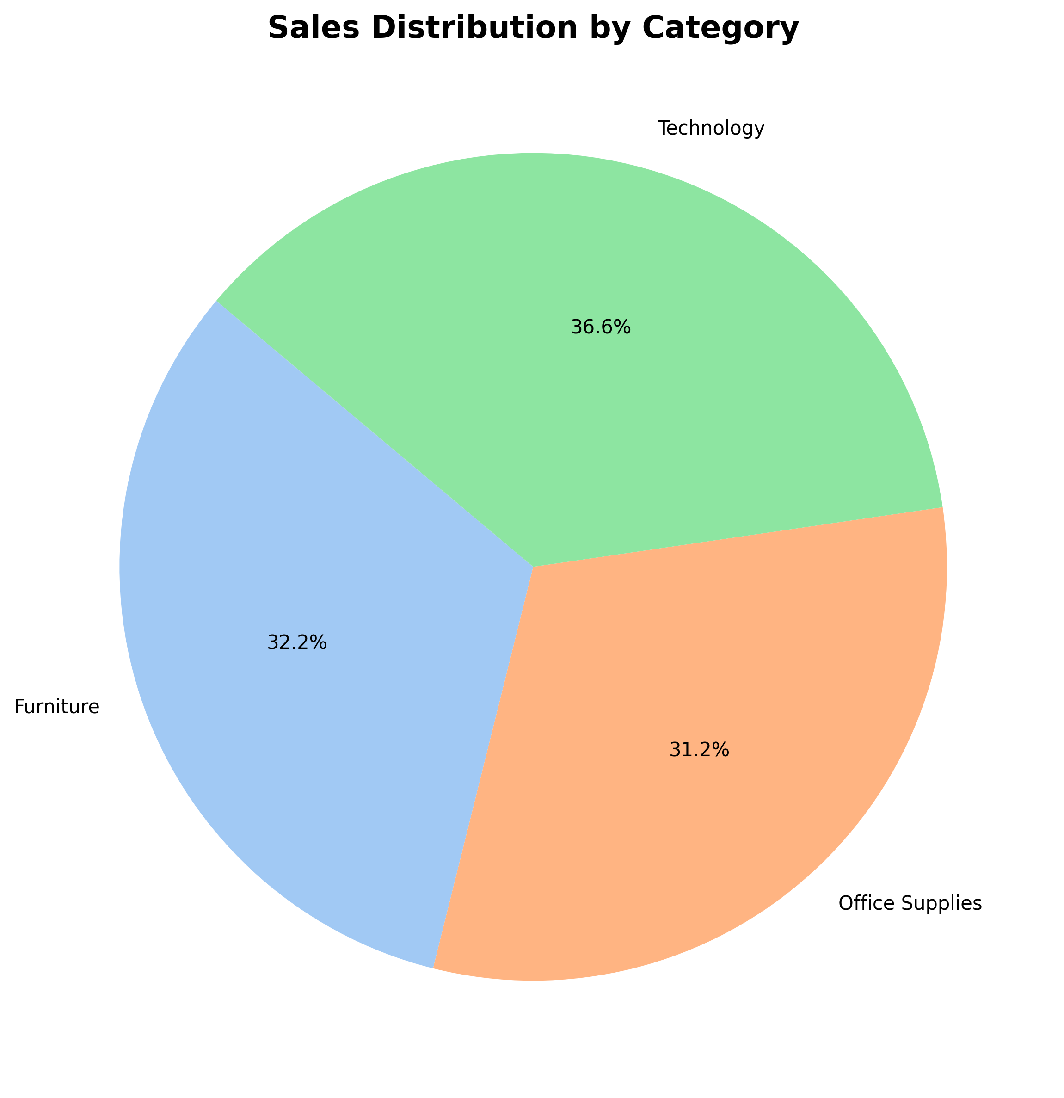
Category Performance:
• Technology: $827,455.87 (36.4%)
• Furniture: $728,658.58 (32.3%)
• Office Supplies: $705,422.33 (31.3%)
This balanced portfolio reduces business risk. Technology's slight lead indicates opportunity for margin optimization in high-value tech products.
Figure 6: Sub-Category Revenue Performance
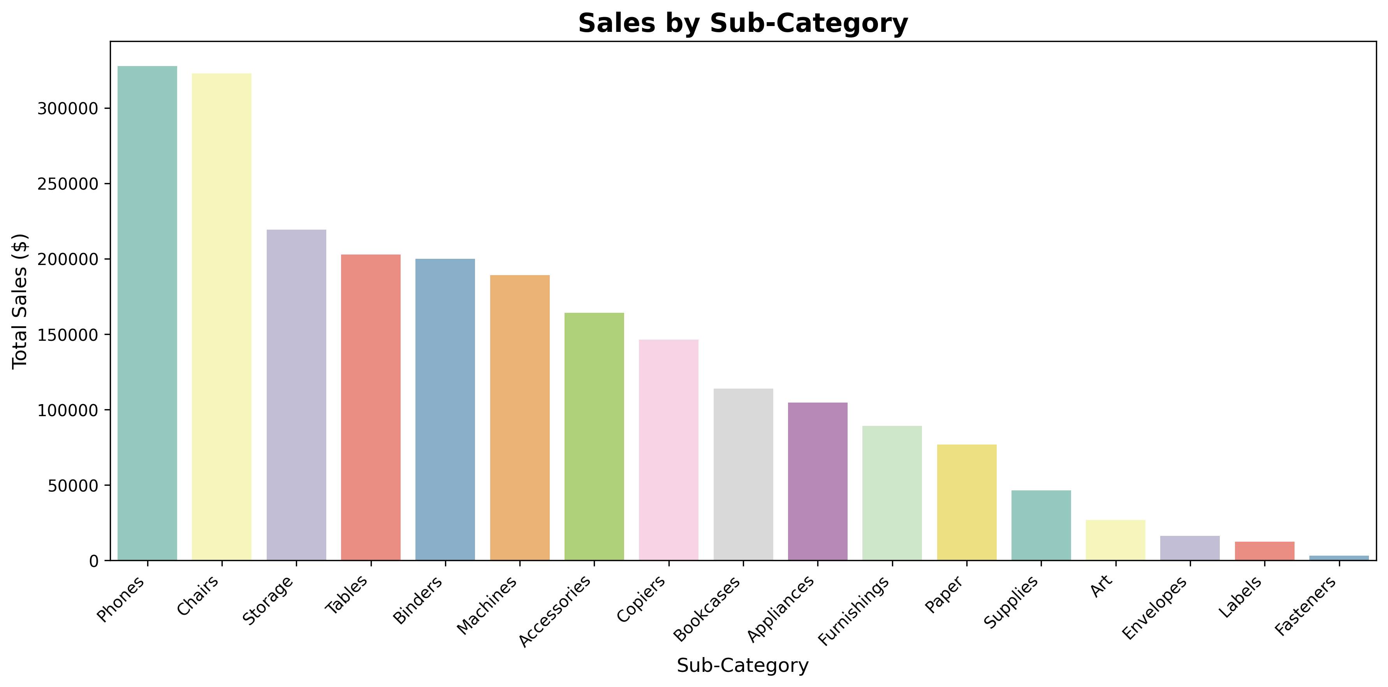
Top Revenue Sub-Categories:
1. Phones: $327,782.45
2. Chairs: $322,822.73
3. Storage: $219,343.39
These categories represent strategic focus areas for inventory optimization and targeted marketing campaigns.

Strategic Product Classification: New York Case Study
Figure 7: Product Portfolio Matrix (New York State)
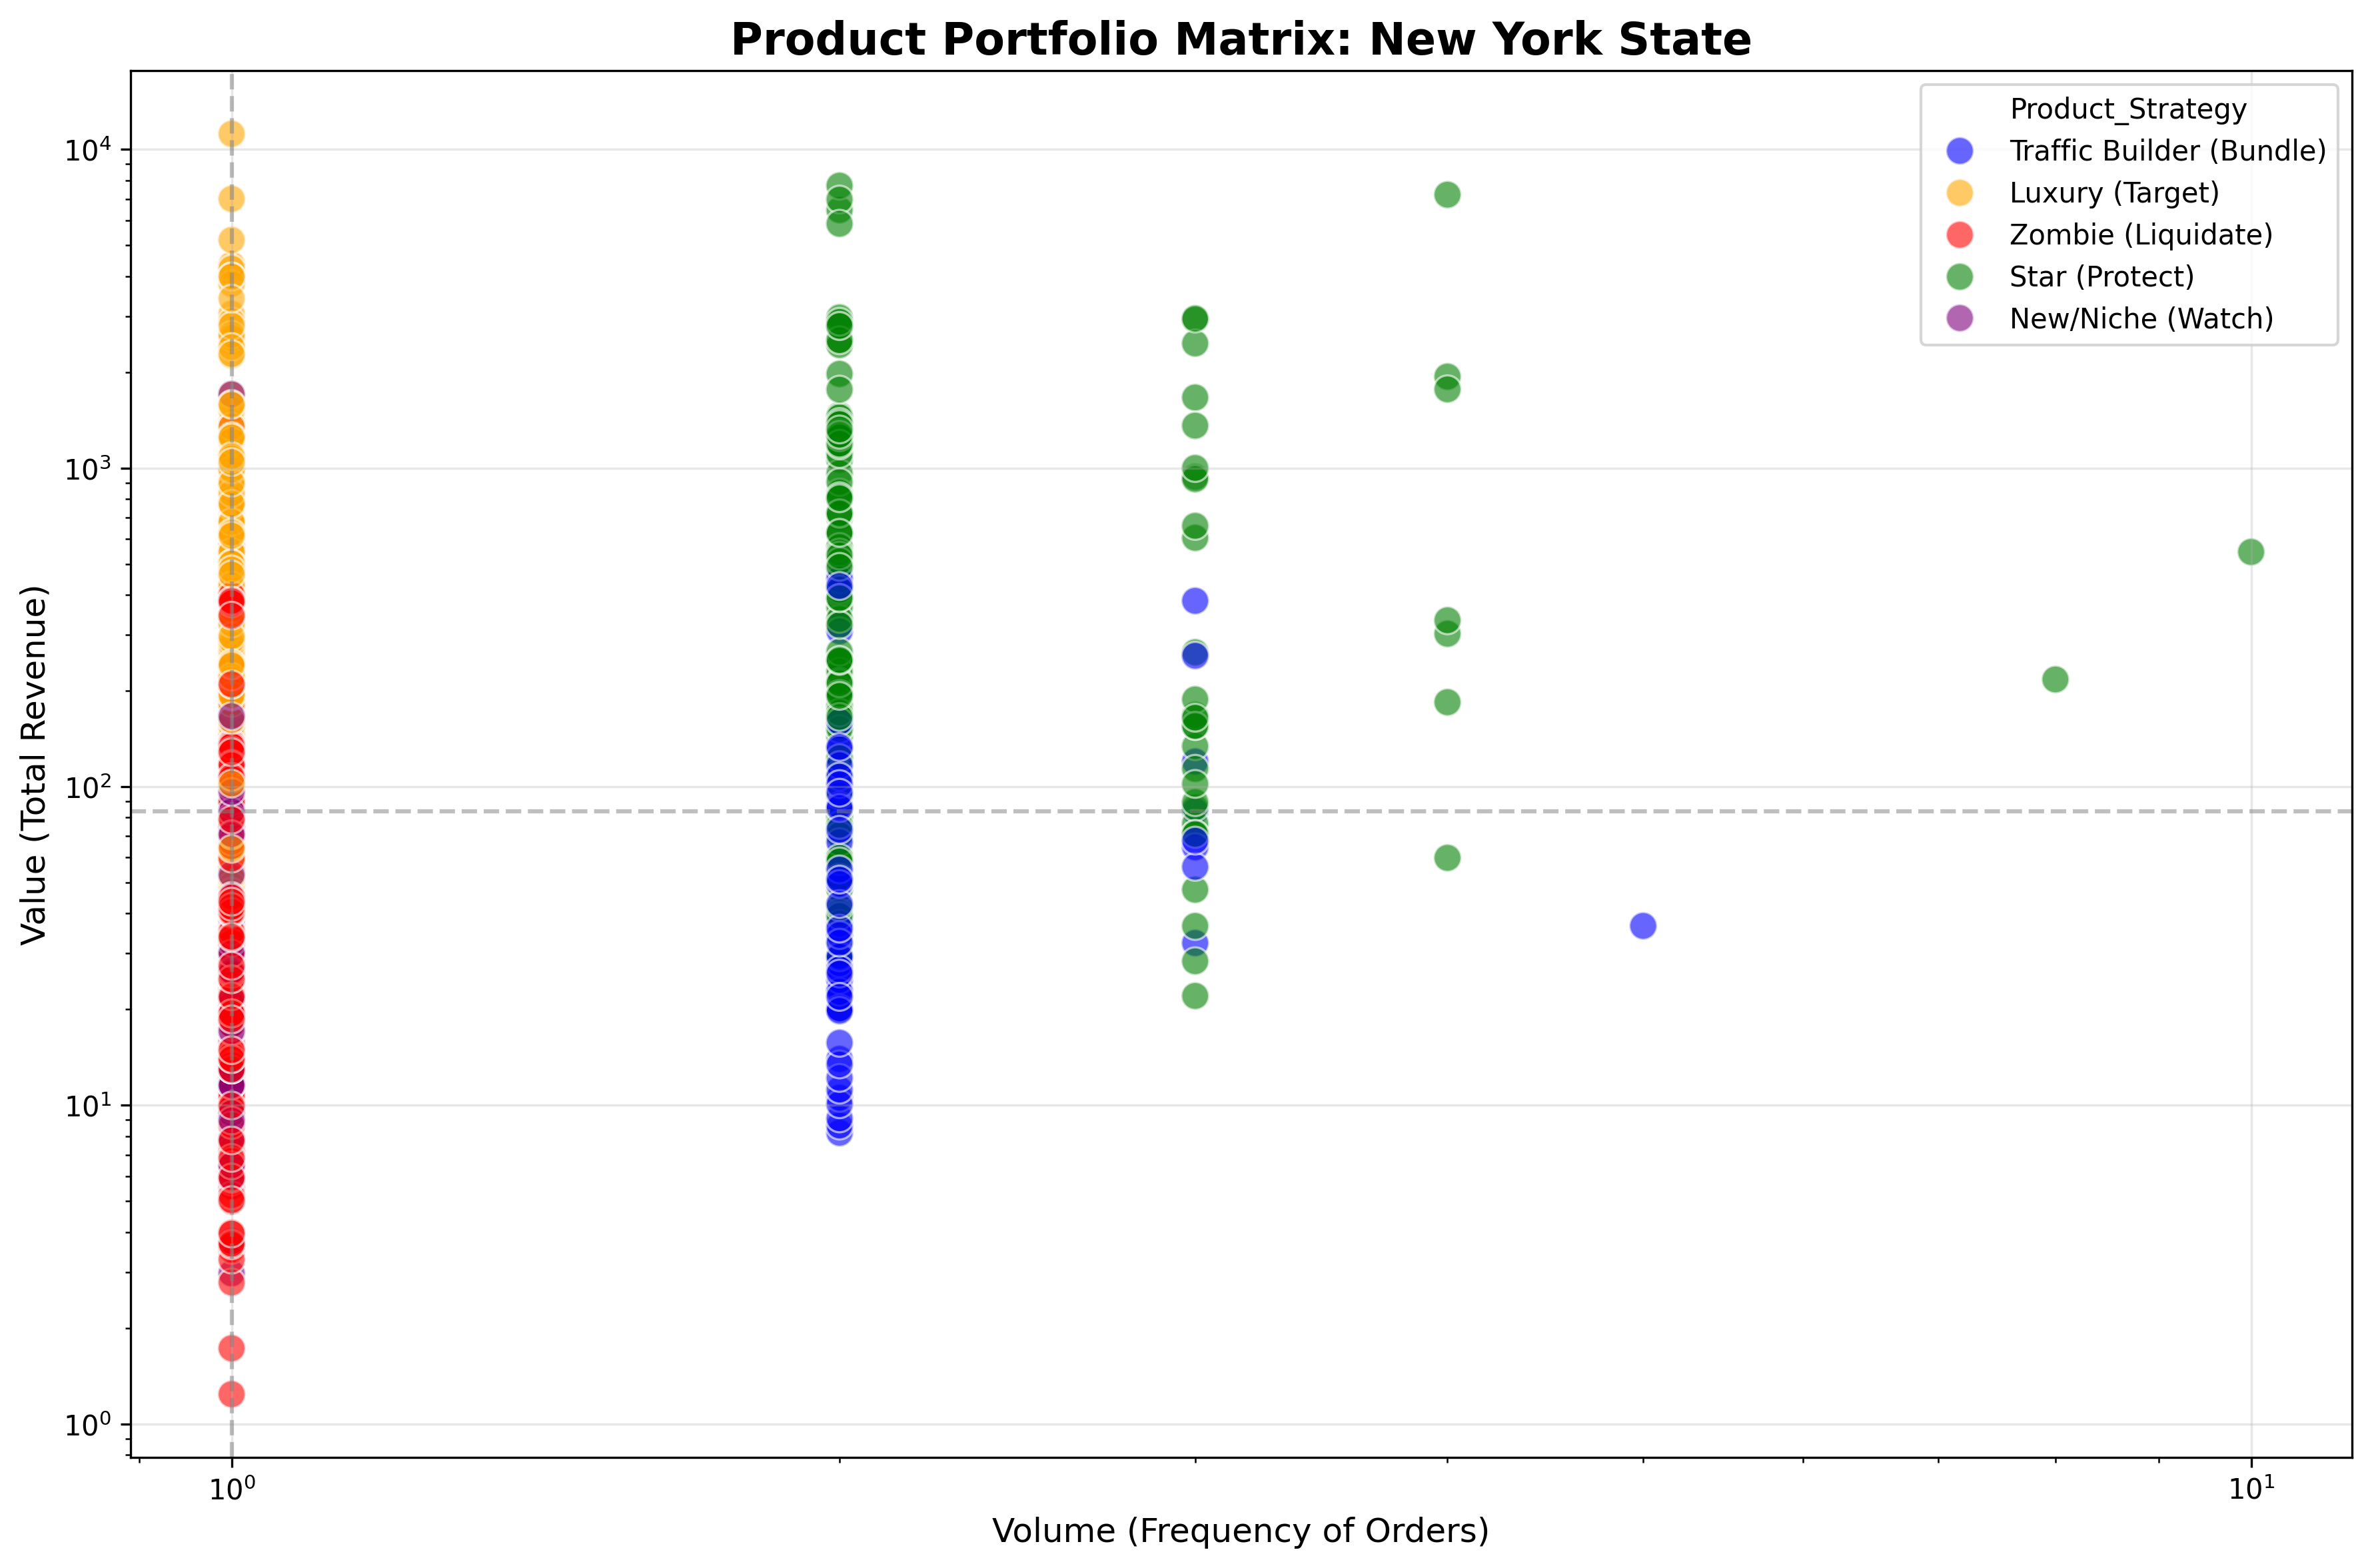
The Strategic Product Matrix classifies products into five categories based on Value (revenue) and Volume (transaction frequency):
1. Star (Protect) - High Value, High Volume
Strategy: Maintain premium positioning, never discount, ensure stock availability
2. Luxury (Target) - High Value, Low Volume
Strategy: Targeted promotions to high-value customers, bundle with stars
3. Traffic Builder (Bundle) - Low Value, High Volume
Strategy: Use for promotional bundles, cross-sell with luxury items
4. New/Niche (Watch) - Low Value, Low Volume, Recent Sales
Strategy: Monitor performance, test marketing channels
5. Dead Zombie (Liquidate) - Low Value, Low Volume, No Recent Sales (>6 months)
Strategy: Aggressive clearance, discontinue ordering
Key Finding: New York market shows high fragmentation (80% single-purchase products), shifting strategy from mass volume to high-value capture.

Strategic Recommendations

1. Revenue Optimization
• Protect Star products: Never discount high-value, high-volume items
• Target Luxury products: Offer exclusive promotions to premium customer segments
• Bundle Traffic Builders: Use high-frequency, low-value items to drive cross-sales
• Liquidate Zombies: Aggressive clearance for products with no sales in 6+ months
• Watch New/Niche: Allocate marketing budget to test emerging product potential

2. Seasonal Timing
• Peak Harvest (Index >1.2): Maximize margins during September, November, December
• Valley Discounts (Index <0.8): Clear inventory during Q1 (January-March)
• Normal Maintenance: Standard pricing for stable months (April-August, October)
• Category-specific timing: Apply seasonality index by sub-category for precision

3. Regional Strategy
• West Region: Leverage California's dominant position (62% of West sales)
• Central Region: Expand Texas market share (43% of Central sales)
• South Region: Focus on Florida as strategic hub (23% of South sales)
• East Region: Maintain New York's market leadership (45% of East sales)
• Apply "Kingmaker Rule": Prioritize top 1-2 revenue-generating states per region

4. Inventory Management
• All focus states show healthy inventory turnover (no dead zombies in West/Central)
• Florida exception: Liquidate "Fasteners" sub-category (last sale: 3 years ago)
• Maintain 6-month recency threshold for zombie classification
• Use Coefficient of Variation (CV) to identify reliable vs. unpredictable products

Conclusion
This analysis provides a data-driven framework for revenue optimization across the superstore's product portfolio. By combining strategic product classification with seasonality indexing, the business can:
1. Tailor discount strategies to product performance tiers
2. Time promotions to align with seasonal demand patterns
3. Focus resources on high-impact states within each region
4. Maintain healthy inventory turnover through proactive zombie liquidation
The methodology is replicable across all regions and can be automated for continuous monitoring. Implementation of these recommendations is projected to improve margin protection on Star products while accelerating turnover of underperforming inventory.
Next steps include:
• Export strategic product classifications to operational systems
• Integrate seasonality indices into promotional planning calendars
• Monitor regional performance against established benchmarks
• Quarterly review of product classifications and zombie status

Appendix: Technical Details

Data Summary
Total Records | 9,800
Date Range | 2022-01-03 to 2025-12-30
Unique Products | 1,849
Unique Customers | 793
States Covered | 49
Product Categories | 3
Product Sub-Categories | 17

Classification Thresholds
• Value Threshold: Median revenue within sub-category
• Volume Threshold: Median transaction frequency within sub-category
• Recency Threshold: 6 months (180 days) from analysis date
• Seasonality Index: Monthly Sales ÷ Average Monthly Sales
• Peak Definition: Index ≥ 1.2
• Valley Definition: Index ≤ 0.8

