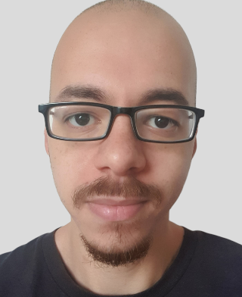

**Mohamed** **Youssef**

Duisburg, NW, 47119 | +49(0)1708993135

mohamed.youssef@hsrw.org | https://moyouss88.github.io/personal-webpage/

Software Engineer Intern dedicated to improving skills through hands-on learning and development work. Proficient in mobile and desktop development environments. Adept at using HTML5, JavaScript and other programming languages to produce clean code. Well-organized and collaborative team player with strong communication and analytical abilities.

**EDUCATION**

**Bachelor of Applied Science (B.A.Sc.) - Infotronic Systems Engineering** Oct 2017 - 2023

*Rhein-Waal University of Applied Sciences, Kamp-Lintfort*

**Bachelor of Commerce (B.Comm.) - accounting**  Sep 2008 - Jun 2012

*Ain Shams University, Cairo*

GPA: 2.6

**Bachelor of Engineering** Sep 2006 - Jun 2008

*Ain Shams University, Cairo*

**High School Diploma - Mathematics** Sep 2004 - Jun 2006

*El Motfawkin high school, Cairo*

GPA: 1.3

**EXPERIENCE**

**Logistics Assistant** Jan 2020 - Oct 2021

*Kühne+Nagel (AG& Co.) KG, Duisburg*

**Shipping Agent** Nov 2019 - Dec 2019

*Amazon Fulfillment Center, Rheinberg*

**Shipping Agent** Nov 2018 - Dec 2018

*Amazon Fulfillment Center, Rheinberg*

**IT Intern** Jan 2016 - Jun 2016

*ICT Cube, Cairo*

* Aided problem resolution measures and suggested patches and hardware, software and network troubleshooting alternatives.
* Contributed within team environment by assisting and interfacing with full-time software engineers.
* Helped department set up equipment for meetings, events and operations.
* Assisted computer users with technical issues remotely and at workstations.
* Installed, modified and repaired software and hardware to resolve technical issues.
* Followed up with clients to verify optimal customer satisfaction following support engagement and problem resolution.
* Coordinated with IT teams to resolve advanced computer software and hardware problems.

**Accounting Intern** Aug 2013 - Feb 2014

*Al Fath Group – A.F, Cairo*

* Analyzed account information and reconciled financial discrepancies to maintain records integrity and compliance.
* Applied proper codes to invoices, files and receipts to keep records organized and easily searchable.
* Compiled monthly journal entries into general ledger system.
* Prepared monthly closings by creating journal entries and reconciling accounts.
* Organized budget documentation and tracked expenses to maintain tight business controls.

**Projects**

**Typing Relay Race (DS)** WS2020Coursework: Semester long project

* User registration: Registering in the server using a username and password.
* User login: Establish a connection authenticated by the server.
* Join a team: An authenticated user can join a team.
* Play the game: An authenticated user that is a member of a team shall type  
  chunk of texts (80 characters) provided by the server as fast as possible.

**Innovation Management Workshop** WS2020

* Conduct research on cross innovation.
* Implementation of two innovation methods (reverse brainstorming & Empathy map).
* Conduct two workshops over the chosen methods.
* Develop questionnaires to measure innovative strength of companies.
* Design a poster about cross innovation (definition, processes and phases).

**Software Radio Design (SDR)** WS2019

* Design software defined radio.
* Receive and filter three signal with different distortion levels.
* Present the final project and deign reasoning choices.

**SKILLS**

Responsive Web Design, Front-End Skills: HTML, CSS, Java, Python, JavaScript, Software Components and Libraries, Project Management, MS Office