One startup company had an idea to come up with a product classifier that classifies between the following objects:

Screw Metal Nut Capsule Pill
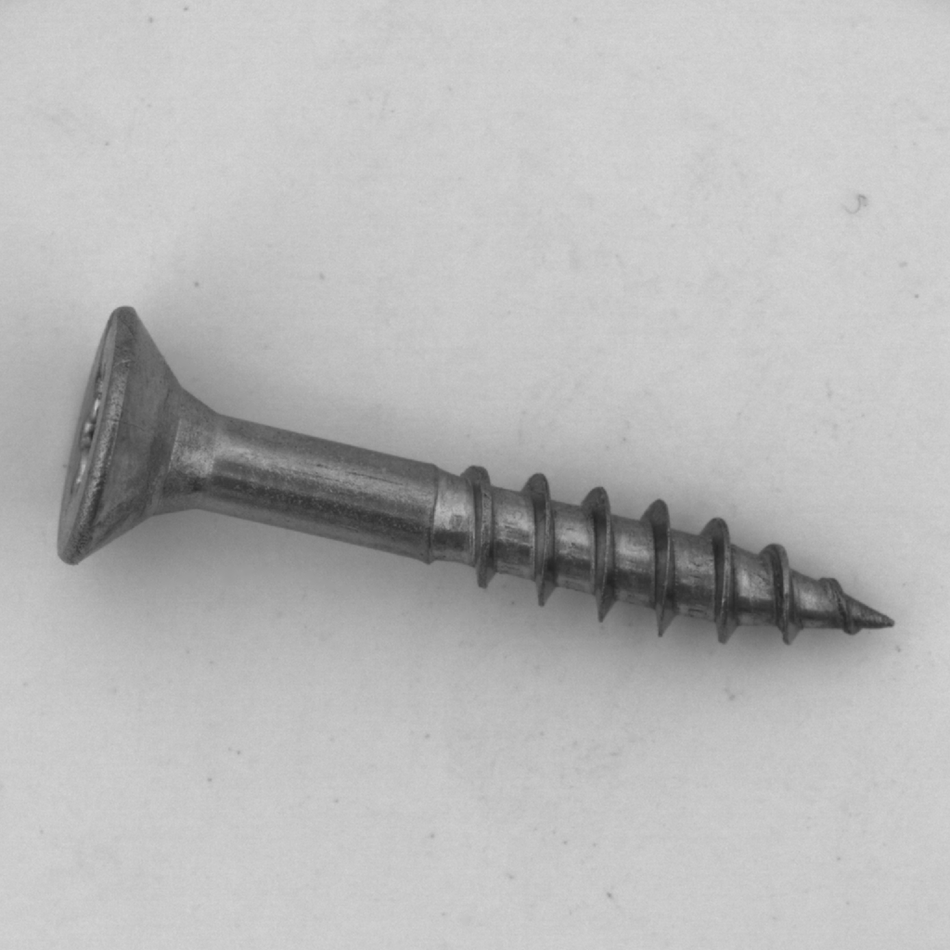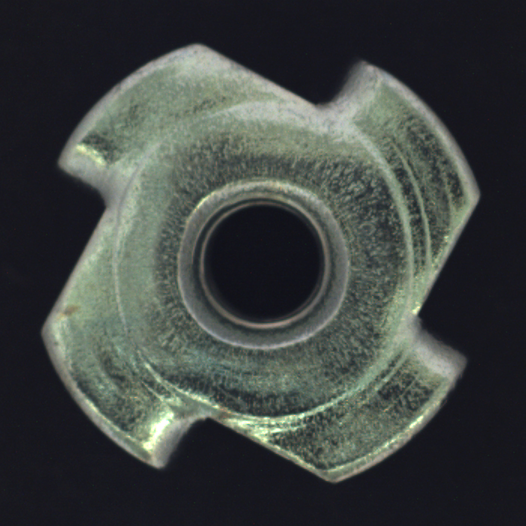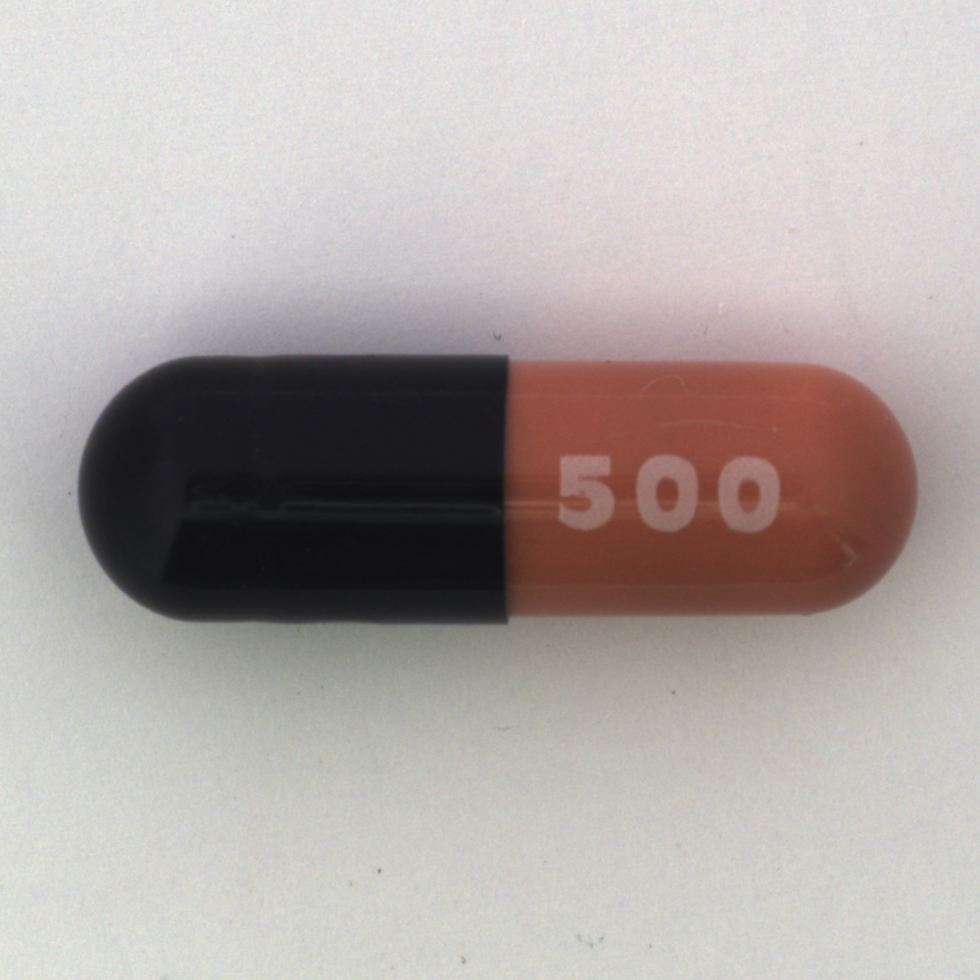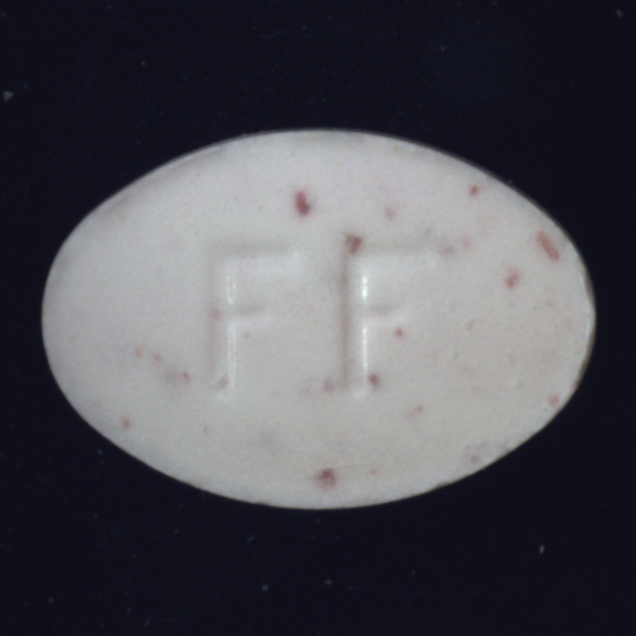

The data was outsourced to an external annotation company that was set to annotate the data.

Due to a mistake of the annotation team the data were classified by background, instead of by object category, resulting in two classes representing color - white and black.

White Black

The startup company doesn't have time to reannotate the data and they are reaching up to you for help.

You need to provide a classifier that will be able to classify between the 4 object categories in the test folder (categories_dataset), based on the annotated data by background color (black_white_dataset). You may ONLY use the categories_dataset for testing and not any assignment or decision, and the expected performance should reach 100% for all classes.

Because of some copyright issues, you must not use any pre-trained models (you can use out of the box networks, but without the weights)

Important detail regarding the data that might help. The training data is not balanced
Capsule data is : 14.2% from the whole dataset
Metal Nut data is : 21.4% from the whole dataset
Pill data is : 28.5% from the whole dataset
Screw data is : 35.7% from the whole dataset

Use deep learning to solve the assignment! Don’t use classic cv or ML approaches as anything other than tools (i.e. for pre or post processing data or similar actions). DON’T manually annotate or label anything and don’t relabel the data using classical CV or ML methods. The only data that will be used to test the assignment is the original dataset without any modifications.
The categories dataset may only be used for testing your final results, any other usage isn’t allowed.

The solution should include full python (no colab/notebooks) code with all the steps including plots/graphs etc with a simple run script to enable us to run the entire process (including training whatever needs to be trained) in order to reach the same results as you have. Do not submit any weights or data as they will not be used or tested.
Including any intermediary results with explanations to your thought process in the process of the solution as well as explanation to the code in comments, is recommended.

