In PostgreSQL, there are three ways to encapsulate logic: stored procedures, functions, and anonymous blocks: Stored procedures, Functions and Anonymous blocks

* ***Stored procedures*** can be used for transactions and called from the Java project in the following way:

1. For a single stored procedure call:

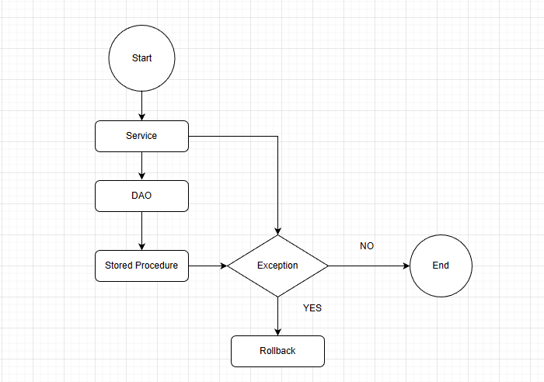

1. For multiple stored procedure call:

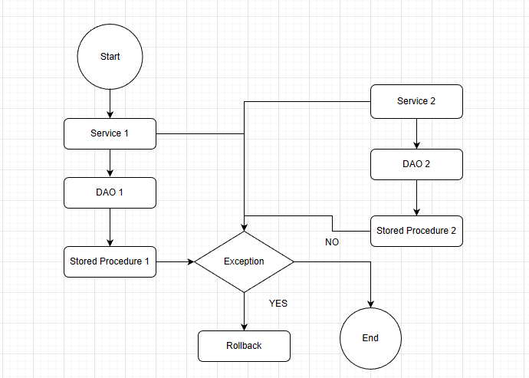

1. In the case of stored procedures with explicit transaction commands, we cannot call it from the Java layer. It has to be called from the database. The internal structure of that kind of stored procedure is given below:

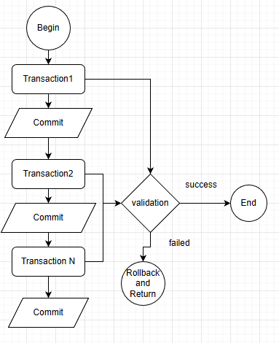

* ***Functions*** can also be used for transactions in PostgreSQL. The calling procedure from the Java project is the same as the stored procedure. However, we can’t use explicit transaction commands in functions.
* ***Anonymous blocks*** are short blocks of code that are executed immediately. They can be used to perform a single task or to test out some code. Here is an example:

BEGIN;

DO $$

DECLARE

x INTEGER;

BEGIN

x := 10;

INSERT INTO people (name, age) VALUES ('John Doe', x);

END;

$$;

COMMIT;

***Transaction Limitation:***

1. Nested transaction: We cannot nest transactions in PostgreSQL. In case of that kind of transaction, we need ‘savepoint’.