EXPERIMENTAL REPORT
GraphFeedback
Score-Guided Black-Box Textual Robustness Evaluation of GraphCLIP

Author: ZHANG Yangzonghan
Project: The black-box attack against Graph Neural Networks
Project ID: P0053609
Institution: The Hong Kong Polytechnic University
Evidence base: CiteSeer · released GraphCLIP checkpoint · two frozen local experiments
Date: 24 July 2026

Abstract
Text-attributed graph foundation models expose a robustness surface that is not captured by conventional edge- or feature-space perturbations: small natural-language edits to an existing node may alter its semantic representation while leaving graph topology unchanged. This report presents GraphFeedback, a bounded two-round black-box search procedure that uses observed GraphCLIP class scores to refine graph-aware textual candidates. The method was evaluated on a released GraphCLIP checkpoint and the CiteSeer node-classification task under a six-query budget, a 20% aligned-token edit limit, and a minimum sentence-embedding similarity of 0.85. A 30-node stratified low-margin stress test produced 7/30 GraphFeedback successes, compared with 5/30 for its matched one-round graph-aware baseline; two successes arose only during feedback-guided refinement, although the paired exact comparison was not significant (p = 0.5000). A frozen, non-overlapping 60-node class-balanced random experiment did not reproduce the effect: GraphFeedback and the graph-aware baseline both achieved 0/60. The combined evidence demonstrates local feasibility near the decision boundary but does not support population-level superiority. The study therefore contributes a reproducible methodology for margin-sensitive textual robustness evaluation and an empirical account of how target selection, candidate validity, and query feedback shape apparent vulnerability.
Keywords: text-attributed graphs; GraphCLIP; adversarial robustness; black-box evaluation; score feedback; query efficiency

1. Research Scope and Questions
GraphCLIP transfers semantic knowledge to text-attributed graphs by aligning textual and structural representations [1]. This capability also makes node text a meaningful robustness-testing surface. Structural attacks modify edges or graph connectivity, whereas graph-injection attacks introduce new graph elements. The present study adopts a narrower topology-preserving setting: only the text of an existing target node may be edited, while edges, neighbouring features, positional encodings, class prompts, and model parameters remain fixed. The purpose is not to compromise a deployed service, but to determine whether a public research checkpoint exhibits measurable prediction sensitivity under controlled, semantically constrained input edits.
The investigation addresses two questions. RQ1 asks whether a second candidate-generation round informed by actual GraphCLIP score changes can identify additional valid label-changing texts under the same six-query budget as one-round prompting. RQ2 asks whether any signal found on deliberately selected lower-margin nodes persists on an independent, class-balanced random sample. PromptAttack motivates the use of language-model self-refinement [2], while Intruding with Words motivates a graph-aware textual threat model [3]. The resulting contribution is best characterised as a methodological and empirical robustness study rather than a claim of a universally stronger attack algorithm.

2. Threat Model and Problem Formulation

2.1 Victim access and permitted intervention
The victim is a frozen released GraphCLIP checkpoint evaluated in zero-shot node classification. The evaluator has score-only black-box access: for a submitted candidate ego-graph, it observes the six class scores but cannot inspect gradients, hidden representations, training data, or victim parameters. Candidate generation is performed by a local language model that receives neither victim gradients nor internal model state.
For each target node, the original ego-graph is copied in memory. Candidate text is encoded with the same all-MiniLM-L6-v2 sentence encoder used to construct GraphCLIP node features, and the resulting 384-dimensional vector replaces only the root-node feature in the copied graph. No source data file is modified. This intervention isolates sensitivity to the target text while preserving topology and all non-target graph information.

2.2 Prediction, margin, and search objective
Let p_i(x) be the victim score vector for target node i after its text is set to x, and let C be the number of classes. The predicted class is
$${\hat{y}}_{i}(x)=arg\max_{c∈\{1,…,C\}}p_{i,c}(x)$$ (1)
Only nodes classified correctly before editing enter the attacked set. For such a node, y_i denotes both the ground-truth class and the clean prediction. The clean-class decision margin is
$$m_{i}(x)=p_{i,y_{i}}(x)−\max_{c≠y_{i}}p_{i,c}(x)$$ (2)
A negative margin implies that another class has overtaken the original class. When no queried candidate changes the label, the candidate with the smallest margin is treated as the most informative direction for refinement. Subject to validity constraints and the finite query budget, the operational search objective is
$$x_{i}^{⋆}=arg\min_{x∈C_{i}^{valid}}m_{i}(x)$$ (3)
This objective does not assume differentiability and does not approximate victim gradients. It ranks only the candidates that have actually passed the textual constraints and been submitted to GraphCLIP.

3. GraphFeedback Methodology

3.1 Two-round score-guided search
GraphFeedback divides the six-query budget into at most three initial graph-aware candidates and at most three feedback-guided refinements. The initial prompt contains the target text, class information, the adversarial evaluation objective, and compact one-hop neighbourhood context. Each parseable candidate is filtered before victim evaluation. Evaluation terminates immediately if a valid candidate changes the predicted class. Otherwise, the valid candidate producing the smallest clean-class margin becomes the current best candidate.
$$C_{i}=C_{i}^{(1)}∪C_{i}^{(2)}, |C_{i}^{(1)}|≤3, |C_{i}^{(2)}|≤3$$ (4)
The second-round prompt receives the current best candidate, its predicted scores and clean-class margin, its margin change relative to the original input, and a compact account of first-round margin changes. It is instructed to make a local refinement rather than generate an unrelated rewrite. All second-round candidates are rechecked against the original text, preventing iterative drift from escaping the frozen edit and semantic budgets.
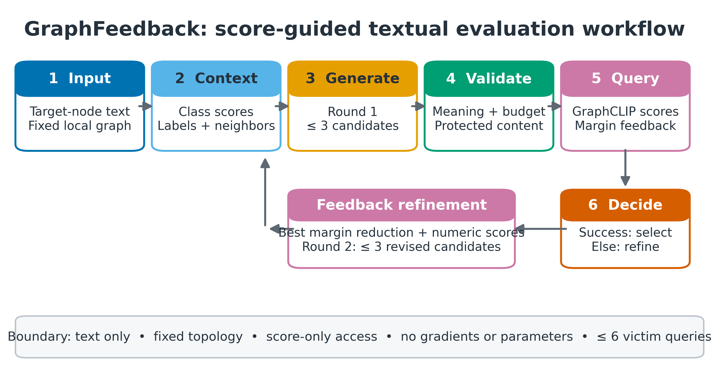
Figure 1. GraphFeedback performs constrained generation, validity filtering, victim evaluation, and a bounded score-feedback refinement round. Only the target-node text representation is replaced.

3.2 Candidate validity constraints
Candidate filtering precedes victim evaluation. A candidate must contain English text without explanatory wrappers, have a token-length ratio between 0.80 and 1.20, change no more than 20% of aligned tokens, and achieve cosine similarity of at least 0.85 under an independent all-mpnet-base-v2 encoder. Numbers, citation markers, explicit negations, polarity terms, acronyms, and detected model names must be preserved. Invalid or unparsable generations consume generation effort but do not consume victim-model queries. These automatic checks reduce obvious corruption and make the protocol repeatable; they do not establish human-equivalent meaning.

3.3 Baselines and controlled comparisons
Table 1. Evaluated methods and the factor isolated by each comparison.
Method | Generation information | Role in the evaluation
Random edit | No language-model prompt | Deletion/swap sanity baseline with up to six candidates
Generic paraphrase | Original text only | Conservative rewrite without an adversarial objective; stress run only
Non-graph attack | Text, class information, attack instruction | Independent one-round candidates without neighbourhood context
Graph prompt attack | Non-graph information plus one-hop context | Independent one-round graph-aware candidates
Feedback without graph context | First-round scores and margin changes | Three initial plus up to three refinement queries
GraphFeedback | Graph context plus first-round scores and margins | Matched two-round graph-aware score-feedback search

The feedback variants reuse the first three already evaluated candidates from their matched one-round baselines. Round-one inputs are therefore identical rather than regenerated from similar prompts. GraphFeedback versus graph prompt attack isolates the incremental value of score-guided refinement; GraphFeedback versus feedback without graph context examines whether neighbourhood context changes aggregate effectiveness under the same feedback mechanism.

4. Experimental Design

4.1 Victim, dataset, and implementation
The released GraphCLIP checkpoint was evaluated on CiteSeer. Clean inference reproduced 69.28% test accuracy, corresponding to 442 correct predictions among 638 test nodes. Qwen2.5-0.5B-Instruct generated candidates at temperature 0.7 with a maximum of 256 new tokens. Candidate text was re-encoded with all-MiniLM-L6-v2, while all-mpnet-base-v2 served as the independent semantic filter. The experiments used Python 3.10.20, PyTorch 2.4.1 with CUDA 12.1, and an NVIDIA GeForce RTX 4050 Laptop GPU.

4.2 Exploratory stress test and frozen confirmation
Table 2. Two-stage experimental design. Results are analysed separately and never pooled.
Component | stress30v1 | random60v1
Sampling strategy | Stratified lower-margin correct nodes | Stratified random correct nodes
Sample size | 30 nodes; five per class | 60 nodes; ten per class
Seed | 88 | 240726
Overlap | — | 0 nodes shared with stress30v1
Methods | Six, including generic paraphrase | Five; generic paraphrase omitted
Maximum victim queries | Six per node and method | Six per node and method
Edit / semantic thresholds | ≤20% changed tokens; similarity ≥0.85 | Identical frozen thresholds

The stress sample tests whether the mechanism can operate near the victim decision boundary; it is not a population estimate. The confirmatory sample was frozen before outcomes were viewed, excluded all stress-node identifiers, and retained the same prompts, query budget, validity thresholds, generator, and victim. This separation prevents the favourable stress result from being presented as if it arose from representative random sampling.

5. Evaluation Metrics and Statistical Analysis

5.1 Attack effectiveness
Let T={1,...,N} denote the initially correct target nodes, where N=30 for the stress test and N=60 for confirmation. An attack success requires both validity and a changed prediction:
$$s_{i}=I​\left[x_{i}^{⋆} is valid ∧ {\hat{y}}_{i}(x_{i}^{⋆})≠y_{i}\right]$$ (5)
Nodes without a valid candidate remain in the denominator as failures. Attack success rate (ASR) and attacked-subset accuracy are therefore
$$ASR=\frac{1}{N}\sum_{i=1}^{N}{s_{i}}$$ (6)
$${Acc}_{attack}=\frac{1}{N}\sum_{i=1}^{N}{I}​\left[{\hat{y}}_{i}(x_{i}^{⋆})=y_{i}\right]=1−ASR$$ (7)
The attacked-subset accuracy concerns only the predefined initially correct targets and is distinct from GraphCLIP's overall clean test accuracy. Candidate-generation reliability is summarised by the no-valid-candidate rate
$$NVCR=\frac{1}{N}\sum_{i=1}^{N}{I}​\left[|C_{i}^{valid}|=0\right]$$ (8)

5.2 Semantic fidelity, edit magnitude, and margin movement
Semantic preservation is approximated by cosine similarity between independent sentence embeddings h(x):
$$Sim(x_{i},x_{i}^{⋆})=\frac{h(x_{i})^{⊤}h(x_{i}^{⋆})}{∥h(x_{i})∥_{2} ∥h(x_{i}^{⋆})∥_{2}}$$ (9)
Lexical change is measured by the aligned changed-token ratio. W(x_i) is the original token sequence, and E counts each non-matching alignment span using the larger of its source and target lengths:
$${CTR}_{i}=\frac{E(x_{i},x_{i}^{⋆})}{max(1,|W(x_{i})|)}$$ (10)
Movement toward the decision boundary is quantified by margin reduction
$$Δm_{i}=m_{i}(x_{i})−m_{i}(x_{i}^{⋆})$$ (11)
Positive values indicate reduced preference for the original class even when the final label does not change. Medians are reported for similarity, edit ratio, and margin reduction because these quantities are skewed and may contain a small number of large changes.

5.3 Query accounting and inferential treatment
Let q_i be the number of valid candidates submitted to the victim for node i. Mean query use and mean query use among successful cases are
$$\overline{Q}=\frac{1}{N}\sum_{i=1}^{N}{q_{i}}, {\overline{Q}}_{success}=\frac{\sum_{i=1}^{N}{s_{i}}q_{i}}{\sum_{i=1}^{N}{s_{i}}}$$ (12)
Query accounting is a formal evaluation dimension because black-box textual attacks trade effectiveness against victim interactions [4]. Ninety-five per cent ASR intervals use a seeded non-parametric bootstrap with 10,000 node-level resamples:
$${CI}_{95\%}=\left[Q_{0.025}​\left({\hat{ASR}}^{(1:B)}\right), Q_{0.975}​\left({\hat{ASR}}^{(1:B)}\right)\right], B=10,000$$ (13)
Within each run, methods attack the same nodes. Pairwise comparisons therefore use discordant binary outcomes: n10 counts nodes successful only for method A and n01 counts nodes successful only for method B. The reported two-sided exact McNemar-style p-value is
$$p_{exact}=min​\left\{1, 2\sum_{k=0}^{min(n_{10},n_{01})}{\left({n_{10}+n_{01} \atop k}\right)}(0.5)^{n_{10}+n_{01}}\right\}$$ (14)
Because successes and discordant pairs are sparse, the exact tests are descriptive and have low power. No statistical significance claim is made, and the disjoint stress and confirmatory samples are neither paired nor pooled.

6. Results

6.1 Low-margin stress evaluation
Table 3. Main results on the 30-node stratified low-margin stress sample.
Method | Success | ASR %, 95% CI | Mean Q | Median Δm | Median Sim. | Median CTR %
Random edit | 5/30 | 16.7 [3.3, 30.0] | 5.63 | 0.0709 | 0.9979 | 2.71
Generic paraphrase | 5/30 | 16.7 [3.3, 30.0] | 1.80 | 0.0892 | 0.9875 | 4.94
Non-graph attack | 4/30 | 13.3 [3.3, 26.7] | 1.80 | 0.0548 | 0.9924 | 5.76
Graph prompt attack | 5/30 | 16.7 [3.3, 30.0] | 1.90 | 0.1830 | 0.9921 | 2.52
Feedback, non-graph | 7/30 | 23.3 [10.0, 40.0] | 2.77 | 0.1037 | 0.9873 | 6.16
GraphFeedback | 7/30 | 23.3 [10.0, 40.0] | 2.50 | 0.1962 | 0.9896 | 2.69

GraphFeedback changed 7 of 30 initially correct predictions, whereas the matched one-round graph prompt changed 5. Five GraphFeedback successes were already present among the shared first-round candidates, and two additional nodes were changed only by feedback-guided refinement. The paired comparison contained two GraphFeedback-only successes and no graph-prompt-only success (p=0.5000). The direction is consistent with useful refinement on this fixed sample, but the confidence interval is wide and the exact test is not significant.
Feedback without graph context also achieved 7/30, including three refinement-only successes. In the direct comparison between the two feedback methods, each produced five method-only successes (p=1.0000). Graph context changed which nodes were affected but did not improve aggregate stress-set ASR. The random-edit baseline also achieved 5/30, demonstrating that the deliberately selected low-margin subset was broadly sensitive to small edits.
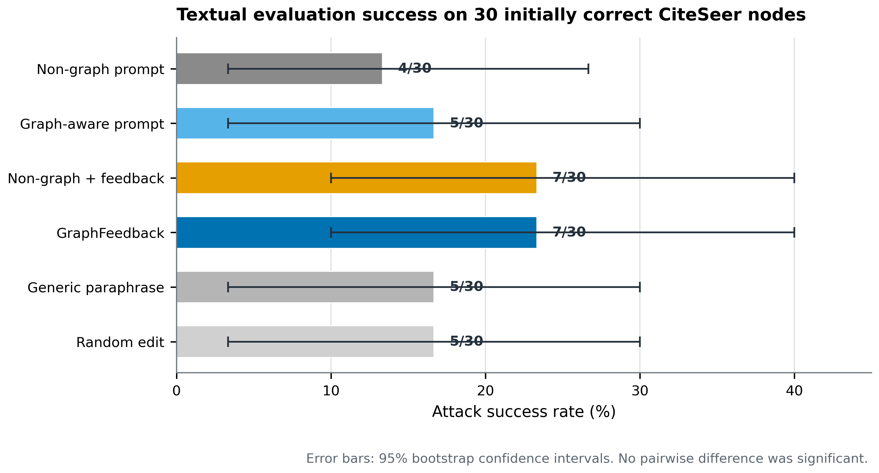
Figure 2. Stress-test effectiveness, query use, margin reduction, and candidate validity. Error bars show node-bootstrap 95% confidence intervals for ASR.
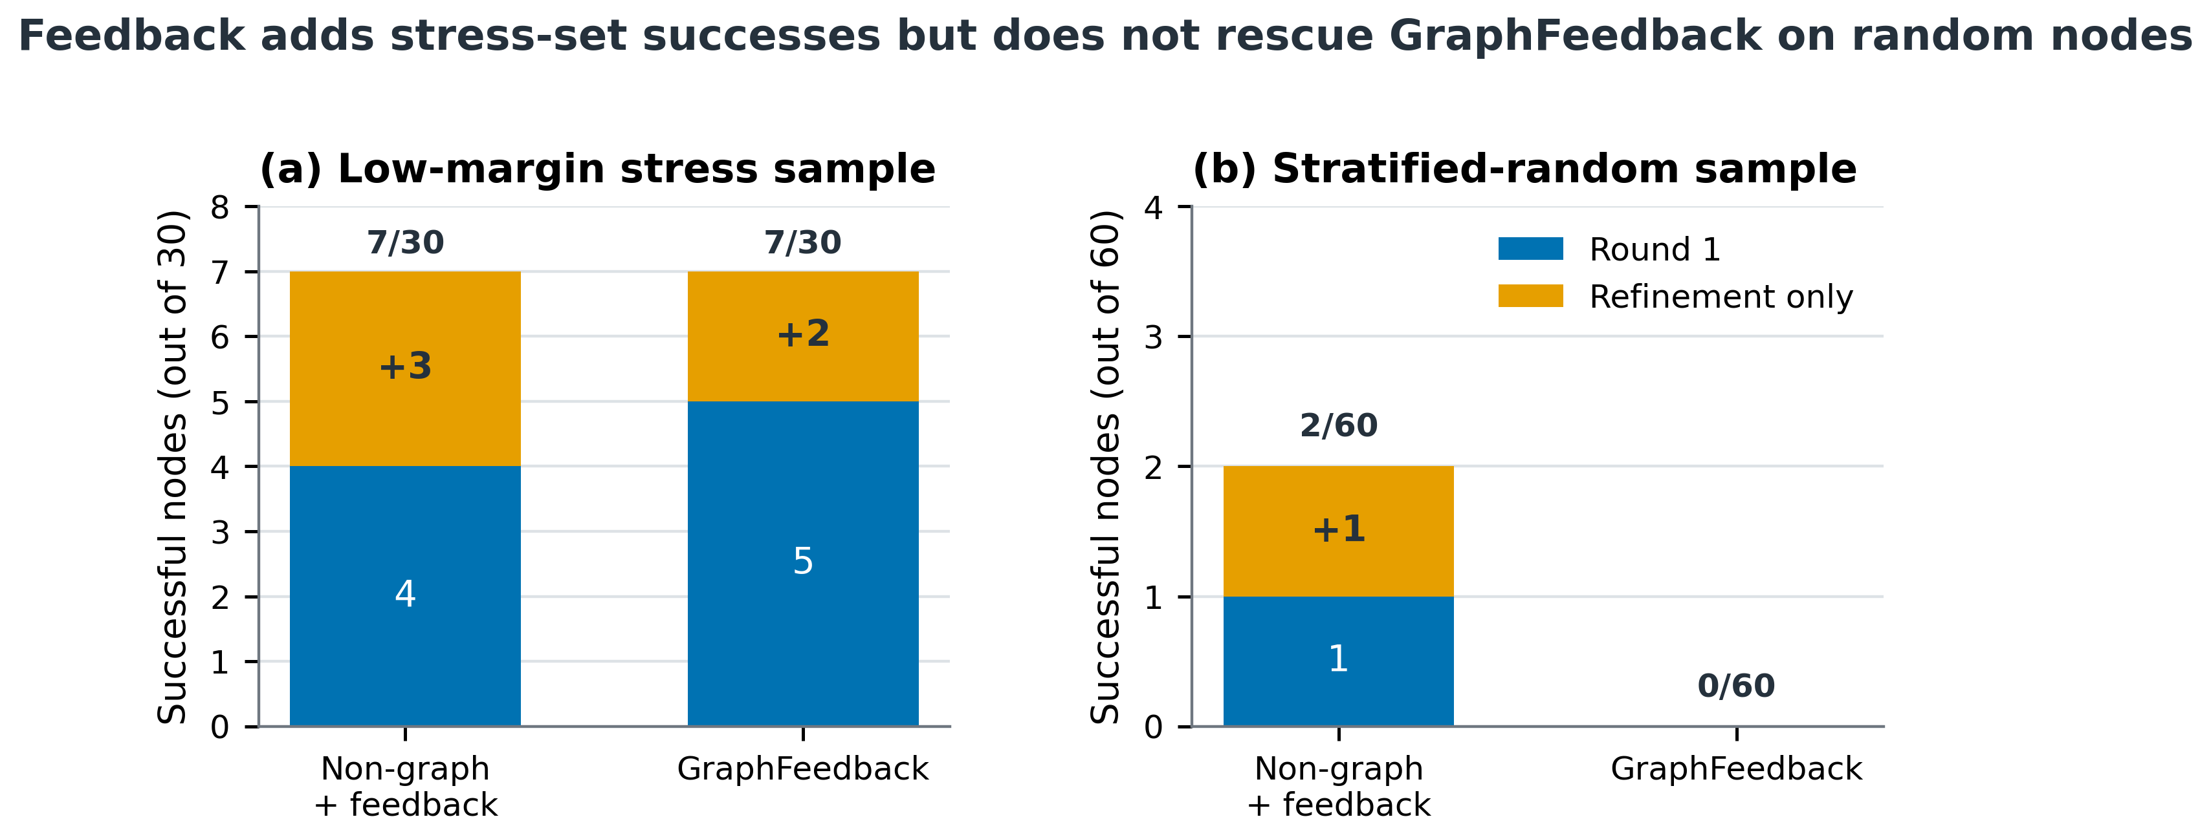
Figure 3. Attribution of feedback-method successes to shared first-round candidates and refinement-only candidates in the stress and confirmatory samples.

6.2 Frozen confirmatory evaluation
Table 4. Results on the independent 60-node class-balanced random sample.
Method | Success | ASR %, 95% CI | Mean Q | NVCR % | Median Sim.
Random edit | 0/60 | 0.0 [0.0, 0.0] | 5.73 | 0.0 | 0.9983
Non-graph attack | 1/60 | 1.7 [0.0, 5.0] | 2.02 | 15.0 | 0.9888
Graph prompt attack | 0/60 | 0.0 [0.0, 0.0] | 1.53 | 28.3 | 0.9935
Feedback, non-graph | 2/60 | 3.3 [0.0, 8.3] | 2.87 | 3.3 | 0.9863
GraphFeedback | 0/60 | 0.0 [0.0, 0.0] | 2.27 | 15.0 | 0.9918

The confirmatory run did not reproduce the GraphFeedback signal. GraphFeedback and the graph prompt both achieved 0/60. Feedback without graph context achieved 2/60, including one refinement-only success, while its one-round baseline achieved 1/60. GraphFeedback had no unique success against non-graph feedback, which had two (p=0.5000); GraphFeedback and graph prompt had no discordant successes (p=1.0000).
GraphFeedback decreased from 23.3% ASR on the low-margin stress sample to 0.0% on the random sample. Graph prompt decreased from 16.7% to 0.0%, and random edit also decreased from 16.7% to 0.0%. Because all methods declined together, target-node difficulty provides a more credible explanation than a method-specific implementation failure. The stress result establishes local feasibility near the decision boundary, whereas the random result places a strict boundary on generalisation.
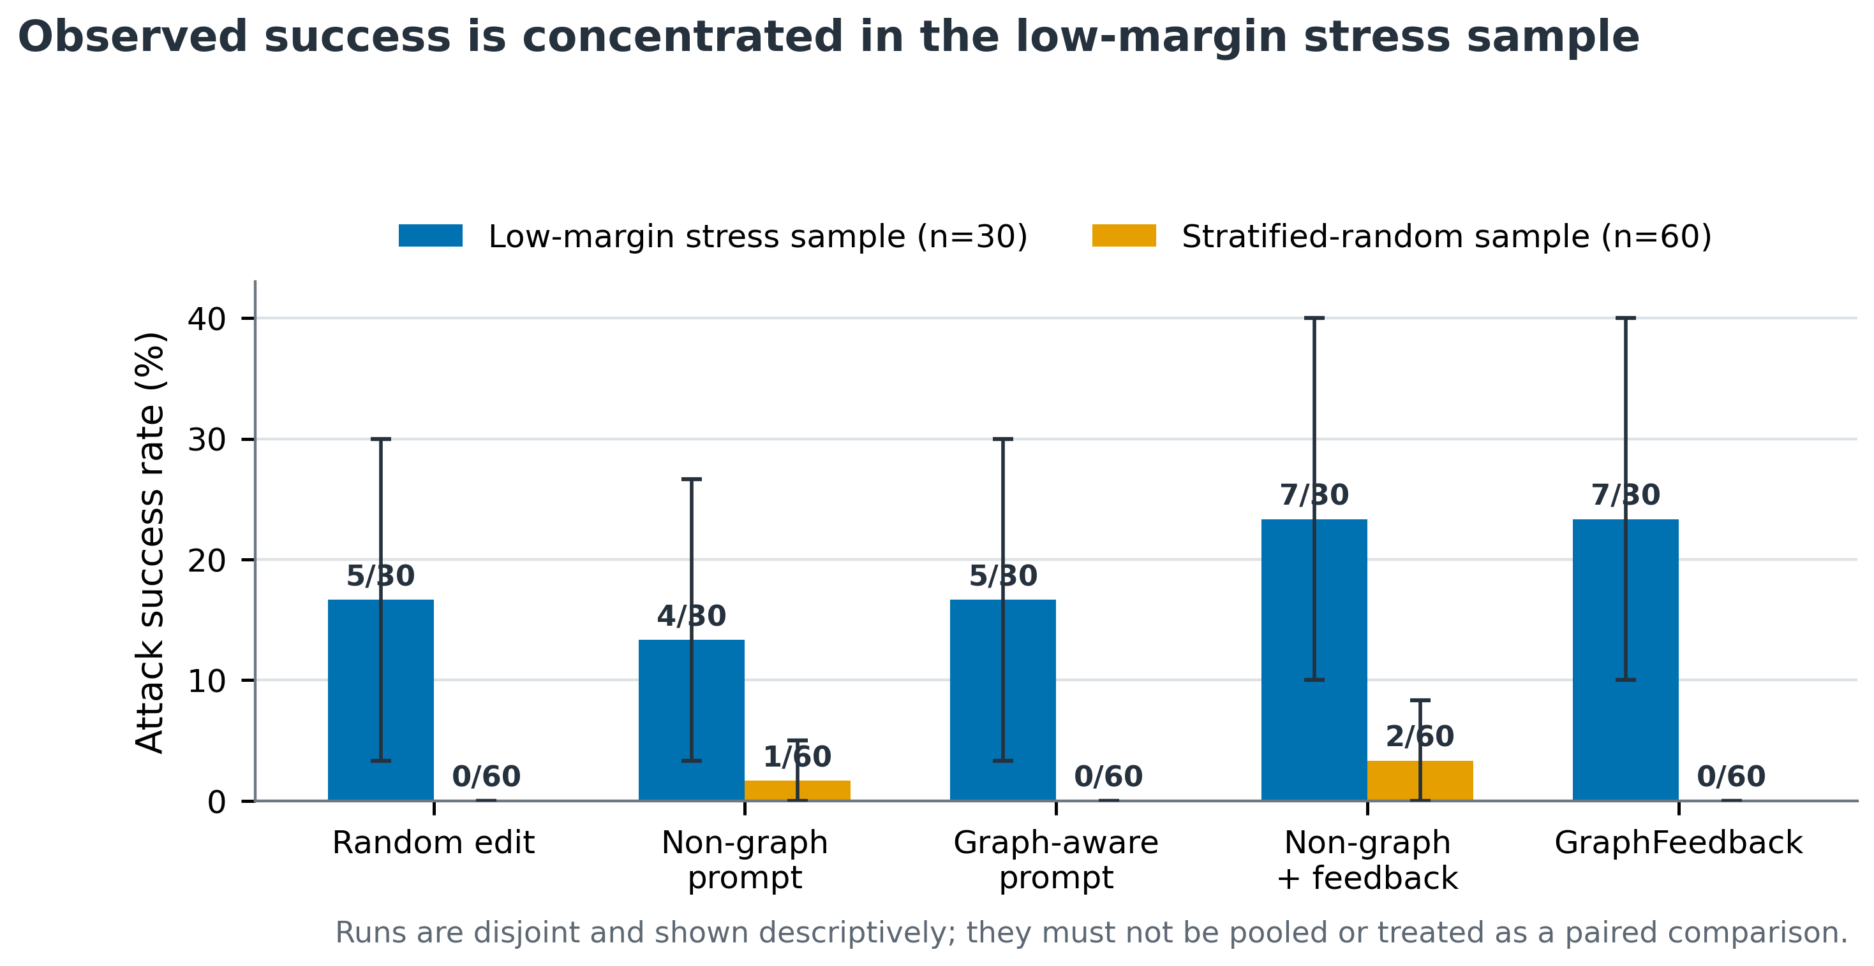
Figure 4. ASR under low-margin stress sampling and class-balanced random sampling. The samples are disjoint and must not be interpreted as a paired comparison.

6.3 Efficiency, reliability, and class-level behaviour
GraphFeedback used 2.50 victim queries per stress node and 2.27 per confirmatory node, below the six-query maximum because successful valid candidates triggered early stopping and invalid candidates were not submitted. In the confirmatory run, the graph prompt produced no valid candidate for 17/60 nodes, compared with 9/60 for GraphFeedback. Score feedback therefore improved candidate availability relative to one-round graph prompting, but the additional valid texts did not cross the victim decision boundary.
Class-level counts are descriptive because each stress class contains only five nodes and each confirmatory class ten. In the stress sample, three GraphFeedback successes occurred in Artificial Intelligence, including two refinement-only cases, whereas no evaluated method succeeded on the selected Agents nodes. The random sample contained no GraphFeedback success in any class. These patterns reinforce the need to report sampling and class composition rather than treating a single aggregate ASR as a stable property of the model.
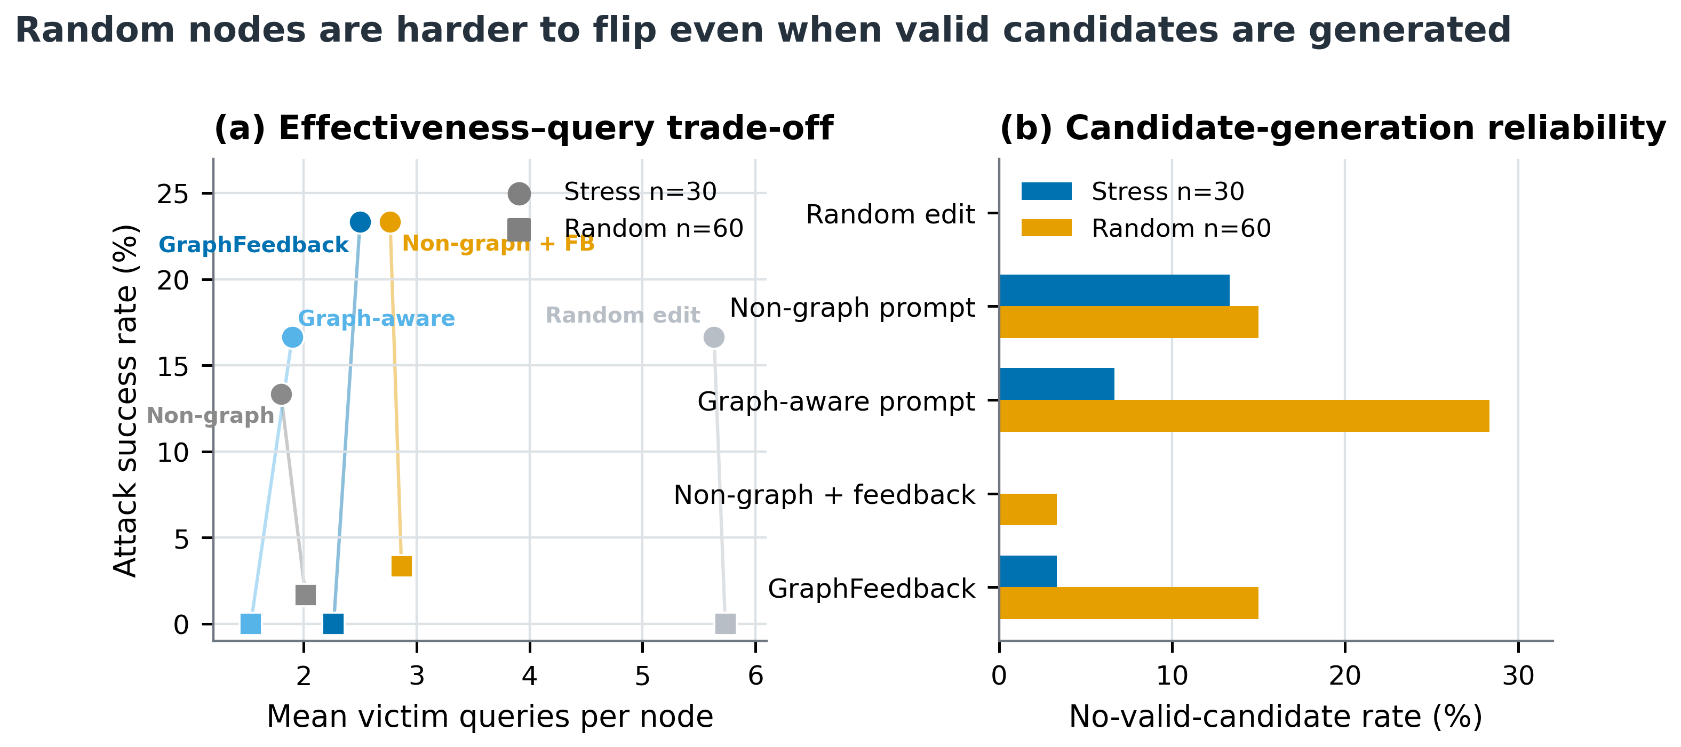
Figure 5. Query cost and valid-candidate reliability across the two formal experiments. Candidate availability and attack success are related but not equivalent.
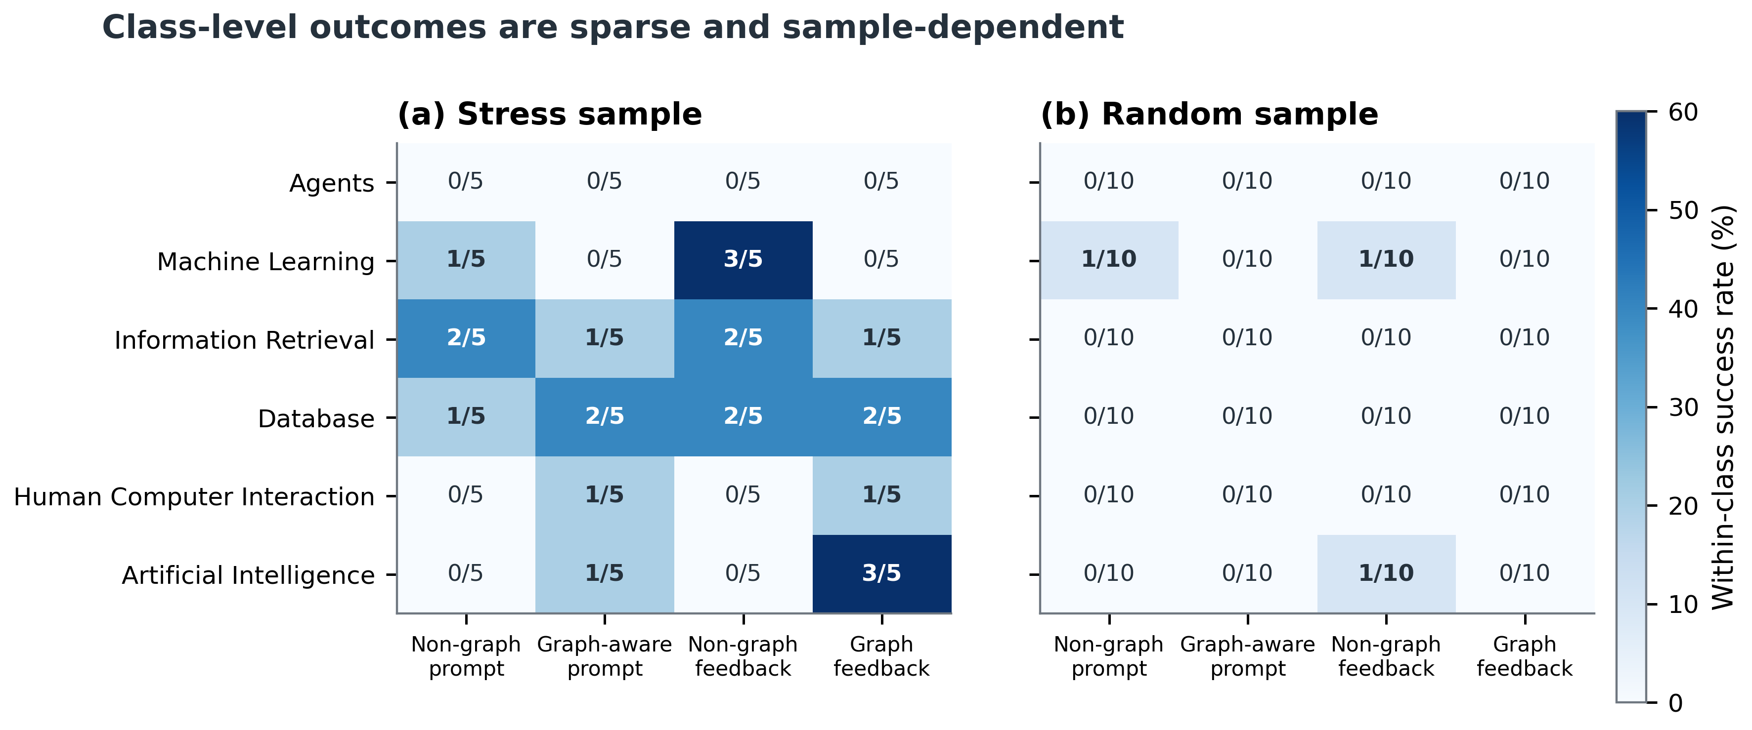
Figure 6. Descriptive per-class success counts. Each stress cell represents five nodes per class and each confirmatory cell ten; no class-level inference is claimed.

7. Qualitative Failure and Success Analysis
CiteSeer node 1544 illustrates a refinement-only GraphFeedback success in the stress run. GraphCLIP initially classified the paper as Artificial Intelligence. Three valid initial candidates failed to change the label. The fourth victim query evaluated a feedback-guided refinement and changed the prediction to Machine Learning. The clean-class margin moved from 0.9972 to −0.3558, a reduction of 1.3529. The selected text retained an embedding similarity of 0.9653 and changed 4.85% of aligned tokens. This case demonstrates how observed margin movement can identify a productive local direction that independent first-round candidates did not complete.
The confirmatory run contained no GraphFeedback success. Its only refinement-only success arose from feedback without graph context on node 2651, changing the prediction from Artificial Intelligence to Machine Learning on the fifth query. The margin decreased from 0.5842 to −0.0124, similarity was 0.9429, and the changed-token ratio was 9.38%. Inspection indicated that the substitutions made the abstract more explicitly machine-learning-oriented but also introduced debatable semantic shifts. Both examples show why high embedding similarity cannot substitute for blinded human assessment of meaning and factual consistency.

8. Reproducibility and Evidence Preservation
Both formal experiments were executed from predefined configurations. For each run, the pipeline recorded the random seed, selected target nodes, attack parameters, query budget, semantic and edit thresholds, software environment, hardware configuration, and hashes of the model checkpoint and processed data. The pilot and confirmatory results were aggregated separately, and completed node–method evaluations were deduplicated before summary generation.
Node-level records were retained for generation, parsing, filtering, victim scoring, selection, and feedback. The stress experiment produced 158 query-level feedback trajectories and the confirmatory experiment produced 308. All reported tables and figures were generated deterministically from these saved records; no outcome values were manually created or adjusted. This procedure supports auditability and local reproduction, while the evidential scope remains bounded to one victim checkpoint, one dataset, one local generator, and the stated budgets.

9. Discussion and Limitations
The experiment separates attack feasibility from general effectiveness. The stress sample confirms that small, automatically constrained text changes can alter some lower-margin GraphCLIP predictions, and that score-guided refinement can add successes without increasing the maximum query budget. The independent random sample, however, shows that this behaviour is not broadly visible under the same local setup. The strongest supported conclusion is therefore margin sensitivity: apparent vulnerability depends heavily on target selection and proximity to the decision boundary.
Several limitations restrict publication-level claims. Only CiteSeer and one released GraphCLIP checkpoint were tested. The local 0.5B generator may lack the rewriting capacity of larger language models. The samples are small, successful outcomes are sparse, and the bootstrap intervals and paired tests consequently have limited precision. Semantic fidelity was evaluated automatically rather than through blinded human annotation. The confirmatory seed also affects upstream stochastic graph construction, so the second run is an independent replication rather than an identical-universe resample. Future work should test additional text-attributed datasets, checkpoints, generators, seeds, and query budgets, and should include human evaluation of semantic and factual preservation.

10. Conclusion
GraphFeedback provides a reproducible score-guided framework for topology-preserving textual robustness evaluation of GraphCLIP. On a 30-node lower-margin stress sample, it identified two refinement-only successes beyond a matched one-round graph-aware baseline and achieved 7/30 total successes. The effect did not persist on a frozen, non-overlapping 60-node class-balanced random sample, where GraphFeedback achieved 0/60. These results do not establish broad model insecurity or method superiority. They show that closed-loop score feedback can be operationally useful near selected decision boundaries, while representative robustness conclusions require broader sampling and stronger semantic validation.

References
[1] Y. Zhu, H. Shi, X. Wang, et al., “GraphCLIP: Enhancing Transferability in Graph Foundation Models for Text-Attributed Graphs,” Proceedings of The Web Conference, 2025.
[2] X. Xu, K. Kong, N. Liu, et al., “An LLM Can Fool Itself: A Prompt-Based Adversarial Attack,” Proceedings of the International Conference on Learning Representations, 2024.
[3] R. Lei, Y. Hu, Y. Ren, and Z. Wei, “Intruding with Words: Towards Understanding Graph Injection Attacks at the Text Level,” Advances in Neural Information Processing Systems, vol. 37, 2024.
[4] Z. Yu, Z. Chen, and K. He, “Query-Efficient Textual Adversarial Example Generation for Black-Box Attacks,” Proceedings of NAACL-HLT, pp. 556–569, 2024.

