Simple with color and back color.

Since officegen 0.2.12 you can do more cool stuff!

Even add [external link](https://github.com)!

**Bold + underline**

Center this text

Align this text to the right.

Those two lines are in the same paragraph,  
but they are separated by a line break.

Fonts face only. Fonts face and size.

בדיקה האם אפשר לכתוב טקסט בעברית

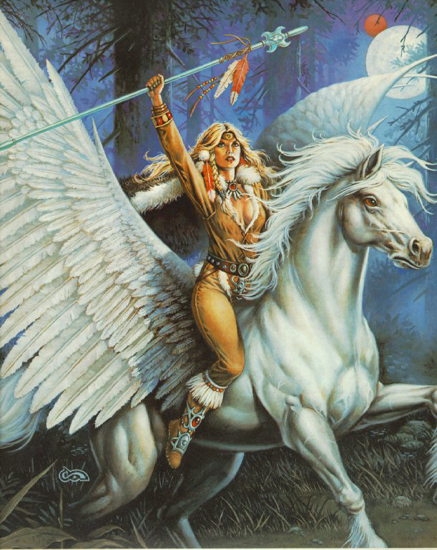

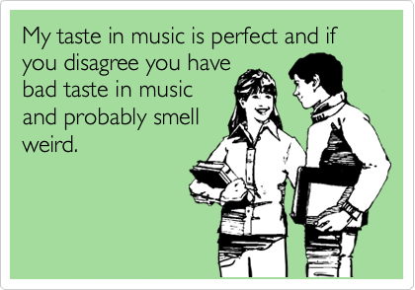

Picture 2Picture 3Picture 4... some text here ...Picture 5



Option 1

Option 2

Backline text1 text2

~~Strikethrough text~~superscriptsubscript

|  |  |  |
| --- | --- | --- |
| **No.** | **Title1** | **Title2** |
| 1 | All grown-ups were once children |  |
| 2 | there is no harm in putting off a piece of work until another day. |  |
| 3 | But when it is a matter of baobabs, that always means a catastrophe. |  |
| 4 | watch out for the baobabs! | END |