Relatório de Execução Financeira do MEC
  - Análise da dotação e execução financeira no Ministério da Educação e Cultura
MEC-DAF
2026-04-17

1 Resumo Executivo
Table 1: Execução Global
 | Valor
Dotação Actualizada (DA) | MZN 94,773.3M
Despesa Paga (AFDP) | MZN 85,180.2M
Taxa de Execução Global | 89.9%
Table 1: Dotação e Despesa por Tipo de Reporte
Tipo de Reporte | Dotação Actualizada | Despesa Paga
Funcionamento | 76,677,247,086 | 79,308,161,129
Investimento Externo | 16,683,706,679 | 5,408,185,024
Investimento Interno | 1,412,350,022 | 463,868,593
Total | 94,773,303,787 | 85,180,214,747
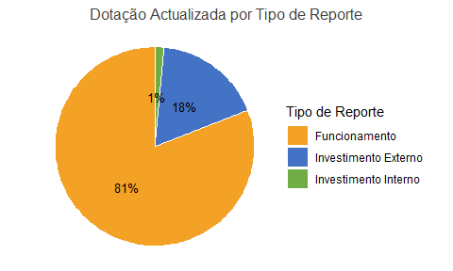
Table 1: Dotação Actualizada por Instituição
 | Dotação Actualizada
SDEJT | 78,874,587,792
MEC | 12,018,843,334
DPE - OGDP | 2,996,046,152
Outras Instituições | 848,263,825
CPED | 35,562,684
SPAS | 0
Grand Total | 94,773,303,787
Table 1: Dotação Actualizada por Tipo de Reporte e Instituição
 | Funcionamento |  |  |  | Investimento Interno |  |  |  | Investimento Externo |  |  |  | Total
 | DPE - OGDP | SPAS | Total | Peso % | DPE - OGDP | SPAS | Total | Peso % | DPE - OGDP | SPAS | Total | Peso % | DPE - OGDP | SPAS | Grand Total | Peso %
Cabo Delgado | 104,112,919 | 0 | 104,112,919 | 12.3 | 93,426,608 | 0 | 93,426,608 | 12.4 | 101,303,058 | 0 | 101,303,058 | 7.3 | 298,842,585 | 0 | 298,842,585 | 10.0
Gaza | 60,954,566 | 0 | 60,954,566 | 7.2 | 6,745,045 | 0 | 6,745,045 | 0.9 | 67,604,169 | 0 | 67,604,169 | 4.8 | 135,303,780 | 0 | 135,303,780 | 4.5
Inhambane | 55,366,037 | 0 | 55,366,037 | 6.5 | 14,337,484 | 0 | 14,337,484 | 1.9 | 56,583,835 | 0 | 56,583,835 | 4.1 | 126,287,356 | 0 | 126,287,356 | 4.2
Manica | 84,218,625 | 0 | 84,218,625 | 9.9 | 95,751,985 | 0 | 95,751,985 | 12.7 | 86,047,082 | 0 | 86,047,082 | 6.2 | 266,017,692 | 0 | 266,017,692 | 8.9
Maputo Cidade | 0 | 0 | 0 | 0.0 | 0 | 0 | 0 | 0.0 | 0 | 0 | 0 | 0.0 | 0 | 0 | 0 | 0.0
Maputo Província | 67,239,248 | 0 | 67,239,248 | 7.9 | 32,000,394 | 0 | 32,000,394 | 4.2 | 59,765,945 | 0 | 59,765,945 | 4.3 | 159,005,587 | 0 | 159,005,587 | 5.3
Nampula | 122,047,009 | 0 | 122,047,009 | 14.4 | 30,654,843 | 0 | 30,654,843 | 4.1 | 238,167,561 | 0 | 238,167,561 | 17.1 | 390,869,414 | 0 | 390,869,414 | 13.0
Niassa | 81,446,418 | 0 | 81,446,418 | 9.6 | 48,087,161 | 0 | 48,087,161 | 6.4 | 113,867,600 | 0 | 113,867,600 | 8.2 | 243,401,178 | 0 | 243,401,178 | 8.1
Sofala | 67,050,736 | 0 | 67,050,736 | 7.9 | 41,853,643 | 0 | 41,853,643 | 5.5 | 144,609,230 | 0 | 144,609,230 | 10.4 | 253,513,609 | 0 | 253,513,609 | 8.5
Tete | 82,790,079 | 0 | 82,790,079 | 9.8 | 311,356,187 | 0 | 311,356,187 | 41.3 | 115,808,954 | 0 | 115,808,954 | 8.3 | 509,955,220 | 0 | 509,955,220 | 17.0
Zambézia | 121,294,495 | 0 | 121,294,495 | 14.3 | 80,524,591 | 0 | 80,524,591 | 10.7 | 411,030,645 | 0 | 411,030,645 | 29.5 | 612,849,731 | 0 | 612,849,731 | 20.5
Grand Total | 846,520,132 | 0 | 846,520,132 | 100.0 | 754,737,942 | 0 | 754,737,942 | 100.0 | 1,394,788,079 | 0 | 1,394,788,079 | 100.0 | 2,996,046,152 | 0 | 2,996,046,152 | 100.0
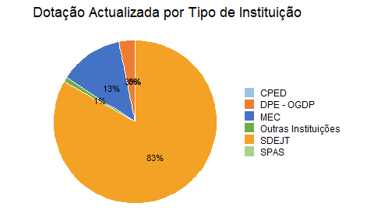

2 Execução por Função
Esta secção replica a tabela dinâmica Excel, mostrando dotação, despesa e taxa de execução por classificação funcional (funcao), com reporte_tipo como coluna.
Table 1: Execução orçamental por função e tipo de reporte
Table 1: Execução por Função
 | Função | Dotação Actualizada | Despesa Paga | Taxa de Execução
 | ENSINO PRIMARIO COMPLETO (EPC) | 19.3B | 18.0B | 93.3%
 | ENSINO PRIMARIO DO 1 GRAU (EP1) | 18.4B | 16.4B | 89.0%
 | ENSINO SECUNDARIO GERAL DO 1 CICLO (ESG1) | 12.8B | 7.6B | 59.6%
 | SERVICOS AUXILIARES DE EDUCACAO | 12.1B | 11.4B | 94.2%
 | SERVICOS PUBLICOS GERAIS N.E. | 6.6B | 6.5B | 99.3%
 | ENSINO SECUNDARIO GERAL DO 2 CICLO (ESG2) | 6.5B | 7.8B | 119.2%
 | ADMINISTRACAO FINANCEIRA E FISCAL | 3.7B | 3.6B | 97.0%
 | ENSINO N.E. | 3.6B | 2.5B | 68.6%
 | ENSINO PRE-PRIMARIO | 2.9B | 2.8B | 95.6%
 | ORGAOS EXECUTIVOS E LEGISLATIVOS | 2.7B | 2.8B | 102.2%
 | ENSINO TECNICO MEDIO | 1.1B | 1.3B | 117.2%
 | ENSINO PRIMARIO DO 2 GRAU (EP2) | 1.0B | 1.0B | 99.2%
 | ENSINO SECUNDARIO GERAL | 885.5M | 37.1M | 4.2%
 | SERVICOS PUBLICOS GERAIS | 604.0M | 610.6M | 101.1%
 | EDUCACAO NAO DEFINIVEL POR NIVEL | 572.0M | 628.8M | 109.9%
 | ENSINO TECNICO PROFISSIONALIZANTE | 499.3M | 295.6M | 59.2%
 | SERVICOS DE SAUDE PUBLICA | 261.7M | 245.9M | 94.0%
 | ALFABETIZACAO DE ADULTOS | 209.7M | 115.3M | 55.0%
 | SEGURANCA E ACCAO SOCIAL N.E. | 170.9M | 728.0M | 425.9%
 | ENSINO TECNICO | 123.6M | 112.3M | 90.9%
 | ENSINO PRIMARIO | 112.5M | 69.2M | 61.6%
 | EDUCACAO | 82.6M | 77.0M | 93.2%
 | SEGURANCA E ORDEM PUBLICA N.E. | 78.8M | 82.1M | 104.2%
 | OUTROS SERVICOS GERAIS | 73.5M | 8.6M | 11.8%
 | SERVICOS CULTURAIS | 56.4M | 172.3M | 305.8%
 | SERVICOS HOSPITALARES ESPECIALIZADOS | 55.2M | 55.1M | 99.8%
 | SAUDE N.E. | 43.4M | 43.4M | 99.9%
 | TURISMO | 37.0M | 12.5M | 33.9%
 | EDUCACAO DE ADULTOS | 17.8M | 17.7M | 99.8%
 | TRIBUNAIS | 16.7M | 16.5M | 99.1%
 | ENSINO TECNICO BASICO | 11.2M | 10.6M | 94.4%
 | ASSUNTOS ECONOMICOS N.E. | 5.7M | 5.2M | 91.5%
 | GRADUACAO | 4.0M | 11.2M | 279.1%
 | AJUDA ECONOMICA AOS PAISES EM DESENV. E PAISES EM TRANSICAO | 3.0M | 3.0M | 100.0%
 | PRISOES | 2.3M | 2.3M | 98.4%
 | AGRICULTURA, SILVICULTURA, PESCA E CACA N.E. | 2.2M | 940.3K | 43.4%
 | PESQUISA E DESEN. AGRICULTURA, SIVIC, PECUARIA, PESCA | 1.9M | 1.9M | 100.0%
 | ASSUNTOS ECONOMICOS E COMERCIAIS GERAIS | 1.9M | 1.9M | 100.0%
 | PROTECCAO AMBIENTAL N.E. | 1.4M | 1.4M | 99.0%
 | HABITACAO E SERVICOS COLECTIVOS N.E. | 1.0M | 719.1K | 68.6%
 | FUNCIONAMENTO DO SISTEMA DE TRANSPORTE POR AGUA | 302.0K | 102.0K | 33.8%
 | DESENVOLVIMENTO DA HABITACAO | 250.0K | 180.8K | 72.3%
 | EXCLUSAO SOCIAL N.E. | 202.5K | 201.7K | 99.6%
 | SERVICOS HOSPITALARES GERAIS | 186.8K | 77.1K | 41.3%
 | ASSUNTOS LABORAIS GERAIS | 166.1K | 16.2M | 9,726.4%
 | PESCA | 158.7K | 155.6K | 98.0%
 | DEFESA MILITAR | 141.1K | 141.1K | 100.0%
 | ENSINO PRE-PRIMARIO E PRIMARIO | 66.5K | 62.7K | 94.3%
 | RADIODIFUSAO E SERVICOS EDITORIAIS | 30.0K | 30.0K | 100.0%
 | PLANEAMENTO GLOBAL E ESTATISTICA | 16.7K | 16.7K | 100.0%
 | ASSUNTOS ECONOMICOS | 13.3K | 13.3K | 100.0%
 | COMUNICACOES N.E. | 8.0K | 8.0K | 100.0%
 | ENSINO SUPERIOR N.E. | 0.0 | 0.0 | NA
 | PESQUISA BASICA | 0.0 | 49.0M | NA
 | PESQUISA E DESENVOLVIMENTO EM EDUCACAO | 0.0 | 1.3M | NA
 | RECREACAO E SERVICOS DESPORTIVOS | 0.0 | 17.8M | NA
 | RECREACAO, CULTURA E RELIGIAO N.E. | 0.0 | 15.7M | NA
Total | — | 94.8B | 85.2B | 89.9%

3 Execução por Província
Table 2: Execução orçamental por província
Table 1: Execução por Província
Ordenado por taxa de execução (descendente)
Província | Dotação Actualizada | Despesa Paga | Nº UGBs | Taxa de Execução
Maputo Cidade | <?xml version='1.0' encoding='UTF-8' ?><svg xmlns='http://www.w3.org/2000/svg' xmlns:xlink='http://www.w3.org/1999/xlink' width='113.39pt' height='14.17pt' viewBox='0 0 113.39 14.17'><g class='svglite'><defs> <style type='text/css'><![CDATA[ .svglite line, .svglite polyline, .svglite polygon, .svglite path, .svglite rect, .svglite circle { fill: none; stroke: #000000; stroke-linecap: round; stroke-linejoin: round; stroke-miterlimit: 10.00; } .svglite text { white-space: pre; } .svglite g.glyphgroup path { fill: inherit; stroke: none; } ]]></style></defs><rect width='100%' height='100%' style='stroke: none; fill: none;'/><defs> <clipPath id='cpMC4wMHwxMTMuMzl8MC4wMHwxNC4xNw=='> <rect x='0.00' y='0.00' width='113.39' height='14.17' /> </clipPath></defs><g clip-path='url(#cpMC4wMHwxMTMuMzl8MC4wMHwxNC4xNw==)'><rect x='0.00' y='0.0000000000000018' width='113.39' height='14.17' style='stroke-width: 0.00; stroke: none;' /><line x1='5.02' y1='14.17' x2='5.02' y2='0.0000000000000018' style='stroke-width: 1.07; stroke-linecap: butt;' /></g></g></svg> | 3.8B | 2 | 29,385.8%
Zambézia | <?xml version='1.0' encoding='UTF-8' ?><svg xmlns='http://www.w3.org/2000/svg' xmlns:xlink='http://www.w3.org/1999/xlink' width='113.39pt' height='14.17pt' viewBox='0 0 113.39 14.17'><g class='svglite'><defs> <style type='text/css'><![CDATA[ .svglite line, .svglite polyline, .svglite polygon, .svglite path, .svglite rect, .svglite circle { fill: none; stroke: #000000; stroke-linecap: round; stroke-linejoin: round; stroke-miterlimit: 10.00; } .svglite text { white-space: pre; } .svglite g.glyphgroup path { fill: inherit; stroke: none; } ]]></style></defs><rect width='100%' height='100%' style='stroke: none; fill: none;'/><defs> <clipPath id='cpMC4wMHwxMTMuMzl8MC4wMHwxNC4xNw=='> <rect x='0.00' y='0.00' width='113.39' height='14.17' /> </clipPath></defs><g clip-path='url(#cpMC4wMHwxMTMuMzl8MC4wMHwxNC4xNw==)'><rect x='0.00' y='0.0000000000000018' width='113.39' height='14.17' style='stroke-width: 0.00; stroke: none;' /><line x1='5.02' y1='14.17' x2='5.02' y2='0.0000000000000018' style='stroke-width: 1.07; stroke-linecap: butt;' /></g></g></svg> | 15.1B | 24 | 97.6%
Tete | <?xml version='1.0' encoding='UTF-8' ?><svg xmlns='http://www.w3.org/2000/svg' xmlns:xlink='http://www.w3.org/1999/xlink' width='113.39pt' height='14.17pt' viewBox='0 0 113.39 14.17'><g class='svglite'><defs> <style type='text/css'><![CDATA[ .svglite line, .svglite polyline, .svglite polygon, .svglite path, .svglite rect, .svglite circle { fill: none; stroke: #000000; stroke-linecap: round; stroke-linejoin: round; stroke-miterlimit: 10.00; } .svglite text { white-space: pre; } .svglite g.glyphgroup path { fill: inherit; stroke: none; } ]]></style></defs><rect width='100%' height='100%' style='stroke: none; fill: none;'/><defs> <clipPath id='cpMC4wMHwxMTMuMzl8MC4wMHwxNC4xNw=='> <rect x='0.00' y='0.00' width='113.39' height='14.17' /> </clipPath></defs><g clip-path='url(#cpMC4wMHwxMTMuMzl8MC4wMHwxNC4xNw==)'><rect x='0.00' y='0.0000000000000018' width='113.39' height='14.17' style='stroke-width: 0.00; stroke: none;' /><line x1='5.02' y1='14.17' x2='5.02' y2='0.0000000000000018' style='stroke-width: 1.07; stroke-linecap: butt;' /></g></g></svg> | 6.9B | 17 | 97.5%
Gaza | <?xml version='1.0' encoding='UTF-8' ?><svg xmlns='http://www.w3.org/2000/svg' xmlns:xlink='http://www.w3.org/1999/xlink' width='113.39pt' height='14.17pt' viewBox='0 0 113.39 14.17'><g class='svglite'><defs> <style type='text/css'><![CDATA[ .svglite line, .svglite polyline, .svglite polygon, .svglite path, .svglite rect, .svglite circle { fill: none; stroke: #000000; stroke-linecap: round; stroke-linejoin: round; stroke-miterlimit: 10.00; } .svglite text { white-space: pre; } .svglite g.glyphgroup path { fill: inherit; stroke: none; } ]]></style></defs><rect width='100%' height='100%' style='stroke: none; fill: none;'/><defs> <clipPath id='cpMC4wMHwxMTMuMzl8MC4wMHwxNC4xNw=='> <rect x='0.00' y='0.00' width='113.39' height='14.17' /> </clipPath></defs><g clip-path='url(#cpMC4wMHwxMTMuMzl8MC4wMHwxNC4xNw==)'><rect x='0.00' y='0.0000000000000018' width='113.39' height='14.17' style='stroke-width: 0.00; stroke: none;' /><line x1='5.02' y1='14.17' x2='5.02' y2='0.0000000000000018' style='stroke-width: 1.07; stroke-linecap: butt;' /></g></g></svg> | 5.5B | 17 | 96.5%
Manica | <?xml version='1.0' encoding='UTF-8' ?><svg xmlns='http://www.w3.org/2000/svg' xmlns:xlink='http://www.w3.org/1999/xlink' width='113.39pt' height='14.17pt' viewBox='0 0 113.39 14.17'><g class='svglite'><defs> <style type='text/css'><![CDATA[ .svglite line, .svglite polyline, .svglite polygon, .svglite path, .svglite rect, .svglite circle { fill: none; stroke: #000000; stroke-linecap: round; stroke-linejoin: round; stroke-miterlimit: 10.00; } .svglite text { white-space: pre; } .svglite g.glyphgroup path { fill: inherit; stroke: none; } ]]></style></defs><rect width='100%' height='100%' style='stroke: none; fill: none;'/><defs> <clipPath id='cpMC4wMHwxMTMuMzl8MC4wMHwxNC4xNw=='> <rect x='0.00' y='0.00' width='113.39' height='14.17' /> </clipPath></defs><g clip-path='url(#cpMC4wMHwxMTMuMzl8MC4wMHwxNC4xNw==)'><rect x='0.00' y='0.0000000000000018' width='113.39' height='14.17' style='stroke-width: 0.00; stroke: none;' /><line x1='5.02' y1='14.17' x2='5.02' y2='0.0000000000000018' style='stroke-width: 1.07; stroke-linecap: butt;' /></g></g></svg> | 6.8B | 15 | 96.3%
Inhambane | <?xml version='1.0' encoding='UTF-8' ?><svg xmlns='http://www.w3.org/2000/svg' xmlns:xlink='http://www.w3.org/1999/xlink' width='113.39pt' height='14.17pt' viewBox='0 0 113.39 14.17'><g class='svglite'><defs> <style type='text/css'><![CDATA[ .svglite line, .svglite polyline, .svglite polygon, .svglite path, .svglite rect, .svglite circle { fill: none; stroke: #000000; stroke-linecap: round; stroke-linejoin: round; stroke-miterlimit: 10.00; } .svglite text { white-space: pre; } .svglite g.glyphgroup path { fill: inherit; stroke: none; } ]]></style></defs><rect width='100%' height='100%' style='stroke: none; fill: none;'/><defs> <clipPath id='cpMC4wMHwxMTMuMzl8MC4wMHwxNC4xNw=='> <rect x='0.00' y='0.00' width='113.39' height='14.17' /> </clipPath></defs><g clip-path='url(#cpMC4wMHwxMTMuMzl8MC4wMHwxNC4xNw==)'><rect x='0.00' y='0.0000000000000018' width='113.39' height='14.17' style='stroke-width: 0.00; stroke: none;' /><line x1='5.02' y1='14.17' x2='5.02' y2='0.0000000000000018' style='stroke-width: 1.07; stroke-linecap: butt;' /></g></g></svg> | 6.4B | 16 | 96.0%
Maputo Província | <?xml version='1.0' encoding='UTF-8' ?><svg xmlns='http://www.w3.org/2000/svg' xmlns:xlink='http://www.w3.org/1999/xlink' width='113.39pt' height='14.17pt' viewBox='0 0 113.39 14.17'><g class='svglite'><defs> <style type='text/css'><![CDATA[ .svglite line, .svglite polyline, .svglite polygon, .svglite path, .svglite rect, .svglite circle { fill: none; stroke: #000000; stroke-linecap: round; stroke-linejoin: round; stroke-miterlimit: 10.00; } .svglite text { white-space: pre; } .svglite g.glyphgroup path { fill: inherit; stroke: none; } ]]></style></defs><rect width='100%' height='100%' style='stroke: none; fill: none;'/><defs> <clipPath id='cpMC4wMHwxMTMuMzl8MC4wMHwxNC4xNw=='> <rect x='0.00' y='0.00' width='113.39' height='14.17' /> </clipPath></defs><g clip-path='url(#cpMC4wMHwxMTMuMzl8MC4wMHwxNC4xNw==)'><rect x='0.00' y='0.0000000000000018' width='113.39' height='14.17' style='stroke-width: 0.00; stroke: none;' /><line x1='5.02' y1='14.17' x2='5.02' y2='0.0000000000000018' style='stroke-width: 1.07; stroke-linecap: butt;' /></g></g></svg> | 6.5B | 10 | 96.0%
Nampula | <?xml version='1.0' encoding='UTF-8' ?><svg xmlns='http://www.w3.org/2000/svg' xmlns:xlink='http://www.w3.org/1999/xlink' width='113.39pt' height='14.17pt' viewBox='0 0 113.39 14.17'><g class='svglite'><defs> <style type='text/css'><![CDATA[ .svglite line, .svglite polyline, .svglite polygon, .svglite path, .svglite rect, .svglite circle { fill: none; stroke: #000000; stroke-linecap: round; stroke-linejoin: round; stroke-miterlimit: 10.00; } .svglite text { white-space: pre; } .svglite g.glyphgroup path { fill: inherit; stroke: none; } ]]></style></defs><rect width='100%' height='100%' style='stroke: none; fill: none;'/><defs> <clipPath id='cpMC4wMHwxMTMuMzl8MC4wMHwxNC4xNw=='> <rect x='0.00' y='0.00' width='113.39' height='14.17' /> </clipPath></defs><g clip-path='url(#cpMC4wMHwxMTMuMzl8MC4wMHwxNC4xNw==)'><rect x='0.00' y='0.0000000000000018' width='113.39' height='14.17' style='stroke-width: 0.00; stroke: none;' /><line x1='5.02' y1='14.17' x2='5.02' y2='0.0000000000000018' style='stroke-width: 1.07; stroke-linecap: butt;' /></g></g></svg> | 12.9B | 25 | 95.8%
Cabo Delgado | <?xml version='1.0' encoding='UTF-8' ?><svg xmlns='http://www.w3.org/2000/svg' xmlns:xlink='http://www.w3.org/1999/xlink' width='113.39pt' height='14.17pt' viewBox='0 0 113.39 14.17'><g class='svglite'><defs> <style type='text/css'><![CDATA[ .svglite line, .svglite polyline, .svglite polygon, .svglite path, .svglite rect, .svglite circle { fill: none; stroke: #000000; stroke-linecap: round; stroke-linejoin: round; stroke-miterlimit: 10.00; } .svglite text { white-space: pre; } .svglite g.glyphgroup path { fill: inherit; stroke: none; } ]]></style></defs><rect width='100%' height='100%' style='stroke: none; fill: none;'/><defs> <clipPath id='cpMC4wMHwxMTMuMzl8MC4wMHwxNC4xNw=='> <rect x='0.00' y='0.00' width='113.39' height='14.17' /> </clipPath></defs><g clip-path='url(#cpMC4wMHwxMTMuMzl8MC4wMHwxNC4xNw==)'><rect x='0.00' y='0.0000000000000018' width='113.39' height='14.17' style='stroke-width: 0.00; stroke: none;' /><line x1='5.02' y1='14.17' x2='5.02' y2='0.0000000000000018' style='stroke-width: 1.07; stroke-linecap: butt;' /></g></g></svg> | 5.4B | 19 | 94.9%
Sofala | <?xml version='1.0' encoding='UTF-8' ?><svg xmlns='http://www.w3.org/2000/svg' xmlns:xlink='http://www.w3.org/1999/xlink' width='113.39pt' height='14.17pt' viewBox='0 0 113.39 14.17'><g class='svglite'><defs> <style type='text/css'><![CDATA[ .svglite line, .svglite polyline, .svglite polygon, .svglite path, .svglite rect, .svglite circle { fill: none; stroke: #000000; stroke-linecap: round; stroke-linejoin: round; stroke-miterlimit: 10.00; } .svglite text { white-space: pre; } .svglite g.glyphgroup path { fill: inherit; stroke: none; } ]]></style></defs><rect width='100%' height='100%' style='stroke: none; fill: none;'/><defs> <clipPath id='cpMC4wMHwxMTMuMzl8MC4wMHwxNC4xNw=='> <rect x='0.00' y='0.00' width='113.39' height='14.17' /> </clipPath></defs><g clip-path='url(#cpMC4wMHwxMTMuMzl8MC4wMHwxNC4xNw==)'><rect x='0.00' y='0.0000000000000018' width='113.39' height='14.17' style='stroke-width: 0.00; stroke: none;' /><line x1='5.02' y1='14.17' x2='5.02' y2='0.0000000000000018' style='stroke-width: 1.07; stroke-linecap: butt;' /></g></g></svg> | 6.8B | 15 | 94.8%
Niassa | <?xml version='1.0' encoding='UTF-8' ?><svg xmlns='http://www.w3.org/2000/svg' xmlns:xlink='http://www.w3.org/1999/xlink' width='113.39pt' height='14.17pt' viewBox='0 0 113.39 14.17'><g class='svglite'><defs> <style type='text/css'><![CDATA[ .svglite line, .svglite polyline, .svglite polygon, .svglite path, .svglite rect, .svglite circle { fill: none; stroke: #000000; stroke-linecap: round; stroke-linejoin: round; stroke-miterlimit: 10.00; } .svglite text { white-space: pre; } .svglite g.glyphgroup path { fill: inherit; stroke: none; } ]]></style></defs><rect width='100%' height='100%' style='stroke: none; fill: none;'/><defs> <clipPath id='cpMC4wMHwxMTMuMzl8MC4wMHwxNC4xNw=='> <rect x='0.00' y='0.00' width='113.39' height='14.17' /> </clipPath></defs><g clip-path='url(#cpMC4wMHwxMTMuMzl8MC4wMHwxNC4xNw==)'><rect x='0.00' y='0.0000000000000018' width='113.39' height='14.17' style='stroke-width: 0.00; stroke: none;' /><line x1='5.02' y1='14.17' x2='5.02' y2='0.0000000000000018' style='stroke-width: 1.07; stroke-linecap: butt;' /></g></g></svg> | 5.3B | 19 | 79.0%
- | <?xml version='1.0' encoding='UTF-8' ?><svg xmlns='http://www.w3.org/2000/svg' xmlns:xlink='http://www.w3.org/1999/xlink' width='113.39pt' height='14.17pt' viewBox='0 0 113.39 14.17'><g class='svglite'><defs> <style type='text/css'><![CDATA[ .svglite line, .svglite polyline, .svglite polygon, .svglite path, .svglite rect, .svglite circle { fill: none; stroke: #000000; stroke-linecap: round; stroke-linejoin: round; stroke-miterlimit: 10.00; } .svglite text { white-space: pre; } .svglite g.glyphgroup path { fill: inherit; stroke: none; } ]]></style></defs><rect width='100%' height='100%' style='stroke: none; fill: none;'/><defs> <clipPath id='cpMC4wMHwxMTMuMzl8MC4wMHwxNC4xNw=='> <rect x='0.00' y='0.00' width='113.39' height='14.17' /> </clipPath></defs><g clip-path='url(#cpMC4wMHwxMTMuMzl8MC4wMHwxNC4xNw==)'><rect x='0.00' y='0.0000000000000018' width='113.39' height='14.17' style='stroke-width: 0.00; stroke: none;' /><line x1='5.02' y1='14.17' x2='5.02' y2='0.0000000000000018' style='stroke-width: 1.07; stroke-linecap: butt;' /></g></g></svg> | 3.7B | 22 | 28.4%
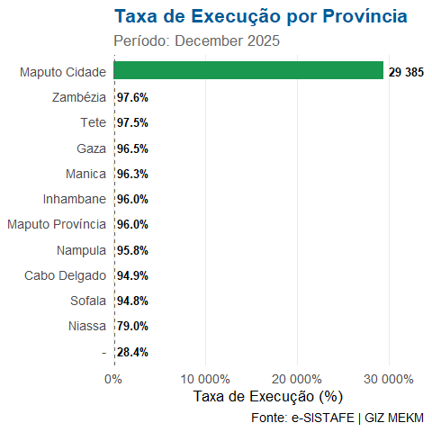
Figure 1: Taxa de execução por província

4 Mapa de Calor: Província × Função
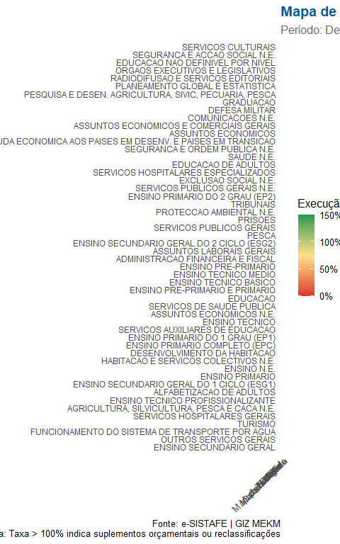
Figure 2: Taxa de execução por província e função (apenas funções com dotação > 0)

5 Execução por Distrito (Top/Bottom)
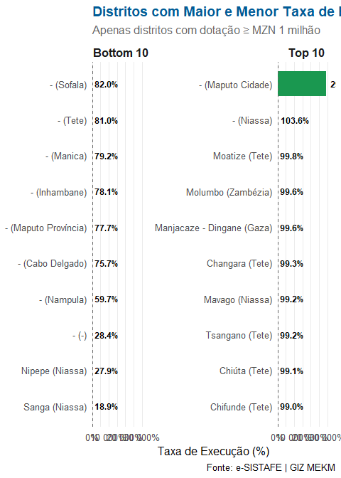
Figure 3: Top 10 e Bottom 10 distritos por taxa de execução (mínimo MZN 1M de dotação)

6 Notas Metodológicas
- Fonte de dados: e-SISTAFE, exportado via relatório consolidado por UGB/Funcional/Programa/FR/CED.
- Filtro aplicado: data_tipo == "Valor" (exclui percentagens já calculadas no sistema).
- Taxa de Execução: calculada como ad_fundos_desp_paga_vd_afdp / dotacao_actualizada_da. UGBs com dotação zero são excluídas do cálculo.
- Notas sobre taxas > 100%: Podem reflectir suplementos orçamentais aprovados após a dotação inicial, ou reclassificações de despesa.
- Período: 31/12/2025 – 31/12/2025

Relatório gerado automaticamente em R/Quarto · GIZ Moçambique — MEKM

