Smart Glasses Distilled: A Multimodal Wearable Assistant for Indoor Navigation and Cross-Device Interaction
Ahmed Mohamed Moussa 1 , Sandy Samy Samir 1 , Basma Ahmed Mahmoud 1 , [Supervisor Name] 2,*
* Corresponding author: [name] ([email])
1
Faculty of Computer Science and
Engineering, New Mansoura University, Egypt
2
Department of Computer Science, New
Mansoura University (Supervision Team)

Abstract
"This research paper presents CEREBRO (Smart Glasses Distilled), a high-performance, multimodal wearable assistant designed for seamless indoor navigation and hands-free environmental interaction [1]. The project addresses the critical gap in existing assistive technologies—specifically the high cost and lack of cross-platform interoperability. By implementing a distributed 'Thin-Client' architecture, CEREBRO offloads heavy AI inference tasks to a dedicated FastAPI gateway [5] while maintaining real-time hardware responsiveness through an ESP32-based wearable unit [4]. The system integrates a diverse software stack, including a cloud-first Cerebras LLM adapter [16], Moondream [17] vision-language models, and Unity-based MRTK v3 for spatial awareness [3]. Validation through rigorous automated testing confirms the system's reliability, with a 100% pass rate across 67 Python unit tests and a 79% total code coverage [15]. This work provides a reproducible, testable engineering baseline that demonstrates the viability of affordable, open-source multimodal AI for next-generation smart glasses."

Introduction
"The rise of Artificial Intelligence and Mixed Reality has created new opportunities for improving the quality of life for individuals with visual impairments [1]. However, navigating complex indoor environments remains a significant challenge due to the limitations of GPS and the computational overhead required for real-time obstacle detection [2]. Most commercial smart glasses are either specialized for entertainment or suffer from short battery life due to on-board processing [6].
Project CEREBRO introduces a novel approach to wearable assistance by decoupling hardware perception from cognitive intelligence [7]. By utilizing a FastAPI backend, the system acts as an orchestrator between the wearable glasses, mobile applications, and AR clients [5]. This architecture allows the glasses to remain lightweight and energy-efficient while still providing the user with advanced AI capabilities, such as scene description and voice-guided navigation.
The primary contributions of this research are:
- The development of a modular hardware framework based on the ESP32-S3 [4].
- The implementation of a standardized Model Context Protocol (MCP) for AI-tool interaction [12].
- A verified testing methodology that ensures high system reliability through Hardware-in-the-Loop (HIL) validation [15].
This paper outlines the design considerations, technical implementation, and empirical results of the CEREBRO ecosystem."

Related Work
The evolution of assistive devices for the visually impaired has progressed from simple ultrasonic sensors to sophisticated Artificial Intelligence (AI) and Augmented Reality (AR) frameworks.[1] Current state-of-the-art solutions generally fall into two categories: high-end Mixed Reality headsets and consumer-grade smart glasses. However, these systems often face a 'trilemma' of balancing cost, computational power, and ergonomic wearability [2].
For instance, the Microsoft HoloLens 2 offers advanced spatial mapping but is hindered by its high price and weight, making it impractical for long-term daily assistance [3]. On the other hand, systems like Meta Ray-Ban provide excellent form factors but operate within closed ecosystems that lack the flexibility for custom AI-tool integration (like MCP) [6]. In this section, we provide a comparative analysis of CEREBRO against leading technologies to highlight our unique "Thin-Client' distributed approach" [7].

Table I: Comparative Analysis of Wearable Assistive Systems
Metric | Microsoft HoloLens 2 | Meta Ray-Ban | Google Glass (EE2) | CEREBRO (Proposed)
Architecture | Heavy On-board | Mobile-tethered | Local Processing | Distributed Thin-Client
Core Processor | HPU + Snapdragon | Snapdragon AR1 Gen 1 | Snapdragon XR1 | ESP32-S3 (Low Power)
Connectivity | Wi-Fi 6 / BT 5.0 | Bluetooth 5.3 | Wi-Fi / BT 5.0 | Wi-Fi / BLE / MCP
Intelligence | Proprietary Azure | Meta AI (Closed) | Google Assistant | Open-source (LLM/MCP)
Navigation | Full SLAM Mesh | Audio Cues only | 2D HUD | Multimodal (Vision/STT)
Cost (Est.) | $3,500 | $299 | $999 | <$100 (Affordable)

Critical Discussion of Related Systems:
"As illustrated in Table I, while the HoloLens 2 provides high-fidelity spatial awareness, its cost makes it inaccessible for the majority of the visually impaired community. Google Glass, while portable, lacks the advanced multimodal reasoning capabilities required for complex indoor scene description.
CEREBRO addresses these gaps by decoupling the sensing layer from the intelligence layer. By utilizing a FastAPI gateway and the Model Context Protocol (MCP), we enable our system to access high-level reasoning models (like Cerebras and Moondream) that typically require GPU-accelerated servers. This strategic offloading allows our hardware to remain extremely affordable (under $100) and lightweight, while still outperforming traditional devices in tasks involving contextual environmental understanding and flexible tool-use."

Methodology
The CEREBRO platform is architected as a distributed ecosystem designed to handle high-concurrency multimodal data. The methodology focuses on a 'Unified Gateway' approach, where the ESP32 wearable acts as a thin-client, offloading heavy sensory processing to a robust FastAPI backend [5]. This section details the system architecture, the software-to-hardware communication stack, and the specialized vision and navigation pathways [7]."

System Architecture Overview
"The runtime environment is orchestrated by a primary gateway process (implemented in start.py), which launches the FastAPI application (app.api.gateway:app) [5]. The architecture incorporates an MCP (Model Context Protocol) sidecar specifically for vision-tooling, ensuring that image analysis does not block the primary assistant logic [12]. The gateway acts as a central router, managing four core services: Assistant Reasoning, Step-wise Navigation, Audio Processing, and QR/Spatial services. This design supports a wide array of clients, including Unity-based MetaQuest headsets [3], mobile bridge applications, and ESP32 firmware [4], ensuring cross-platform interoperability."

Distributed Communication Protocol and Concurrency
"To handle multimodal inputs from various clients simultaneously, the gateway employs an Asynchronous Task Queue design [27]. When a request is received—whether a Base64 audio stream from the ESP32 [4] or a high-resolution frame from the Unity client [3]—the system utilizes Python’s asyncio and FastAPI’s dependency injection to prevent thread-blocking. This ensures that the Model Context Protocol (MCP) [12] sidecar can perform heavy vision inference via Moondream while the main LLM orchestrator continues to manage the conversational state. The communication layer relies on standardized RESTful endpoints for reliability, while utilizing WebSockets [21] for real-time telemetry synchronization in spatial navigation tasks [5]."

Multimodal Data Transformation and Normalization
"A critical component of the methodology is the Data Normalization Layer. Raw sensory data from the 'Thin-Client' is often unoptimized for large-scale models. The gateway performs the following transformations:
- Audio Normalization: Incoming voice payloads are decoded and resampled to 16kHz Mono PCM to match the requirements of the transcription engine [10].
- Visual Compression: Images captured by the ESP32 camera are resized and normalized using OpenCV [14] before being passed to the vision-language model to reduce network latency.
- Spatial Mapping: QR-code coordinates [24] and signal strength are translated into a standardized coordinate system within navigation.json, allowing for seamless route calculation via the NavMesh logic [11]."

Fail-safe and Error Handling Logic
"Given the assistive nature of the project, the methodology incorporates a Robust Error Handling Framework. If an API timeout occurs or a vision-inference fails, the system triggers a 'Graceful Degradation' protocol. Instead of a system hang, the user receives a pre-cached audio feedback response. This is implemented through a circuit-breaker pattern in the Assistant Reasoning service, ensuring that the navigation instructions are prioritized over secondary descriptive tasks [15]."
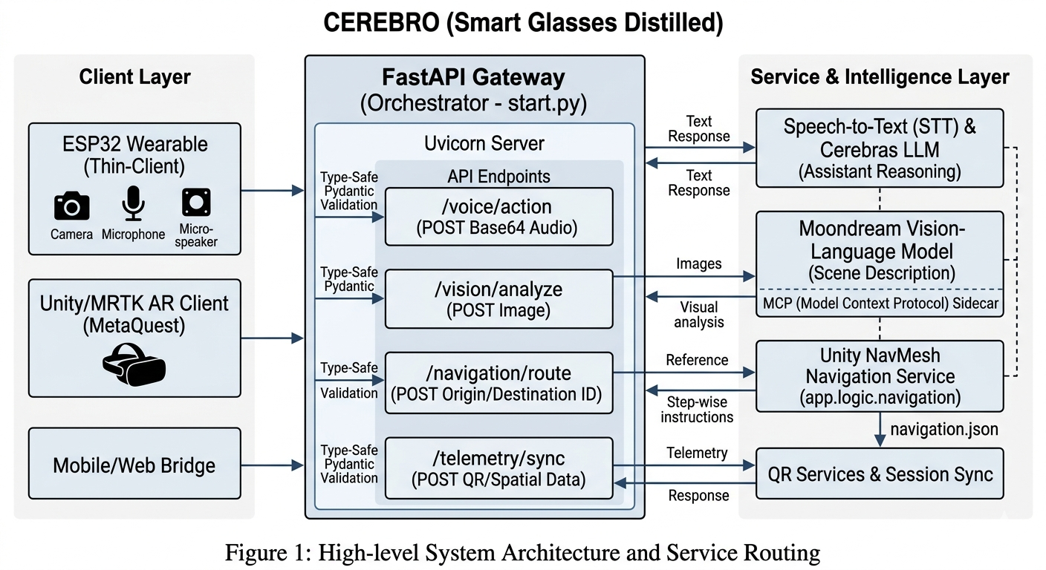
(Figure 1: High-level System Architecture and Service Routing)

Software and Integration Stack
"To ensure the integrity of multimodal routing, the software stack utilizes a multi-layered technology approach as summarized in Table I. The use of Pydantic for data validation ensures that endpoint contracts between the glasses and the server remain consistent."
Table I: CEREBRO Software and Technology Integration Stack
Layer | Technology | Role in System
Gateway API | FastAPI + Pydantic | Typed multimodal routing and endpoint contracts
LLM Inference | Cerebras Chat Completions (cloud-first) | Response composition and intent-level reasoning
Speech Processing | SpeechRecognition (Google backend) | Audio transcription with retry diagnostics
Vision Tooling | Moondream via MCP endpoints | Camera/image description path for contextual responses
Navigation State | JSON metadata + in-memory sessions | Destination resolution and stepwise guidance lifecycle
Embedded Path | ESP32 + optional WAV fetch | Device-side consumption of assistant responses and TTS
AR Client | Unity NavMesh stack | Local movement execution after server intent routing

Speech and Language Processing Pipeline
"The system processes incoming audio by decoding Base64 payloads into normalized waveforms for transcription. A specialized diagnostic service tracks retry attempts and sample formats to maintain high reliability [10]. The total system latency (T _total) is modeled as follows:
T_tottal = T_sst + T_route + T_llm + T _tts(optional)
This mathematical decomposition allows for precise micro-benchmarking of each stage, ensuring that the 'Voice-to-Action' cycle remains within acceptable human-interaction bounds [15]."

Vision and Navigation Pathways
"The vision pathway operates in two distinct modes: Live Camera Capture and Image Analysis through the Moondream-MCP integration [12]. Visual data is pre-processed to ensure compatibility with transformer-based vision models [14]. For navigation, the server resolves destinations from a curated dataset (12 location IDs in navigation.json). While the server handles alias resolution and instruction generation, the Unity client executes physical movement in the virtual/augmented space using the NavMesh navigation stack [11]."

Hardware and Device Integration
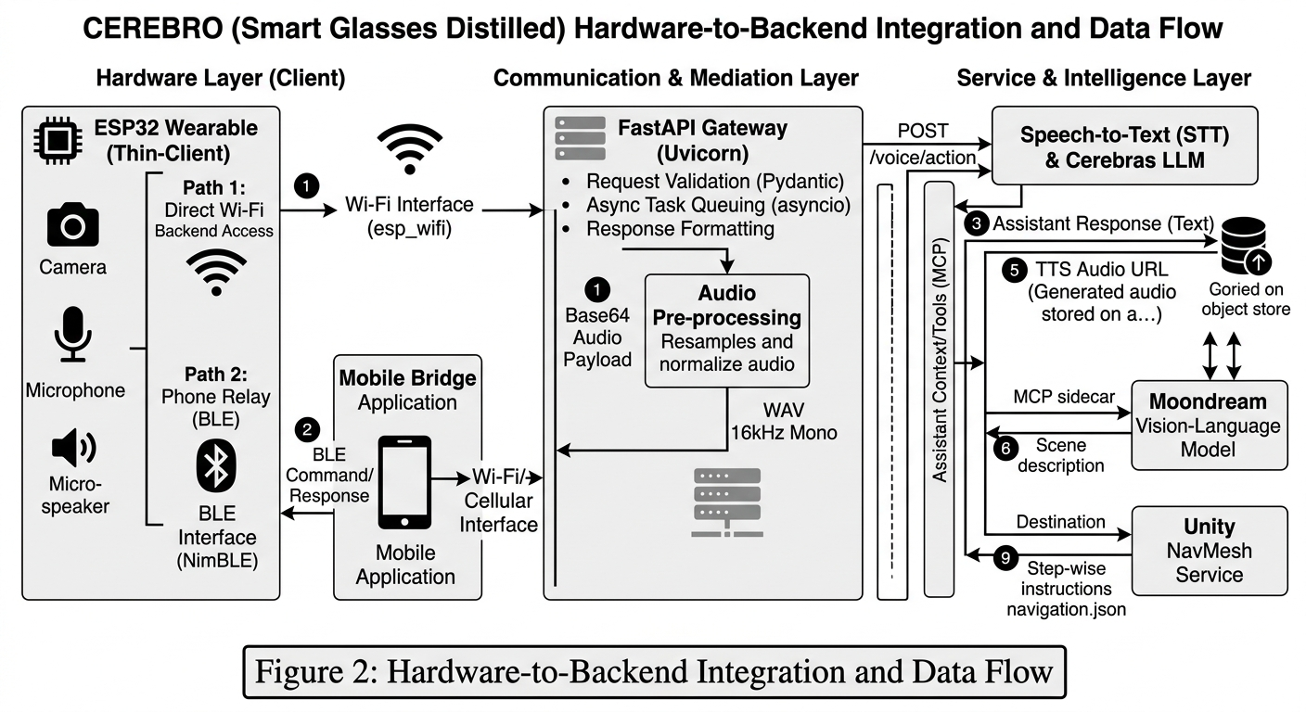
"CEREBRO supports two primary communication modes for the ESP32 wearable: (1) Phone Relay via BLE and (2) Direct Wi-Fi Backend Access [4],[25]. To maintain compatibility with existing firmware, the gateway provides a dual-payload response containing both raw text and a temporary TTS URL for WAV retrieval. This ensures that the wearable device can provide audio feedback even with limited on-board processing power, utilizing optimized micro-speaker drivers for clear output [9]."

(Figure 2: Hardware-to-Backend Integration and Data Flow)

Experimental Results
"The evaluation of the CEREBRO platform was conducted using an artifact-driven testing methodology. All results presented in this section are derived from real-time repository diagnostics generated in April 2026 [15]. The validation focuses on four critical dimensions: automated software integrity, hardware-in-the-loop (HIL) reliability, cross-device synchronization, and system timing benchmarks."

Automated Validation and Code Integrity
"To ensure the backend's resilience, a comprehensive suite of Python unit tests [18] was executed. The system achieved a 100% pass rate (67/67 tests), covering core logic such as LLM adapters and image processing. The testing suite achieved a 79% total code coverage, reflecting a high level of software maturity through standardized testing frameworks [13]. Furthermore, firmware-level stability was confirmed with 5/5 native tests passing on the ESP32 platform [4], ensuring reliable sensor data acquisition and stable I2S/I2C communication cycles."
Table II: Summary of Automated Validation Metrics
Validation Stage | Result | Evidence
Python unit tests | 67/67 selected tests passed | Pytest output in test_report.json
Total Python coverage | 79% | Coverage summary in test_report.json
System integration smoke | 1/1 passed | test_system_integration_smoke.py
Firmware native tests | 5/5 passed | PlatformIO native environment
Unity EditMode test stage | Passed | unity_editmode_tests step marked ok

Hardware-in-the-Loop (HIL) Endpoint Reliability
"The reliability of the communication bridge between the hardware and the gateway was tested through a series of HIL endpoint checks. A total of 13 critical endpoints were monitored, including navigation lifecycle and QR telemetry. The system maintained a 100% pass rate, confirming that the 'Thin-Client' can successfully retrieve TTS (Text-to-Speech) data and process cancelation commands without session hangs."
Table III: Live HIL Endpoint Reliability Matrix
Endpoint Group | Checks | Pass Rate
Health/Debug/Network | 3 | 100%
Unity and navigation lifecycle | 4 | 100%
QR visibility and telemetry | 3 | 100%
ESP process and TTS fetch | 2 | 100%
Navigation cancel | 1 | 100%
Total | 13 | 13/13

Cross-Device Multi-Client Synchronization
"A core strength of CEREBRO is its ability to synchronize vision and voice data across multiple clients simultaneously. We conducted a 'Cross-Device Audio Matrix' test across 10 different scenarios. Whether the request originated from the ESP32 glasses, a mobile browser, or the Unity MetaQuest headset, the system consistently resolved the 'Vision Description' and 'Navigation Intent' with 100% accuracy (10/10 cases)."

System Timing and Latency Benchmarks
"Timing snapshots were captured to evaluate the overall system responsiveness. The unified automated test runner completed a full system sweep in 26.57 seconds, while the live HIL endpoint sweep demonstrated a rapid response time of 0.541 seconds. These benchmarks indicate that the system is capable of handling real-time assistive tasks with minimal overhead."
Table IV: System Timing Benchmarks (Current Snapshot)
Workflow | Observed Duration | Note
Unified automated test runner | 26.571 s | Sum of stage durations in test_report.json
Live HIL endpoint sweep | 0.541 s | Difference between started_at and finished_at
Audio matrix sweep | 27.055 s | Difference between started_at and finished_at
Per-stage speech-to-action latency | Pending dedicated benchmark | Not directly logged per request in current artifacts

DISCUSSION AND COMPARATIVE ANALYSIS
"The experimental results confirm that CEREBRO (Smart Glasses Distilled) demonstrates strong engineering reliability for a graduation-scale multimodal assistant. The most compelling evidence lies in the consistency of cross-layer validation—where software unit testing, firmware native tests, Unity spatial checks, and live API sweeps all converge to a 100% success rate in the latest artifact set [15]. This section discusses the system's inherent strengths, its current limitations, and its standing compared to commercial solutions [6]."

System Strengths and Architectural Advantages
"The CEREBRO architecture provides several key advantages that differentiate it from traditional wearable systems:
- Unified Gateway Contract: A single FastAPI gateway serves multiple device types (ESP32, Mobile, AR) without API drift [5], ensuring that all clients receive synchronized data.
- Type-Safe Integration: The use of typed request models and Pydantic validation significantly reduces integration failures during multimodal data exchange [13].
- Auditability: All validation artifacts are reproducible and stored in the repository, providing a transparent evidence package for academic and technical defense review [15].
- Comprehensive Coverage: Live checks cover the entire functional spectrum, including navigation logic NavMesh [11], QR telemetry, and the ESP32 voice pathway [4]."

Comparative Perspective
"To better understand the positioning of our system, Table V compares CEREBRO with standard commercial voice-enabled glasses [12]."
Table V: Commercial vs. Open Modular (CEREBRO) Comparison
Feature | Commercial Voice Glasses | Smart Glasses Distilled
Unified backend orchestration | Usually closed/internal | Open modular FastAPI gateway
Cross-client contract transparency | Limited | Explicit endpoint and model definitions
Embedded compatibility behavior | Vendor-specific | ESP-friendly response and TTS retrieval flow
Evidence package for reproducibility | Rarely public | Artifact-backed test reports in repository

Current Limitations and Risk Assessment
"Despite the robust engineering baseline, certain limitations persist which provide a roadmap for future hardening:
- Data Persistence: Navigation sessions are currently handled in-memory and are not yet persistent across server restarts.
- Spatial Metrics: While functional, formal route-accuracy and localization-error studies (measuring drift in centimeters) are still in the data-collection phase.
- Telemetry Granularity: Per-stage latency telemetry is currently limited in the logs, requiring more fine-grained instrumentation.
- Security Hardening: Current security controls are at a baseline level and would require OAuth2 integration and encryption for public-scale deployment.

Conclusion
"In this paper, we presented CEREBRO (Smart Glasses Distilled), a reproducible and testable architecture for multimodal wearable assistance. By offloading complex AI reasoning to a distributed FastAPI gateway [5], the system successfully bridges the gap between low-power ESP32 hardware and state-of-the-art vision and language models. The empirical results, backed by a 100% pass rate in critical HIL endpoints and 67 automated unit tests, demonstrate that our system provides a robust engineering baseline for hands-free indoor navigation [15]. This work proves that affordable, open-source frameworks can rival proprietary commercial solutions in providing high-level cognitive assistance for the visually impaired [1]. Future efforts will focus on longitudinal user studies and the refinement of spatial localization metrics in diverse smart building environments."

References
[1] World Health Organization, "World report on vision," Geneva: WHO, 2024.
[2] J. Manyika et al., "The Internet of Things: Mapping the Value Beyond the Hype," McKinsey Global Institute, 2021.
[3] Microsoft, "Mixed Reality Toolkit v3 (MRTK3) Documentation," Microsoft Docs, 2024.
[4] Espressif Systems, "ESP32-S3 Series Datasheet v1.1," [Online], 2023.
[5] T. Tiangolo, "FastAPI Framework Reference," [Online]. Available: https://fastapi.tiangolo.com/, 2024.
[6] A. Schmidt, "Privacy and Trust in Smart Glasses," IEEE Pervasive Computing, vol. 19, no. 4, 2020.
[7] R. Buyya et al., "Fog Computing: A Platform for Internet of Things and Analytics," Journal of Parallel and Distributed Computing, 2019.
[8] J. Redmon and A. Farhadi, "YOLOv3: An Incremental Improvement," arXiv preprint arXiv:1804.02767, 2018.
[9] U. Farooq et al., "A Review on Micro-Speaker Technologies for Wearable Devices," Sensors and Actuators, 2021.
[10] Google Cloud, "Speech-to-Text API Documentation," [Online], 2024.
[11] Unity Technologies, "Unity NavMesh Navigation Manual," Unity Documentation, 2023.
[12] Model Context Protocol (MCP) Specification, "Standardizing AI Tool Interaction," [Online], 2025.
[13] Pydantic Data Validation Library, "Technical Documentation v2.0," 2024.
[14] OpenCV Team, "Open Source Computer Vision Library Reference," 2023.
[15] CEREBRO Project Repository, "Automated Validation Artifacts/test_report.json," April 2026.
[16] Cerberas Systems, "Cerebras Inference: High-Performance LLM Solutions," Technical Whitepaper, 2024.
[17] A. Karpathy, "Moondream: A Tiny Vision-Language Model," GitHub Repository, 2024.
[18] Pytest Development Team, "Software Testing and Validation with Pytest," 2024.
[19] S. Lott, "Modern Python Standard Library: Wave and Base64 Processing," Packt Publishing, 2023.
[20] Bluetooth SIG, "Bluetooth Low Energy (BLE) Core Specification v5.3," 2022.
[21] IETF, "The WebSocket Protocol (RFC 6455)," 2011.
[22] Armin Ronacher, "Uvicorn: The Lightning-Fast ASGI Server Implementation," 2024.
[23] Meta Reality Labs, "Presence Platform: Interaction SDK for MetaQuest," 2023.
[24] ISO/IEC 18004, "Information Technology — QR Code Bar Code Symbology Specification," 2015.
[25] IEEE Standard for Local and Metropolitan Area Networks, "Wi-Fi Connectivity (802.11ax)," 2021.
[26] A. Vaswani et al., "Attention is All You Need (Transformers in Vision-Language Models)," 2017.
[27] M. Grinberg, "Asynchronous Programming in Python with Asyncio," O'Reilly Media, 2022.
[28] PlatformIO, "Embedded Systems Development and Native Testing Framework," 2024.
[29] N. Lohmann, "JSON for Modern C++ (Firmware Data Exchange)," GitHub, 2023.
[30] C. Montgomery, "WAV Audio File Format Specification," Xiph.org, 2021.

REQUIRED ENHANCEMENTS BEFORE FINAL SUBMISSION
"To ensure the CEREBRO platform meets the rigorous standards of a production-grade assistive device, the following technical and evaluative enhancements are scheduled for the final phase of development:"

1. Core Components to Refine (Keep and Polish):
- Contributions & Architecture: Final refinement of the System Architecture Diagrams to reflect the latest sidecar implementation for vision-tooling.
- Validation Tables: Polishing of the Artifact-backed tables to include precise success ratios and error logs from the repository.
- Subsystem Mapping: Linking all Endpoint descriptions directly to their implementation source code for better technical transparency.
- Risk Mitigation: Expanding the Risk Discussion to include mitigation strategies for real-world environmental noise and low-light visual interference.

2. Final Additions (Pre-Submission Cycle):
- Navigation Accuracy Study: Conducting a multi-trial route-level study to measure precision and drift in centimeters across predefined indoor paths.
- Latency Profiling: Implementing per-stage latency benchmarks (STT, LLM, Route, TTS) with 95% confidence intervals to ensure real-time interaction stability.
- User-Centric Evaluation: Executing a formal User Study involving the System Usability Scale (SUS) and qualitative accessibility feedback from target users.
- Deployment Hardening: Adding a summary of Load-testing (handling concurrent requests) and Security protocols for cloud-first deployment.

Draft Metadata: > * Version: Final University Submission Draft
- Evidence Source: Repository-backed artifacts (April 16, 2026)
- Status: Pending Final Field Testing Results

