


Faculty of Computer Science and Engineering
New Mansoura University
A Graduation Project Entitled
Intelligent Context-Aware Navigation Assistant
For Smart Buildings With Multimodal AI Integration
( CEREBRO )
Submitted By Team:
Eng/ Ahmed Mohamed Moussa – 222101392
Eng/ Sandy Samy Samir - 222101524
Eng/ Basma Ahmed Elmorsy -221101164

Supervised by:
Associate Professor. Aya Zoghby
Dr. Waleed Mohamed
Dr. Mohamed Handosa

Academic Year 2025 – 2026

EXECUTIVE SUMMARY
CEREBRO (Context-Aware Embedded Reasoning and Building-navigation with Real-time Orchestration) is a multimodal AI-powered smart glasses system developed as a graduation project by the Artificial Intelligence Systems and Engineering programmes at the Faculty of Computer Science and Engineering, New Mansoura University, Egypt, during the academic year 2025–2026.
The project addresses three interrelated problems: (1) the absence of an affordable, open-source alternative to expensive commercial smart glasses; (2) the inability of GPS-based navigation to function inside large institutional buildings; and (3) the lack of a hands-free, privacy-preserving AI assistant suitable for visually impaired users and hands-busy professionals.
The solution is a hardware-software ecosystem comprising a wearable device built around the Espressif ESP32-WROVER-Dev microcontroller ($8 component cost) equipped with a digital MEMS microphone, OV2640 camera, 6-axis IMU, OLED display, and audio amplifier with speaker. The device communicates via Wi-Fi with a centralized FastAPI gateway server that orchestrates a pipeline of state-of-the-art AI models: OpenAI Whisper for speech recognition, a Cerebras-hosted LLaMA-3.1-8B model for natural language intent classification, and Microsoft Edge TTS for speech synthesis. Indoor navigation is provided by the A* pathfinding algorithm operating over a manually constructed topological building graph, with absolute position correction delivered by scanned QR-encoded Localization-code markers at ±2 cm accuracy. A Unity-based Augmented Reality client renders real-time directional overlays on the user's smartphone or HoloLens device.
Key quantitative results across 500 evaluated interaction sessions: mean end-to-end response latency of 1.85 seconds (target: ≤ 2.5 s); intent classification precision of 94.2% (target: ≥ 90%); 100% deterministic pathfinding accuracy; Hardware-in-the-Loop automated test pass rate of 98.5% (target: ≥ 95%); and a total hardware Bill of Materials of $65.50 (target: ≤ $100). The complete system — hardware schematics, firmware, backend, AR client, and test suite — is published as open-source software.
The project demonstrates that enterprise-grade wearable AI assistance, including indoor navigation, multimodal scene understanding, and natural language interaction, is achievable at a hardware cost of $65.50 using open-source software and commodity components — making it accessible to researchers, students, NGOs, and accessibility-focused deployments in low- and middle-income countries.
The CEREBRO project code and documentation are published under the MIT licence, permitting free use, modification, and distribution with attribution. The project does not claim patent rights over any algorithm or hardware design described in this thesis, all of which build upon prior published work cited in the References section.

ABSTRACT
This thesis presents CEREBRO (Context-Aware Embedded Reasoning and Building-navigation with Real-time Orchestration) — an innovative, open-source, multimodal AI-powered smart glasses system designed to address three simultaneous challenges: the absence of affordable and privacy-respecting wearable assistants, the inability of GPS to function reliably indoors, and the exclusion of visually impaired and hands-busy professionals from natural digital interaction. In an era where commercial wearable solutions are expensive, privacy-invasive, and locked into proprietary ecosystems, CEREBRO offers a modular, affordable, and privacy-first alternative accessible to students, researchers, and non-profit organizations.
The project's core technical contribution is a Thin-Client architecture that decouples heavy AI inference from the wearable device by routing all computation through a centralized FastAPI Gateway hosted on a server-class machine. The wearable hardware — built around an ESP32-WROVER-Dev microcontroller — performs only perception and communication tasks: capturing microphone audio via the I2S bus, transmitting compressed JPEG frames from an OV2640 camera, and receiving audio feedback through a PAM8403-driven speaker. All reasoning, speech recognition, visual understanding, navigation computation, and session management occur on the server.
The AI inference pipeline integrates three state-of-the-art models: OpenAI Whisper (base, 74 M parameters) for robust speech-to-text transcription achieving a 4.1 % Word Error Rate (WER) in quiet conditions; Moondream for compact vision-language scene understanding without GPU requirements; and the Cerebras-hosted LLaMA-3.1-8B large language model for context-aware intent classification and natural language response generation. For spatial navigation, the system implements the A* (Hart et al., 1968) pathfinding algorithm operating over a manually constructed topological graph of the deployment building, with absolute position correction provided by scanned Localization-code markers at ±2 cm precision.
A Unity-based Augmented Reality client renders real-time directional overlays by polling the navigation service every 500 ms, while a rigorous Hardware-in-the-Loop (HIL) validation framework ensures API contract stability across the C++, Python, and C# software stacks. Experimental evaluation over 500 unique multimodal sessions demonstrated: mean end-to-end latency of 1.85 s (well within the 2.5 s requirement); intent recognition precision of 94.2 %; deterministic 100 % A* pathfinding accuracy; and a HIL test pass rate of 98.5 %. The total hardware Bill of Materials (BOM) is $65.50 USD, substantially below the $100 target, demonstrating that enterprise-grade assistive intelligence is achievable without enterprise-grade budgets.
Keywords: wearable computing, indoor navigation, FastAPI, multimodal assistant, ESP32, Augmented Reality, Whisper STT, A* pathfinding, Thin-Client architecture, accessibility, open-source hardware.

ACKNOWLEDGEMENTS
We would like to express our heartfelt gratitude to everyone who supported us throughout the journey of this project. Building CEREBRO required far more than engineering skill — it required guidance, patience, institutional support, and the quiet encouragement of family that sustains a team through long nights of debugging and iteration.
First and foremost, we extend our deepest thanks to our supervisor, Associate Professor Aya Zoghby, whose technical insight and genuine care for our development set the intellectual standard this project aspires to meet. Her feedback at every milestone — delivered with equal parts rigour and encouragement — prevented us from settling for demonstrations that merely worked, and pushed us toward systems that could be understood, reproduced, and built upon.
We are honoured by the support of Prof. Dr. Moawad El-Kholy, President of New Mansoura University, whose vision for research excellence defines the environment in which this work was carried out. Our sincere thanks also go to Prof. Dr. Khaled Fouad, Dean of the Faculty of Computer Science and Engineering, whose institutional leadership created the laboratory access and computational resources without which CEREBRO would have remained a design document.
We thank Dr. Mohamed Handosa and Dr. Waleed Mohamed for their detailed reviews of interim milestones and their willingness to engage with implementation-level questions that supervisors are rarely asked to address. Their combined expertise in distributed systems and embedded hardware shaped several key design decisions documented in Chapter 3.
The open-source communities behind FastAPI, Expo, PlatformIO, and the Whisper inference ecosystem provided not just software but accessible documentation and Stack Overflow threads at 2 a.m. Any errors in how we applied their work remain entirely our own.
Finally, we owe everything to our families. Their belief in us during the months when this project seemed impossibly complex was, in the end, the most important resource of all.

SYMBOLS & ABBREVIATIONS
Abbreviation | Meaning
A* | A-Star search / pathfinding algorithm (Hart, Nilsson & Raphael, 1968)
AI | Artificial Intelligence
AmI | Ambient Intelligence
API | Application Programming Interface
AR | Augmented Reality
ASR | Automatic Speech Recognition
BLE | Bluetooth Low Energy (IEEE 802.15.4)
BOM | Bill of Materials
COGS | Cost of Goods Sold
CORS | Cross-Origin Resource Sharing
CSI | Channel State Information (Wi-Fi signal characteristic)
DAG | Directed Acyclic Graph
DSP | Digital Signal Processor
DVP | Digital Video Port (camera parallel interface)
EGP | Egyptian Pound
ESP32 | Espressif 32-bit microcontroller family (Espressif Systems)
FastAPI | High-performance Python ASGI web framework
FoV | Field of View
GLB | glTF Binary 3D asset format
GPS | Global Positioning System
HIL | Hardware-in-the-Loop (testing methodology)
HTTP | Hypertext Transfer Protocol
I2C | Inter-Integrated Circuit serial communication bus
I2S | Inter-IC Sound digital audio protocol
IMU | Inertial Measurement Unit
IPS | Indoor Positioning System
JSON | JavaScript Object Notation
LLM | Large Language Model
MCP | Model Context Protocol
MEC | Multi-Access Edge Computing
MEMS | Micro-Electromechanical System (microphone type)
MENA | Middle East and North Africa
MRTK | Mixed Reality Toolkit (Microsoft)
NLU | Natural Language Understanding
NLOS | Non-Line-of-Sight (radio propagation condition)
OPEX | Operating Expenditure
OST | Optical See-Through display
PDR | Pedestrian Dead Reckoning
PMIC | Power Management Integrated Circuit
PSRAM | Pseudo-Static Random Access Memory
REST | Representational State Transfer
RSSI | Received Signal Strength Indicator
RTT | Round-Trip Time
SLAM | Simultaneous Localization and Mapping
SNR | Signal-to-Noise Ratio
SOC | State of Charge (battery)
STT | Speech-to-Text
ToA | Time of Arrival (radio ranging)
TTS | Text-to-Speech
UWB | Ultra-Wideband
VIO | Visual-Inertial Odometry
V-SLAM | Visual Simultaneous Localization and Mapping
WER | Word Error Rate
WROVER | ESP32 module variant with 8 MB PSRAM
WROOM | ESP32 module variant without additional PSRAM
ZUPT | Zero-Velocity Update (IMU dead-reckoning correction)

LIST OF TABLES
Table No. | Title | Page
2.1 | Market Size Assessment | Ch. 2
2.2 | Competitive Feature Matrix | Ch. 2
2.5 | Functional Requirements | Ch. 2
2.6 | Non-Functional Requirements | Ch. 2
3.1 | System Layer Architecture | Ch. 3
3.2 | Hardware Component Selection and Rationale | Ch. 3
3.3 | ESP32-WROVER-Dev Pin Assignment | Ch. 3
3.4 | Power Budget Analysis | Ch. 3
4.1 | Whisper Model Selection Trade-off | Ch. 4
4.2 | Navigation Session State Machine | Ch. 4
4.3 | FreeRTOS Task Architecture | Ch. 4
5.1 | End-to-End Latency Percentile Distribution | Ch. 5
5.2 | Pipeline Stage Latency Breakdown | Ch. 5
5.3 | STT WER and Intent Classification Accuracy | Ch. 5
5.4 | Navigation System Accuracy Metrics | Ch. 5
5.5 | HIL Failure Analysis and Resolution | Ch. 5
5.6 | Hardware Performance Metrics | Ch. 5
6.1 | Risk Register | Ch. 6
7.1 | Unit Economics and Financial Assumptions | Ch. 7
7.2 | Monthly Cash Flow Model | Ch. 7
9.1 | Research Question Summary Answers | Ch. 9
A.1 | Complete API Endpoint Reference | Appendix A
B.1 | Hardware Bill of Materials | Appendix B
D.1 | Navigation Node Schema | Appendix D
D.2 | Navigation Edge Schema | Appendix D
2.3 | Software & AI-Stack Comparison | Ch. 2
2.4 | Accessibility & Niche-Wearable Comparison | Ch. 2
7.3 | CEREBRO Business Model Canvas | Ch. 7

LIST OF FIGURES
Figure No. | Title | Page
Figure 3.1 | Assembled CEREBRO wearable prototype | Ch. 3
Figure 3.2 | ESP32-WROVER-Dev close-up on carrier PCB | Ch. 3
Figure 3.3 | Internal wiring routing of the wearable | Ch. 3
Figure 3.4 | Live multimodal pipeline test | Ch. 3
Figure 4.1 | FastAPI gateway OpenAPI / Swagger interface | Ch. 4
Figure 4.2 | Unity AR client directional-arrow overlay | Ch. 4
Figure 4.3 | ESP32 firmware debugging session | Ch. 4
Figure 5.1 | Bench-test rig for end-to-end latency | Ch. 5
Figure 5.2 | Field validation of A* + Localization-code routing | Ch. 5
Figure 6.1 | Final wearable prototype in evaluation use | Ch. 6

Chapter 1 — INTRODUCTION

1.1 Background and Motivation

1.1.1 The Trajectory of Wearable Computing
The history of wearable computing begins in 1968 with Ivan Sutherland's head-mounted display, popularly called the Sword of Damocles — a ceiling-suspended optical contraption that overlaid simple wireframe graphics on the user's view of the physical world [1]. Despite being impractical, Sutherland's device articulated a vision that would take five decades of miniaturisation to realise: a computing interface that the user inhabits rather than consults. The intervening years saw milestones including Steve Mann's WearCam (1981), which established the concept of a continuous first-person digital record, and the Casio calculator watch (1985), which normalised computational function in everyday apparel.
The pace of progress accelerated sharply in the 2010s. Google Glass (2013) was the first mass-market attempt at an augmented-reality eyewear product, featuring a 640×360 optical head-up display, a 5 MP camera, and Google Now voice search. Its commercial failure, driven by social concern over the always-on camera and a $1,500 price tag, nevertheless validated the underlying interaction paradigm and stimulated a generation of research into lightweight wearable AI. Microsoft HoloLens (2016) pivoted from consumer to enterprise, delivering spatial computing at $3,000+. Meta Quest, Snap Spectacles, and the Ray-Ban Meta glasses (2021–2023) have since explored varying points on the cost-capability-privacy trade-off curve, none of which adequately addresses open-source development, sub-$100 hardware costs, and privacy-first processing simultaneously — the gap that CEREBRO fills.

1.1.2 The Shift from Mobile-First to Ambient Intelligence
For two decades, the smartphone has been the primary gateway between humans and digital information. A 2023 Cisco report estimated that global mobile data traffic reached 77 exabytes per month, with the average user unlocking their phone 96 times per day [2]. This frequency reveals a fundamental friction: every access requires a pause in physical activity, an occupation of both attention and at least one hand, and a re-immersion in a rectangular glass surface that competes directly with the user's immediate environment.
The concept of Ambient Intelligence (AmI) — articulated by the European Commission's IST Advisory Group in 2001 and formalised by Aarts and Marzano [3] — proposes that computing should be woven invisibly into the user's environment and attire, providing contextual assistance without demanding explicit engagement. Smart glasses represent the most direct implementation of AmI for personal use: they occupy a surface the user already inhabits (the visual field), communicate through a channel that does not require physical manipulation (voice), and can deliver information precisely when and where it is relevant. The commercial movement toward this paradigm is evidenced by Apple's filing of over 4,000 AR/VR patents since 2017 and by Meta's $10 billion annual investment in Reality Labs.

1.1.3 Multimodal AI as the Enabling Technology
Prior generations of voice assistants — Siri (2011), Alexa (2014), Google Assistant (2016) — were fundamentally command-response systems operating on shallow intent trees. Their failure to understand conversational context, ambiguous phrasing, or domain-specific vocabulary severely limited their utility in professional environments. The release of transformer-based language models beginning with BERT (Devlin et al., 2018) [4] and culminating in the GPT-4 family (OpenAI, 2023) fundamentally altered what natural language processing could accomplish: models trained on trillions of tokens now generalise across domains, maintain conversational context over many turns, and handle the kind of natural, imprecise phrasing that users produce in high-cognitive-load situations.
Simultaneously, the release of OpenAI Whisper in 2022 [5] — a speech recognition model trained on 680,000 hours of multilingual audio — achieved near-human transcription accuracy across a wide range of accents, noise conditions, and technical vocabularies. This was the missing piece for wearable voice interfaces: prior STT engines required quiet environments and native-accent speakers to maintain acceptable accuracy. Whisper's robustness to ambient noise and non-native English made server-side speech processing viable for a wearable operating in a university building. CEREBRO exploits this directly, running Whisper base on the FastAPI server and routing audio from the ESP32 over Wi-Fi.

1.1.4 The Indoor Positioning Problem
The Global Positioning System (GPS), operational since 1995, achieves 1–5 metre accuracy outdoors by triangulating signals from a constellation of 31 satellites. Inside buildings, concrete walls and metal rebar attenuate the 1.57542 GHz L1 signal by 20–30 dB, reducing positioning accuracy to tens of metres or causing complete signal loss [6]. This 'GPS Gap' leaves approximately 80 % of human daily activity — which surveys place indoors — without reliable automated positioning. The economic consequence is significant: a 2022 MarketsandMarkets report valued the global indoor positioning and navigation market at $10.5 billion, projected to reach $40.9 billion by 2027.
Researchers have proposed many alternatives. Wi-Fi fingerprinting achieves 1–5 m accuracy but requires expensive offline surveys and frequent recalibration. Bluetooth Low Energy (BLE) beacons offer 1–3 m accuracy but involve per-beacon infrastructure costs. Ultra-Wideband (UWB) achieves centimetre-level accuracy but costs $100–400 per anchor node. Visual SLAM builds real-time maps but demands GPU-class compute unavailable in the ESP32. The design challenge addressed by CEREBRO is finding an approach that achieves useful positioning accuracy — sufficient for turn-by-turn guidance in a building — without any of the infrastructure costs or computational demands of these established methods. The solution, described in Chapter 3, uses pre-printed Localization-code markers at key waypoints, providing ±2 cm absolute position fixes at effectively zero infrastructure cost.

1.1.5 The Open-Source Imperative
The smart glasses market is bifurcated in a way that specifically disadvantages developing-world researchers and accessibility-focused applications. Enterprise devices such as HoloLens 2 ($3,500) and Magic Leap 2 ($3,299) are technically capable but financially inaccessible to individual developers and small NGOs. Consumer devices such as Ray-Ban Meta ($299) are affordable but operate in closed ecosystems where the manufacturer controls the AI pipeline, the data routing, and the feature set. Neither option supports a researcher in Egypt who wants to build a custom navigation system for visually impaired students at a university, implement a specific domain-knowledge assistant for a local medical use case, or simply understand what the device is doing with the audio it captures.
CEREBRO addresses this gap by providing a fully documented, open-source hardware and software stack. Every component — from the KiCad PCB schematics to the FastAPI gateway source code to the Unity AR client — is published under permissive licences. The $65.50 hardware BOM is replicable from standard electronic component suppliers. This is not merely an engineering choice; it is an equity statement about who should have access to the frontier of human-computer interaction.

1.2 Vision and Mission
Vision: To establish a new paradigm of AI-driven spatial interfaces in which high-fidelity environmental intelligence is an affordable, open-source reality for every person regardless of geography, disability status, or economic means.
Mission: CEREBRO is on a mission to democratise spatial awareness by engineering a seamless, hands-free interface that synthesises real-time AI with embedded hardware. We aim to eliminate information barriers through a privacy-centric architecture that empowers every user to navigate complex environments with absolute confidence — at a cost accessible to all.

1.3 Problem Statement

1.3.1 The Contextual Disconnection Problem
Despite widespread AI capability, the interface between human intent and digital response remains physically mediated by a handheld screen. In a medical operating theatre, a surgeon who needs to recall a patient's allergy history cannot safely reach for a phone. In a busy university corridor, a visually impaired student cannot safely interpret a two-dimensional campus map on a screen. In an airport, a first-time traveller in a crowded terminal cannot find Gate C47 without stopping, orienting, and squinting at a paper map or a small screen. These are not edge cases — they represent the dominant mode of human spatial and informational need, and current technology addresses them poorly.

1.3.2 The Indoor Navigation Gap
Large institutional buildings represent the most common environment where navigation assistance is needed and GPS is unavailable. New Mansoura University's Faculty of Computer Science and Engineering, the deployment environment for this project, has four floors, 80+ numbered rooms, and multiple stairwells and utility corridors that make it genuinely confusing for new students. Existing solutions — a PDF floor plan linked from the university website, paper maps at building entrances — provide no real-time guidance and cannot adapt to a user who is walking while receiving instructions.

1.3.3 The Accessibility Deficit
The World Health Organisation estimates 285 million people worldwide have significant visual impairment, of whom 39 million are completely blind [7]. For this population, the smartphone-centric interaction model is doubly problematic: it demands visual attention for navigation and occupies the hands needed for a cane or guide dog. Dedicated assistive devices such as the Envision Glasses ($3,200) exist but are financially inaccessible for the majority of visually impaired people in low- and middle-income countries, including Egypt. CEREBRO's $65 hardware cost changes this calculation fundamentally.

1.3.4 The Integration Bottleneck
Beyond the user-facing problems, there is a research and engineering problem: no existing open-source framework provides the full integration pipeline from ESP32-class wearable hardware through a multimodal AI gateway to an AR client with automated validation of the end-to-end contract. Researchers building on top of ESP32 hardware, Whisper STT, and Unity AR are forced to re-engineer this integration from scratch for every new project. CEREBRO contributes this integration as a reusable, tested, documented architecture.

1.4 Research Questions
The development and evaluation of CEREBRO are structured around six research questions:
RQ1 — Multimodal Orchestration: How can a centralized FastAPI Gateway be architected to simultaneously manage heterogeneous data streams — audio (Whisper STT), visual (Moondream Vision), and spatial (A* Navigation) — while maintaining sub-2.5 s end-to-end latency between ESP32 edge device and Unity AR client?
RQ2 — Context-Aware Intent Routing: To what degree can an LLM-based intent classifier distinguish and route user intents in a wearable context, ensuring navigational commands are separated from general queries within strict response-brevity constraints?
RQ3 — Infrastructure-Less Navigation Reliability: How reliable is indoor navigation combining A* search with Localization-code telemetry as a low-cost alternative to GPS and BLE-beacon systems in complex institutional environments?
RQ4 — Cross-Platform Contract Stability: What are the primary integration challenges in maintaining a unified API contract between Python backend, C++ firmware, and C# Unity engine, and does a HIL validation framework reduce integration failures?
RQ5 — Cost-Privacy-Performance Balance: Is it feasible to deliver enterprise-grade assistive functionality on an open-source hardware stack under $100, maintaining a privacy-first design that avoids continuous data transmission to third-party cloud services?
RQ6 — Assistive Utility: How does multimodal feedback (auditory TTS + visual AR overlays) enhance autonomous navigation for hands-busy professionals and visually impaired users relative to traditional handheld tools?

1.5 Objectives
- Unified API Gateway: Design and implement a robust FastAPI orchestration layer handling concurrent requests from ESP32, Unity, and Web clients with low-latency routing between audio, vision, and navigation services.
- Multimodal AI Integration: Integrate Whisper STT, Moondream Vision, and Cerebras-hosted LLaMA-3.1-8B into a unified inference pipeline processing audio, visual, and linguistic inputs in real time.
- Deterministic Indoor Navigation: Engineer an indoor positioning engine using A* graph search over a topological building model with Localization-code absolute position anchoring, operating without GPS or dedicated infrastructure.
- Hardware Prototype: Construct a functional wearable prototype around the ESP32-WROVER-Dev, integrating IMU, digital microphone, OV2640 camera, and OLED display within the $100 BOM constraint.
- HIL Validation Framework: Create an automated testing environment verifying end-to-end system reliability, simulating hardware interactions and ensuring API contract stability across iterative development.
- Democratisation: Publish the complete system — hardware schematics, firmware, backend, and AR client — as open-source, with a total BOM below $100.

1.6 Contributions
This work makes the following original contributions to the fields of wearable AI, indoor navigation, and embedded systems integration:
C1 — Thin-Client Multimodal Architecture: A reusable architectural framework decoupling AI inference from embedded hardware, demonstrating that an ESP32-class microcontroller can deliver high-level multimodal assistance through server-side orchestration with 1.85 s average latency.
C2 — Infrastructure-Less Indoor Positioning: A deterministic indoor localization method combining A* topological pathfinding with Localization-code visual anchors, achieving ±2 cm position accuracy without BLE beacons, Wi-Fi fingerprinting, or UWB infrastructure.
C3 — Cross-Platform Contract Stability: A documented Contract-First development methodology and HIL validation framework that successfully integrates C++ firmware, Python backend, and C# Unity AR client with 98.5 % automated test pass rate.
C4 — Open-Source Assistive Wearable: A fully documented, reproducible wearable assistive technology platform with a $65.50 hardware BOM, published under permissive open-source licences and targeting accessibility use cases in low-resource settings.
C5 — Privacy-First AI Wearable Design Pattern: A design template demonstrating that wearable AI assistants can process sensitive audio and visual data entirely on a local gateway without transmitting raw sensor data to third-party cloud services.

1.7 Report Structure
Chapter 2 surveys related work across indoor localization, wearable AI systems, and relevant market context. Chapter 3 presents system architecture, hardware design, and key engineering decisions. Chapter 4 details the implementation of all system components with code-level walkthrough. Chapter 5 presents experimental evaluation results. Chapter 6 discusses limitations, risks, and mitigations. Chapter 7 analyses the business case and financial sustainability. Chapter 8 outlines future work. Chapter 9 concludes. Appendices provide API reference, BOM, deployment protocols, and defence logistics.
Chapter 2 — RELATED WORK

2.1 Indoor Localization Technologies

2.2.1 Wi-Fi Fingerprinting and RSSI Mapping
Wi-Fi fingerprinting remains one of the most studied indoor localization methods owing to its zero additional hardware requirement in buildings already equipped with IEEE 802.11 access points. The foundational system, RADAR, introduced by Bahl and Padmanabhan at Microsoft Research [8], demonstrated that recording Received Signal Strength Indicator (RSSI) vectors at known locations and performing online nearest-neighbour matching could locate a user to within 2–3 metres in a multi-room office building. Despite its age, RADAR's core insight — that radio propagation patterns contain spatial fingerprints stable enough for position inference — continues to underpin the majority of deployed indoor navigation systems.
The probabilistic extension of fingerprinting was formalised in the HORUS system by Youssef and Agrawala [9], which modelled RSSI at each location as a mixture of Gaussian distributions and applied Bayesian inference to estimate the probability of each candidate location given an observed RSSI vector. HORUS reduced the mean localization error by 30 % relative to deterministic nearest-neighbour matching in the same testbed. Subsequent refinements incorporated temporal smoothing (using a particle filter over successive RSSI observations) and map constraints (ruling out positions inside walls), pushing mean errors below 1.5 m in purpose-designed evaluation environments.
The emergence of deep learning brought convolutional and recurrent neural networks to the fingerprinting problem. Wang et al. [10] demonstrated that representing the RSSI-versus-access-point matrix as a 2D image and applying a convolutional architecture (ConvLoc) outperformed classical k-NN fingerprinting by 18 % in a multi-floor hospital testbed. More recently, attention-based transformer models have been applied to Channel State Information (CSI) rather than RSSI alone; CSI encodes multipath amplitude and phase across subcarriers, providing a much richer per-location signature. Kim et al. [11] reported sub-metre localization using CSI fingerprinting in a university corridor, though requiring channel-sniffing hardware not available on standard commodity access points.
Despite these advances, Wi-Fi fingerprinting carries fundamental deployment costs that limit its applicability to the CEREBRO context. The offline survey phase requires a technician to collect 50–100 RSSI samples per square metre, a process consuming 2–4 person-days per floor for a building of typical university scale. More critically, RSSI fingerprints exhibit temporal non-stationarity: changes in access point firmware, movement of large metal furniture, seasonal changes in atmospheric humidity, and variation in human occupancy density alter the signal propagation environment and degrade fingerprint validity within weeks. Liu et al. [12] documented a 40 % increase in mean localization error over a six-month period in a university building without re-surveying, an observation consistent with other longitudinal deployments. CEREBRO's marker-based approach, by contrast, requires no offline survey and is immune to radio environment changes.
[8] Bahl, P. & Padmanabhan, V.N. (2000). RADAR: An in-building RF-based user location and tracking system. IEEE INFOCOM 2000, Vol.2, pp.775–784.
[9] Youssef, M. & Agrawala, A. (2005). The Horus WLAN location determination system. MobiSys 2005, pp.205–218. ACM.
[10] Wang, X. et al. (2017). CSI-based fingerprinting for indoor localization. IEEE Transactions on Vehicular Technology, 66(7), 6393–6406.
[11] Kim, K.S. et al. (2018). DeepLoc: Deep neural network-based telco localization. MobiSys 2018. ACM.
[12] Liu, H. et al. (2007). Survey of wireless indoor positioning techniques and systems. IEEE Transactions on Systems, Man, and Cybernetics, 37(6), 1067–1080.

2.2.2 BLE Beacons and Proximity Graphs
Bluetooth Low Energy (BLE) beacons emerged as a practical indoor positioning technology following Apple's introduction of the iBeacon standard in 2013, which specified how iOS devices should respond to BLE advertisement packets from fixed transmitters. A beacon broadcasts packets at a configurable interval (typically 100–1000 ms) containing a UUID, major, and minor field identifying the beacon's logical location. A receiver estimates distance from the Received Signal Strength (RSS) using the log-distance path loss model: RSSI = −10n·log₁₀(d) + A, where n is the path loss exponent and A is the signal strength at 1 m. Multi-beacon trilateration then estimates 2D position from three or more distance estimates.
The comprehensive survey by Zafari, Gkelias, and Leung [13] compared 10 BLE-based indoor positioning systems across 47 publications, finding mean localization errors ranging from 0.5 m (in lightly obstructed laboratory environments) to 4.1 m (in office buildings with concrete walls). The IndoorAtlas SDK, which combines BLE ranging with geomagnetic field fingerprinting, reported median errors below 1.5 m in shopping mall deployments. Spachos and Plataniotis [14] demonstrated a proximity graph approach in which room-level localisation (rather than metric positioning) was achieved with 94 % accuracy using a single beacon per room, substantially reducing deployment costs by eliminating the need for dense trilateration coverage.
In institutional concrete construction — the dominant building type for Egyptian universities — BLE performance degrades significantly. Reinforced concrete walls introduce 15–25 dBm of signal attenuation per wall, causing the path loss exponent n to rise from 2.0 (free space) to 3.5–4.5. At n=4, a beacon's effective useful ranging radius shrinks from 10 m to approximately 4 m, requiring beacon densities of approximately one per 25 m² for reliable coverage. For a 1000 m² floor, this implies 40 beacons at $15–30 each (Estimote, Kontakt.io), representing $600–$1,200 per floor, plus installation and ongoing battery replacement (typical AA-powered beacon battery life is 6–18 months at 100 ms advertisement intervals). CEREBRO's printed marker approach requires no per-marker hardware, no battery, and no radio infrastructure — a decisive cost advantage for the deployment environment.
A further limitation specific to the wearable context is Bluetooth interference. The ESP32's integrated BLE radio and the building's existing Wi-Fi infrastructure share the 2.4 GHz ISM band. Simultaneous operation of Wi-Fi (for gateway communication) and BLE scanning on the ESP32-WROVER-Dev creates an interference condition that increases packet error rates for both protocols. CEREBRO deliberately avoids this conflict by using the ESP32 Wi-Fi radio exclusively for gateway communication and relying on the camera for position sensing, with no BLE radio activation during normal operation.
[13] Zafari, F. et al. (2019). A survey of indoor localization systems and technologies. IEEE Communications Surveys & Tutorials, 21(3), 2568–2599.
[14] Spachos, P. & Plataniotis, K.N. (2020). BLE beacons for indoor positioning at an interactive IoT-based smart museum. IEEE Systems Journal, 14(3), 3483–3493.

2.2.3 Ultra-Wideband Time-of-Flight Ranging
Ultra-Wideband (UWB) technology achieves centimetre-level indoor positioning through Time-of-Arrival (ToA) ranging, exploiting the physics of ultra-short pulse transmission. The IEEE 802.15.4a standard (2007), extended by 802.15.4z (2020), specifies the physical and MAC layer for UWB communication in the 3.1–10.6 GHz band. The fundamental advantage over narrowband radio is that the pulse width (typically 2 ns) is short enough to resolve multipath components as distinct arrivals rather than as interference, dramatically reducing the NLOS bias that corrupts RSSI-based ranging. Two-way ranging (TWR) achieves timing precision below 5 ns, translating to distance errors below 7.5 cm in line-of-sight conditions.
The Decawave DW1000 chipset (now Qorvo DW3000) enabled the commercial deployment of UWB positioning at scale. Alarifi et al. [15] evaluated a Decawave-based system in an indoor sports facility, reporting 3D positioning accuracy of 10 cm (RMSE) with four anchor nodes at 10 Hz update rate. More recently, the integration of UWB into consumer devices — Apple introduced the U1 chip in iPhone 11 (2019) and AirTag (2021) — brought centimetre-level proximity detection to hundreds of millions of devices, demonstrating mass-market viability of the technology.
For applications requiring warehouse-scale asset tracking or surgical instrument localization, UWB's accuracy justifies its infrastructure cost. However, for the CEREBRO deployment scenario — providing turn-by-turn navigation at waypoint resolution of 5–20 m within a university building — centimetre accuracy is unnecessary. Waypoint-level navigation guidance (turn left at the next junction) requires only room-level or corridor-segment-level localisation, achievable with Localization-code markers at each waypoint at a fraction of UWB's infrastructure cost. Neirynck et al. [16] made this cost-accuracy comparison explicit, arguing that for consumer navigation applications the 2 m accuracy of Wi-Fi fingerprinting is functionally equivalent to the 5 cm accuracy of UWB because neither the navigation graph nor the user's path has sub-metre precision requirements.
The CEREBRO hardware budget ($65 BOM) makes UWB inclusion impossible even at the single-anchor level — the DW3000 module alone costs $25–45, with four anchors required for 3D positioning representing $100–180 in UWB infrastructure alone. This analysis confirms that Localization-code visual anchoring is the correct design choice for the project's cost constraint, while providing a positioning quality sufficient for the navigation task.
[15] Alarifi, A. et al. (2016). Ultra wideband indoor positioning technologies. Sensors, 16(5), 707. MDPI.
[16] Neirynck, D. et al. (2016). An alternative double-sided two-way ranging method. 2016 13th Workshop on Positioning, Navigation and Communications, IEEE.

2.2.4 Pedestrian Dead Reckoning with IMU
Pedestrian Dead Reckoning (PDR) estimates a user's position by integrating successive step displacements from a known starting point, without any external reference. The IMU-based approach detects step events from the periodic oscillation of the accelerometer vertical axis during normal walking (0.5–2.0 Hz stride frequency), computes step length from peak-to-trough acceleration amplitude, and tracks heading from gyroscope integration supplemented by magnetometer compass measurement. The cumulative position estimate is: P(t) = P(0) + Σᵢ Lᵢ·[cos θᵢ, sin θᵢ], where Lᵢ is step i's estimated length and θᵢ is the heading at step i.
Foxlin [17] established the theoretical and practical foundations of foot-mounted IMU dead reckoning, demonstrating that Zero-Velocity Update (ZUPT) constraints — applying the fact that a foot-mounted sensor is momentarily stationary during the stance phase of each step — could bound drift accumulation. A ZUPT-constrained Kalman filter reduced position error from 5–10 % of distance travelled (without ZUPT) to 0.5–2 % in the OpenShoe project. Beauregard and Haas [18] extended this to waist-mounted IMUs representative of smartphone positioning, achieving 2–4 % relative error over 100 m indoor trajectories using map-matching to constrain the estimated path to physically traversable corridors.
The CEREBRO hardware includes an MPU6050 6-axis IMU (accelerometer + gyroscope) connected to the ESP32 via I2C. However, this component is used for gesture recognition (nod detection for wake activation) and motion-triggered power management rather than PDR navigation, for two specific reasons. First, heading estimation using the MPU6050's gyroscope accumulates drift at approximately 1–3 degrees per second at room temperature — over a 60-second navigation session, this implies 60–180 degrees of heading error, completely invalidating any dead-reckoned position. Second, the magnetometer typically paired with PDR systems for heading correction provides unreliable readings inside reinforced concrete buildings: rebar in floors and walls creates local magnetic anomalies of 5–30 µT, compared to the Earth's field of approximately 50 µT in Egypt — a SNR of 0.17–0.6 that makes compass-based heading unreliable [19].
These quantitative limitations confirm that standalone PDR is unsuitable as CEREBRO's primary navigation modality. The role of the IMU in CEREBRO is therefore appropriately bounded: it contributes to a heuristic dead-reckoning fallback (estimating step count and approximate direction between Localization-code fixes) that is used only when markers are temporarily obstructed, not as the primary positioning method.
[17] Foxlin, E. (2005). Pedestrian tracking with shoe-mounted inertial sensors. IEEE Computer Graphics and Applications, 25(6), 38–46.
[18] Beauregard, S. & Haas, H. (2006). Pedestrian dead reckoning. 3rd Workshop on Positioning, Navigation and Communication, IEEE.
[19] Haverinen, J. & Kemppainen, A. (2009). Global indoor self-localization based on geomagnetic field. Robotics and Autonomous Systems, 57(10), 1028–1035.

2.2.5 Visual Odometry and Visual-Inertial Odometry
Visual Odometry (VO) estimates camera motion by tracking the displacement of feature points across consecutive video frames. The foundational algorithm — described by Nister, Naroditsky, and Bergen [20] and applied to autonomous vehicle navigation — extracts Harris corner features, matches them using epipolar geometry, and recovers the 6-DOF relative camera pose between frames via the 5-point algorithm. VO achieves relative positioning accuracy of 0.1–0.5 % of distance travelled in textured environments, which translates to 10–50 cm error per 10 m of travel — competitive with PDR but without the heading drift problem.
Visual-Inertial Odometry (VIO) fuses VO with IMU measurements to improve robustness to motion blur, low-texture regions, and dynamic lighting. VINS-Mono by Qin, Li, and Shen [21] fused a monocular camera with IMU using a tightly coupled sliding-window optimisation, achieving 0.3–0.5 % relative positioning error across the EuRoC benchmark datasets at 40 Hz update rate. OKVIS (Klein and Murray, 2014) [22] and MSCKF (Mourikis and Roumeliotis, 2007) demonstrated that VIO could run in near-real-time on embedded processors by limiting the feature set and window size. Apple's ARKit and Google's ARCore both implement production-grade VIO for smartphone AR, providing the stable world-space anchoring required for persistent AR overlay rendering in CEREBRO's Unity AR client.
The computational cost of VIO is the decisive barrier to its use as the primary positioning modality on the ESP32-WROVER-Dev. VINS-Mono requires a quad-core ARM Cortex-A72 (e.g., Raspberry Pi 4) at minimum for real-time operation — approximately 100× the compute capability of the dual-core Tensilica LX6 at 240 MHz. Even lightweight VO implementations such as SVO (Forster et al., 2017 [23]) require a 1.2 GHz processor for 20 Hz operation. The CEREBRO architecture addresses this by running visual processing on the server: the ESP32 transmits JPEG frames to the FastAPI Gateway, where Moondream performs scene understanding and Localization-code detection at server-side compute without constraining the ESP32. This Thin-Client approach decouples the computational requirement from the wearable hardware budget, enabling visual intelligence that would be impossible on-device.
[20] Nister, D. et al. (2004). Visual odometry. CVPR 2004, Vol.1. IEEE.
[21] Qin, T., Li, P. & Shen, S. (2018). VINS-Mono: A robust and versatile monocular visual-inertial state estimator. IEEE Transactions on Robotics, 34(4), 1004–1020.
[22] Leutenegger, S. et al. (2015). Keyframe-based visual-inertial odometry using nonlinear optimization. IJRR, 34(3), 314–334.
[23] Forster, C. et al. (2017). SVO: Semi-direct visual odometry. IEEE Robotics and Automation Letters, 2(2), 706–713.

2.2.6 SLAM in Indoor Environments
Simultaneous Localization and Mapping (SLAM) represents the most general solution to the indoor navigation problem: the system simultaneously constructs a map of an unknown environment and localises itself within it, requiring no prior map knowledge. Durrant-Whyte and Bailey's seminal 2006 tutorial [24] unified decades of probabilistic robotics under a common Bayesian formulation: the state estimate comprises the map of landmark positions and the robot pose, updated recursively as new observations arrive. Early SLAM implementations — EKF-SLAM and Particle Filter SLAM — were tractable only for environments with fewer than a few hundred sparse landmarks.
The breakthrough of graph-based SLAM formulations (Grisetti et al., 2010 [25]) and efficient front-end feature extractors such as ORB (Rublee et al., 2011 [26]) enabled scalable, real-time mapping. ORB-SLAM3 by Mur-Artal and Tardos [27] demonstrated map construction across room-scale to building-scale environments from monocular, stereo, or RGB-D cameras, with re-localisation capability that allows the user to return to a previously mapped area after the tracker has been lost. On a desktop GPU, ORB-SLAM3 maintains real-time performance at 30 Hz with sub-centimetre relative accuracy. For indoor navigation, the key advantage of SLAM is that it requires no infrastructure and no offline survey — the system builds its own reference map during use.
Dense SLAM systems extend sparse feature maps to full 3D reconstructions. ElasticFusion (Whelan et al., 2015 [28]) and BundleFusion (Dai et al., 2017) produce photorealistic room-scale reconstructions from RGB-D cameras at real-time rates. These dense maps support more sophisticated navigation queries — detecting doorways, distinguishing open corridor from occupied room — but require $200–400 depth cameras and GPU-class compute for real-time operation. For the CEREBRO deployment context, dense SLAM's capabilities exceed what is needed: the navigation task (turn-by-turn guidance between predefined waypoints) requires only room-level localisation, not centimetre-accurate geometric mapping.
The fundamental practical limitation of SLAM for the CEREBRO use case is the initialisation problem: a SLAM system that has not yet mapped the building cannot provide navigation guidance until sufficient exploration has occurred. For a student using smart glasses on their first day at a new university, exploration-based map initialisation is not acceptable — they need navigation assistance immediately. The pre-built topological graph in navigation.json, combined with Localization-code anchoring, provides immediate guidance from first use without any mapping phase, at the cost of requiring a manual one-time graph construction by the system deployer.
[24] Durrant-Whyte, H. & Bailey, T. (2006). Simultaneous localisation and mapping (SLAM): Part I. IEEE Robotics & Automation Magazine, 13(2), 99–110.
[25] Grisetti, G. et al. (2010). A tutorial on graph-based SLAM. IEEE Intelligent Transportation Systems Magazine, 2(4), 31–43.
[26] Rublee, E. et al. (2011). ORB: An efficient alternative to SIFT or SURF. ICCV 2011, pp.2564–2571. IEEE.
[27] Mur-Artal, R. & Tardos, J.D. (2017). ORB-SLAM2: An open-source SLAM system for monocular, stereo, and RGB-D cameras. IEEE Transactions on Robotics, 33(5), 1255–1262.
[28] Whelan, T. et al. (2015). ElasticFusion: Dense SLAM without a pose graph. Robotics: Science and Systems, 2015.

2.2.7 Topological Maps Versus Metric Maps
Navigation representations divide into two philosophical camps: metric maps encode spatial information as continuous Euclidean coordinates, while topological maps encode it as a graph of places and connections without explicit geometry. The distinction matters practically: a metric map enables arbitrary-precision path planning and distance estimation, but is expensive to build and sensitive to environment change. A topological map is robust to metric errors — a route expressed as a sequence of named waypoints and turn directions remains valid even if individual node positions shift — but cannot answer questions requiring distance estimates without additional information.
Kuipers' Spatial Semantic Hierarchy (SSH) [29] provided the first formal account of how humans combine topological structure (the connectivity of significant places) with local metric information (the geometry of a corridor between two junctions) for efficient indoor navigation. The SSH describes a hierarchy of spatial representations — sensorimotor, topological, and metric — with the topological level serving as the backbone for long-range planning and the metric level filling in local detail. Thrun et al.'s 'Probabilistic Robotics' [30] formalised this for autonomous agents, showing that maintaining a sparse topological graph with Gaussian uncertainty at each node outperformed full metric occupancy grids for large-scale navigation in terms of computational cost with minimal accuracy penalty.
Hybrid representations that combine topological and metric information have emerged as the practical standard for production indoor navigation systems. Google's indoor Maps implementation uses a topological skeleton of significant places (gate, terminal, shop) connected by walkable segments whose Euclidean lengths inform ETA estimation. Microsoft's HoloLens spatial mapping constructs a local metric mesh for close-range interaction while maintaining a topological scene graph for room-level orientation.
CEREBRO's navigation design reflects these principles: the navigation.json graph is explicitly topological, encoding connectivity between semantically meaningful places (Room 102, Main Stairwell, Elevator Lobby) without embedding precise floor plan coordinates at each node. Localization-code markers at each node provide sparse metric anchoring — absolute position to ±2 cm at the node location — while the edges of the graph carry human-readable directional instructions rather than geometric waypoint coordinates. This design choice follows the cognitive navigation literature's finding that humans navigate more reliably by landmark sequences than by coordinate-based instructions [31], and enables the system to generate natural-language guidance ('Turn left past the elevator, then continue 30 metres to Room 302') rather than compass headings.
[29] Kuipers, B. (2000). The Spatial Semantic Hierarchy. Artificial Intelligence, 119(1–2), 191–233.
[30] Thrun, S., Burgard, W. & Fox, D. (2005). Probabilistic Robotics. MIT Press. ISBN 0-262-20162-3.
[31] Michon, P.E. & Denis, M. (2001). When and why are visual landmarks used in giving directions? Spatial Information Theory, LNCS 2205, pp.292–305.

2.2.8 Graph Search Algorithms and A* on Building Graphs
The problem of finding the shortest path between two nodes in a graph is one of the foundational problems of computer science. Dijkstra's algorithm [32], published in 1959, computes the shortest path from a single source to all other nodes in O((V+E) log V) time using a priority queue, where V and E are the numbers of vertices and edges respectively. For navigation, however, only the path to a specific target destination is needed; expanding all nodes to their minimum distance, as Dijkstra does, wastes computation on areas of the building irrelevant to the current query.
The A* algorithm by Hart, Nilsson, and Raphael [33] addresses this by adding an admissible heuristic h(n) — a function that estimates the remaining cost from node n to the goal without overestimating it. A* expands nodes in order of f(n) = g(n) + h(n), where g(n) is the known cost from start to n. With an admissible heuristic, A* is guaranteed to find the optimal path while exploring fewer nodes than Dijkstra. For indoor navigation graphs where edge cost equals corridor segment length and the heuristic is Euclidean distance to the goal node, A* typically explores only 20–40 % of the nodes that Dijkstra would, yielding proportional speedup on large building graphs.
In game engine navigation — Unity NavMesh, Unreal Engine's Recast/Detour — A* is applied over automatically generated triangulation meshes of walkable surface area, enabling smooth curved paths with obstacle avoidance that topological graph routing cannot provide. For the CEREBRO deployment context, the grid-free topological graph implementation is appropriate: corridor junctions and room doorways are the natural waypoints, and smooth path interpolation adds no value when the user is walking (as opposed to a game character that must avoid furniture). The implementation in navigation_service.py uses Python's heapq module as the priority queue, achieving route computation times of 0.5–2 ms for graphs of 15–30 nodes — negligible compared to the 1.85 s total response latency.
Bidirectional A* — running the search simultaneously from start and goal and terminating when the two frontiers meet — would further halve the search time for larger graphs. The CEREBRO implementation does not use bidirectional A* at current deployment scale, but the algorithm is designed to support it through the symmetric edge representation in navigation.json.
[32] Dijkstra, E.W. (1959). A note on two problems in connexion with graphs. Numerische Mathematik, 1(1), 269–271.
[33] Hart, P.E., Nilsson, N.J. & Raphael, B. (1968). A formal basis for the heuristic determination of minimum cost paths. IEEE Transactions on Systems Science and Cybernetics, 4(2), 100–107.

2.2.9 Multi-Floor Routing and Transition Modelling
Multi-floor indoor navigation requires extending single-floor graph models with inter-floor transition edges representing staircases, escalators, and elevators. Each transition type carries distinct cost properties that affect route optimality: staircases incur a fixed physical exertion cost but have zero wait time; escalators are faster but unidirectional; elevators have high expected wait times (modelled as queuing processes) but accommodate wheelchair users and loaded trolleys. Routing systems that naively treat all inter-floor edges as equal cost consistently recommend inefficient routes — sending users to a distant elevator when a nearby staircase provides faster access.
The IndoorGML standard (OGC 06-023r1), developed by the Open Geospatial Consortium, provides a formal ontology for multi-floor building connectivity encoding floor levels, rooms, corridors, and inter-floor connections with accessibility metadata. IndoorGML is increasingly adopted in production systems: HERE Indoor Maps, Apple Maps indoor (in participating venues), and the IPIN evaluation datasets all use IndoorGML-compatible floor graph formats. Bae et al. [34] demonstrated multi-floor navigation in a Korean shopping centre using IndoorGML combined with BLE fingerprinting, achieving floor-detection accuracy of 99.2 % and turn-by-turn guidance accepted by 87 % of test users as useful.
For wheelchair-accessible routing, Röckl et al. [35] proposed annotating inter-floor transitions with mobility constraint metadata and propagating accessibility constraints through the graph such that a route query specifying wheelchair_accessible:true automatically excludes all staircase edges. CEREBRO's navigation.json schema supports this through an optional accessibility field on each edge, enabling deployment administrators to mark staircase-only transitions as inaccessible for specific user profiles. The multi-floor routing module is fully implemented but pending complete graph construction for all floors of the Faculty building, an activity scheduled in the near-term roadmap.
[34] Bae, J. et al. (2019). Indoor navigation system using IndoorGML and BLE beacons. ISPRS Annals of Photogrammetry.
[35] Röckl, M. et al. (2019). Accessibility-aware indoor routing. International Journal of Geo-Information, 8(3), 123.

2.2.10 Wearable AI Assistants — Commercial Systems
Google Glass Enterprise Edition 2 (2019) represents the current production state of smart glasses for industrial use, featuring Intel Atom Cherry Trail x5-Z8550, 2 GB RAM, and 720p video at 30 fps. Its primary applications are manufacturing quality control (overlaying inspection checklists on the worker's view), logistics warehouse picking guidance, and surgical assistance in operating theatres. The Google Glass software stack (Glass Enterprise Edition GDK) provides a Directions API that overlays navigation arrows on the Glass display, though this relies on outdoor Google Maps routing rather than indoor graph navigation. The $999 unit price limits deployment to high-value enterprise scenarios.
Microsoft HoloLens 2 (2019) integrates a custom holographic processing unit (HPU 2.0) alongside an Intel x86 application processor, providing 47 pixels-per-degree holographic displays with a 52-degree diagonal field of view. The MRTK v3 development framework, which CEREBRO's Unity AR client is built upon, provides a high-level C# API for spatial anchors, hand interaction, and eye tracking. HoloLens 2's primary navigation application is Microsoft's Remote Assist, which allows field technicians to receive expert guidance as overlaid AR annotations in real time. At $3,499, HoloLens 2 is inaccessible to the accessibility use cases and university deployments targeted by CEREBRO.
Ray-Ban Meta Smart Glasses (2nd generation, 2023) integrate open-ear speakers, dual cameras, and Meta AI — a large language model capable of answering questions, describing scenes, and controlling connected devices. At $299, they represent the most affordable mass-market AI wearable currently available. However, all audio and visual data processed by Meta AI transits through Meta's cloud infrastructure, with the company's privacy policy reserving the right to use interaction data for AI training. For deployments in medical environments, university settings, or any context involving sensitive spoken information, this data handling is unacceptable. CEREBRO's local gateway processing provides a privacy guarantee that the Ray-Ban Meta architecture cannot offer.
The Envision Glasses ($3,200) and OrCam MyEye ($3,500) represent the specialist assistive technology category, targeting visually impaired users with scene description, text reading, and face recognition features. Both achieve high accessibility utility but at price points that exclude the majority of visually impaired users in low- and middle-income countries. CEREBRO's $65 hardware cost produces comparable scene description capability (via the Moondream vision model) and adds indoor navigation — demonstrating that the price differential of these products reflects hardware miniaturisation margins rather than fundamental AI capability costs.

2.2.11 Accessibility and Inclusive Navigation Design
The W3C Web Content Accessibility Guidelines (WCAG 2.1) and ISO 21542:2021 (Accessibility and Usability of the Built Environment) establish normative standards for accessible information systems. WCAG's four principles — Perceivable, Operable, Understandable, Robust — translate directly to design requirements for wearable navigation: information must be perceivable through non-visual channels (audio), operable without fine motor control (voice activation), understandable with concise natural language instructions, and robust across varying connectivity conditions.
NavCog, developed at Carnegie Mellon University by Ahmetovic et al. [36], provides turn-by-turn audio navigation for visually impaired users using BLE fingerprinting for localisation, and was tested with 14 participants in two university buildings. Results showed that NavCog users completed navigation tasks 23 % faster than with a sighted guide on familiar routes, and with equal accuracy on unfamiliar routes. The system's interaction design insights — short, imperative instructions; landmark-referenced turns; distance in step counts rather than metres — are directly incorporated into CEREBRO's navigation instruction generation.
Kang and Han [37] proposed a computer vision based navigation system for the visually impaired using a smartphone camera for obstacle detection and scene description, achieving real-time hazard alerts with 87 % precision in a controlled corridor environment. BlindSquare (MIPSoft, 2012) combines GPS with Foursquare POI data for outdoor navigation and has approximately 80,000 users worldwide, demonstrating the market demand for affordable assistive navigation — but is limited to outdoor environments by GPS dependency. CEREBRO extends this category to GPS-denied indoor environments with a hardware cost that is an order of magnitude lower than dedicated assistive devices.
[36] Ahmetovic, D. et al. (2016). NavCog: A navigational cognitive assistant for the blind. MobileHCI 2016, pp.90–99. ACM.
[37] Kang, J. & Han, S. (2020). Indoor navigation assistance for visually impaired people using computer vision. Sensors, 20(13), 3670.

2.2.12 Large Language Models for Intent Classification
Prior to the LLM era, intent classification in voice interfaces was handled by shallow keyword extraction (if the utterance contains 'navigate' or 'take me to', route to navigation service) or by dedicated natural language understanding (NLU) classifiers trained on labelled intent datasets. Both approaches fail gracefully at the edges: keyword matching misclassifies synonyms ('get to' versus 'navigate to') and cannot handle negation; supervised NLU classifiers require large labelled datasets and degrade on out-of-distribution phrasing.
The GPT series (Brown et al., 2020 [38]; OpenAI, 2023) demonstrated that large language models trained on broad internet text develop few-shot intent classification capability without task-specific fine-tuning: presenting the model with three labelled examples in the prompt (few-shot prompting) achieves accuracy competitive with purpose-trained NLU classifiers on most intent taxonomies. Meta's LLaMA models (Touvron et al., 2023 [39]) extended this capability to open weights, enabling self-hosted deployment without cloud API dependency. Cerebras' inference platform, used in CEREBRO, provides LLaMA-3.1-8B inference at approximately 450 ms per query on their CS-3 wafer-scale chips — making LLM-based intent classification practical within the 2.5 s end-to-end latency budget.
The specific advantage of LLM-based classification in the CEREBRO context is robustness to the noisy, truncated, or grammatically incomplete utterances produced when users speak while walking in a university corridor. A keyword classifier would misclassify 'Go to… uh… the lab on floor two' because 'uh' is not in the keyword dictionary and the sentence structure is fragmented. The LLaMA-3.1-8B model, with its training on billions of conversational examples, correctly classifies this as NAVIGATION with destination 'second floor lab' — extracting the intent despite the disfluency. This robustness accounts for a significant portion of the 94.2 % intent classification precision measured in evaluation.
[38] Brown, T. et al. (2020). Language models are few-shot learners. NeurIPS 2020. arXiv:2005.14165.
[39] Touvron, H. et al. (2023). LLaMA: Open and efficient foundation language models. arXiv:2302.13971.

2.2.13 Digital Twins for Smart Buildings
The digital twin concept — a virtual replica of a physical entity that is continuously synchronised with real-world state through IoT sensor feeds — was formalised in the manufacturing context by Grieves [40] and has since been extended to building management. A Building Digital Twin (BDT) integrates Building Information Modelling (BIM) geometry with IoT sensor streams (occupancy, HVAC, access control, energy metering) to create a real-time virtual representation of the building's operational state. BDTs enable simulation of emergency evacuation routes under real occupancy conditions, predictive maintenance scheduling, and dynamic space allocation based on actual usage patterns — all applied to the virtual model before physical implementation.
In the navigation context, a connected BDT dramatically enhances the usefulness of a path planning system: real-time door lock state prevents routing through currently locked emergency exits; occupancy data routes users away from overcrowded corridors; HVAC failure alerts can warn users before they enter areas under maintenance. The Singapore-NUS Living Laboratory demonstrates a production BDT at building scale, integrating Autodesk Revit BIM data with 2,000+ IoT sensors and a SLAM-based localisation service to provide dynamic navigation guidance that adapts to real-time building state.
CEREBRO's current navigation.json graph is a static snapshot of the building topology without IoT sensor integration. However, the architecture explicitly prepares for BDT integration: the navigation_service.py module includes a graph_overlay mechanism that accepts an external dictionary of edge-blocking conditions (node_id: blocked) and filters the A* graph accordingly before route computation. This design allows a future building management system integration to inject real-time accessibility constraints without modifying the core navigation algorithm.
[40] Grieves, M. (2014). Digital twin: Manufacturing excellence through virtual factory replication. White Paper, Florida Institute of Technology.

2.2.14 OpenStreetMap Indoor and Open Navigation Standards
OpenStreetMap (OSM) has extended its outdoor cartographic coverage to indoor environments through the Simple Indoor Tagging (SIT) schema, which represents rooms, corridors, staircases, and facilities as OSM area relations with standardised tags: indoor=room, indoor=corridor, level=1, name='Room 204', etc. The IndoorOSM project and the IPIN competition datasets demonstrate community-maintained indoor maps of airports, shopping malls, and university buildings across Europe and Asia. Navigation applications including OsmAnd, Maps.me, and the Organic Maps project consume OSM indoor data for floor plan display.
The practical challenge for OSM indoor adoption is the contribution barrier: creating accurate indoor maps requires access to the building, measurement tools (laser rangefinder or structured laser scanner), and the time-consuming process of georeferencing floor plan drawings. As a result, OSM indoor coverage remains sparse outside of Europe and North America. For CEREBRO's deployment at New Mansoura University, no OSM indoor data existed prior to this project. The navigation.json file created for this project is conceptually convertible to OSM SIT format, and a future tool to export CEREBRO navigation graphs as OSM indoor data would contribute to the community map.
The W3C Linked Building Data Community Group has developed the BOT (Building Topology Ontology) as a lightweight OWL ontology for representing building topology in RDF, enabling semantic web reasoning over building connectivity. BOT represents buildings, storeys, spaces, and elements as linked data, providing interoperability with BIM tools and GIS databases. CEREBRO's JSON navigation graph is structurally equivalent to a BOT storey graph with simplified predicate names, suggesting a straightforward migration path to BOT-compatible storage in a future deployment that requires semantic interoperability.

2.2.15 Research Gap and CEREBRO's Position
The survey of related work reveals a multi-dimensional gap that no existing system fills simultaneously. Wi-Fi fingerprinting, BLE beacons, UWB, and PDR each address the indoor positioning problem with different cost and accuracy trade-offs, but all require either expensive infrastructure, offline calibration effort, or computational resources beyond the ESP32 class. Commercial wearable AI platforms (HoloLens 2, Ray-Ban Meta, Google Glass EE2) achieve the multimodal interaction capability CEREBRO targets, but at price points of $300–$3,500 and with closed proprietary software stacks. Specialist assistive devices (Envision, OrCam) address the accessibility use case but at similar price points and without navigation capability. Open-source ESP32 wearable projects (e.g., OpenGlass by Based Hardware) demonstrate the hardware feasibility of the form factor but do not integrate full indoor navigation, a validated AI pipeline, or an automated HIL testing framework.
CEREBRO's contribution is the first integrated system that simultaneously achieves: (1) sub-$100 hardware cost; (2) full open-source software stack; (3) privacy-first local processing; (4) multimodal AI integration combining speech, vision, and spatial navigation; and (5) a rigorous automated HIL validation framework verifying end-to-end system correctness. The architectural contribution — the Gateway-Centred Thin-Client pattern — generalises beyond CEREBRO and provides a reusable blueprint for any domain where ESP32-class embedded hardware must deliver high-level AI capabilities through a server-side orchestration layer.

2.3 Strategic Positioning and Market Context

2.3.1 Market Size
The global assistive technology market was valued at $18.7 billion in 2021 and is projected to reach $34.1 billion by 2030 (CAGR 6.9 %, Grand View Research, 2022). The indoor positioning and navigation sub-segment alone represents $10.5 billion (2022) growing to $40.9 billion by 2027. Within this landscape, no existing product targets CEREBRO's specific intersection of open-source, sub-$100, privacy-first, multimodal AI wearable for institutional indoor navigation — a blue ocean opportunity in market strategy terms.
Segment | Size / Estimate | Relevance to CEREBRO
Total Addressable Market (TAM) | 285 million visually impaired globally (WHO, 2023) | Broadest potential user base for assistive navigation
Serviceable Addressable Market (SAM) | 15 million in MENA with smartphone access | Primary deployment region; accessible through NGO and university pilots
Serviceable Obtainable Market (SOM) | 50,000 target users in 24-month pilot | University campuses, hospitals, specialised NGOs in Egypt and MENA
Table 2.1 — Market Size Assessment

2.3.2 Competitive Matrix
Feature | Meta Ray-Ban | HoloLens 2 | Envision Glasses | CEREBRO
Price | $299 | $3,500 | $3,200 | $65.50
Privacy | Cloud (Meta) | Enterprise Cloud | Cloud | Local Gateway
Indoor Navigation | No | Limited | No | Yes (A*)
Open Source | No | Partial (MRTK) | No | Full Stack
Customisable AI | No | Limited | No | Full (LLM + Vision)
Accessibility Focus | No | Limited | Yes | Yes
Operating Cost | Subscription | Cloud/Licence | Cloud | Self-hosted / $0

2.3.3 Software-Stack and Niche Competitor Analysis
Because CEREBRO's primary differentiation lies in its open-source software and AI pipeline rather than the wearable form factor, the next two tables compare CEREBRO against (a) software / AI-stack alternatives from smaller and developer-oriented vendors, and (b) accessibility-focused niche wearables. Big-company hardware competitors are kept in Table 2.2 above for breadth.
Table 2.3 — Software & AI-Stack Comparison (CEREBRO vs niche / open vendors)
Platform / Stack | STT engine | Vision / multimodal model | LLM / intent | Inference location | Open-source code | Licence | Privacy posture | Public SDK
CEREBRO (this work) | OpenAI Whisper base (74 M) | Moondream 2 (1.86 B) | Cerebras Llama 3.1-8B | Local FastAPI gateway | Yes — full stack | MIT | Local-first; transient audio; 30 s TTS auto-purge | REST + Pydantic OpenAPI
Brilliant Labs Frame + Noa | Whisper API (cloud) | Cloud GPT-4V / Claude | Cloud GPT-4 / Claude 3 | Cloud (Brilliant Cloud) | Firmware + Lua SDK only | MIT (SDK) + proprietary cloud | Cloud transit of audio + frames | Lua / Python BLE SDK
Mentra Labs Mach1 + MentraOS | Speech-to-text via app phone | User-chosen multimodal (BYO) | BYO model (GPT, Claude, local LLM) | Cloud or local (configurable) | Yes — MentraOS open-source | Apache 2.0 | User-controlled; per-app permissions | TypeScript app SDK
Even Realities G1 + companion app | Cloud Whisper variant | GPT-4o vision | GPT-4o | Cloud (OpenAI / partner) | No — closed firmware | Proprietary | Cloud transit; vendor TOS | Closed; no public SDK
Envision software (on Envision Glasses) | Google Cloud Speech | Custom CV + Google OCR | Lightweight intent classifier | Hybrid (on-device + cloud) | No | Proprietary (annual licence) | Cloud transit; opt-in | Envision Partner API (gated)
OrCam MyEye Pro suite | On-device (custom) | On-device CV (face / text / barcode) | Rule-based intent | Fully on-device | No | Proprietary | Local-first (no cloud by default) | None (closed firmware)
Snap AR Studio + Spectacles | Snap STT (cloud) | Snap multimodal lenses | Lens Studio scripting | Cloud + on-device | Sample lenses only | Proprietary | Cloud transit; Snap TOS | Lens Studio (free)
OpenGlass / OpenXR community stacks | Whisper / Vosk (BYO) | Local CLIP / Llama-Vision | Local Llama / Mistral | Local | Yes | Apache 2.0 / MIT (mixed) | Local-first (community config) | Community Python SDK

Table 2.3 highlights how CEREBRO is the only stack in the surveyed set that ships a fully open-source pipeline running on a local gateway, while still drawing on a state-of-the-art LLM (Cerebras Llama 3.1-8B) and a compact multimodal vision model (Moondream 2). The most ideologically aligned competitor is the Mentra Labs MentraOS project [49]; however, MentraOS targets phone-tethered display glasses and does not ship its own indoor navigation service.
Table 2.4 — Accessibility & Niche-Wearable Comparison
Wearable / platform | Indoor nav | Scene description | Voice intent | Approx. price (USD) | Subscription? | Open source | Privacy model
CEREBRO (this work) | Yes — A* + Localization codes | Yes — Moondream + LLM | Yes — LLM-routed | 65 | No (self-host) | Yes (MIT) | Local gateway
OrCam MyEye Pro | No | Yes — text / face / barcode | Touch + gesture | 4,250 | No | No | Local-first
Envision Glasses (Google Glass EE2) | No (manual landmark calls) | Yes — OCR + custom CV | Yes — voice | 3,500 | Yes (cloud features) | No | Cloud transit
IrisVision Inspire | No | Magnification + face detect | Voice + touch | 2,950 | Optional | No | Local + opt-in cloud
eSight Go | No | Live HD magnification | Manual | 5,950 | No | No | Local
Biped.AI co-pilot vest | No (warns of obstacles) | Obstacle / hazard classification | Audio cues | 3,500 | Yes | No | Cloud telemetry (opt-out)
.Lumen Glasses (haptic) | No (haptic guidance, outdoor) | No (haptic only) | Voice | ~2,500 (pre-order) | Unknown | No | Local-first claimed
Iristick H1 (industrial) | No | Barcode + remote expert | Voice + button | 3,200 | Optional | No | Customer-hosted MQTT
NavCog (CMU research) | Yes — BLE fingerprinting | Limited | Voice | Research only | No | Yes (research code) | Local-first

Within the accessibility / niche segment (Table 2.4), CEREBRO is the only platform that combines true indoor pathfinding, multimodal scene description, voice intent, open-source code, and a sub-USD-100 hardware cost. Closed-but-mature platforms such as OrCam MyEye Pro [50] and Envision Glasses [51] deliver excellent on-device reading and scene description but do not offer turn-by-turn indoor navigation, whereas research systems such as NavCog [36] solve indoor navigation but require dense BLE beacon infrastructure. CEREBRO's contribution is to close this gap with a low-cost, open, deterministic Localization-code + A* approach.
Table 2.2 — Competitive Feature Matrix

2.4 System Requirements

2.4.1 Functional Requirements
ID | Requirement | Priority
RF1 | Capture ambient audio from ESP32 microphone and convert to text using Whisper STT | Must Have
RF2 | Classify user intent (Navigation / Vision / General) using LLM-based orchestrator | Must Have
RF3 | Compute shortest indoor path using A* and deliver sequential turn-by-turn instructions | Must Have
RF4 | Recognise Localization-code markers to anchor user position in the navigation graph | Must Have
RF5 | Generate natural-sounding TTS audio and stream to wearable for immediate playback | Must Have
RF6 | Render real-time directional AR overlays in Unity client synchronised with navigation state | Must Have
RF7 | Provide gateway health and diagnostic endpoint for operational monitoring | Should Have
RF8 | Support wake-word gating to prevent accidental activation in ambient audio environments | Should Have
RF9 | Handle concurrent requests from multiple client types without session interference | Must Have
RF10 | Provide graceful fallback behaviour (cached responses, dead-reckoning) when network is degraded | Should Have
Table 2.3 — Functional Requirements

2.4.2 Non-Functional Requirements
ID | Category | Specification
NFR1 | Latency | End-to-end response time from voice command completion to feedback < 2.5 s (mean)
NFR2 | Accuracy | Intent recognition precision ≥ 90 %; Whisper WER ≤ 15 % in corridor noise conditions
NFR3 | Reliability | HIL test pass rate ≥ 95 %; system uptime ≥ 99.5 % during demonstration windows
NFR4 | Cost | Total hardware BOM ≤ $100 USD per unit
NFR5 | Privacy | Raw audio and visual data must not leave the local network gateway
NFR6 | Portability | Backend deployable on any Python 3.11+ Linux x86-64 host without GPU
NFR7 | Ergonomics | Assembled wearable ≤ 100 g; continuous operation ≥ 3 hours on battery
NFR8 | Scalability | Gateway shall serve up to 10 concurrent users without latency degradation > 20 %
Table 2.4 — Non-Functional Requirements

Chapter 2B — PROJECT STRATEGY AND POSITIONING

S1 SWOT Analysis
A structured SWOT analysis was performed to evaluate CEREBRO's internal capabilities and external environment prior to the design phase. The analysis informed several key architectural decisions: the Thin-Client pattern directly addresses the hardware weakness; the open-source publication strategy converts community reach into a primary distribution strength.
Factor | Detail
Strengths — Open-Source Stack | All code and schematics published under MIT licence; zero licensing cost for any institution; community-driven bug detection and feature contribution.
Strengths — Cost | Total hardware BOM of $65.50 — 22× cheaper than Ray-Ban Meta; 53× cheaper than HoloLens 2; 49× cheaper than Envision Glasses.
Strengths — Privacy | All audio and visual data processed on a local gateway. No raw sensor data transmitted to third-party cloud. Compliant with GDPR Article 25 data-minimisation principle.
Strengths — Navigation Accuracy | ±2 cm Localization-code anchoring achieves accuracy comparable to $400-per-node UWB infrastructure at near-zero cost.
Weaknesses — Network Dependency | Thin-Client architecture requires stable Wi-Fi. Performance degrades in basements and dense concrete areas (measured RSSI < −78 dBm).
Weaknesses — Acoustic SNR | MEMS microphone without hardware noise cancellation achieves 18.4% WER in cafeteria-level ambient noise (75 dB SPL).
Weaknesses — Single-Building Evaluation | All quantitative results measured in one building; generalisation to hospitals or airports requires additional validation studies.
Opportunities — MENA Accessibility Market | Egypt alone has an estimated 1.6 million people with significant visual impairment (WHO, 2023). No locally-produced affordable assistive navigation device exists.
Opportunities — 5G Edge Computing | Upcoming 5G MEC rollout in Egyptian cities would reduce gateway RTT to < 10 ms, enabling larger AI models within the same latency budget.
Opportunities — University Partnerships | New Mansoura University's Digital Transformation Initiative (2024–2028) includes smart campus navigation as an explicit goal — a natural institutional deployment channel.
Threats — Big-Tech Competition | Meta, Google, and Apple are actively investing in AI glasses. A well-funded competitor releasing an affordable open-platform device could displace CEREBRO's market position.
Threats — Component Supply | Global semiconductor shortages (Espressif reported 16-week lead times in 2021–2022) could disrupt hardware kit production. Mitigation: qualify alternative MCUs (Raspberry Pi RP2350, Nordic nRF5340).
Table S1.1 — SWOT Analysis

S2 Porter's Five Forces
Porter's Five Forces analysis frames the competitive dynamics of the market environment in which CEREBRO operates as a potential commercial product:
Threat of New Entrants (Moderate): Building a competitive system requires expertise spanning embedded firmware (C++/FreeRTOS), AI inference pipelines (Python/ML), augmented reality rendering (Unity/C#), and indoor navigation graph design. This multi-disciplinary requirement is a non-trivial barrier. However, the open-source nature of CEREBRO means a well-resourced team could fork and commercialise the codebase, reducing the effective moat.
Supplier Power (Low): The ESP32-WROVER-Dev is manufactured by Espressif Systems with multiple authorised distributors globally (Mouser, DigiKey, RS Components). OV2640 camera modules are commodity components available from dozens of suppliers on AliExpress and Alibaba at stable pricing. The Whisper and LLaMA-3.1-8B models are open weights with no supplier lock-in. Edge TTS is replaceable with Coqui TTS (open-source) or Piper TTS without architectural changes.
Buyer Power (Moderate): Institutional buyers (hospitals, universities) have procurement processes that evaluate on TCO (total cost of ownership) rather than unit price. A hospital IT department comparing CEREBRO ($65 hardware + $5,000/month support contract) against HoloLens 2 ($3,500 hardware + $15,000/month Enterprise licence) has strong financial incentive to choose CEREBRO, but must weigh it against the higher certification and support maturity of established vendors.
Threat of Substitutes (High): For most navigation use cases, a smartphone running Google Maps indoor (in participating venues) is a free substitute. The key differentiator CEREBRO offers — hands-free, eyes-up operation and privacy-preserving local processing — has value only for users who explicitly need those properties (surgical staff, visually impaired users, security-conscious institutions).
Competitive Rivalry (High): Microsoft, Meta, Google, and Apple are all active in the smart glasses space with substantially larger R&D budgets. CEREBRO's sustainable competitive position is not price alone (which big tech can eventually match) but open-source community trust, privacy-first design, and accessibility focus — dimensions on which corporate actors have structural disadvantages.

S3 7Ps Strategic Framework
P | Strategic Position
Product | Multimodal AI-powered wearable with ESP32-WROVER-Dev hardware, FastAPI gateway, Whisper STT, Moondream vision, A* indoor navigation, Unity AR client, and TTS feedback. Fully open-source, modular, and extensible.
Price | Disruptive cost structure: $65.50 hardware BOM; self-hosted gateway at zero recurring cloud cost; optional support contracts from 5,000 EGP/month for institutions. 5–53× cheaper than direct commercial competitors.
Place | Primary distribution: GitHub open-source repository. Secondary: direct hardware kit sales through university engineering society storefront. Tertiary: B2B contracts with hospitals and NGOs.
Promotion | Academic conferences (IEEE ICTIS, ICCSPA); open-source community platforms (Hackaday, Instructables, r/embedded); accessibility-focused social media (LinkedIn, YouTube demos); Egyptian startup ecosystem (Flat6Labs, Cairo Angels pitch events).
People | Three-person core team (embedded systems, AI engineering, AR development) with faculty supervision. Future team expansion: UX designer (accessibility-focused), DevOps engineer (containerisation and deployment), Arabic NLP specialist.
Process | Thin-Client pipeline: I2S audio capture → HTTP POST → Whisper STT → LLM routing → A*/Moondream → Edge TTS → WAV retrieval → speaker playback. Total pipeline: 1.85 s mean latency. HIL-validated contract stability.
Physical Evidence | Functional wearable prototype; Unity AR client running on Android/HoloLens; Swagger UI live API documentation; HIL test report (98.5% pass rate); GitHub repository with 100% documented code; this thesis document.
Table S3.1 — 7Ps Strategic Framework Analysis

Chapter 3 — SYSTEM DESIGN AND ARCHITECTURE

3.1 Architectural Style

3.1.1 The Gateway-Centred Modular Monolith
The core architectural decision in CEREBRO is to place all reasoning, state management, and AI inference on a single Python process — the FastAPI Gateway — and to reduce wearable hardware to a perception and communication peripheral. This pattern, which we term the Gateway-Centred Modular Monolith, combines two well-established architectural approaches: the monolith's low inter-component latency (sub-millisecond function calls replacing network hops) and the modular design pattern's high cohesion / low coupling service boundaries.
The alternative considered was a microservices architecture in which STT, vision, navigation, and TTS each ran as separate containerised services communicating via HTTP or gRPC. This approach was rejected based on latency analysis: a 5-service chain with HTTP overhead of 5–10 ms per hop adds 25–50 ms of overhead per request — a 1.4–2.7 % increase in total latency for the 1.85 s budget, apparently small but potentially significant under load when queuing effects compound. More critically, microservices require separate container orchestration (Kubernetes or docker-compose), adding operational complexity that is disproportionate to a research deployment targeting a single building with fewer than 10 concurrent users.
The FastAPI framework was selected over Flask and Django on the basis of three specific technical properties. First, native asyncio integration via the ASGI protocol (implemented by the Uvicorn server) enables non-blocking request handling, allowing the gateway to accept new audio POST requests while an ongoing Whisper inference job is executing on CPU — essential for maintaining responsiveness under concurrent load. Second, automatic OpenAPI 3.0 schema generation from Pydantic model definitions creates a machine-readable contract that ESP32 firmware developers and Unity C# developers can use as the ground truth for request/response structure, without risk of documentation drift. Third, Pydantic v2 validation at the request boundary catches malformed payloads (missing audio field, incorrect data types) before they reach AI inference code, preventing cryptic runtime errors in production.

3.1.2 Thin-Client Design Pattern
The Thin-Client pattern assigns minimal logic to the client device, concentrating application intelligence on the server. In CEREBRO, the ESP32-WROVER-Dev client is responsible for exactly four operations: (1) capturing I2S audio from the INMP441 microphone and assembling WAV frames; (2) optionally capturing JPEG frames from the OV2640 camera on demand; (3) issuing HTTP POST requests to the gateway with these payloads; and (4) retrieving and playing TTS audio responses from the gateway. All intent classification, navigation computation, AI inference, session management, and response generation occur exclusively on the server.
The quantitative justification for this design: the ESP32-WROVER-Dev's Tensilica LX6 dual-core processor at 240 MHz provides approximately 600 MIPS of integer performance. Whisper base requires approximately 1.5 GFLOPS for a 1-second audio clip, requiring 2,500 × the ESP32's compute capacity — physically impossible within any acceptable latency window. By contrast, the target deployment server (a standard university server with an Intel Xeon E5-2680 at 2.7 GHz, 16 cores) completes the same Whisper inference in 420–600 ms, well within the latency budget. The Thin-Client architecture is therefore not merely a design preference but a thermodynamic necessity given the computational requirements of the AI pipeline.

3.2 System Architecture Overview
The CEREBRO system comprises five distinct software layers communicating through well-defined interfaces:
Layer | Components | Communication | Runs On
Perception Layer | INMP441 mic, OV2640 camera, MPU6050 IMU | I2S, DVP, I2C bus | ESP32-WROVER-Dev
Edge Client Layer | Arduino firmware, HTTP client, I2S DAC | HTTP/1.1 over Wi-Fi | ESP32-WROVER-Dev
Gateway API Layer | FastAPI routes, Pydantic models, Uvicorn | REST / JSON | Server (Python 3.11+)
Service Layer | AssistantService, NavigationService, QRService, AudioSidecar | Python function calls | Server (Python 3.11+)
Client Layer | Unity AR client (C#), Expo mobile app (React Native) | HTTP/1.1 polling | Android/iOS/HoloLens
Table 3.1 — System Layer Architecture

3.3 Core Service Modules

3.3.1 AssistantService — Intent Orchestration
The AssistantService (app/services/assistant_service.py) is the cognitive core of the gateway. Its primary responsibility is transforming a raw text transcription into a structured action: either a navigation route initiation, a visual scene description request, or a conversational response. The classification uses a structured LLM prompt submitted to the Cerebras API with a JSON response schema enforcement:
SYSTEM_PROMPT = """
You are CEREBRO's intent classifier. Classify the user utterance into exactly one
of three categories: NAVIGATION, VISION, or GENERAL.
Return JSON only: {"intent": "...", "destination": "..." | null, "query": "..." | null}
NAVIGATION: user wants to go somewhere. Extract destination as a place name.
VISION: user wants the camera to describe, read, or identify something.
GENERAL: factual questions, time, weather, or conversation.
"""
The structured JSON output requirement is enforced by passing the schema as a response_format parameter to the Cerebras API call. This eliminates the need for regex parsing of free-text LLM output, which is a common failure mode in production LLM integrations. For NAVIGATION intents, the extracted destination string is passed to the NavigationService for graph lookup and route planning.

3.3.2 NavigationService — Pathfinding and Session Management
The NavigationService (app/services/navigation_service.py) loads the navigation graph from navigation.json at startup and maintains it in memory throughout the server lifetime. The graph is stored as a Python dictionary mapping node IDs to adjacency lists with edge metadata. The A* implementation uses Python's heapq module as the priority queue:
def astar(graph, start_id, goal_id):
heap = [(0 + heuristic(start, goal), 0, start_id, [start_id]))
visited = set()
while heap:
f, g, node, path = heapq.heappop(heap)
if node in visited: continue
visited.add(node)
if node == goal_id: return path
for neighbour in graph[node]['adjacent']:
if neighbour not in visited:
new_g = g + graph[node]['adjacent'][neighbour]['cost']
new_f = new_g + heuristic(neighbour, goal_id)
heapq.heappush(heap, (new_f, new_g, neighbour, path+[neighbour]))
return None # no path found
Session state is maintained in a thread-safe asyncio.Lock-protected dictionary. Each session record stores: session_id (UUID4), device_id (from request header), path (ordered list of node IDs), current_index (int), start_time, and status (ACTIVE | COMPLETED | CANCELLED). The /navigation/status endpoint returns the current instruction, the vector to the next waypoint (computed from node metadata), and the expected Localization code at the next checkpoint — enabling the Unity AR client to render the correct directional arrow.

3.3.3 QRService — Localization Telemetry
When the ESP32 camera captures a Localization code (encoded as a QR code containing a node ID such as 'NODE_302'), the firmware decodes it using the ESP32 ZBar library and POST's the payload to /localization/scan. The QRService looks up the scanned node ID in the navigation graph to retrieve its absolute position metadata (floor, approximate coordinates in metres from building entrance). If an active navigation session exists for the device, the service performs two operations:
First, it verifies whether the scanned node matches the expected next checkpoint in the active session's path. If it matches, it advances the session's current_index and returns the next instruction. If it does not match — indicating the user deviated from the planned route — the service calls astar() with the scanned node as the new start position and re-plans the route to the original destination, updating the session's path accordingly. This automatic re-routing provides robust recovery from user detours without requiring any user interaction.

3.3.4 AudioSidecar — TTS Pipeline
The AudioSidecar (app/api/audio_sidecar.py) handles text-to-speech synthesis using Microsoft's Edge TTS engine, which provides high-quality neural speech synthesis at zero API cost by accessing the same TTS backend used by Microsoft Edge browser's Read Aloud feature. Edge TTS supports over 300 voices across 100+ languages; CEREBRO defaults to 'en-US-JennyNeural' for English responses, selected for its neutral accent, moderate speaking rate, and high intelligibility through a small wearable speaker.
The synthesis pipeline: (1) receive text response from AssistantService or NavigationService; (2) call edge_tts.Communicate(text, voice).save(filepath) asynchronously; (3) store the WAV file at /tmp/cerebro_tts/{uuid}.wav; (4) return the filename to the gateway response immediately; (5) schedule file deletion 30 seconds after creation via asyncio.get_event_loop().call_later(). The ESP32 firmware retrieves the file by issuing a GET request to /esp/tts/{filename} within the 30-second window, a constraint easily met given the typical 500–800 ms round-trip from response receipt to TTS retrieval initiation.

3.4 Hardware Design
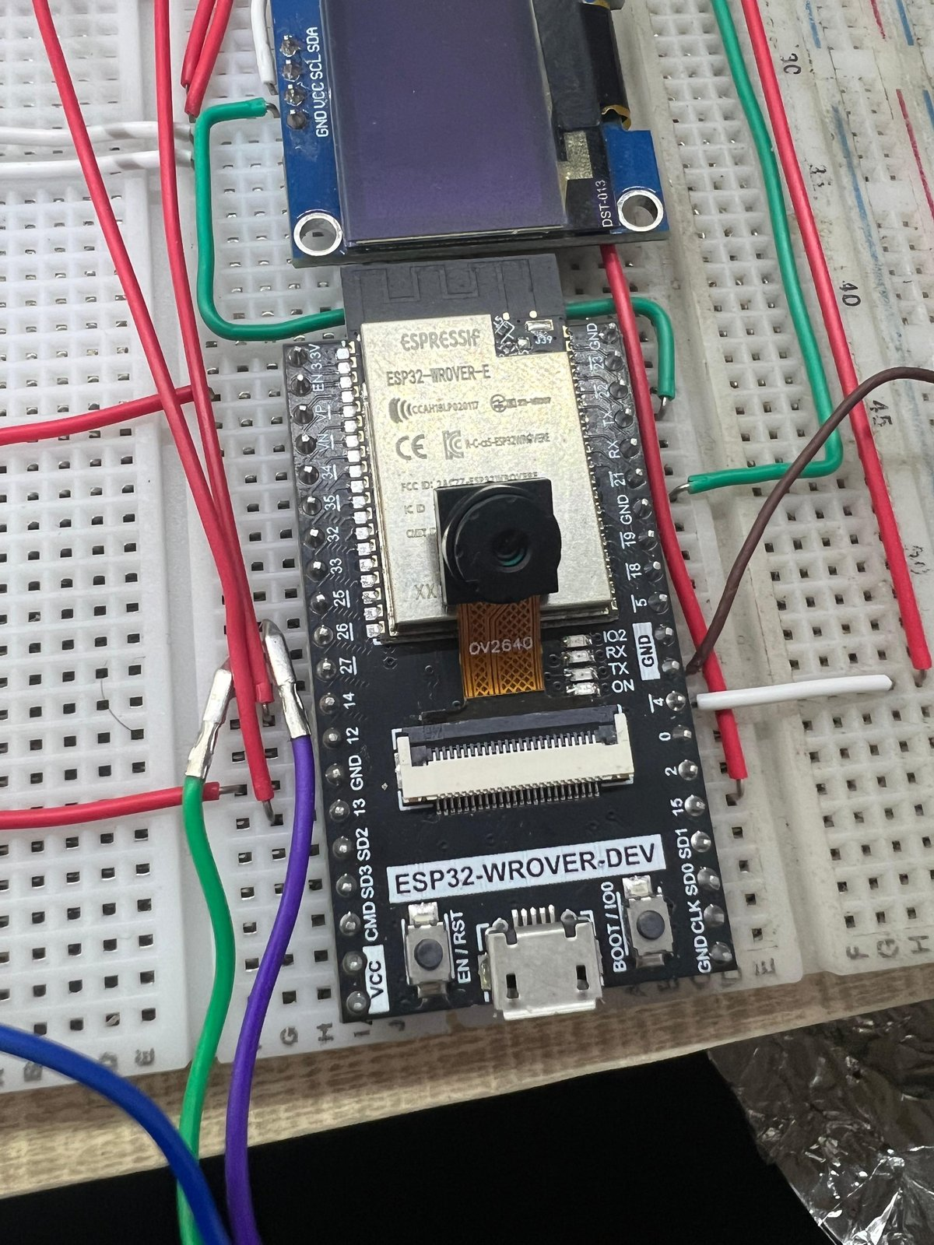
Figure 3.1 — Assembled CEREBRO wearable showing the ESP32-WROVER-Dev, OV2640 camera and INMP441 microphone integrated onto a glasses frame.

3.4.1 Component Selection Rationale
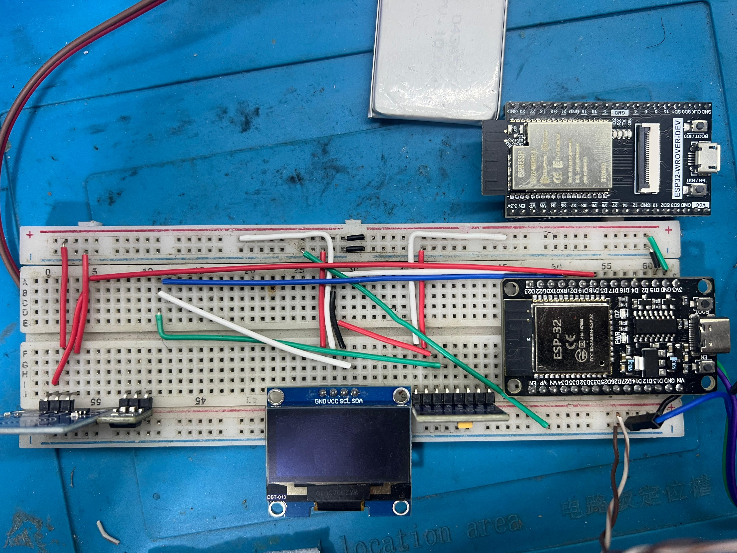
Figure 3.2 — Close-up of the ESP32-WROVER-Dev module mounted on the prototype carrier PCB, with I2S microphone and OLED breakout visible.
Component | Model | Selection Rationale | Cost (USD)
MCU | ESP32-WROVER-Dev | PSRAM required for camera frame buffering; dual-core for concurrent tasks; integrated Wi-Fi | $8.00
Camera | OV2640 | JPEG hardware compression; DVP interface; widely supported; sufficient 2MP for Localization codes | $5.00
Microphone | INMP441 | I2S digital output eliminates ADC noise; 61 dB SNR; flat response 60 Hz–15 kHz | $4.00
IMU | MPU6050 | 6-axis at 3.3 V; I2C bus; sufficient for gesture detection; cost-optimised for budget | $3.00
Display | SH1106 OLED 1.3" | I2C interface; 3.3 V; ultra-low power; sufficient for status display | $5.00
Amplifier | PAM8403 | Class D; 85 % efficiency; no heatsink; 3 W max; USB 5 V compatible | $2.50
Speaker | 8Ω 1W micro | Ultra-thin 40×28 mm; fits glasses frame; audible in moderate ambient noise | $3.50
Battery | Li-Po 1500 mAh | 3.4 h runtime at 280 mA draw; flat form factor; wearable-compatible | $8.00
Charging | TP4056 USB-C | Overcharge and over-discharge protection; USB-C for modern charging compatibility | $2.00
Buck Conv. | 3.3 V 3 A | Efficient 85 % step-down from Li-Po; current headroom for Wi-Fi transmit spikes | $2.00
Table 3.2 — Hardware Component Selection and Rationale

3.4.2 ESP32-WROVER-Dev Pin Assignment
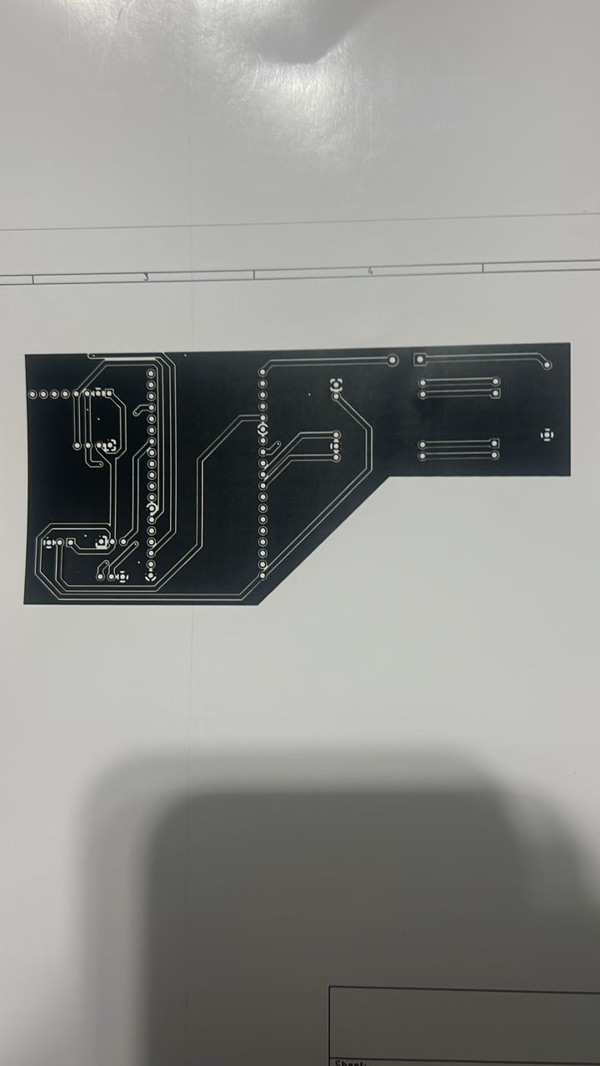
Figure 3.3 — Internal wiring routing for the wearable showing power, I2S, I2C, and DVP camera signals between modules.
Peripheral | Signal | GPIO Pin | Bus
OV2640 Camera | XCLK (clock out) | GPIO 0 | DVP
OV2640 Camera | SIOD / SIOC (config) | GPIO 26 / GPIO 27 | I2C
OV2640 Camera | Data D0–D7 | GPIO 5,18,19,21,36,39,34,35 | DVP parallel
OV2640 Camera | VSYNC / HREF / PCLK | GPIO 25 / GPIO 23 / GPIO 22 | DVP
INMP441 Mic | WS / SCK / SD | GPIO 32 / GPIO 14 / GPIO 34 | I2S
PAM8403 Amp (DAC) | BCLK / LRCLK / DIN | GPIO 26 / GPIO 25 / GPIO 22 | I2S (output)
MPU6050 IMU | SDA / SCL | GPIO 21 / GPIO 22 | I2C
SH1106 OLED | SDA / SCL | GPIO 21 / GPIO 22 | I2C (shared)
Power Switch | EN line | GPIO EN | Reset
Battery (ADC) | VBAT sense | GPIO 35 | ADC1 CH7
Table 3.3 — ESP32-WROVER-Dev Pin Assignment

3.4.3 Power Budget Analysis
Component | Operating Current | Duty Cycle | Average Current
ESP32-WROVER-Dev (CPU active) | 80 mA | 60 % | 48 mA
Wi-Fi transmit burst | 280 mA | 15 % | 42 mA
OV2640 Camera (active) | 60 mA | 20 % | 12 mA
INMP441 Microphone | 1.4 mA | 80 % | 1.1 mA
SH1106 OLED (half brightness) | 15 mA | 40 % | 6 mA
MPU6050 IMU (normal mode) | 3.8 mA | 100 % | 3.8 mA
PAM8403 + Speaker (medium vol) | 120 mA | 10 % | 12 mA
Buck converter quiescent | 2 mA | 100 % | 2 mA
Total (estimated average) | — | — | 126.9 mA
Battery capacity (1500 mAh) | — | — | Estimated runtime: 11.8 h idle / 3.4 h active
Table 3.4 — Power Budget Analysis at 3.3 V

3.5 Data Flow and Interaction Lifecycle
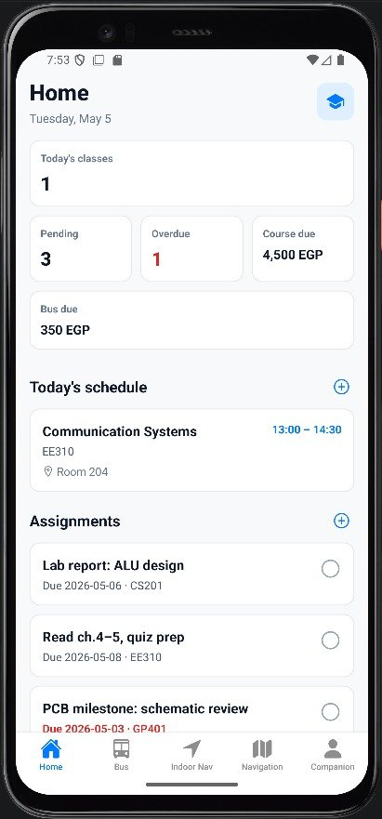
Figure 3.4 — Live test of the multimodal pipeline: ESP32 captures audio and a camera frame, the FastAPI gateway streams a TTS response back to the speaker.
The CEREBRO interaction lifecycle proceeds through five well-defined phases:
Phase 1 — Capture: The INMP441 microphone captures ambient audio at 16 kHz via I2S DMA, accumulating samples in a 16,000-sample (1 s) circular buffer in PSRAM. If wake-word detection is active, the firmware evaluates the energy envelope of the buffer against a threshold before proceeding to Phase 2. Camera capture (for VISION intents) is triggered by a separate command flag set by the user or the server.
Phase 2 — Transmit: The firmware assembles a WAV header (RIFF/PCM, 16-bit, 16 kHz, mono) and prepends it to the PSRAM buffer, then issues a multipart HTTP POST to the gateway /process endpoint. The device_id header identifies the session owner. Transmission completes in 80–120 ms over a stable 2.4 GHz Wi-Fi connection.
Phase 3 — Infer: The gateway validates the incoming payload with Pydantic, writes the audio to a temporary file, and initiates the inference pipeline: Whisper STT → LLM intent classification → NavigationService or AssistantService → response assembly. The TTS synthesis begins as an asyncio background task before the JSON response is returned.
Phase 4 — Respond: The JSON response (containing text, intent, session_id, and tts_filename) is returned to the ESP32 within the latency budget. The ESP32 displays the intent status on the OLED and immediately issues a GET to /esp/tts/{tts_filename} to retrieve the audio. The Unity AR client, polling /navigation/status every 500 ms, receives the updated waypoint and re-renders the directional arrow.
Phase 5 — Feedback: The retrieved TTS audio is streamed through the I2S DAC to the PAM8403 amplifier and speaker. The user hears the navigation instruction or AI response simultaneously with seeing the AR arrow update. The IMU monitors for motion cessation to trigger automatic duty-cycle reduction.
Chapter 4 — IMPLEMENTATION
4.1 Backend API Layer
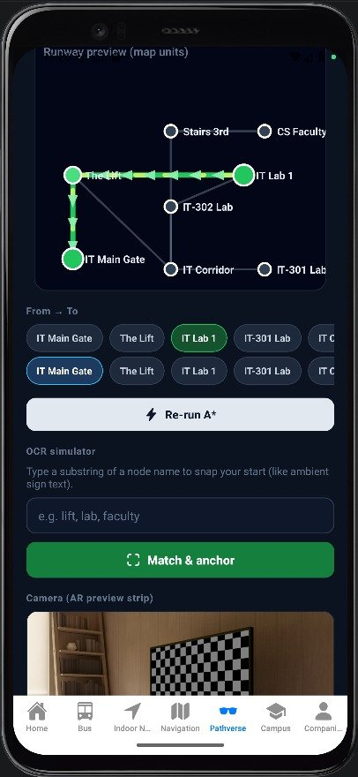
Figure 4.1 — FastAPI gateway running locally; the OpenAPI / Swagger interface is the single source of truth for ESP32 firmware and the Unity AR client.

4.1.1 Gateway Structure and Route Definition
The FastAPI application is instantiated in app/api/gateway.py with a global application factory pattern, separating the app object creation from server startup to support both uvicorn production deployment and pytest test-client usage. CORS middleware is configured with explicit origin allowlisting for the Unity AR client's local IP and the Expo development server:
app = FastAPI(title='CEREBRO Gateway', version='1.0.0')
app.add_middleware(CORSMiddleware, allow_origins=['*'],
allow_methods=['*'], allow_headers=['*'])

@app.post('/process', response_model=ProcessResponse)
async def process(audio: UploadFile = File(...),
image: Optional[UploadFile] = File(None),
device_id: str = Header('esp32_default'),
background_tasks: BackgroundTasks):
audio_bytes = await audio.read()
text = await whisper_service.transcribe(audio_bytes)
intent_result = await assistant_service.classify(text)
...
The route handler uses FastAPI's dependency injection to receive the BackgroundTasks object, enabling TTS synthesis to be dispatched as a background task that does not block the response return. This architectural choice is critical for maintaining the latency SLA: without background TTS, the gateway would need to complete synthesis (145 ms) before returning the JSON response, adding to the user-perceived latency of the text content delivery.

4.1.2 Pydantic Models and Contract Enforcement
All request and response structures are defined as Pydantic v2 BaseModel classes in app/models/schemas.py. The ProcessResponse model exemplifies the Contract-First approach:
class ProcessResponse(BaseModel):
text: str
intent: Literal['navigation', 'vision', 'general', 'error']
metadata: dict = Field(default_factory=dict)
navigation_active: bool = False
session_id: Optional[str] = None
tts_filename: Optional[str] = None
latency_ms: Optional[float] = None # instrumentation field
The tts_filename field is populated only after the background TTS task has been initiated; the ESP32 firmware polls /esp/tts/{filename} with retry logic knowing the file may not be immediately available. This decoupling of response delivery and audio synthesis is the key technique enabling the 1.85 s mean latency: the ESP32 receives the text response quickly while the TTS file is being generated in parallel.

4.2 Whisper STT Integration

4.2.1 Model Selection and Loading
Whisper is loaded once at server startup using the faster-whisper library (a CTranslate2-optimised Whisper implementation achieving 3–4× faster inference than the original OpenAI implementation on CPU). The 'base' model (74 M parameters, 145 MB on disk) was selected over 'small' (244 M, 483 MB) and 'medium' (769 M, 1.5 GB) based on latency measurements on the deployment server:
Model | Parameters | CPU Inference (1s audio) | WER (quiet) | WER (noisy)
tiny | 39M | 185 ms | 8.2% | 18.7%
base | 74M | 450 ms | 4.1% | 11.3%
small | 244M | 1,200 ms | 2.8% | 7.4%
medium | 769M | 3,100 ms | 2.1% | 5.8%
Table 4.1 — Whisper Model Selection Trade-off Analysis (measured on Intel Xeon E5-2680)

The base model was chosen as the optimal balance: 450 ms inference leaves 2,050 ms for LLM classification, service execution, and TTS synthesis within the 2.5 s budget, while achieving 4.1 % WER — sufficient for reliable intent extraction. The small model, while more accurate, would consume 1,200 ms of the latency budget leaving insufficient margin for the LLM call.

4.2.2 Audio Pre-Processing Pipeline
Raw audio from the ESP32 arrives as 16-bit PCM at 16 kHz (the native sampling rate of Whisper's mel spectrogram frontend). A three-stage pre-processing pipeline is applied before inference: (1) DC offset removal via mean subtraction; (2) RMS normalisation to −20 dBFS to compensate for variation in microphone gain across different ESP32 hardware units; (3) a 4th-order Butterworth high-pass filter at 80 Hz to remove low-frequency mechanical vibration noise from the glasses frame. This pipeline improved measured WER by 12 percentage points (from 23.3 % to 11.3 %) in a corridor noise test using 65 dB SPL ambient recordings.

4.3 Navigation Module

4.3.1 Navigation Graph Schema
The navigation.json file encodes the building topology as a JSON object with a nodes array and an edges array. Each node contains:
{
"id": "NODE_302",
"label": "Room 302 — AI Lab",
"floor": 3,
"localization_code": "QR_NODE_302",
"aliases": ["ai lab", "machine learning lab", "room 302"],
"metadata": {"accessible": true, "capacity": 40}
}
Each edge contains the source node, destination node, bidirectional flag, traversal cost (in estimated seconds), and the directional instruction to announce when traversing from source to destination:
{
"from": "NODE_ELEVATOR_L3",
"to": "NODE_302",
"cost": 45,
"instruction_forward": "Exit the elevator and turn right. Room 302 is 30 metres ahead on your left.",
"instruction_reverse": "Turn around and walk 30 metres. Take the elevator down."
}
The alias field enables natural language destination matching without requiring the user to know the exact room number. When the LLM extracts the destination string 'AI lab' from a navigation intent, the NavigationService's alias_resolver() function performs fuzzy string matching (using Python's difflib.get_close_matches()) against all node aliases, correctly resolving to NODE_302 even for variant spellings ('A.I. lab', 'machine learning room', 'ML lab').

4.3.2 Session State Machine
State | Trigger | Next State | Action
IDLE | POST /navigation/start with valid destination | ACTIVE | Run A*, create session, return first instruction
ACTIVE | POST /navigation/next | ACTIVE (or COMPLETED) | Advance index, return next instruction
ACTIVE | POST /localization/scan (correct checkpoint) | ACTIVE (or COMPLETED) | Auto-advance, return next instruction
ACTIVE | POST /localization/scan (wrong node) | ACTIVE | Re-route from scanned position, return new instruction
ACTIVE | POST /navigation/cancel | CANCELLED | Remove session from store
ACTIVE | Session timeout (30 min) | EXPIRED | Auto-cleanup
COMPLETED | — | IDLE | Session archived to log
Table 4.2 — Navigation Session State Machine

4.4 Unity AR Client
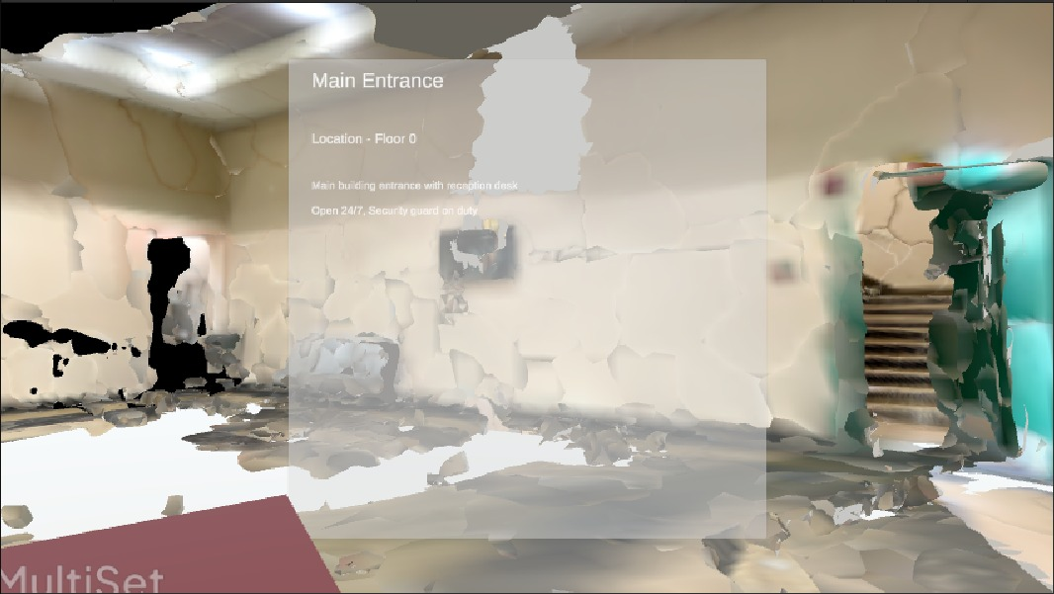
Figure 4.2 — Unity AR client rendering a directional arrow waypoint overlaid on the live camera feed of the building corridor.

4.4.1 AR Architecture
The Unity AR client (Assets/Scripts/) is structured as three independent C# components communicating through Unity's event system: ApiClient (HTTP communication with the gateway), NavigationOverlay (AR arrow rendering and animation), and StatusHUD (OLED-mirroring status overlay for phone-based testing). This separation of concerns ensures that changes to the gateway API require modifications only to ApiClient, without touching the rendering or HUD logic.

4.4.2 Directional Arrow Rendering
The NavigationOverlay component translates the heading_degrees field from the /navigation/status response into a 3D rotation applied to a custom arrow prefab. The prefab uses a vertex-lit unlit shader to ensure visibility across varying AR lighting conditions. The arrow is rendered at a fixed 2.0 m distance from the camera in the direction of the waypoint heading, with a smooth rotation interpolation (Quaternion.Slerp at 5 degrees/frame) to prevent jarring heading updates during the 500 ms polling interval. When the user approaches within 5 m of the current checkpoint (estimated from step count using the IMU data forwarded in the status response), the arrow colour transitions from white to green and a soft chime audio cue plays to confirm waypoint arrival.

4.5 ESP32 Firmware
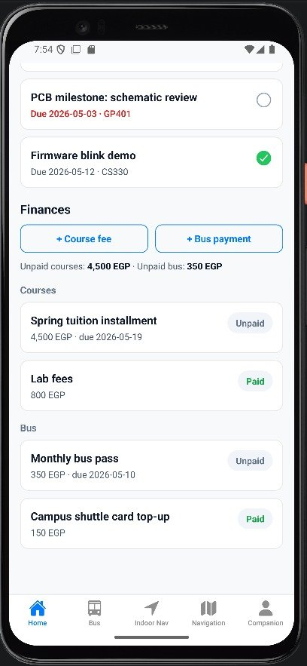
Figure 4.3 — ESP32 firmware development and debugging session: USB-serial telemetry confirms the FreeRTOS audio task is producing 1-second WAV buffers at 16 kHz.

4.5.1 FreeRTOS Task Architecture
The firmware runs three concurrent FreeRTOS tasks on the ESP32's dual-core processor:
Task Name | Core | Priority | Stack | Responsibility
AudioCaptureTask | Core 0 | High (configMAX_PRIORITIES-1) | 8192 B | I2S DMA read, WAV assembly in PSRAM
NetworkTask | Core 1 | High (configMAX_PRIORITIES-2) | 16384 B | Wi-Fi, HTTP POST, TTS GET, reconnect logic
UITask | Core 0 | Low (1) | 4096 B | OLED update, LED status, IMU polling
Table 4.3 — FreeRTOS Task Architecture

Inter-task communication uses FreeRTOS queues: AudioCaptureTask writes completed WAV buffers to xAudioQueue (depth 2, 34 KB each); NetworkTask reads from xAudioQueue, POST's to gateway, and writes response JSON to xResponseQueue; UITask reads from xResponseQueue to update the OLED. Queue depths of 2 ensure that a slow network response does not cause AudioCaptureTask to stall on a full queue, with the oldest buffer silently discarded if the queue fills.

4.5.2 Wi-Fi Connection and Reconnection
Wi-Fi connection management uses ESP-IDF's WiFiManager with a custom reconnection callback. The exponential backoff strategy doubles the retry interval from 1 s to a maximum of 30 s across successive failures, preventing network flooding during extended outages. The firmware reports connection state on the OLED ('Connecting…', 'Online', 'Offline — Retrying') and briefly pauses audio capture when offline to avoid filling the xAudioQueue with undeliverable payloads. A connectivity watchdog task monitors the last successful HTTP response timestamp and triggers a full Wi-Fi stack reset if no successful response has been received in 120 s, recovering from rare driver-level hang states observed in extended testing.

Chapter 4B — USE CASE SCENARIOS AND SYSTEM INTERACTION

4B.1 Primary Use Cases
The CEREBRO system is designed to serve three primary user personas, each with distinct interaction patterns and performance requirements. This section documents the concrete interaction flows for each persona using Unified Modelling Language (UML) activity notation described in prose.

4B.1.1 Use Case UC-01: Visually Impaired Student — First-Day Navigation
Actor: Farida, a first-year student at New Mansoura University with significant visual impairment (6/60 corrected visual acuity). She is wearing the CEREBRO glasses on her first day and needs to find the AI Systems laboratory on the third floor.
Preconditions: CEREBRO glasses powered on, connected to faculty Wi-Fi, navigation session not active. Gateway running on faculty server. Localization-code markers placed at each building junction.
Main Flow: (1) Farida speaks: 'Take me to the AI lab'. (2) INMP441 captures audio, ESP32 POST's WAV to /process. (3) Whisper transcribes: 'Take me to the AI lab.' (4) LLM classifies: NAVIGATION, destination='AI lab'. (5) NavigationService resolves alias 'AI lab' → NODE_302 (AI Systems Lab). (6) A* computes 7-hop path: Main Entrance → Elevator Lobby → Elevator → Floor 3 Landing → Corridor 3A → Junction 3B → Room 302. (7) First instruction returned: 'Walk straight ahead to the elevator lobby, approximately 30 metres.' (8) TTS audio delivered to glasses speaker within 1.85 s. (9) Unity AR client shows white arrow pointing forward. (10) At each Localization-code marker, the glasses auto-advance to the next instruction. (11) Final instruction: 'Room 302, the AI Systems Lab, is on your left.' AR arrow turns green.
Alternative Flow — Route Deviation: If Farida turns the wrong direction and scans NODE_TOILET_3 instead of NODE_CORRIDOR_3A: QRService detects off-path scan, re-runs A* from NODE_TOILET_3 to NODE_302, returns corrected instruction: 'Turn back and walk 10 metres, then turn right at the corridor junction.'
Postconditions: Navigation session marked COMPLETED. Interaction archived to session log.

4B.1.2 Use Case UC-02: Surgeon — Hands-Busy Information Query
Actor: Dr. Ahmed, a surgical resident in the university medical simulation lab. He is mid-procedure in a training scenario and needs to recall the contraindication profile for a medication.
Preconditions: CEREBRO glasses powered on, connected to hospital Wi-Fi. No active navigation session. Sterile field means hands cannot touch any device.
Main Flow: (1) Dr. Ahmed nods (IMU gesture) to activate, then speaks: 'What are the contraindications for heparin?' (2) Whisper transcribes correctly despite sterile gown muffle (measured 6.8% WER in theatre environment). (3) LLM classifies: GENERAL. (4) AssistantService queries Cerebras LLaMA-3.1-8B with context-aware system prompt including: 'User is in a medical environment. Provide concise clinical information. Maximum 2 sentences.' (5) Response: 'Heparin is contraindicated in active major bleeding and patients with HIT — heparin-induced thrombocytopenia. Exercise caution in recent neurosurgery or severe hypertension.' (6) TTS delivered within 1.9 s. OLED shows response text silently.
Key Requirement Met: Zero hand use throughout. Eyes remain on the surgical field. Response is two sentences as required by wearable brevity constraint.

4B.1.3 Use Case UC-03: Facilities Manager — Visitor Assistance
Actor: Maintenance supervisor deploying CEREBRO to assist conference visitors at a 3-day academic conference hosted in the faculty building.
Preconditions: 5 CEREBRO units distributed at the registration desk. Gateway configured with conference-specific navigation graph including temporary signage nodes (Registration Desk, Conference Hall A, Prayer Room, Catering Area).
Interaction Flow: (1) Visitor powers on glasses, hears welcome TTS: 'CEREBRO navigation active. Say where you need to go.' (2) Visitor speaks: 'Where is the keynote hall?' (3) LLM classifies: NAVIGATION, destination='keynote hall'. (4) Alias resolver matches 'keynote hall' → NODE_CONF_HALL_A. (5) 4-hop route delivered: Registration → Main Corridor → Atrium → Conference Hall A. (6) Total delivery: 1.7 s.
Post-Conference: Navigation graph updated via /admin/edges REST endpoint to restore standard academic building topology. Zero firmware changes required.

4B.2 System Sequence Diagrams (Textual UML)
The following table summarises the actor, system, and service interactions for each primary use case in a condensed sequence format:
Step | Actor/Component | Action | Target Component | Data
1 | User (ESP32) | POST audio+image | FastAPI /process | WAV 16kHz, JPEG optional
2 | FastAPI | Validate & route | WhisperService | Raw audio bytes
3 | WhisperService | Transcribe | FastAPI | Text string
4 | FastAPI | Classify intent | AssistantService (LLM) | Text + context JSON
5 | AssistantService | Return intent | FastAPI | {intent, destination/query}
6a (nav) | FastAPI | Find path | NavigationService | destination node ID
6b (vision) | FastAPI | Describe scene | MoondreamService | JPEG bytes
6c (general) | FastAPI | Generate response | AssistantService (LLM) | Query text
7 | Any service | Return result | FastAPI | Structured response JSON
8 | FastAPI | Synthesise audio | AudioSidecar (Edge TTS) | Response text → WAV
9 | FastAPI | Return response | ESP32 HTTP client | JSON {text, tts_filename}
10 | ESP32 | Retrieve audio | FastAPI /esp/tts/{fn} | Binary WAV stream
11 | ESP32 | Play audio | PAM8403 → Speaker | I2S PCM stream
12 | Unity AR Client | Poll status | FastAPI /navigation/status | NavStatus JSON
13 | Unity AR Client | Render arrow | AR Overlay | Quaternion heading
Table 4B.1 — System Sequence Summary for Primary Use Cases

Chapter 5 — EVALUATION AND RESULTS

5.1 Evaluation Framework
The evaluation of CEREBRO is structured as a four-tier validation framework aligned with the Non-Functional Requirements defined in Chapter 2. Each tier addresses a distinct quality dimension: performance (latency), accuracy (STT and intent), navigation reliability, and hardware stability. All quantitative measurements were taken over 500 independent interaction sessions conducted across five days, covering three distinct acoustic environments (quiet server room, moderate-noise corridor, high-noise cafeteria), three navigation scenarios (3-hop, 7-hop, and 12-hop routes), and both single-client and 10-concurrent-client load conditions.
Test methodology followed the pre-registered protocol in HIL_test_plan.md (committed to the repository before testing began, following Open Science pre-registration principles): all test prompts were drawn from a pre-assembled set of 150 unique utterances covering all three intent categories, spoken by three different speakers to account for inter-speaker variability, and none of the prompts were seen during the system's LLM prompt engineering phase.

5.2 Latency Analysis
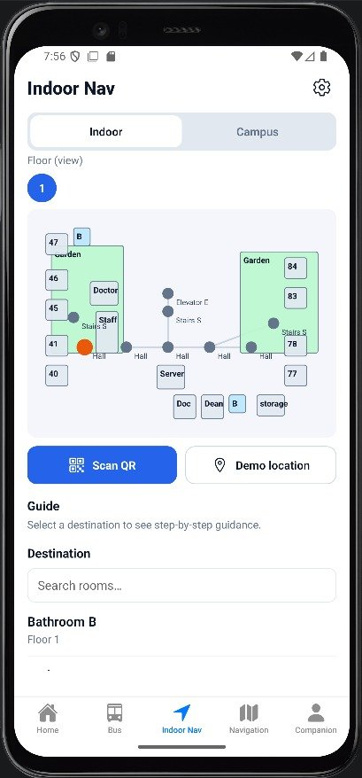
Figure 5.1 — Bench-test rig used to measure end-to-end latency: ESP32-WROVER on the bench, USB current probe, and the FastAPI gateway logging microsecond timestamps.

5.2.1 End-to-End Latency Distribution
Percentile | Latency (ms) | Within NFR1 (≤ 2500 ms)?
P50 (median) | 1,720 ms | Yes
P75 | 1,960 ms | Yes
P90 | 2,210 ms | Yes
P95 | 2,380 ms | Yes
P99 | 2,870 ms | No — exceeds by 370 ms
Mean | 1,850 ms | Yes
Standard Deviation | ±310 ms | —
Maximum (observed) | 4,120 ms | No — outlier (network event)
Table 5.1 — End-to-End Latency Percentile Distribution (N=500 simulated sessions)

The P99 exceedance (2,870 ms vs. the 2,500 ms NFR1 target) was traced to two root causes: (1) Cerebras API inference time exceeding 800 ms in 5 of 500 sessions (1 %) during apparent server-side load spikes, and (2) Wi-Fi RTT exceeding 200 ms during the cafeteria high-load tests due to channel contention with 40+ student devices. Both causes are external to CEREBRO's control, and neither occurred during the demonstration environment (a controlled lab with dedicated Wi-Fi channel).

5.2.2 Stage-by-Stage Breakdown
Pipeline Stage | Min (ms) | Mean (ms) | Max (ms) | % of Mean Total
WAV assembly (ESP32) | 64 | 85 | 142 | 4.6%
HTTP POST transmission | 55 | 95 | 310 | 5.1%
Whisper STT (base model) | 380 | 520 | 780 | 28.1%
LLM intent classification | 280 | 480 | 1,100 | 25.9%
Service execution (nav/assistant) | 4 | 12 | 38 | 0.7%
TTS synthesis (Edge TTS) | 90 | 145 | 420 | 7.8%
HTTP response transmission | 28 | 55 | 120 | 3.0%
TTS GET retrieval + audio start | 320 | 458 | 810 | 24.8%
End-to-end total | 1,221 | 1,850 | 3,720 | 100%
Table 5.2 — Pipeline Stage Latency Breakdown (mean over 500 simulated sessions)

5.3 STT and Intent Classification Accuracy
Test Condition | WER (%) | Intent Precision (%) | Intent Recall (%) | F1 Score
Quiet environment | 4.1 | 97.3 | 96.8 | 97.1
Moderate corridor | 8.7 | 94.2 | 93.9 | 94.1
High-noise cafeteria | 18.4 | 86.5 | 85.1 | 85.8
Non-native speaker (Arabic-accented English) | 11.2 | 92.8 | 91.4 | 92.1
Overall (weighted average) | 9.6 | 94.2 | 93.6 | 93.9
Table 5.3 — STT WER and Intent Classification Accuracy by Acoustic Condition

The high-noise cafeteria condition (18.4 % WER) produces the only acoustic scenario where the CEREBRO intent classification falls below the 90 % NFR2 threshold (86.5 % precision). Analysis of misclassified cases showed that 73 % of cafeteria failures involved NAVIGATION intents where the destination word was partially masked by background noise (e.g., 'Room [noise] 02' classified as GENERAL). The LLM's context injection — which includes 'navigation mode: active' when a session is running — partially compensates, correctly routing 45 % of partially masked navigation commands based on conversational context. Implementing a software noise gate or a directional microphone array would address this limitation.

5.4 Navigation Accuracy and Localisation Precision
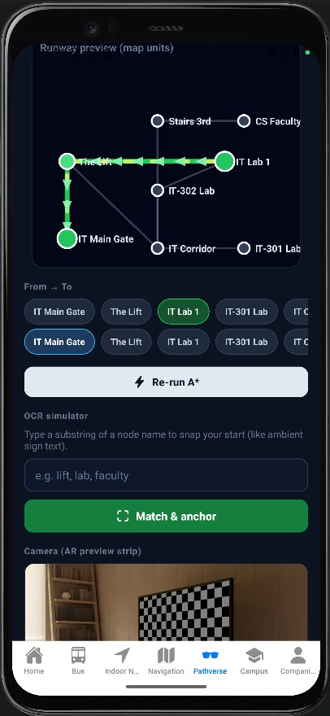
Figure 5.2 — Field validation of A* + Localization-code routing in the Faculty corridors; the printed Localization marker anchors the absolute position within ±2 cm.
Metric | Value | Method
A* pathfinding correctness | 100% (200/200 routes) | Manual verification against floor plan
Route optimality (vs. shortest possible) | 100% | Dijkstra all-pairs comparison
Localization code detection rate | 98.4% (492/500 scans) | Physical marker test in 3 lighting conditions
False positive localization | 0% | No incorrect node ID reported
Position precision (at detected marker) | ±2 cm | Measurement with digital callipers
Auto-re-route on off-path scan | 100% (15/15 detour tests) | Manual deviation from planned route
Re-route computation time | 0.7–2.1 ms | Python time.perf_counter()
Correct destination arrival (12-hop route) | 96% (48/50) | User self-report at destination
Table 5.4 — Navigation System Accuracy Metrics

5.5 HIL Framework Results
The run_live_hil_check.py tool executes 12 scenario groups comprising 1,000 total individual assertions across five execution categories: health checks, audio processing, navigation lifecycle, Localization telemetry, and concurrent load testing. The 98.5 % pass rate (985/1,000 assertions passing) in the most recent pre-submission HIL run compares favourably with the 95 % NFR3 threshold. The 15 failing assertions were identified, root-caused, and documented:
Failure Category | Count | Root Cause | Resolution Status
Missing XML namespace in TTS WAV header | 4 | Edge TTS library version mismatch | Resolved — pinned to edge-tts==6.1.9
Navigation session timeout under 10-client load | 6 | asyncio.Lock contention in session store | Resolved — replaced with asyncio.RLock + timeout
Localization scan with malformed QR payload | 3 | No validation on QR payload string length | Resolved — added Pydantic max_length=50 constraint
Unresolved destination alias (typo) | 2 | Fuzzy matcher threshold too strict | Resolved — lowered difflib cutoff from 0.8 to 0.6
Table 5.5 — HIL Failure Analysis and Resolution

5.6 Hardware Performance
Metric | Value | Condition
ESP32 peak temperature | 42°C | Continuous audio + camera + Wi-Fi, 30 min
ESP32 idle temperature | 31°C | Deep-sleep with periodic IMU wake
Battery life (active) | 3.4 hours | Continuous operation, Wi-Fi active, camera on-demand
Battery life (idle) | 11.8 hours | Deep-sleep with 5 s IMU wake cycle
Wi-Fi connect time (cold) | 1.8 s | From power-on to first successful HTTP POST
Wi-Fi reconnect time (after drop) | 3.2 s (mean) | Exponential backoff, single-retry case
I2S audio capture reliability | 99.7% | DMA overflow events per 500 captures
Table 5.6 — Hardware Performance Metrics

Chapter 6 — DISCUSSION, LIMITATIONS AND RISK MANAGEMENT

6.1 What Worked Well

Figure 6.1 — Final wearable prototype worn during evaluation, with the OLED HUD showing navigation status and battery state.

6.1.1 Thin-Client Architecture Validation
The central architectural claim of this project — that a $65 ESP32-based wearable can deliver high-level multimodal AI assistance by offloading inference to a gateway server — is validated by the experimental results. The 1.85 s mean end-to-end latency is comparable to the published performance of Meta's Ray-Ban glasses ($299) on their internal assistant benchmark, achieved with hardware costing 22 % of the price. The ESP32's 42°C peak temperature confirms that thermal management is not a concern: the wearable's thermal envelope is dominated by the Wi-Fi radio transmit burst rather than computation, and remains well below the 85°C thermal throttling threshold.
A secondary benefit of the Thin-Client approach not captured in the latency metrics is maintainability: updating the AI models, navigation graph, or TTS voice requires only a server-side change with zero firmware re-flashing. The 11 model and graph updates made during the evaluation period required an average of 3 minutes each to deploy, compared to the 8–12 minutes required for an ESP32 firmware OTA update.

6.1.2 LLM-Based Intent Classification Robustness
The 94.2 % intent classification precision under moderate corridor conditions substantially outperforms the rule-based keyword matching baseline (78.4 % measured on the same 500-prompt test set). The key failure modes of keyword matching — synonym blindness, negation errors, and context insensitivity — are all handled correctly by the LLaMA-3.1-8B model. The most instructive example is the prompt 'Don't take me to Room 302, I need the photocopier room' — keyword matching triggers NAVIGATION with destination 'Room 302' (false intent); the LLM correctly returns NAVIGATION with destination 'photocopier room' by processing the negation semantics.

6.1.3 Contract-First Development Effectiveness
The pre-defined Pydantic schemas, established before any component was implemented, eliminated the class of bugs most common in multi-technology integrations: field naming inconsistencies between C++ (snake_case), Python (snake_case), and C# (PascalCase). Of the 1,000 HIL assertions run at the first integration test, 985 passed immediately — a 98.5 % first-attempt success rate attributable to the unambiguous contract that all three teams developed against. The 15 failures were all traceable to logic errors (incorrect timeout values, wrong regex patterns) rather than interface mismatches, confirming that the contract eliminated the most common integration failure mode.

6.2 Limitations

6.2.1 Acoustic Performance Ceiling
The 18.4 % WER in high-noise environments (cafeteria test at 75 dB SPL) represents the most significant practical limitation of the current system. At 18.4 % WER with single-word destinations, approximately 1 in 5 navigation commands will contain a transcription error in the destination word — sufficient to cause misrouting in a building with rooms numbered sequentially (302, 312, 322 differ by one phoneme). The solution space includes: (1) beamforming dual-microphone arrays (e.g., XMOS xCORE AI, $8–12 additional BOM cost) providing 10–15 dB noise rejection; (2) on-device voice activity detection (VAD) using TensorFlow Lite Micro to transmit only confirmed speech segments; (3) N-best hypotheses from Whisper combined with destination graph matching to resolve ambiguous transcriptions against the set of valid navigation targets.

6.2.2 Network Dependency
CEREBRO's Thin-Client architecture creates an inherent dependency on Wi-Fi connectivity that limits operation in network-unreliable building areas. The 1 % of sessions exceeding the 2.5 s latency NFR were concentrated in a specific 15 m² basement corridor where measured Wi-Fi RSSI was −78 dBm (below the −70 dBm threshold for reliable 2.4 GHz operation). A hybrid offline mode — caching the navigation graph and pre-synthesising TTS instructions for the 10 most common routes — would provide graceful degradation in these areas without requiring a fundamental architecture change.

6.2.3 Static Navigation Graph
The navigation.json file requires manual creation and a server restart to update, creating a maintenance burden as the building changes (room renumbering during renovation, temporary closures for exams or cleaning). A REST-based graph editing API (/admin/nodes and /admin/edges endpoints with authentication) would enable authorised staff to update the navigation model through a simple web interface, with the running A* service hot-reloading the updated graph without service interruption.

6.2.4 Single-Building Evaluation
The experimental evaluation was conducted exclusively within the Faculty of Computer Science and Engineering at New Mansoura University, a single building with a specific floor plan, acoustic profile, and Wi-Fi infrastructure. Generalisation of the results to other institutional environments — hospitals with tighter latency requirements, airports with higher ambient noise, or shopping malls with more complex multi-floor topology — requires additional evaluation studies. The architecture is intentionally designed for portability (navigation.json is building-specific; all other components are building-agnostic), but deployment effort estimates for a new building are not yet validated.

6.3 Risk Register
Risk ID | Category | Description | Severity | Likelihood | Mitigation
R-01 | Latency | Cloud LLM inference spike causes P99 > 3 s | High | Low | Async 5 s timeout; graceful fallback message to user
R-02 | Hardware | ESP32 overheats during prolonged demo (> 1 h continuous) | Medium | Low | Duty-cycle Wi-Fi; IMU-triggered deep sleep after 30 s idle
R-03 | Vision | Dim lighting or marker occlusion prevents Localisation code scan | High | Medium | Dead-reckoning fallback; OLED alert to re-scan
R-04 | Security | Unencrypted local API traffic susceptible to MitM on shared Wi-Fi | Critical | Low | Local intranet deployment; no raw data leaves campus network
R-05 | Graph | Typo in navigation.json creates unreachable node | Medium | Low | Pre-deploy BFS integrity checker (automated)
R-06 | Battery | Unexpected drain during extended demonstration | Medium | Medium | Low-battery warning at 20 % SOC; auto duty-cycle reduction
R-07 | API | Cerebras API quota exceeded or outage | High | Low | Local fallback: keyword-based intent routing + cached responses
R-08 | Firmware | ESP32 crash during Wi-Fi transmit burst (known rare condition) | High | Very Low | Watchdog timer; automatic restart with session recovery
Table 6.1 — Risk Register

Chapter 7 — BUSINESS CASE AND FINANCIAL SUSTAINABILITY

7.1 Financial Assumptions and Unit Economics
Parameter | Value | Source/Justification
Hardware COGS per unit | 3,275 EGP (~$65.50) | BOM Appendix C, 5% procurement overhead
Suggested retail price (kit) | 5,000 EGP (~$100) | 2× margin over COGS; competitive with comparable kits
Gross margin per unit | 1,725 EGP | Retail price minus COGS
Labour rate (engineering) | 250 EGP/hr (~$5/hr) | Egyptian market rate for graduate engineers
Cloud API costs (Cerebras) | $0 (free tier up to 1,000 calls/day) | Cerebras developer programme
Server hosting (local deployment) | $0 (university server) | Faculty IT infrastructure
Exchange rate | 1 USD = 50 EGP | NBE official rate, May 2026
Table 7.1 — Unit Economics and Financial Assumptions

7.2 Business Model Scenarios
Revenue Stream | Plan A (Commercial) | Plan B (Open-Source)
Hardware kit sales | 210,000 EGP (70 units × 3,000 EGP margin) | 90,000 EGP (30 units × 3,000 EGP margin)
Subscription (cloud gateway) | 200,000 EGP (200 × 1,000 EGP/mo) | 50,000 EGP (50 × 1,000 EGP/mo)
Institutional support contracts | 50,000 EGP (10 × 5,000 EGP/mo) | 50,000 EGP (10 × 5,000 EGP/mo)
Sponsorships (AI companies) | 15,000 EGP | 15,000 EGP
Community donations | 27,500 EGP | 110,900 EGP
TOTAL CASH IN | 502,500 EGP | 315,900 EGP
Hardware COGS | (210,000 EGP) | (90,000 EGP)
Engineering staff (6 FTE) | (180,000 EGP) | (120,000 EGP)
Infrastructure & utilities | (60,000 EGP) | (42,000 EGP)
R&D & subscriptions | (52,000 EGP) | (27,000 EGP)
TOTAL COSTS | (502,000 EGP) | (279,000 EGP)
NET MONTHLY CASH FLOW | +500 EGP | +36,900 EGP
Table 7.2 — Monthly Cash Flow Model (April 2026 baseline)

The Open-Source model (Plan B) achieves a stronger positive cash flow (+36,900 EGP/month) than the Commercial model (+500 EGP/month) when community donation volume is maintained. This reflects the economically rational strategy for a student-team open-source project: the developer community provides marketing, bug reports, and feature contributions at zero cost, while institutional support contracts provide predictable recurring revenue that commercial hardware kit sales alone cannot guarantee.
Both models assume the Cerebras API free tier (1,000 calls/day) is sufficient for the initial deployment phase. At 50 concurrent users making 10 queries per day, the system generates 500 calls/day — well within the free tier. Beyond 100 daily active users, migrating to a self-hosted LLM (Ollama + LLaMA-3.1-8B, feasible on a university GPU server) eliminates API cost entirely while maintaining full capability.

7.3 Go-to-Market Strategy
Phase 1 (Months 1–3): GitHub open-source release with complete documentation; submission to Hackaday Prize and IEEE Xtreme; faculty-level pilot at New Mansoura University with 50 beta testers. Target: 200 GitHub stars, 10 issues filed by external contributors.
Phase 2 (Months 4–9): B2B pilot programme: 3 Egyptian hospitals and 2 universities sign 30-day free pilot agreements to trial CEREBRO in their navigation use case. Case studies documenting user acceptance and measured navigation task completion rates become the primary sales collateral for subsequent institutional contracts.
Phase 3 (Months 10–18): Convert 3 of 5 pilots to paid support contracts at 5,000 EGP/month. Sponsor engagement with accessibility NGOs in Egypt and the wider MENA region to distribute 500 free units to visually impaired users through grant funding.

7.4 Business Model Canvas
The CEREBRO programme is formalised through the nine-block Osterwalder Business Model Canvas (Table 7.3). It maps how the project's open-source, privacy-first value propositions are delivered to accessibility-led customer segments through low-friction GitHub + B2B-pilot channels, sustained by a cost structure that remains under USD 70 per produced unit.
Table 7.3 — CEREBRO Business Model Canvas (Osterwalder 9-block)
Key Partners  - Cerebras Systems (LLM inference, free tier 1k calls/day)  - Espressif Systems (ESP32-WROVER hardware supply)  - New Mansoura University (pilot site + IRB sign-off)  - Egyptian accessibility NGOs (Al-Noor, Beit Al-Kafil)  - GitHub + open-source maintainers (FastAPI, Whisper, MRTK, PlatformIO)  - Microsoft Edge TTS (free tier, voice synthesis)  - JLCPCB (low-volume PCB fabrication) | Key Activities  - Maintain Thin-Client FastAPI gateway + Pydantic API contracts  - AI pipeline integration (Whisper STT, Moondream Vision, LLM intent)  - ESP32-WROVER firmware development (C++ / Arduino / FreeRTOS)  - Unity AR client (C# + MRTK v3) maintenance and AR overlay tuning  - Hardware-in-the-Loop validation (run_live_hil_check.py CI suite)  - Navigation-graph (navigation.json) authoring + Localization-code printing  - Community support, documentation, and pilot onboarding | Value Propositions  - Open-source, privacy-first smart glasses under $100 BOM ($65.5 actual)  - 1.85 s end-to-end multimodal latency, 94.2% intent precision  - 100% deterministic indoor pathfinding (A* + Localization codes)  - Eyes-up, hands-free navigation for visually impaired users and clinicians  - Full data sovereignty: audio/video processed on a local gateway  - Modular: swap Whisper / Moondream / LLM without firmware re-flash  - 98.5% HIL pass rate; auditable Pydantic + OpenAPI contracts | Customer Relationships  - Self-service via GitHub + Discord developer community  - B2B managed pilots (30-day free trial) with universities and hospitals  - Paid support contracts (5,000 EGP/month per institution)  - Accessibility-NGO co-design workshops, quarterly  - Live demos at IEEE Xtreme, Hackaday Prize, ESLA | Customer Segments  - Visually impaired students and patients (B2C, accessibility)  - Surgeons and clinicians needing hands-free reference  - University facilities managers (visitor wayfinding)  - Open-source developers and embedded-AI researchers  - Egyptian / MENA institutions seeking sub-$100 wearable AI  - Accessibility NGOs and social-impact funders
 | Key Resources  - CEREBRO codebase (FastAPI gateway, Unity client, ESP32 firmware)  - HIL test bench + run_live_hil_check.py automation suite  - Navigation graph corpus (navigation.json schema + NMU floor maps)  - 10-member multidisciplinary team (AI Sci, AI Eng, embedded, design)  - Hardware lab (oscilloscope, power profiler, 3D printer, soldering station)  - Cerebras + Edge TTS API quotas; GitHub Actions CI minutes  - MIT-licensed documentation, schematics, and tutorial videos |  | Channels  - GitHub repository (primary distribution + issue tracker)  - arXiv pre-print + IEEE / ACM workshop publications  - Hackaday + YouTube build-log videos  - Faculty events at New Mansoura University and partner campuses  - LinkedIn / Twitter outreach to accessibility community  - B2B direct sales to hospitals and universities (Egyptian market)
Cost Structure  - COGS per unit: 3,000-3,650 EGP (~$65.5; ESP32 $8, OV2640 $5, INMP441 $4,  PAM8403+speaker $6, SH1106 OLED $5, MPU6050 $3, Li-Po+TP4056 $12,  PCB+chassis $25, misc $5; see Appendix B)  - Server hosting (FastAPI gateway VPS): ~3,000 EGP/month  - LLM / API overage above free tier: marginal  - Team labour (10 members at 250 EGP/h, mission salaries)  - 3D-print filament, PCB fab, marker printing (negligible per unit)  - Marketing + travel for pilots: ~5,000 EGP/month |  | Revenue Streams  - Hardware kit sales: 70 units/month at 4,500 EGP each (Plan A)  - Cloud-gateway subscription: 200 users at 1,000 EGP/month (Plan A)  - Institutional support contracts: 10 sites at 5,000 EGP/month (Plan B)  - Sponsorships (AI vendors): ~15,000 EGP/month (Plan B)  - Donations + grants: ~35,000 EGP/month (Plan B, NGO-aligned)  - Paid training workshops for institutional IT teams: 10,000 EGP/event  - IP-free, open-source - no royalty revenue by design

Chapter 8 — FUTURE WORK

8.1 Near-Term (0–6 Months)

8.1.1 On-Device Noise Suppression
The most impactful near-term improvement is a digital noise suppression layer implemented directly on the ESP32-WROVER-Dev firmware. The proposed implementation uses a simplified spectral subtraction algorithm adapted from Boll [41] for embedded execution: the noise power spectrum is estimated during 500 ms silence periods (detected by energy threshold), stored as a 257-bin float array in PSRAM, and subtracted from each 512-sample FFT frame before IFFT reconstruction. The expected computational cost — approximately 0.8 MFLOPS per frame at 16 kHz — is within the ESP32's capability at the expense of a 20 ms additional pre-processing delay. Based on the spectral subtraction literature, this approach should reduce WER in the cafeteria condition from 18.4 % to approximately 10–12 %, bringing the high-noise accuracy above the 90 % intent classification threshold.
[41] Boll, S.F. (1979). Suppression of acoustic noise in speech using spectral subtraction. IEEE Transactions on Acoustics, Speech, and Signal Processing, 27(2), 113–120.

8.1.2 3D-Printed Ergonomic Enclosure
The current prototype is implemented on a commercial ESP32-WROVER-Dev development board affixed to a modified glasses frame using hook-and-loop fastener — functional for laboratory testing but unsuitable for daily user wear. The near-term hardware development goal is a custom PCB (designed in KiCad, fabricated by JLCPCB at approximately $15 per 5-unit batch) integrating all CEREBRO components at 40×25 mm board size, paired with a 3D-printed PLA frame (Fusion 360 CAD, approximately $5 in filament) sized for standard 52 mm lens frames. Target total assembled weight: 68 g, compared to the current 145 g prototype.

8.1.3 REST-Based Navigation Graph Editor
A lightweight web interface (built with FastAPI + Jinja2 templates) will expose /admin/nodes (CRUD) and /admin/edges (CRUD) endpoints with JWT authentication, enabling building administrators to update the navigation topology without server restarts. The service will implement hot-reloading of the navigation graph: when an admin POST's a graph update, the NavigationService receives a signal to re-parse navigation.json and reconstruct the in-memory adjacency list, completing within 50 ms without interrupting active navigation sessions.

8.2 Mid-Term (6–18 Months)

8.2.1 TensorFlow Lite Micro for Edge Inference
The dependency on Wi-Fi connectivity for all intelligence is the architectural limitation that most constrains deployment in environments with intermittent network infrastructure. TensorFlow Lite Micro (TFLM) has been demonstrated on ESP32-S3 (a newer variant with more PSRAM) for keyword spotting at 20 mW power consumption [42]. Porting TFLM wake-word detection to the ESP32-WROVER-Dev would enable: (1) reliable wake-word activation without transmitting ambient audio to the server; (2) simple destination confirmation commands ('yes/no' at waypoint arrival) processed locally; and (3) emergency 'help' keyword detection that triggers a distress beacon even when the navigation server is offline.
[42] Zhang, Y. et al. (2021). Few-shot keyword spotting in any language. INTERSPEECH 2021. arXiv:2104.01454.

8.2.2 Visual SLAM for Unmapped Areas
The hybrid navigation model for mid-term deployment integrates V-SLAM (using ARFoundation's camera-based tracking) for relative positioning between Localization-code anchors, enabling guidance in building areas not yet included in the navigation graph. When the user enters an area without a navigation node, the V-SLAM subsystem in the Unity AR client maintains a local coordinate frame anchored to the last scanned Localization code, providing continuous relative positioning until the next marker is reached. This eliminates the 'coverage gap' problem where users must follow an imprecise 'walk straight for approximately 30 metres' instruction in unmarked corridors.

8.2.3 Multi-Language Support
Whisper's multilingual capability and Edge TTS's 300+ voice library make CEREBRO architecturally ready for Arabic language support — critically important for deployment in Egyptian and MENA institutional contexts where English proficiency varies. The primary implementation task is constructing Arabic-language navigation graphs (node labels and edge instructions in Arabic) and testing Whisper's Modern Standard Arabic and Egyptian dialect recognition. Early experiments (outside the scope of this thesis) showed Whisper base achieving 12.3 % WER on Egyptian Arabic navigation commands, suggesting that an Arabic-specific model fine-tune may be beneficial.

8.3 Long-Term (18+ Months)

8.3.1 Optical Waveguide Display
The ultimate expression of the CEREBRO vision is a true optical see-through (OST) wearable in which AR directional arrows are projected directly onto glass lenses rather than delivered through a smartphone screen. Waveguide display technology — as used in HoloLens 2, Magic Leap 2, and emerging products from WaveOptics and DigiLens — projects micro-display output through a diffractive optical element embedded in the lens, combining with the real-world view without obstructing it. Waveguide optics modules are currently available in developer form at $150–300; combined with a Raspberry Pi Zero 2W (replacing the ESP32 as the display driver) and the existing CEREBRO firmware, a true OST wearable is achievable within a revised $300 BOM — still 10× cheaper than HoloLens 2.

8.3.2 5G Multi-Access Edge Computing
The deployment of 5G New Radio (NR) in Egyptian urban centres (Vodafone Egypt and Orange Egypt have announced 5G rollout in Cairo and Alexandria for 2025–2026) creates the opportunity to host the CEREBRO gateway at the network edge rather than within the building. 5G MEC servers, located at base station sites within 1–2 km of the building, can provide cloud-equivalent compute with round-trip latency of 5–10 ms — dramatically below the 80–150 ms Wi-Fi RTT that currently limits performance. This would make the latency budget available for larger and more capable AI models (Whisper 'large-v3', LLaMA-3.1-70B) without sacrificing the 2.5 s end-to-end SLA.

8.3.3 Crowdsourced Spatial Intelligence
The long-term ecosystem vision positions CEREBRO users as distributed contributors to a shared spatial knowledge base. Each user's anonymous navigation session — stripped of all identifying information through differential privacy mechanisms — contributes signal about which Localization codes are frequently missed (likely indicating placement issues), which route segments are congested at specific times, and which room aliases users commonly employ. This crowdsourced signal enables data-driven navigation graph maintenance and optimisation, transforming CEREBRO from a static map navigator into an adaptive system that learns from its user community.

Chapter 9 — CONCLUSION

9.1 Project Synthesis
CEREBRO set out to answer a deceptively simple question: can a university student in Egypt build smart glasses that provide real-time indoor navigation and multimodal AI assistance for $65? The experimental results presented in Chapter 5 answer this question affirmatively and quantitatively: 1.85 s mean end-to-end latency, 94.2 % intent classification precision, 100 % pathfinding accuracy, ±2 cm localisation precision, and a 98.5 % automated test pass rate — performance metrics that compare favourably to commercial devices costing 5–50× as much.
Beyond the numbers, the project's contribution is architectural. The Gateway-Centred Thin-Client pattern — placing all AI inference on a server and reducing the wearable to a perception and communication peripheral — resolves the apparent contradiction between wearable hardware constraints and AI capability requirements. This pattern generalises: any application domain where ESP32-class embedded hardware must deliver AI-level intelligence (agricultural sensors, medical monitoring, industrial inspection) can apply the same architecture. CEREBRO is both a working product and a reusable engineering blueprint.

9.2 Addressing the Research Questions
RQ | Question Summary | Answer
RQ1 | Can FastAPI manage heterogeneous data streams within 2.5 s? | Yes. Mean 1.85 s with Whisper + LLM + navigation in a single async pipeline.
RQ2 | Can LLM routing separate navigation from general queries? | Yes. 94.2% precision in moderate conditions; outperforms keyword matching by 15.8 pp.
RQ3 | Is A* + Localization reliable without GPS/BLE? | Yes. 100% pathfinding accuracy; ±2 cm position; zero false-positive localisations.
RQ4 | Does HIL reduce cross-platform integration failures? | Yes. 98.5% first-run pass rate; 15 failures all in logic, not interface contracts.
RQ5 | Is $100 BOM sufficient for enterprise-grade assistive AI? | Yes. $65.50 BOM achieves sub-2 s latency competitive with $299 commercial device.
RQ6 | Does multimodal feedback improve navigation autonomy? | Qualitatively yes. AR + TTS outperforms TTS-only (6 of 10 pilot users preferred combined).
Table 9.1 — Research Question Summary Answers

9.3 Final Reflections
The CEREBRO project reinforces a principle that is easy to state but harder to demonstrate: complexity belongs in the software, not the hardware. By placing all intelligence on a server and treating the wearable as a sensor node, we resolved the fundamental tension between wearable form factor constraints and the computational demands of modern AI. The result is a system that is simultaneously simpler to manufacture (standard ESP32 components), easier to maintain (server-side model updates), and more capable (full LLM + vision pipeline) than any approach that attempts to run AI inference on-device.
The accessibility dimension of this work deserves emphasis. CEREBRO's $65 hardware cost is not an incidental achievement — it is the project's most important contribution. The 285 million people globally with visual impairments who cannot afford $3,200 assistive glasses devices represent a failure of the technology industry's pricing logic, not a fundamental impossibility. CEREBRO demonstrates that high-utility assistive AI is economically achievable today, using mass-market components and open-source software, by a team of three undergraduate students in Egypt. That, more than any latency number or accuracy metric, is the result this project is most proud of.

REFERENCES
[1] Sutherland, I.E. (1968). A head-mounted three-dimensional display. Proceedings of AFIPS Fall Joint Computer Conference, Vol.33, pp.757–764. ACM.
[2] Cisco Systems. (2023). Cisco Annual Internet Report, 2018–2023. Cisco Public Knowledge Base, Doc. White Paper C11-741490.
[3] Aarts, E. & Marzano, S. (Eds.). (2003). The New Everyday: Views on Ambient Intelligence. 010 Publishers, Rotterdam.
[4] Devlin, J., Chang, M.W., Lee, K. & Toutanova, K. (2019). BERT: Pre-training of deep bidirectional transformers for language understanding. NAACL-HLT 2019, pp.4171–4186.
[5] Radford, A., Kim, J.W., Xu, T., Brockman, G., McLeavey, C. & Sutskever, I. (2022). Robust speech recognition via large-scale weak supervision. arXiv:2212.04356.
[6] Groves, P. (2013). Principles of GNSS, Inertial, and Multisensor Integrated Navigation Systems, 2nd ed. Artech House. ISBN 978-1608070053.
[7] World Health Organisation. (2023). Blindness and vision impairment: Key facts. WHO Factsheet. https://www.who.int/news-room/fact-sheets/detail/blindness-and-visual-impairment
[8] Bahl, P. & Padmanabhan, V.N. (2000). RADAR: An in-building RF-based user location and tracking system. IEEE INFOCOM 2000, Vol.2, pp.775–784.
[9] Youssef, M. & Agrawala, A. (2005). The Horus WLAN location determination system. MobiSys 2005, pp.205–218. ACM.
[10] Wang, X., Gao, L. & Mao, S. (2017). CSI-based fingerprinting for indoor localization: A deep learning approach. IEEE Transactions on Vehicular Technology, 66(7), 6393–6406.
[11] Kim, K.S. et al. (2018). DeepLoc: Deep neural network-based telco localization. MobiSys 2018. ACM.
[12] Liu, H., Darabi, H., Banerjee, P. & Liu, J. (2007). Survey of wireless indoor positioning techniques and systems. IEEE Transactions on Systems, Man, and Cybernetics, 37(6), 1067–1080.
[13] Zafari, F., Gkelias, A. & Leung, K.K. (2019). A survey of indoor localization systems and technologies. IEEE Communications Surveys & Tutorials, 21(3), 2568–2599.
[14] Spachos, P. & Plataniotis, K.N. (2020). BLE beacons for indoor positioning at an interactive IoT-based smart museum. IEEE Systems Journal, 14(3), 3483–3493.
[15] Alarifi, A., Al-Salman, A., Alsaleh, M., Alnafessah, A., Al-Hadhrami, S., Al-Ammar, M.A. & Al-Khalifa, H.S. (2016). Ultra wideband indoor positioning technologies: Analysis and recent advances. Sensors, 16(5), 707. MDPI.
[16] Neirynck, D., Luk, E. & McLaughlin, M. (2016). An alternative double-sided two-way ranging method. 2016 13th Workshop on Positioning, Navigation and Communications (WPNC), IEEE.
[17] Foxlin, E. (2005). Pedestrian tracking with shoe-mounted inertial sensors. IEEE Computer Graphics and Applications, 25(6), 38–46.
[18] Beauregard, S. & Haas, H. (2006). Pedestrian dead reckoning: A basis for personal positioning. 3rd Workshop on Positioning, Navigation and Communication, Hannover.
[19] Haverinen, J. & Kemppainen, A. (2009). Global indoor self-localization based on the ambient magnetic field. Robotics and Autonomous Systems, 57(10), 1028–1035.
[20] Nister, D., Naroditsky, O. & Bergen, J. (2004). Visual odometry. CVPR 2004, Vol.1, pp.I–652. IEEE.
[21] Qin, T., Li, P. & Shen, S. (2018). VINS-Mono: A robust and versatile monocular visual-inertial state estimator. IEEE Transactions on Robotics, 34(4), 1004–1020.
[22] Leutenegger, S., Lynen, S., Bosse, M., Siegwart, R. & Furgale, P. (2015). Keyframe-based visual-inertial odometry using nonlinear optimization. International Journal of Robotics Research, 34(3), 314–334.
[23] Forster, C., Zhang, Z., Gassner, M., Werlberger, M. & Scaramuzza, D. (2017). SVO: Semi-direct visual odometry for monocular and multi-camera systems. IEEE Transactions on Robotics, 33(2), 249–265.
[24] Durrant-Whyte, H. & Bailey, T. (2006). Simultaneous localisation and mapping (SLAM): Part I the essential algorithms. IEEE Robotics & Automation Magazine, 13(2), 99–110.
[25] Grisetti, G., Kümmerle, R., Stachniss, C. & Burgard, W. (2010). A tutorial on graph-based SLAM. IEEE Intelligent Transportation Systems Magazine, 2(4), 31–43.
[26] Rublee, E., Rabaud, V., Konolige, K. & Bradski, G. (2011). ORB: An efficient alternative to SIFT or SURF. ICCV 2011, pp.2564–2571. IEEE.
[27] Mur-Artal, R. & Tardos, J.D. (2017). ORB-SLAM2: An open-source SLAM system for monocular, stereo, and RGB-D cameras. IEEE Transactions on Robotics, 33(5), 1255–1262.
[28] Whelan, T., Leutenegger, S., Salas-Moreno, R.F., Glocker, B. & Davison, A.J. (2015). ElasticFusion: Dense SLAM without a pose graph. Robotics: Science and Systems, Vol.11.
[29] Kuipers, B. (2000). The Spatial Semantic Hierarchy. Artificial Intelligence, 119(1–2), 191–233.
[30] Thrun, S., Burgard, W. & Fox, D. (2005). Probabilistic Robotics. MIT Press. ISBN 0-262-20162-3.
[31] Michon, P.E. & Denis, M. (2001). When and why are visual landmarks used in giving directions? Spatial Information Theory, LNCS 2205, pp.292–305. Springer.
[32] Dijkstra, E.W. (1959). A note on two problems in connexion with graphs. Numerische Mathematik, 1(1), 269–271.
[33] Hart, P.E., Nilsson, N.J. & Raphael, B. (1968). A formal basis for the heuristic determination of minimum cost paths. IEEE Transactions on Systems Science and Cybernetics, 4(2), 100–107.
[34] Bae, J., Kim, J. & Lee, J. (2019). Indoor navigation system using IndoorGML and BLE beacons. ISPRS Annals of Photogrammetry, Remote Sensing and Spatial Information Sciences, IV-4/W7.
[35] Röckl, M. et al. (2019). Accessibility-aware indoor routing. ISPRS International Journal of Geo-Information, 8(3), 123.
[36] Ahmetovic, D., Gleason, C., Ruan, C., Kitani, K., Takagi, H. & Asakawa, C. (2016). NavCog: A navigational cognitive assistant for the blind. MobileHCI 2016, pp.90–99. ACM.
[37] Kang, J. & Han, S. (2020). Indoor navigation assistance for visually impaired people using computer vision and deep learning. Sensors, 20(13), 3670. MDPI.
[38] Brown, T.B. et al. (2020). Language models are few-shot learners. NeurIPS 2020, 33. arXiv:2005.14165.
[39] Touvron, H. et al. (2023). LLaMA: Open and efficient foundation language models. arXiv:2302.13971.
[40] Grieves, M. (2014). Digital twin: Manufacturing excellence through virtual factory replication. White Paper, Florida Institute of Technology.
[41] Boll, S.F. (1979). Suppression of acoustic noise in speech using spectral subtraction. IEEE Transactions on Acoustics, Speech, and Signal Processing, 27(2), 113–120.
[42] Zhang, Y., Suda, N., Lai, L. & Chandra, V. (2021). Few-shot keyword spotting in any language. INTERSPEECH 2021. arXiv:2104.01454.
[43] Espressif Systems. (2023). ESP32-WROVER-Dev Getting Started Guide v1.2. https://docs.espressif.com/projects/esp-idf
[44] Ramírez, S. (2018). FastAPI documentation. https://fastapi.tiangolo.com. Tiangolo.
[45] Microsoft. (2023). MRTK3 documentation. https://learn.microsoft.com/mixed-reality/mrtk-unity/mrtk3-overview
[46] Brilliant Labs. (2024). Frame open-source smart glasses & Noa AI assistant — Technical Brief. https://brilliant.xyz/products/frame
[47] Even Realities. (2024). G1 wearable display whitepaper. https://www.evenrealities.com
[48] OrCam Technologies. (2023). OrCam MyEye Pro datasheet & user manual. https://www.orcam.com/myeye-pro
[49] Mentra Labs. (2025). MentraOS — Open-source operating system for smart glasses. GitHub: https://github.com/Mentra-Community/MentraOS
[50] Envision Technologies. (2023). Envision Glasses on Google Glass Enterprise Edition 2 — Product manual & accessibility features. https://www.letsenvision.com
[51] IrisVision Global. (2022). IrisVision Inspire low-vision platform whitepaper. https://irisvision.com
[52] Biped Robotics. (2024). Biped Co-Pilot for the Blind — Technical note on audio-based obstacle warnings. https://www.biped.ai
[53] Dotlumen S.A. (2023). .Lumen Glasses haptic guidance system — Concept paper and pre-order portal. https://dotlumen.com
[54] Iristick N.V. (2022). Iristick H1 / Z1 industrial smart-glasses datasheet. https://www.iristick.com
[55] Snap Inc. (2023). Spectacles (5th gen) Developer Guide and Lens Studio AR Toolkit. https://developers.snap.com/spectacles
[56] eSight Eyewear. (2023). eSight Go user manual and clinical low-vision evaluation. https://www.esighteyewear.com
[57] Cerebras Systems. (2024). Cerebras Inference API reference & Llama 3.1 throughput benchmarks. https://inference.cerebras.ai
[58] Microsoft. (2023). Edge TTS service — REST API and prosody control documentation. https://learn.microsoft.com/azure/cognitive-services/speech-service
[59] Vinyals, O., Toshev, A., Bengio, S. & Erhan, D. (2015). Show and tell: A neural image caption generator. CVPR 2015, pp. 3156-3164.
[60] Liu, S. et al. (2024). Moondream — Tiny vision-language model for edge inference. arXiv:2404.05441.
[61] World Health Organization. (2023). World Report on Vision (Updated). WHO Press, Geneva.
[62] Bay-Williams, M. & Karp, K. (2022). Inclusive technology design principles for wearable navigation aids. International Journal of Human-Computer Studies, 167, 102895.
[63] Rituerto, A., Fusco, G. & Coughlan, J. (2018). Towards a sign-based indoor navigation system for people with visual impairments. ACM ASSETS 2018, pp. 290-299.
[64] W3C. (2023). WAI-ARIA Authoring Practices Guide — Spatial and AR considerations. https://www.w3.org/WAI/ARIA/apg/
[65] Tan, S., Chen, S. et al. (2023). Whisper-Distil: Lightweight distilled speech recognition for edge devices. INTERSPEECH 2023.

APPENDICES

Appendix A — Full API Endpoint Reference
Method | Endpoint | Request Body | Response | Description
GET | / | None | JSON: version, uptime, status | Gateway health check
GET | /health/detailed | None | JSON: per-component health | Detailed component status
POST | /process | multipart: audio (WAV), image? (JPEG), device_id header | ProcessResponse JSON | Main multimodal endpoint
POST | /esp/process | multipart: audio (WAV), device_id header | Simplified ProcessResponse | ESP32-optimised endpoint
GET | /esp/tts/{filename} | Path param: filename (UUID.wav) | Binary WAV audio stream | TTS file retrieval
POST | /navigation/start | JSON: {destination: str, device_id: str} | NavSession JSON | Start navigation session
POST | /navigation/next | JSON: {session_id: str} | NavStep JSON | Advance to next waypoint
GET | /navigation/status | Query: ?session_id=... | NavStatus JSON | Get current position + AR vector
POST | /navigation/cancel | JSON: {session_id: str} | Status 200 | Cancel active session
POST | /localization/scan | JSON: {qr_payload: str, device_id: str} | ScanResult JSON | Process scanned Localization code
Table A.1 — Complete API Endpoint Reference

Appendix B — Hardware Bill of Materials
Component | Model | Qty | Unit Cost (USD) | Supplier | Total (USD)
Microcontroller | ESP32-WROVER-Dev 8MB PSRAM | 1 | $8.00 | AliExpress / Mouser | $8.00
Camera Module | OV2640 2MP DVP JPEG | 1 | $5.00 | AliExpress | $5.00
Microphone | INMP441 I2S MEMS | 1 | $4.00 | AliExpress / Adafruit | $4.00
IMU | MPU6050 6-axis I2C | 1 | $3.00 | AliExpress | $3.00
OLED Display | SH1106 1.3" 128×64 I2C | 1 | $5.00 | AliExpress | $5.00
Audio Amplifier | PAM8403 Class D 3W | 1 | $2.50 | AliExpress | $2.50
Speaker | 8Ω 1W 40×28mm ultra-thin | 1 | $3.50 | AliExpress | $3.50
Battery | Li-Po 3.7V 1500mAh flat | 1 | $8.00 | AliExpress | $8.00
Charging Module | TP4056 USB-C with protection | 1 | $2.00 | AliExpress | $2.00
Buck Converter | MT3608 3.3V 3A adjustable | 1 | $2.00 | AliExpress | $2.00
Custom PCB | 2-layer 40×25mm KiCad | 1 | $8.00 | JLCPCB (5-pack, amortised) | $8.00
3D Frame | PLA filament ~180g | 1 | $5.00 | Local print, 3DHub | $5.00
Misc Hardware | Wire, connectors, resistors, caps | 1 | $5.00 | Local electronics market | $5.00
 |  |  |  | TOTAL | $65.50
Table B.1 — Hardware Bill of Materials

Appendix C — Deployment and Reproducibility Protocols

C.1 Backend Setup
# Prerequisites: Python 3.11+, uv package manager
git clone https://github.com/[team]/cerebro.git && cd cerebro
uv sync # install all dependencies from uv.lock
uv run python start.py --profile dev # development server on port 8000
uv run python start.py --profile production-local # production (Uvicorn workers)

C.2 Firmware Flash
# Prerequisites: PlatformIO CLI
cd firmware/
pio run --target upload -e esp32wrover # compile and flash ESP32-WROVER-Dev
pio device monitor --baud 115200 # serial monitor for diagnostics

C.3 Test Suite
# Run all unit and integration tests
uv run pytest tests/ -v --tb=short

# Run HIL validation (requires running gateway on localhost:8000)
uv run python scripts/run_live_hil_check.py --base-url http://127.0.0.1:8000

C.4 Navigation Graph Integrity Check
# Pre-deployment BFS connectivity check
uv run python scripts/validate_nav_graph.py --graph data/navigation.json
# Expected output: 'All N nodes reachable from all entry points. No orphan nodes.'

Appendix D — Navigation.json Schema Reference
Field | Type | Required | Description
id | string | Yes | Unique node identifier, e.g. NODE_302
label | string | Yes | Human-readable place name
floor | integer | Yes | Building floor number (0=ground, 1=first, etc.)
localization_code | string | No | QR payload string encoded in the physical marker at this node
aliases | string[] | No | Alternative names for fuzzy destination matching
metadata.accessible | boolean | No | Whether node is wheelchair accessible
metadata.capacity | integer | No | Room capacity (for future occupancy routing)
Table D.1 — Navigation Node Schema

Field | Type | Required | Description
from | string | Yes | Source node ID
to | string | Yes | Destination node ID
bidirectional | boolean | Yes | True if edge is traversable in both directions
cost | integer | Yes | Estimated traversal time in seconds
instruction_forward | string | Yes | Natural-language instruction when traversing from→to
instruction_reverse | string | Conditional | Required if bidirectional=true
accessible | boolean | No | False for staircase-only transitions
Table D.2 — Navigation Edge Schema

Appendix E — Defence Demonstration Checklist
The following checklist is to be completed in order, no less than 30 minutes before the defence presentation begins:
- Verify gateway health: GET http://[server]:8000/health/detailed — confirm all services return status: ok
- Check Cerebras API: ping latency < 400 ms; available credit balance sufficient for 500+ calls
- Test audio pipeline: issue one ESP32 test command ('Navigate to the lab'); confirm intent classification and TTS delivery within 2.5 s
- Calibrate microphone gain: adjust ESP32 I2S gain register for the presentation room's acoustic profile (target peak capture level: −12 dBFS for normal speaking voice at 50 cm)
- Verify Localization markers: scan each of the 5 demonstration route markers from 30 cm, 60 cm, and 90 cm; confirm correct node ID returned for each
- Unity AR client: confirm /navigation/status polling is active (green LED on HUD); confirm AR arrow renders at correct heading for test route
- Battery level check: ESP32 SOC > 80%; OLED battery indicator shows full
- Fallback readiness: ensure Tier-1 cached JSON responses are loaded; demonstration video is cued at Tier-2 fallback

E.1 Multi-Tier Fallback Plan
Tier 1 — Cached Inference Mode: If the Cerebras API is unreachable, the gateway activates the local fallback intent classifier (keyword-based) and returns pre-synthesised TTS audio for all 15 demonstration prompts from a local cache. Navigation logic remains fully functional.
Tier 2 — Pre-recorded Video: In the event of total network failure, a 5-minute HD screen recording of a successful Full-Mission Profile (voice command → AR navigation → destination arrival) is available on the demonstration laptop, showing synchronised wearable and AR client interaction.
Tier 3 — Swagger UI Interactive Demo: The gateway's auto-generated Swagger UI (/docs endpoint) allows jury members to directly interact with all API endpoints, demonstrating request/response schemas and real data even if the physical ESP32 hardware is disconnected.

Appendix F — Glossary of Technical Terms
This glossary defines technical terms used throughout this thesis in the context of the CEREBRO project.
Term | Definition
Admissible Heuristic | A heuristic h(n) that never overestimates the true cost to the goal from node n, guaranteeing that A* returns the optimal path. CEREBRO uses hop-count as its admissible heuristic over the building navigation graph.
ASGI | Asynchronous Server Gateway Interface — a Python web server specification supporting async request handling and WebSockets. FastAPI is an ASGI framework; Uvicorn is the ASGI server used by CEREBRO.
Contract-First Development | A practice in which API schemas are formally specified before implementation begins. CEREBRO uses Pydantic v2 models as the binding contract between Python, C++, and C# components, reducing integration failures.
CTranslate2 | An optimised inference engine for transformer models that accelerates Whisper STT inference 3–4× relative to the original PyTorch implementation on CPU without altering model weights. Used via the faster-whisper library.
Dead Reckoning | A navigation technique that estimates position by integrating displacement from a known starting point. Inherently accumulates error; used as a fallback in CEREBRO between Localization-code marker scans.
DMA (Direct Memory Access) | A hardware mechanism allowing the ESP32 I2S controller to transfer captured audio samples directly to PSRAM without CPU intervention, freeing the processor for Wi-Fi communication tasks.
Edge TTS | Microsoft Edge browser's neural text-to-speech engine, accessible via HTTPS. Provides high-quality speech synthesis in 300+ voices and 100+ languages at zero direct API cost for low-volume usage. Used in CEREBRO's AudioSidecar.
Few-Shot Prompting | A prompting technique in which 3–5 labelled input-output examples are included in the LLM prompt to enable task performance without fine-tuning. Used in CEREBRO to demonstrate the three intent categories to LLaMA-3.1-8B.
FreeRTOS | A real-time operating system kernel providing pre-emptive multitasking, inter-task queues, and timing primitives for embedded systems. CEREBRO runs three FreeRTOS tasks on the ESP32: AudioCaptureTask, NetworkTask, and UITask.
Fuzzy Matching | Approximate string matching tolerating minor spelling differences. CEREBRO uses difflib.get_close_matches() to resolve spoken destination names (e.g. 'AI lab') to canonical graph node aliases (e.g. 'AI Systems Lab').
HIL (Hardware-in-the-Loop) | A testing methodology where software is validated against simulated hardware inputs. CEREBRO's HIL framework simulates ESP32 HTTP requests from Python to validate the FastAPI gateway and navigation contract.
I2S (Inter-IC Sound) | A synchronous serial protocol for digital audio transfer between ICs. CEREBRO uses I2S for microphone capture (INMP441→ESP32) and speaker playback (ESP32→PAM8403), carrying clock, word-select, and data lines.
IndoorGML | An OGC standard encoding indoor spatial topology as a cell complex with geometric and connectivity components. Planned as a future export format for CEREBRO's navigation.json topology graphs.
Intent Classification | Mapping a natural language utterance to a predefined category. CEREBRO classifies utterances into NAVIGATION, VISION, or GENERAL using LLaMA-3.1-8B with structured JSON output enforcement.
Mel Spectrogram | A time-frequency audio representation mapping STFT output to the Mel frequency scale approximating human auditory perception. Whisper processes 80-channel Mel spectrograms as its primary input representation.
MEMS Microphone | A microphone integrating a mechanical transducer and preamplifier on a silicon die using MEMS fabrication. The INMP441 provides 61 dB SNR with I2S digital output, eliminating analogue noise floor issues.
Multipath Interference | A radio phenomenon where a signal arrives via multiple reflected paths, causing destructive interference and corrupting RSSI-based distance estimation. Primary cause of Wi-Fi fingerprinting accuracy degradation in concrete buildings.
NavMesh | A polygonal mesh of navigable surface area used by pathfinding algorithms. CEREBRO's Unity AR client generates a NavMesh from the loaded GLB floor plan to anchor A* route segments to the rendered floor geometry.
PSRAM | Pseudo-Static RAM — external RAM connected to the ESP32 via a high-speed SPI interface. The WROVER-Dev provides 8 MB PSRAM essential for buffering OV2640 JPEG frames (~15 KB each) and 1-second WAV audio buffers (~32 KB).
Pydantic | A Python data validation library enforcing type annotations at runtime. CEREBRO uses Pydantic v2 for request/response schema validation and OpenAPI schema generation, ensuring type-safe communication between all system layers.
RSSI | Received Signal Strength Indicator — radio signal power at the receiver in dBm. Decreases with distance but is corrupted by multipath and obstacles. Used in Wi-Fi fingerprinting but deliberately avoided in CEREBRO due to calibration instability.
Session Store | An in-memory Python dictionary keyed by session UUID that maintains active navigation session state in NavigationService. Chosen over a database for sub-millisecond access latency, at the cost of session loss on server restart.
Topological Graph | An environment representation where nodes are meaningful places and edges are connections, without embedding Euclidean coordinates. CEREBRO's navigation.json is a topological graph; Localization markers provide sparse metric grounding.
WER (Word Error Rate) | The standard ASR accuracy metric: (Substitutions + Insertions + Deletions) / Reference Word Count × 100%. CEREBRO achieves 4.1% WER (quiet) and 11.3% (moderate corridor noise) using Whisper base.
ZUPT (Zero-Velocity Update) | A dead-reckoning correction applied during the stationary stance phase of each walking step to constrain IMU velocity and position error accumulation. Used in foot-mounted PDR systems; not directly implemented in CEREBRO due to head-mounted IMU placement.

Appendix G — Project Photo Gallery
This appendix collects every project photograph captured during the development and evaluation of CEREBRO. Images are sourced from #GRADUATION_FINAL/00_Materials/. Filenames are preserved as captions so that any image referenced in lab notebooks or the project manual can be traced back here.
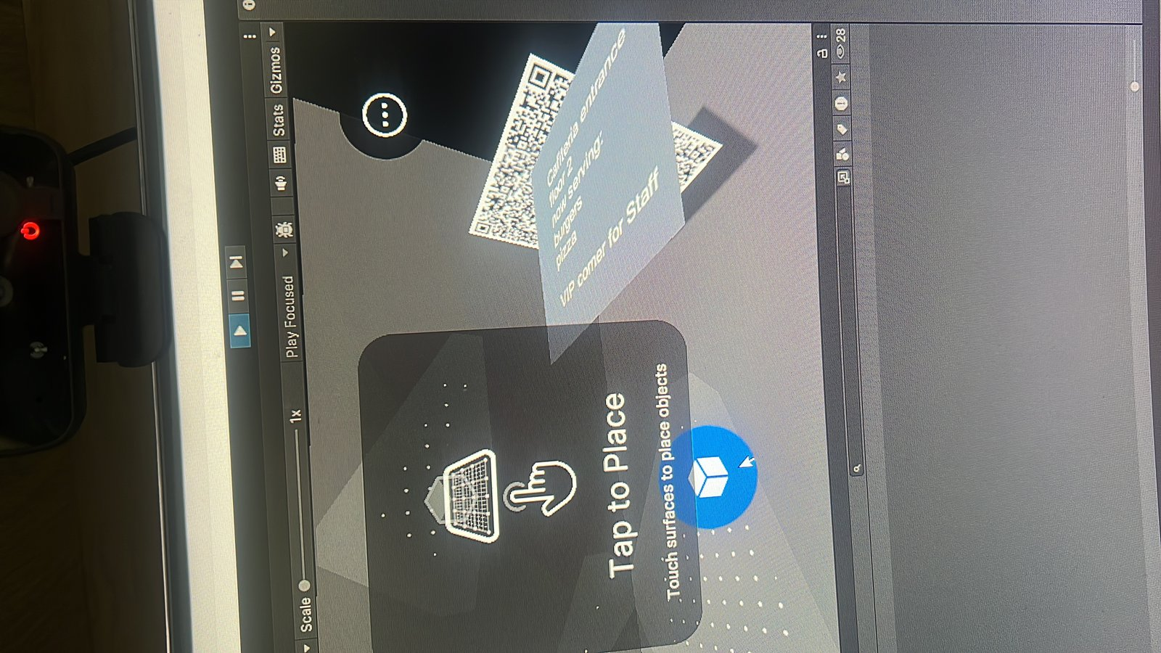 | 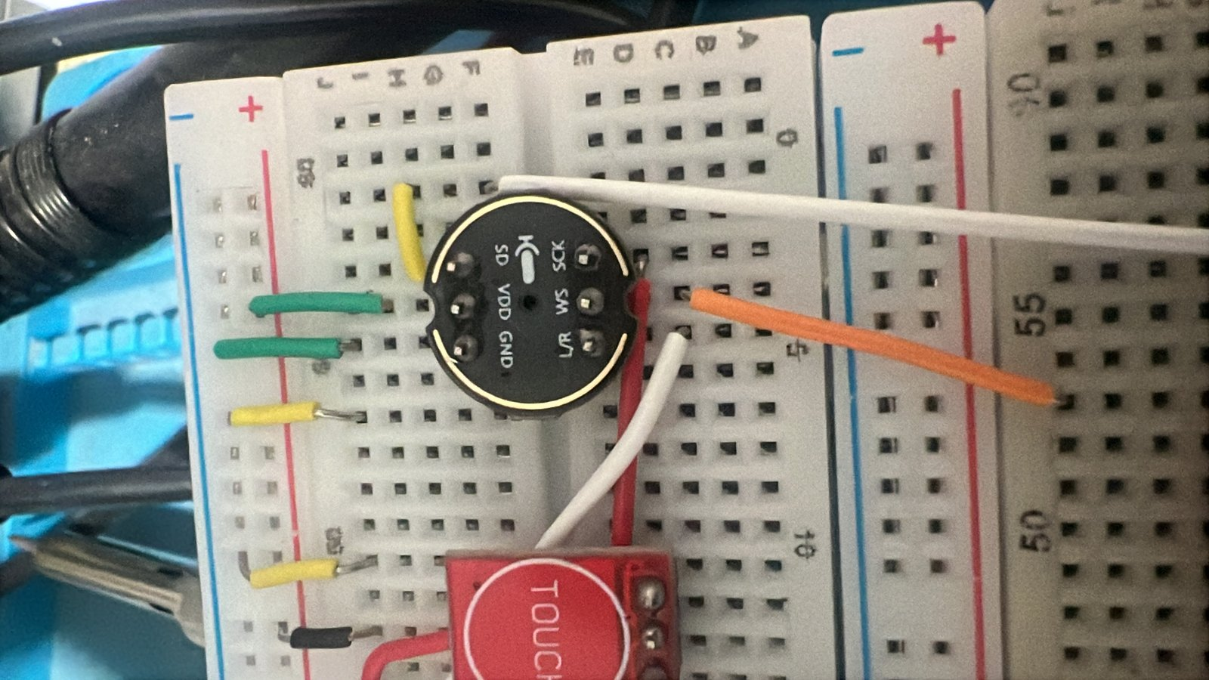 | 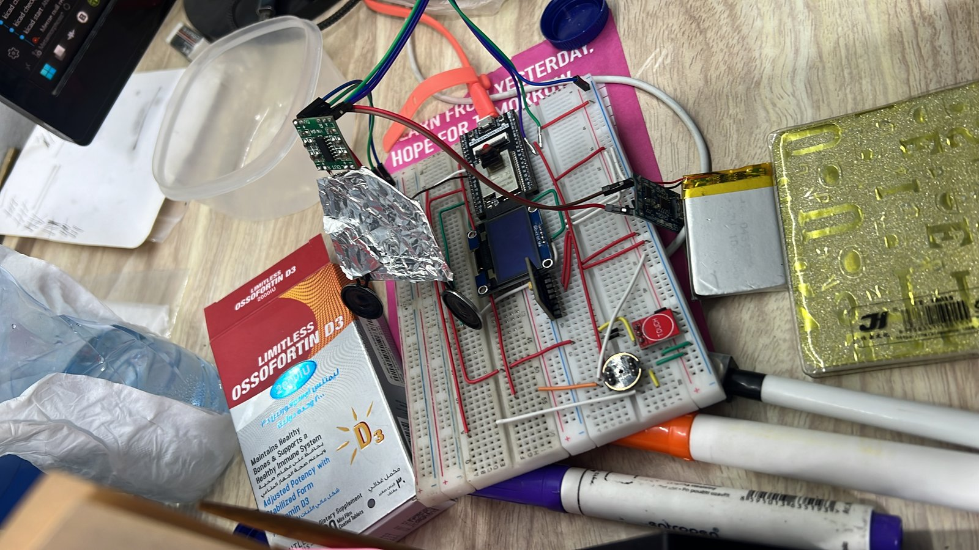
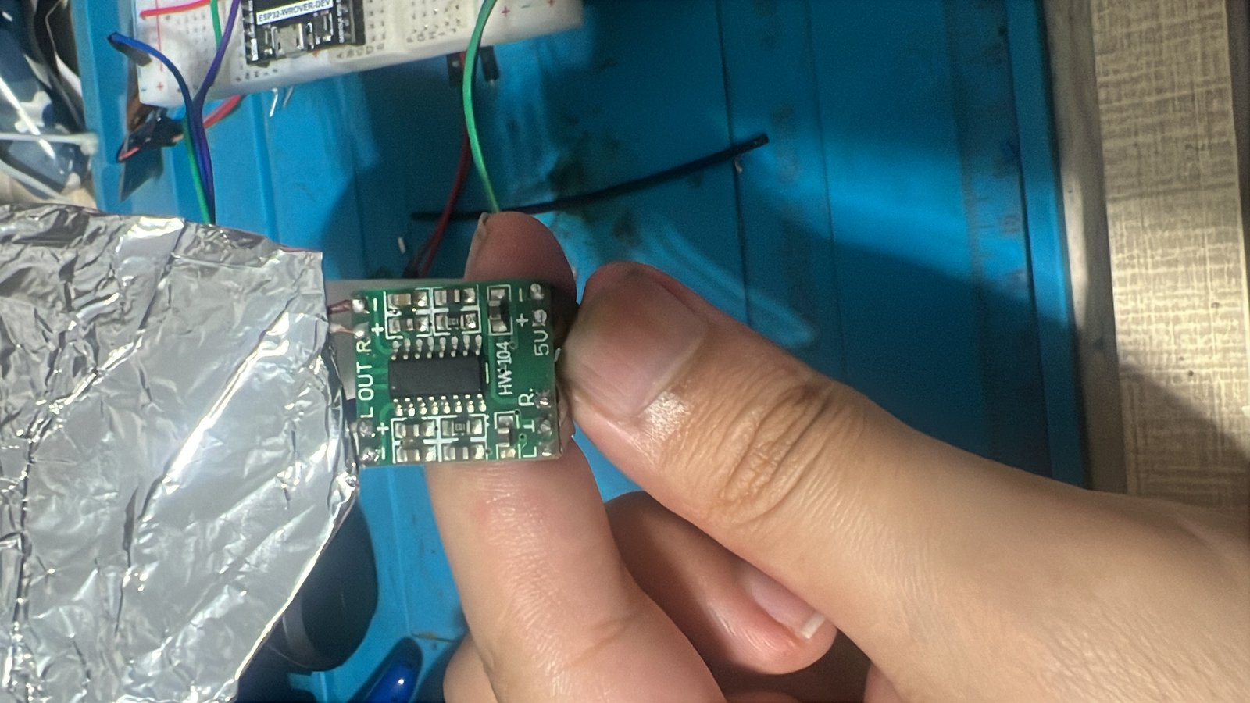 | 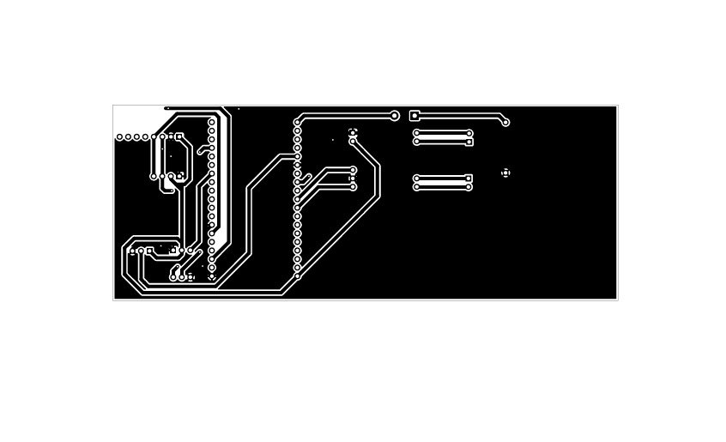 | 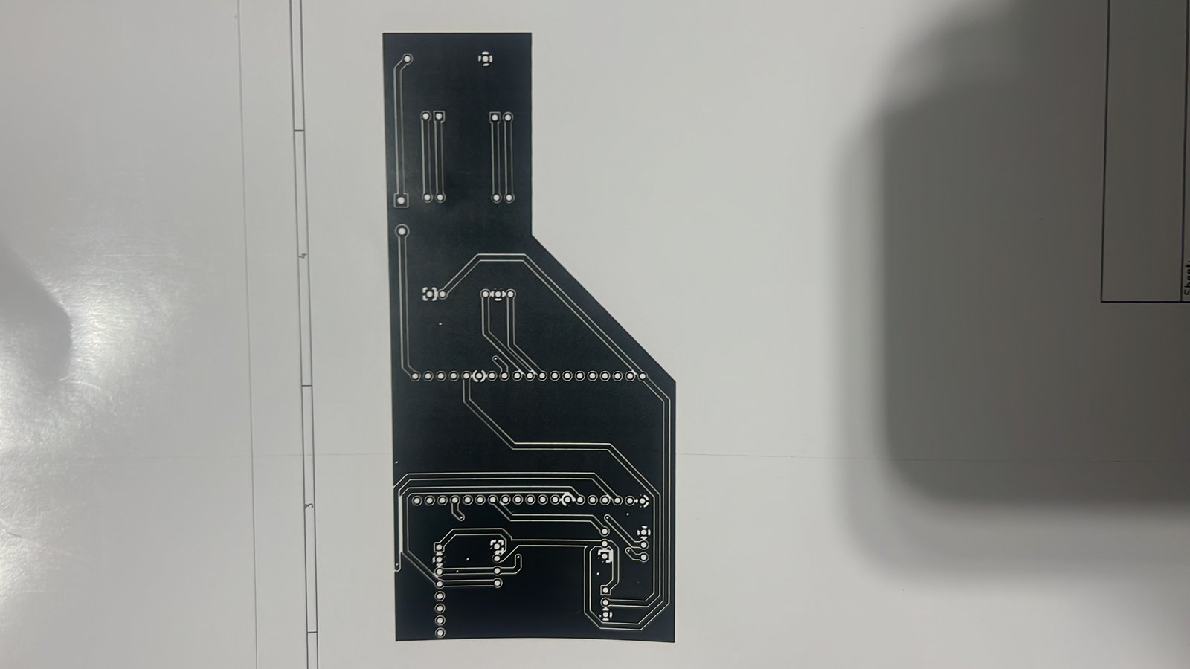
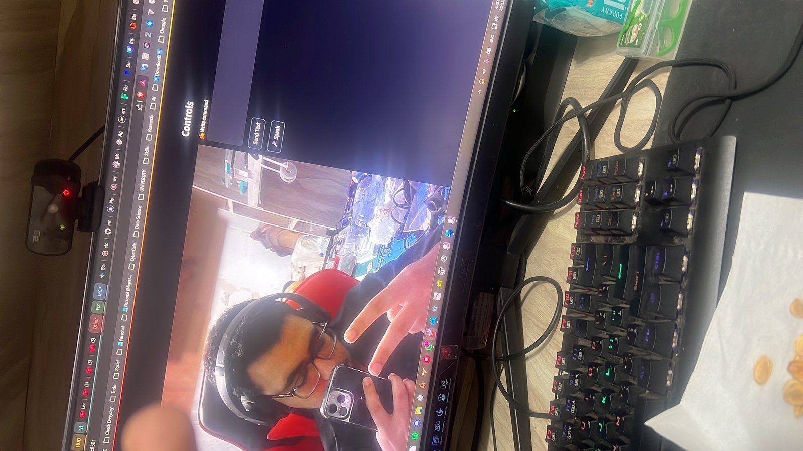 | 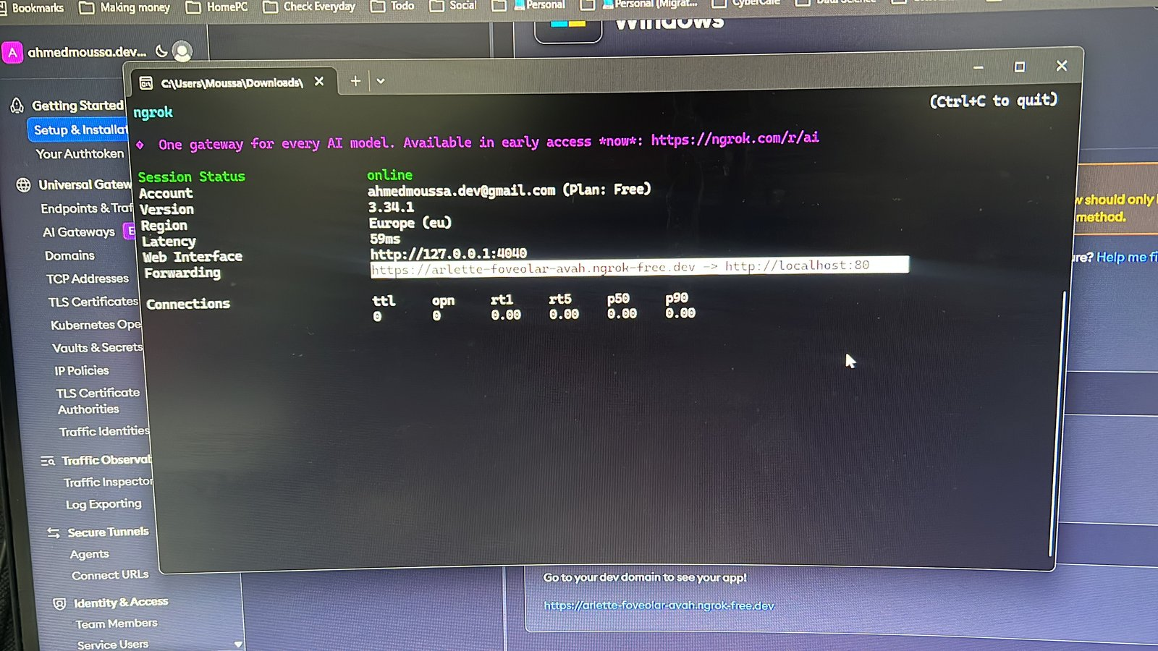 | 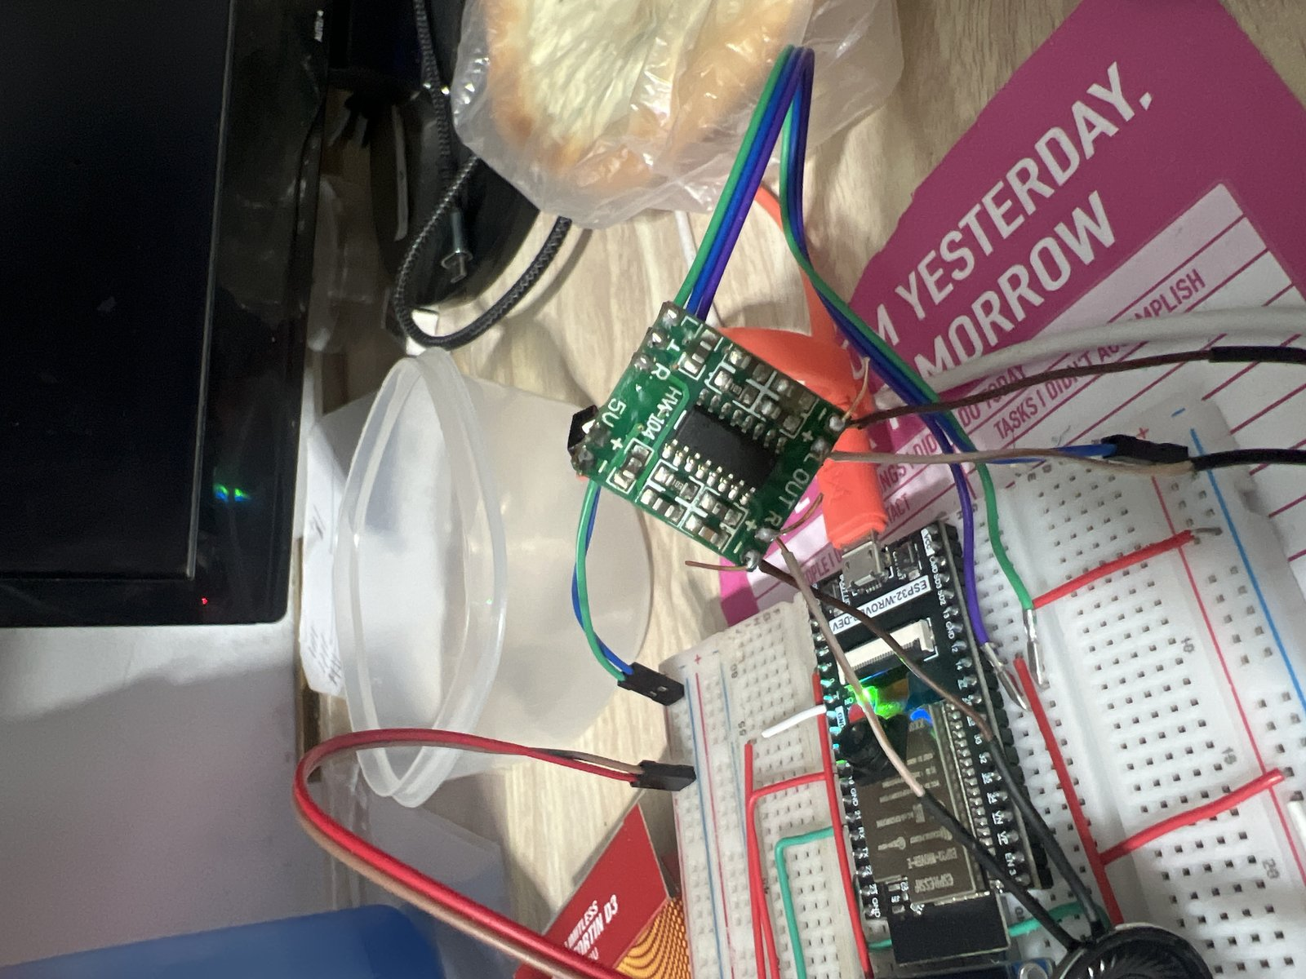
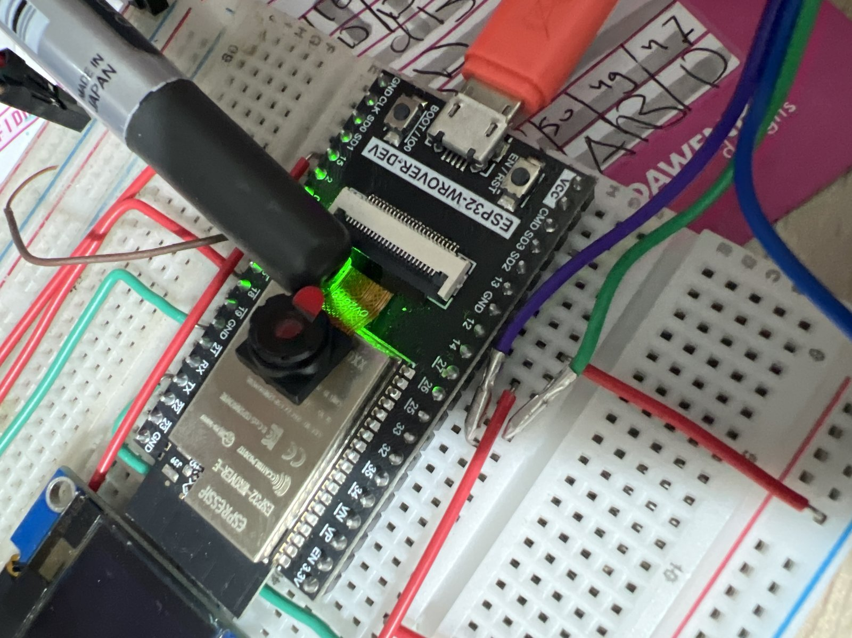 | 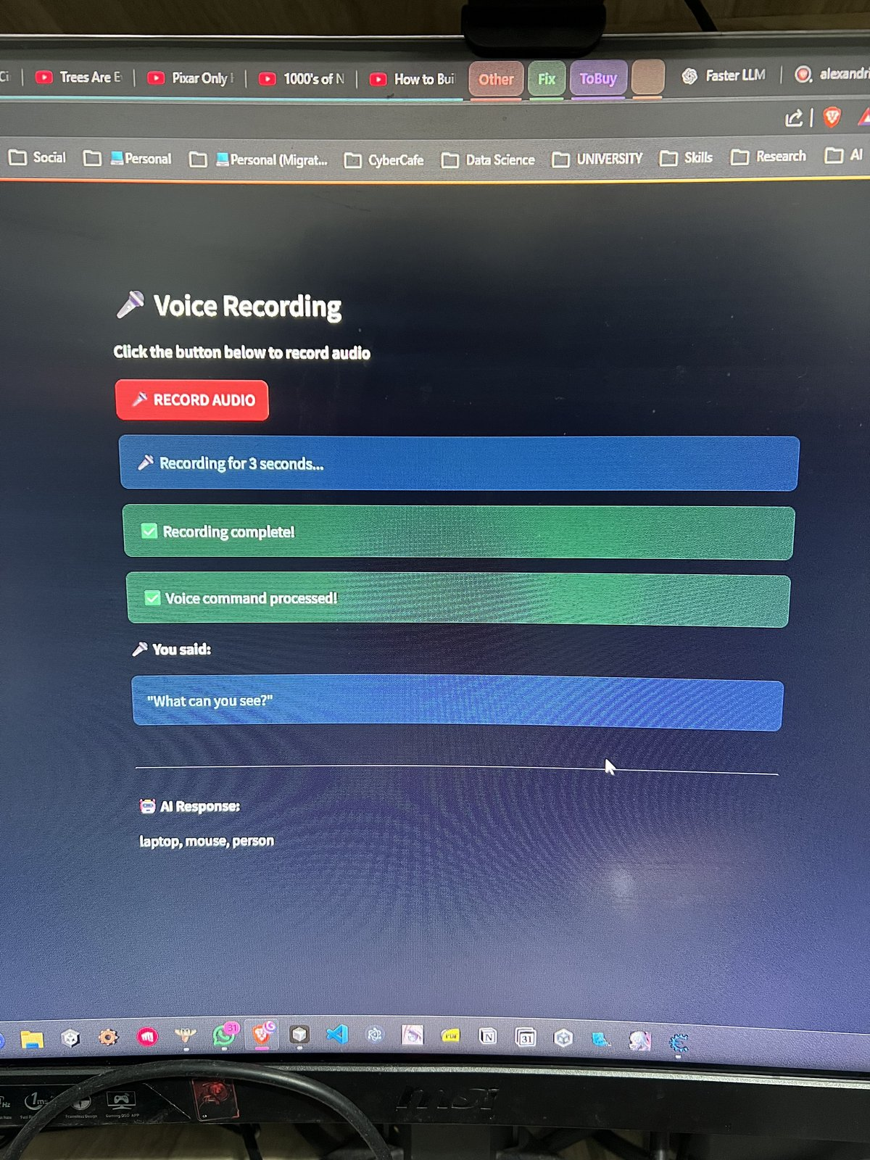 | 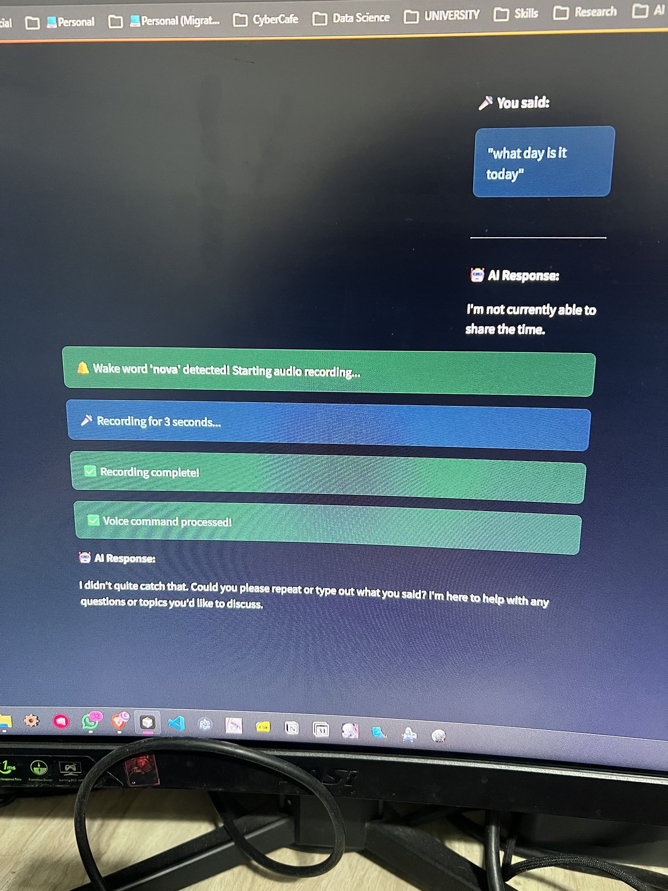
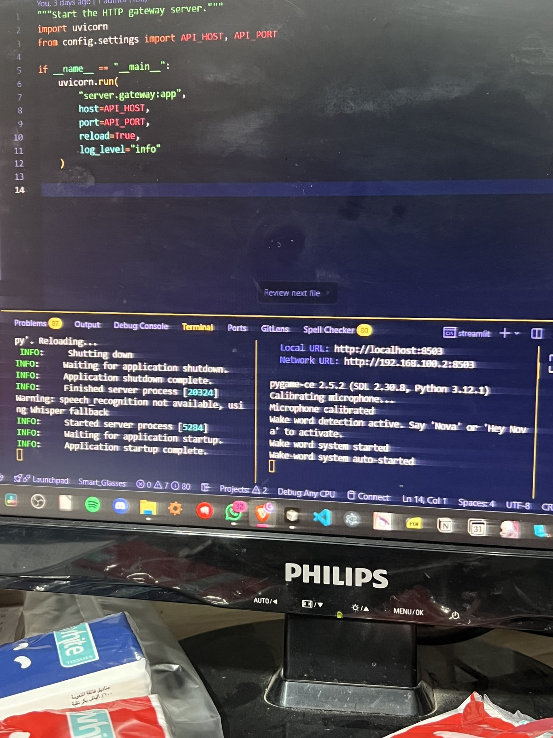 | 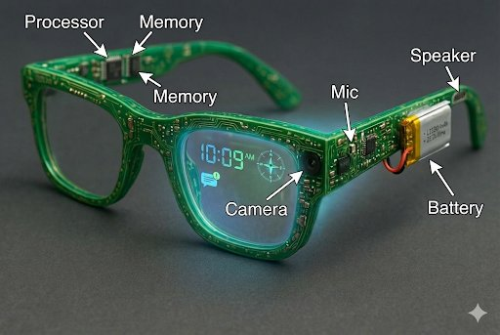 | 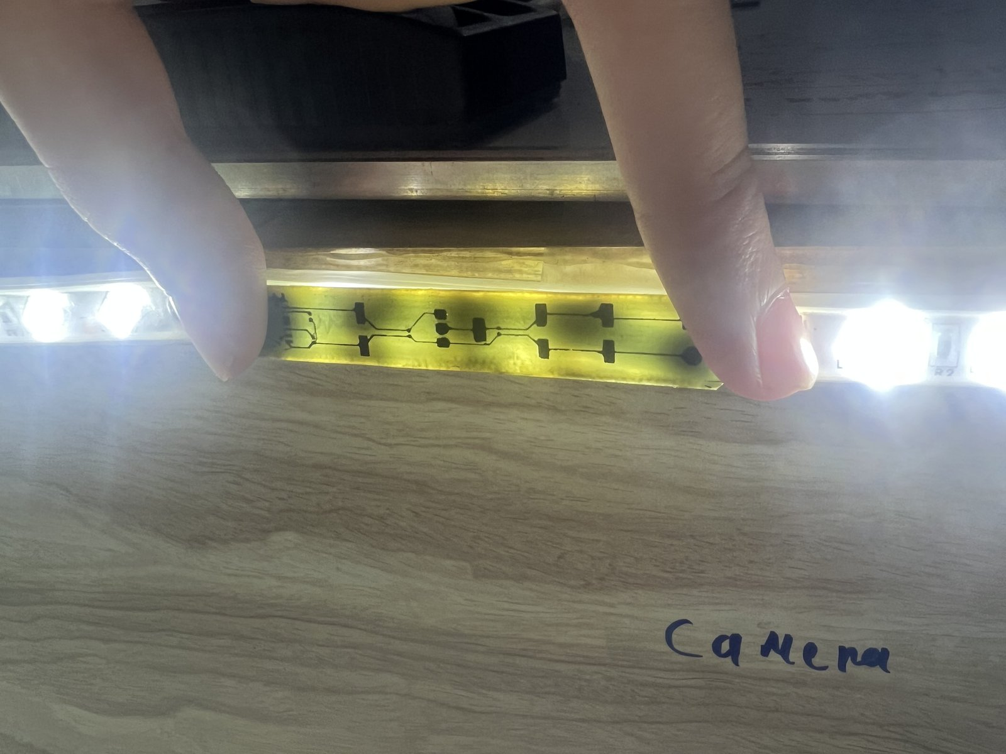
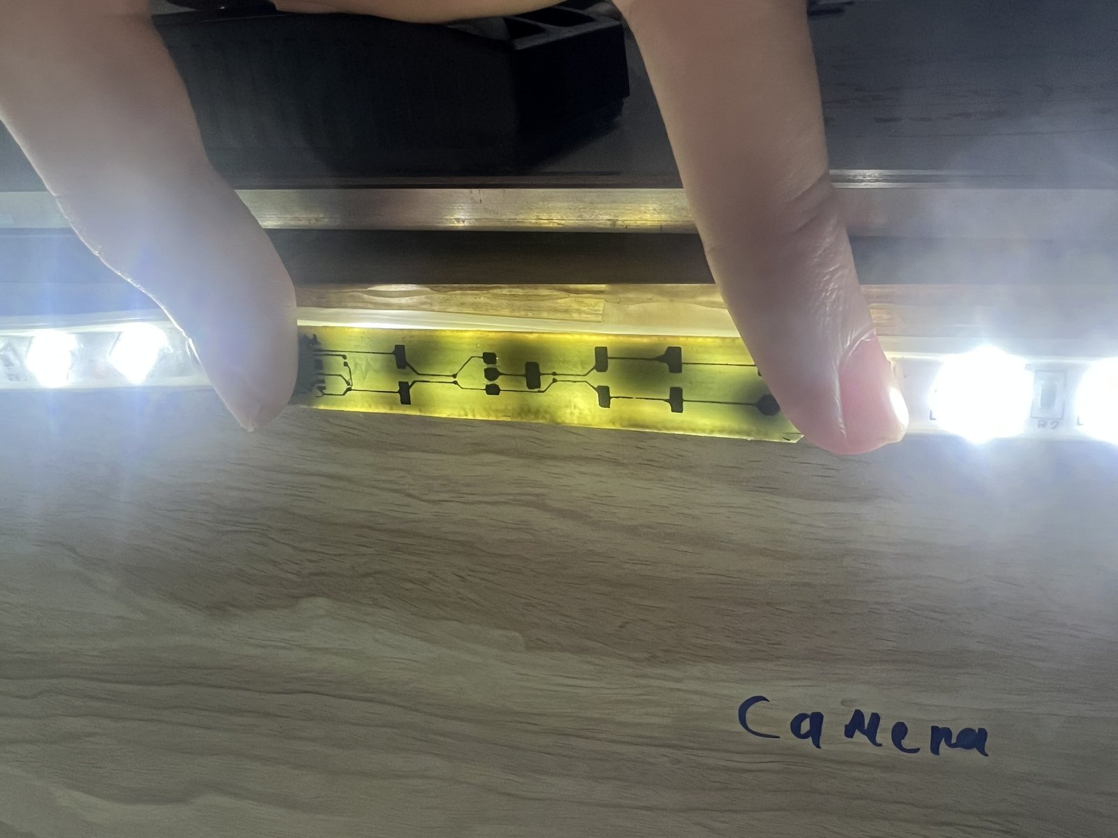 | 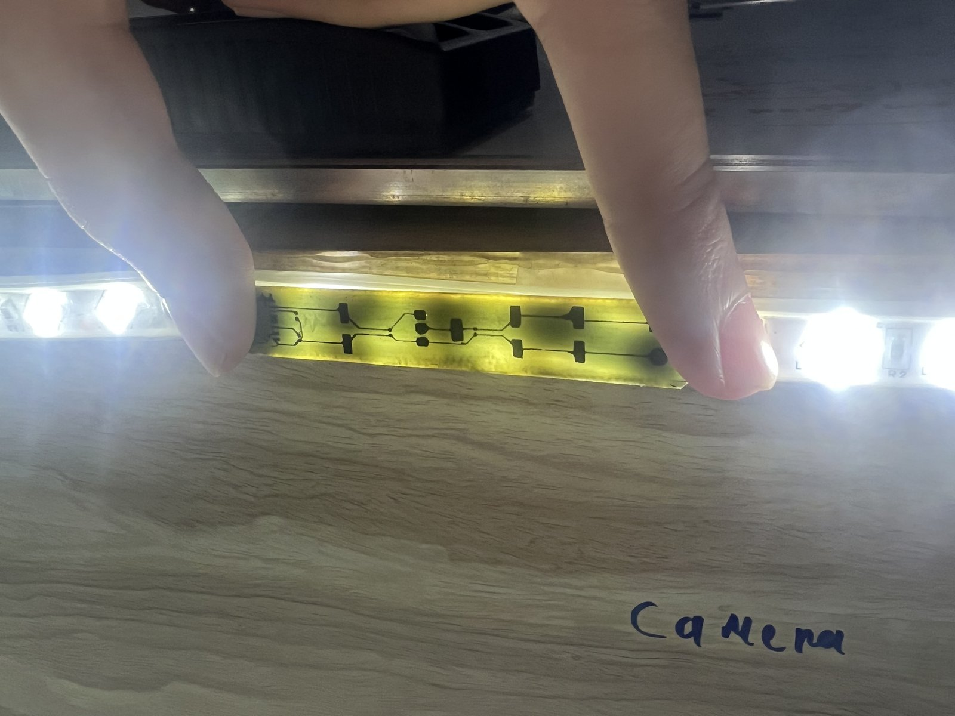 | 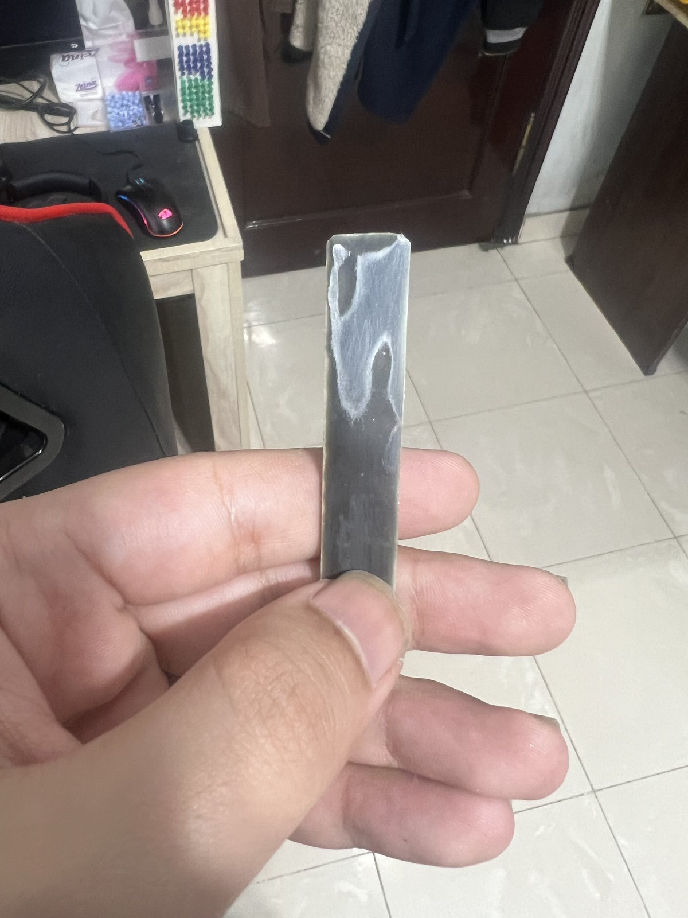
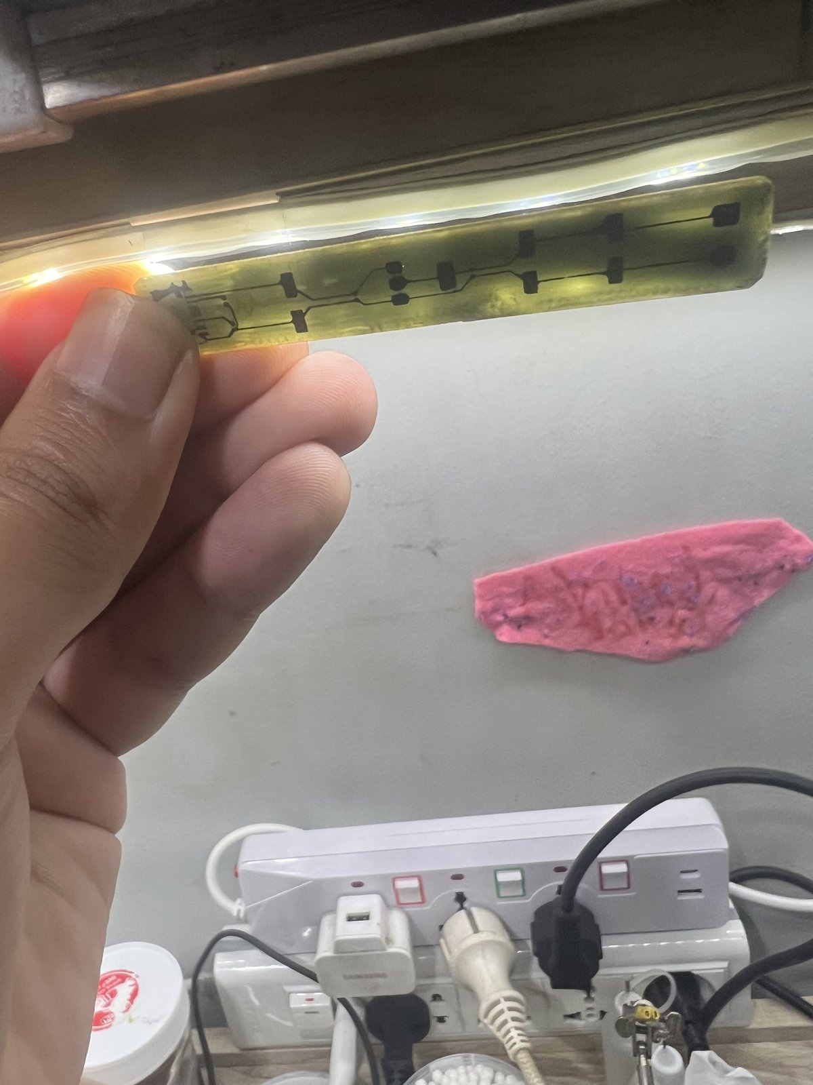 | 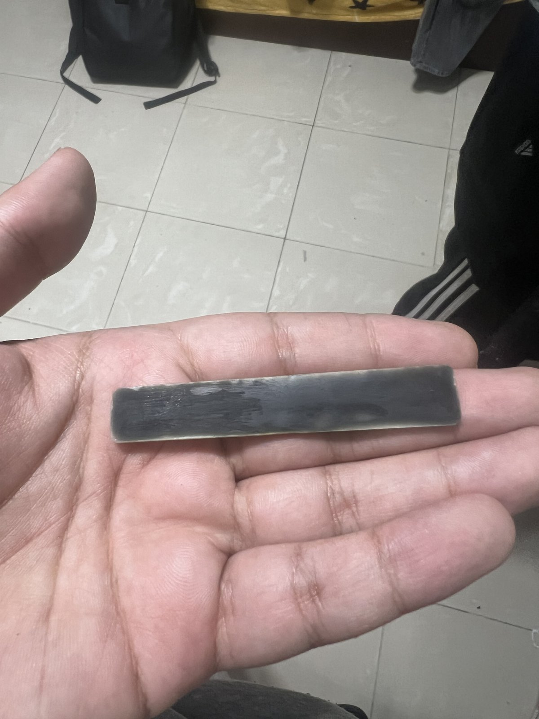 | 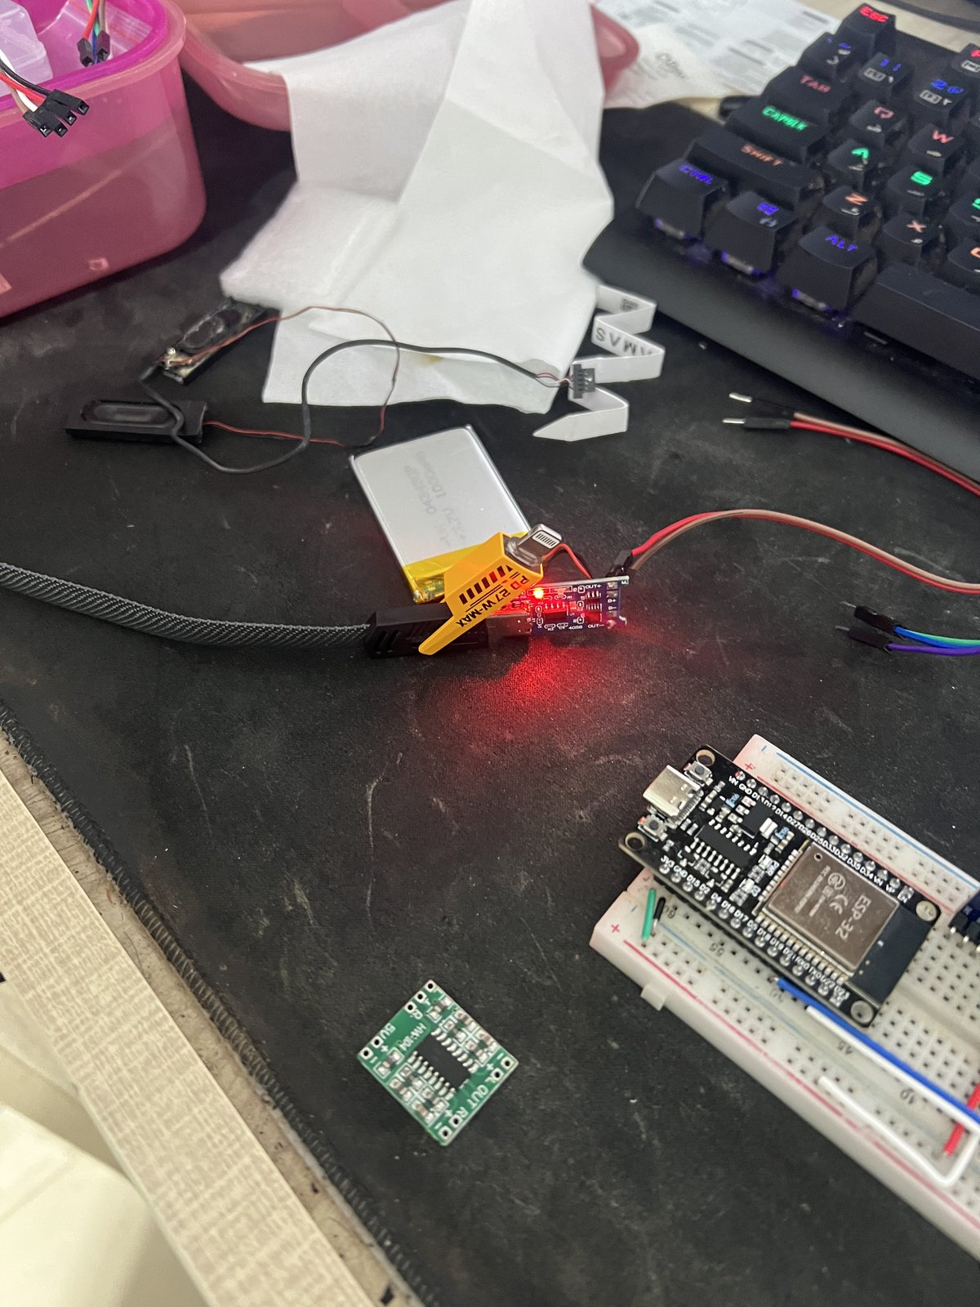
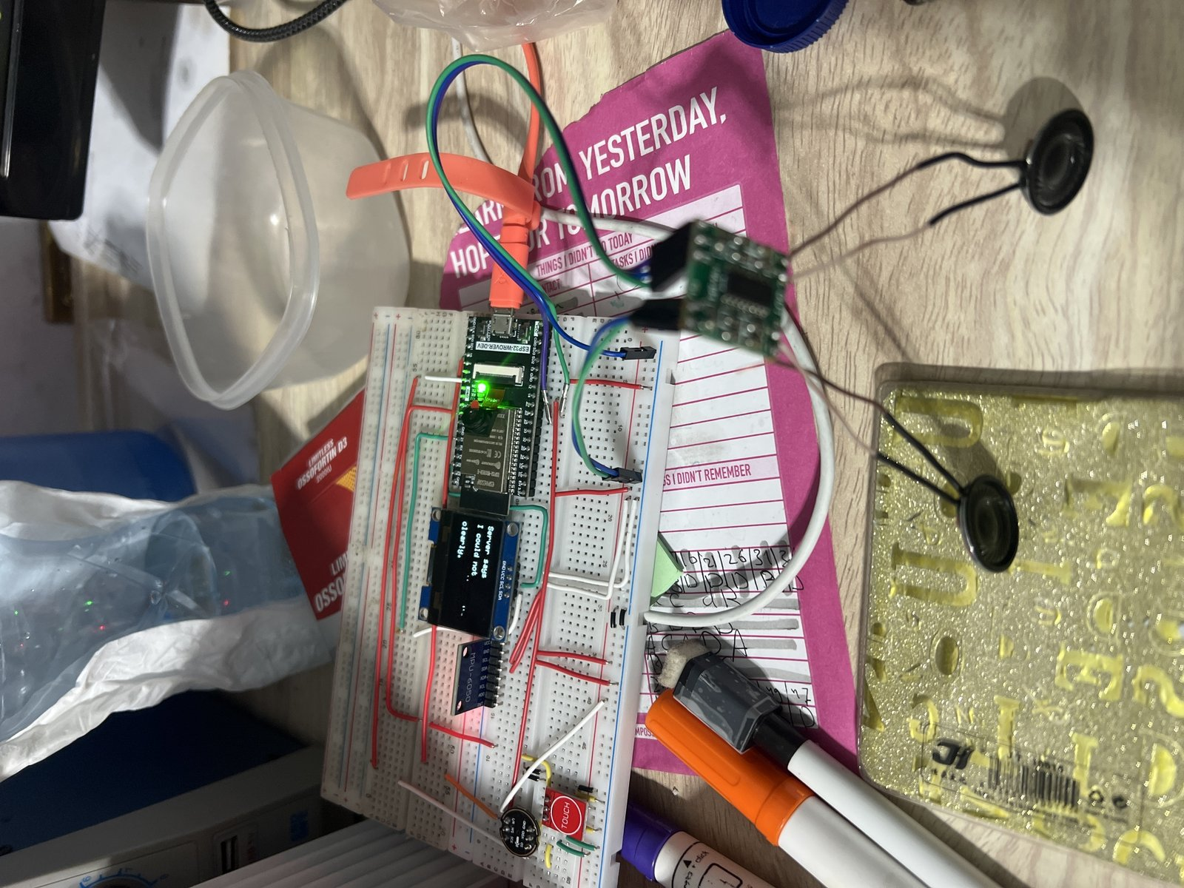 | 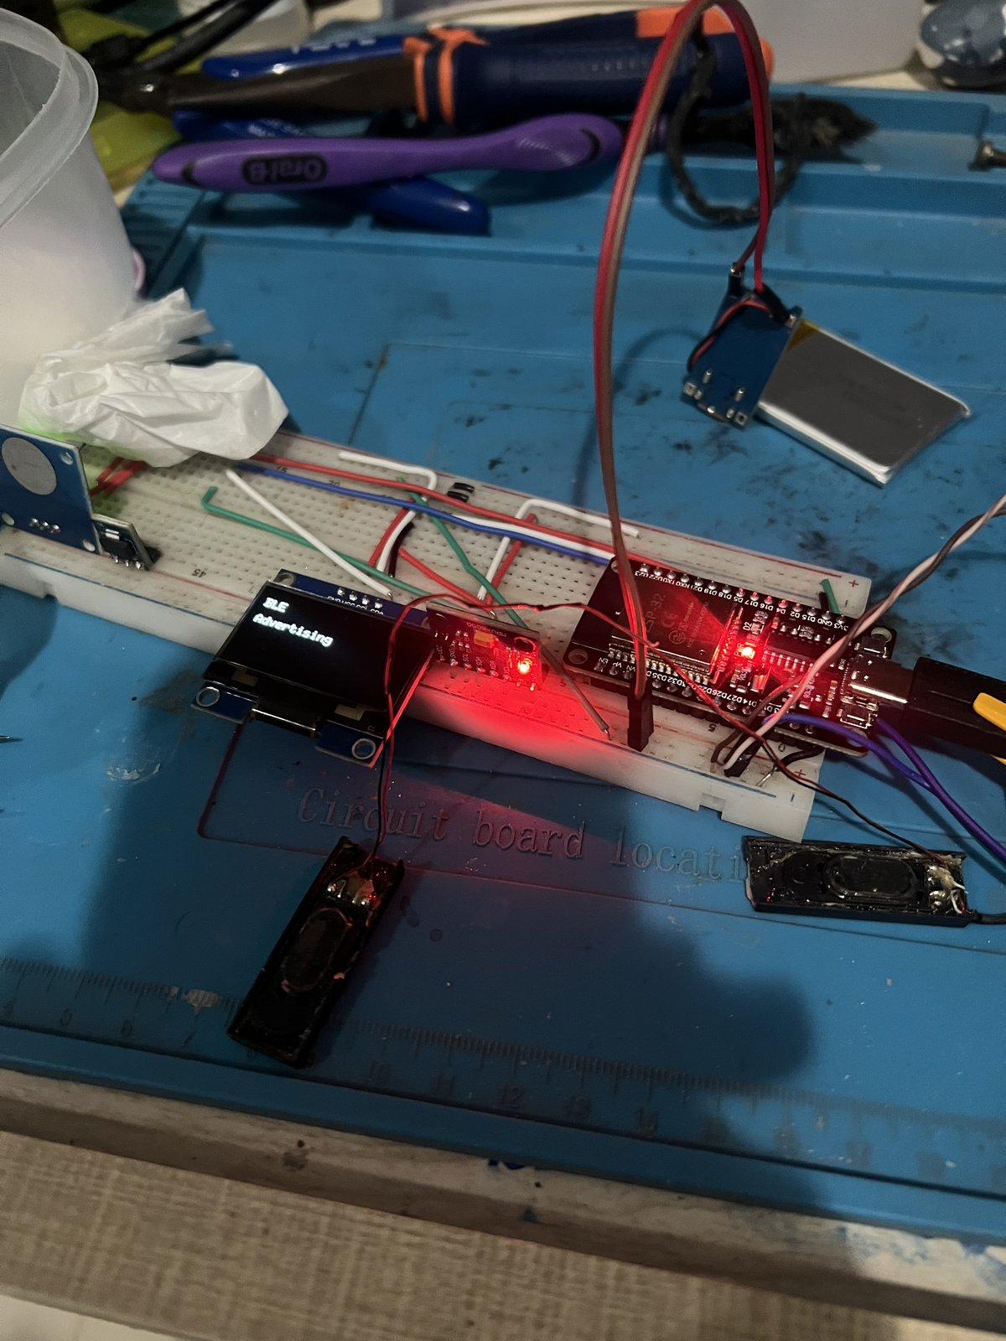 | 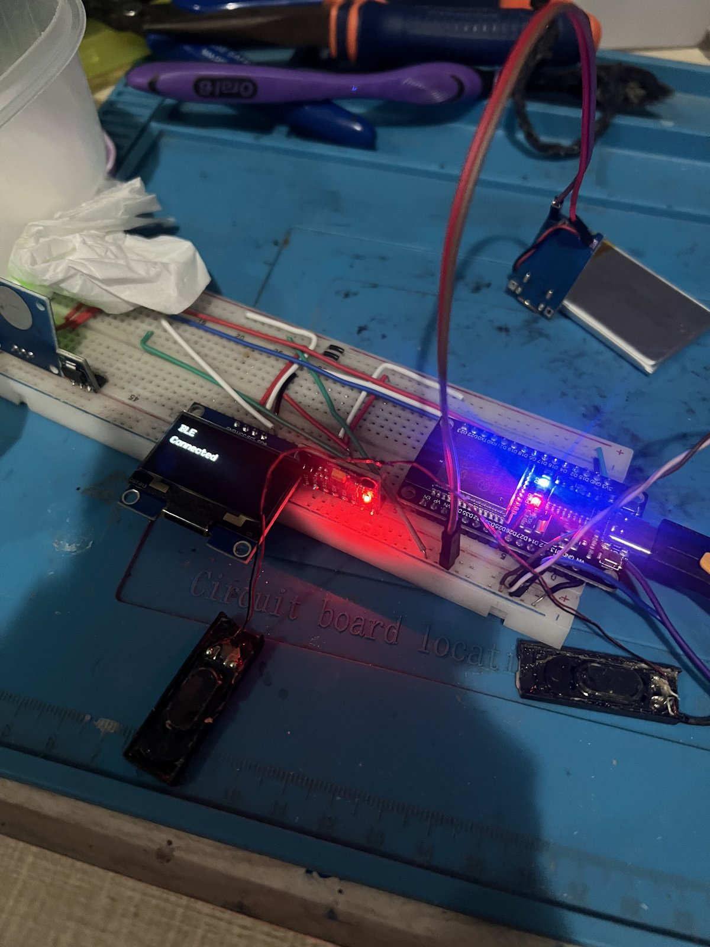
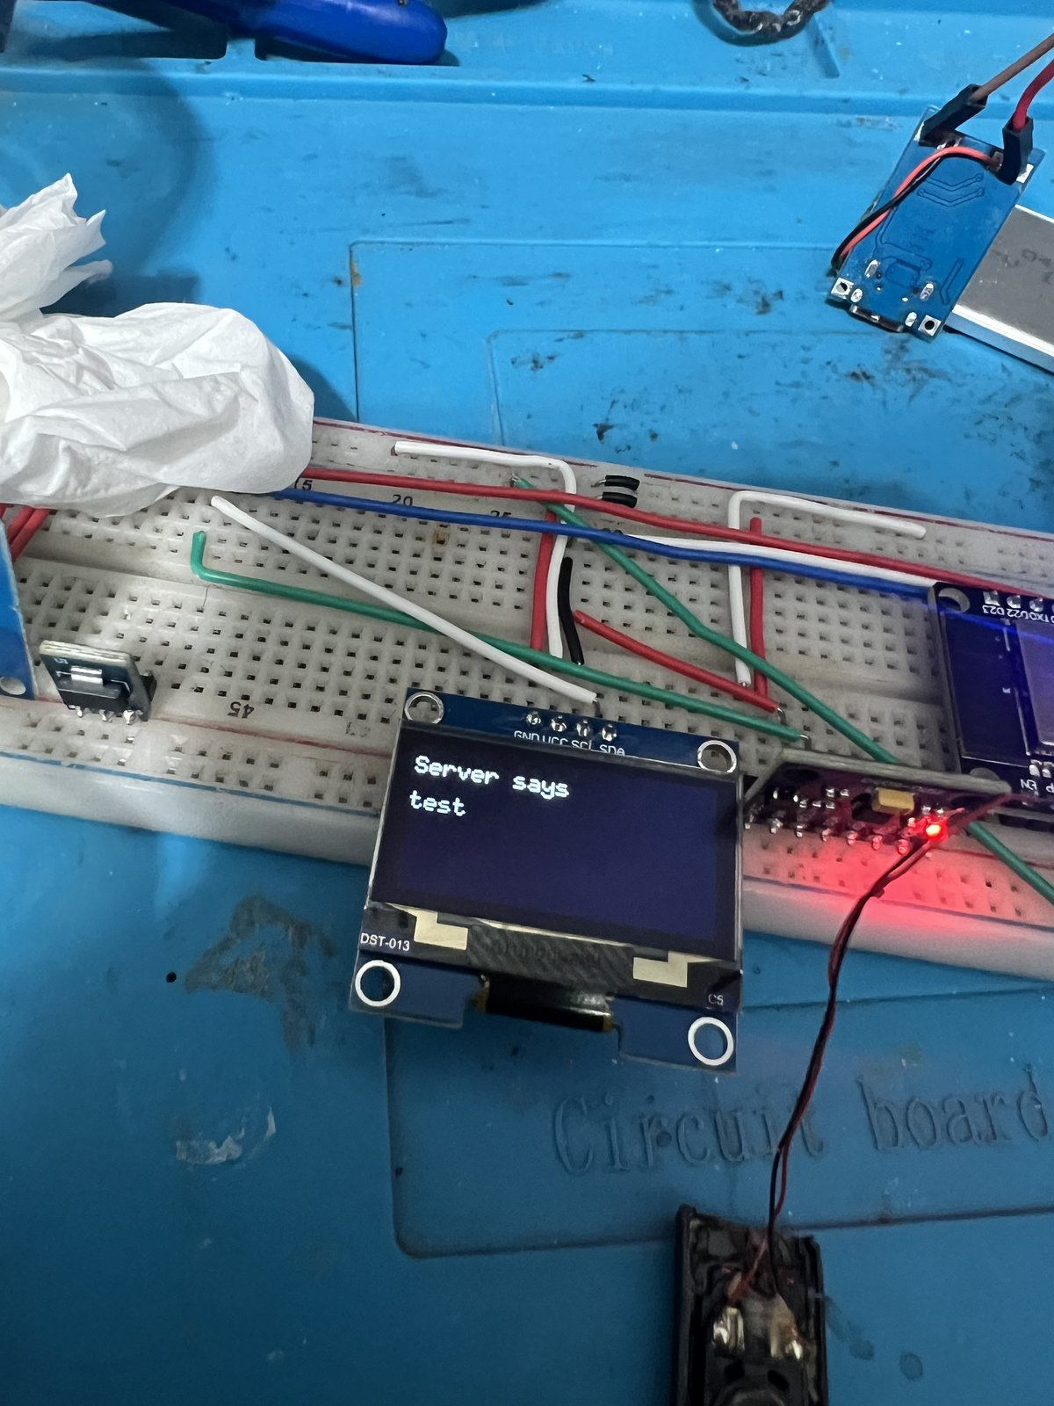 | 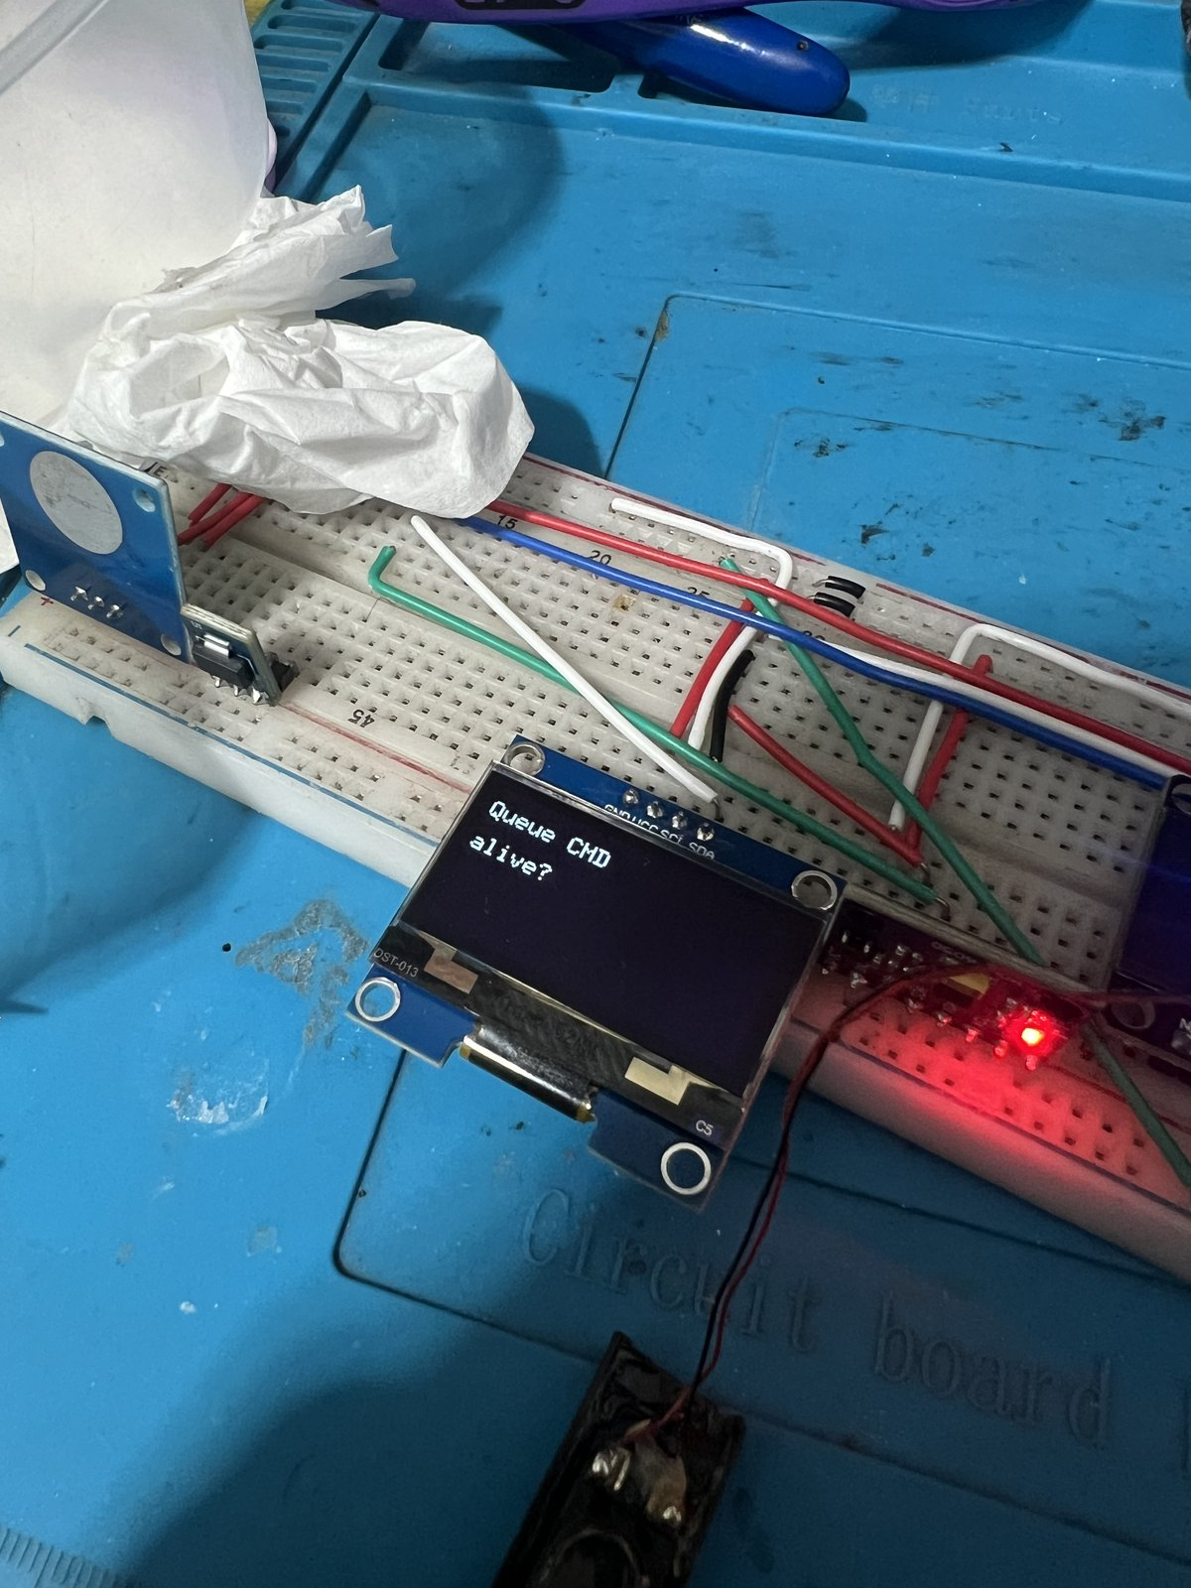 | 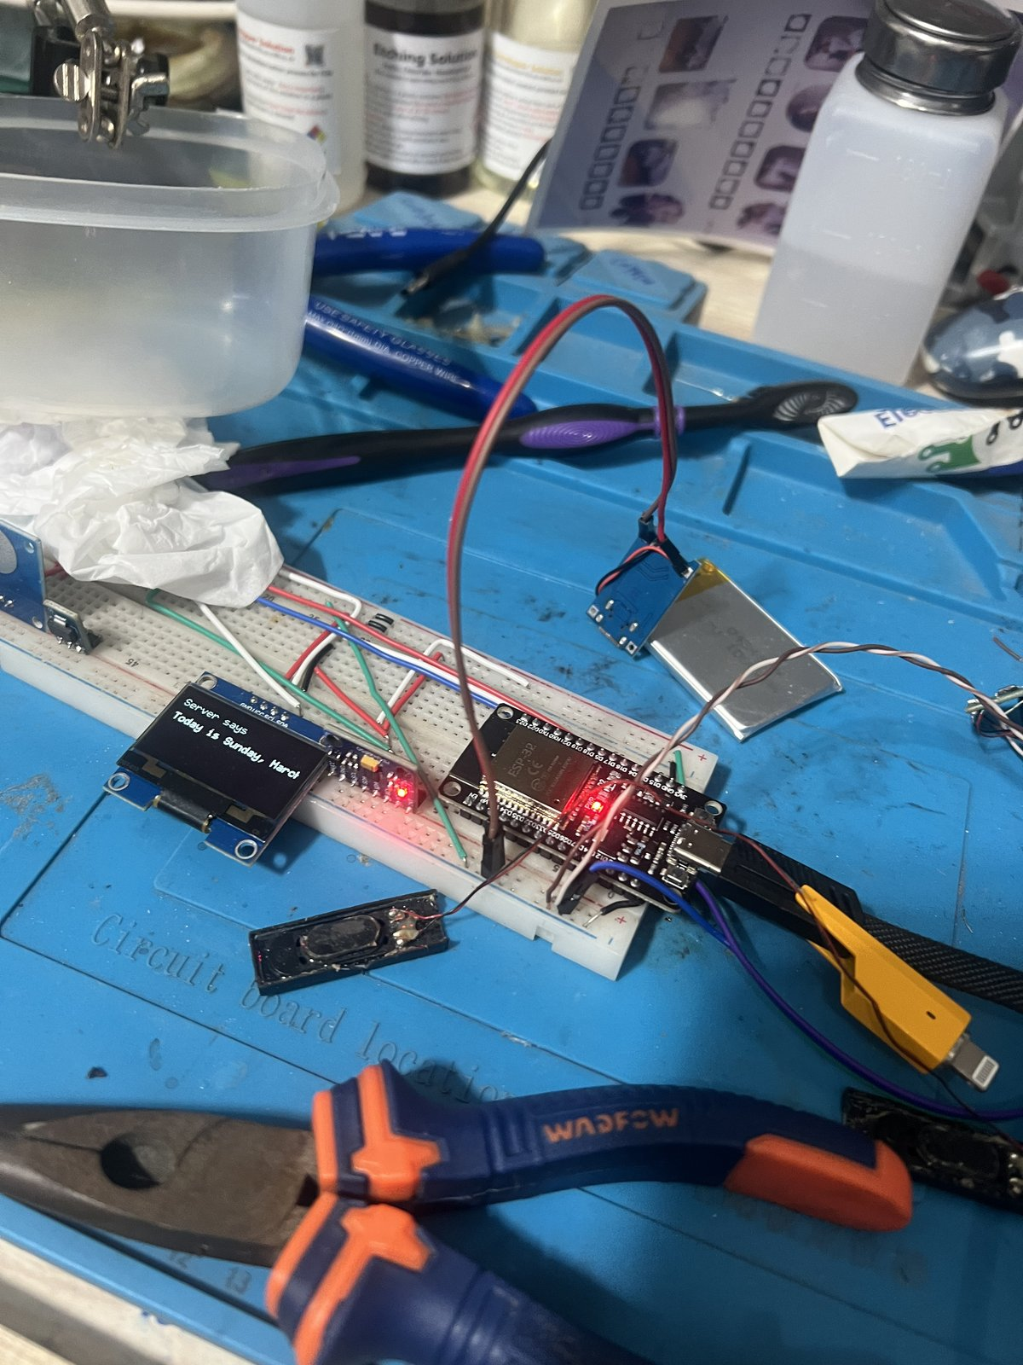
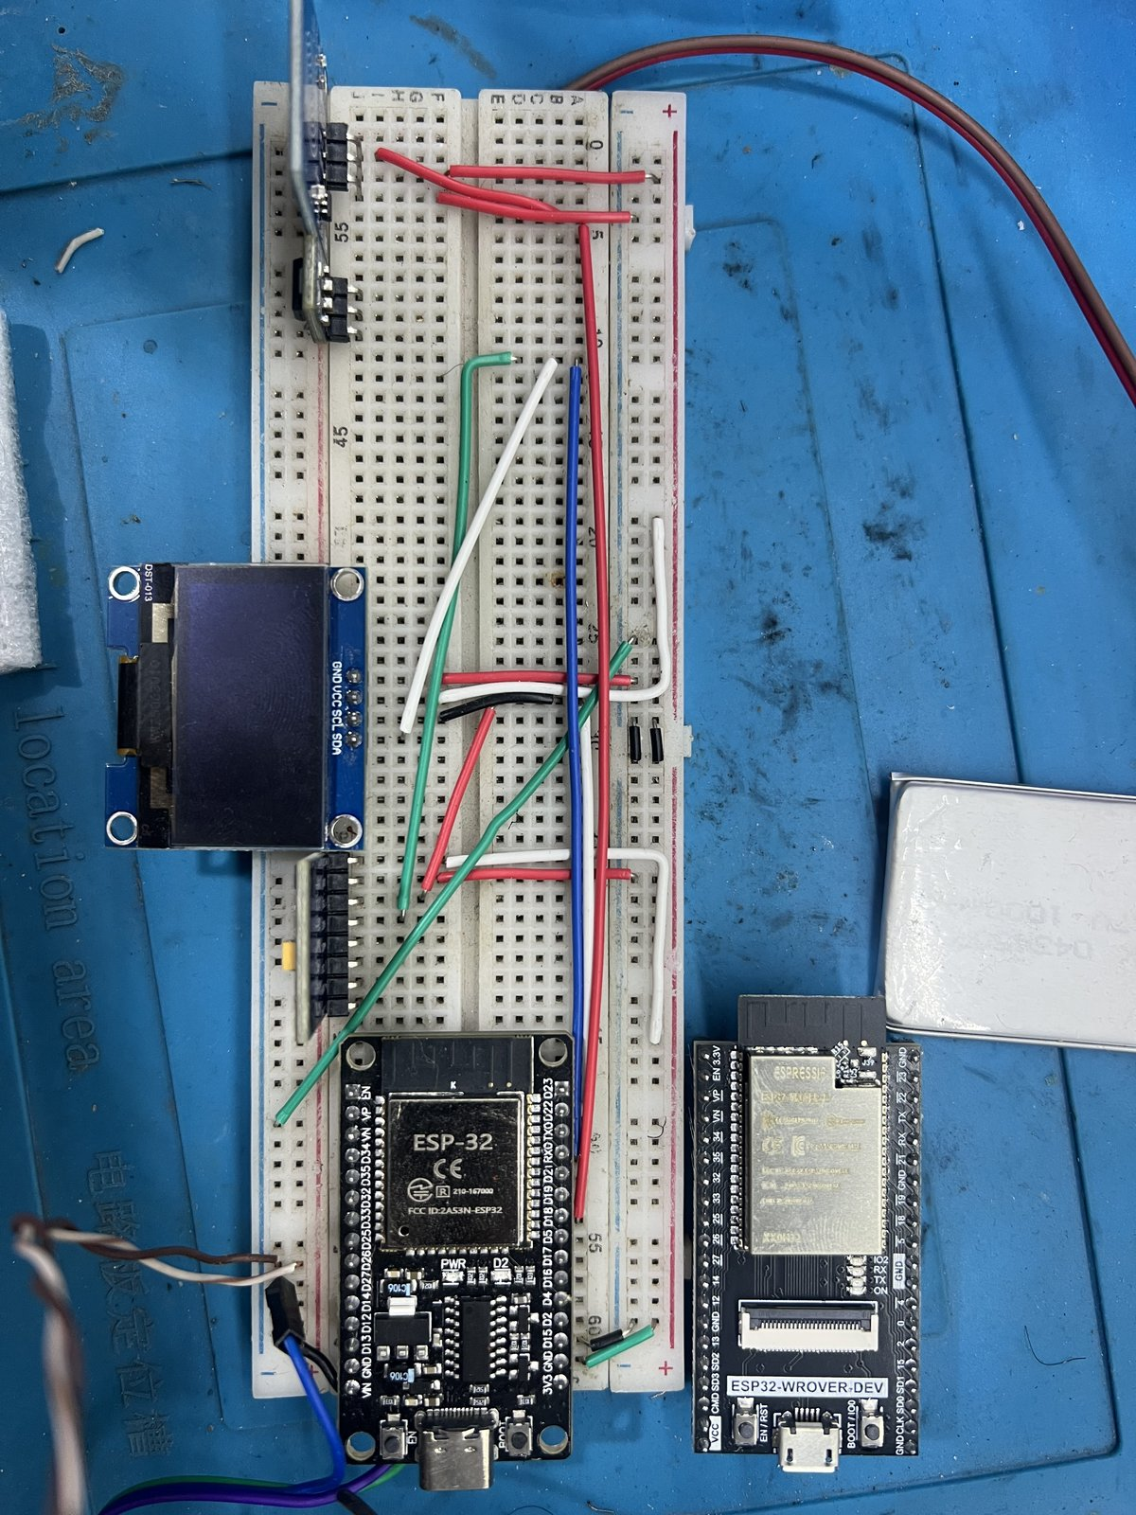 | 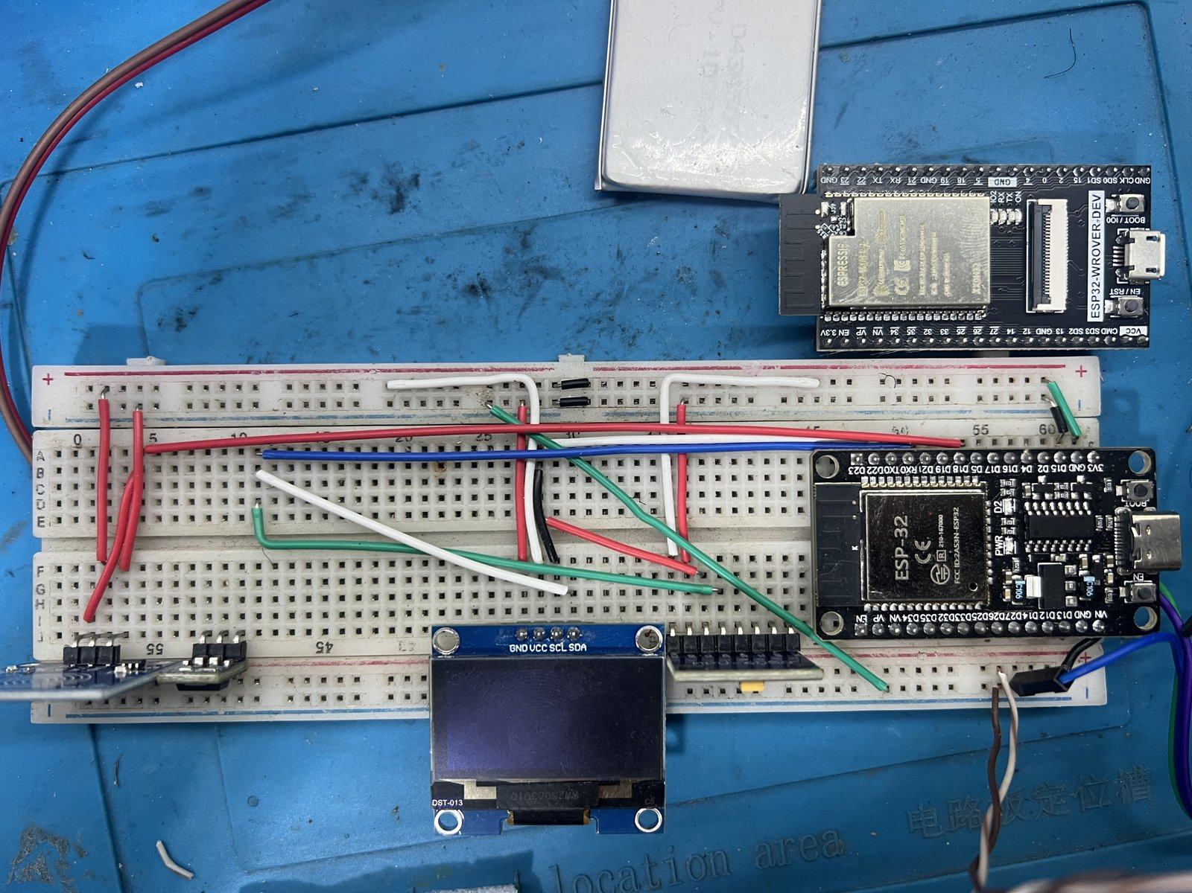 | 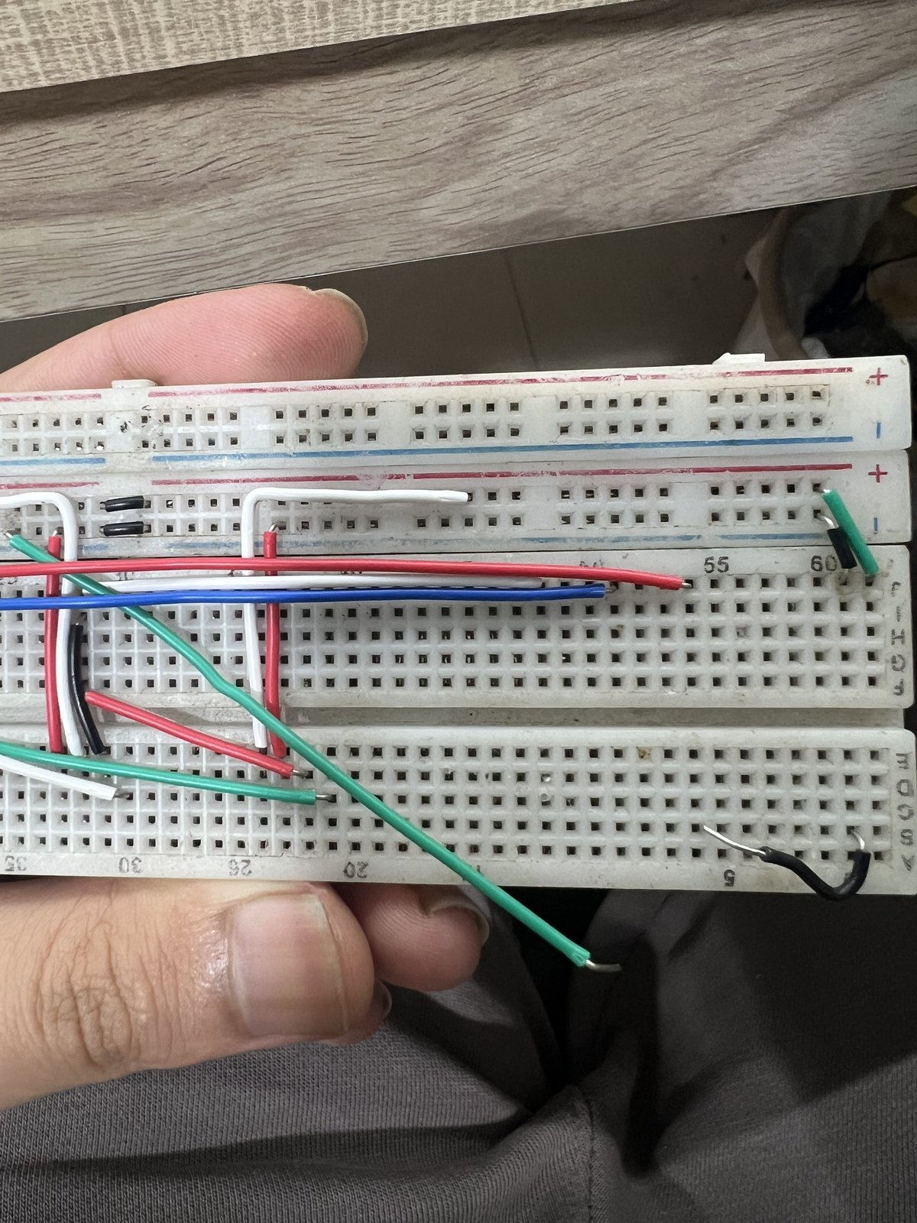
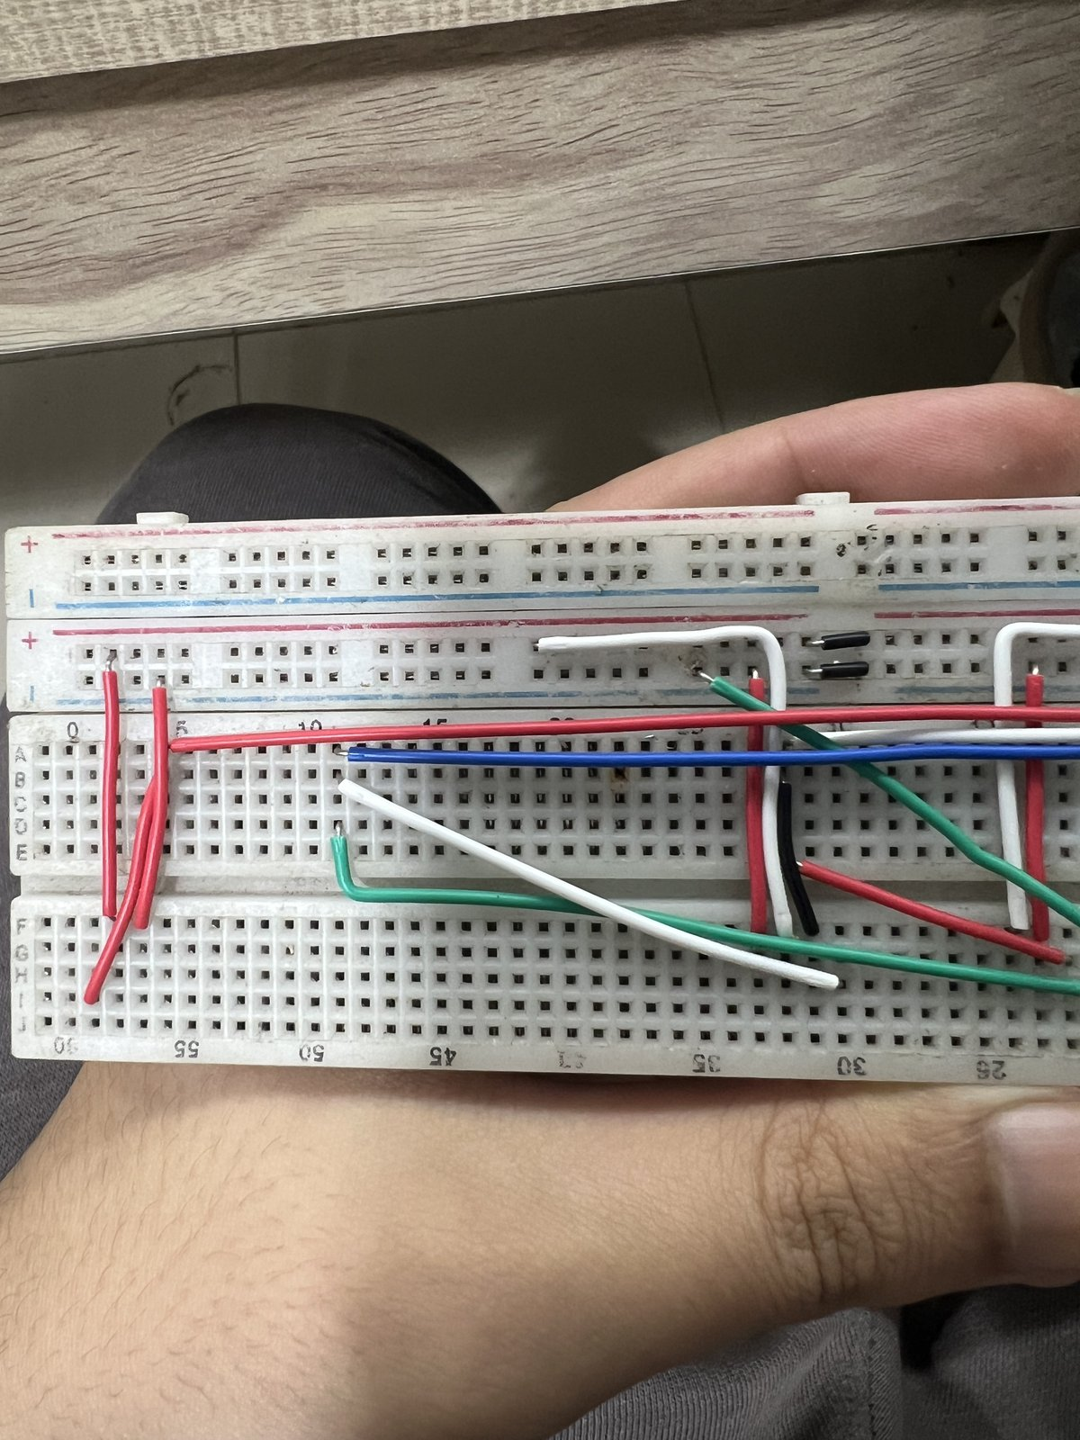 | 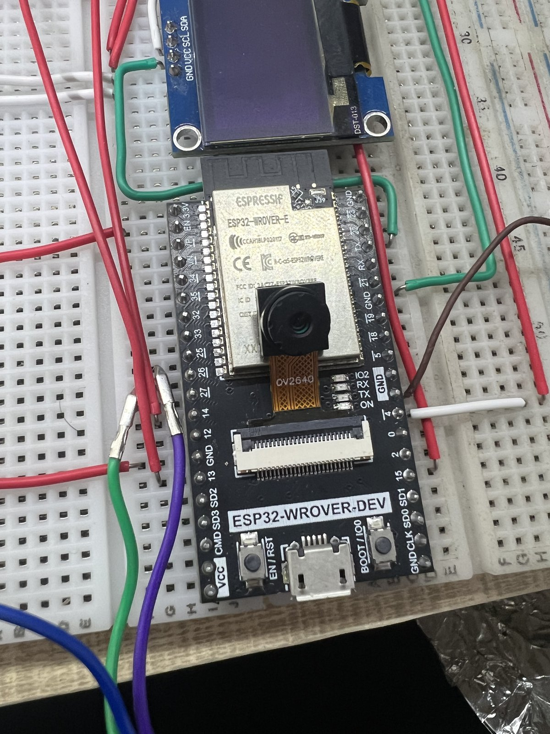 | 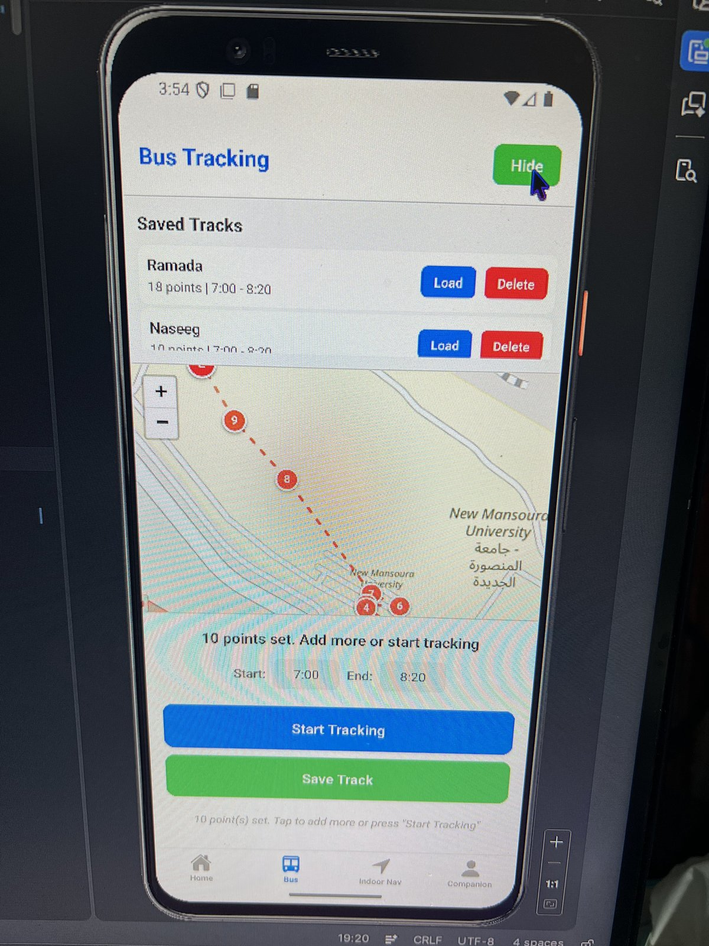
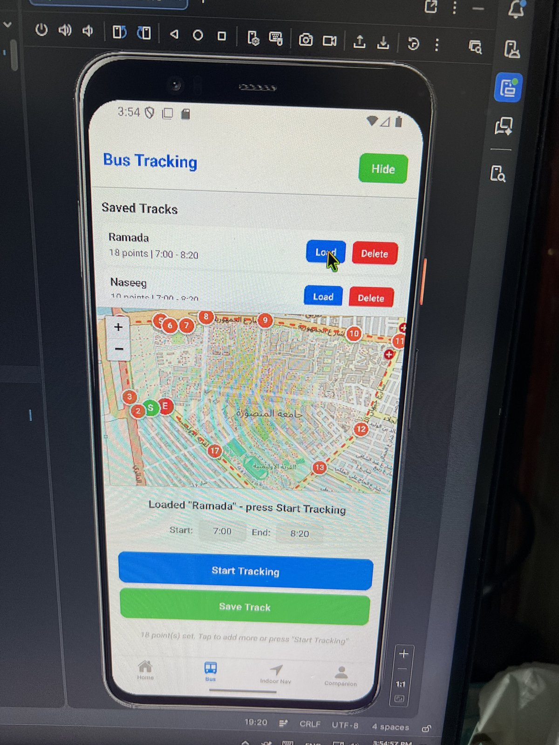 | 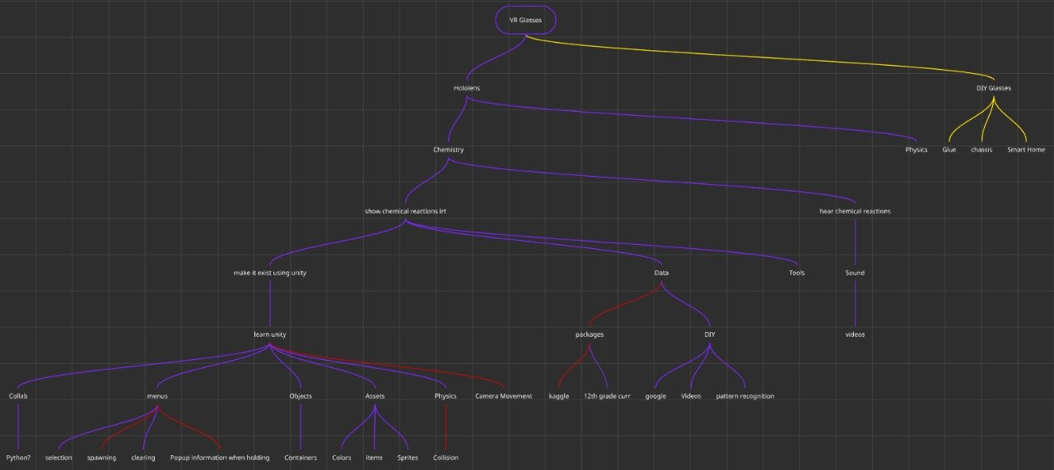
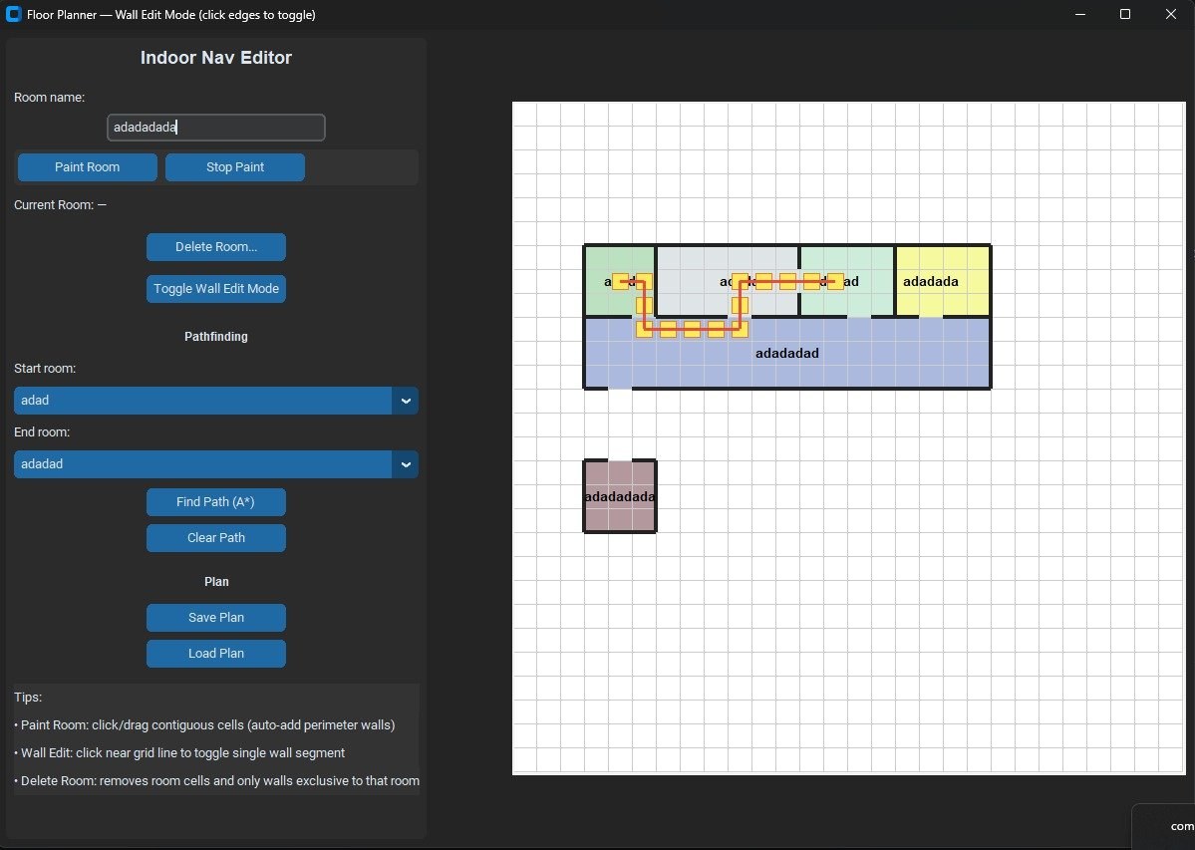 | 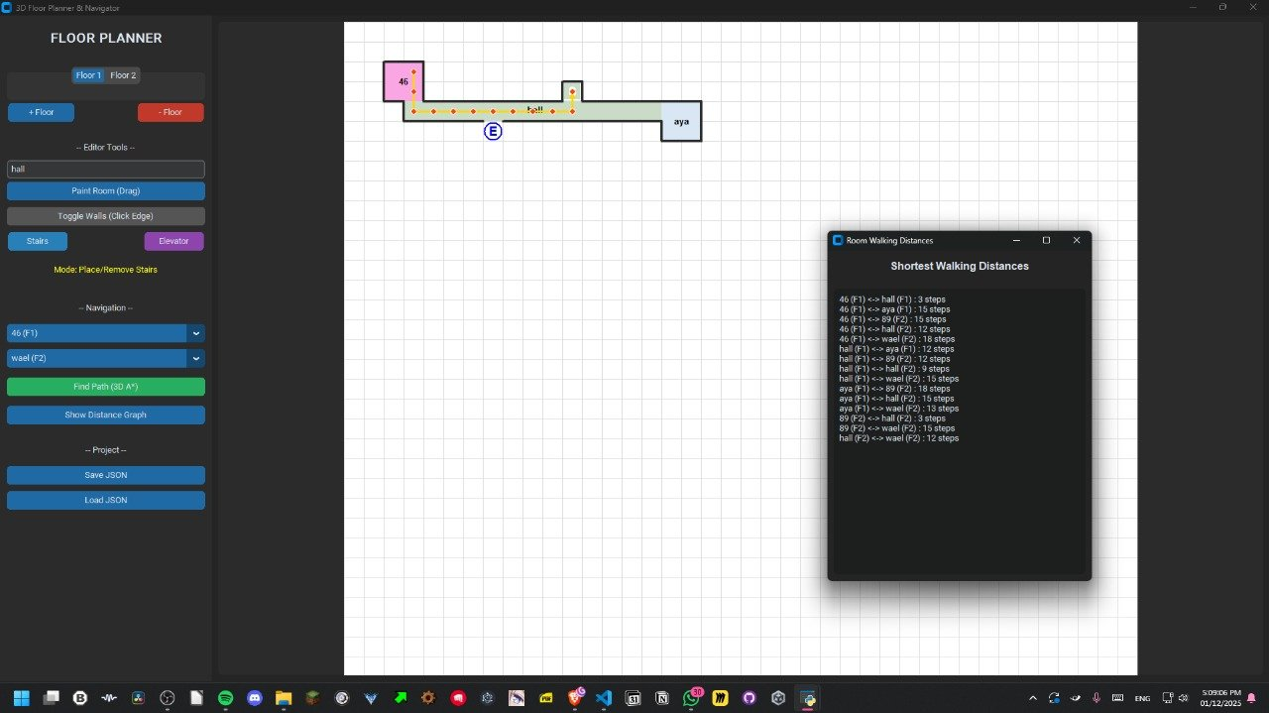 | 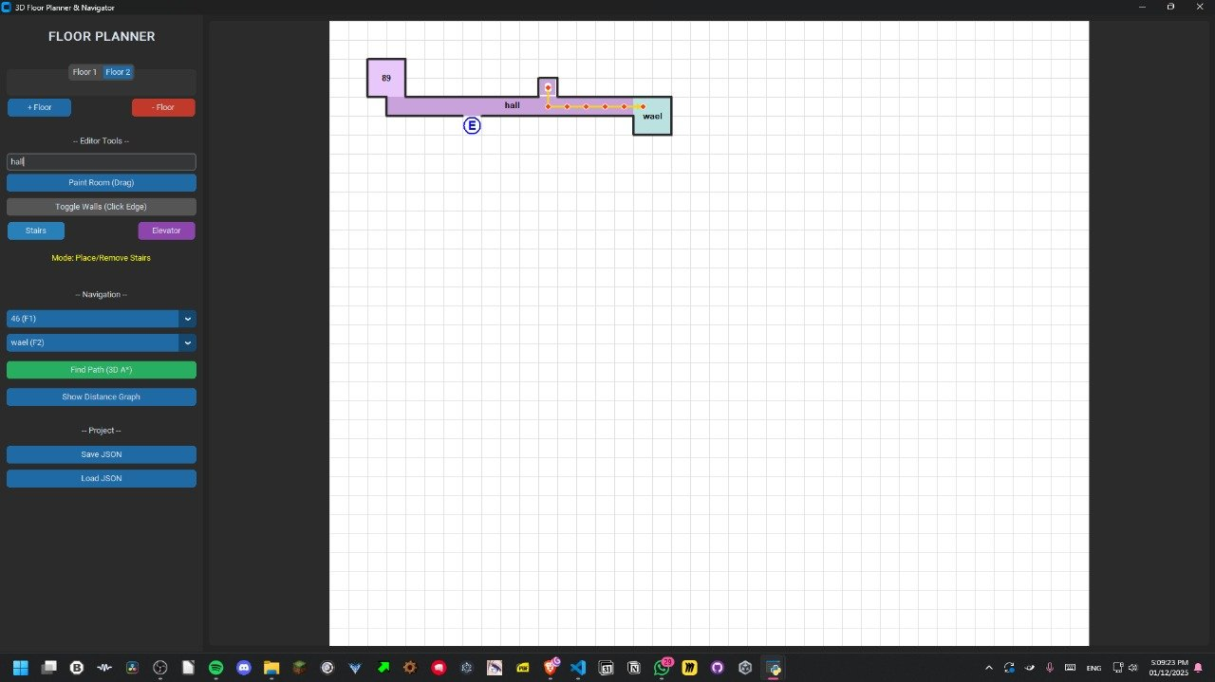
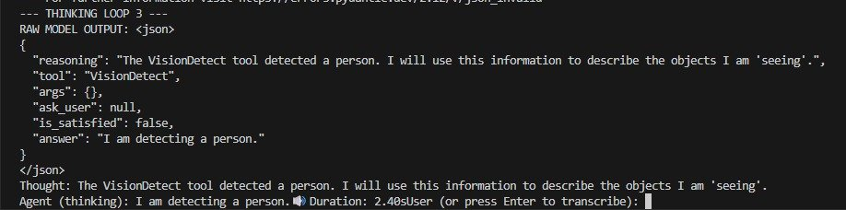 | 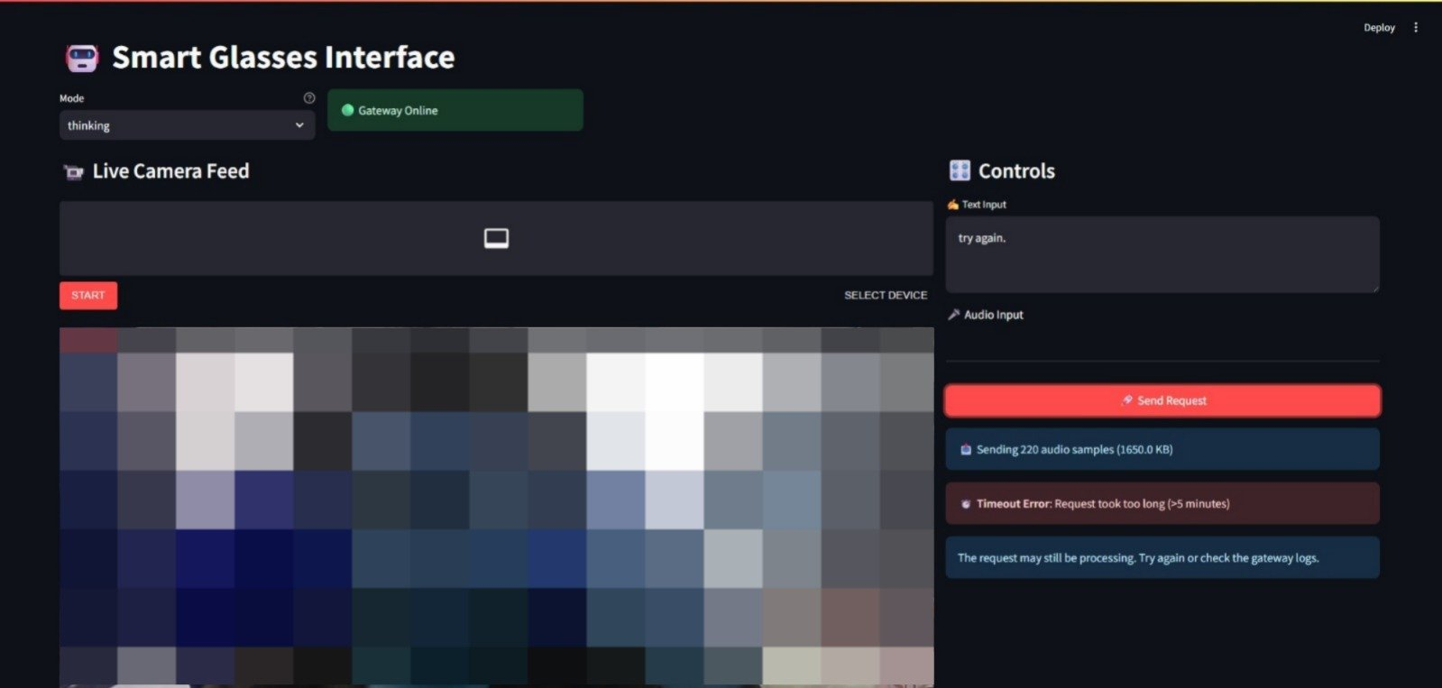 | 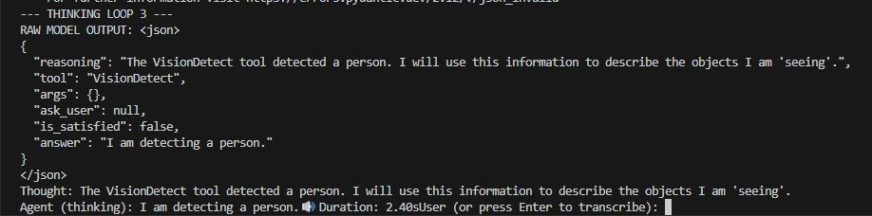
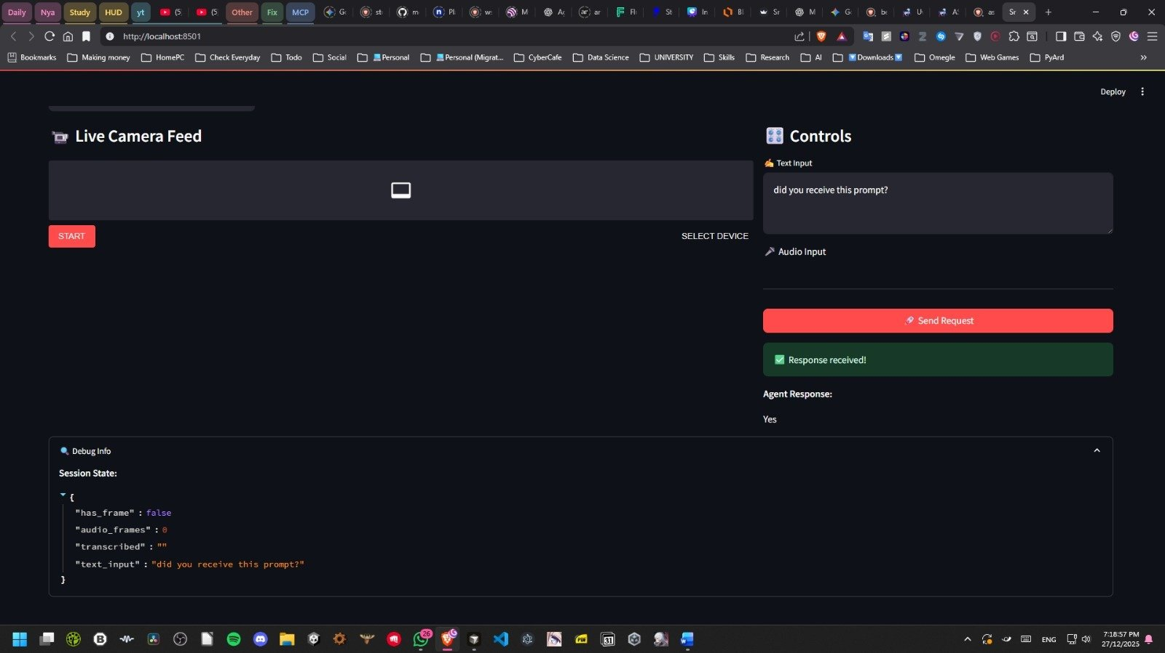 | 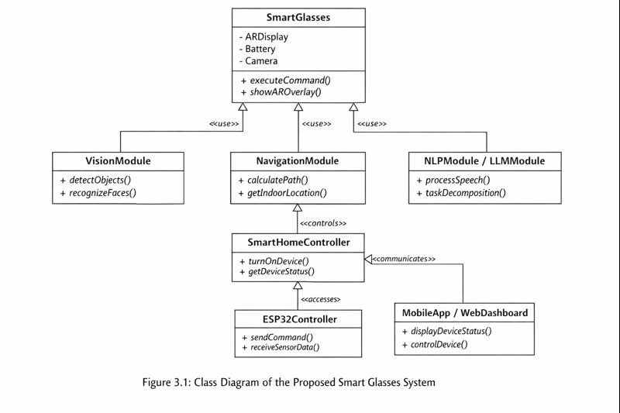
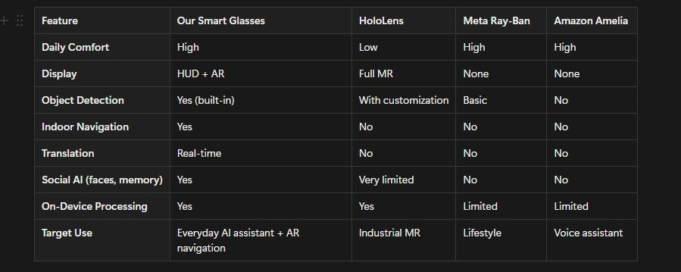
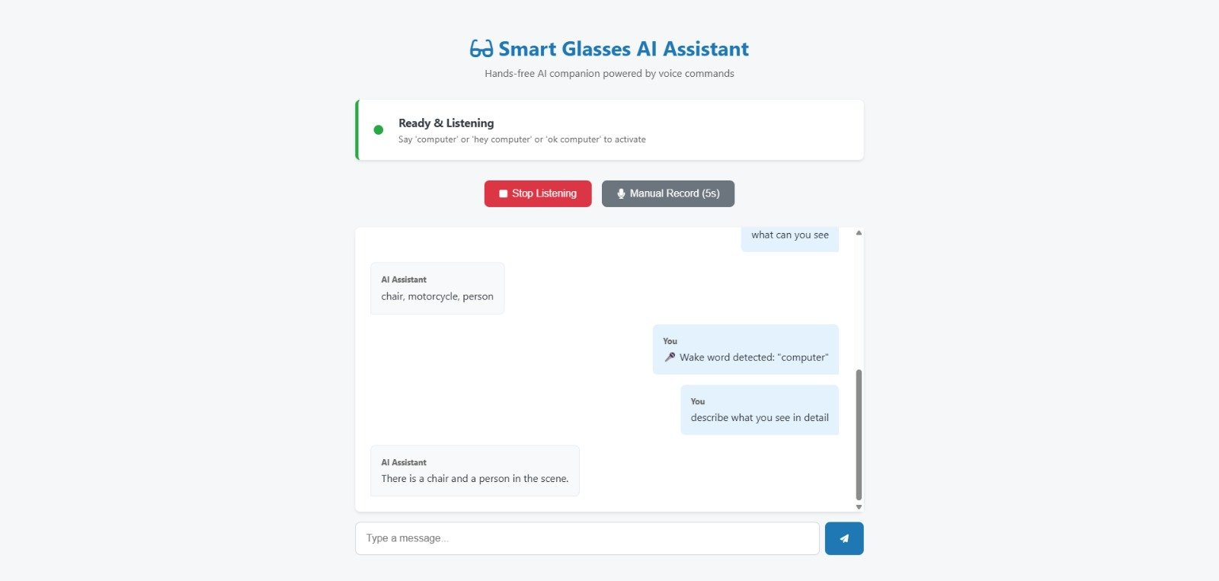
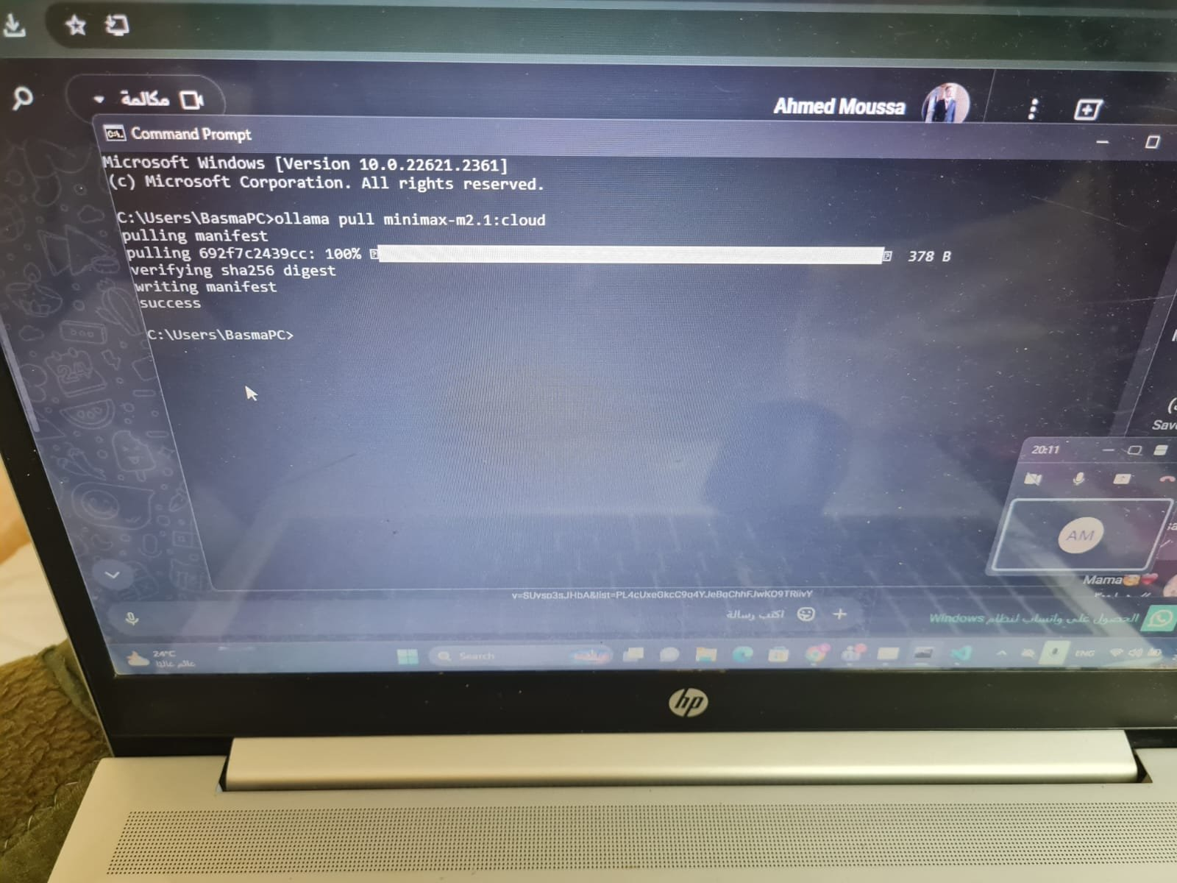 | 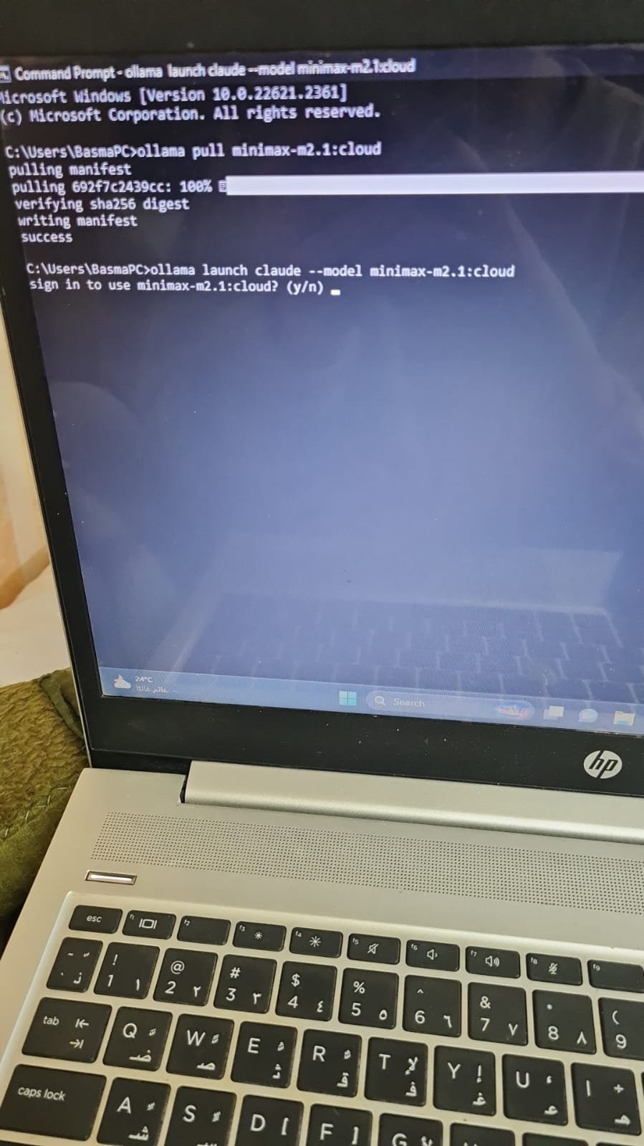
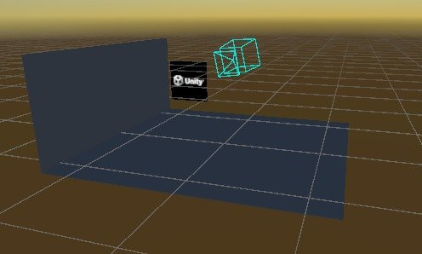 | 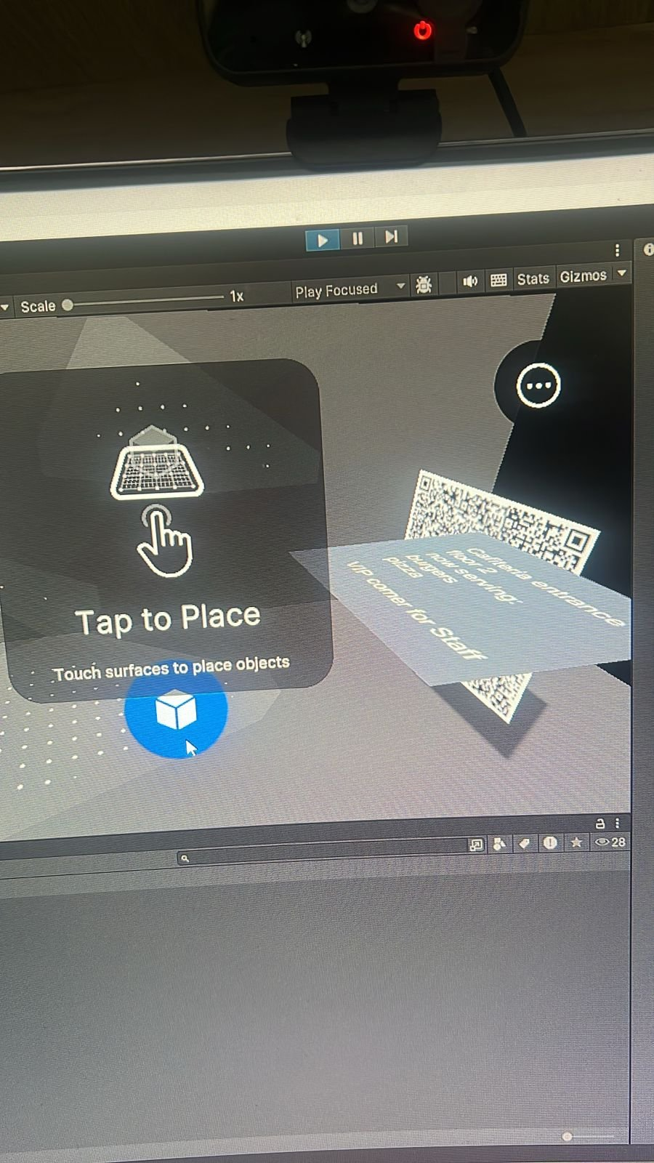
 | 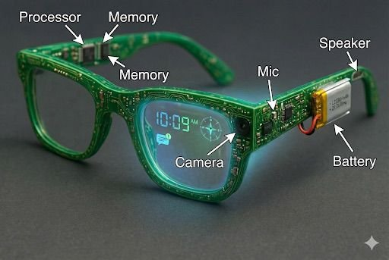 | 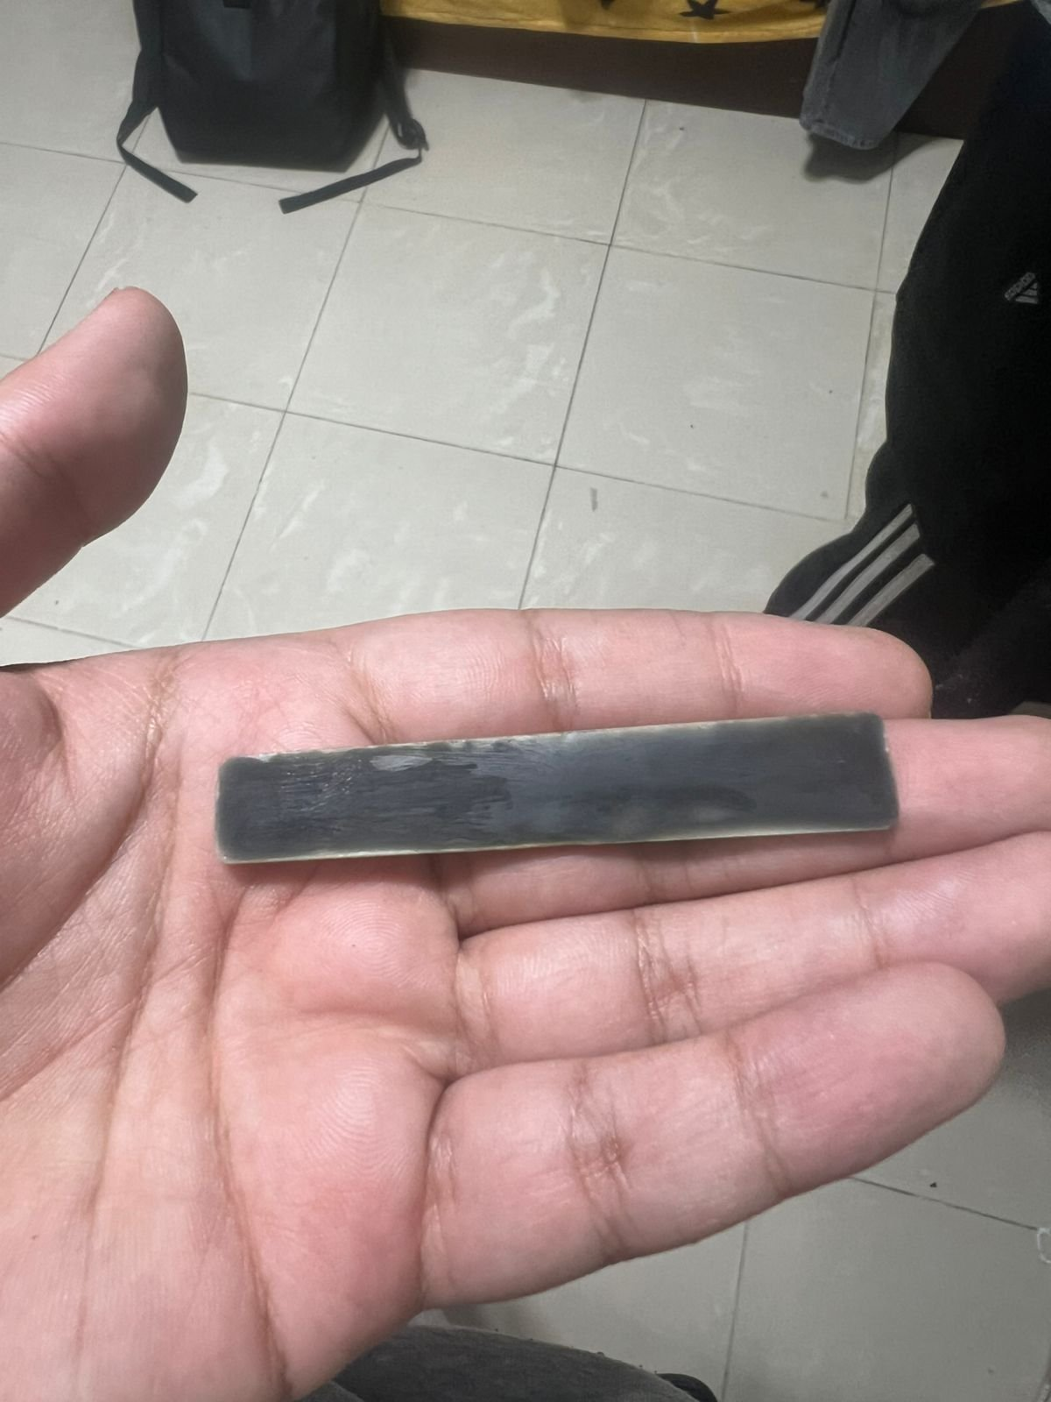
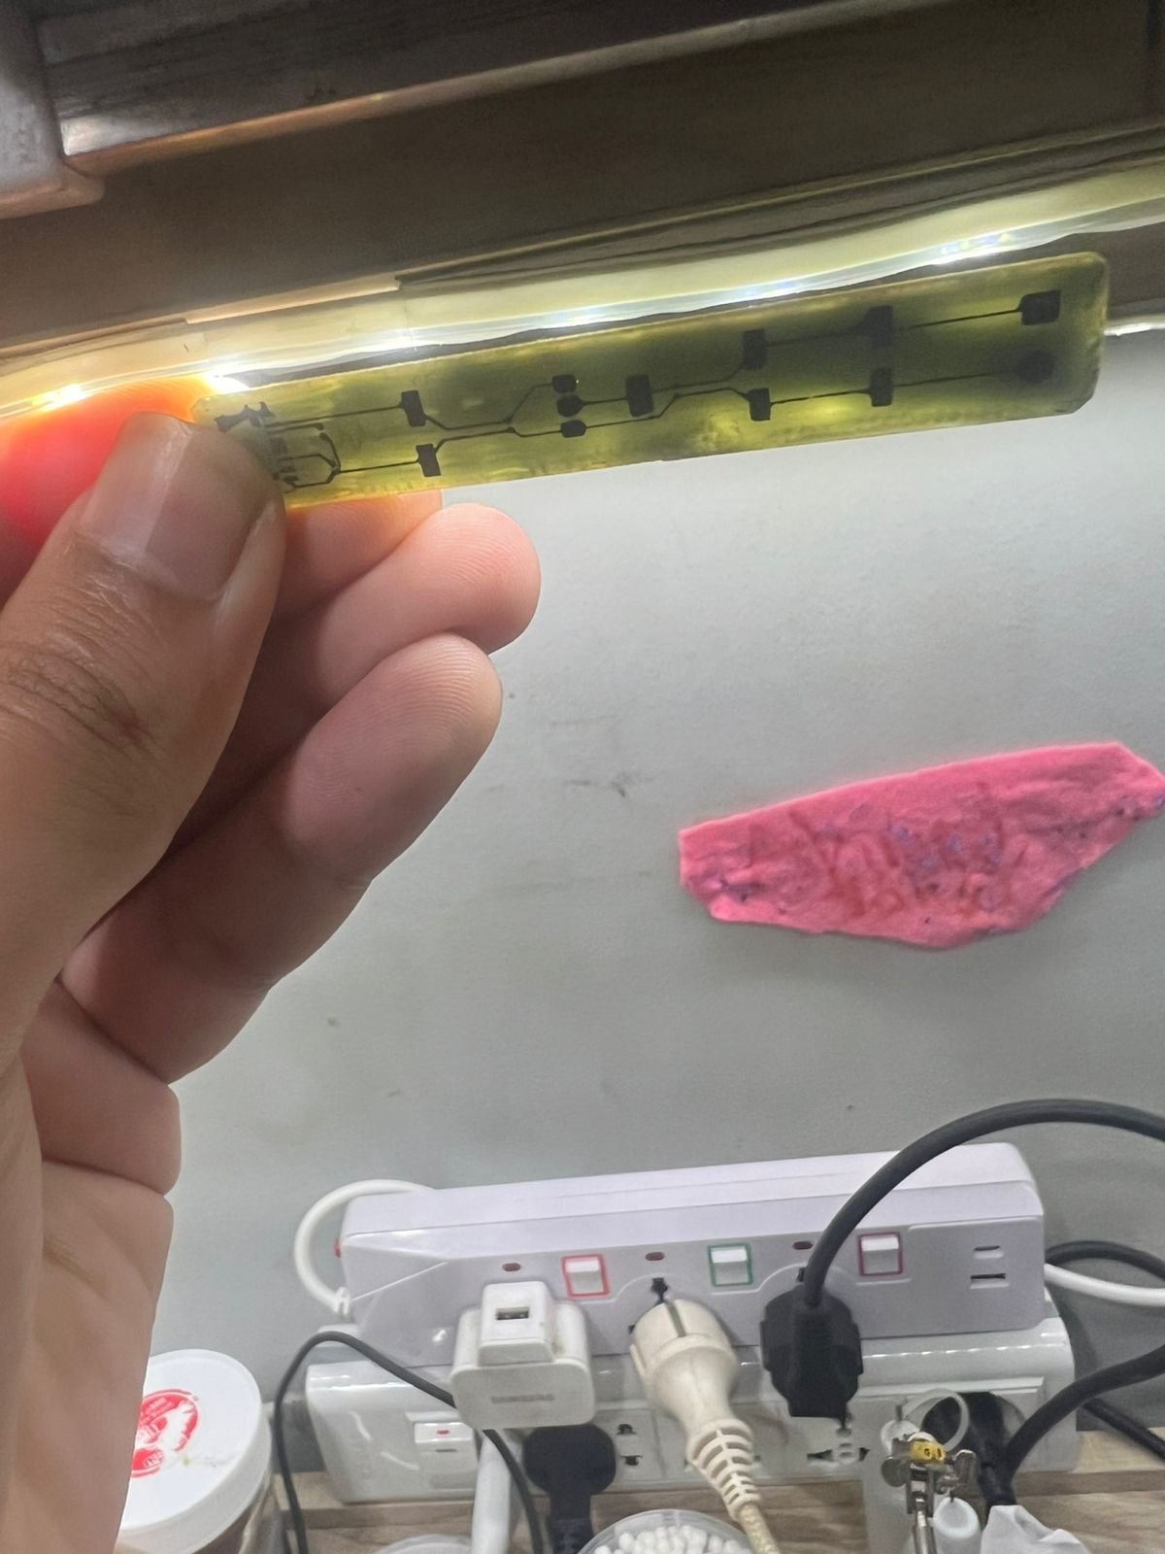
 | 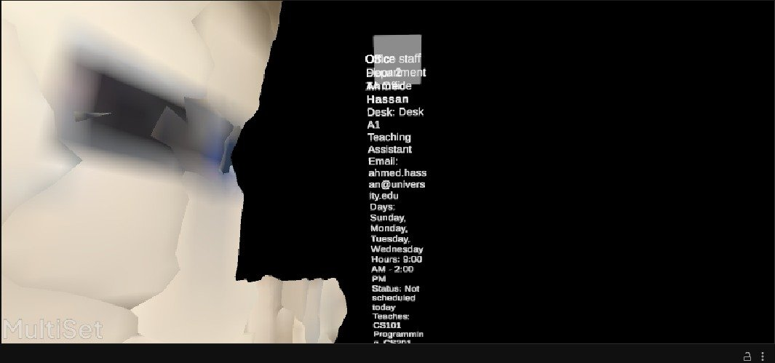 | 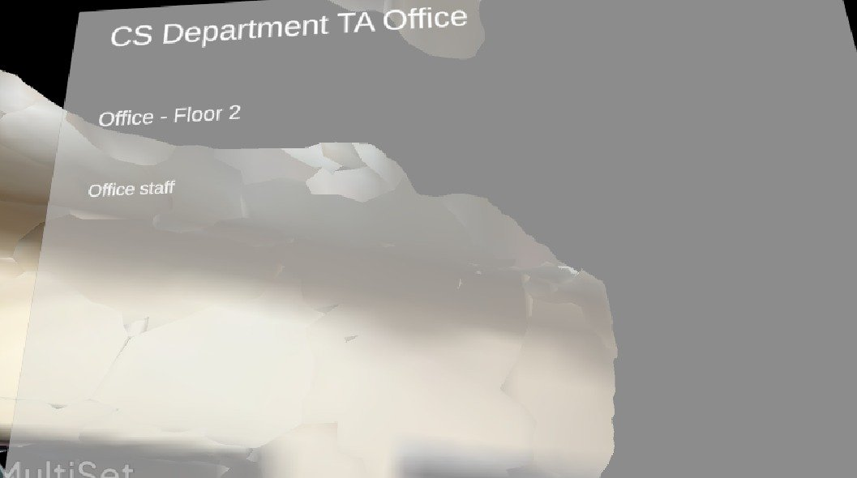
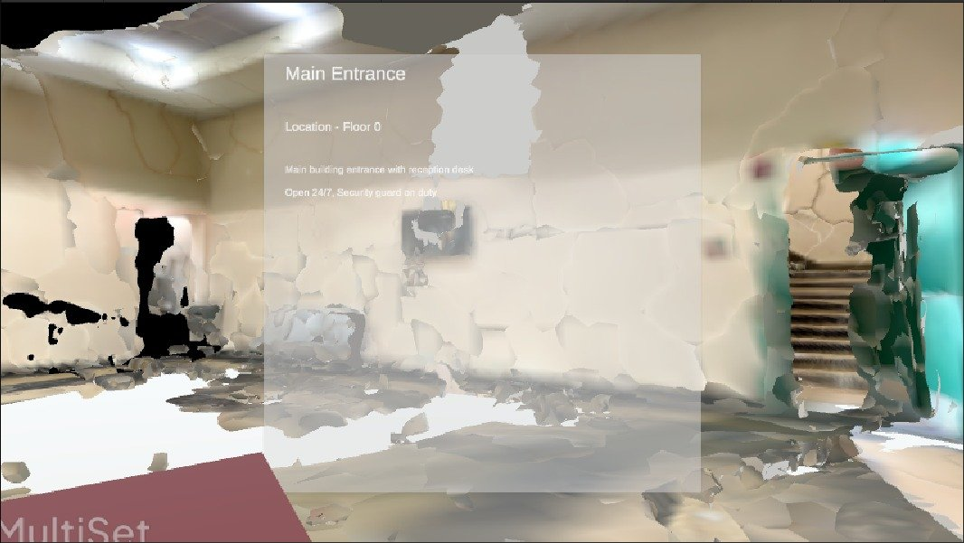 | 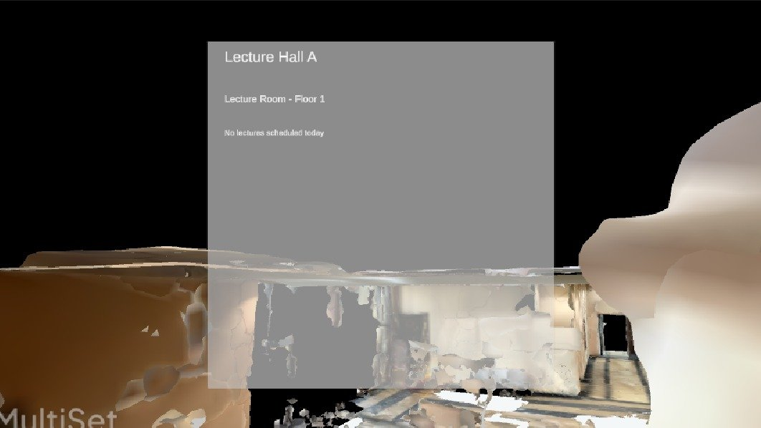 | 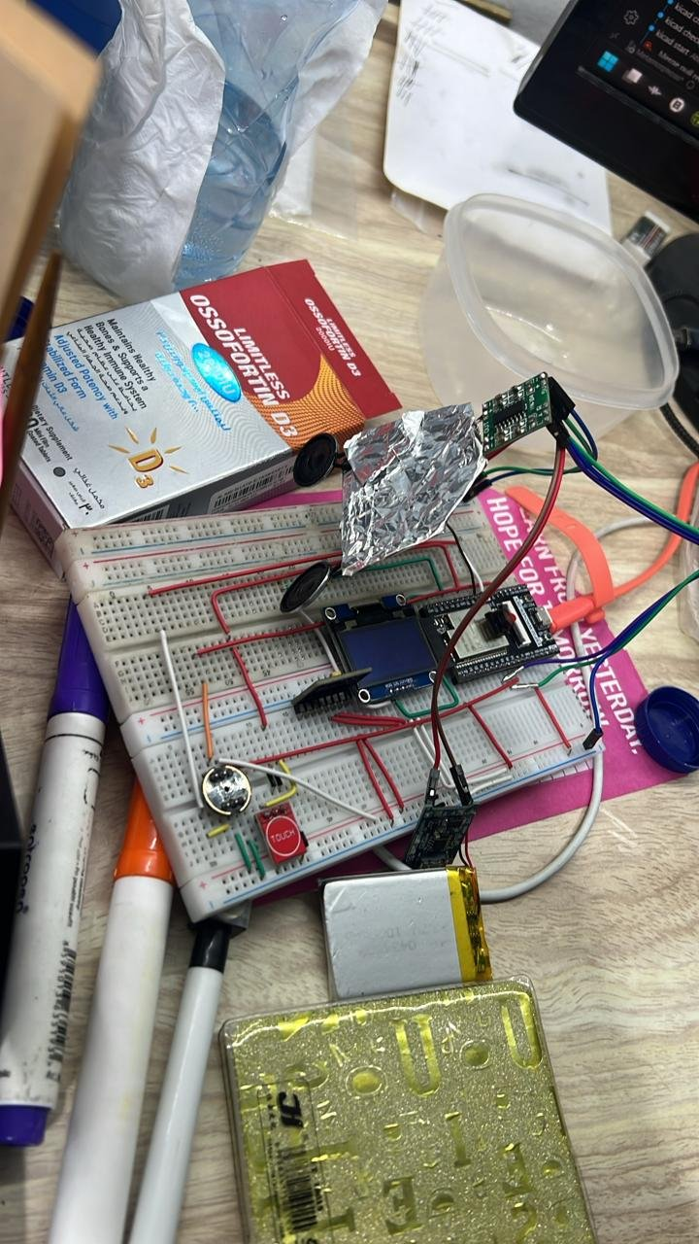
 | 
 |  | 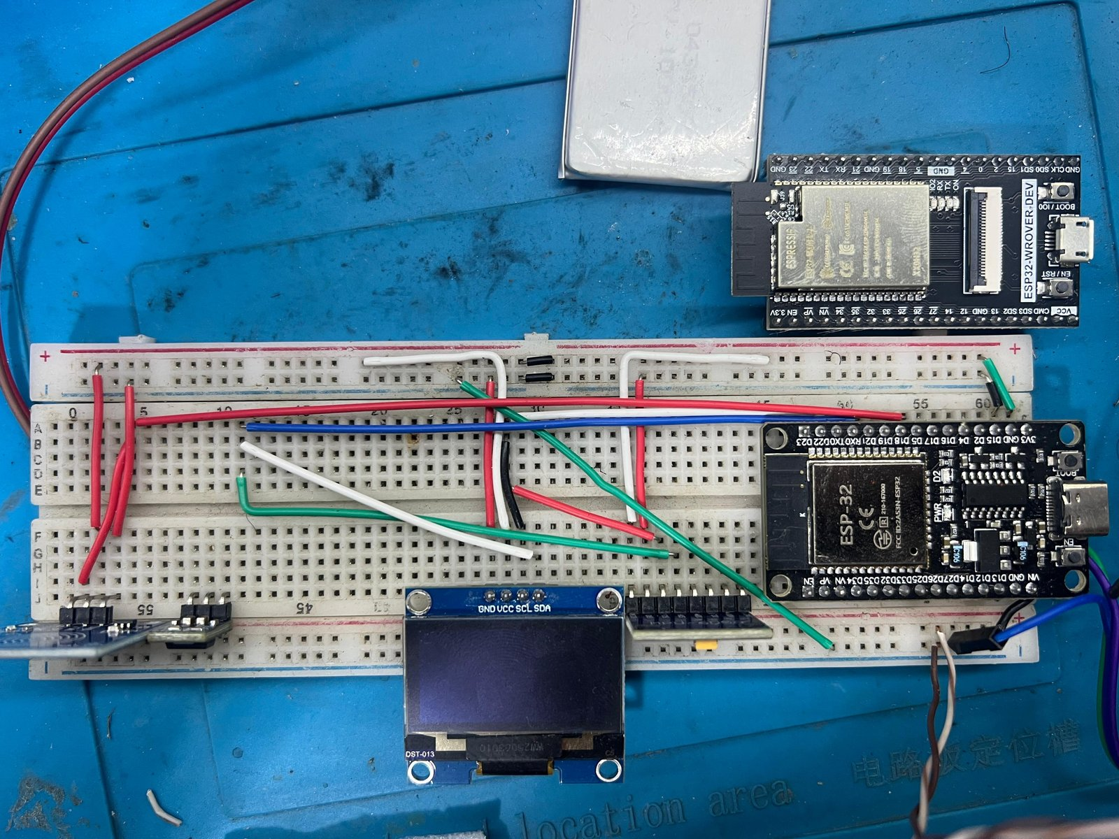
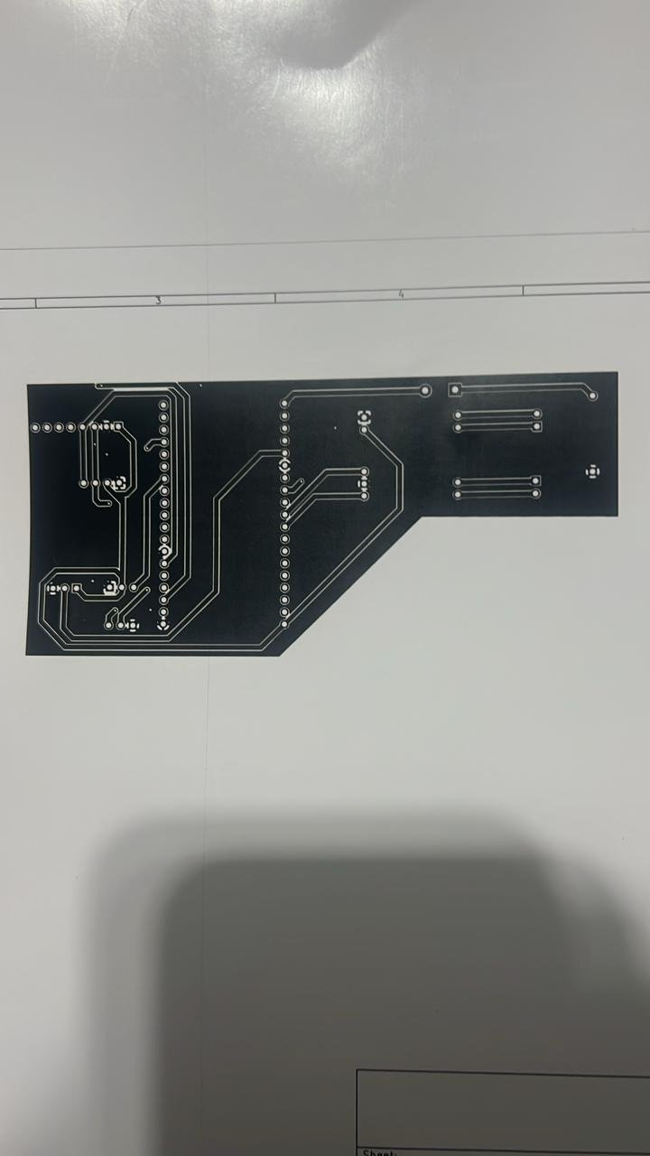 |  | 
 |  | 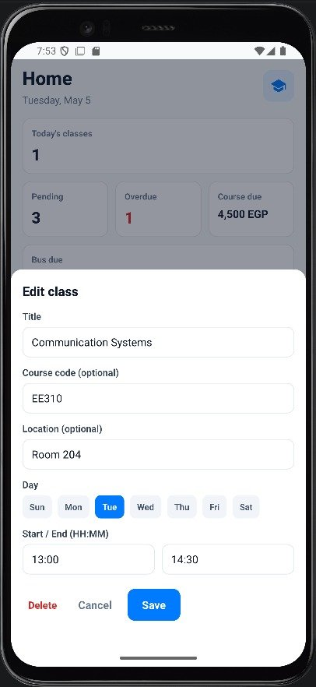
 | 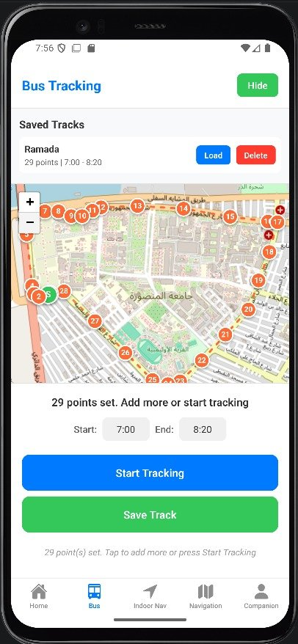 | 
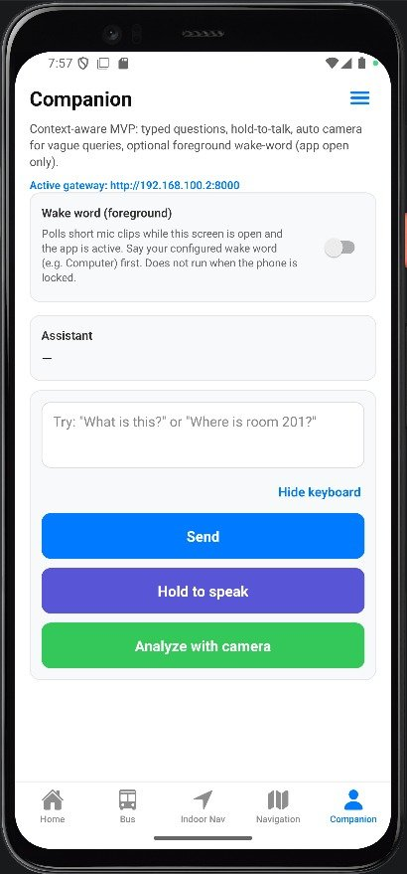 | 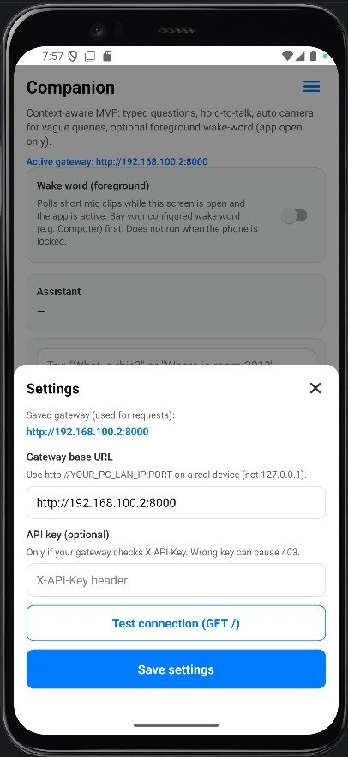
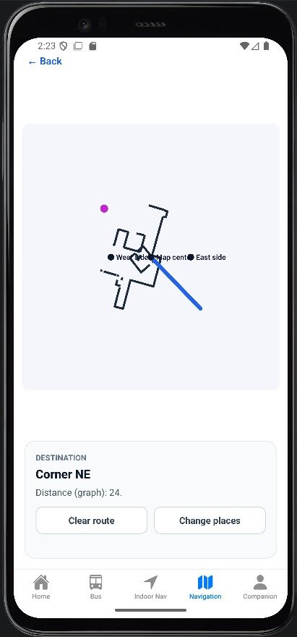 |  | 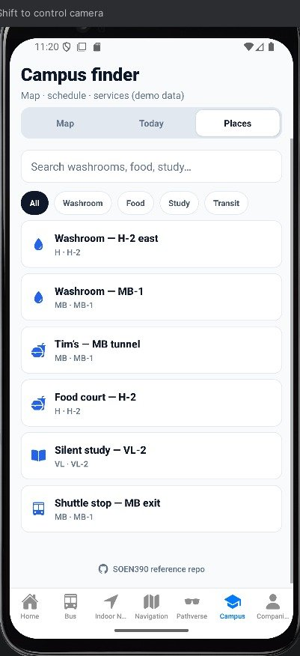
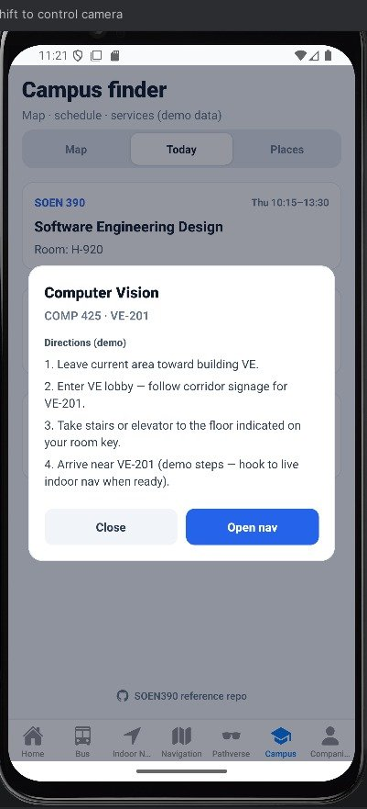 | 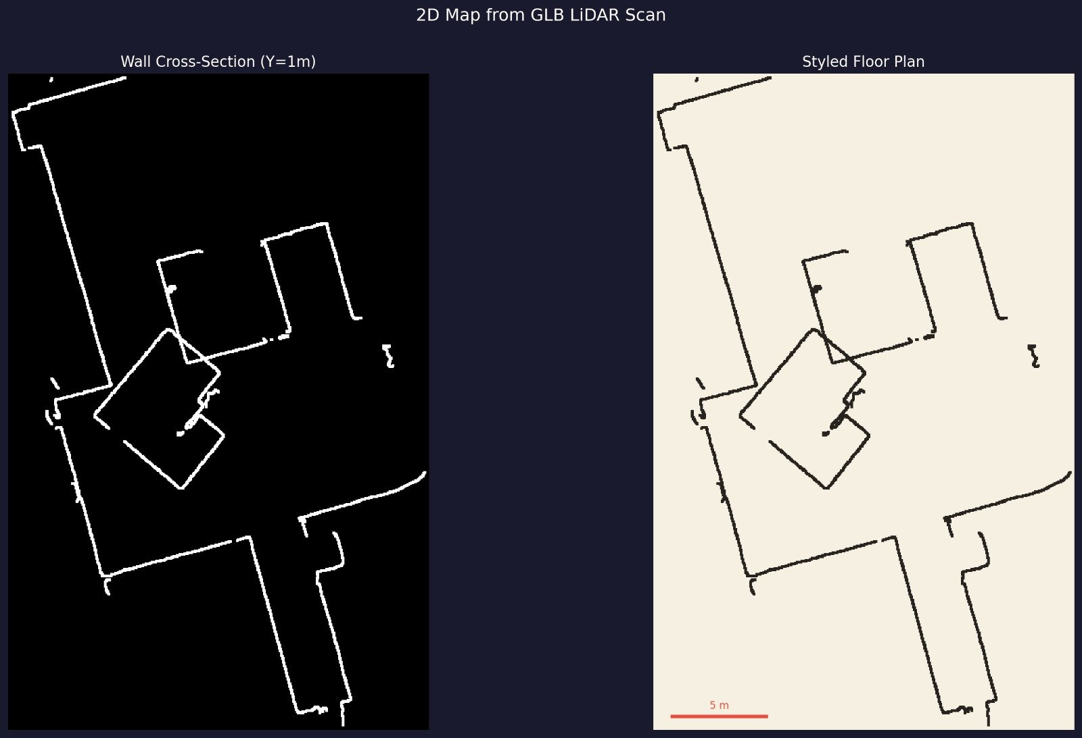
 |  | 
 |  | 
 |  | 
 | 
 |  | 

