
NTRA Graduation Project Competition
Ongoing (Academic year 2025/2026)

Prof: AYA ELZOGHBY
DR. Mohamed handosa
dr. waleed mohamed
Faculty/Institude Dean: KHALD FOAD
Signature:…………………………
[SIGNATURE ORGANIZATION]

Project title | Intelligent Mixed Reality Navigation Assistant for Smart Buildings with Multimodal AI Integration
Project Track | Artificial Intelligence (AI) and Machine Learning (ML)
University | New Mansoura University
Department/Faculty | Computer Science and Engineering (CSE)
Industrial partner  (if any) | None

- Project Information

Project title | Intelligent Mixed Reality Navigation Assistant for Smart Buildings with Multimodal AI Integration
Project Track | Artificial Intelligence (AI) and Machine Learning (ML)
University | New Mansoura University
Department/Faculty | Computer Science and Engineering (CSE)
Industrial partner  (if any) | None

- Supervisor Information

Supervisor Name | Waleed mohamed
Title | Lecturer (Dr.)
Work Address | Mansoura University
Mobile | 01001971714
E-mail | Waleed_m_m@mans.edu.eg
Brief summary of expertise | - working on unity 2d and 3d projects for more than 8 years.  - working on HIBI project: a project for phycology therapy for kids in 2019 using games and interactive stories, using unity 2d and inkscape. This project was by the Accura group in mansoura. it was for android and ios platforms. video previews are available here:  https://www.youtube.com/playlist?list=PLqeOitic86jxpRW706SKJc1vSuHPGpeNW  - working on more than 20 freelancing projects using unity 2d/3d and blender 3D during the last 7 years.  - working on (ARGeo) project: an augmented reality project to teach 3d geometry for kids, the project was for android platform and was made using unity, vuforia and blender. video previews are available here: https://www.youtube.com/playlist?list=PLqeOitic86jxCNuH-R3upGVoEhUOjjhv2  and the project can downloaded for free:  https://play.google.com/store/apps/details?id=com.exploreFuture.ARGeo  - presenting 4 sessions of Game development use cases in TIEC- Mansoura branch in 2020.  - working on 3d game “Galaxy In Peril-1”, a project by Barty Games 2019:  https://store.steampowered.com/app/1061620/Galaxy_in_Peril/  - working on 3d game “Galaxy In Peril-2”, a project by Barty Games 2020:  https://store.steampowered.com/app/1398510/Galaxy_in_Peril_Time_Trouble/  - working on 3d game “Dark Matter” project , a project by Barty Games 2018 (video)  - Educational Augmented reality project for special needs students for studying geography and history (prep-leve) using Augmented reality, 2022 (Videos )

- Project Members Information

# | Name | Department | Mobile number | Email
1 | Ahmed Mohamed Mousaa | AIS | 0 15 01844888 | ahmed222101392@nmu.edu.eg
2 | Sandy Samy Samir | AIS | 0 12 01538851 | sandy222101524@nmu.edu.eg
3 | Aya Wael Elshamy | AIS | 0 11 43650956 | aya22210383@nmu.edu.eg
4 | Mariam Khaled Hassan | CS | 0 15 50335990 | mariam222101358@nmu.edu.eg
5 | Alaa Adel Elsayed | CS | 0 10 33519497 | alaa222101567@nmu.edu.eg
6 | Aya tarek mahmoud | CS | 0 10 06131693 | aya222101469@nmu.edu.eg
7 | Basma Ahmed Mahmoud | AIE | 0 10 17944873 | basma221101164@nmu.edu.eg

* Please note that the first name will be referred to as the main contact person for the whole group in addition to the Project Supervisor.

- PROJECT DESCRIPTION
This project presents an AI-powered Smart Glasses system designed to enhance daily communication, productivity, accessibility, and indoor navigation. The solution integrates computer vision, speech recognition, large language models, augmented reality, and IoT into a single, low-cost wearable device. Using real-time object detection, multilingual voice interaction (Arabic and English), and AR-based indoor navigation, the system provides hands-free, context-aware assistance in complex indoor environments such as universities, hospitals, and enterprise buildings. By leveraging open-source AI models and affordable hardware, the project delivers an intelligent, scalable, and accessible smart companion that improves user independence, safety, and efficiency while supporting smart building and telecommunication infrastructures.
- OVERVIEW
- Problem definition, (ii) approach and tools/techniques, and (iii) overview of system modules.
Use block diagrams and figures to describe your ideas. Be as clear as possible about the ideas in order to show the reviewer the value of your idea.
In today’s fast-paced world, technology has become an integral part of daily life. However, users face several challenges when interacting with various technological devices, particularly in daily communication, productivity, and navigation. Key problems include:

1. Language Barriers: Users often struggle to communicate effectively due to differences in spoken or written language, especially in international environments or while traveling.

2. Task Distraction: Managing multiple tasks at once—such as note-taking, capturing photos, recording audio, or checking messages—can overwhelm users and reduce efficiency.

3. Lack of Intelligent Assistance: Most devices do not provide a personal smart companion capable of understanding user needs and offering real-time guidance.

4. Indoor Navigation Limitations: In large or complex buildings like universities, hospitals, or corporate campuses, finding the desired destination can be difficult without accurate navigation support.

The proposed system, Smart Glasses, addresses these challenges by combining AI-driven smart assistance, speech recognition, real-time translation, augmented reality, indoor navigation, and environmental and health monitoring sensors into a single portable and ergonomic device.
======================================================
1. Hardware Development:

• Wearable device platform with microphone, speakers, camera, display, and sensors.

• GPS module for location-based services and indoor positioning.

• Low-latency wireless connectivity (Wi-Fi, Bluetooth).

2. Software Development:

• Speech recognition and text-to-speech (TTS) systems.

• Natural Language Processing (NLP) for task understanding.

• AI-powered smart companion for scheduling, reminders, and assistance.

• Machine learning models for adaptive and personalized user experience.

• Augmented reality interface for immersive visualization and interaction.

• Web browsing and dashboard interface for remote management.

3. User Interaction Features:

• Hands-free operation with voice commands and gesture recognition.

• Real-time translation for multiple languages.

• Environmental and health monitoring with alerts and recommendations.

• Seamless communication with loved ones

===================================================
Computer vision has been used in mobile and robotics systems, but rarely in smart glasses. Using YOLO11, the proposed solution provides:
• Feature extraction
• Object detection
• Identifying obstacles
• Enhancing indoor navigation
This improves:
• Safety
• Context awareness
• Accessibility for people of determination

2.5 Indoor Navigation Using Graph-Based Mapping
Traditional GPS fails indoors due to:
• No satellite visibility
• Weak signal penetration
• Multipath interference
Existing research shows that indoor navigation requires:
• Graph-based modeling
• Manual map digitization
• JSON-based routing
• Customized building layouts
Our system maps Building 2 (Computer Science Building) manually, converts rooms, stairs, and elevators into nodes and edges, and uses it for indoor navigation.

2.6 Hardware in Smart Glasses
Existing systems use expensive hardware.
By contrast, ESP32 offers:
• Low cost
• WiFi/Bluetooth
• Compact size
• Easy integration with glasses
• Real-time communication
Microphone + speakers allow:
• Real-time speech capture
• Playback of TTS responses
• Audio feedback for navigation

2.7 Speech Recognition (Whisper) in Wearables
Whisper is used because:
• It supports Arabic and English
• High accuracy
• Can transcribe audio/video
• Converts speech to .txt file
• Works offline or online
This enables:
• Hands-free interaction
• Fast processing
• Reliable commands for LLM

2.8 Text-to-Speech Systems
TTS research shows bilingual support improves accessibility.
Our system uses two voices:
• Arabic TTS
• English TTS
Smart Glasses decide the output voice depending on LLM language.

2.9 Large Language Models
LLMs like GPT and LLaMA transform commands into structured actions.
They provide:
• Context-aware reasoning
• Intelligent decision making
• Multi-step interpretation
This is enhanced by the MCP NLP pipeline, which performs:
• Intent classification
• Task decomposition
• Action-to-JSON transformation
• Model execution routing

2.10 Smart Home Integration
Existing smart homes lack wearable integration.
Our system introduces:
• Mobile app dashboard
• Web dashboard
• Device management
• Controllers
• Logs
• Statistics
• AR/VR interaction
This unifies all control methods.

2.11 User Flow and Multimodal Interaction
Compared to existing products, our system includes:
• Natural speech → text → commands
• Vision-based alerts
• AR navigation
• App dashboards
• Web dashboards
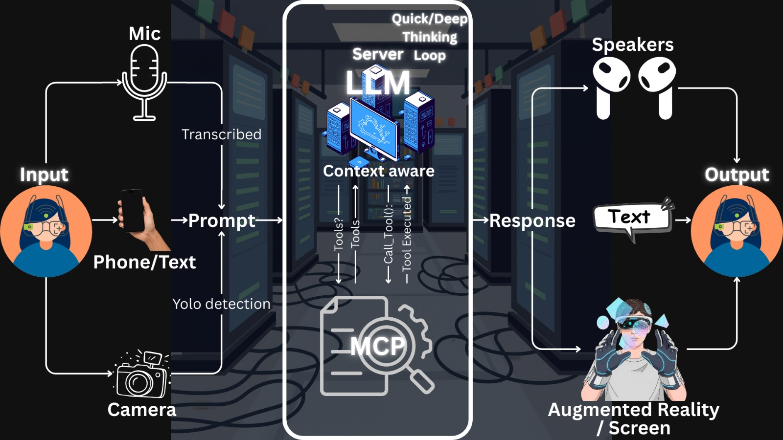
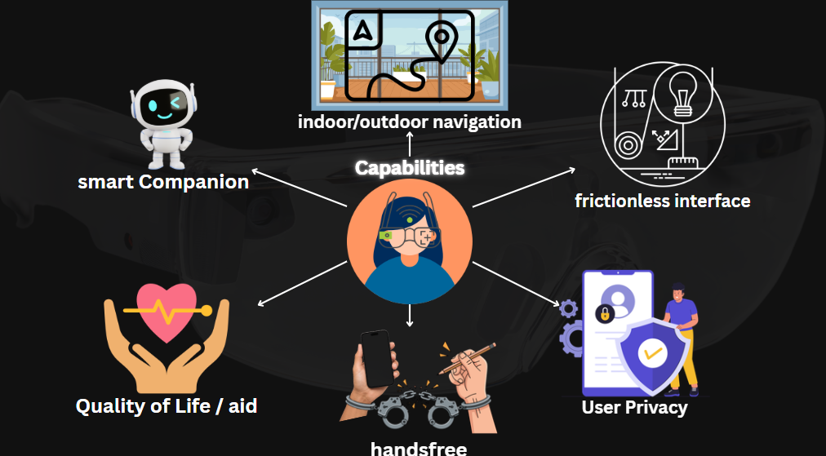
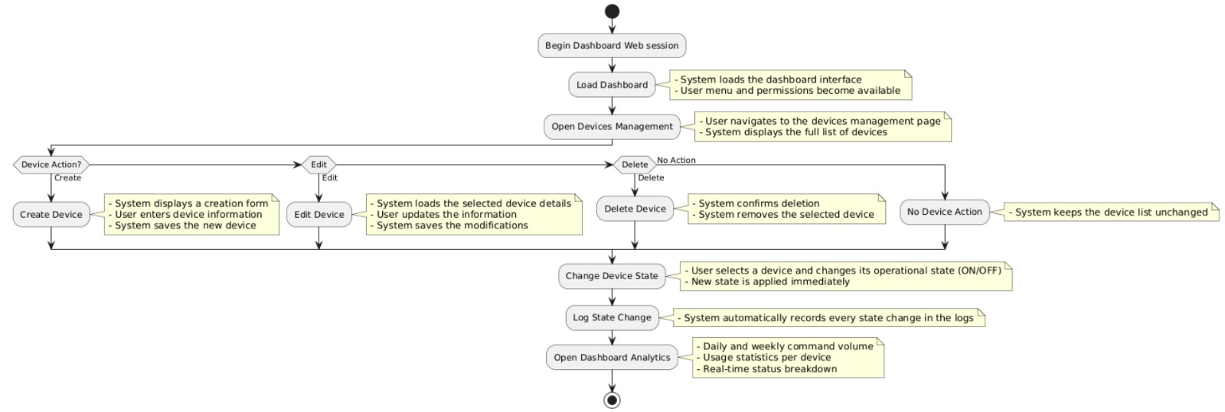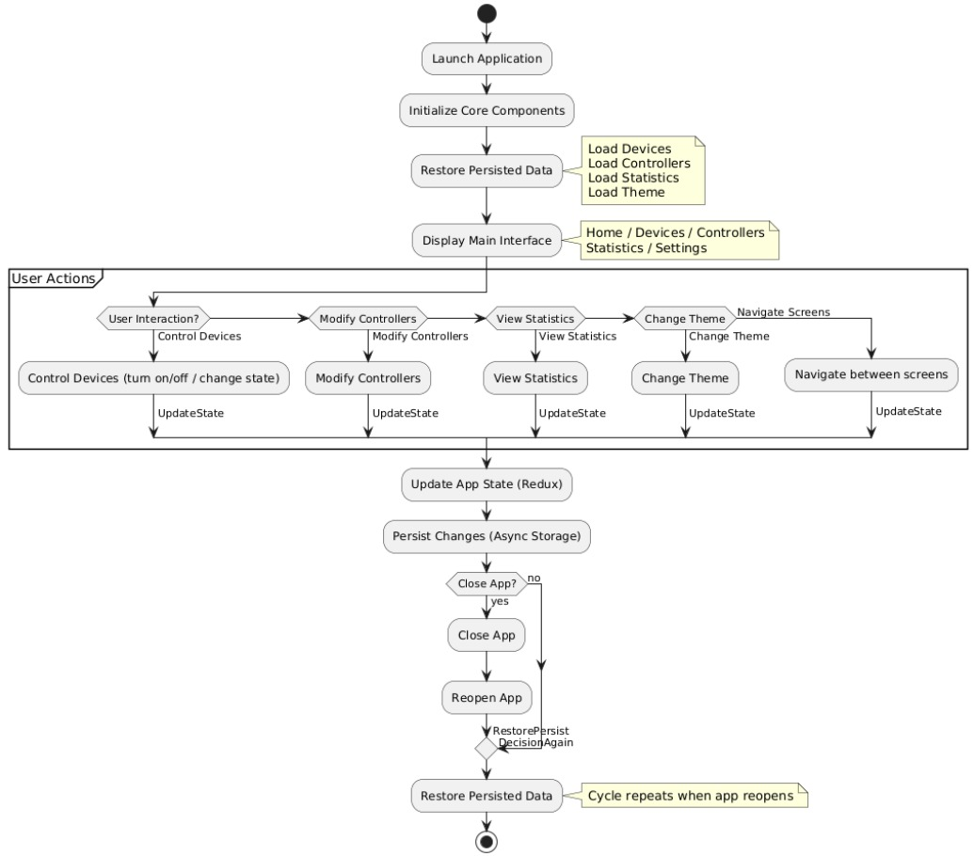
- IMPACT
Why do you consider this project? What is its impact on community/market/end user/… specially telecommunication sector?
solve real-world problems using advanced Artificial Intelligence and telecommunication technologies. The integration of computer vision, speech processing, mixed reality, and IoT makes the system highly innovative and socially impactful.

The project addresses critical challenges in indoor navigation, accessibility, smart environments, and human–machine interaction, especially in complex indoor spaces such as universities, hospitals, telecom buildings, and enterprise facilities.

Impact on End Users

The system significantly enhances the user experience by enabling:
Hands-free interaction using voice commands, which is essential for visually impaired and mobility-restricted users.
Accurate indoor navigation in large buildings where GPS is unavailable.
Real-time guidance and object recognition, reducing confusion and dependency on human assistance.
Multilingual communication, supporting both Arabic and English users.
This leads to improved independence, safety, and productivity for end users.

Impact on Community

From a societal perspective, the project contributes to:
Digital inclusion, by providing assistive technology for people with disabilities.
Smarter public buildings, such as universities, hospitals, and government facilities.
Reduced cognitive load and stress in crowded or unfamiliar environments.
Promotion of smart cities concepts, aligning with modern digital transformation initiatives.
Impact on Market

The project has strong commercial potential and market relevance:
It can be deployed as a commercial AR navigation solution for malls, airports, telecom headquarters, and smart campuses.
It supports IoT-based automation, which is a rapidly growing market.
The system is scalable and customizable, allowing companies to adapt it to different environments.
This makes the project attractive for startups, enterprises, and technology providers.

Impact on the Telecommunication Sector

The project has a direct and strategic impact on the telecommunication sector, including:
Increased demand for high-speed, low-latency networks (5G / Wi-Fi 6) to support real-time AR, AI inference, and voice processing.
Integration with IoT ecosystems, where telecom operators act as connectivity and platform providers.
Edge computing utilization, allowing AI models (YOLO, Whisper) to run closer to users, reducing latency.
Smart building solutions for telecom operators, enabling automated control, monitoring, and navigation inside large telecom facilities.
New service models, such as AR-assisted customer support, smart maintenance, and immersive enterprise solutions.
Telecom companies can leverage this system to deliver value-added services beyond connectivity, positioning themselves as digital solution providers.

- NOVELTY AND FEATURES
Explain (i) novelty (ii) features, and (iii) related products, if any.
Originality doesn’t always mean coming up with completely new ideas. Building on previously developed project and adding new modules that increase their value is considered novelty. Doing a previous idea with lower cost or a better performance is considered novelty.
The novelty of this project lies in the integration and enhancement of existing technologies into a unified, intelligent, and cost-effective system rather than inventing a completely new concept.
While object detection, speech recognition, and indoor navigation have been explored separately in previous works, this project builds upon these ideas and significantly increases their value by:
Combining computer vision (YOLO), speech recognition (Whisper), large language models (LLMs), mixed reality (AR), and IoT control into a single wearable system.
Providing real-time indoor navigation and object detection through AR glasses, which is still limited in existing solutions.
Supporting multilingual interaction (Arabic and English), which is rarely addressed in similar projects.
Offering a low-cost and scalable alternative to expensive proprietary smart glasses solutions by using open-source models and commodity hardware.
Therefore, the novelty of the project is achieved through system-level innovation, enhanced functionality, improved performance, and reduced cost, which fully aligns with the provided definition of originality.
(ii) Features

The proposed system offers a rich set of advanced features, including:
Real-Time Object Detection
Accurate detection of indoor landmarks using a custom-trained YOLO model.
Visual labeling and highlighting through AR overlays.
Indoor Navigation Without GPS
Intelligent path planning using a custom indoor map.
Turn-by-turn guidance rendered in augmented reality.
Multimodal Interaction
Voice-based interaction using Whisper for speech-to-text.
Context-aware responses generated by an LLM.
Visual and audio feedback to the user.
Smart Home and IoT Control
Voice-controlled operation of smart devices using ESP32.
Secure and real-time communication with IoT devices.
Multilingual Support
Real-time speech transcription, translation, and synthesis in Arabic and English.
Mixed Reality Experience
Dynamic AR elements such as arrows, icons, and labels anchored to real-world objects.
Accessibility-Oriented Design
Hands-free usage suitable for visually impaired and mobility-restricted users.
(iii) Related Products

Several existing products and systems are related to this project; however, they lack full integration or have notable limitations:
Google Indoor Maps
Provides indoor navigation but lacks real-time AR guidance and object detection.
Does not support smart device control or conversational interaction.
Microsoft HoloLens
Offers advanced AR capabilities but is expensive and not targeted at navigation or accessibility use cases.
Limited integration with IoT and speech-based AI assistants.
Apple Vision Pro
Delivers high-quality mixed reality experiences but at a very high cost.
Focuses on media and productivity rather than indoor navigation and assistive applications.
Amazon Echo / Google Assistant
Strong in voice interaction and smart home control.
Do not provide visual AR navigation or real-time object detection.
Be My Eyes
Assists visually impaired users through human support or AI.
Does not offer autonomous indoor navigation or AR-based guidance.

- DELIVERABLES
What is the project final outcome (HW device, SW package, simulation ...)?
It is important to clearly identify the final outcomes supported by evidence and results.
Project Final Outcome

The final outcome of this project is a fully functional integrated system that combines hardware and software components, supported by experimental results and performance evaluation.

1. Hardware Outcome

A wearable smart glasses prototype or mobile-based AR device equipped with:

Camera for real-time video streaming.

Microphone for voice interaction.

An ESP32-based IoT control unit connected to smart home devices (lights, switches, sensors).

Wireless communication using Wi-Fi and Bluetooth.

2. Software Outcome

A complete software package including:

A custom-trained YOLO-based object detection model for indoor environments.

A speech-to-text module using Whisper.

An LLM-based intelligent assistant for command understanding and decision making.

An indoor navigation module using a custom indoor map and shortest-path algorithms illustrating the navigation process.

An augmented reality application that renders navigation arrows, labels, and detected objects in real time.

A backend system for handling communication between AI modules and IoT devices.

3. Experimental and Evaluation Results

Quantitative results demonstrating:

Object detection accuracy (mAP).

Speech recognition accuracy and latency.

System response time and frame rate (FPS).

Qualitative results including:

Real-world testing inside Building 2.

User feedback and usability observations.

Visual evidence such as screenshots, AR views, and system logs.

- BUSINESS PLAN AND MARKET ANALYSIS
Market research is essential to be included, whether national or multinational, showing the level of competition, business opportunities, and the niche added value. Do you foresee any potential market for your project? Do you expect any demand on the final product?
Market Research and Potential Demand

Market research indicates a strong and growing demand for intelligent indoor navigation, assistive technologies, and smart environment solutions at both national and international levels. The proposed project targets multiple overlapping markets, creating a unique competitive position.

Level of Competition
Currently, the market includes several partial solutions:
Indoor navigation systems (e.g., mall or airport navigation apps) that rely on static maps without real-time object detection or AR guidance.
Smart assistants and IoT platforms (e.g., Google Assistant, Amazon Alexa) that focus on voice interaction and device control but lack visual navigation and contextual awareness.
High-end mixed reality devices (e.g., Microsoft HoloLens, Apple Vision Pro) that provide advanced AR experiences but are expensive and not optimized for indoor navigation or accessibility use cases.
These solutions address individual aspects of the problem, but no single product offers a fully integrated, low-cost, AI-powered AR navigation and assistive system like the proposed project.

Business Opportunities

The project opens several business opportunities, including:
Smart campuses and universities, where indoor navigation and accessibility services are essential.
Hospitals and healthcare facilities, which require accurate indoor guidance for patients and visitors.
Telecommunication companies, for smart building management, maintenance guidance, and customer support.
Shopping malls, airports, and large enterprises, where user navigation and smart services enhance customer experience.
Assistive technology markets, targeting visually impaired and elderly users.
These sectors represent scalable and recurring business models through system deployment, customization, and maintenance services.

Niche Added Value

The niche value of the proposed system lies in:
Full integration of AI vision, speech, AR, and IoT in a single platform.
Affordable implementation, relying on open-source models and low-cost hardware.
Arabic language support, addressing a largely underserved regional market.
Wearable and hands-free design, suitable for accessibility-focused applications.
Telecom-ready architecture, enabling deployment over 5G, Wi-Fi 6, and edge computing infrastructures.
This combination creates a clear differentiation from existing market offerings.

Potential Market and Expected Demand

Yes, a potential market is clearly foreseen for this project. The increasing adoption of smart buildings, digital transformation initiatives, and assistive technologies indicates a growing demand for such systems.

Demand is expected from:
Educational institutions and public facilities.
Telecom operators and enterprise service providers.
Smart city initiatives.
Organizations focusing on accessibility and inclusion.
With further development and commercialization, the final product can evolve into a market-ready solution addressing real customer needs at both local and global levels.

- ROLE OF THE INDUSTRIAL PARTNER (IF ANY)
What is the type of support to be provided by the industrial partner (technical, financial, access…)?
Type of Support Provided by the University (Industrial Partner)

The university, as the project’s industrial partner, will provide technical and logistical support to ensure the successful development and testing of the smart glasses system.

1. Technical Support

Providing technical guidance on hardware integration and software deployment.

Advising on AR system setup, networking, and IoT integration.

Reviewing the system design, performance, and usability to align with university standards.

2. Access to Infrastructure

Granting access to Building 2 and other campus areas for indoor navigation testing.

Allowing the use of classrooms, labs, and Wi-Fi network for system experiments.

Providing university smart devices or sensors if available for IoT testing.

3. Data and Use-Case Support

Offering realistic scenarios such as navigating to rooms, labs, and offices.

Supplying floor plans and building maps to improve navigation accuracy.

4. Evaluation and Feedback

Participating in testing and evaluation sessions with students and staff.

Providing feedback on usability, accessibility, and practical performance.

5. Logistical Support

Assistance in scheduling testing sessions with students and staff.

Access to labs and equipment needed for assembling the prototype.

- Project EXPENSES
List the main equipment, tools, modules, components, software, … that were used to implement the project.

Item | Type (Hardware/ Software/ Other) | Specifications (brief description) | Cost (LE.)
1 | Software | YOLOv11 for object detection; trained on custom dataset | open source
2 | Software | Whisper for speech-to-text transcription | open source
3 | Software | Large Language Model (LLM) for natural language understanding | open source
4 | Software | AR/VR rendering (Unity / Unreal Engine for AR overlays) | open source
5 | Software | React framework for Smart Home Dashboard (Web & Mobile) | open source
6 | Software | Node.js backend for API handling and device communication | open source
7 | Software | JSON format for storing maps and navigation data | open source
8 | Software | Git + GitHub for version control and collaboration | open source
9 | Software | Python for backend logic and module integration | open source
10 | Software | Expo / React Native for mobile Smart Glasses app | open source
Total Project Cost |  | 0

REFERENCES
Cite to the references those related to your idea
[1] Luo, Z., Shi, X., Lin, X., & Gao, J. (2025, April 15). Evaluation Report on MCP Servers. arXiv.
[2] Huang, B.-C., Hsu, J., Chu, E. T.-H., & Wu, H.-M. (2020). ARBIN: Augmented reality based indoor navigation system. Sensors, 20(20), 5890
[3] Alkady, Y., Rizk, R., Alsekait, D. M., Alluhaidan, A. S., & Abdelminaam, D. S. (2024). SINS_AR: An efficient smart indoor navigation system based on augmented reality. IEEE Access, 12, 109171–109183.
[4] Tepper, O. M., Rudy, H. L., Lefkowitz, A. B., Weimer, K. A., Marks, S. M., Stern, C. S., & Garfein, E. S. (2017). Mixed reality with HoloLens: Where virtual reality meets augmented reality in the operating room. Plastic and Reconstructive Surgery, 140(5), 1066–1070.
[5] Alla, M. (2025). Scalable MCP server-client architecture with FastMCP in microservices. Sarcouncil Journal of Multidisciplinary
[6] Singh, A., Ehtesham, A., Kumar, S., & Talaei Khoei, T. (2025). A survey of the Model Context Protocol (MCP): Standardizing context to enhance large language models (LLMs). arXiv.
[7] He, L.-H., Zhou, Y.-Z., Liu, L., Zhang, Y.-Q., & Ma, J.-H. (2025). Research on the directional bounding box algorithm of YOLO11 in tailings pond identification. Measurement, 253(Part C), 117674.
[8] Mastouri, M., Ksontini, E., & Kessentini, W. (2025). Making REST APIs agent-ready: From OpenAPI to MCP servers for tool-augmented LLMs. arXiv.
[9] Kelly, C., Hu, L., Yang, B., Tian, Y., Yang, D., Yang, C., Huang, Z., Li, Z., Hu, J., & Zou, Y. (2024). VisionGPT: Vision-language understanding agent using generalized multimodal framework. arXiv.
[10] C. Wang, W. Luo, S. Dong, X. Xuan, Z. Li, and L. Ma, “MLLM-Tool: A Multimodal Large Language Model for Tool Agent Learning,” in Proceedings of the 2025 IEEE/CVF Winter Conference on Applications of Computer Vision (WACV), Tucson, AZ, USA, Feb. 26–Mar. 6, 2025
[11] W. Berrios, G. Mittal, T. Thrush, D. Kiela, and A. Singh, “Towards Language Models That Can See: Computer Vision Through the LENS of Natural Language,” arXiv preprint arXiv:2306.16410, 2023.
[12] S. P. Samarth and S. B. Mahalingam, “The Gemma Sutras: Fine-Tuning Gemma 3 for Sanskrit Sandhi Splitting,” in Proceedings of the 9th Widening NLP Workshop (WiNLP), Association for Computational Linguistics, Suzhou, China, Nov. 2025, pp. 235–241
[13] Kopanov, K., & Atanasova, T. (2025). A comparative pattern analysis of Qwen 2.5 and Gemma 3 text generation. Institute of Information and Communication Technologies, Bulgarian Academy of Sciences.
[14] Wang, S., Yang, C.-H., Wu, J., & Zhang, C. (2024). Can Whisper perform speech-based in-context learning? In Proceedings of the 2024 IEEE International Conference on Acoustics, Speech and Signal Processing
[15] Yuan, J. (2024). Performance analysis of deep learning algorithms implemented using PyTorch in image recognition. Procedia Computer Science.
[16] Lei, X., Jiang, X., & Wang, C. (2013). Design and implementation of a real-time video stream analysis system based on FFMPEG. In 2013 Fourth World Congress on Software Engineering. IEEE.
[17] Hassler, D. M., Norbury, J. W., & Reitz, G. (2017). Mars science laboratory radiation assessment detector (MSL/RAD) modeling workshop proceedings. Life Sciences in Space Research, 14, 1–2.

