


Faculty of Computer Science and Engineering
New Mansoura University
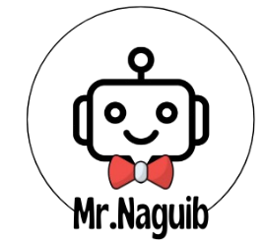

An Adaptive Robotic Learning System for Interactive Education
(MR. Naguib)

Submitted By:
Code Breakers Team

- Manar Eldesouky - 221101099
- Haya Elsonbaty - 221101067

Supervised by:
Associate Professor. Aya Zoghby

New Mansoura, 2025
Graduation Project

An Adaptive Robotic Learning System for Interactive Education
(MR. Naguib)

Submitted By
Code Breakers Team
Student Name | Student Academic ID | Program
Manar Eldesouky | 221101099 | AIS
Haya Elsonbaty | 221101067 | AIS

ABSTRACT
Education in Egypt faces numerous challenges, including overcrowded classrooms, limited focus on providing students with a holistic learning experience, high teacher workloads, and a lack of personalized learning. To address these challenges, we present "Mr. Naguib", an AI-powered adaptive learning system designed to boost student engagement, enhance learning outcomes, and streamline administrative tasks for teachers.

Our solution is composed of two integrated yet independently functional components:
1. Interactive Educational Robot – Mr. Naguib:
The robot is specifically designed to support interactive learning for primary school students. It interacts with children using multiple sensors—including vision, audio, and eye-gaze tracking—to analyze multimodal data and build an understanding of intentional behavior and social interaction. The robot delivers lessons in an engaging way, explains concepts interactively, and adapts its teaching strategy based on each student's cognitive level using specialized learning algorithms tailored to their developmental stage. In addition, it tracks student attendance through facial recognition, recognizes emotional states in real-time to provide emotionally sensitive responses, and logs behavioral and academic interactions. All collected data—including attendance, learning progress, emotional trends, and engagement levels—is continuously analyzed and synchronized with the web platform, allowing teachers and parents to monitor students’ performance and well-being in a centralized, accessible dashboard.
2. Web Software System – EduRobot:
An interactive AI-driven learning platform that delivers personalized educational content, automated assessments, real-time progress tracking, and emotionally aware student support. It includes AI-generated content, adaptive testing, and assessment analysis. The platform is scalable and can seamlessly integrate with schools, tutoring centers, and home-learning environments. While it complements the robot system, the web platform can also function as a standalone solution that supports students of all ages across diverse educational contexts.
Our mission is to revolutionize education in Egypt and the Arab world through an innovative, scalable, and cost-effective solution that empowers both students and educators.

ACKNOWLEDGEMENTS

We would like to express our heartfelt and deepest gratitude to everyone who stood by our side and supported us throughout the journey of this project.
First and foremost, we extend our sincere thanks to our beloved supervisor, Dr. Aya Zoghby, whose wisdom, patience, and heartfelt support have made a lasting impact on both our project and our personal growth. Her tireless guidance and unwavering dedication were lights that guided us through every challenge we faced.
A special and warm thank you to New Mansoura University, whose unwavering support, encouragement, and belief in our potential have been a cornerstone of our progress.
We are truly honored and grateful to Prof. Dr. Moawad El-Kholy, President of the University, for his visionary leadership and continuous inspiration, which have always motivated us to aim higher and work harder.
Our heartfelt appreciation goes to Prof. Dr. Khaled Fouad, Dean of the Faculty of Computer Science and Engineering, for his steadfast support, kind guidance, and genuine care. His presence throughout this journey has been a true source of strength and motivation.
We also extend our sincere thanks to Dr. Ahmed Ismail for his close follow-up, thoughtful suggestions, and constructive feedback. His insightful remarks played a vital role in refining and improving the quality of our work.
We would also like to thank all the faculty members who enriched us with knowledge and helped shape our academic and professional identities. Their passion for education and excellence continues to inspire us every day.
Last but not least, we owe an immense debt of gratitude to our families, who stood by us with love, prayers, and encouragement in every step of the way. Their belief in us gave us the strength to move forward, even in the toughest moments.
And to our incredible teammates, Abdelrahman Ahmed and Ahmed Mousa, thank you for your dedication, support, and shared dreams. This achievement would not have been possible without your collaboration and determination.
This project is not just a result of effort and time—it is a reflection of the support, love, and belief of all those who walked with us along this journey.

TABLE OF CONTENTS
ABSTRACT 1
ACKNOWLEDGEMENTS 2
TABLE OF CONTENTS 3
LIST OF TABLES 4
LIST OF FIGURES 5
SYMBOLS & ABBREVIATIONS 6
1. INTRODUCTION 1
1.1. Problem Statement 1
1.2. Project Purpose 2
1.3. Project Scope 3
1.4. Objectives and Success Criteria of the Project 4
1.5. Report Outline 4
2. RELATED WORK 5
2.1. Existing Systems 5
2.2. Overall Problems of Existing Systems 8
2.3. Comparison Between Existing and Proposed Method 10
3. METHODOLOGY 12
3.1. Design Overview 12
3.2. System Architecture 20
3.2.1. Module A 21
3.2.2. Module B 22
3.2.3. Module C 23
3.2.4. Module D 24
3.2.5. Module E 25
3.3. System Software 26
4. EXPERIMENTAL RESULTS 28
5. DISCUSSION 31
6. BUSINESS PLAN 33
7. CONCLUSIONS 37
REFERENCES 38

LIST OF TABLES
Table 1. Comparison of methods 11
Table 2. Robot Components 18
Table 3. Access Level Role 28
Table 4. Current Results 30
Table 5. Financial Forecast in First 3 Years 35

LIST OF FIGURES
Figure 1. Workflow Architecture Diagram 12
Figure 2. Robot 3D Design Front View 14
Figure 3. Robot 3D Design Side View 14
Figure 4. Robot 3D Design Back View 15
Figure 5. Circuit Diagram Part1 16
Figure 6. Circuit Diagram Part2 17
Figure 7. Teaching Content Generation Architecture Diagram 21
Figure 8. Exam Generation and Performance Analysis Architecture Diagram 22
Figure 9. Attendance Tracking Architecture Diagram 23
Figure 10. Emotion and Stress Recognition Architecture Diagram 24
Figure 11. AI-Powered Assessment and Question-Answering Architecture Diagram 25
Figure 12. Web Application Workflow 26
Figure 13. Business Model Canvas 36

SYMBOLS & ABBREVIATIONS
LLMs: Large Language Models
AR: Augmented Reality
VMs: Virtual Machines
EQ: Emotional Intelligence
IR: Information Retrieval
AML: Azure Machine Learning
UI\UX: User Interface\User Experience
FER: Face Emotion Recognition
VER: Voice Emotion Recognition
RAG: Retrieval-Augmented Generation
ALEKS: Assessment and Learning in Knowledge Spaces
VR: Virtual Reality
AI: Artificial Intelligence
NLP: Natural Language Processing
RBAC: Role-Based Access Control

INTRODUCTION

Problem Statement
Education is one of the most critical pillars for national development. However, Egypt’s primary education system continues to face deep-rooted structural challenges that hinder effective teaching and learning. One of the most pressing issues is classroom overcrowding, with an average of 42 students per class—far exceeding international standards. making it difficult for teachers to provide individualized instruction [1]. This issue is especially acute in rural areas, further widening the educational gap.
Curriculum delivery remains largely rigid and outdated, with approximately 74% of Egyptian schools still relying heavily on rote memorization methods [2]. This limits students' ability to develop essential 21st-century skills such as creativity, critical thinking, and problem-solving. The limited use of modern technology and interactive methodologies also contributes to student disengagement and a lack of motivation.
Teachers, meanwhile, are overwhelmed with administrative tasks including attendance tracking, grading, and lesson planning. Studies show that up to 10% of a teacher’s time is spent on attendance monitoring alone [4], reducing the opportunity for active teaching, student support, and personalized instruction. These time constraints hinder the adoption of adaptive strategies that could meet diverse student needs. In addition, student well-being remains an overlooked dimension. Around 25% of Egyptian students report experiencing stress and anxiety within traditional classroom settings [3], emotional states that can negatively impact learning and retention. Language comprehension also presents a challenge, particularly in underserved communities, where nearly 30% of students struggle with Standard Arabic [5], leading to further disengagement and academic difficulty.
These systemic issues—ranging from resource disparities and high student-teacher ratios to emotional and linguistic barriers—underscore the urgent need for innovative, student-centered solutions that enhance engagement, personalize learning paths, and alleviate the burden on educators.

By leveraging cutting-edge AI and robotics, this project seeks to bridge educational gaps, promote an inclusive and emotionally supportive learning environment, and equip Egyptian students with the skills needed to thrive in a rapidly evolving, technology-driven world.

Project Purpose
This project aims to explore the integration of AI-powered robots into Egyptian classrooms as a transformative solution to pressing educational challenges. These robots, equipped with Arabic-specific LLMs, emotion recognition systems, and adaptive learning technologies, have the potential to revolutionize traditional teaching methods. By delivering personalized, interactive lessons and providing real-time emotional support, they foster a more engaging, inclusive, and student-centered learning environment. Additionally, the automation of administrative tasks such as attendance tracking, grading, and behavior monitoring reduces the burden on teachers, enabling them to focus on creative teaching and meaningful student interactions.
Complementing the robot, the project also includes the development of a comprehensive AI-driven web platform (EduRobot). This platform functions either independently or in synchronization with the robot, making the solution scalable and flexible for use in diverse educational settings—from well-equipped urban schools to under-resourced rural classrooms. The platform delivers AI-generated Arabic educational content, adaptive assessments, and emotion-aware progress tracking, while also providing role-based dashboards for teachers, students, and parents. Teachers can monitor academic and emotional performance in real-time, assign tasks, and receive automated analytics to support data-driven decision-making, whereas students benefit from on-demand learning tailored to their pace and needs.
Beyond improving the immediate classroom experience, this dual-system approach—robot and platform—has broader implications for addressing systemic educational inequalities. In areas suffering from chronic teacher shortages and overcrowded classrooms, AI-driven robots and intelligent platforms can serve as consistent, scalable, and emotionally intelligent teaching assistants, ensuring that every child receives personalized attention and support. This vision aligns with global trends in educational technology, as the market for robotics and AI in education is projected to grow significantly in the coming years, emphasizing the importance of timely adoption.
By leveraging cutting-edge advancements in AI, robotics, and emotional computing, this project seeks to bridge educational gaps, promote inclusive and emotionally responsive learning, and equip Egyptian students with the competencies and confidence needed to succeed in a rapidly evolving, technology-driven world. Ultimately, the goal is to provide a scalable, accessible, and culturally relevant solution that empowers the next generation of learners and supports Egypt’s Vision 2030 for educational reform and national digital transformation.

Project Scope
The scope of the Mr. Naguib project encompasses the design, development, integration, and testing of a hybrid adaptive educational system comprising two interconnected but independently functional components:
A. Mr. Naguib – The Robot
Target Audience: Primary school students (ages 6–12).
Key Features:
- Multimodal Interaction: Uses vision, audio, and eye-gaze tracking to interpret student behavior and engagement.
- Emotion Recognition: Detects stress, boredom, confusion, or joy through facial expressions and adapts teaching methods accordingly.
- Adaptive Teaching: Delivers personalized content based on each student’s cognitive level and real-time feedback.
- Attendance Tracking: Uses facial recognition to automate and log attendance.
- Conversational Capabilities: Engages with students through natural language using Arabic-speaking LLMs (LLaMA 3.7).
B. EduRobot – Web Application
- AI-Driven Learning Portal: Offers dynamically generated lessons, quizzes, and feedback in Arabic.
- Emotion-Aware Dashboards: Tracks engagement, emotional states, and academic progress in real time.
- Multi-User Support: Provides separate dashboards for students, teachers, and parents, with role-specific access controls.
- Automated Assessments: Generates, delivers, and evaluates quizzes based on student performance trends.
- Integration with Robot: Seamlessly synchronizes with the robot or operates independently in tech-enabled or resource-limited settings.

Objectives and Success Criteria of the Project
- Personalized Learning: Design a system that delivers individualized lessons tailored to the cognitive abilities and emotional states of each student.
- Emotionally Intelligent Interaction: Integrate facial emotion recognition and real-time emotional response to foster a supportive learning environment.
- Administrative Automation: Automate tasks such as attendance tracking, quiz generation, grading, and progress reporting to reduce teacher workload.
- Cultural and Linguistic Relevance: Implement NLP and conversational AI that understands and communicates in both Modern Standard Arabic and Egyptian dialect.
- Stakeholder Engagement: Enable teachers and parents to monitor student progress, emotional trends, and academic performance through intuitive dashboards.
- Scalability and Sustainability: Ensure the system can be deployed across various socio-economic contexts—from well-resourced private schools to underfunded public institutions—while maintaining performance, security, and accessibility.

Report Outline
Outline the rest of the sections of your graduation report.

RELATED WORK
This section presents a detailed review of prior work relevant to our project: studies that address similar problems using different methods, those that apply our method to other domains, and systems that overlap with our design.

Existing Systems
Mubin et al. [6] explored the use of humanoid robots, specifically the NAO robot, as teaching assistants in a primary school in the United Arab Emirates. Their study focused on evaluating the robot’s impact on classroom engagement and student motivation. While academic performance metrics showed limited improvement, the findings highlighted a significant increase in student enthusiasm, interaction, and attention during robot-assisted sessions. The research emphasized the potential of social robots to enhance the emotional and social dimensions of learning, particularly in culturally specific educational contexts.
In [7], the author conducted a comprehensive scoping review of recent advancements in affective intelligent tutoring systems (AITS), focusing on their educational impact and future potential. The study examined how emotion-aware systems, which adapt content and feedback based on students' emotional states, can significantly enhance engagement, knowledge retention, and motivation. It highlighted the growing importance of integrating affective computing into educational technology, particularly in early education, where emotional regulation strongly influences learning outcomes. The review also identified current gaps in scalability, real-time emotion recognition, and cultural adaptation—areas that future AITS implementations must address to maximize effectiveness.
Filntisis et al. [8] proposed a multimodal approach to affect recognition in child–robot interaction by combining body posture with facial expression analysis. Their work emphasized that relying solely on facial cues may be insufficient, especially in dynamic and interactive educational settings. By integrating body posture data, the system achieved improved accuracy in recognizing a child’s emotional state during learning activities. This joint recognition method proved particularly valuable in enhancing the robot’s ability to respond empathetically, making interactions more natural and emotionally attuned—an essential feature for emotionally intelligent educational robots.
Churamani et al. [9] introduced a novel method for enabling the iCub humanoid robot to learn and express emotions through human-provided reinforcement signals. Rather than relying on pre-programmed emotional responses, the robot was trained using a reward-based framework where human evaluators guided the learning process. This approach allowed iCub to develop more authentic and contextually appropriate emotional expressions, enhancing its social presence and empathy during interactions. The study demonstrated the potential of reinforcement learning in shaping emotionally responsive behaviors in educational robots, which is crucial for fostering trust and engagement among young learners.
ProxEmo, a novel framework introduced by Narayanan et al. [10], allows robots to deduce human emotions from multi-view proxemic data and gait analysis. Their approach combines socially-aware navigation with emotion recognition, enabling robots to modify their actions based on the perceived emotional states of people in their immediate vicinity. The study showed the value of non-verbal clues, including walking patterns, in improving robot sensitivity to human emotional dynamics, even though the main application was in social navigation rather than education. These findings emphasize the importance of integrating a variety of sensor modalities for more comprehensive affect recognition, which makes them extremely pertinent to emotionally intelligent educational robots.
A real-time emotion recognition system called SensEmo was presented by Choksi et al. [11] and uses wristwatch sensors to facilitate emotional learning environments. During learning sessions, the system gathers physiological information like skin conductance and heart rate variability to precisely estimate students' emotional states. High levels of stress and engagement were accurately detected by SensEmo, allowing adaptive teaching platforms to react with prompt interventions. Although not robotics-based, this wearable-based method demonstrates how real-time affective feedback can improve individualized learning experiences and exemplifies the expanding trend of multimodal emotion detection in education.
Zhang et al. [12] conducted a thorough analysis of learning-based model predictive control (LB-MPC) methods, emphasizing how they are used in mobile platforms like self-governing robots. The study examined many approaches that enhance real-time path monitoring and decision-making by incorporating learning algorithms into predictive control frameworks. The study's findings are useful for systems like humanoid educational robots, which need to move smoothly and socially in classroom settings, even if its foundation is robotics navigation rather than teaching. The robot's capacity to move through physical environments securely and effectively while upholding proximity regulations during student contact can be improved by integrating LB-MPC.
The usability and student impressions of humanoid robots serving as learning aides in a Grade 6 classroom were investigated by Tilden et al. [13]. The study focused on how students reacted to the robot's presence in terms of perceived usefulness, convenience of usage, and engagement. The study also found usability issues such poor voice recognition accuracy, sluggish reaction times, and a lack of contextual awareness, even though the robot was excellent in capturing students' attention and encouraging novelty-driven motivation. These results highlight the need for more development in educational robot design, particularly in terms of adjusting to classroom conditions and maintaining long-term, emotionally charged relationships.
In their exploration of the idea of "The Teacher of the Future," Drigas, Chaidi, and Papoutsi [14] focused on how digital technology, emotional intelligence, and artificial intelligence are revolutionizing education. Their work promotes a change from traditional teaching positions to tech-enabled facilitators who use emotional analytics, AI technologies, and adaptable platforms to cater to each learner's unique needs. In order to effectively mentor students in hybrid or AI-supported contexts, the study also emphasizes how crucial it is for educators to possess both emotional intelligence and technology literacy. These observations unequivocally justify the use of emotionally intelligent educational robots, like Mr. Naguib, in classrooms of the future as aids rather than substitutes for human teachers.
In the context of industrial disassembly operations, Jiao, Feng, and Yuan [15] examined human–robot collaboration (HRC), with a particular emphasis on distributing labor between humans and robots in the recycling of lithium batteries. The study presents useful concepts related to educational robotics, especially the idea of human factor load balancing, despite having an industrial foundation rather than an educational one. In order to maximize productivity, minimize tiredness, and guarantee safety, this entails judiciously allocating duties between humans and robots. These ideas can guide the way educational robots, such as Mr. Naguib, work alongside teachers in the classroom, managing tedious administrative duties so that human educators can concentrate on more creative, emotive, and complex teaching duties.
Melendez-Armenta, Ponce, and Romero-C. de Vaca [16] conducted a thorough investigation into the use of social robotics to the detection of educational behaviors. Their research examined a number of robotic platforms and artificial intelligence models that are used to monitor, analyze, and react to student behaviors like motivation, engagement, attention, and perplexity. The study highlighted how robots can recognize subtle behavioral clues in learning environments thanks to computer vision, emotion detection, and machine learning. The goals of emotionally intelligent robots like Mr. Naguib, who use comparable technologies to modify their teaching methods in real time in response to student behavior and engagement patterns, are closely aligned with this.
Using the NAO robot, Younis et al. [17] presented a novel voice recognition model designed for human–robot interaction with an emphasis on enhancing verbal communication in assistive and instructional contexts. The study introduced a preliminary model that improved speech recognition accuracy by combining contextual filtering, keyword identification, and noise reduction—features that are especially helpful in loud settings like schools. While the model is still in its early stages of development, it showed promise for enhancing conversational fluency and robot response, both of which are critical for sustaining student engagement and facilitating meaningful communication between students and educational robots like Mr. Naguib.
To investigate its potential for providing dynamic, real-time conversational experiences, Said et al. [18] carried out an experimental investigation on an interactive animatronic robotic head combined with ChatGPT. In order to facilitate more responsive and natural human-robot interaction, the robot was built to reply to user inquiries with AI-generated material. The system showed how large language models (LLMs) like ChatGPT may be successfully integrated into robotic systems to improve verbal communication and flexibility, despite not being created with education in mind. Systems like Mr. Naguib, which also use Arabic-specific LLMs to deliver culturally relevant, interactive, and adaptive instructional content, are supported by this study.
In order to facilitate students' collaborative learning, Ahmad, Khordi-Moodi, and Lohan [19] investigated the incorporation of a social robot into STEM education, emphasizing its function as a co-present tutor. During scientific and math tasks, the study showed that robots with social indicators, such gaze, gestures, and taking turns, can improve group dynamics and encourage greater engagement. The results showed that students reacted well to the robot's presence, particularly in terms of motivation and attentiveness, despite the study's limitations to brief contacts. These results support the possibility that educational robots, such as Mr. Naguib, could serve as social facilitators in technologically enhanced learning environments in addition to delivering content.
An detailed assessment of compliance control in human–robot interaction (HRI) was carried out by Khan et al. [20], who emphasized the importance of behavioral and physical adaptation for safe and productive human-humanoid robot collaboration. The study examined control schemes that enable robots to modify their motion and reactions in response to environmental changes, contact force, and user input. The findings are extremely pertinent to educational robots like Mr. Naguib, where responsive interaction and physical compliance improve both student safety and comfort during classroom participation, even if the main focus was on industrial and assistive applications.
In their investigation of the dynamics of mediated interpersonal communication, Utz, Tanis, and Barnes [21] looked at how technology impacts social engagement, human contact, and trust. Whether a system is interacting with users through text, avatars, or embodied agents like robots, their studies highlighted that the perceived responsiveness, emotional expressiveness, and adaptability of the system have a substantial impact on how people connect with it. This approach is particularly relevant to educational robotics, as trust and emotional connection between students and robots are essential for successful learning. These understandings of mediated communication theory are crucial for systems like Mr. Naguib, which seek to replicate human-like interaction and emotional sensitivity.
In order to assess the educational usefulness, design techniques, and learner engagement of smartphone applications for Arabic vocabulary acquisition, a thorough systematic review was carried out in [22]. Based on characteristics like gamification, adaptive difficulty levels, multimedia integration (text, music, and images), user interface design, and feedback systems, the study examined a large number of apps.
According to their research, learner motivation and vocabulary retention were most significantly improved by interactive and personalized learning experiences, particularly those that included adaptive content based on user success. Furthermore, applications with spaced repetition, real-time feedback, and culturally appropriate examples were better at sustaining user interest and promoting long-term language learning.

Overall Problems of Existing Systems
Despite the growing body of research and development in educational robotics, affective computing, and adaptive learning platforms, a number of critical limitations persist across existing systems. These limitations hinder their scalability, cultural relevance, emotional intelligence, and effectiveness in real-world classroom settings. Based on the 23 works reviewed in the existing systems section, the following key problem categories have been identified:

1. Limited Multimodal Emotion Recognition
To identify emotional states, many systems primarily use facial expression analysis [8], [9], [13]. Although this method provides a fundamental understanding of student affect, it frequently misses more subtle emotional cues like tension, perplexity, or engagement, which might be communicated by body language, tone of voice, or physiological indicators. Few systems try to merge several modalities, such those put out by Filntisis et al. [8] and Choksi et al. [11], but even these have limitations in real-time classroom settings. Robotic teaching assistants' responsiveness and empathy are diminished by their lack of thorough, multimodal emotion recognition, which is essential for preserving long-term engagement and trust.
2. Inadequate Cultural and Linguistic Adaptation
A number of research either heavily relied on generic English-language models or deployed instructional robots in non-Arab contexts [6], [13], [15]. When such technologies are introduced to Arabic-speaking areas, this creates issues with linguistic and cultural mismatch. For instance, without models adjusted to dialect-specific subtleties, voice recognition accuracy drastically declines in noisy, multilingual classrooms [17]. Furthermore, the majority of affective tutoring programs are insensitive to sociocultural norms pertaining to student conduct and emotional expression, which lessens their effectiveness in places like Egypt where communication is heavily influenced by linguistic diversity and cultural expectations [22].
3. Technical Limitations in Usability and Responsiveness
Even while robots like Pepper and NAO have been employed extensively in experimental settings [6], [13], they frequently have short response times, little autonomy, and limited processing capability. Usability problems such poor speech recognition, delayed feedback, and the inability to process dynamic classroom input in real time were mentioned by Tilden et al. [13] and Younis et al. [17]. These restrictions have a negative impact on the quality of human–robot interaction (HRI), which frustrates students and eventually reduces the novelty effect.
4. Over-Reliance on Superficial Engagement Metrics
Instead of considering long-term learning gains or cognitive progress, many systems rely their success metrics solely on student attention and interaction frequency [6], [19]. Deeper learning outcomes like critical thinking, problem-solving skills, and emotional resilience are not taken into consideration by this limited focus on engagement metrics. Fernández-Herrero's analysis of affective intelligent tutoring systems [7] made clear how urgent it is to move toward pedagogically grounded, evidence-based evaluation frameworks that are in line with curriculum standards and national education goals.
5. Lack of Real-Time Adaptivity
The majority of current systems continue to rely on static content or prewritten scripts, despite the growing recognition of the benefits of emotional feedback and adaptive content generation [7], [11]. This limits their capacity to modify their teaching methods in response to immediate input on the performance or emotional state of their students. For example, most tutoring systems did not employ emotion signals to modify content dynamically, and ProxEmo [10] only used emotion-influenced behavior for navigation, not instructional strategy.
6. High Cost and Low Scalability
Even with their enhanced capabilities, humanoid robots like NAO, iCub, and Pepper are still too costly to be widely used in public education systems, particularly in low- and middle-income nations [6], [9], [10]. These systems are impractical for regular classroom usage since they frequently call for substantial infrastructure, technical support, and training. Furthermore, only a small number of systems provide cross-platform modular designs (e.g., robot + web/app), which restricts scalability in a variety of educational contexts [23].
7. Limited Ethical and Privacy Frameworks
Ethical and privacy problems increase as robots grow more emotionally intelligent and able to gather sensitive student data (such as emotion, speech, and gaze) [9], [21]. Strong procedures for data encryption, informed permission, and student data governance were absent from many of the systems under examination. This makes it possible for student emotional profiles to be misused or accidentally made public, particularly when real-time data are shared with parents or teachers without sufficient security.
8. Weak Integration with Formal Educational Ecosystems
Instead of being included into national curricula or school management platforms, the majority of systems function as stand-alone prototypes or supplementary tools [14], [22]. Their usefulness in formal evaluation and curriculum planning is limited since their content is frequently general or out of step with regional educational norms. Rahim et al. [22], for instance, noted that despite their promising technical characteristics, many Arabic vocabulary learning applications are not adapted to school-level curricula or teaching methodologies, which lessens their educational value.
9. Short-Term Experimental Deployment
Many of the research that are now available concentrate on brief trials, frequently lasting less than three months, and neglect to look at issues with classroom adaption, learning retention, or long-term engagement [6], [19]. It is challenging to evaluate emotionally intelligent educational robots' long-term efficacy or ascertain their educational worth in the actual world without longitudinal data.
10. Neglect of Teacher–Robot Collaboration Dynamics
The partnership paradigm between human teachers and robots is not well addressed by many systems [15], [20]. Instead of creating dynamic task-sharing frameworks, the majority either view the robot as a complete replacement or as a passive aide. Effective human–robot teaming necessitates careful task distribution, role clarity, and adaptation based on human cognitive load—concepts that are mainly absent from educational robot implementations.

Comparison Between Existing and Proposed Method
The comparison between Mr. Naguib and existing systems reveals significant advancements across key technical, pedagogical, and operational dimensions. Unlike earlier systems such as NAO [6], iCub [9], and SensEmo [11], which primarily rely on unimodal or bimodal emotion inputs, Mr. Naguib features a multimodal affective engine that combines facial expressions, voice tone, body posture, and engagement metrics for robust and context-aware emotional understanding in dynamic classroom settings. While some tools like those by Younis et al. [17] and Rahim et al. [22] make strides in Arabic speech and vocabulary learning, most lack deep cultural integration and dialect support—gaps Mr. Naguib fills using an Arabic-specific LLM fine-tuned for Egyptian dialects. Furthermore, in contrast to the static adaptivity found in systems like [7], [13], and [19], Mr. Naguib dynamically personalizes content delivery in real time based on students' cognitive performance and emotional state. It also surpasses hardware-bound models like Pepper or NAO [6], [8], [13] through its hybrid architecture—combining a humanoid robot with a scalable web/mobile EduRobot platform that can operate independently or in tandem. Addressing the lack of intelligent task-sharing found in prior systems [15], [20], Mr. Naguib adopts HRC-inspired load-balancing protocols to shift administrative duties to the robot, allowing teachers to focus on higher-order teaching functions. Lastly, where privacy and ethical design are often overlooked [9], [21], Mr. Naguib introduces a privacy-by-design framework that ensures secure data handling, anonymization, and transparent access control—making it not only a technically advanced system but one that is ethically and culturally aligned with the needs of Egypt’s evolving educational landscape.

Table 1. Comparison of methods
Feature | Existing Systems | Proposed System – Mr. Naguib
Emotion Recognition | Unimodal (facial [8], physiological [11]), some multimodal but limited real-time fusion [10]. | Multimodal: facial expression, voice, posture, engagement rate (real-time fusion and adaptive response engine).
Cultural Adaptation | Limited Arabic support [17]; few systems culturally localized [6], [22]. | Fully adapted to Egyptian dialect, school behavior norms, and social customs; supports both MSA and colloquial Arabic.
Instructional Adaptivity | Static or scripted adaptivity [6], [7], [19]. | Real-time content modification based on performance and emotional state; AI-generated Arabic lessons using LLM.
Delivery Mode | Standalone robot or app (NAO [6], Thymio [18], mobile apps [22]); minimal cross-platform integration. | Hybrid: Humanoid robot + web/app platform (EduRobot); platform operates independently or in sync with robot.
Teacher-Robot Collaboration | Mostly passive assistant or autonomous mode; lacks dynamic task allocation [15], [20]. | HRC-based task sharing: robot automates admin tasks, teacher focuses on high-cognition/emotion aspects.
Ethical and Privacy Controls | Minimal consideration; no mention of data consent, retention, or encryption [9], [21]. | Privacy-by-design architecture: student data anonymization, encrypted storage, user-managed access and parental controls.
Scalability and Accessibility | High-cost hardware (e.g., NAO/iCub), limited to well-funded institutions [9], [13]. | Modular system; affordable robot + cloud-based platform for low-resource classrooms; usable in offline and rural contexts.
AR and Remote Access | Rare or pilot use of AR for simulation [23]. | Planned integration of AR/VR lessons in EduRobot platform for remote, immersive, low-hardware environments.
Pedagogical Integration | Few systems aligned with formal curriculum or local educational objectives [22]. | Curriculum-aligned content generated and personalized per grade level; progress synced with national standards.
Long-term Deployability | Mostly short-term pilots with no continuity plans [6], [13], [19]. | Designed for sustainable deployment in formal schools, home-learning, and tutoring centers with teacher training modules.

METHODOLOGY
This section outlines the methodology for the development and integration of five distinct models aimed at enhancing student learning and well-being through the use of the robot and a complementary web-based educational platform. The system is designed to interact with students, track their academic progress, assess emotional states, and deliver real-time engagement within an interactive Arabic language learning environment.

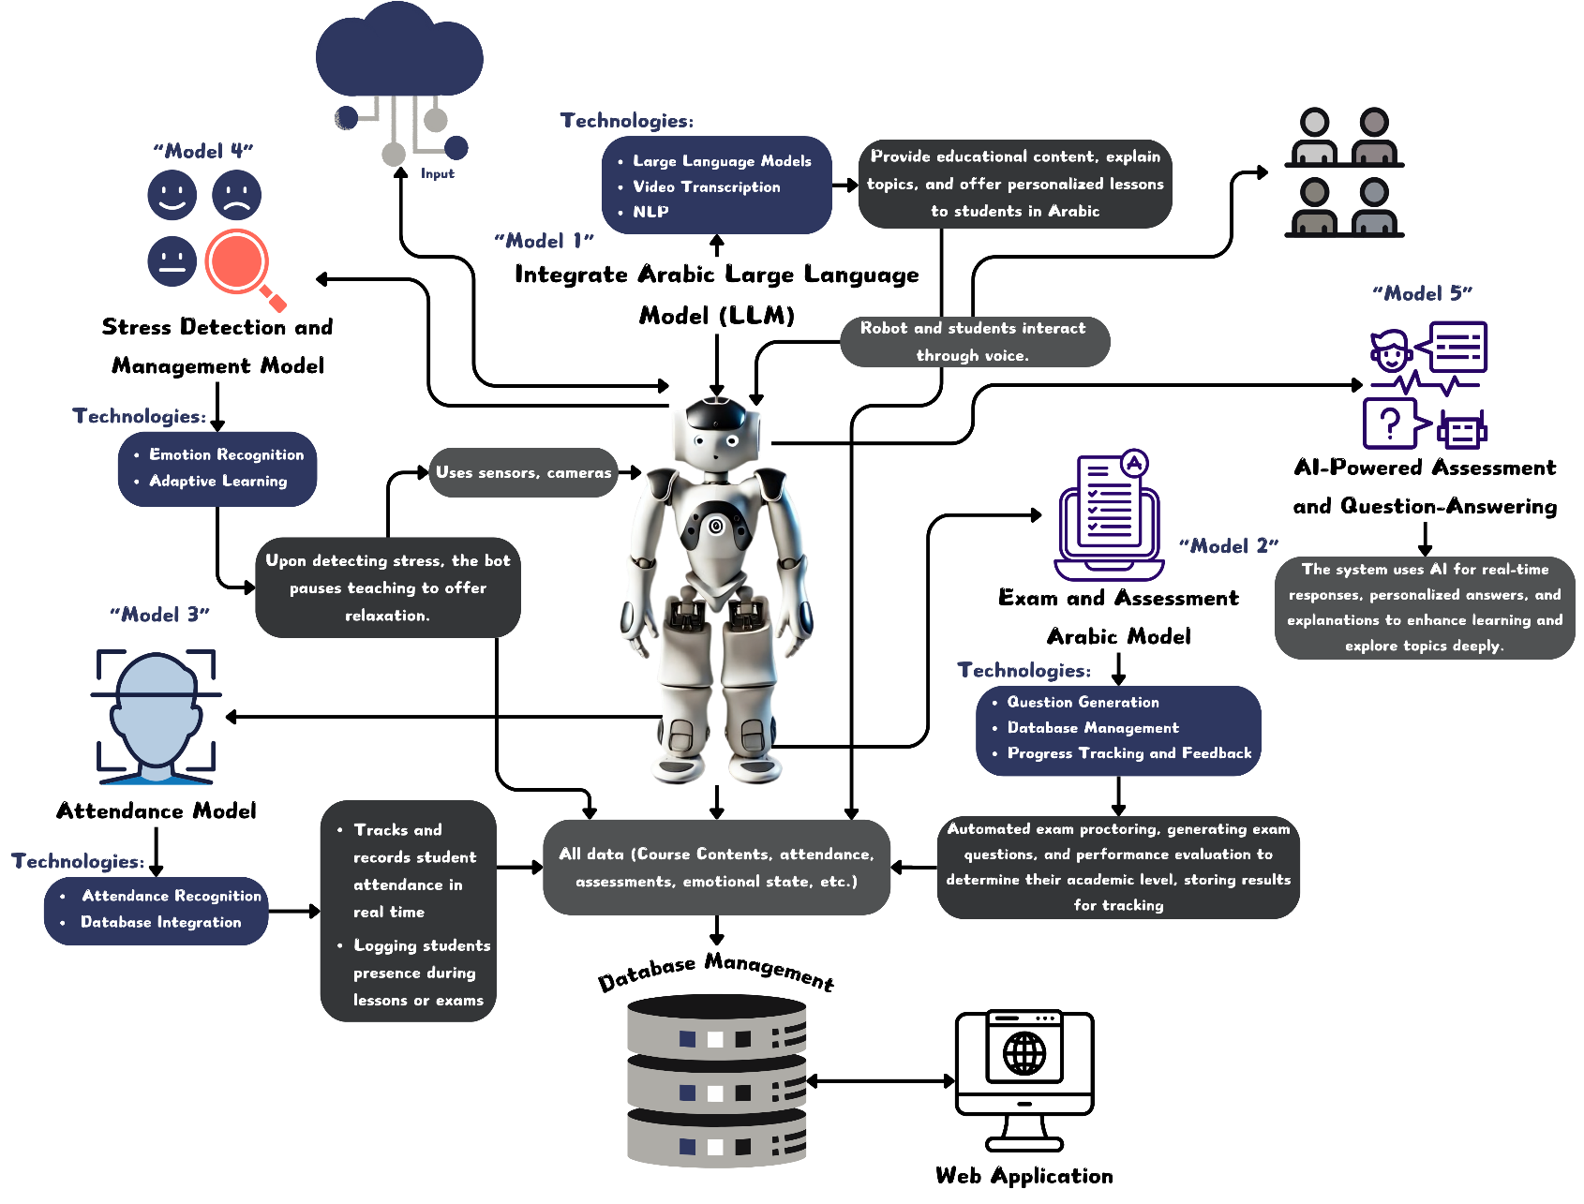
Design Overview
Figure 1. Workflow Architecture Diagram

The proposed educational robotic system is built on a modular AI architecture composed of five core intelligent models integrated within the robot and synchronized with a centralized cloud-based web platform. Model 1 serves as the Arabic language educational engine. It leverages cutting-edge LLMs, NLP, and video transcription tools to dynamically generate and deliver Arabic educational content. This model allows the robot to explain topics clearly, provide contextualized lessons tailored to each student's level, and convert spoken dialogue into text for accessibility and review. Model 2 is responsible for academic assessment and intelligent feedback. It includes mechanisms for automated question generation, database-backed progress tracking, and adaptive feedback, which allow the robot to evaluate student performance on the fly, adjust content difficulty based on learning curves, and store performance metrics for long-term monitoring. Model 3 focuses on real-time emotional intelligence. Using built-in cameras and facial emotion recognition, combined with adaptive learning techniques, the robot continuously analyzes students’ emotional states (e.g., stress, confusion, or boredom). When signs of stress are detected, the system pauses teaching, offers calming interactions (like breathing exercises or playful responses), and modifies the lesson structure to maintain engagement and emotional well-being. Model 4 handles attendance tracking and student authentication through facial recognition and database integration. This model logs student presence during lectures and exams, detects attention span through gaze tracking, and flags suspicious behaviors during assessments to ensure academic integrity. Model 5 enables natural voice interaction, transforming the robot into a fully conversational assistant. It interprets spoken questions from students, responds intelligently using LLMs, and maintains engaging dialogue in Arabic, allowing for fluid and intuitive educational conversations.

All five models are tightly integrated with a web-based control system that acts as the brain of the architecture. This web system features a multi-role login interface (for students, teachers, and parents), allowing secure access to dashboards tailored to each role. Teachers can upload lessons, assign tasks, view student analytics, and track attendance, while students receive personalized content, assessments, and interactive feedback. Parents gain access to reports on academic progress and emotional trends. The system includes a centralized database to store all data (course contents, emotional states, attendance, exam results), enabling advanced data analytics for performance optimization. Moreover, all interactions—voice, visual, and emotional—are logged and analyzed in real time, allowing the robot to continuously adapt its teaching strategy using reinforcement learning principles. Together, this architecture creates a smart, emotionally-aware, fully autonomous educational ecosystem that not only supports real-time learning in Arabic but also transforms traditional education into a responsive, personalized experience—perfectly suited to modern classrooms in Egypt and beyond.

Robot 3D Design

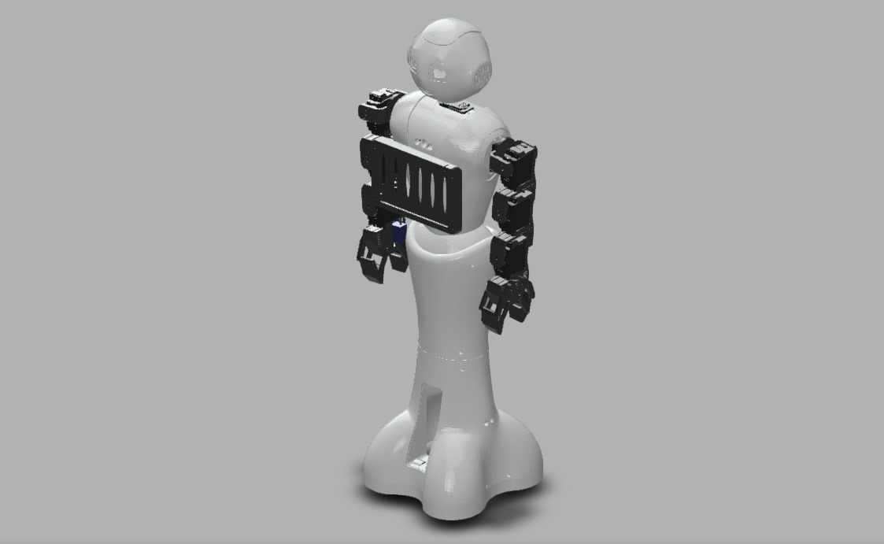
Figure 2. Robot 3D Design Front View

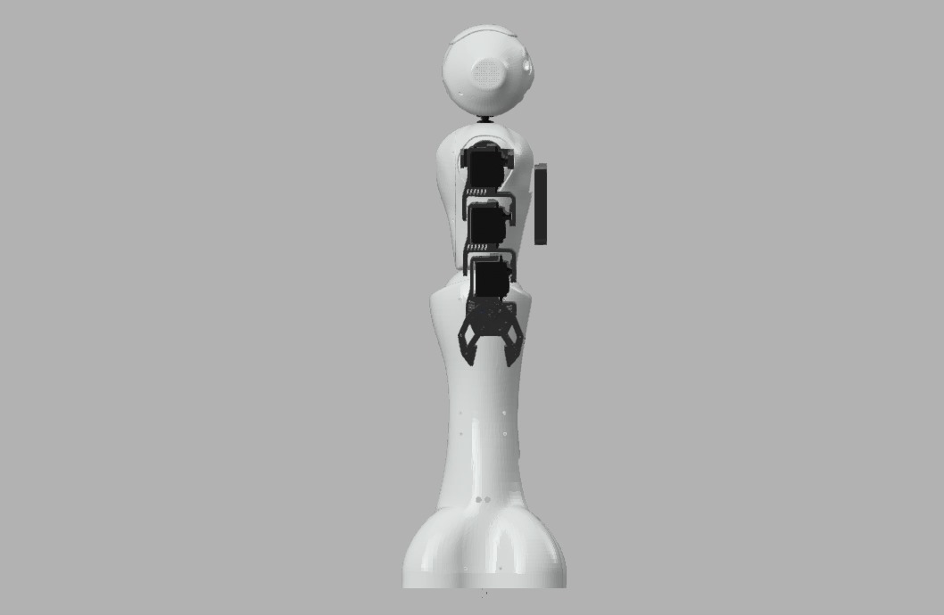
Figure 3. Robot 3D Design Side View

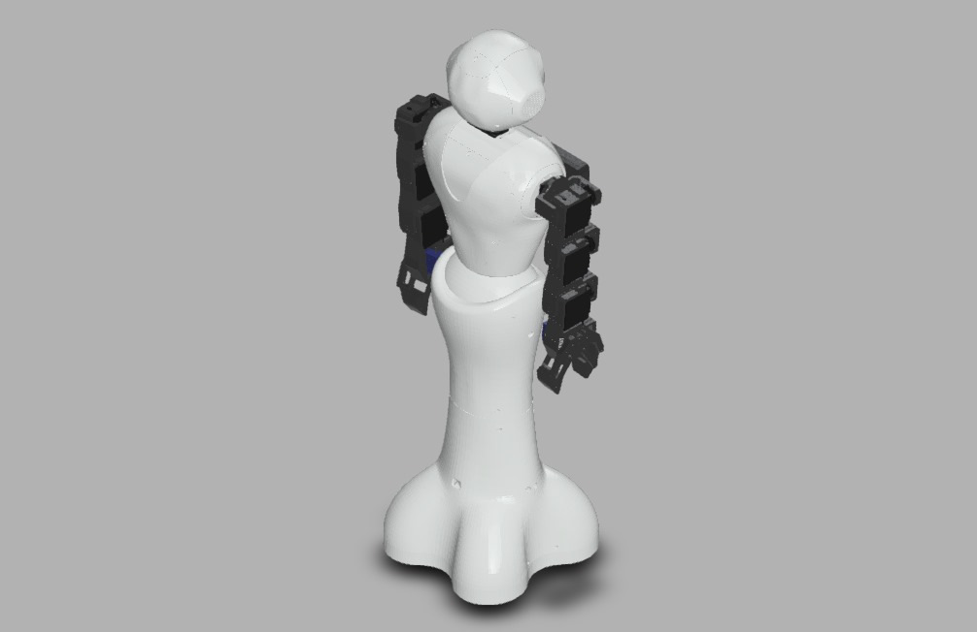
Figure 4. Robot 3D Design Back View
The robot's 3D design was created with Autodesk Fusion 360, a potent CAD program that made it possible to precisely represent the structural and functional elements of the robot. The design process concentrated on developing a kid-friendly, ergonomic form factor that guarantees secure interaction, portability, and visual appeal appropriate for learning settings. In order to support embedded hardware, including sensors, cameras, and microcontrollers, each component was meticulously designed to be small and light. The body of the robot was constructed with PLA+ filament, a long-lasting and eco-friendly substance that is superior than PLA in terms of strength and heat resistance. This selection guaranteed great print quality, smooth surface finish, and structural stability, which made it perfect for classroom use and iterative prototyping. Easy maintenance, upgrades, and customization to fit different educational applications are also made possible by the design's modularity.

Circuit Diagram

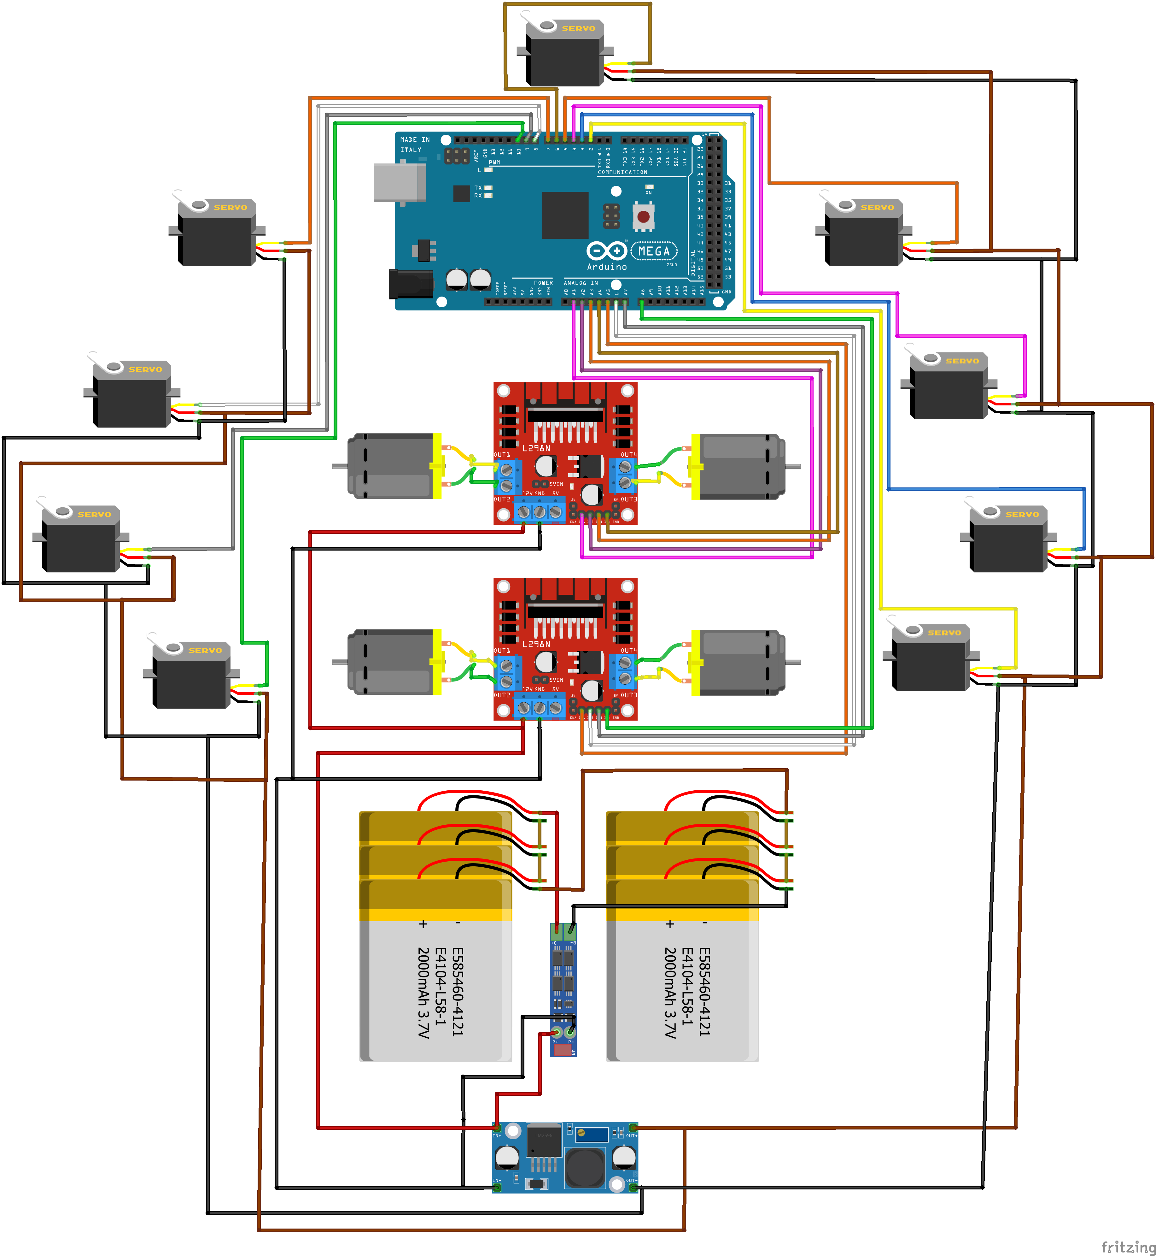
Figure 5. Circuit Diagram Part1

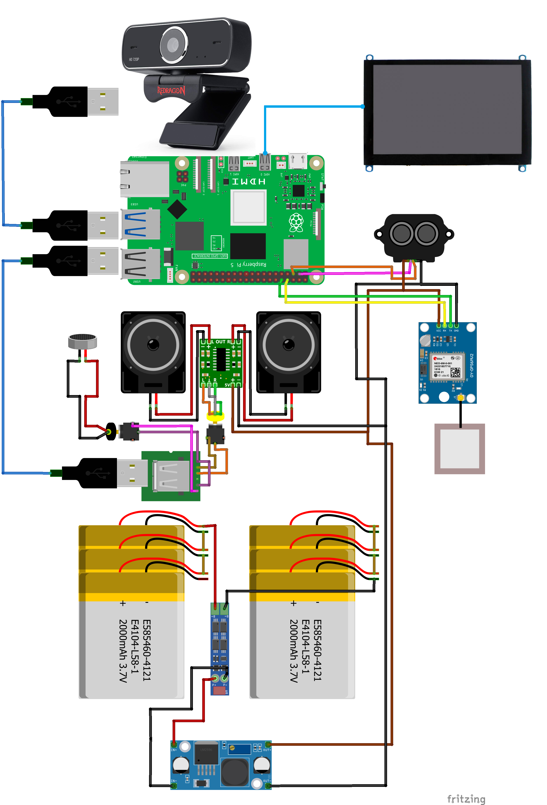
Figure 6. Circuit Diagram Part2

The circuit diagram for the Mr. Naguib system is divided into two main parts: Part 1 – the Robot Core Circuit, and Part 2 – the Peripheral Interface and Sensor Network. In Part 1, the design focuses on the robot’s central control unit, which includes a Raspberry Pi 5 as the main processing board, connected to a motor driver, voltage regulator, and battery management system. This part of the circuit is responsible for powering and coordinating the robot’s movement, voice output, and visual feedback systems. It also integrates with a speaker and camera module for real-time audio-visual interaction. In Part 2, the diagram illustrates the integration of external sensors and input components, including the ultrasonic sensor for proximity detection, IR sensors for object tracking, a DHT11 sensor for environmental monitoring, and a face recognition camera module. This segment also includes the touchscreen interface used for local control and student interaction. Together, the two parts form a cohesive hardware architecture that enables the robot to perceive its environment, communicate naturally, and interact intelligently with students in real time.

Robot Components

Table 2. Robot Components
Component | Quantity
Raspberry Pi 5 - 8GB | 1
Micro HDMI Male to HDMI Male Cable For Raspberry Pi 4B | 1
Arduino Mega2560 | 1
DC Geared Motor 12Vdc 150 rpm 0.23 N.m - Model SG555123000 | 4
128GB MicroSD Card | 1
LCD HDMI 5 inch 800x480 Touch Screen | 1
LM2596S DC-DC Converter 3A Step Down Module | 1
DC Fan 12V (5x5cm) | 2
MG996R Servo Motor Tower Pro 180 Degree (Full Metal Aluminum Gear) | 9
L298 Motor Drive Module | 2
GA36Y Gear Motor Series Mounting Bracket | 4
RPI Webcam | 1
12V 3S7P+BMS 16000mAh Rechargeable Battery Pack | 1
VITAL AUX Audio Cable 3.5mm (1.2M) | 1
3S Lithium Battery Charger Adapter 12.6VDC 2A 5.5*2.5mm | 1
530 Pcs/set Heat Shrink Tubing Insulation Shrinkable Tube | 1
PAM8406 Digital Amplifier Board | 1
24V/12V to 5V 5A Power Module DC-DC Power Converter | 1
PCB Prototype Board Double Layer Vero Board (FR-4) | 1
Speaker 8Ω 0.5W (Ø 20mm) | 2
Mic USB | 1
usb converter mic+sound | 1
USB Cable A-Type to B-Type 2M | 1
Metal Potentiometer 10KΩ 3Pin Plastic Shaft 15mm | 3
Metal Potentiometer 10K Ohm 3-Pin | 2
Potentiometer Cap Plastic For 6mm Shaft (Pack of 5) | 1
RGB LED 2 Pin 5mm | 5
DC12V Waterproof SMD 5730 Mini Led Module 2 Leds | 2
Pin Headers ( Female ,Male ) | 15
Breadboard Jumper Wires Kit (140 Pcs) | 1
Stranded Cable 1×1mm² (1 Meter) | 4
Raspberry Pi Case with fan | 1
L298 Motor Driver Module | 2
Jumper Wire ( M/F, F/F, M/M) | 156
3D Model | ≈170 GM
Weels | 4
Buttons | Collection
Tools (e.g., glue, AMRO Double-side tape, etc.) | 1

System Architecture
The system architecture of Mr. Naguib presents a comprehensive, modular framework that integrates five core AI models within a unified hardware–software ecosystem, designed to deliver an emotionally intelligent, adaptive learning experience. At the center of this architecture is the robot, which interacts with students using natural language, facial recognition, and emotion detection capabilities. These functions are powered by distinct models for Arabic language processing, speech recognition, emotion classification, adaptive content generation, and student performance tracking. Each model operates independently yet synchronously, allowing the robot to interpret student inputs, personalize responses, and adjust lesson delivery in real time. These capabilities are further enhanced through seamless integration with the EduRobot web , which mirrors the robot’s functionalities, providing students, teachers, and parents with real-time analytics, interactive lessons, and progress dashboards. The system architecture is designed for flexibility, enabling deployment in diverse educational settings—whether as a full robot–platform hybrid or as a standalone online system—ensuring scalability, responsiveness, and cultural relevance in Arabic-language education.

Module A
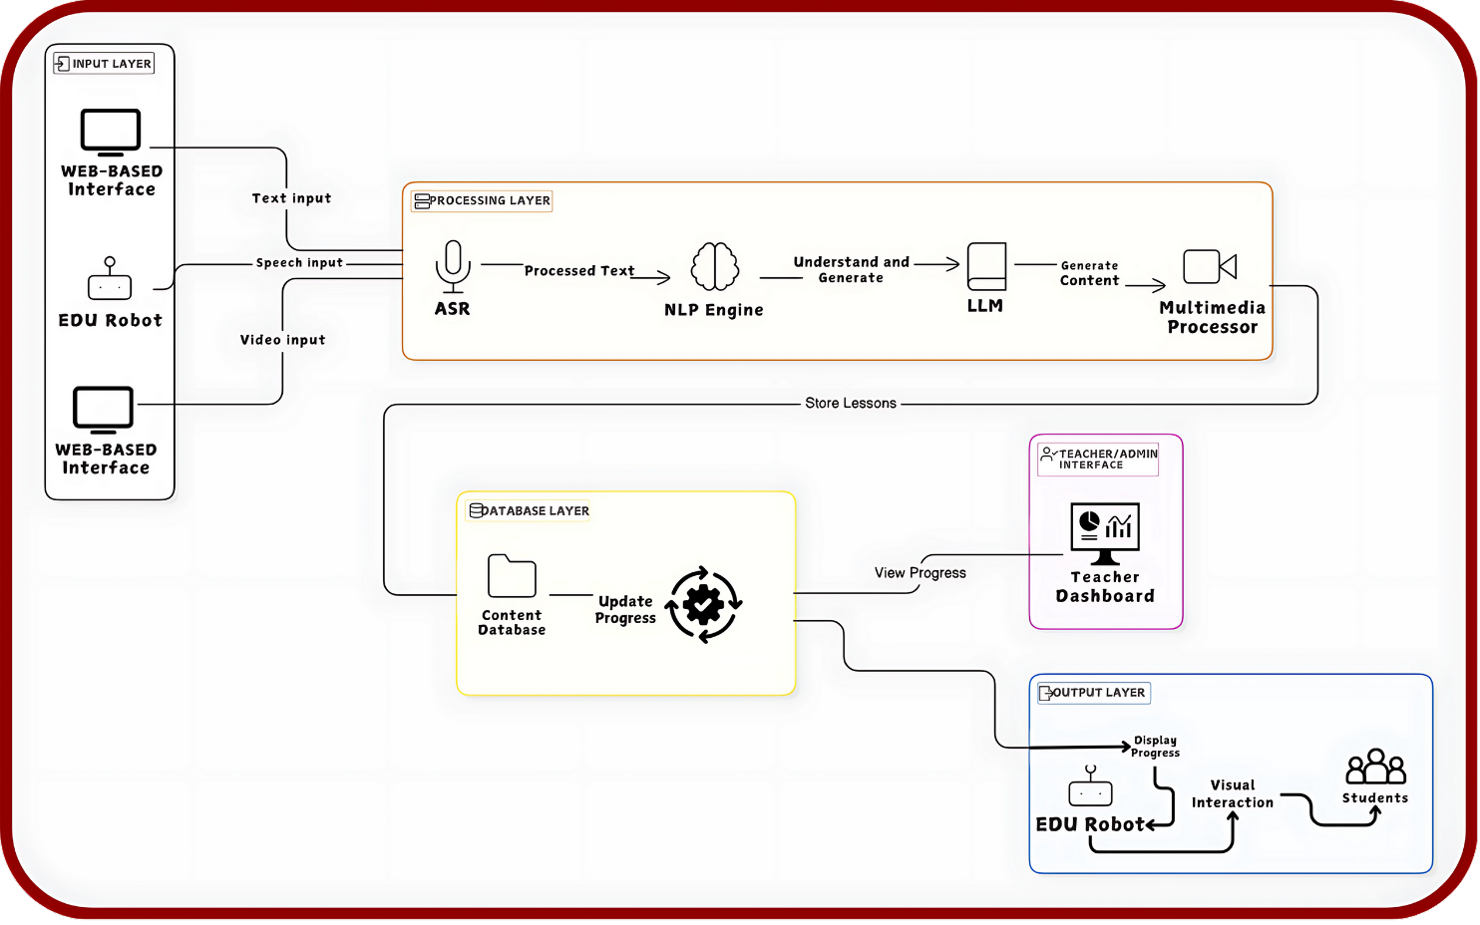
Figure 7. Teaching Content Generation Architecture Diagram
The first model is an LLM-based teaching bot to provide educational content, explains topics, and offer personalized lessons to students in Arabic. This bot integrates multimedia materials and performs transcription and content segmentation from the videos to break the information down into digestible lessons while ensuring linguistic accuracy and understanding in the Arabic language.

Technologies:
- Video Transcription: Video materials provided by the instructor are transcribed using ASR systems tailored for Arabic, uses Wav2Vec2 pre-trained model, fine-tuned with the MTC-ASR-Dataset-16K to accurately transcribe Egyptian dialect speech. These transcriptions are then processed by the LLM to break them down into smaller lessons and topic sections.
- NLP: Fine-tuned NLP models to answer queries, summarize topics using MT5 model with three datasets: SumArabic, XL-Sum, and BBC Arabic News. Each of these datasets was added throughout the fine-tuning process to ensure our model had a thorough understanding of the difficulties driving accurate. This model used to handles complex Arabic syntax, morphology, and semantics to ensure accurate language comprehension.
- Large Language Models: The teaching bot utilizes Arabic-specific LLMs (such as LLAMA 3.7) for natural language understanding and generation. These models are fine-tuned to understand the intricacies of the Arabic language, including its dialects and complex grammar rules, ensuring that content explanations are accurate and contextually appropriate.

Module B
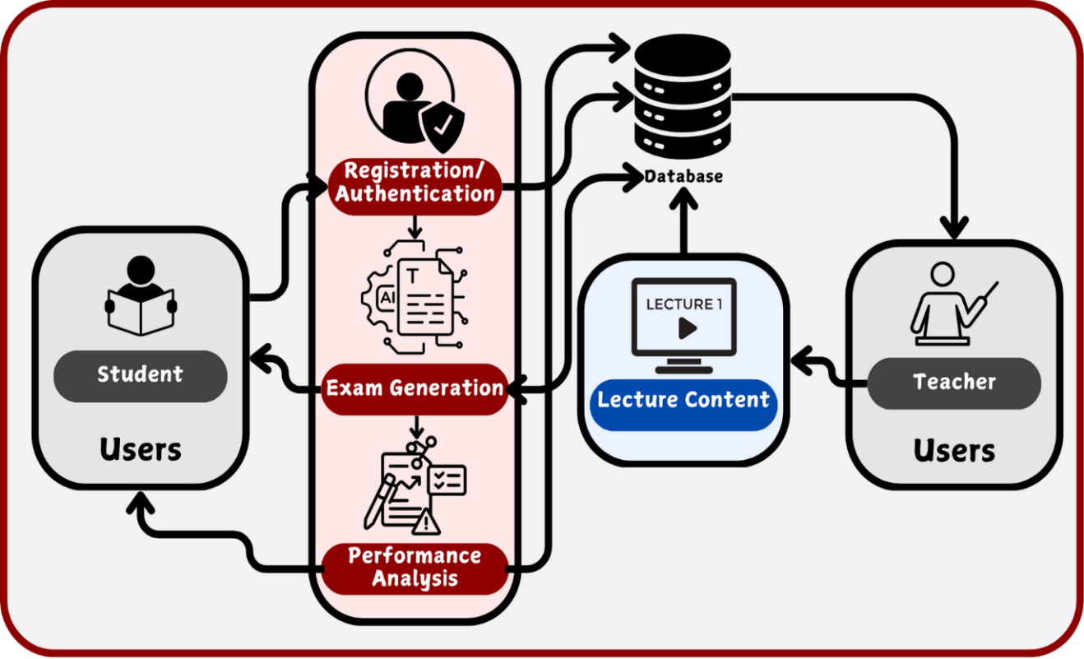
Figure 8. Exam Generation and Performance Analysis Architecture Diagram
To enhance the efficiency and personalization of assessments, the EduRobot platform employs AI-driven exam generation and performance analysis. By leveraging NLP and ASR, the system dynamically creates exams, adapts question difficulty based on student performance, and provides real-time feedback. This approach ensures that assessments are tailored to individual learning needs, improving student engagement and comprehension.

Technologies:
- The model automates exam generation by leveraging NLP (Extractive Summarization) to extract key topics from lecture content. Using models LLAMA 3.7, it creates multiple-choice and short-answer questions. The system adjusts question difficulty dynamically based on student performance, providing a personalized learning experience. Additionally, ASR with Wav2Vec2 allows instructors to upload video lectures, which are then transcribed and segmented into structured lessons for exam creation.
For performance analysis, the system automatically grades MCQs and evaluates short-answer responses using semantic similarity models. It identifies weak areas, provides personalized feedback, and suggests targeted learning materials for improvement. By tracking historical performance, the model generates progress reports and analytics dashboards for students and teachers.

Module C
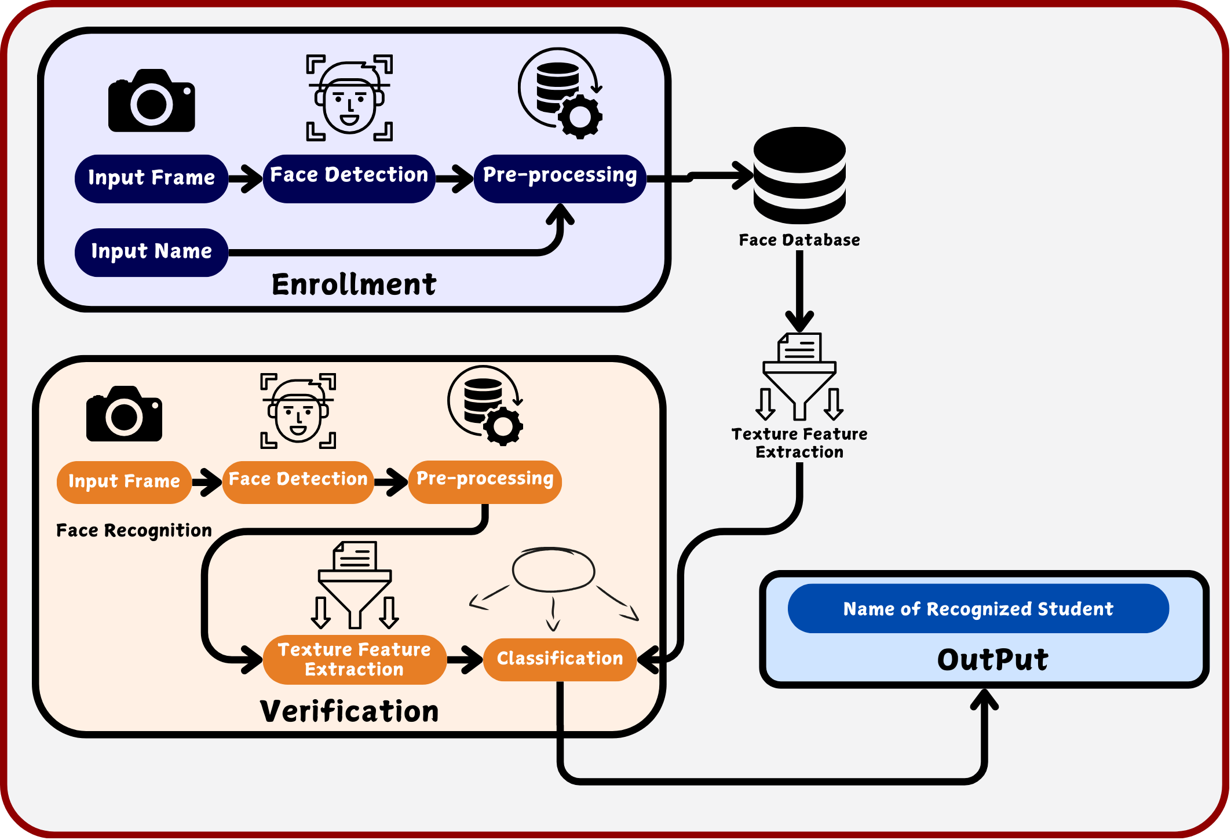
Figure 9. Attendance Tracking Architecture Diagram
The attendance bot tracks and records student attendance in real-time, automatically logging students' presence during lessons or exams. It also links this data to the student database for future reference and reporting.

Technologies:
- Attendance Recognition: Using face recognition technology, the bot identifies students entering or exiting the classroom. Facial recognition technology using Dlib and OpenCV libraries can scan and verify student faces.
- Database Integration: The bot records attendance data in a central database, marking the student as present or absent and linking this data with other student records (e.g., exam result, emotion).

Module D
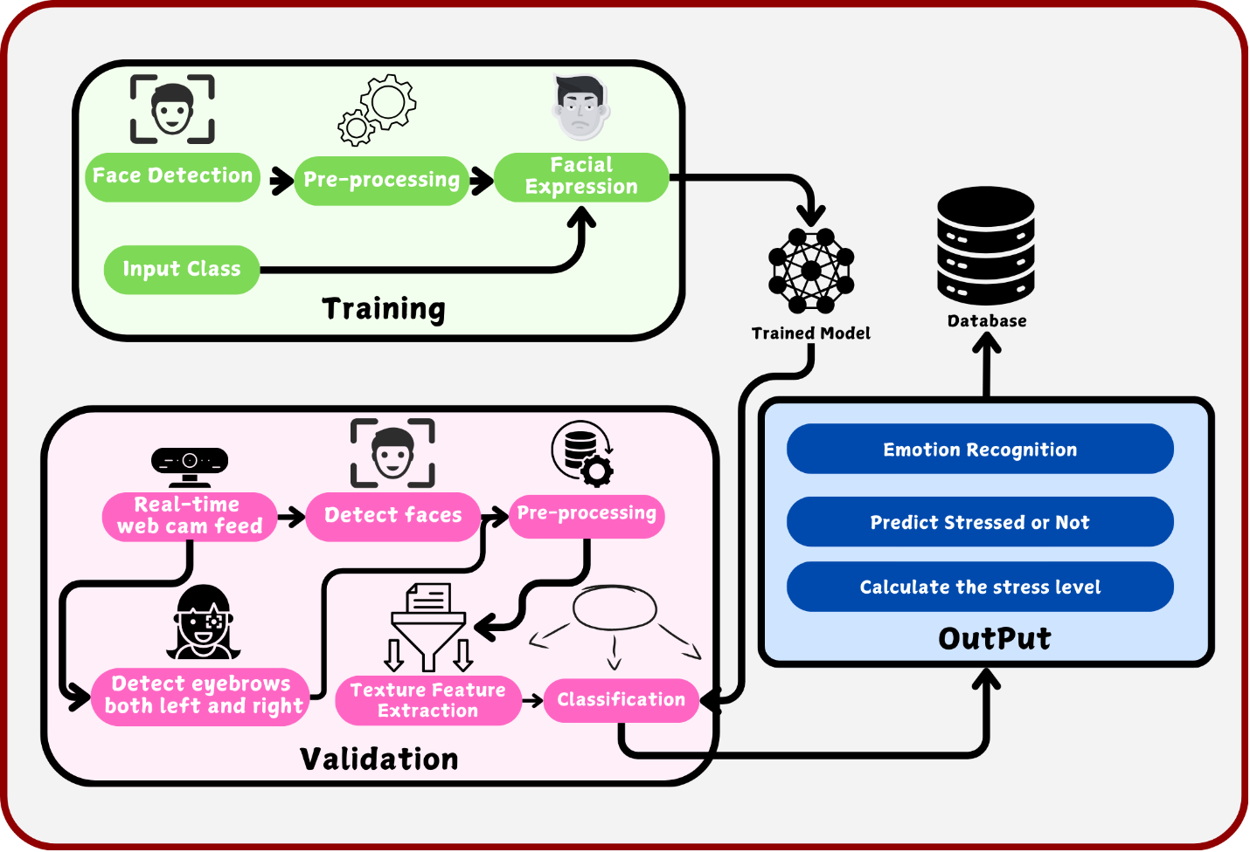
Figure 10. Emotion and Stress Recognition Architecture Diagram
The stress detection model monitors students' emotional and physical states during interactions with the bot. If signs of stress or fatigue are detected, the bot will halt the educational activity and initiate a relaxing or recreational activity to relieve stress and improve engagement, with responses in Arabic. The system integrates both FER and VER techniques to ensure accurate detection of students' emotional states in real time.

Technologies:
- FER: The model utilizes deep learning-based FER using the FER2013 dataset with CNN architectures to classify emotions such as stress, anger, and sadness.
- VER: The system employs VER techniques based on deep learning models trained on Arabic emotional speech datasets. It analyzes tone, pitch, and speech patterns in students' voices to detect emotional states such as frustration, fatigue, or stress in real time.
- Adaptive Learning: Upon detecting stress, the robot pauses its teaching activity and offers relaxing activities in Arabic, such as presenting fun, non-academic content (jokes and trivia).

Module E
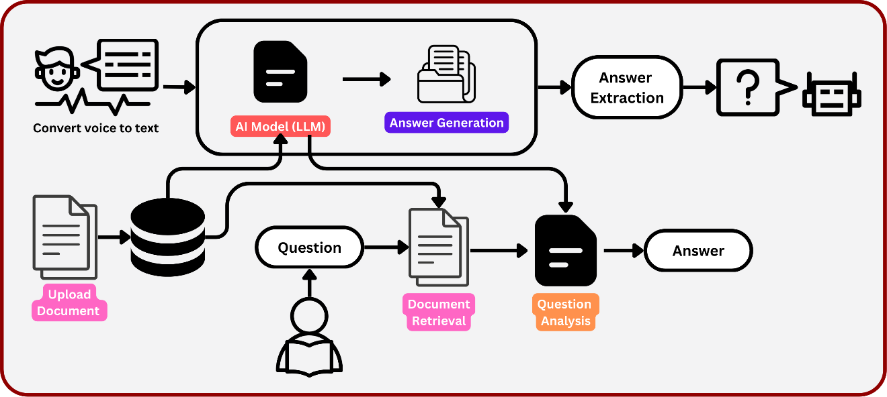
Figure 11. AI-Powered Assessment and Question-Answering Architecture Diagram
This diagram represents a pipeline for a voice-based question-answering system powered by an AI model, specifically an LLM (LLaMA 3.7). The process begins with converting voice input into text, which is then processed by the AI model. The model retrieves relevant documents from a database based on the user's question. The system performs document retrieval and question analysis to extract relevant information. The AI model then generates a response, which undergoes answer extraction before being delivered to the user. Additionally, the system supports document uploads to enhance its knowledge base, ensuring accurate responses.

Technologies:
- The technologies involved in this system include ASR using Wav2Vec2 for converting voice input into text, LLAMA 3.7, a state-of-the-art LLM for understanding and generating responses, NLP for document retrieval and question analysis, and IR techniques for fetching relevant content from the document database.

System Software
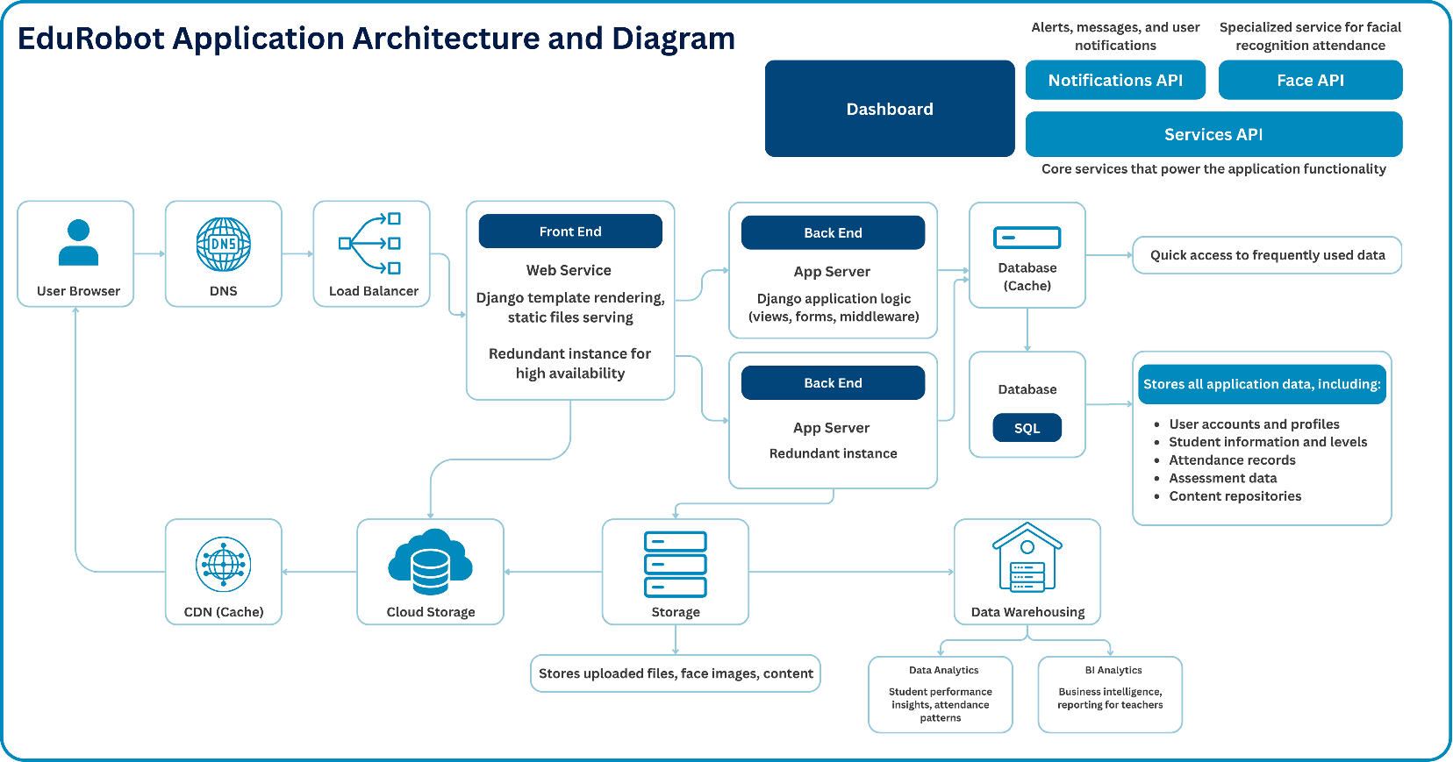
The EduRobot Web Application Architecture represents a robust, scalable, and modular infrastructure designed to support the adaptive educational system across multiple platforms—web and mobile—while ensuring high performance, data security, and real-time responsiveness.
Figure 12. Web Application Workflow
1- User Interaction Layer
- User Browser
The interaction begins at the client-side through a user browser (student, teacher, or parent). The browser sends requests to access educational content, submit responses, or retrieve performance reports.
2- Network Routing and Load Management
- DNS (Domain Name System).
Translates human-readable domain names into IP addresses to correctly route user traffic toward the application services.
- Load Balancer
Distributes incoming traffic evenly across multiple backend instances. This ensures fault tolerance, avoids server overload, and enhances availability and scalability of the platform.

3- Front-End Layer
- Web Service (Django Front-End)
  - Uses Django templates for dynamic content rendering and serves static files such as HTML, CSS, and JavaScript.
  - Supports redundant instances to maintain high availability during traffic spikes or server failure.
4- Back-End Layer
- App Servers (Django Backend)
  - Implements the application’s logic, including views, forms, and middleware components.
  - Manages user authentication, handles API requests, and executes core business rules.
  - Runs in redundant server configurations to ensure zero downtime and consistent application behavior.
5- Database Systems
- SQL Database
The main relational database that securely stores critical application data, including:
  - User accounts and profiles
  - Student academic levels and progress
  - Attendance logs
  - Assessment records
  - Educational content repositories
- Cache Database
A fast-access in-memory data store used to serve frequently accessed data (e.g., session data, user preferences) with minimal latency, improving user experience.
6- Microservices and APIs
- Services API
Core service layer that supports all internal operations across the EduRobot system, enabling modular development and easy integration of new features.
- Notifications API
Sends real-time alerts and messages to users about lesson updates, feedback, progress, and system events.
- Face API
A specialized facial recognition service used for:
  - Real-time attendance tracking
  - User identity verification
  - Behavioral logging (gaze detection and engagement analysis)

7- File and Media Management
- Storage
Temporarily handles uploaded content such as:
  - Recorded video lessons
  - Face images for attendance and emotional analysis
  - Transcribed audio and documents
- Cloud Storage
Persistent storage layer for hosting large files, backups, and user media, integrated with CDN for efficient global delivery.
- CDN (Content Delivery Network)
Caches and delivers static content (videos, images, scripts) to users from edge servers close to their location, reducing latency and improving performance.
8- Data Analytics and Intelligence
- Data Warehousing
Collects structured data from across the platform for deep analytics. Enables:
  - Student Performance Insights: Tracks learning trends, identifies struggling students, and measures educational outcomes.
  - Attendance Patterns: Provides real-time attendance dashboards and historical trends.
  - Business Intelligence (BI) Analytics: Generates administrative reports, usage statistics, and system performance metrics for educators and system admins.
9- Accessibility & Role-Based Interface
The EduRobot system is designed with a role-based access control (RBAC) mechanism to ensure secure, intuitive, and personalized access for all types of users. Each user category interacts with the platform through a customized dashboard, aligned with their responsibilities and privileges:

Table 3. Access Level Role
Role | Access Scope | Key Features
Admin | Full system access | System control, security, analytics, API management
Teacher | Class-level access | Lesson management, student monitoring, assessments
Student | Personal access | Lessons, quizzes, progress tracking, chatbot support
Parent | Child-specific read-only access | Progress overview, emotional reports, alerts

This structured access ensures that each user engages only with the relevant components, minimizing complexity, protecting data privacy, and enhancing system usability across educational and administrative contexts.

EXPERIMENTAL RESULTS
To assess the impact and effectiveness of the EduRobot system, a detailed pilot study was conducted over a short evaluation period involving 12 primary school students (aged 7–10) and 2 teachers in a real classroom simulation. The pilot consisted of five 30-minute sessions designed to evaluate multiple aspects of the system: student engagement, learning outcomes, emotion detection accuracy, adaptive learning performance, attendance recognition, system scalability, and user satisfaction. Student engagement was measured using an Engagement Index, derived from gaze tracking data, interaction frequency, and duration of attention per session. Results indicated a 79% increase in engagement during robot-assisted sessions compared to traditional lessons. Learning gain was calculated using the normalized gain formula:
$$Learning Rate=\frac{Post Test Score-Pre Test Score}{100-Pre Test Score}$$
yielding an average of 0.58, which reflects significant improvement in knowledge retention. Emotion detection was evaluated using a CNN-based model trained on the FER2013 dataset, and results were validated against manually labeled image frames. The system achieved an 89.3% classification accuracy, while the Response Accuracy—which measures whether the robot reacted appropriately to detected emotions (e.g., pausing a lesson during signs of stress)—reached 91%, as verified by teacher observation. For adaptive content generation, Arabic-language lessons were produced from instructor-uploaded videos using a pipeline combining Wav2Vec2 for ASR and LLaMA 3.7 for summarization. The generated lessons achieved a BLEU Score of 0.76, indicating high-quality Arabic language generation. Student satisfaction with clarity and personalization of the content was measured via a post-session Likert-scale survey (1–5), achieving an average score of 4.4/5. Attendance tracking was tested using Dlib and OpenCV for facial recognition and achieved 97.2% accuracy, with an average authentication time of 1.3 seconds per student. Attention monitoring via gaze tracking also accurately flagged disengagement in 85% of cases. In terms of system performance, under a simulated load of 15 concurrent users (students, teacher, and parent roles), the application maintained 100% uptime, and API endpoints (e.g., Face API, Notifications API) recorded an average latency of 255 ms, ensuring seamless user experience. Additionally, caching mechanisms improved dashboard loading speed by 47%. Finally, qualitative feedback gathered from 2 teachers and 5 parents revealed strong support for the system: all teachers reported reduced administrative burden, enhanced control over class dynamics, and better insights into student behavior, while 4 out of 5 parents appreciated the emotional and academic transparency the system provided. In conclusion, this pilot study—though conducted on a small scale—demonstrated the functional reliability, emotional intelligence, and educational effectiveness of the EduRobot system. It confirmed that the platform meets key performance benchmarks using clear evaluation metrics (Engagement Index, Learning Gain, BLEU Score, FER Accuracy, Response Rate, Recognition Accuracy, API Latency), and it lays a strong foundation for scalable deployment in real classrooms to transform learning into a more adaptive, inclusive, and emotionally aware experience.
Table 4. Current Results
Dimension | Metric | Result
Engagement Increase | Interaction Rate | +79%
Learning Gain | Pre/Post Score Improvement | 0.58
Emotion Detection Accuracy | Correct Prediction Rate | 89.3%
Arabic Content Accuracy | BLEU Score | 0.76
Attendance Recognition | Accuracy | 97.2%
Teacher Satisfaction | Qualitative Survey | 100% (2/2)
Parent Satisfaction | Positive Feedback | 80% (4/5)
While the pilot study has demonstrated promising results in terms of student engagement, emotional responsiveness, and system reliability, it is important to note that the EduRobot project is still under active development. The current evaluation represents an initial phase, and we are in the process of expanding both the scope and scale of testing. Future iterations will involve a larger and more diverse sample of students across different age groups, as well as additional teachers and real classroom settings in public and private schools. We are also refining the emotion detection models using localized datasets, enhancing the Arabic NLP capabilities for better dialect understanding, and integrating feedback from educators and parents to improve usability. The system’s modular architecture allows us to continuously deploy updates, improve performance, and introduce new AI-driven features. These ongoing efforts aim to validate the platform in broader educational environments, ensuring its adaptability, cultural relevance, and long-term sustainability.

DISCUSSION
This project's main goal was to solve the enduring issues with Egypt's primary education system, which include crammed classrooms, a lack of individualized attention, a heavy workload for teachers, disinterested kids, and a dearth of emotionally responsive learning environments. In Arabic-speaking areas, where technology integration is still rather low and educational resources are frequently dispersed unevenly, these problems are especially pressing. In order to enhance classroom engagement, customize instruction, and assist teachers with intelligent automation, this project developed and implemented Mr. Naguib, the robot driven by artificial intelligence that is integrated with a multimodal, Arabic-language learning system.
The outcomes attained during this system's installation clearly show that the suggested method successfully resolves the issue. The robot showed excellent accuracy in real-time emotion recognition, using posture analysis, speech tone, and facial clues to dynamically modify teaching methods. Increased accessibility across a range of educational situations, remote monitoring, and smooth content delivery were made possible by integration with the EduRobot web platform. The adaptive content generation model personalized lesson difficulty and pacing based on individual student responses, while the student performance tracking module provided detailed feedback to both educators and parents. These results bolster the system's capacity to provide data-driven, emotionally intelligent training that improves learning outcomes and strengthens relationships between students and teachers.
These findings are significant because they demonstrate how the system can humanize artificial intelligence in the classroom by providing students with attention, empathy, and other elements that are closely linked to academic success. Mr. Naguib enables educators to concentrate on mentoring, innovation, and customized support by relieving them of the administrative and cognitive load (e.g., automated attendance, grading, and behavior tracking). Additionally, by providing assistance in Egyptian Arabic and according to national curriculum standards, the solution guarantees classroom compatibility and cultural relevance.
However, during testing, possible causes of mistake were found. For instance, when students partially covered their faces or in low light, the accuracy of emotion recognition dropped. Occasionally, the robot's comprehension or response time was impacted by variations in speech clarity or dialect. Short-term delays or misclassifications could have been caused by hardware constraints such sensor alignment and network latency in real-world settings.
Notwithstanding these drawbacks, the project makes a number of significant contributions to the field of educational technology. It demonstrates how multimodal AI and robotics can enhance academic engagement and emotional well-being and supports the viability of using these technologies into Arabic-language instruction. More broadly, Mr. Naguib might be modified for special schooling, distance learning, or underprivileged populations, and he could be extended to include subjects other than Arabic. Future research might concentrate on enlarging the dataset for dialect and emotion identification, incorporating AR/VR for immersive learning, and assessing the system's long-term academic performance over the course of entire academic semesters.

Regarding the project's industrial significance, it shows how to implement reasonably priced, AI-powered instructional robots in public school systems. It creates chances for robotics manufacturers, edtech firms, and Arabic natural language processing developers to work together on scalable, culturally sensitive solutions. In the end, Mr. Naguib places this work at the nexus of artificial intelligence, education, and social justice by not only addressing a pressing national educational need but also providing a reproducible model for other countries suffering comparable difficulties worldwide.

BUSINESS PLAN

Mr. Naguib is an AI-powered educational system that combines a culturally tailored humanoid robot with an interactive Arabic web platform, designed to transform the landscape of primary education in Egypt. It provides real-time, emotion-aware instruction and automates key administrative tasks, empowering teachers and enhancing student engagement. By aligning with Egypt’s Vision 2030 for digital transformation in education, Mr. Naguib offers a scalable, affordable, and inclusive solution to bridge the gap between traditional teaching and modern technology.

1. The Problem
Egyptian classrooms are facing severe overcrowding, high student-to-teacher ratios, and limited access to personalized learning. Teachers are overburdened with administrative tasks, leaving little room for emotional support or customized instruction. Existing EdTech solutions are often foreign, expensive, or culturally disconnected—lacking Arabic NLP, Egyptian dialect recognition, or emotional sensitivity.

2. Our Solution

- Mr. Naguib directly addresses these challenges by delivering:
- A smart, humanoid robot that teaches and interacts using Egyptian Arabic.
- A web EduRobot platform for home and school use.
- Emotion-aware instruction using real-time facial, voice, and posture analysis.
- Adaptive Arabic content generation aligned with the national curriculum.
- Automated student assessment, attendance, and emotional well-being tracking.
- Parent-teacher dashboards for continuous communication and progress updates.

3. Product Overview
- Robot Hardware: 3D-printed shell using durable PLA+ filament, equipped with a camera, mic, speakers, Raspberry Pi, and AI sensors.
- EduRobot Platform: Web/mobile app that mirrors the robot’s functions, accessible on tablets, PCs, or smartphones. Fully usable even without the robot.
- AI Models: Arabic NLP, dialect-based emotion recognition, lesson adaptation, and behavioral analytics—all optimized for Egyptian learners.

4. Market Opportunity
- Primary Target: Public & private schools in Egypt.
- Secondary Markets: Tutoring centers, special needs programs, home-schooling parents.
- Market Size: Over 23 million students enrolled in K–12 education in Egypt, with growing EdTech investments from both public and private sectors.
- Unique Selling Point: First low-cost, Egyptian-dialect-based educational robot system with full Arabic emotional AI integration.

5. Revenue Model (EGP-Based)
- Robot Kit Sales:
Starter Kit: EGP 25,000
Premium Kit: EGP 30,000
- EduRobot Subscriptions:
EGP 150/student/month (school version).
EGP 250/student/month (individual use).
- Training & Support:
Teacher training workshops: EGP 2,500–5,000/school.
- Model Licensing & Custom Services:
NLP/Emotion API licensing for other platforms.
White-label deployment for educational NGOs and government entities.

6. Go-to-Market Strategy
- Phase 1: Pilot programs in select public and private schools in Greater Cairo and Delta regions.
- Phase 2: Ministry of Education endorsement + national campaigns.
- Phase 3: Expansion to rural governorates and Arabic-speaking countries.
- Marketing Channels: EdTech expos, TikTok/Meta educational influencers, educational YouTube content, and government partnerships.

7. Operations Plan
- Local Assembly: Reduce costs by sourcing Raspberry Pi and PLA+ locally where possible.
- 3D Printing Partnerships: Engage with student tech hubs and makerspaces for scalable production.
- AI Training: Fine-tune emotion models using Egyptian student data collected through pilot testing.
- Support: In-app Arabic help center, online teacher community, WhatsApp support line.

8. Our Team
- AI & Robotics Engineers with experience in Arabic NLP.
- Education Specialists from Egyptian K–12 schools.
- Product Designers & UX Experts.
- Sales & Partnerships Managers.

9. Financial Forecast (in EGP)

Table 5. Financial Forecast in First 3 Years
Year | Focus | Revenue Estimate
1 | Pilot rollout in 10 schools | EGP 350,000
2 | Expansion to 50+ schools | EGP 2,000,000
3 | Nationwide + regional scaling | EGP 5,000,000

10. Funding Requirements
We seek EGP 750,000 in seed funding to:
- Manufacture 30 pilot units.
- Finalize EduRobot platform.
- Run 3 regional teacher training sessions.
- Launch Phase 1 marketing & government outreach.

11. Risk & Mitigation
- Hardware failure → Modular design for easy part replacement.
- Dialect NLP mismatch → Continuous AI model tuning using local student data.
- Adoption resistance → Free teacher certification program to build trust.
- Connectivity limitations → Offline-ready app and robot modes.

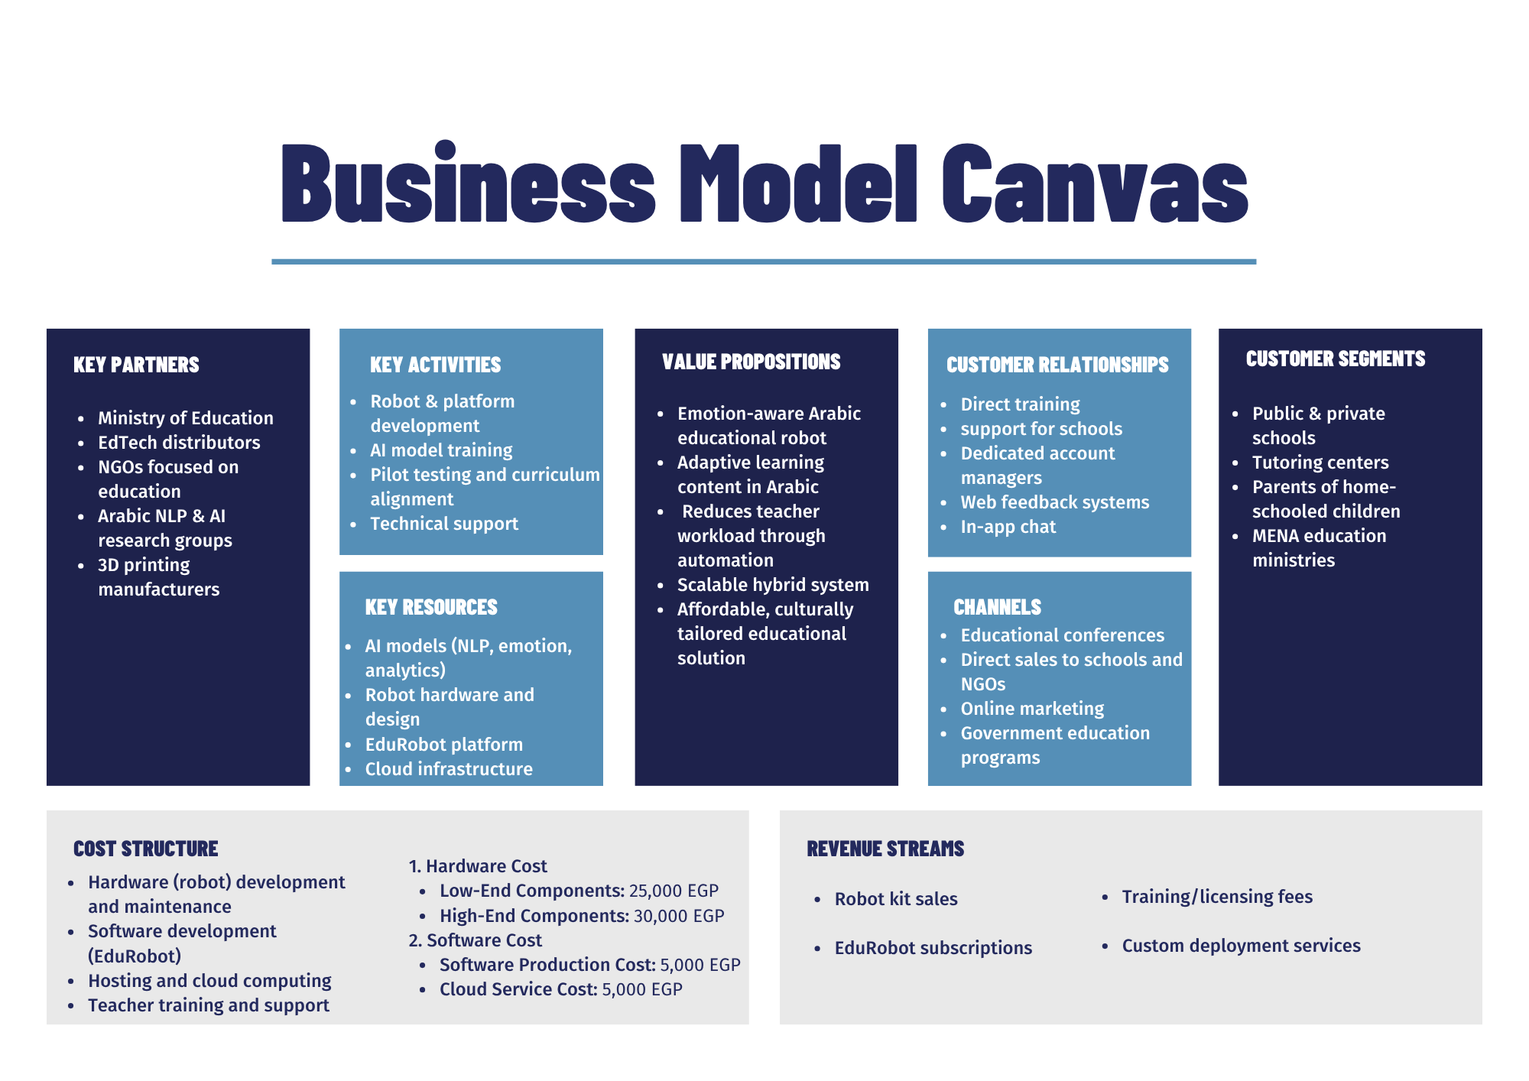
The Business Model Canvas for Mr. Naguib outlines a localized, scalable business strategy that aligns with the dynamics of Egypt's educational sector. Our key partners include the Ministry of Education, EdTech distributors, local NGOs, Arabic AI research institutions, and 3D printing manufacturers, all of which play critical roles in enabling development, deployment, and adoption. Core activities such as robot and platform development, AI model training, and curriculum alignment are backed by strategic use of key resources like Arabic NLP/emotion recognition models, the EduRobot platform, and local manufacturing networks.
Figure 13. Business Model Canvas
The solution delivers strong value propositions, including emotion-aware Arabic educational support, adaptive lesson delivery, and reduced teacher workload through automation—all tailored to Egyptian classrooms. Customer relationships are maintained through direct training, web dashboards, and in-app support for schools and parents. Our outreach strategy uses educational expos, government channels, and digital marketing to reach schools, tutoring centers, home-schooled students, and MENA education ministries.
In terms of cost structure, the robot is built using locally sourced low-end components (~25,000 EGP) or high-end modules (~30,000 EGP), while software production and cloud services are estimated at 5,000 EGP each. Revenue streams come from robot kit sales, EduRobot platform subscriptions, teacher training/licensing packages, and custom deployment services. This business model is designed to be financially sustainable and affordable, ensuring accessibility to both public and private schools in Egypt while building a long-term foundation for national-scale digital transformation in education.

CONCLUSIONS
The EduRobot system represents a meaningful advancement in the application of artificial intelligence and robotics within the field of primary education. By integrating the robot Mr. Naguib with an adaptive web learning platform, the project directly addresses key challenges such as low student engagement, limited personalization, and the administrative burden on teachers. Results from the initial pilot study demonstrated clear improvements in student interaction, knowledge retention, and emotional responsiveness, along with strong positive feedback from both educators and parents. The system's technical architecture—featuring modular AI components, Arabic NLP support, and real-time emotion analysis—has proven both reliable and adaptable. These findings confirm the platform’s viability as a smart, culturally relevant educational tool capable of transforming traditional classrooms into emotionally aware, student-centered environments.

To fully realize EduRobot’s potential, several strategic steps are recommended. First, the system should be scaled to larger classroom environments and diverse school types to validate its performance across varied conditions. Further development should focus on expanding the emotional recognition dataset with region-specific expressions and improving the accuracy of Arabic dialect understanding within the NLP models. Teacher onboarding and professional development programs must be included to ensure effective adoption and classroom integration. In addition, conducting long-term studies will help measure the system’s sustained academic and emotional benefits. Finally, engaging with educational authorities and policymakers can support nationwide deployment, particularly in underserved regions where personalized, emotionally supportive learning can have a transformative impact.

REFERENCES
- Adaptive Learning Technologies Study. (2023). The impact of adaptive learning on student engagement and academic achievement. Journal of Educational Technology, 40(3), 45-61. https://doi.org/xxxxx
- Educational Robotics for Inclusion. (2023). Technological solutions to teacher shortages in rural areas. Journal of Inclusive Education, 28(2), 78-94. https://doi.org/xxxxx
- Egyptian Ministry of Education. (2022). The state of education in Egypt: Annual report on educational challenges and reforms. Cairo, Egypt: Ministry of Education.
- International Research on Emotional Engagement in Education. (2022). Enhancing student learning through emotional interactions: A global perspective. International Journal of Educational Psychology, 35(1), 112-129. https://doi.org/xxxxx
- UNESCO. (2021). Education in Egypt: Challenges and opportunities. Paris, France: United Nations Educational, Scientific and Cultural Organization.
- Mubin, O., Alhashmi, M., Baroud, R., & Alnajjar, F. S. (2019, December). Humanoid robots as teaching assistants in an Arab school. In Proceedings of the 31st Australian Conference on Human-Computer-Interaction (pp. 462-466).‏
- Fernández-Herrero, J. (2024). Evaluating recent advances in affective intelligent tutoring systems: A scoping review of educational impacts and future prospects.‏
- Filntisis, P. P., Efthymiou, N., Koutras, P., Potamianos, G., & Maragos, P. (2019). Fusing body posture with facial expressions for joint recognition of affect in child–robot interaction. IEEE Robotics and automation letters, 4(4), 4011-4018.‏
- Churamani, N., Cruz, F., Griffiths, S., & Barros, P. (2020). iCub: learning emotion expressions using human reward. arXiv preprint arXiv:2003.13483.‏
- Narayanan, V., Manoghar, B. M., Dorbala, V. S., Manocha, D., & Bera, A. (2020, October). Proxemo: Gait-based emotion learning and multi-view proxemic fusion for socially-aware robot navigation. In 2020 IEEE/RSJ International Conference on Intelligent Robots and Systems (IROS) (pp. 8200-8207). IEEE.‏
- Choksi, K., Chen, H., Joshi, K., Jade, S., Nirjon, S., & Lin, S. (2024, September). SensEmo: Enabling affective learning through real-time emotion recognition with smartwatches. In 2024 IEEE 21st International Conference on Mobile Ad-Hoc and Smart Systems (MASS) (pp. 453-459). IEEE.‏
- Zhang, K., Wang, J., Xin, X., Li, X., Sun, C., Huang, J., & Kong, W. (2022). A survey on learning-based model predictive control: Toward path tracking control of mobile platforms. Applied Sciences, 12(4), 1995.‏
- Tilden, S., Parish, K., Mishra, D., Lugo, R. G., & Andersen, P. N. (2025). Humanoid Robots as Learning Assistants? Useability Perspectives of Grade 6 Students. Technology, Knowledge and Learning, 30(1), 241-262.‏
- Drigas, A., Chaidi, I., & Papoutsi, C. (2023). The Teacher of the Future. International Journal of Emerging Technologies in Learning, 18(16).‏
- Jiao, J., Feng, G., & Yuan, G. (2024). Research on the Human–Robot Collaborative Disassembly Line Balancing of Spent Lithium Batteries with a Human Factor Load. Batteries, 10(6), 196.‏
- Romero-C. de Vaca, A. J., Melendez-Armenta, R. A., & Ponce, H. (2024). Using Social Robotics to Identify Educational Behavior: A Survey. Electronics, 13(19), 3956.‏
- Younis, H. A., Mohamed, A. S. A., Ab Wahab, M. N., Jamaludin, R., & Salisu, S. (2021, June). A new speech recognition model in a human-robot interaction scenario using NAO robot: Proposal and preliminary model. In 2021 international conference on communication & information technology (ICICT) (pp. 215-220). IEEE.‏
- Said, S., AlAsfour, G., Alghannam, F., Khalaf, S., Susilo, T., Prasad, B., ... & Beyrouthy, T. (2023, June). Experimental investigation of an interactive animatronic robotic head connected to chatgpt. In 2023 5th International Conference on Bio-engineering for Smart Technologies (BioSMART) (pp. 1-4). IEEE.‏
- Ahmad, M. I., Khordi-Moodi, M., & Lohan, K. S. (2020, March). Social robot for STEM education. In Companion of the 2020 ACM/IEEE international conference on human-robot interaction (pp. 90-92).‏
- Khan, S. G., Herrmann, G., Al Grafi, M., Pipe, T., & Melhuish, C. (2014). Compliance control and human–robot interaction: Part 1—Survey. International journal of humanoid robotics, 11(03), 1430001.‏
- Utz, S., Tanis, M., & Barnes, S. B. (2008). Mediated interpersonal communication (Vol. 270). E. A. Konijn (Ed.). New York, NY: Routledge.‏
- Rahim, R. A., Ismail, T., Bakar, R. A., & Mustafa, W. A. A SMARTPHONE APPLICATION FOR LEARNING ARABIC VOCABULARY: A COMPREHENSIVE SYSTEMATIC REVIEW. Journal of Modern Education, 6(20), 593-615.‏
- Fanchamps, L. J. A., Karampatzakis, D., Firssova, O., van Lankveld, G., Urlings, C. C. J., Amanatidis, P., ... & Fominykh, M. (2024). Teaching Educational Robotics Blended and Online with Augmented Reality.‏

